Variable | OR (95% CI )
5 days mean PEEP (per 1 cmH₂O increase) | 1.2 (0.82 – 1.79)
5 days mean leukocytes (per 1G/L increase) | 1.3 (1.09 – 1.60)
SAPS II (per 1 increase) | 1 (0.99 – 1.09)

Table S1 : Multivariate model including 5 days mean PEEP, 5 days mean leukocytes and SAPS II for the prediction of worsening renal function

Variable | OR (95% CI )
5 days mean CVP (per 1mmHg increase) | 2 (1.12 – 4.33)
5 days mean leukocytes (per 1G/L increase) | 1.4 (1.10 – 1.82)
SAPS II (per 1 increase) | 1.1 (0.92 – 1.14)
Table S2: Multivariate model including 5 days mean CVP, 5 days mean leukocytes and SAPS II for the risk of worsening renal function

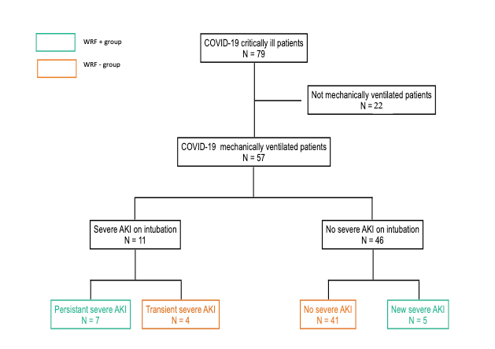

Figure S1 : flow chart

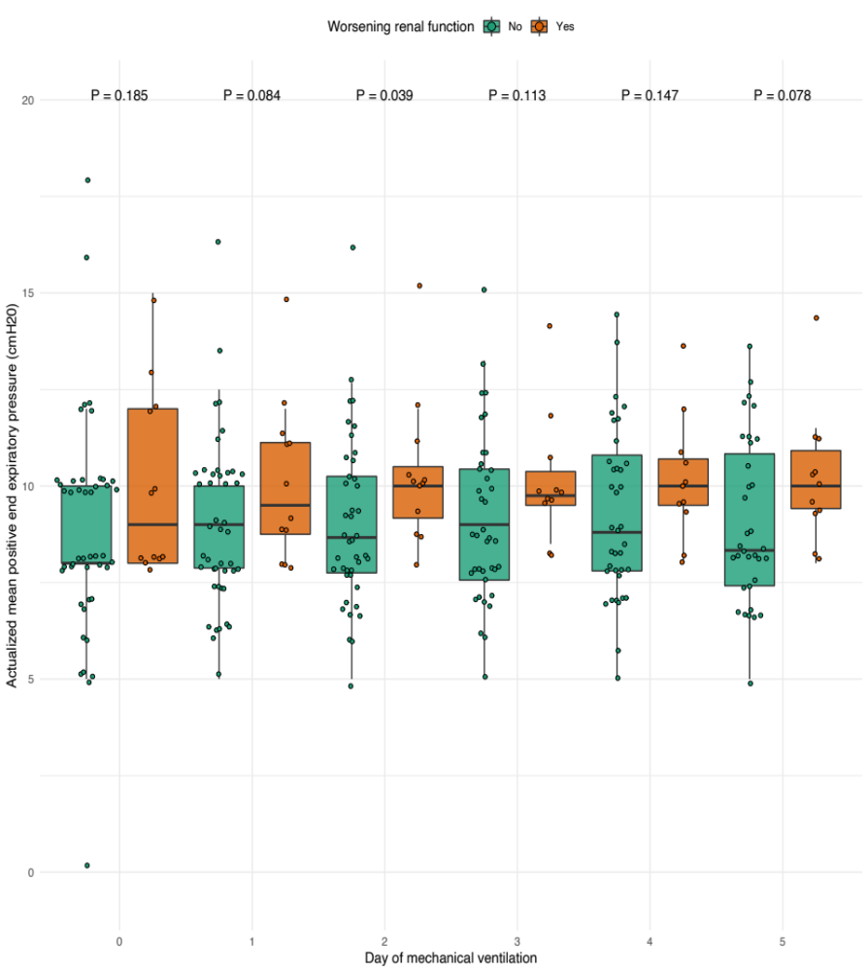

Figure S2 : Comparison of daily actualized mean peep during the 5 days following intubation

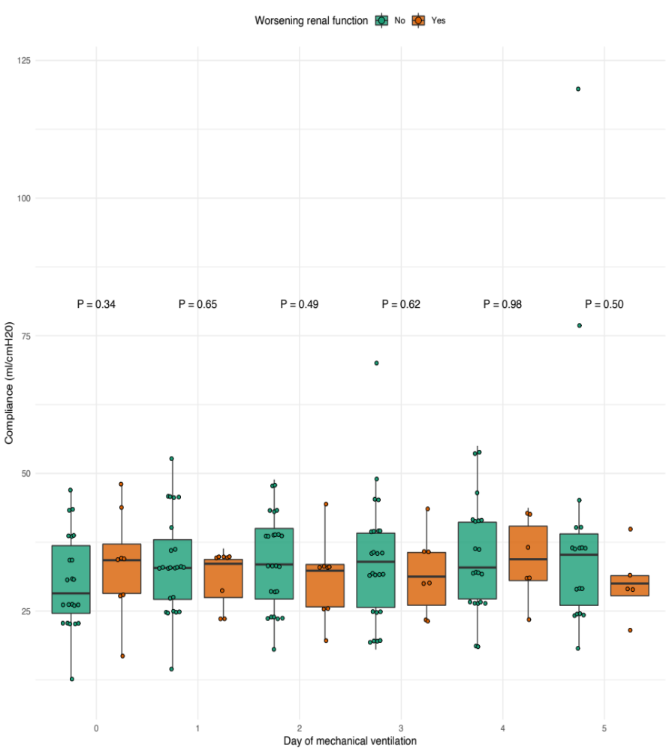

Figure S3 : Comparison of daily compliance during the 5 days following intubation

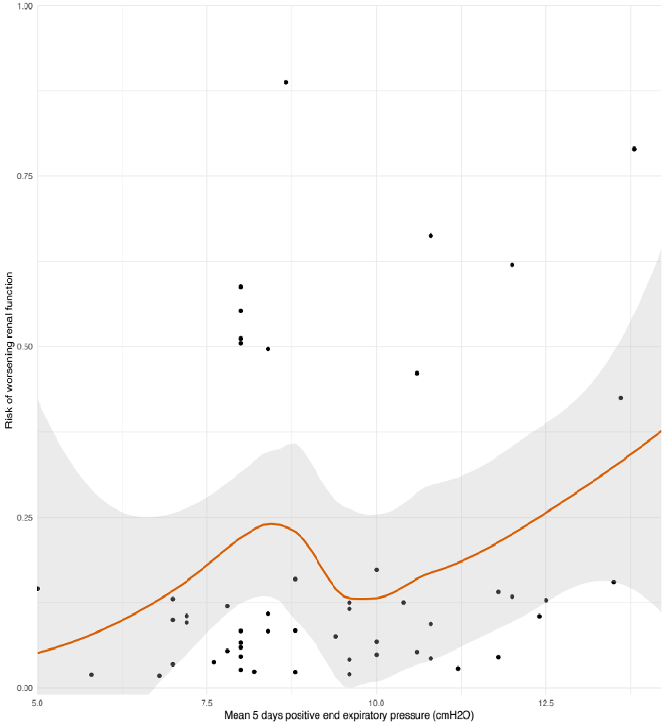

Figure S4 : Risk of worsening renal function according to the mean value of peep value

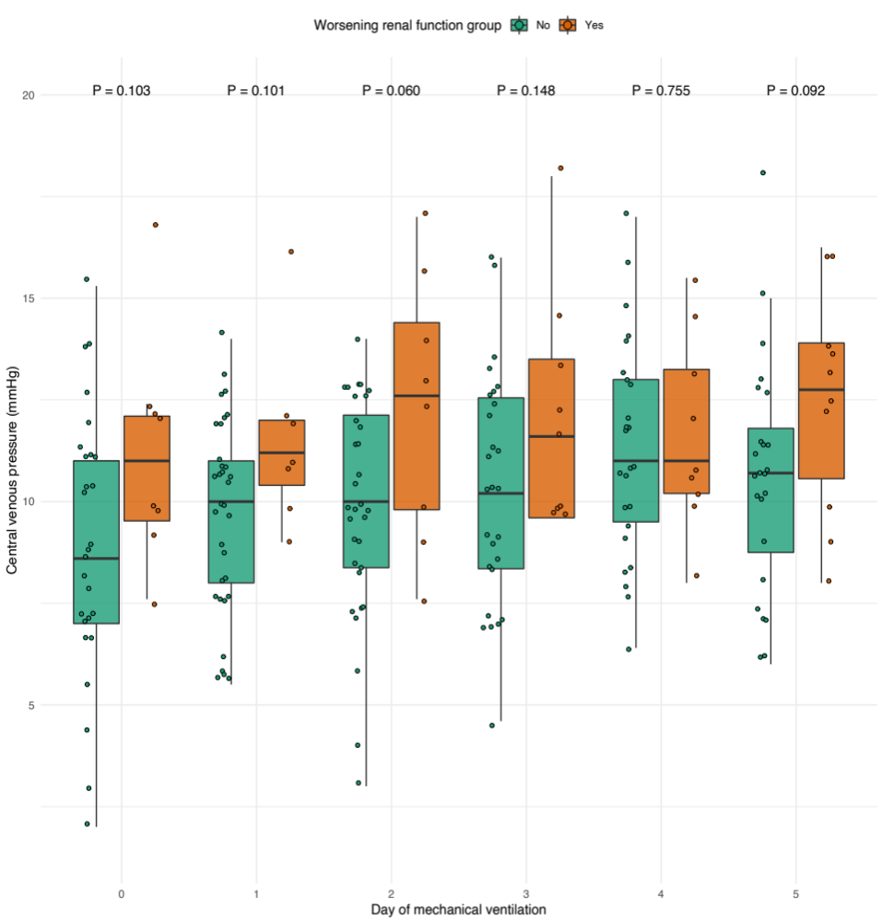

Figure S5 : comparison of daily central venous pressure during the 5 days following intubation

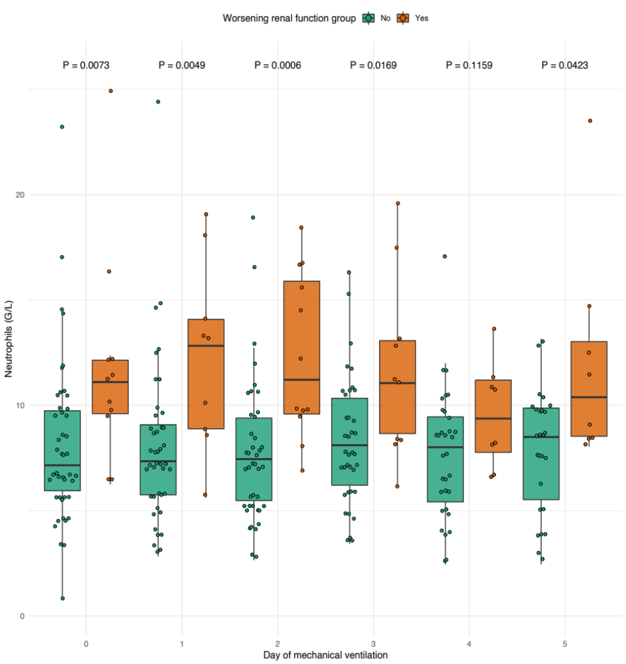

Figure S6 : Comparison of daily neutrophils during the 5 days following intubation

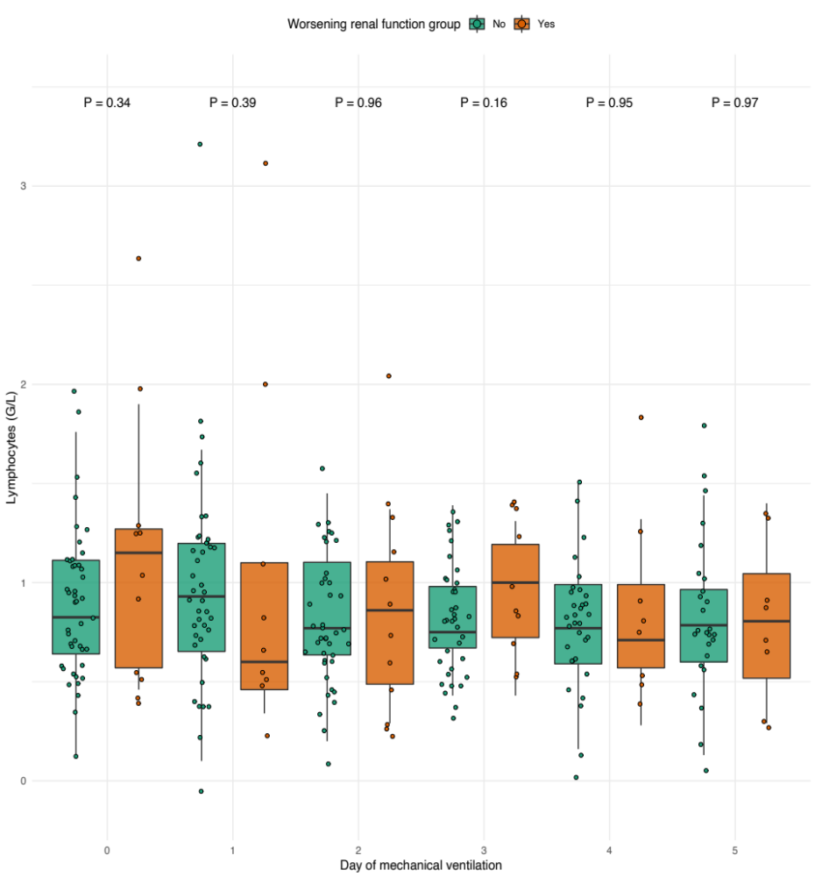

Figure S7 : Comparison of daily lymphocytes during the 5 days following intubation

