Supplementary Materials
Exploration of a superior water-resistant protein coating with inherent functionality inspired by scallop byssus

Lulu Wang^{1,2}†, Bo Xue^{1,2}†, Pingping Xu^{1,2}, Weizhi Liu^{1,2}*
*Corresponding author. Email: liuweizhi@ouc.edu.cn

This PDF file includes:
Supplementary Methods
Figs. S1 to S16
Tables S1
Movies S1 to S2
References (1 to 13)

Supplementary Methods
Amino acid sequence analysis
Sequence analysis was performed using ProtParam (ExPASy) tool, including amino acid composition via ProtParam (https://web.expasy.org/protparam/) and hydrophobicity analysis via ProtScale using Kyte & Doolittle parameters (https://web.expasy.org/protscale/). Multiple sequence alignment was generated with BioEdit version 7.2.5.
Turbidity assays
To monitor the assembly formation in protein solutions containing different metal ions, turbidity of absorbance at 340 nm was applied as an indicator. 20 μL of metal ions at a final concentration of 1 mM were added into 180 μL of the Sbp9^{Δ} solution (0.6 mg/mL) respectively, and the mixtures were transferred to 96-well plates on microplate reader (Synergy H1, BioTek, USA) at different time intervals. The turbidity was defined as T-T₀, where T and T₀ were the light transmittance with and without metal ions in protein solutions, respectively. Each sample was measured in triplicate.
Dynamic light scattering (DLS)
To monitor the assembly formation in protein solutions containing different metal ions, particle sizes of Sbp9^{Δ} were also detected by DLS (DynaPro NanoStar, WYATT). 2 μL of metal ions at a final concentration of 1 mM were added into 18 μL of the Sbp9^{Δ} solution (0.6 mg/mL) respectively, and the mixtures were transferred to capped cuvette. The machine automatically read data every two minutes at 25 ℃. Each sample was measured in triplicate. Among them, the particle size distributions of Ca²⁺-triggered Sbp9∆ assemblies at 0, 1, 8 min were detected to clarify the self-assembly process.
Water contact angle (WCA)
The WCA measurements were performed with ultrapure water (2 μL) at room temperature using a JY-82B Kruss DSA instrument (Germany) following the sessile drop method. The Sbp9^{Δ} coatings on mica, glass, polystyrene (PS), polyethylene (PE), titanium (Ti) and aluminium (Al) were thoroughly washed with ultrapure water and dried in air. The relevant bare substrates without protein coatings were used as control.
Atomic force microscope (AFM) imaging
Typically, to observe the metal ions-triggered assemblies, a total of 10 μL diluted protein solutions mixed with different metal ions were incubated on mica for 30 min to allow deposition on mica surface. To observe the micromorphology of Sbp9^{Δ} coating, 4 μL of Ca²⁺ at a final concentration of 5 mM were added into 36 μL of the Sbp9^{Δ} solution (0.6 mg/mL), followed by adsorption on mice surface for 30 min. In addition, to verify the substrate universality, above mixtures were transferred into mica, glass, PS, PE, Ti and Al, respectively. After removal of the upper solution, mica was dried in air. Tapping mode was performed on AFM 5100N (Hitachi, Japan). The scan rate was maintained at 1 Hz and the scan resolution was 512 × 512 pixels.
Scanning electron microscope (SEM) imaging
Sbp9^{Δ} coating was formed on glass slide with a diameter of 1 cm, and washed with deionized water, followed by air-dried under constant flow of nitrogen gas. Bare glass slide was used as control. To image the interface formed between protein coating and glass slide, the sample was cut vertically using a blade. The prepared samples were sputter-coated with platinum in ion sputter coater (Hitachi MC1000). The thickness of the sputtered layer created by sputtering at a current of 15 mA for 45 s was approximately 8 nm. SEM (Hitachi S-3400 N, 15 kV) was used to observe the morphology of coating surface and cross section.
Fourier transform infrared (FTIR) spectroscopy
100 μL of Ca²⁺ at a final concentration of 5 mM were added into 900 μL of the Sbp9^{Δ} solution (0.6 mg/mL) for 30 min. Pure protein solution and Ca²⁺-protein complex were quickly frozen in liquid nitrogen and then lyophilized for 24 h. All spectra were recorded with a resolution of 2 cm⁻¹, and the wavenumbers ranged from 500 to 4000 cm⁻¹. The spectra were analyzed by using OMNIC 8.2 software, and the area under the amide I region (1700–1600 cm⁻¹) were decomposed with PeakFit 4.12 software. The spectra were characterized by strong absorbance at approximately 1610–1640 cm⁻¹ assigned to β-sheet, 1640–1648 cm⁻¹ assigned to random coils, 1648–1660 cm⁻¹ assigned to α-helix, 1660–1685 cm⁻¹ assigned to β-turn ¹.
X-ray photoelectron spectroscopy (XPS)
The sample preparation of pure protein and Ca²⁺-protein complex was same as FTIR. The surface elemental composition was evaluated by XPS using PHI5000 VersaProbe III apparatus with an Al Kα (1486.6 eV) X-ray source and a monochromator. The X-ray beam size was 500 μm, and survey spectra were recorded with pass energy 224 eV and high-energy resolution spectra were recorded with PE 69 eV. Analysis was performed with a takeoff angle of 45°.The spectral components of C1s, O1s, N1s, Ca2p, and S2p signals were found by fitting a sum of single component lines to the experimental data. Data were processed using OriginPro software v 9.1.
X-ray diffraction (XRD)
The sample preparation of pure protein and Ca²⁺-protein complex was same as FTIR. XRD was performed to characterize the assembly structures using an X-ray diffractometer (Rigaku Ultima IV, Japan) with monochromatic Cu Kα radiation source. The powders were placed in sample slot and pressed smoothly with frosted glass. The XRD patterns were recorded in the region of 2θ from 5 to 50° at a 1°/min speed, 40 kV and 40 mA.
Isothermal titration calorimetry (ITC)
The thermodynamic parameters of molecular interaction between Sbp9^{Δ} with Ca²⁺ at 25 ℃ were monitored on a MicroCal PEAQ-ITC (Malvern) instrument. Sbp9^{Δ} with Ca²⁺ were in the same buffer containing 20 mM Tris-HCl (pH 8.5), which was filtered and degassed before each run. Typical ITC measurements were performed by titrating 80 μM Sbp9^{Δ} with injection of 8 mM of Ca²⁺ (total injections 30) with an injection interval of 150 s. During the titration, the stirring speed was 750 rpm, and the first injection was ignored for analysis. 20 mM Tris-HCl (pH8.5) without protein was used as a blank reference, and the dilution heat was subtracted from the raw data to measure corrected enthalpy changes. Thermodynamic parameters including enthalpy (∆H) and entropy (∆S) changes were calculated by iterative curve fitting of the binding isotherms using the ‘‘single binding site’’ model. The Gibbs free energy change (∆G) was calculated from the equation (∆G = ∆H - T∆S).
AFM for force measurements
Force measurements of the protein coatings were carried out at room temperature in air using AFM (Bruker Dimension Icon, Germany) equipped with RTESPA-150 probes (Bruker AFM Probes, Germany) under peak force quantitative nano-mechanical (PF-QNM) mode. Force-displacement curves were made at a rate of 0.3 Hz, using silicon cantilevers modified with sphere with a radius of 20 nm and calibrated spring constants of 1.8 N/m. The deflection sensitivity was ~45 nm/V. Data analysis of force curves were performed using NanoScope Software v1.8. Adhesion was measured during retract curve and corresponds to the minimum of the curve. The modulus was obtained using NanoScope Software applying the Johnson-Kendall-Roberts (JKR) model.
Biodegradability of coatings
Sbp9^{Δ} coatings fabricated on glass slides were placed in sterilized culture dishes containing 5 mL of solution protease XIV (≥10 U/mL) from Streptomyces griseus. After incubation at 37 ℃ for 2 and 4 days, substrates were washed by deionized water for surface coating analysis.
Cytocompatibility of coatings
L929 and HUVEC cells were used to evaluate the cytotoxicity of coating by the 3-(4,5-dimethylthiazol-2-yl)-2,5-diphenyltetrazolium bromide (MTT) colorimetry. 96-well plates were pretreated Sbp9^{Δ} coating and incubated for 30 min. TCP treated wells were used as control. Wash the plate 3 times with PBS, and 100 μL of L929 and HUVEC cells in medium were seeded into 96-well plates at a density of 10⁵ cells/well. MTT was added to each well after co-culture for 1, 3 and 5 days. 100 μL DMSO was added to each well after 4 h of incubation. The absorbance was measured at 570 nm (n = 6), and A_{control} was defined as 100%. Cell viability was calculated by the following formula.

Cell viability (%) = (A_{sample}/A_{control}) × 100

Where A_{sample} and A_{control} are absorbance of cells cultured on coating and TCP. The live/dead cell staining of L929 and HUVEC cells were determined by Live/dead stain kit (Beyotime Biotechnology, China) according to manufacturer’s protocol.
Hemocompatibility of coatings
Hemocompatibility was evaluated according to the modification of a previously described protocol ². Mice blood was drawn through the tail vein, and places in anticoagulant coated with sodium citrate and dilute (5% (v/v)). 500 μL of Sbp9^{Δ} coating solution was added to 500 μL of erythrocytes stock at 37 °C for 1 h in an incubator. 500 μL of sterile water was used as positive control, and normal saline (NS) were used as the negative control. The absorbance was measured at 540 nm (n = 3). The hemolysis rate was calculated by the following formula.

Hemolysis (%) = [(A_{p}–A_{b})/(A_{t}–A_{b})] × 100

Where A_{p} represents the experiment group. A_{t} represents the sterile water group and A_{b} represents the NS group.
Antioxidant evaluation
Antioxidant activity was quantified using the 1,1-diphenyl-2-picrylhydrazyl (DPPH) radical scavenging method ³. To determine the antioxidant activity of Sbp9∆ protein solutions, 100 μL samples at various concentrations (0.5–150 μM) were added to 100 μL of DPPH solution (0.2 mM, dissolved by methanol) in 96-well microplates and left in the dark for 30 min. Vitamin C (1-100 μM) was used as positive controls. The absorbance was measured using a microplate reader at 517 nm (n = 3). The free radical scavenging effect was calculated by the following formula.

Scavenging effect (%) = (1-(A_{sample}/A_{DPPH})) × 100

Where A_{sample} and A_{DPPH} are the remaining absorbance of DPPH in samples and methanol.
Intracellular ROS determination
Sbp9^{Δ} coating (7.5 μg/cm²) and L929 cells were cocultured in 24-well plates for 24 h. Vitamin C was used as positive control. Cells of each group were incubated with 2,7-dichlorodihydrofluorescein diacetate (DCFH-DA) for 30 min at 37℃. H₂O₂ (200 μM) was added in fresh medium with incubation of 6 h to induce the oxidative stress. Total cellular ROS levels were determined using ROS assay kits (Beyotime Biotechnology, China). The fluorescence of DCFH-DA was measured at an excitation wavelength of 488 nm and an emission wavelength of 525 nm. The relative fluorescence intensity was quantified using Image J (n = 3).

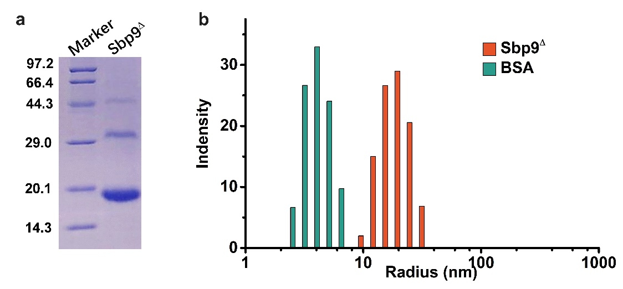
Fig.S1. Expression of recombinant Sbp9∆. a Purified protein was dialyzed directly against Tris-HCl buffer, and molecular weights (kDa) was shown in SDS-PAGE image. b The particle size distribution of BSA and Sbp9∆ was detected to evaluate the polymerization status of proteins.

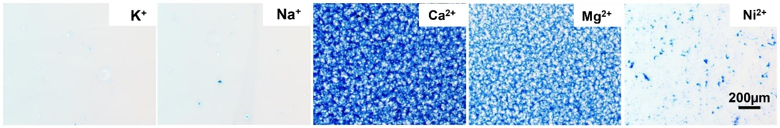
Fig.S2. Surface morphology observation of protein coatings triggered by 5 mM K⁺, Na⁺, Ni²⁺, Mg²⁺, and Ca²⁺, respectively.

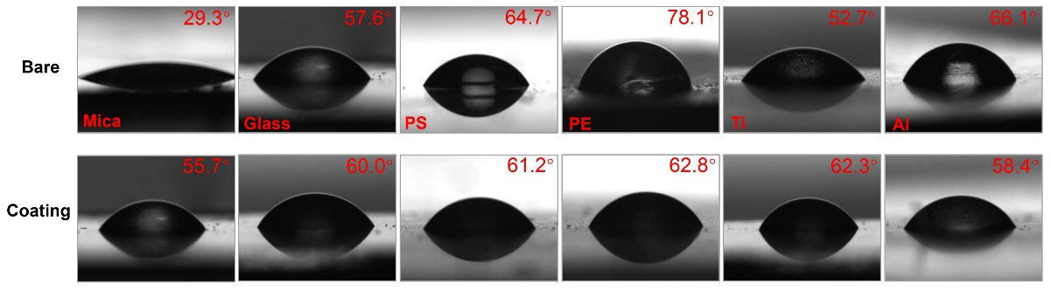
Fig.S3. The water contact angle images on the substrates before (top) and after (bottom) the Sbp9∆ coating. The preparation of Sbp9∆ coating: the reaction time was 30 min, the Sbp9∆ and CaCl₂ concentration were 0.6 mg/mL and 5 mM, respectively.

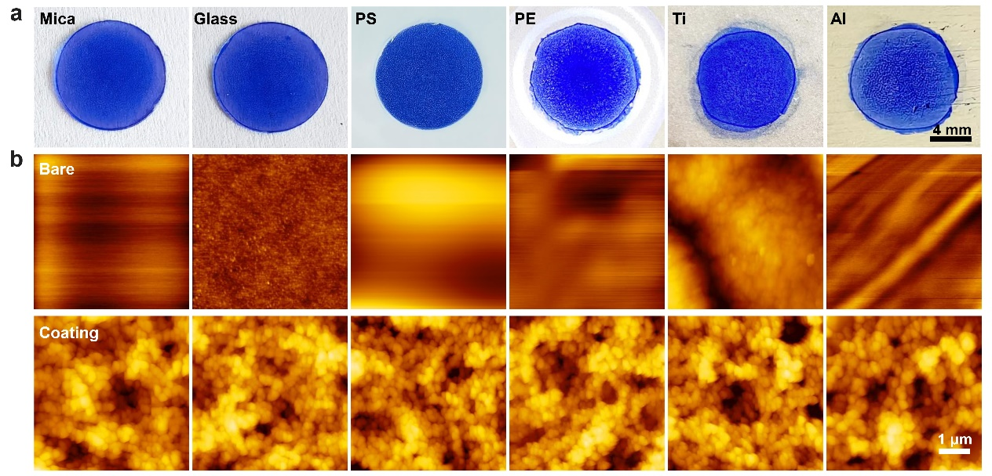
Fig.S4. The substrate universality of Sbp9∆ coating. a Surface coating analysis after visual staining. b AFM images showing the morphology of the substrates before and after the Sbp9∆ coating.

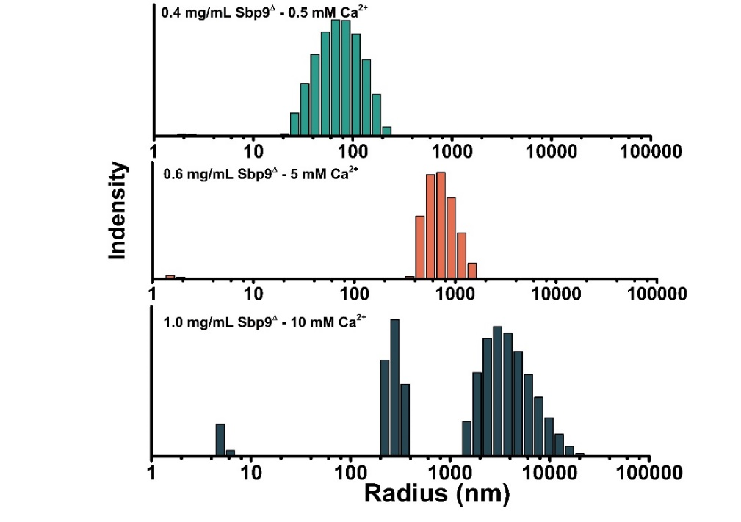
Fig.S5. The particle size distribution of different concentrations combination of Sbp9∆ and Ca²⁺. The protein concentrations were 0.4, 0.6 and 1.0 mg/mL, and the correspondent Ca²⁺ concentrations were 0.5, 5 and 10 mM, respectively.

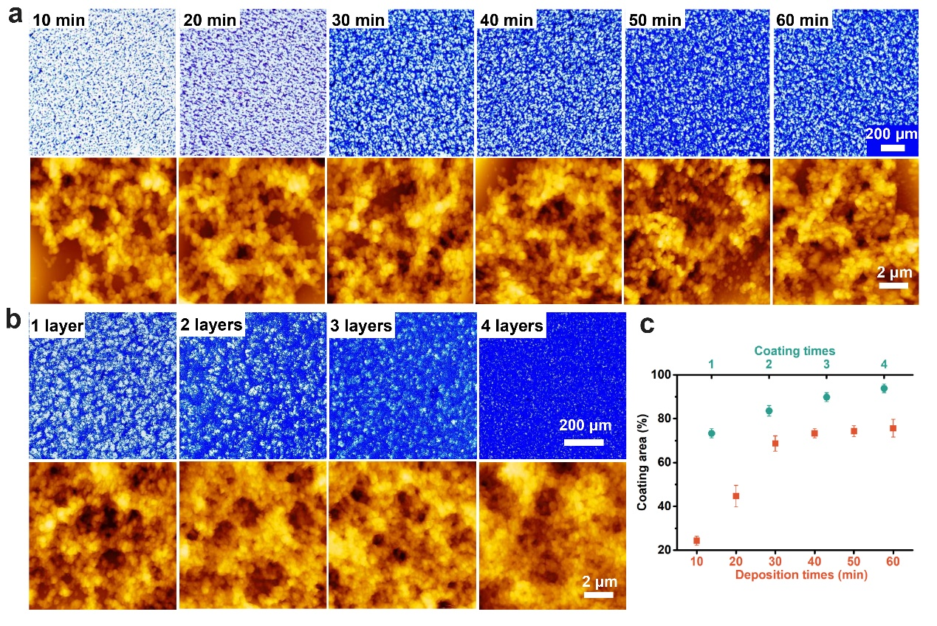
Fig.S6. The surface morphology observations of coatings under different deposition time and repetitive coating times. a The surface morphology and b Area of coatings covered on glass coverslips with different coating cycles. c Coating area after different deposition time and coating times.

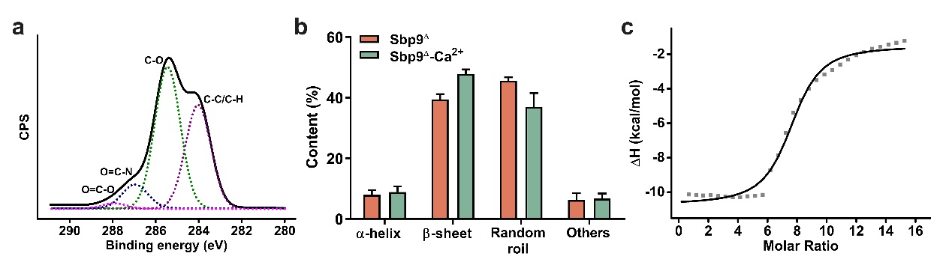
Fig.S7. Molecular mechanism of Ca²⁺-triggered Sbp9∆ self-assembly. a The high resolution of C1s spectrum of Sbp9∆ assemblies. The deconvolution of the C1s peak indicated that the proteinaceous coating surface presented multiple functional groups, mainly including aliphatic carbon (C-C/C-H), hydroxyls (C-OH), amides (CO-NH), and carboxyl groups (COO-). b Conformation content of Sbp9∆ and Ca²⁺-triggered assemblies. c Isotherms of the titrating Ca²⁺ (8 mM) into 80 μM Sbp9∆ solution at 25℃.

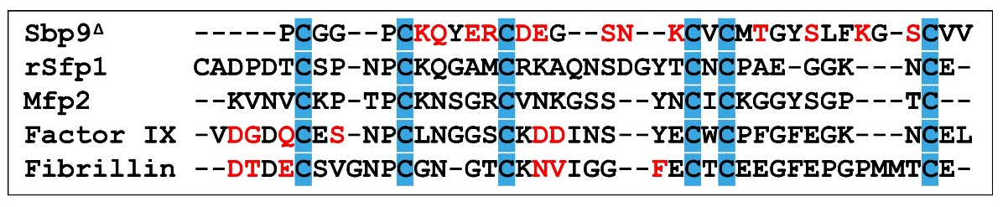
Fig.S8. Sequence alignments of various EGFLs including Factor IX, Fibrillin, Mfp2, rSfp1, and Sbp9∆. Conserved cysteine residues are highlighted by blue, and the amino acids labeled red are Ca²⁺ binding sites

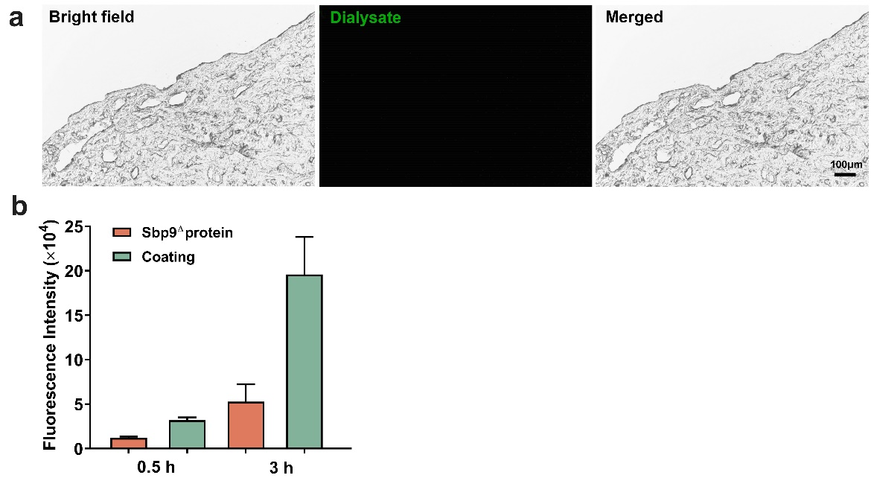
Fig.S9. Water-resistance evaluation of Sbp9∆ coating on pig skin. a The final dialysate was incubated on pig skin for 3 h to detect the presence of free FITC in the FITC-loaded Sbp9∆ solution, indicating that there was no free FITC in protein solution. b The fluorescence was quantified to the average fluorescence of Sbp9∆ and Sbp9∆ coatings. Data are shown as mean ± s.d. (n=3).

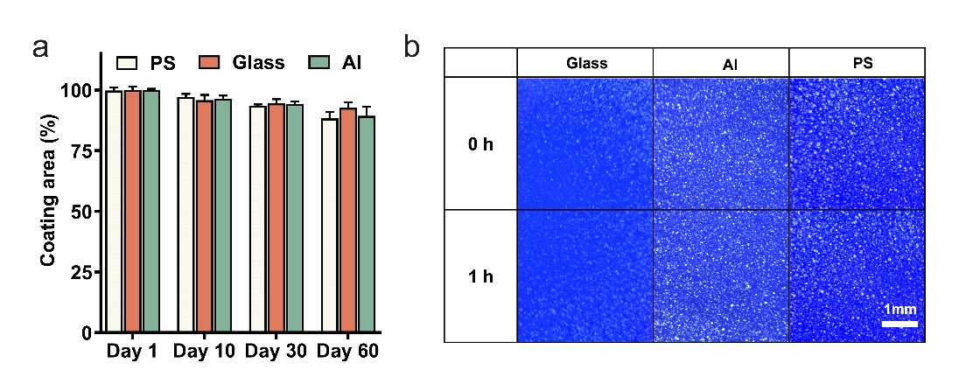
Fig.S10. Water-resistance evaluation of Sbp9∆ coating on glass, polystyrene (PS), and aluminum (Al). a The remained area of coatings after immersion in water for 60 days. b The surface coating analysis of substrates immersion in ultrasonic cleaning machine for 1 h.

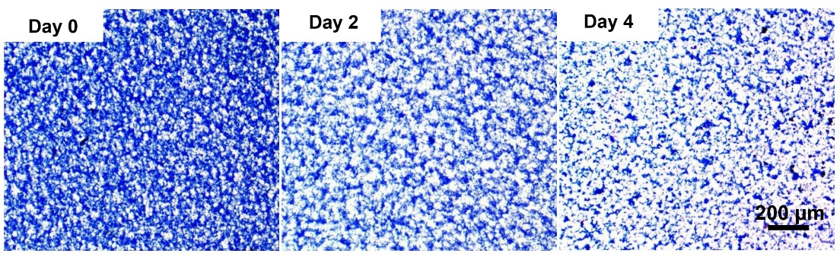
Fig.S11. Biodegradability evaluation of Sbp9∆ coating. Surface morphology observation of coatings under excessive protease digestion with 4 days.

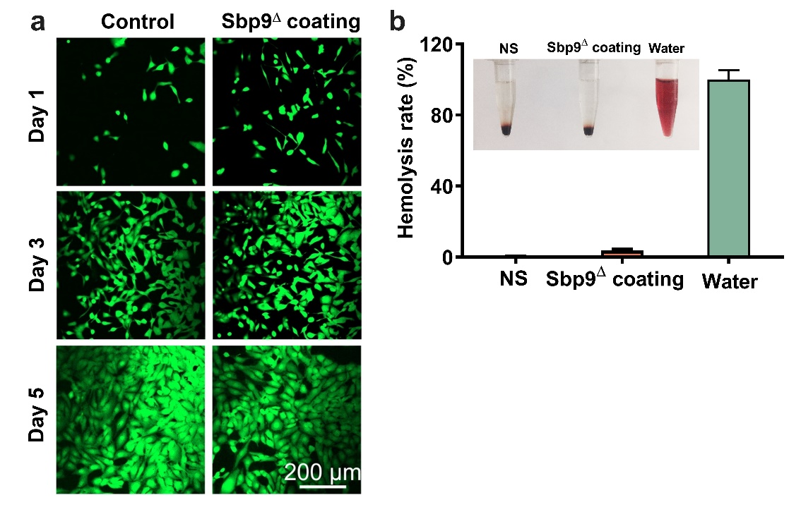
Fig.S12. Biocompatibility evaluation of Sbp9∆ coating. a Fluorescent microscopy images of HUVEC cells after 1, 3, and 5 days cultured on different modified surfaces (TCP, Poly-L-lysine, and Sbp9^{Δ} coating). b Photographs of hemolytic assay and statistical analysis of hemolytic rates in different groups.

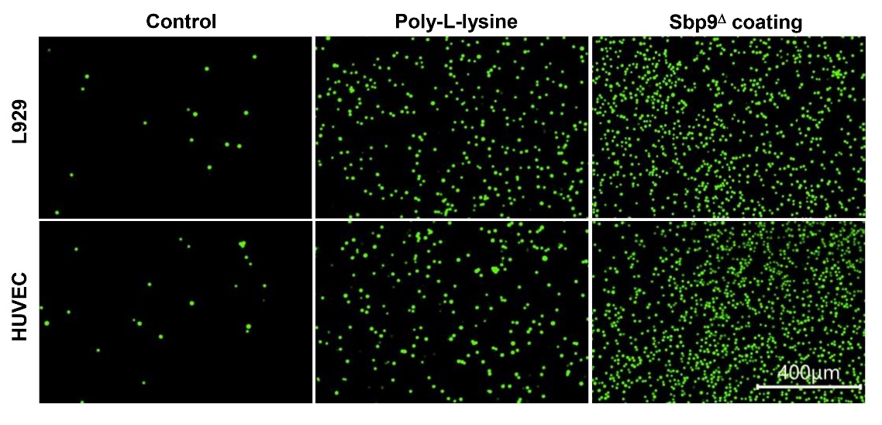
Fig.S13. The evaluation of cell adhesion cultured on Sbp9∆ coating. After the coatings were soaked in PBS at 4 ℃ for 30 days, fluorescent microscopy images of adhesive L929 and HUVEC cells were captured after co-cultured on modified surfaces (non-treated surface, Poly-L-lysine, and Sbp9^{Δ} coating) for 1 h.

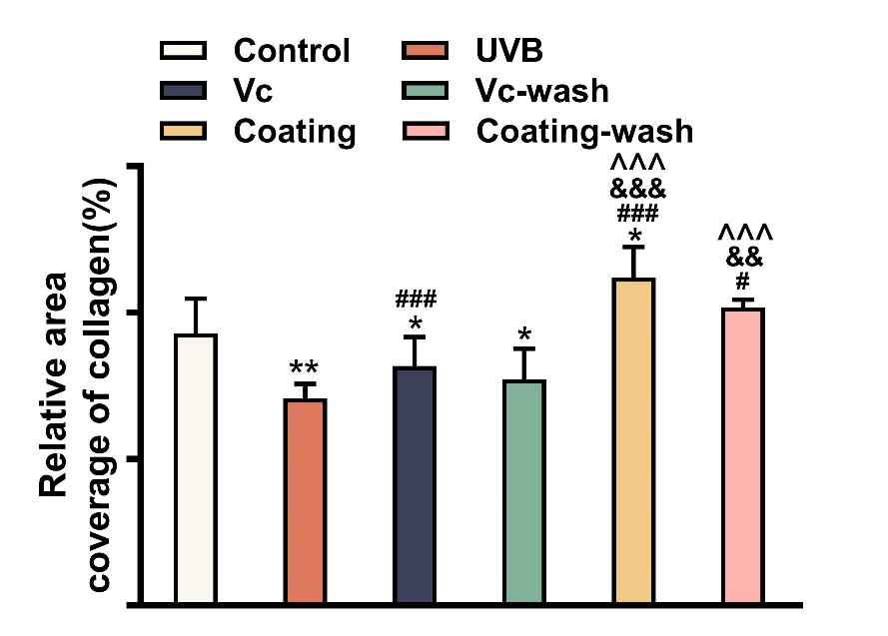
Fig.S14. Protective effects of the Sbp9∆ coating against UVB-induced skin photoaging. The collagen fiber contents of mice skin in each group. P∗< 0.05, P∗∗< 0.01, compared with control. P#< 0.05, P###< 0.001, compared with UVB group. P&&< 0.01, P&&&< 0.001, compared with Vc group. P^^^< 0.001, compared with Vc group.

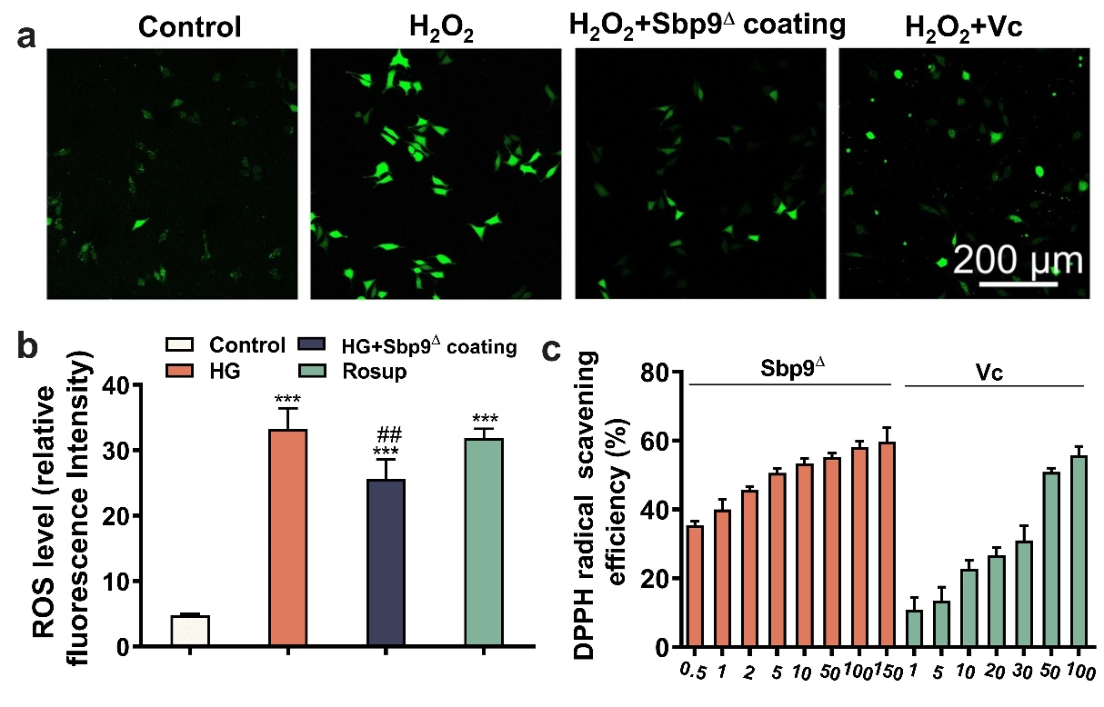
Fig.S15. The antioxidant evaluation of Sbp9∆ coating. a Effects of Sbp9∆ coating on total intracellular ROS (DCFH-DA) in L929 cells after H₂O₂ treatment. b Statistical analysis of ROS staining. P∗∗∗< 0.001, and P∗∗< 0.01 versus control group. P##< 0.01 versus H₂O₂ group. c DPPH radical scavenging assay with different dosage of Sbp9^{Δ} protein and vitamin C (Vc).

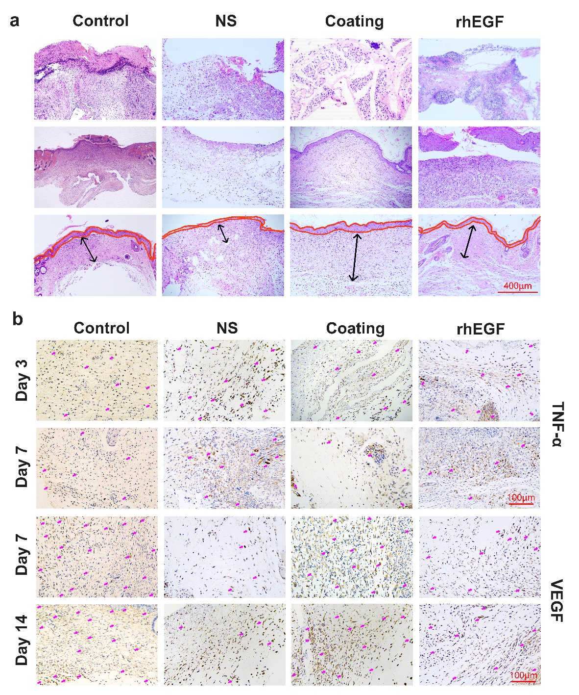
Fig.S16. Sbp9∆ coating accelerated dermal wound healing in diabetic mice. a Representative histological (H&E staining) images of the skin tissues of diabetic mice wounds in different treatment groups including Control, NS, Sbp9∆ coating, and rhEGF. The red lines mark the epidermal thickness, and the arrows point to granulation tissue. Scale bar=100 μm. b The immunohistochemistry of TGF-α and VEGF of the wound tissues in representative treatment groups.

Table S1. Overview of self-assembled protein coatings.
Proteins | Coatings/films | Inducing factor | Time | Secondary structure | Morphology | Driving force | Reference
Amyloid-like | Lysozyme | TCEP | 50 min | β-sheet-rich | Nanoparticle | Hydrophobic interactions | ⁴
Amyloid-like | BSA | TCEP | Tens of minutes | β-sheet-rich | Nanoparticle | Hydrophobic interactions | ⁵
Amyloid-like | Low complexity domain protein | Temperature | Overnight | β-sheet-rich | Nanofiber | Hydrophobic interactions; π-π | ⁶
Mussel foot proteins | MP-KE | Dopa | 12 h | -- | Globular particle | Cation-π; π-π | ⁷
Mussel foot proteins | MAP | Dopa | 6 h | -- | Dense membrane | Hydrophobic interaction | ⁸
Mussel foot proteins | Cofp-MZY/R | Dopa | -- | -- | Membrane | Cation-π; π-π | ⁹
Collagen | HA-collagen | Dopa | 5 h | -- | Globular particle | Electrostatic interaction | ¹⁰
Elastin | ELR | Temperature | Overnight | β-spiral | Globular particle | Hydrogen bond; electrostatic and hydrophobic interactions | ¹¹
Silk | eADF4(C16) | KH₂PO₄ | 24 h | β-sheet-rich | Nanofiber | Hydrogen bond; van der Waals force; electrostatic  and hydrophobic interactions | ¹²
Sea star adhesive proteins | rSfp1 | Ca²⁺/Na⁺ | 16 h | β-sheet-rich | Globular particle | Coordination bond | ¹³
Scallop byssus proteins | Sbp9∆ | Ca²⁺ | 30 min | β-sheet-rich | Globular particle | Hydrogen and coordination bonds | --

Movie S1.
The Sbp9∆ coatings deposited on glass, aluminum and polystyrene remains stable under water scouring.

Movie S2.
The Sbp9∆ coatings deposited on glass, aluminum and polystyrene remains stable in ultrasonic cleaning machine.

Reference
1 Xu, P. et al. The discovered chimeric protein plays the cohesive role to maintain scallop byssal root structural integrity. Sci. Rep. 8, 17082, doi:10.1038/s41598-018-35265-y (2018).
2 Sasidharan, A. et al. Hemocompatibility and Macrophage Response of Pristine and Functionalized Graphene. Small 8, 1251-1263, doi:10.1002/smll.201102393 (2012).
3 Wang, L. et al. Exploration of sea anemone-inspired high-performance biomaterials with enhanced antioxidant activity. Bioactive Materials 10, 504-514, doi:10.1016/j.bioactmat.2021.08.021 (2022).
4 Wang, D. et al. 2D Protein Supramolecular Nanofilm with Exceptionally Large Area and Emergent Functions. Adv. Mater. 28, 7414-7423, doi:10.1002/adma.201506476 (2016).
5 Hu, X. et al. Amyloid-Like Protein Aggregates: A New Class of Bioinspired Materials Merging an Interfacial Anchor with Antifouling. Adv. Mater. 32, e2000128, doi:10.1002/adma.202000128 (2020).
6 Cui, M. et al. Exploiting mammalian low-complexity domains for liquid-liquid phase separation-driven underwater adhesive coatings. Sci Adv 5, eaax3155, doi:10.1126/sciadv.aax3155 (2019).
7 Qi, H., Zheng, W., Zhou, X., Zhang, C. & Zhang, L. A mussel-inspired chimeric protein as a novel facile antifouling coating. Chem. Commun. (Camb.) 54, 11328-11331, doi:10.1039/c8cc05298k (2018).
8 Wang, Y. et al. Covalent immobilization of biomolecules on stent materials through mussel adhesive protein coating to form biofunctional films. Mater. Sci. Eng. C Mater. Biol. Appl. 106, 110187, doi:10.1016/j.msec.2019.110187 (2020).
9 Zheng, W. et al. Mussel-inspired triblock functional protein coating with endothelial cell selectivity for endothelialization. J. Colloid Interface Sci. 576, 68-78, doi:10.1016/j.jcis.2020.04.116 (2020).
10 Yang, L. et al. A tailored extracellular matrix (ECM) - Mimetic coating for cardiovascular stents by stepwise assembly of hyaluronic acid and recombinant human type III collagen. Biomaterials 276, 121055, doi:10.1016/j.biomaterials.2021.121055 (2021).
11 Costa, R. R. et al. Tuning the Stiffness of Surfaces by Assembling Genetically Engineered Polypeptides with Tailored Amino Acid Sequence. Biomacromolecules 19, 3401-3411, doi:10.1021/acs.biomac.8b00723 (2018).
12 Zha, R. H. et al. Universal nanothin silk coatings via controlled spidroin self-assembly. Biomater Sci 7, 683-695, doi:10.1039/c8bm01186a (2019).
13 Lefevre, M. et al. Sea star-inspired recombinant adhesive proteins self-assemble and adsorb on surfaces in aqueous environments to form cytocompatible coatings. Acta Biomater. 112, 62-74, doi:10.1016/j.actbio.2020.05.036 (2020).

