Supplementary material

An efficient synthesis of isoxepac and 2-ethylanthraquinone via intramolecular acylation catalyzed by chloroaluminate ionic liquids with P₂O₅

Qi Wangª, Bin Zhangª, Xiaoxin Zhang^{b}, Hujian Wuª, Haitao Zhanª, Tao Wangª*
The first two authors have the same contribution and are regarded as parallel first authors.

ª Department of Organic Chemistry, College of Chemistry, Beijing University of Chemical Technology, Beijing 100029
^{b} Sinopec Research Institute of Petrochemical Technology, Beijing 100029
* E-mail: wangtwj2000@163.com

Number of pages: 3
Number of figures: 4

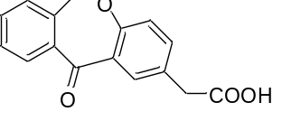
Figure S1. The ¹H NMR spectra of isoxepac
¹H NMR (400 MHz, Chloroform-d) δ 12.43 (s, 1H), 7.78 (d, J = 2.3 Hz, 1H), 7.94 (d, J = 9.2 Hz, 1H), 7.44 (t, J = 7.4 Hz, 1H), 7.35 – 7.46 (m, 3H), 7.24 (d, J = 8.4 Hz, 1H), 5.52 (s, 2H), 3.46 (s, 2H).

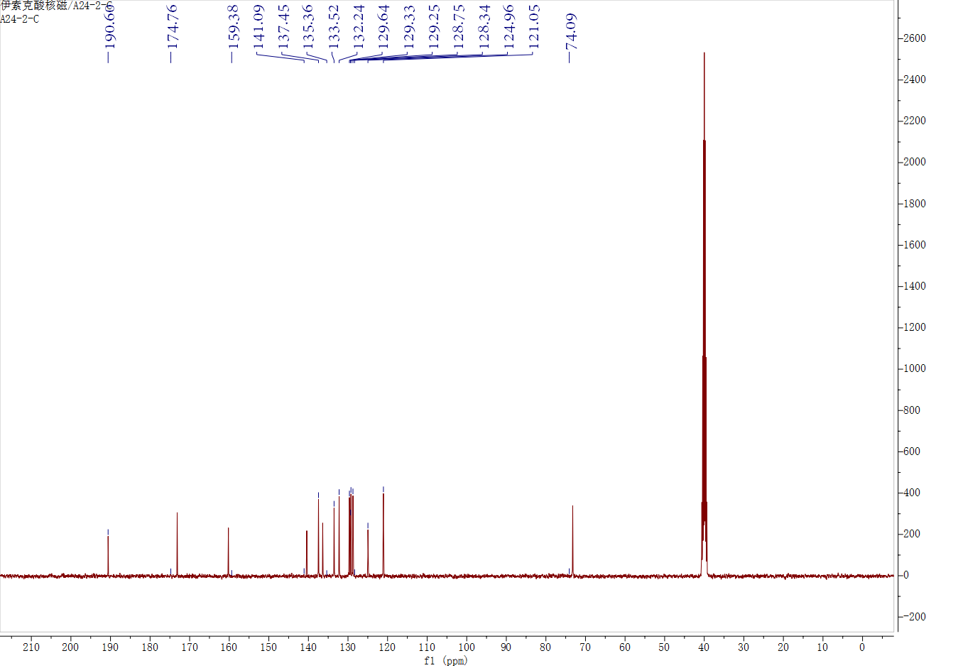
Figure S2. The ¹³C NMR spectra of isoxepac
¹³C NMR (101 MHz, Chloroform-d) δ 190.57, 137.54, 133.51, 132.42, 129.46, 129.22, 129.52, 128.57, 124.96, 121.05.

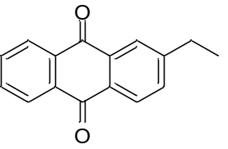
Figure S3. The ¹H NMR spectra of 2-ethylanthraquinone
¹H NMR (400 MHz, Chloroform-d) δ 8.32 (dd, J = 5.5, 3.6 Hz, 2H), 8.25 (d, J = 8.0 Hz, 1H), 8.15 (d, J = 1.8 Hz, 1H), 7.86 – 7.74 (m, 2H), 7.64 (dd, J = 8.0, 1.9 Hz, 1H), 2.85 (q, J = 7.6 Hz, 2H), 1.35 (t, J = 7.6 Hz, 3H).

Figure S4. The ¹³C NMR spectra of 2-ethylanthraquinone
¹³C NMR (101 MHz, Chloroform-d) δ 183.37, 182.91, 151.33, 133.99, 133.87, 133.80, 133.57, 133.50, 131.44, 127.51, 29.15, 14.97.

