Literature Review Method (Supplementary Material)
Purpose
This study aims to investigate how persuasive communication systems can be customized to optimize their effectiveness in the context of online advertising and persuasion. To achieve this, an extensive review of empirical and theoretical literature was conducted, resulting in the development of a comprehensive theoretical framework.
Integrative Reviews
In academic literature, the purpose of an integrative review is to attain a holistic comprehension of a research topic, present the current state of scientific knowledge and contribute to theory development. Integrative reviews are recognized as a valuable approach for synthesizing evidence from diverse sources to establish a comprehensive understanding of a given topic. However, concerns have been raised about the rigour of integrative reviews compared to systematic reviews, due to the limited availability of standards and guidelines for developing a review strategy. This concern was highlighted by Snyder (2019), who cited MacInnis (2011).
Nevertheless, Snyder (2019) also acknowledges the potential rewards of conducting a successful integrative review. Particularly in academic literature, integrative reviews are acknowledged for their unique advantage in incorporating diverse forms of research. Unlike systematic reviews, which may narrow their scope to quantitative studies, integrative reviews are characterized by their flexibility in including a wide range of evidence such as empirical research, case studies, observational studies, meta-analyses, theoretical frameworks, theory and guidelines.
The integration of multiple methodologies in a research review can enhance the reliability and validity of the findings, as it allows for a more comprehensive and diverse perspective on the research topic. Integrative reviews are recognized in scholarly literature for their strengths, but they also face challenges and limitations.
One of the primary challenges is the absence of agreed standards and guidelines for conducting integrative reviews, as pointed out by Snyder (2019), citing MacInnis (2011). This lack of established guidelines may raise concerns regarding the rigor and validity of the review process as variations in methodology and quality may arise across different integrative reviews.
Moreover, it should be noted that synthesizing evidence from diverse sources with varying methodologies may introduce potential biases that can impact the validity and generalizability of the findings. Therefore, authors conducting integrative reviews should exercise caution in maintaining rigour and ensuring the validity of their review process. Similarly, readers should critically evaluate the methodology and quality of integrative reviews when interpreting findings to ensure a robust understanding of the research outcomes.

Methodology
The methodology employed in this study is in line with the integrative review approach, as explained by Snyder (2019). In accordance with Snyder's recommendations (2019), we have outlined the criteria used for selecting the documents cited in our study, as well as the aspects addressed in our literature review. This includes providing comprehensive information on the searches conducted, sources consulted and the inclusion or exclusion criteria employed during our review process. This transparency in methodology aims to adhere to best practices in conducting integrative reviews and ensures rigour and credibility (Eisner, 2023).
The process of organizing this integrative literature review with a conceptual structure involved the following steps:
- Identifying the research topic: The focus of this study centered on the theory and research of persuasion, along with the essential concepts related to it.
- Conducting a literature search: The authors searched for relevant literature related to persuasion research, using academic databases, scholarly journals, books and other reliable sources.
- Reviewing and selecting relevant literature: The researchers reviewed the literature obtained from the search and selected relevant articles or sources that discussed the conceptual structure of persuasion research and highlighted important key concepts. The selection was based on the relevance of the literature to the research topic and the quality of the sources.
- Extracting key concepts: Once the relevant literature were identified, the authors read and analysed the selected articles or sources to identify the key concepts related to persuasion research. These key concepts could include theories, frameworks, models, variables or constructs that are commonly used in persuasion research.
- Organizing the literature review: The process involved categorizing the key concepts based on relevant themes, theories or frameworks, and conducting a thorough analysis of their significance and relevance to the research topic. Alternatively, mind maps were utilized to visually map out the concepts and their relationships.
- Analysing and interpreting the literature: The authors critically analysed and interpreted the literature to identify patterns, trends and gaps in the conceptual structure of persuasion research. This involved comparing different concepts, identifying inconsistencies or contradictions and providing a comprehensive overview of the state of the field.
- Writing the literature review: The literature review was meticulously crafted in a structured and cohesive manner, systematically presenting the key concepts pertaining to persuasion research that were derived from an exhaustive exploration of the existing literature. Typically, the literature review paper consists of an introduction followed by a discussion of the key concepts and concludes with a summary of the main findings and suggestions for future research directions. This approach ensures that the literature review is organized, comprehensive and provides a clear understanding of the adopted concepts from the literature.
Is important to note that the steps outlined above are commonly associated with the methodology of a systematic literature review which involves a structured and comprehensive search for existing literature on a specific topic. It involves a systematic selection, analysis and synthesis of the literature to provide a rigorous summary of the current state of knowledge in the field (Tranfield et al., 2003).
In contrast, the integrative approach we employed in this study aims to provide a broader summary of the literature by incorporating findings from various research designs allowing the combination of diverse methodologies such as the systematic search approach. The goal of an integrative review is to develop a holistic understanding of the topic, present the state of the science and contribute to theory development (Eisner, 2023).

Search Strategy
The search strategy in this integrative review involved a mixed approach, combining both physical exploration of university library books and web-based searches using Google Search and Google Scholar. Key concepts relevant to persuasion research were identified from important books in the field, as illustrated in Figure S1. These concepts were used as a guide for the review, focusing on their interconnections and relevance within the field of persuasion research. Additionally, a snowballing approach, involving reference chasing and tracking citations, was used to identify additional relevant publications.
We also considered quality academic sources and the use of web-based engines such as Google Search and Google Scholar. The database Scopus, run by Elsevier Publishing, was used to search for relevant literature, along with ProQuest, SpringerOpen, IEEE Xplore and EBSCO, as presented in Table 1.
The search strategies in search engines and databases used both text words and relevant phrases. Bibliographic searching was done by using reference lists at the end of each article. Regarding titles and abstracts of studies of search results and other sources were independently screened. The full text of those studies that potentially met the inclusion criteria were retrieved and independently assessed for eligibility by the two authors of this paper.
Online research platforms have extensive databases of research articles, papers, journals, and other publications. Researchers can employ search queries with specific criteria, such as keywords, phrases, and filters, to screen and retrieve relevant content. This efficient and effective approach aids in identifying relevant research articles while saving time and effort. Moreover, search queries can be refined and modified based on initial search results, allowing for an iterative process of search refinement. For instance, in this study, online resources used are summarized in Table 1, while Table 2 presents the various search queries employed during the search phase of this integrative review.

Resource | Web Address
Search Engines
Google Scholar | http://www.scholar.google.com
Google Search | http://www.google.com
Electronic Source of Database

ProQuest | http://www. proquest.com
Scopus | http:// www.scopus.com
SpringerOpen | http://springeropen.com
IEEE Xplore | http://ieeexplore.ieee.org
AcademicSearch Complete | https://www.ebsco.com/products/research-databases/academic-search-complete
Table 1. Description of online research resources used during the search process.
Figure S1 in this study presents the concept matrix utilized, which delineates key terms, concepts, theories and overlaps that were informed by a thorough review of relevant academic books (Cialdini, 2007; Dillard and Pfau, 2002; O'Keefe, 2015). This matrix serves as a visual representation of the conceptual framework that guided the systematic literature review, providing a structured approach to organizing and synthesizing the findings. The concept matrix serves as a valuable tool for identifying patterns, connections and gaps in the existing literature, enabling a comprehensive analysis and synthesis of the research findings. Figure S1 and Figure S2 are in line with the integrative methodology previously described in Step 4 (Extracting key concepts) and Step 5 (Organizing the literature review).
Figure S2 presents a mind map that visually describes the interconnections and relationships among concepts relevant to persuasion research. This graphical format effectively organizes information around the central topic of persuasion research and theory, providing a comprehensive overview of the key elements and their interconnections. Based on the overlapping concepts identified from the literature, a detailed analysis of each concept is conducted, leading to the development of research questions and hypotheses for future research.
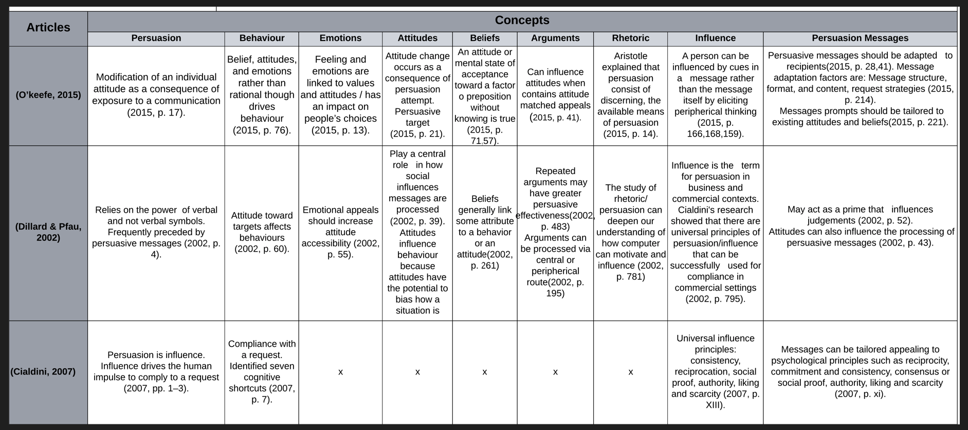
Figure S1. The concept matrix utilized in this study serves to highlight key terms, concepts, theories and overlaps that initially guided the review proce
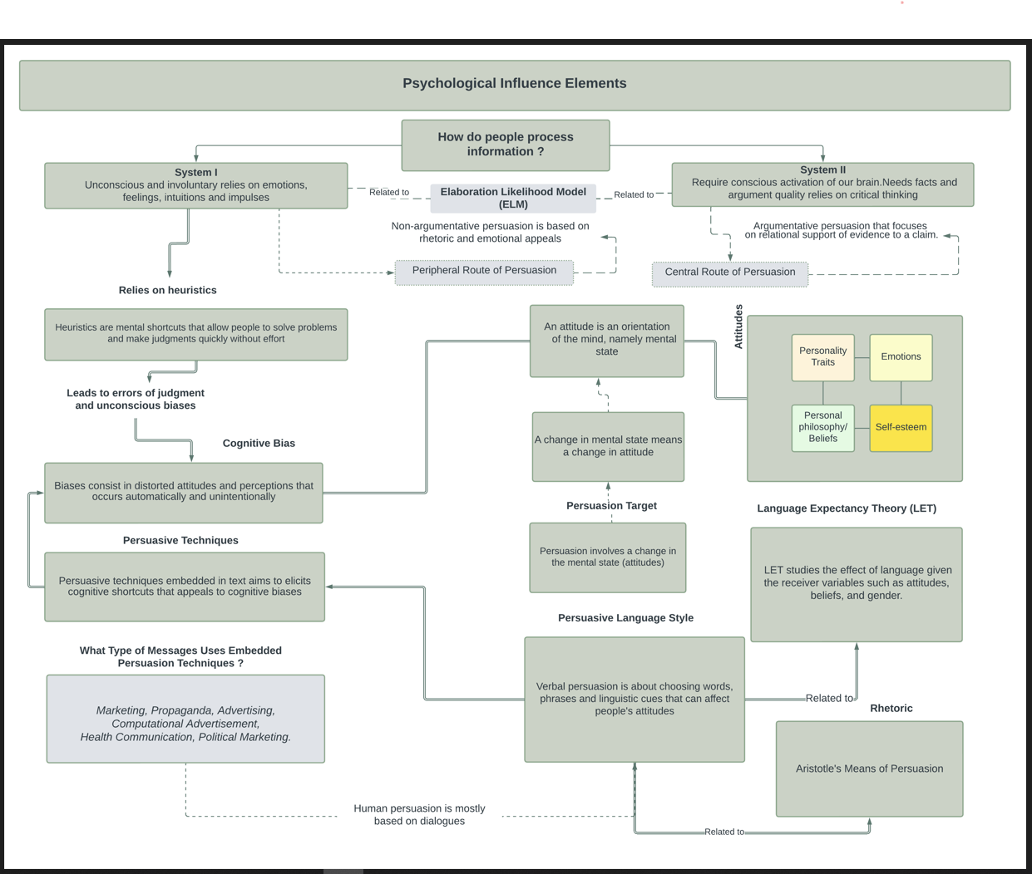

Figure S2 Graphical representation in the form of a mind map, illustrating the interconnections and relationships among key concepts relevant to the field of persuasion research and theory.

Table 2. Search queries used during search phase.
 | Key words | Query
1 | Persuasion | TITLE-ABS-KEY ( 'persuasion' ) AND ( LIMIT-TO ( SUBJAREA , "SOCI" ) OR LIMIT-TO ( SUBJAREA , "PSYC" ) OR LIMIT-TO ( SUBJAREA , "COMP" ) ) AND ( LIMIT-TO ( EXACTKEYWORD , "Persuasion" ) OR LIMIT-TO ( EXACTKEYWORD , "Human" ) OR LIMIT-TO ( EXACTKEYWORD , "Communication" ) OR LIMIT-TO ( EXACTKEYWORD , "Decision Making" ) ) AND ( LIMIT-TO ( LANGUAGE , "English" ) ) AND ( LIMIT-TO ( EXACTKEYWORD , "Persuasive Communication" ) OR LIMIT-TO ( EXACTKEYWORD , "Humans" ) OR LIMIT-TO ( EXACTKEYWORD , "Attitude" ) )
2 | Persuasion techniques and social influence | ( TITLE-ABS-KEY ( persuasion AND techniques ) ) AND ( TITLE-ABS-KEY ( 'social AND influence' AND marketing ) ) AND ( LIMIT-TO ( LANGUAGE , "English" ) ) AND ( LIMIT-TO ( SUBJAREA , "SOCI" ) OR LIMIT-TO ( SUBJAREA , "PSYC" ) OR LIMIT-TO ( SUBJAREA , "COMP" ) ) AND ( LIMIT-TO ( EXACTKEYWORD , "Persuasion" ) OR LIMIT-TO ( EXACTKEYWORD , "Human" ) OR LIMIT-TO ( EXACTKEYWORD , "Communication" ) OR LIMIT-TO ( EXACTKEYWORD , "Decision Making" ) OR LIMIT-TO ( EXACTKEYWORD , "Persuasive Communication" ) OR LIMIT-TO ( EXACTKEYWORD , "Humans" ) OR LIMIT-TO ( EXACTKEYWORD , "Attitude" ) OR LIMIT-TO ( EXACTKEYWORD , "Marketing" ) )
3 | Persuasion cognition and emotions | TITLE-ABS-KEY ( persuasion AND cognition AND emotions ) AND ( LIMIT-TO ( LANGUAGE , "English" ) ) AND ( LIMIT-TO ( SUBJAREA , "SOCI" ) OR LIMIT-TO ( SUBJAREA , "PSYC" ) OR LIMIT-TO ( SUBJAREA , "COMP" ) ) AND ( LIMIT-TO ( EXACTKEYWORD , "Persuasion" ) OR LIMIT-TO ( EXACTKEYWORD , "Human" ) OR LIMIT-TO ( EXACTKEYWORD , "Communication" ) OR LIMIT-TO ( EXACTKEYWORD , "Decision Making" ) OR LIMIT-TO ( EXACTKEYWORD , "Persuasive Communication" ) OR LIMIT-TO ( EXACTKEYWORD , "Humans" ) OR LIMIT-TO ( EXACTKEYWORD , "Attitude" ) OR LIMIT-TO ( EXACTKEYWORD , "Marketing" ) )
4 | Cognitive bias | TITLE-ABS-KEY ( cognitive AND bias ) AND ( LIMIT-TO ( LANGUAGE , "English" ) ) AND ( LIMIT-TO ( SUBJAREA , "PSYC" ) OR LIMIT-TO ( SUBJAREA , "SOCI" ) OR LIMIT-TO ( SUBJAREA , "MEDI" ) OR LIMIT-TO ( SUBJAREA , "COMP" ) OR LIMIT-TO ( SUBJAREA , "DECI" ) ) AND ( LIMIT-TO ( EXACTKEYWORD , "Flattery" ) OR LIMIT-TO ( EXACTKEYWORD , "Human" ) OR LIMIT-TO ( EXACTKEYWORD , "Human Computer Interaction" ) OR LIMIT-TO ( EXACTKEYWORD , "Social Behaviour" ) OR LIMIT-TO ( EXACTKEYWORD , "Rhetoric" ) OR LIMIT-TO ( EXACTKEYWORD , "Praise" ) OR LIMIT-TO ( EXACTKEYWORD , "Internet" ) OR LIMIT-TO ( EXACTKEYWORD , "Deception" ) OR LIMIT-TO ( EXACTKEYWORD , "Psychology" ) OR LIMIT-TO ( EXACTKEYWORD , "Political Communication" ) OR LIMIT-TO ( EXACTKEYWORD , "Persuasive Communication" ) )
5 | Rhetorical devices and language | TITLE-ABS-KEY ( 'rhetorical AND devices' AND language ) AND ( LIMIT-TO ( SUBJAREA , "SOCI" ) OR LIMIT-TO ( SUBJAREA , "PSYC" ) OR LIMIT-TO ( SUBJAREA , "COMP" ) ) AND ( LIMIT-TO ( LANGUAGE , "English" ) ) AND ( LIMIT-TO ( EXACTKEYWORD , "Persuasion" ) OR LIMIT-TO ( EXACTKEYWORD , "Human" ) OR LIMIT-TO ( EXACTKEYWORD , "Communication" ) OR LIMIT-TO ( EXACTKEYWORD , "Decision Making" ) OR LIMIT-TO ( EXACTKEYWORD , "Persuasive Communication" ) OR LIMIT-TO ( EXACTKEYWORD , "Humans" ) OR LIMIT-TO ( EXACTKEYWORD , "Attitude" ) OR LIMIT-TO ( EXACTKEYWORD , "Marketing" ) )
6 | Persuasive technology | TITLE-ABS-KEY("persuasive technology") AND (LIMIT-TO(DOCTYPE,"cp") OR LIMIT-TO(DOCTYPE,"ar") OR LIMIT-TO(DOCTYPE,"re") OR LIMIT-TO(DOCTYPE,"cr") OR LIMIT-TO(DOCTYPE,"ch")) AND (LIMIT-TO(SUBJAREA,"COMP") OR LIMIT-TO(SUBJAREA,"SOCI") OR LIMIT-TO(SUBJAREA,"ARTS") OR LIMIT-TO(SUBJAREA,"PSYC"))
7 | Persuasive Language | TITLE-ABS-KEY("persuasive AND language") AND (LIMIT-TO(DOCTYPE,"ar") OR LIMIT-TO(DOCTYPE,"cp") OR LIMIT-TO(DOCTYPE,"ch")) AND (LIMIT-TO(SUBJAREA,"soci") OR LIMIT-TO(SUBJAREA,"arts")OR LIMIT-TO(SUBJAREA,"comp") OR LIMIT-TO(SUBJAREA,"medi") OR LIMIT-TO(SUBJAREA,"psyc") OR LIMIT-TO(SUBJAREA,"engi")) AND (LIMIT-TO(EXACTKEYWORD,"persuasive communication") OR LIMIT-TO(EXACTKEYWORD,"language") OR LIMIT-TO(EXACTKEYWORD,"persuasion")) AND (LIMIT-TO(LANGUAGE,"english"))

Based on Table 2, here is a detailed explanation of the query used to search for articles and keywords:
1. This query searches for articles that have the keyword "persuasion" in their title, abstract or keywords. The articles must be classified in one of the following subject areas: social sciences (SOCI), psychology (PSYC) or computer science (COMP). Additionally, the articles must have at least one of the following exact keywords: "Persuasion", "Communication" or "Decision Making". The articles must be in the English language. Finally, the articles must have at least one of the following exact keywords: "Persuasive Communication “or "Attitude".
2.- Articles that have the keywords "persuasion AND techniques" in their title, abstract, or keywords, as well as the keywords “social AND influence AND marketing". The articles must be in English language. The articles must be classified in one of the following subject areas: social sciences (SOCI), psychology (PSYC) or computer science (COMP). Additionally, the articles must have at least one of the following exact keywords: "Persuasion", "Communication", "Decision Making", "Persuasive Communication", "Humans", "Attitude" or "Marketing".
3.- Articles that have the keywords "persuasion AND cognition AND emotions" in their title, abstract or keywords. The articles must be in English language. The articles must be classified in one of the following subject areas: social sciences (SOCI), psychology (PSYC) or computer science (COMP). Additionally, the articles must have at least one of the following exact keywords: "Persuasion", "Human", "Communication", "Decision Making", "Persuasive Communication", "Attitude" or "Marketing".
4.- Articles that have the keywords "cognitive AND bias" in their title, abstract or keywords. The articles must be in English language. The articles must be classified in one of the following subject areas: psychology (PSYC), social sciences (SOCI), media studies (MEDI), computer science (COMP) or decision sciences (DECI). Additionally, the articles must have at least one of the following exact keywords: "Flattery", "Human Computer Interaction", "Social Behaviour", "Rhetoric", "Praise", "Internet", "Deception", "Psychology", "Political Communication" or "Persuasive Communication".
5.- Articles that have the keywords "'rhetorical AND devices AND language" in their title, abstract or keywords. The articles must be classified in one of the following subject areas: social sciences (SOCI), psychology (PSYC) or computer science (COMP). The language of the articles must be English. Additionally, the articles must have at least one of the following exact keywords: "Persuasion", "Communication", "Decision Making", "Persuasive Communication", "Attitude" or "Marketing".
6.- Articles that contain the phrase "persuasive technology" in their title, abstract or keywords. The articles must have one of the following document types: conference paper (cp), article (ar), review (re) or chapter (ch). Additionally, the articles must be classified in one of the following subject areas: computer science (COMP), social sciences (SOCI), arts (ARTS) or psychology (PSYC).
7.- Articles that have the keywords "persuasive" and "language" in their title, abstract or keywords. The articles must be of one of the following document types: article (ar), conference paper (cp) or chapter (ch). The articles must be classified in one of the following subject areas: social sciences (soci), arts (arts), computer science (comp), media (medi), psychology (psyc), or engineering (engi). Additionally, the articles must have at least one of the following exact keywords: "persuasive communication", "language" or "persuasion". The articles must be in English.
Inclusion and exclusion criteria
In the present study, a data collection process was conducted to ensure a comprehensive review of the multidisciplinary literature on persuasion. The primary database used for the search was Scopus. Articles published between 1968 and 2022 that met the predefined inclusion and exclusion criteria were identified. The search encompassed diverse academic domains including Social Sciences, Psychology, Arts and Humanities, Computer Science, Mathematics, Engineering, Business, Decision Sciences, Neuroscience or Medicine.
The inclusion criteria for the searchers were:
- Articles that are peer-reviewed and published in academic journals or peer-reviewed reports from international scientific conferences.
- Studies that measure at least one outcome related to beliefs, attitudes, rhetoric, digital persuasion emotions, persuasion or behaviours.
- Studies that are relevant to the design features of propaganda.
- Studies conducted in Western countries or with a focus on Western populations, cultures or contexts.

On the other hand, the exclusion criteria for the searchers were:
- Studies focusing on other forms of persuasion such as visual prompts or graphic design. These studies were excluded from the review.
- Studies that were not cited by other authors.
- Studies that were not published in English. Only English articles were considered for inclusion in the review.
- Studies conducted in non-Western countries or with a focus on non-Western populations, cultures or contexts were excluded from the review - based on the geography criterion.

Research Results
The research methodology for this systematic review involved several steps. Initially, relevant databases were searched, resulting in a total of 5,308 records. After removing duplicate records, the number was reduced to 920. The abstracts of these records were then screened based on predefined inclusion criteria, resulting in the exclusion of 4,388 studies. The full-text articles of the remaining records were carefully assessed for eligibility, considering the predefined keywords related to persuasive techniques and persuasion. Search terms were categorized into two sets: (a) persuasive techniques and (b) persuasion, persuasive language, influence, beliefs, attitudes, intentions, behaviours, rhetoric, and advertisement. These search terms were cross-referenced to identify all possible combinations, resulting in the inclusion of 93 articles. Additionally, a screening process was conducted through citation tracking and reference searching, leading to the inclusion of 130 more articles. In total, the final literature review included 223 articles. A flowchart illustrating the study selection process can be found in Figure S3.
Records identified through database screening
(n=5,308)
Duplicates excluded (n=920)
Abstracts of records screened
(n=4,388)
Studies excluded by abstract and key words only.
(n=4,295)
Full-text article of the identified record assessed for eligibility (n=93)
Additional titles and abstracts screened through citation tracking and reference searching
(n=130)
Total articles included in literature review.
(n=223)

Figure S3. Flow chart of systematic search procedures.

Conclusion:
This integrative literature review makes a valuable contribution to the field of marketing by establishing a strong theoretical framework for customizing persuasive communication systems for marketing objectives, with a specific emphasis on online persuasion. The findings emphasize the importance of considering diverse customization strategies to maximize the effectiveness of persuasive communication systems in marketing campaigns. Furthermore, this study highlights the strength of using an integrative approach in interdisciplinary and mature fields such as persuasion research. The theoretical framework proposed in this study can provide valuable insights for marketing practitioners in designing more effective and targeted persuasive communication systems to achieve their marketing goals in the digital era.

References
Cialdini, R.B. (2007), Influence: The Psychology of Persuasion, Vol. 55, Collins New York.
Dillard, J. and Pfau, M. (2002), The Persuasion Handbook: Developments in Theory and Practice, SAGE Publications, Inc., 2455 Teller Road, Thousand Oaks California 91320 United States, doi: 10.4135/9781412976046.
Eisner, P.J. (2023), “LibGuides: Systematic Reviews: Integrative Review”, 28 March, available at: https://libguides.adelphi.edu/Systematic_Reviews (accessed 13 April 2023).
MacInnis, D.J. (2011), “A Framework for Conceptual Contributions in Marketing”, Journal of Marketing, Vol. 75 No. 4, pp. 136–154, doi: 10.1509/jmkg.75.4.136.
O’Keefe, D.J. (2015), Persuasion: Theory and Research, SAGE Publications.
Snyder, H. (2019), “Literature review as a research methodology: An overview and guidelines”, Journal of Business Research, Vol. 104, pp. 333–339, doi: 10.1016/j.jbusres.2019.07.039.
Torraco, R.J. (2005), “Writing Integrative Literature Reviews: Guidelines and Examples”, Human Resource Development Review, Vol. 4 No. 3, pp. 356–367, doi: 10.1177/1534484305278283.
Tranfield, D., Denyer, D. and Smart, P. (2003), “Towards a Methodology for Developing Evidence-Informed Management Knowledge by Means of Systematic Review”, British Journal of Management, Vol. 14 No. 3, pp. 207–222, doi: 10.1111/1467-8551.00375.

