Supplementary information of impact of clay modifier on structure, thermal, mechanical and transport properties in polyurethane/Maghnite nanocomposites as barrier materials.

Lahouari MRAH ^{1,2*}Zoulikha khiati ³ ·

¹ Ecole Supérieure en Génie Electrique et Energétique d’Oran, BP64, ACHABA HANIFI, USTO, Oran, Algeria.
² Laboratory of Polymer Chemistry, Department of Chemistry, Faculty of Exact and Applied Sciences, University Oran 1 Ahmed Ben Bella, BP 1524 El’Menouer, 31000 Oran, Algeria.
³ Département de chimie-physique, Faculté de chimie, Université des Sciences et de la Technologie d’Oran, M. Boudiaf, BP 1505 El M’naouar, 31000 Oran, Algeria.
Corresponding author’s email: lmrah@yahoo.fr
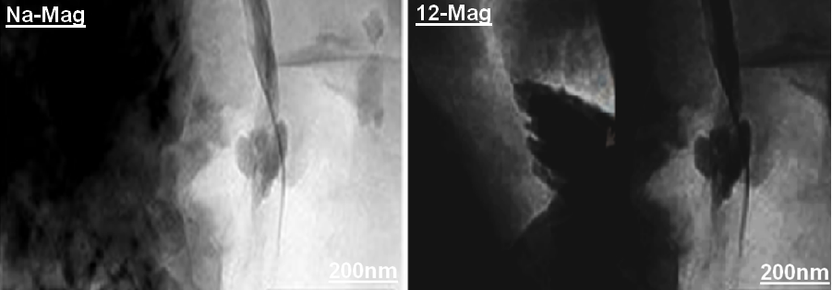
Fig. ES1 TEM images of prepared organophilic clays

2.Scanning electron microscopy analysis
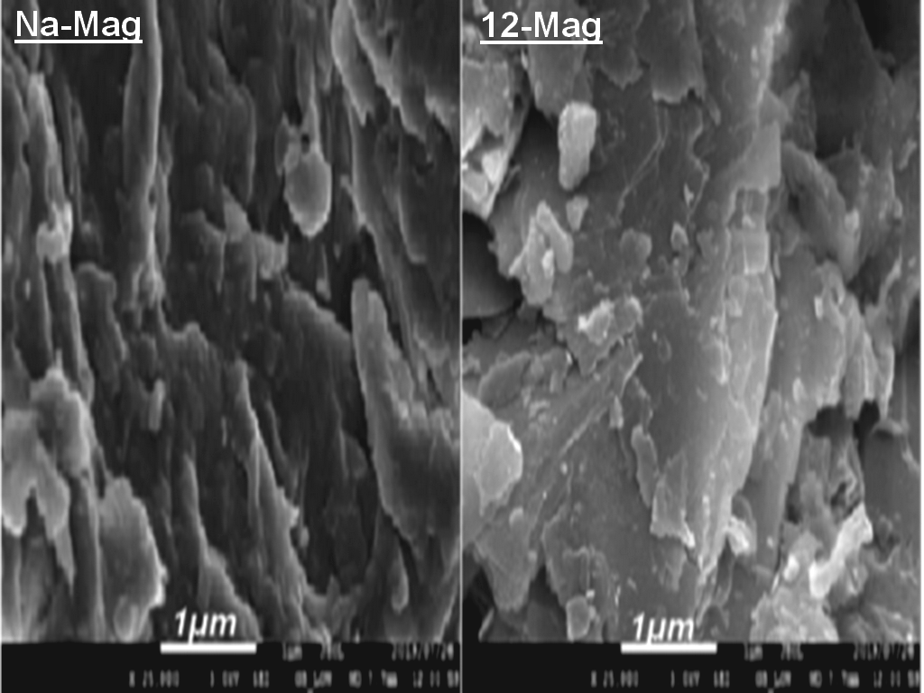
Fig. ES2 SEM images of prepared organophilic clays

