Supporting information

for

Correlating theory with experimental data on the effect of symmetry on the electrocatalytic behaviour of Co phthalocyanines
Reitumetse Nkhahle, Nthabeleng Molupe, John Mack and Tebello Nyokong*
Institute for Nanotechnology Innovation, Rhodes University, Makhanda 6139, South Africa

Figure S1: Molecular structure of complex 2.

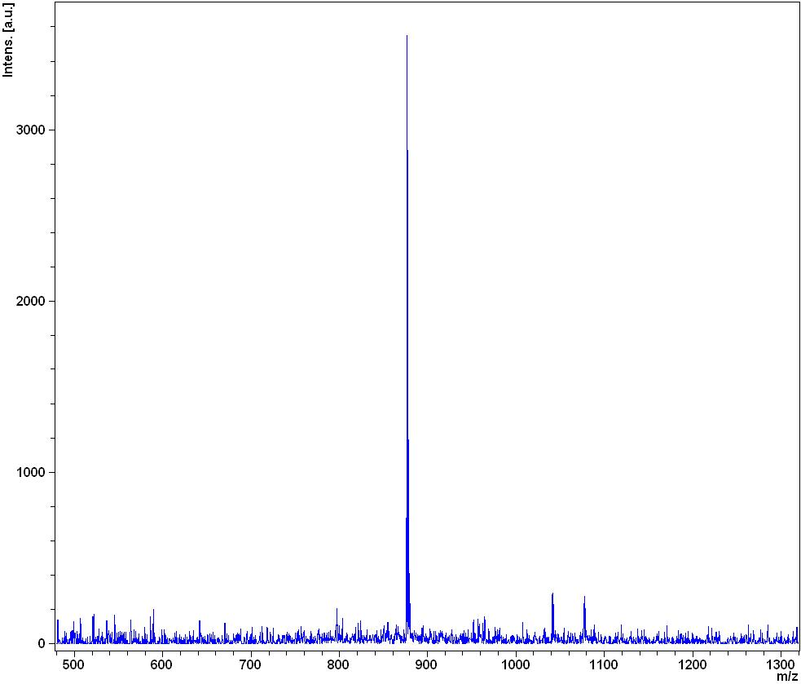
876.98 amu
Figure S2: Mass spectrum for complex 1.
Figure S3: Infrared spectra of 4-(3,4-dicyanophenoxy)benzoic acid and complex 1.

Fig. S4: Nyquist plot for the bare GCE (in 1 mM of Fe(CN)₆^{3−/4−} (in 0.1 M KCl).

Figure S5: A histogram illustrating the energy differences before and after the introduction of hydrazine as an axial ligand. (HLG = HOMO−LUMO gap).

