Supplementary Information (SI)
Morphological identification, molecular characterization and optimization of Cultivation for Acrobeloides maximus species extracted from bitter gourd (Momordica charantia) field at Gujarat, India.
Shweta Thakar¹, Sunita Chauhan², Hyacinth Highland¹ and Linz - Buoy George^{1*}
*linzbuoyg@gujaratuniversity.ac.in
¹Department of Zoology, Biomedical Technology, Human Genetics and Wildlife Conservation and Biology, Gujarat University, Navrangpura, Ahmadabad, Gujarat, India Pincode-380009

²Department of Environmental Science, University School of Sciences, Gujarat University, Navrangpura, Ahmadabad, Gujarat, India Pincode-380009

1. The bootstrap consensus tree inferred from 1000 replicates.

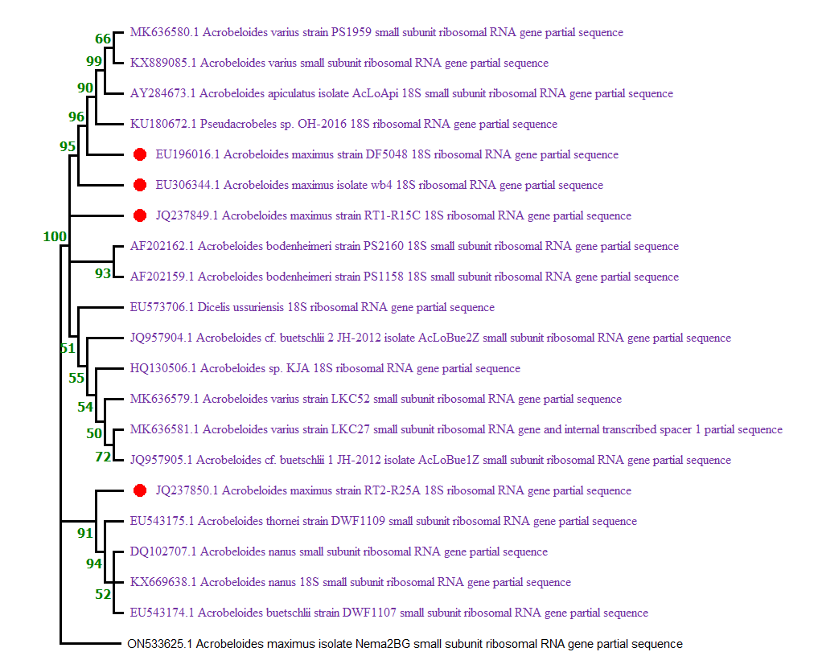
The bootstrap consensus tree inferred from 1000 replicates is taken to represent the evolutionary history of the
taxa analyzed. Branches corresponding to partitions reproduced in less than 50% bootstrap replicates are collapsed.
The percentage of replicate trees in which the associated taxa clustered together in the bootstrap test 1000 replicates
are shown next to the branches.
2. Morphometrics
Sample Lable | Body Length(LS) | Width | A-V length | Tail Length | a(Ls/GBD) | b(LS/AV) | c(LS/Tail)
1.jpg | 1902.729 | 81.413 | 472.597 | 172.07 | 17.61786111 | 4.026113 | 11.05788
2.jpg | 1190.58 | 68 | 373.181 | 123.849 | 11.02388889 | 3.190355 | 9.613158
3.jpg | 1308.671 | 77.795 | 361.386 | 153.701 | 12.11732407 | 3.621255 | 8.514395
4.jpg | 921.569 | 56.036 | 334.521 | 106.075 | 8.533046296 | 2.754891 | 8.6879
5.jpg | 1343.581 | 71.976 | 425.832 | 115.395 | 12.44056481 | 3.15519 | 11.64332
6.jpg | 1352.406 | 79.699 | 365.667 | 108.407 | 12.52227778 | 3.698463 | 12.47526
7.jpg | 1660.618 | 66 | 475.184 | 149.091 | 15.37609259 | 3.494684 | 11.13828
8.jpg | 1077.093 | 61.221 | 375.601 | 134.015 | 9.973083333 | 2.867652 | 8.037108
9.jpg | 1384.014 | 85.907 | 430.488 | 165.239 | 12.81494444 | 3.214989 | 8.375831
10.jpg | 1108.081 | 68.964 | 352.46 | 120.814 | 10.26000926 | 3.143849 | 9.171793
11.jpg | 688.758 | 50.205 | 336.886 | 84.38 | 6.377388889 | 2.044484 | 8.162574
12.jpg | 877.891 | 52.802 | 349.202 | 120.93 | 8.12862037 | 2.513992 | 7.259497
13.jpg | 1406.423 | 75.604 | 402.04 | 108.812 | 13.02243519 | 3.498217 | 12.92526
14.jpg | 1013.326 | 62.61 | 292.193 | 145.382 | 9.382648148 | 3.468002 | 6.970093
15.jpg | 1032.289 | 60 | 367.707 | 122.147 | 9.558231481 | 2.807368 | 8.451202
16.jpg | 1216.624 | 71.386 | 424.284 | 138.708 | 11.26503704 | 2.867476 | 8.771116
17.jpg | 1287.615 | 76.026 | 386.132 | 138.232 | 11.92236111 | 3.33465 | 9.314884
18.jpg | 1786.123 | 108.259 | 563.945 | 132.061 | 16.53817593 | 3.167194 | 13.52498
19.jpg | 903.548 | 74.108 | 328.055 | 144.734 | 8.366185185 | 2.754258 | 6.242818
20.jpg | 1442.42 | 95.603 | 403.053 | 90.554 | 13.35574074 | 3.578735 | 15.92884
21.jpg | 1089.855 | 66.573 | 358.987 | 112.73 | 10.09125 | 3.035918 | 9.667835
22.jpg | 1034.575 | 71.61 | 314.941 | 112.089 | 9.579398148 | 3.28498 | 9.229942
23.jpg | 1088.388 | 71.61 | 322.304 | 94.34 | 10.07766667 | 3.376899 | 11.53687
24.jpg | 922.872 | 80.399 | 335.44 | 127.122 | 8.545111111 | 2.751228 | 7.259735
25.jpg | 1472.561 | 79.246 | 419.605 | 77.201 | 13.63482407 | 3.509398 | 19.07438
26.jpg | 1045.084 | 103.092 | 307.044 | 95.016 | 9.676703704 | 3.403695 | 10.99903
27.jpg | 1559.878 | 70.342 | 472.076 | 142.338 | 14.44331481 | 3.304294 | 10.95897
28.jpg | 1864.94 | 83.546 | 475.343 | 173.217 | 17.26796296 | 3.923356 | 10.7665
29.jpg | 1357.071 | 78.476 | 397.4 | 141.152 | 12.56547222 | 3.414874 | 9.614253
30-1.jpg | 1965.046 | 66.843 | 508.035 | 94.149 | 18.19487037 | 3.867934 | 20.87166
31.jpg | 1157.582 | 89.889 | 325.779 | 87.658 | 10.71835185 | 3.553274 | 13.20566
32.jpg | 1098.525 | 62 | 349.369 | 122.115 | 10.17152778 | 3.144312 | 8.995824
33.jpg | 1352.829 | 52.345 | 383.275 | 121.212 | 12.52619444 | 3.529656 | 11.16085
34.jpg | 1191.48 | 75.286 | 318.522 | 114.63 | 11.03222222 | 3.740652 | 10.39414
35.jpg | 1546.359 | 96.54 | 462.087 | 134.402 | 14.31813889 | 3.346467 | 11.50548
36.jpg | 1853.809 | 86.023 | 483.231 | 125.936 | 17.16489815 | 3.836279 | 14.72025
37.jpg | 1475.036 | 75.073 | 414.121 | 119.281 | 13.65774074 | 3.561848 | 12.36606
38.jpg | 1145.544 | 71.386 | 374.219 | 102.801 | 10.60688889 | 3.061159 | 11.14332
39.jpg | 1044.159 | 58 | 329.873 | 111.803 | 9.668138889 | 3.165336 | 9.339275
40.jpg | 922.894 | 96.167 | 288.721 | 81.216 | 8.545314815 | 3.196491 | 11.36345
41.jpg | 1223.572 | 73.348 | 358.804 | 81.216 | 11.32937037 | 3.41014 | 15.06565
42.jpg | 1129.119 | 62.642 | 320.924 | 121.945 | 10.45480556 | 3.518338 | 9.259248
std | 305.3018154 | 13.44817723 | 63.89007 | 24.22415143 | 2.826868661 | 0.396687 | 3.024001
Mean | 1250.019507 | 72.73251575 | 376.84661 | 118.4276547 | 11.5742547 | 3.221745 | 10.64625
max | 1965.046 | 108.259 | 563.945 | 173.217 | 18.19487037 | 4.026113 | 20.87166
min | 688.758 | 50.205 | 288.721 | 77.201 | 6.377388889 | 2.044484 | 6.242818

Table 1. 42 Females body measurements.
Image Name | L | w | A-v | Tail Length | a | b | c | Spicule length
4x male a.jpg | 894.563 | 52.612 | 224.351 | 73.335 | 13.55398485 | 3.987336807 | 12.19830913 | 50.294
4x male B.jpg | 1155.014 | 58.822 | 345.739 | 83.744 | 17.50021212 | 3.340710767 | 13.79220004 | 59.567
4x male C.jpg | 1039.197 | 48.374 | 333.878 | 87.207 | 15.74540909 | 3.112505167 | 11.91644019 | 46.995
4x male D | 1023.152 | 66 | 330.196 | 83.487 | 15.50230303 | 3.098620213 | 12.25522536 | 75.799
4x male E | 1148.398 | 62.29 | 330.61 | 109.636 | 17.3999697 | 3.473573092 | 10.47464337 | 66.48
4x male.jpg | 1137.231 | 56.462 | 228.057 | 116.842 | 17.23077273 | 4.986608611 | 9.733066877 | 74.031
std | 101.7166376 | 6.40568 | 56.53060447 | 16.96641824 | 1.541161176 | 0.723654631 | 1.438488734 | 12.02581489
Mean | 1066.259167 | 57.4267 | 298.8051667 | 92.37516667 | 16.15544192 | 3.66655911 | 11.72831416 | 62.19433333
Max | 1155.014 | 66 | 345.739 | 116.842 | 17.50021212 | 4.986608611 | 13.79220004 | 75.799
Min | 894.563 | 48.374 | 224.351 | 73.335 | 13.55398485 | 3.098620213 | 9.733066877 | 46.995

Table 2. 6 males body measurements.

Data Analysis
All data analysis was performed in Microsoft excel 2007. All images were clubbed using Microsoft power point 2007.Image analysis was performed by Fiji software. Phylogeny was constructed in MEGA softwere.

