Supplementary Table 1. Risk of Bias Assessment: Based on the Newcastle-Ottawa Scale
Study | Selection |  |  |  | Comparability Control for improtant factor | Exposure |  |  | Scores
Study | Adequate definition of cases | Representat-  iveness of the cases | Selection of controls | Definition of controls | Comparability Control for improtant factor | Ascertain-  ment of exposure | Same method of ascertainment for cases and controls | Non-response rate | Scores
Chen 2021 | 1 | 1 | 1 | 1 | 0 | 1 | 1 | 1 | 7
Chen 2022* | 1 | 1 | 1 | 1 | 1 | 1 | 1 | 1 | 8
Hamai 2021 | 1 | 1 | 1 | 1 | 0 | 1 | 1 | 1 | 7
Merritt 2021* | 1 | 1 | 1 | 1 | 1 | 1 | 1 | 1 | 8
Tang 2018 | 1 | 1 | 1 | 1 | 0 | 1 | 1 | 1 | 7
Tapias 2016 | 1 | 1 | 1 | 1 | 0 | 1 | 1 | 1 | 7
*The data is based on propensity score matching.

Supplementary Figure 1 Detailed flowchart of inclusion and exclusion criteria for the literature search
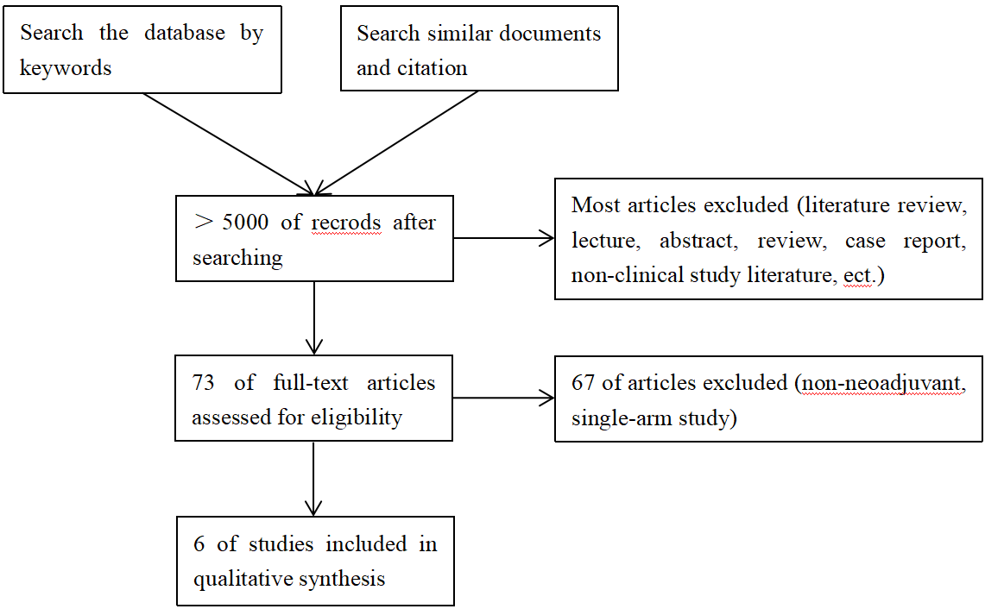
Supplementary Figure 2 Sensitivity analyses of intraoperative blood loss (a), operative time (b), and number of lymph node dissection (c)
(a)
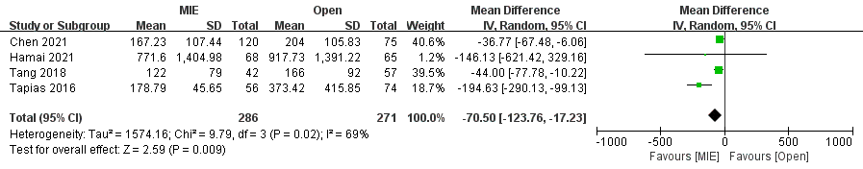
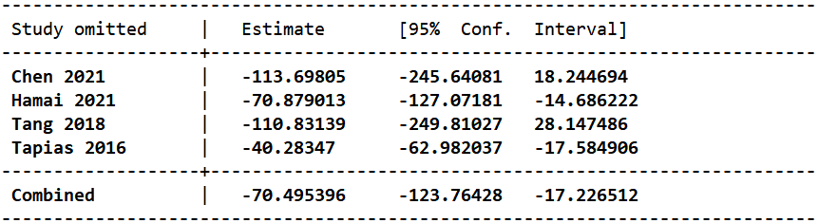
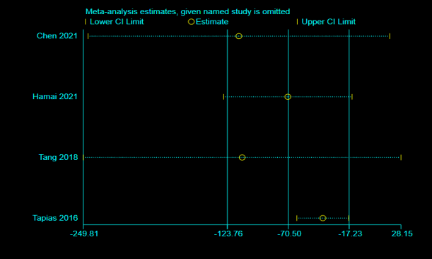
(b)
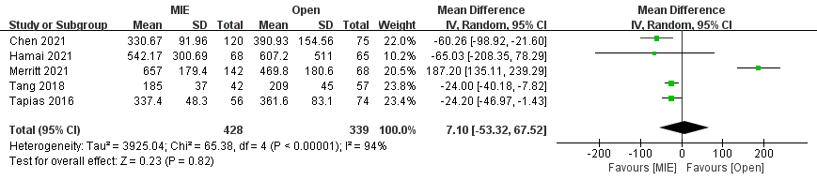
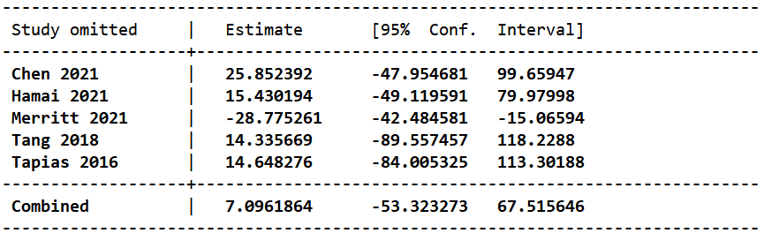
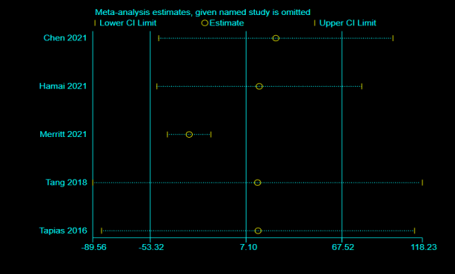
(c)
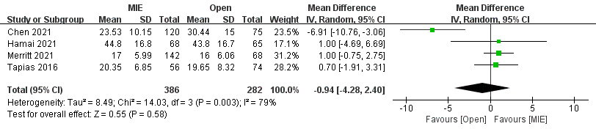
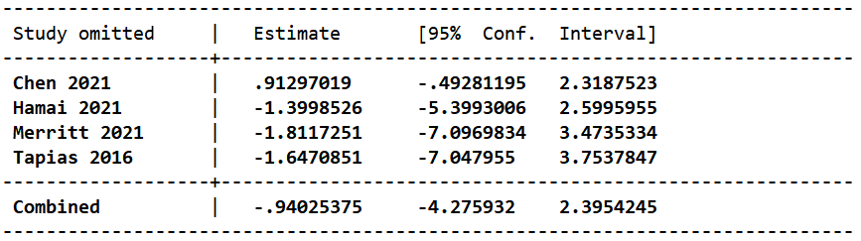
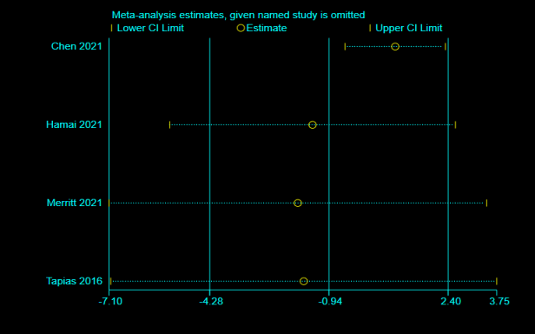

Supplementary Figure 3 Sensitivity analysis of anastomotic leakage

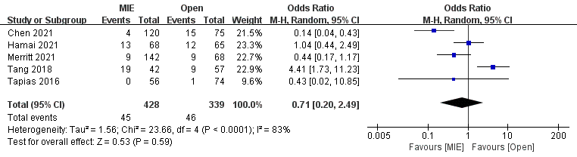
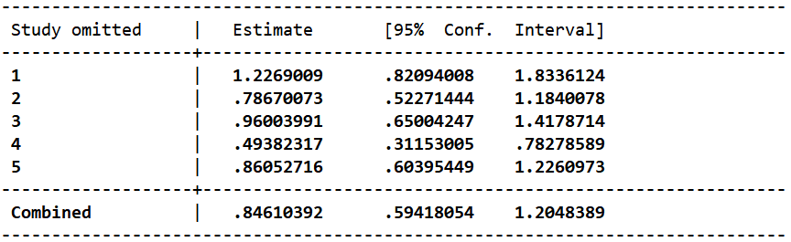
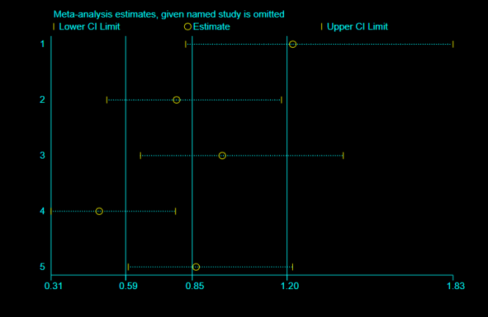

Supplementary Figure 4 Egger's funnel plot of overall survival
