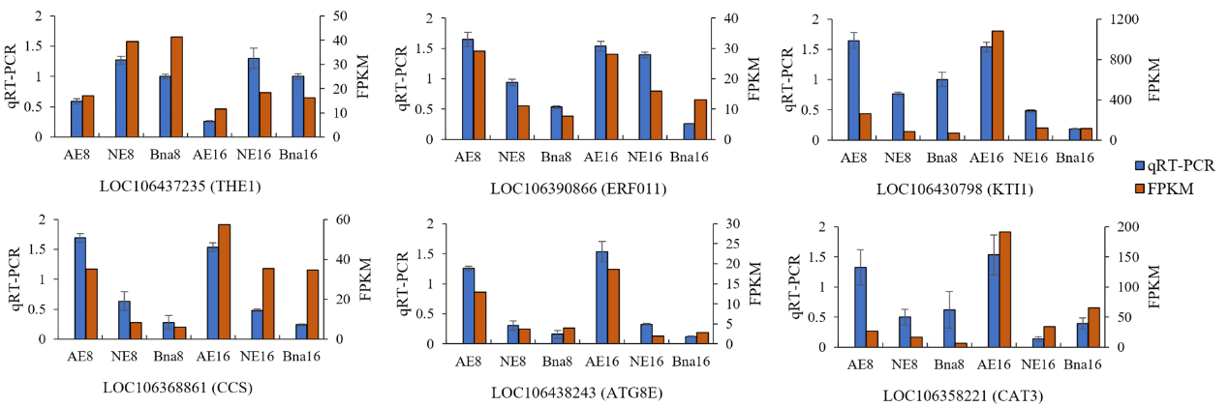
Figure S1. Gene expression of six randomly selected DEGs in silique detected by qRT-PCR (blue bars) and RNA-seq (orange bars) at 8 and 16 DAP.

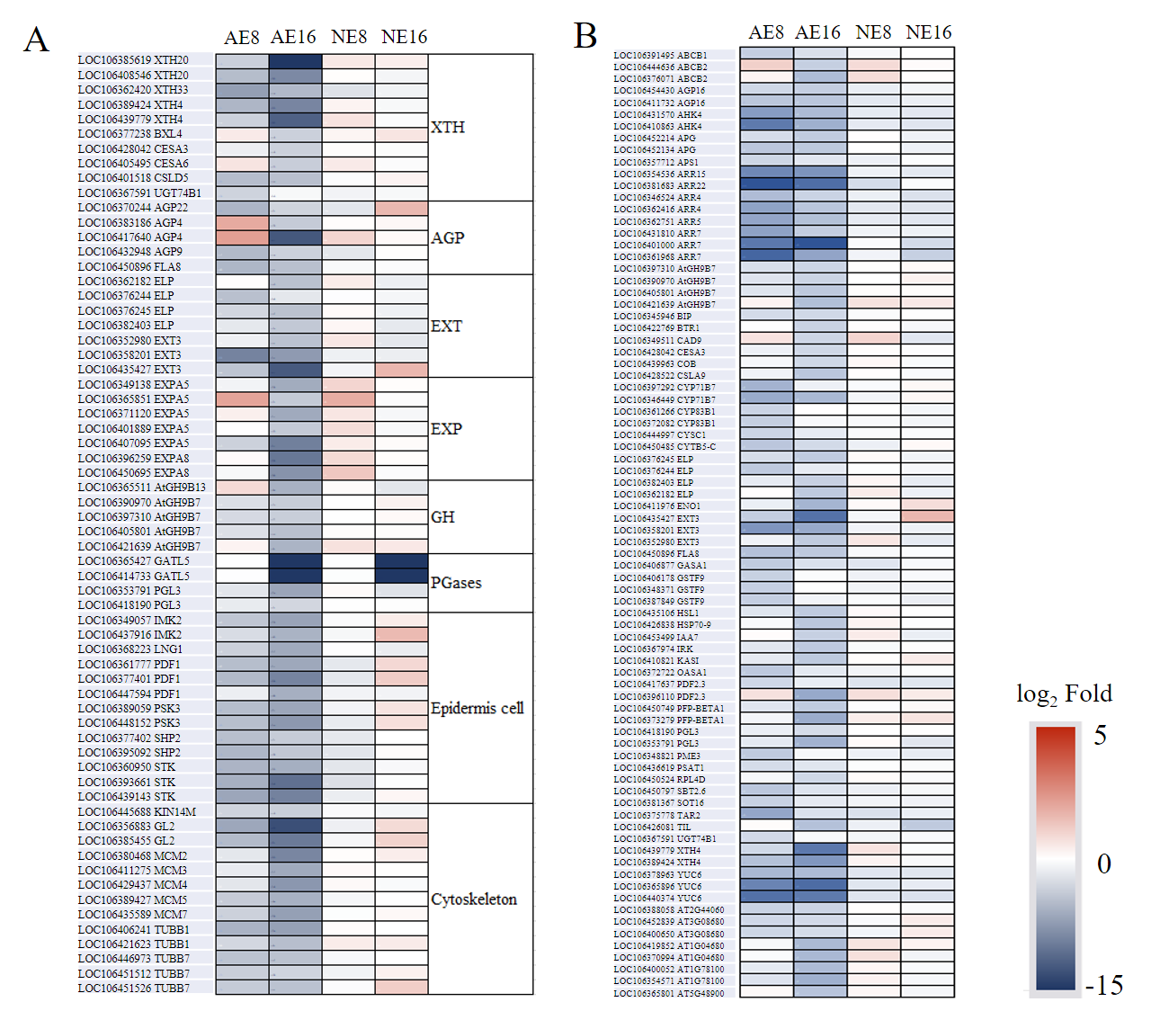
Figure S2. Heat map of genes expression involved in cell growth (A) and growth hormone (B) in AE and NE compared with Bna in silique at 8 and 16 DAP. The color in each cell represents the level of gene expression based on the log₂ fold.

