Supplementary material:

SM1. Study hypotheses
It was expected that a negative POCT result would increase the inclination to stop antibiotics (hypothesis 1), but that the following clinical and cognitive-behavioural factors would reduce it:
- The patient’s clinico-biological trajectory: we hypothesised that clinicians would be less willing to stop antibiotics if the patient’s clinico-biological trajectory was ambiguous or worsening (vs. improving), irrespective of a negative POCT (hypothesis 2);
- The clinician’s initial (pre-POCT) inclination to stop: there is evidence to suggest that “first impressions last”; that is, initial leanings can determine final decisions [21]. Therefore, we expected that clinicians’ early intuitions about stopping antibiotics (prior to availability of POCT) would strongly determine their final decision about stopping antibiotics (following receipt of POCT results; hypothesis 3). A clinician who believes strongly that antibiotics are needed might not be swayed by a negative POCT (suggesting no infection) – this has been termed “anchoring with insufficient adjustment” by Kahneman and Tversky.
- Disinterest in POCT: Prior qualitative research identified low trust in POCT as a potential cause of clinicians’ non-compliance. We therefore expect that clinicians who decline the POCT (a proxy for low trust) will be less willing to act in accord with its findings (i.e., stop antibiotics) than those who request it (hypothesis 4).

Finally, we expected more (vs. less) experienced clinicians to be more confident (in general) and therefore more willing to stop antibiotics (hypothesis 5). Moreover, a recent study investigating ICU clinicians’ antibiotic prescribing following receipt of a molecular PCR POCT result identified “protective prescribing”; that is, a strong tendency to err on the side of caution in antibiotic start- and stop- decision making [25] Based on this, we expected that individual differences in attitudes toward risk-taking (as measured by Grol et al.’s Attitudes to Risk-Taking in Medical Decision Making questionnaire) might moderate the inclination to stop antibiotics (hypothesis 6). Of note, our investigation of clinician characteristics (experience and risk-taking) was purely exploratory, as the study was not powered to detect such effects.

SM2. The 4 clinical vignettes

The “improvement” vignette
Details of admission:
A 66-year-old male with a background of diverticulitis was admitted for elective sigmoid colectomy. Four days post-operatively he developed worsening hypoxia and pyrexia. His observations were the following:

Respiratory rate | 24
SpO2 | 91% on room air
Heart rate | 90
Blood pressure | 102/71 mmHg
Temperature | 38.1 C

There was bilateral pulmonary consolidation on both chest radiograph and a CT pulmonary angiogram, CTPA and nil else. His blood tests demonstrated a WBC of 16 and CRP of 98. He was empirically started on co-amoxiclav.

Five days later:
5 days later, he had improved shortness of breath and was afebrile. His observations were:

Respiratory rate | 18
SpO2 | 98% on room air
Heart rate | 83
Blood pressure | 112/70 mmHg
Temperature | 37.2 C

He was eating and drinking well and mobilising on the ward. His repeat blood tests demonstrated a WBC of 10 and CRP of 25.

The “worsening” vignette
Details of admission:
A 65-year-old female was admitted with a 2-day history of worsening shortness of breath and a non-productive cough. She has no past medical history. She was penicillin allergic. Her admission observations were:

Respiratory rate | 22
SpO2 | 84% on room air
Heart rate | 98
Blood pressure | 104/65 mmHg
Temperature | 37.9 C

There was right basal consolidation on her chest radiograph. Her blood tests demonstrated a WBC of 14 and a CRP of 102. She was empirically started on levofloxacin and clarithromycin. Within 24 hours she deteriorated and required mechanical ventilation.

Three days later:
3 days later, after an initial improvement in ventilation, she became febrile. Her observations were:

Respiratory rate | 25
SpO2 | 92% on FiO2 21%
Heart rate | 120
Blood pressure | 130/70 mmHg
Temperature | 39.0 C

Her repeat blood tests demonstrated WBC 18 and CRP 132.

The discordant vignette with clinical improvement but biochemical worsening (“disc clin better”):
Details of admission:
A 62-year-old male was admitted to ITU with a 4-day history of pyrexia, shortness of breath, and a productive cough with rusty sputum. He has a past medical history of type 2 diabetes and hypertension. His observations were the following:

Respiratory rate | 28
SpO2 | 86% on room air
Heart rate | 125
Blood pressure | 104/64 mmHg
Temperature | 38.1 C

A chest radiograph demonstrated left basal consolidation. His blood tests demonstrated a WBC of 14 and a CRP of 70. Sputum culture grew fully sensitive Klebsiella Pneumonia. He was intubated and ventilated and empirically started on piperacillin/tazobactam. His initial blood gas findings were:
· FiO2 0.6
· PaO2 of 7.9 kPa
· PaCO2 5.5 kPa
· Base excess of -5

Seven days later:
7 days into his admission, he was improving on ventilation and he is extubated and weaned onto room air. He was feeling much better. His observations were:

Respiratory rate | 16
SpO2 | 94% on room air
Heart rate | 85
Blood pressure | 110/70 mmHg
Temperature | 37.4 C

His repeat blood tests demonstrated a WBC of 16 and a CRP of 110.

The discordant vignette with clinical worsening but biochemical improvement (“disc clin worse”):
Details of admission:
A 54-year-old male was admitted to ITU with a 2-day history of pyrexia, shortness of breath and a productive cough. He has no past medical history. His observations were the following:

Respiratory rate | 22
SpO2 | 88% on room air
Heart rate | 130
Blood pressure | 115/54 mmHg
Temperature | 38.1 C

A chest radiograph demonstrated bilateral pulmonary infiltrates. His blood tests demonstrated a WBC of 19 and a CRP of 110. Sputum culture grew fully sensitive to streptococcus pneumonia. He was intubated and ventilated and empirically started on piperacillin/tazobactam. His initial blood gas findings were:
· FiO2 0.6
· PaO2 of 7.9 kPa
· PaCO2 4.5 kPa
· Base excess of -5

Five days later:
5 days into his admission, he was extubated and weaned onto room air. Chest radiograph findings were unchanged. A few days following extubation, he developed new pyrexia and increased oxygen requirement.

Seven days later:
7 days into his admission, his observations were:

Respiratory rate | 20
SpO2 | 92% on FiO2 0.6
Heart rate | 100
Blood pressure | 130/70 mmHg
Temperature | 37.8 C

His repeat blood tests demonstrated a WBC of 9 and a CRP of 24.

SM3. Piloting vignettes

Five non-participating intensivists pilot-tested the vignettes for accessibility and authenticity. We sought feedback regarding the survey structure and format and were able to validate the control vignettes using their anonymised survey responses.

Mid-way through data collection, we were advised by a statistician to validate our sample size by running our analysis (mixed effects model used to test hypotheses 2-4) on data collected from 10 participants (selected at random). Each participant had responded to all four scenarios, yielding 40 scenario responses. The results appear below.

Factor | Coefficient  [95% CI] | p | Part correlation
Clinico-biological trajectory | -0.52 [-2.54, 1.51] | 0.610 | -0.054
Initial inclination-to-stop | 0.78 [0.48, 1.07] | <0.001 | 0.555
In/voluntary receipt of POCT results | 1.74 [-0.64, 4.11] | 0.146 | 0.156
Table SM3. Validation of sample size using pilot data. Clinico-biological trajectory was coded as follows: 1 = improvement, 2 = discordant clin better/discordant clin worse, 3 = worsening. Initial inclination-to-stop ranged from -6 (minimal) to 6 (maximal). In/voluntary receipt of POCT results was coded 1 = POCT rejected, 2 = POCT requested.

R² for the model was 0.605 and f² (which is R²/1-R²) was 1.532 (a very large effect). According to G*Power, we would need at least 16 responses to detect an effect of this size in our analysis (alpha = 0.05, power = 0.95). We noted, however, that the three predictors accounted for different amounts of variance in the data. For example, initial inclination-to-stop had a very large effect (Part correlation = 0.555; R²part = 0.308, f² (which is R²part/1-R²part) = 0.445, which according to G*Power was replicable with only 32 responses. In/voluntary receipt of POCT results however had a smaller effect (Part correlation = 0.156; R²part = 0.024; f² = 0.025), which would require 522 responses. We appreciate therefore that our a priori sample size (N = 55) gave sufficient power to detect the effect of initial inclination-to-stop, but not to detect the smaller individual effects of clinico-biological trajectory or in/voluntary receipt of POCT results. These can only be investigated in an exploratory way. If they are found to be non-significant, this does not necessarily mean that they had no effect; it is possible that they did have an effect, but we did not have the power to detect it.

SM4. List of reasons presented to clinicians that elected to stop antibiotics (left) or continue antibiotics

Reasons for STOPPING antibiotics | Reasons for CONTINUING antibiotics
Clinicians that elected to STOP antibiotics were presented with the following list of reasons and asked to tick all that apply: | Clinicians that elected to CONTINUE antibiotics were presented with the following list of reasons and asked to tick all that apply:
- Continuing antibiotics could harm the patient;  - Continuing antibiotics might be viewed as inappropriate by colleagues;  - Continuing antibiotics is not clinically necessary based on the information provided;  - Continuing antibiotics poses population risks (i.e., antimicrobial resistance);  - Other (if selected, the participant was asked to elaborate using free text). | - Stopping antibiotics could harm the patient;  - Stopping antibiotics might be viewed as inappropriate by colleagues;  - Stopping antibiotics is inappropriate based on the clinical information provided;  - There is relatively minimal harm in continuing antibiotics;  - Other (if selected, the participant was asked to elaborate using free text).

Table SM4. List of reasons presented to clinicians that elected to stop antibiotics (left) or continue antibiotics (right). Reasons were presented in a random order and clinicians could select as many as needed. The reasons were developed using the experiences from senior researchers in combination with the exploratory supplementary material from the VAPRapid2 trial.

SM5. Grol et al.’s Attitudes to Risk-Taking Scale

We have made minimal adaptations for a hospital setting. In brackets lie the original wording (15).

- When in doubt it is preferable to seek an opinion from (refer to) a specialist than to wait and see
- A clinician (GP) must prefer the certain to the uncertain
- A clinician (GP) must not take any risks with physical illness
- For physical complaints, a clinician (GP) should do everything possible to establish the cause of a complaint
- As a clinician (GP) you must always be aware that each complaint can be the beginning of a deterioration (serious disease)

Participants indicated their agreement with item on a 5-point scale ranging from 1 = strongly disagree to 5 = strongly agree.

SM6. Sample characteristics
Gender | n (%) | M (SD), range
Male | 36 (51%)
Female | 25 (36%)
Prefer not to say | 1 (1%)
Missing | 8 (11%)
Grade
Consultant | 18 (26%)
SpR trainee | 16 (23%)
SHO trainee | 17 (24%)
FY trainee | 11 (16%)
Missing | 8 (11%)
Experience: consultantsª
Number of years since consultancy awarded |  | 8.18 (7.36), 0 - 24
Experience: trainees
>24 months on ICU ward  12-24 months on ICU ward  6-12 months on ICU ward  3-6 months on ICU ward | 12 (17%)  4 (6%)  7 (10%)  21 (30%)
Table SM6. Demographic, grade and experience characteristics of the sample (N = 70).

ª One consultant did not provide this information.

SM7. Reasons for clinicians to STOP or NOT STOP (continue) antibiotics

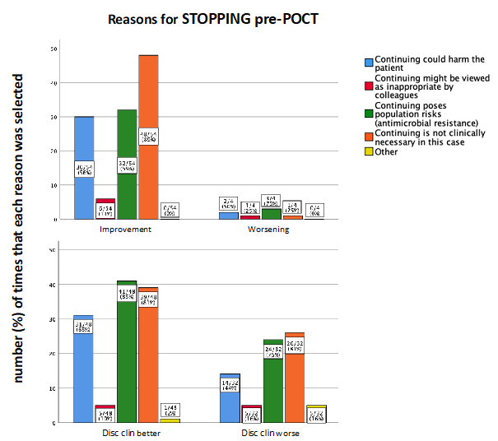
Fig SM7a. Reasons given by clinicians for their decision to STOP antibiotics, in the improvement (top left, n=54), worsening (top right, n=4), disc clin better (bottom left, n=48) and disc clin worse (bottom right, n=32) scenarios. Participants who elected to STOP antibiotics were asked: “In your view, what are the risks of continuing antimicrobial treatment? Tick all that apply.” The options available were: “Continuing antibiotics could harm the patient”, “Continuing antibiotics might be viewed as inappropriate by colleagues”, “Continuing antibiotics poses population risks (i.e. antimicrobial resistance)”, “Continuing antibiotics is not clinically necessary based on the information provided”, and “Other”.

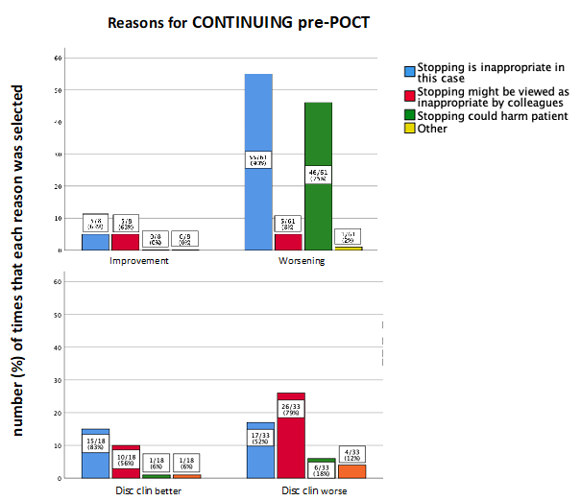
Fig SM7b. Reasons given by clinicians for their initial decision to CONTINUE antibiotics, in the improvement (top left, n=8), worsening (top right, n=61), disc clin better (bottom left, n=18), and disc clin worse (bottom right, n=33) scenarios. Participants who elected to continue antibiotics were asked: “In your view, what are the risks of stopping antimicrobial treatment? Tick all that apply.” The options available were: “Stopping antibiotics is inappropriate based on the clinical information provided”, “Stopping antibiotics might be viewed as inappropriate by colleagues”, “Stopping antibiotics could harm the patient”, “There is relatively minimal harm in continuing antibiotics”, and “Other”. One reason was never selected (“There is relatively minimal harm in continuing antibiotics”) and has been removed from the graph for simplicity.

SM8. Variation in STOP decisions and the influence of POCT on variability of judgements

Table SM6 shows the per-scenario mean and standard deviation (i.e, variability) in inclination-to-stop, before (column 1) and after (column 2) the negative POCT result, per scenario. In all cases except worsening, a negative POCT result reduced variability, albeit to different degrees. As we might expect, the reduction was smallest in the improvement scenario. In the two discordant scenarios, there was a greater reduction in disc clin better (where the negative POCT result was consistent with the patient’s clinical data) than disc clin worse (POCT inconsistent with patient’s clinical data). These supplementary findings suggest that the introduction of POCT might reduce unwanted variability in decision making amongst clinicians.

Scenario | Inclination-to-stop pre-POCT  mean (SD) | Inclination-to-stop post-POCT  mean (SD) | Difference  mean (SD)
Improvement | 3.73 (3.00) | 4.19 (2.82) | 0.46 (-0.18)
Disc clin better | 2.00 (3.73) | 3.77 (2.75) | 1.77 (-0.98)
Disc clin worse | -0.17 (4.01) | 2.46 (3.65) | 2.63 (-0.36)
Worsening | -4.15 (2.56) | -2.00 (3.89) | 2.15 (1.33)

Table SM8. Mean and SD for inclination-to-stop antibiotics, before and after a negative POCT result, per scenario. Variability in clinicians’ judgments (i.e., standard deviations) was reduced by negative POCT results in all but one scenario (worsening).

SM9. Reasons for requesting/rejecting POCT

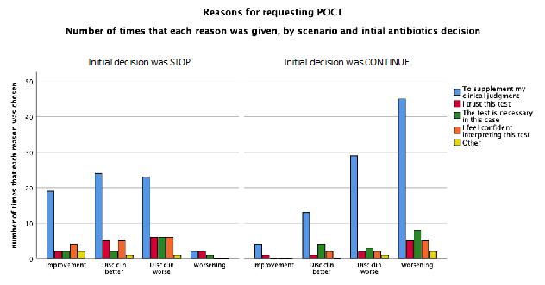
Fig SM9a. Reasons given by clinicians for their decision to request POCT, per scenario and initial antibiotics decision. Participants could select more than one reason for their decision. In the improvement scenario: 24 clinicians requested the POCT; of these, 20 initially elected to stop antibiotics (left panel) and 4 elected to continue (right panel). In the discordant scenario with clinical improvement (disc clin better): 39 clinicians requested the POCT; of these, 25 initially elected to stop (left panel) and 14 elected to continue (right panel). In the discordant scenario with clinical worsening (disc clin worse): 55 clinicians requested the POCT; of these, 24 initially elected to stop (left panel) and 31 elected to continue (right panel). In the worsening scenario: 49 clinicians requested the POCT; of these, 3 initially elected to stop and 46 elected to continue. Data labels are omitted for readability.

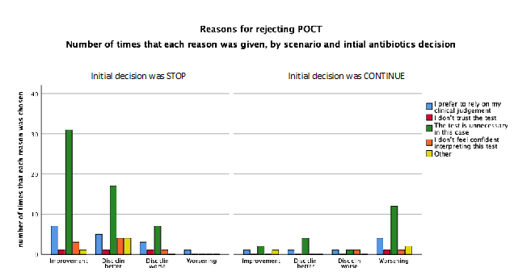

Fig SM9b. Reasons given by clinicians for their decision to reject POCT, per scenario and initial antibiotics decision. Participants could select more than one reason. In the improvement scenario: 38 clinicians rejected the POCT; of these, 34 initially elected to stop antibiotics (left panel) and 4 elected to continue (right panel). In the discordant scenario with clinical improvement (disc clin better): 27 clinicians rejected the POCT; of these, 23 initially elected to stop antibiotics (left panel) and 4 elected to continue (right panel). In the discordant scenario with clinical worsening (disc clin worse): 10 clinicians rejected the POCT; of these, 8 initially elected to stop (left panel) and 2 elected to continue (right panel). In the worsening scenario: 16 clinicians rejected the POCT; of these, 1 initially elected to stop and 15 elected to continue. Data labels are omitted for readability.

SM10. Comparison of consultants vs. trainees on key outcome measures

 | Consultants | Trainees
Initial antibiotics decision | 54% stopped (39/72) | 53% stopped (94/176)
Initial inclination-to-stop | M=0.42, SD=4.76 | M=0.31, SD=4.39
POCT requests | 64% (46/72) | 65% (114/176)
Final antibiotics decision | 71% stopped (51/72) | 69% stopped (121/176)
Final inclination-to-stop | M=2.22 (SD=4.43) | M=2.00 (SD=4.04)
Attitudes Towards Risk Taking score | M=10.78, SD=2.57 | M=11.00, SD=3.44

Table SM10. Comparison of consultants (left) vs. trainees (right) on key outcome measures. n=18 consultants gave a total of 72 scenario responses; n=44 trainees gave a total of 176 scenario responses; n=8 participants did not provide their grade (consultant vs. trainee) and were therefore excluded from this analysis.

