Supplementary Information
Title: Drug approval prediction based on the discrepancy between gene perturbation effects in cells and humans

To whom correspondence should be addressed:
Sanguk Kim, Ph.D.
Department of Life Sciences, Pohang University of Science and Technology, Pohang 790-784, Korea; E-mail: sukim@postech.ac.kr; Tel: +82-54-279-2348; Fax: +82-54-279-2199

Table of contents
Supplementary Information files contain 11 Supplementary Figures

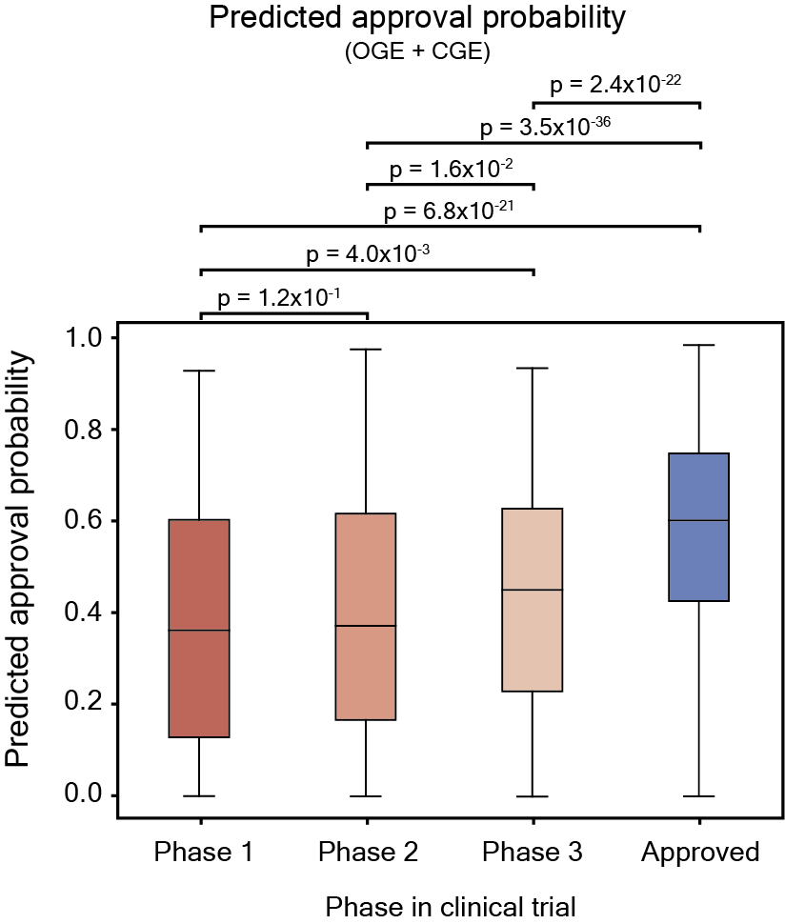
Fig. S1. Predicted approval probability of drugs in clinical trials. Distribution of predicted approval probabilities according to the clinical trial phase of drugs. Statistical significance of the difference between predicted approval probabilities was measured using Mann-Whitney U test.

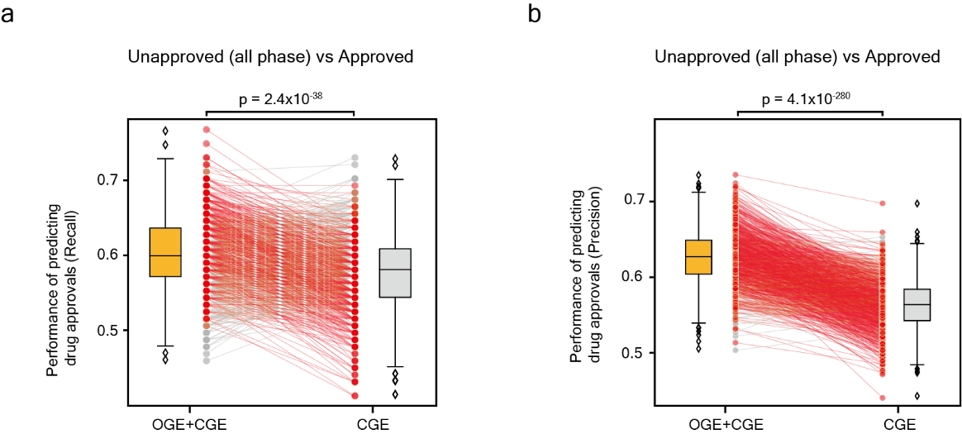
Fig. S2. Recall and precision for predicting drug approval. (a–b) Boxplots represent the recalls and precisions for Monte-Carlo cross-validation (1,000 times). Red dots connected by red lines indicate prediction performance (recall and precision) for models with higher recall, or precision of OGE+CGE, than that of CGE. Conversely, gray dots connected by gray lines indicate the prediction performance for models with higher recall, or precision of CGE, than that of OGE+CGE. Statistical significance of the difference between recalls and precisions was measured using the paired sample t-test. CGE, cellular gene essentiality; OGE, organismal gene essentiality.

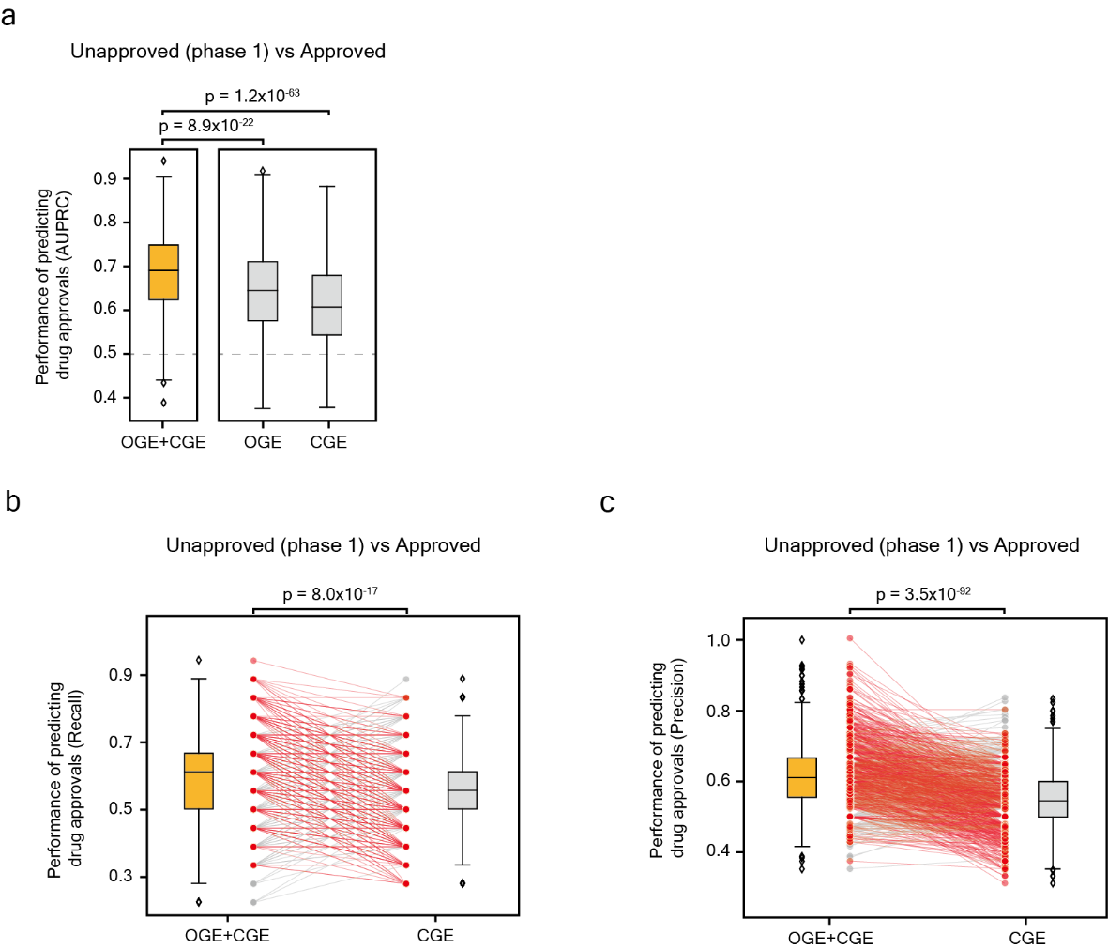
Fig. S3. Prediction performance for unapproved (clinical phase 1) and approved drugs. (a) The AUPRCs of OGE+CGE, OGE, and CGE for predicting the drug approval in phase 1 of clinical trials. Unapproved drugs (drugs with max phase 1) and approved drugs were predicted. Box plots represent the AUPRCs for Monte-Carlo cross-validation (1000 times). Statistically significant values for the difference between AUPRCs were measured using the Mann-Whitney U test. The gray dashed line denotes the baseline. (b–c) Descriptions are the same in Fig. S2. CGE, cellular gene essentiality; OGE, organismal gene essentiality; AUPRC, area under the precision-recall curve.

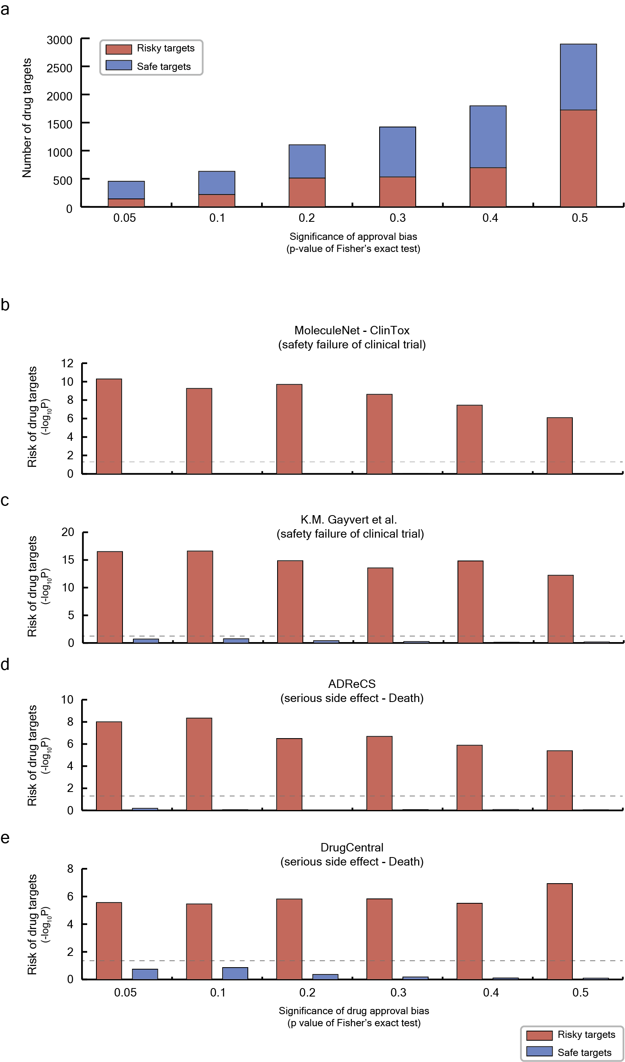
Fig. S4. Enrichment of drugs with relaxed risky and safe targets for drugs having safety issues. (a) The number of risky and safe targets when the threshold for statistical significance for approval bias was relaxed. (b–e) Red and blue bars represent the enrichment of drugs with safety issues for drugs with risky and safe targets, respectively. The statistical significance of enrichment was measured using a hypergeometric test. The gray dashed line denotes a P-value = 0.05.

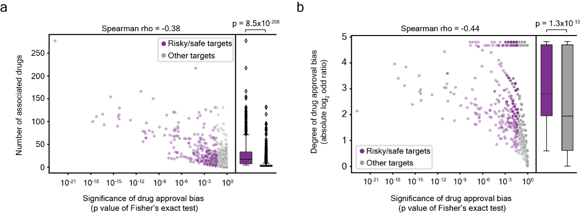
Fig. S5. Correlation of statistical significance of approval bias with the number of associated drugs per target and degree of drug approval bias. (a–b) Purple and gray dots indicate risky/safe targets and drug targets other than risky/safe targets (other targets), respectively. Purple and gray boxplots represent distributions of the value of the y-axis for risky/safe targets and other gargets, respectively. Correlation coefficients were measured by Spearman rank correlation. The x-axes were set to a log₁₀ scale. Statistically significant values for the difference between the values of the x-axes were measured using Mann-Whitney U test.

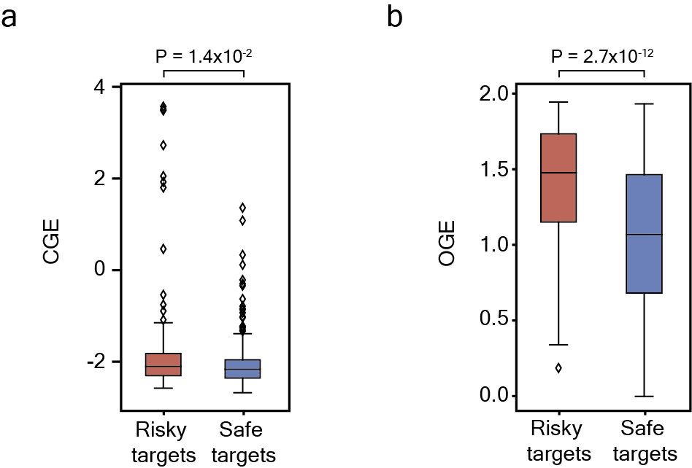
Fig. S6. Difference in CGE and OGE between risky and safe targets. (a–b) Distribution of CGE and OGE for risky and safe targets. Statistically significant values for the difference were measured using Mann-Whitney U test. CGE, cellular gene essentiality; OGE, organismal gene essentiality.

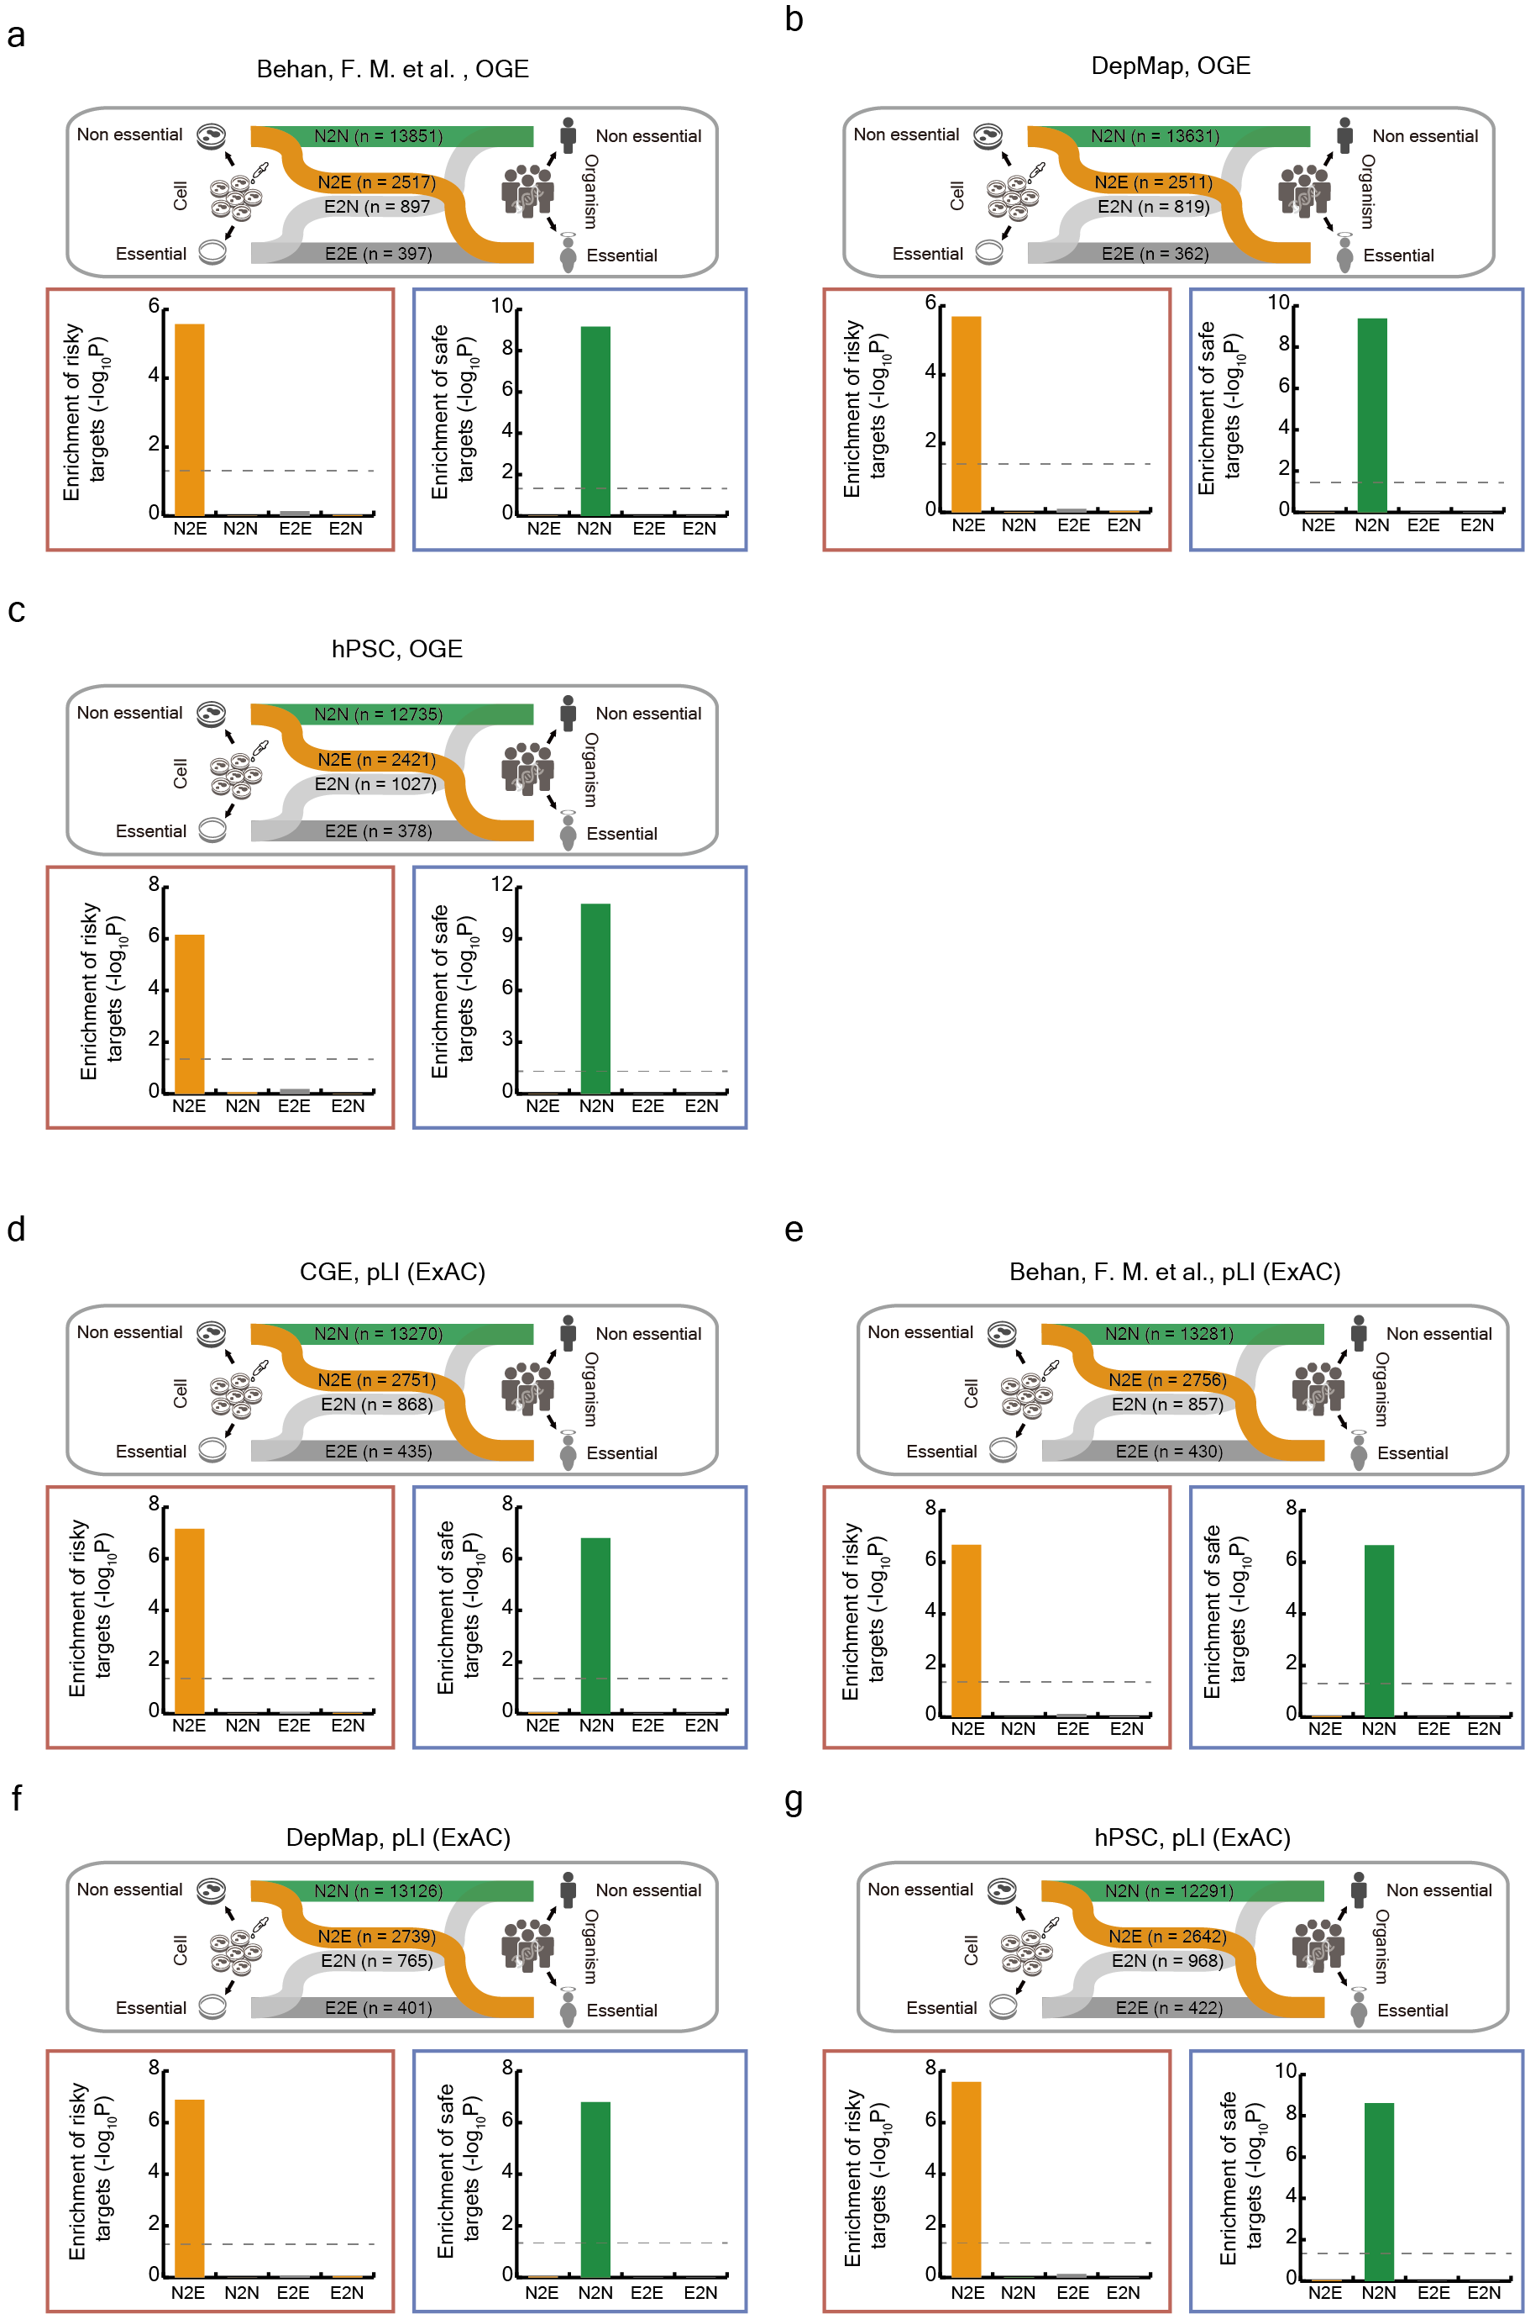
Fig. S7. Enrichment of risky and safe targets in gene sets based on a comparison of CGE and OGE for various metrics. (a–g) Sankey diagram showing the discrepancy in gene perturbation effects (gene essentiality) between cells and humans. The number of genes based on a comparison of CGE and OGE are shown. Bar plots showed the enrichment of risky and safe targets in each gene set (N2E, N2N, E2E, and E2N). Bars in red and blue boxes represent the enrichment of risky and safe targets, respectively. Statistically significant enrichment values were measured using a two-tailed test. The two-tailed test was performed with the observed number of risky/safe targets and expected numbers of risky/safe targets in each gene set with 1000 permutation tests. Gray dashed lines denote the P-value = 0.05. CGE, cellular gene essentiality; OGE, organismal gene essentiality.

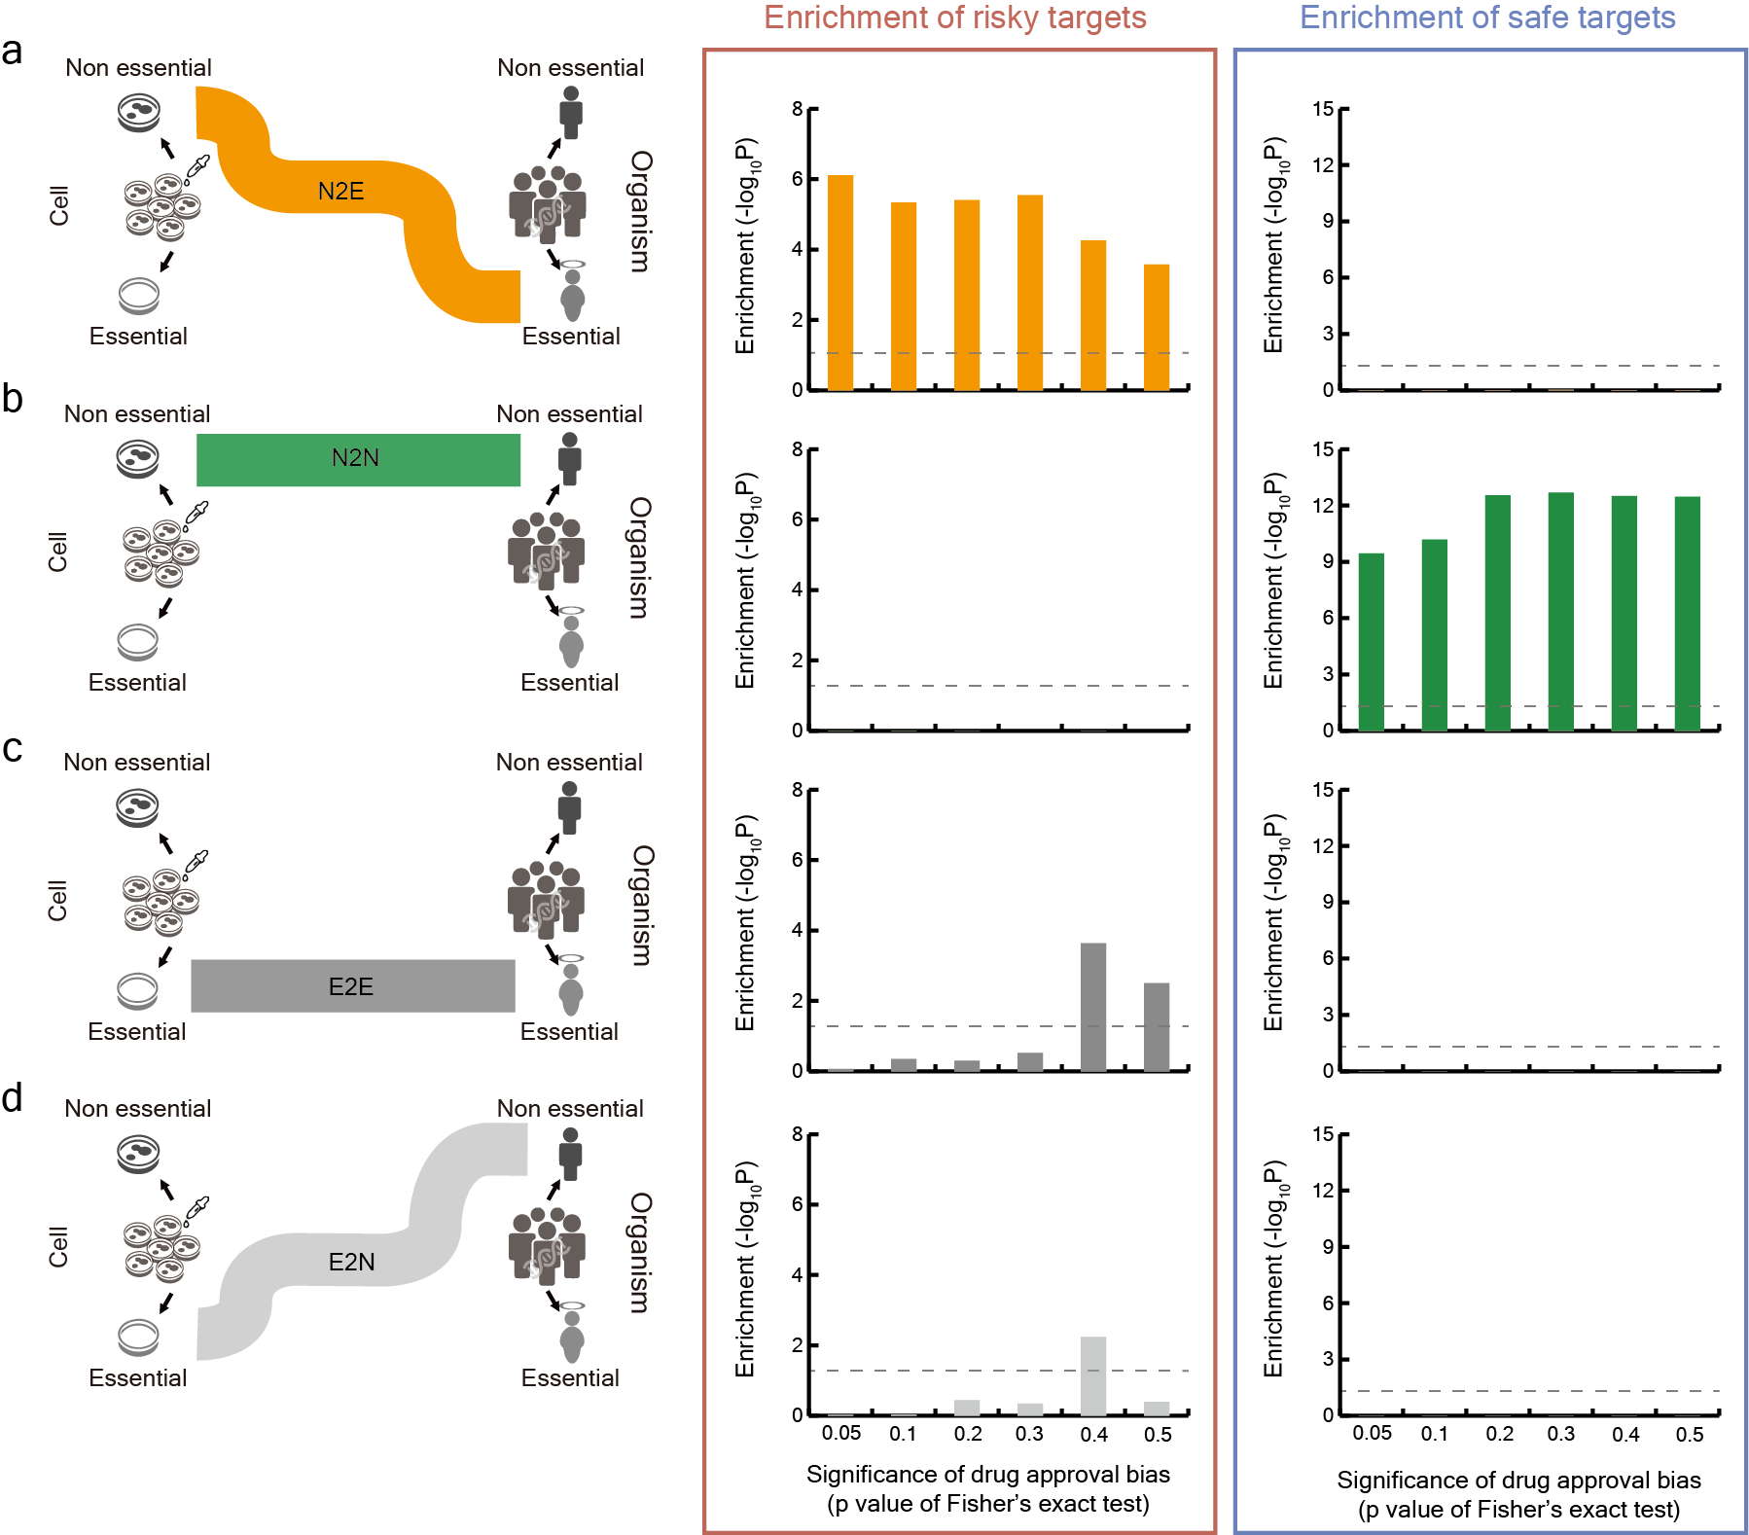
Fig. S8 Enrichment of relaxed risky and safe targets in gene sets based on a comparison of CGE and OGE. (a–d) Enrichment of risky and safe targets when the threshold for statistical significance of approval bias was relaxed to increase the number of risky and safe targets. Descriptions are the same in Fig. S7.

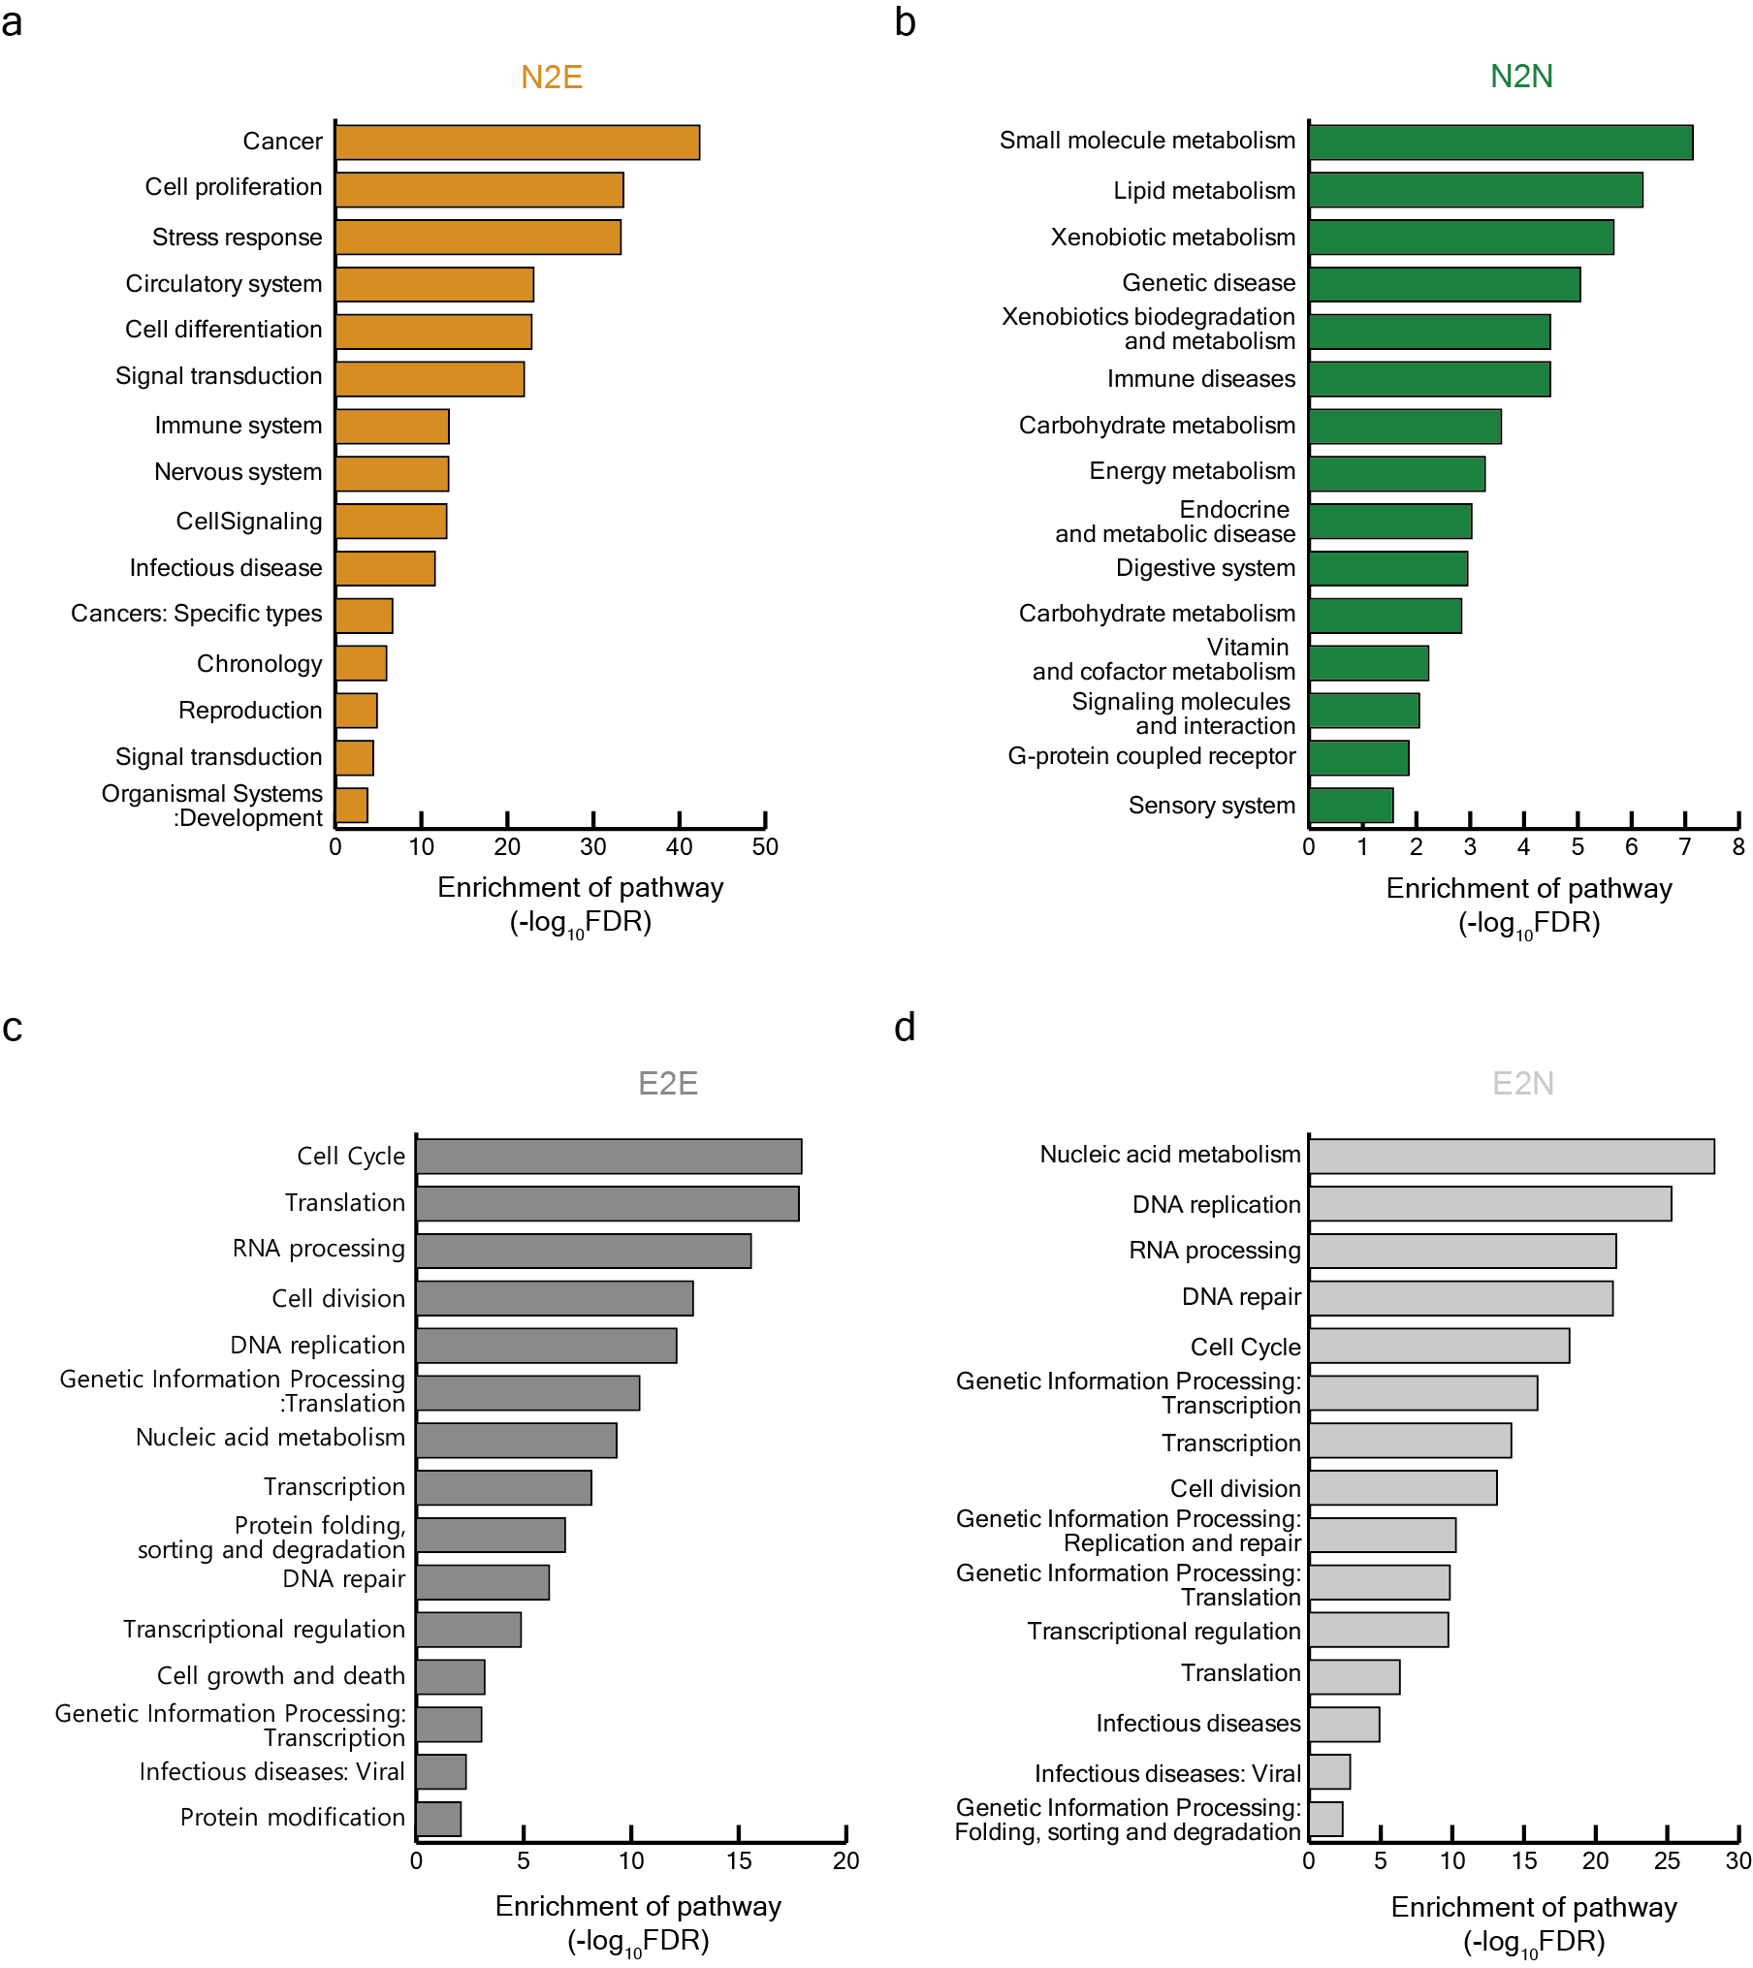
Fig. S9 Pathway enrichment analysis. (a–d) Enrichment of pathways associated with gene sets (N2E, N2N, E2E, and E2N) for each pathway category. Enrichment was measured by the hypergeometric test. The statistical significance P-values were adjusted using the Benjamini-Hochberg false discovery rate (FDR). Pathway categories were sorted by the significance of enrichment.

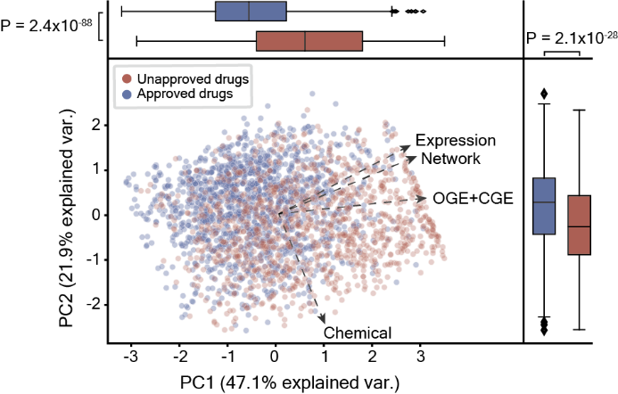
Fig. S10 Principal components analysis (PCA). PCA plot showing the four predicted approval probabilities for various information (OGE+CGE, Network, Expression, and Chemical) projected onto the first two principal components. Dots correspond to unapproved (red) and approved drugs (blue). Vectors indicate the direction of the predicted probability for each drug. CGE, cellular gene essentiality; OGE, organismal gene essentiality.

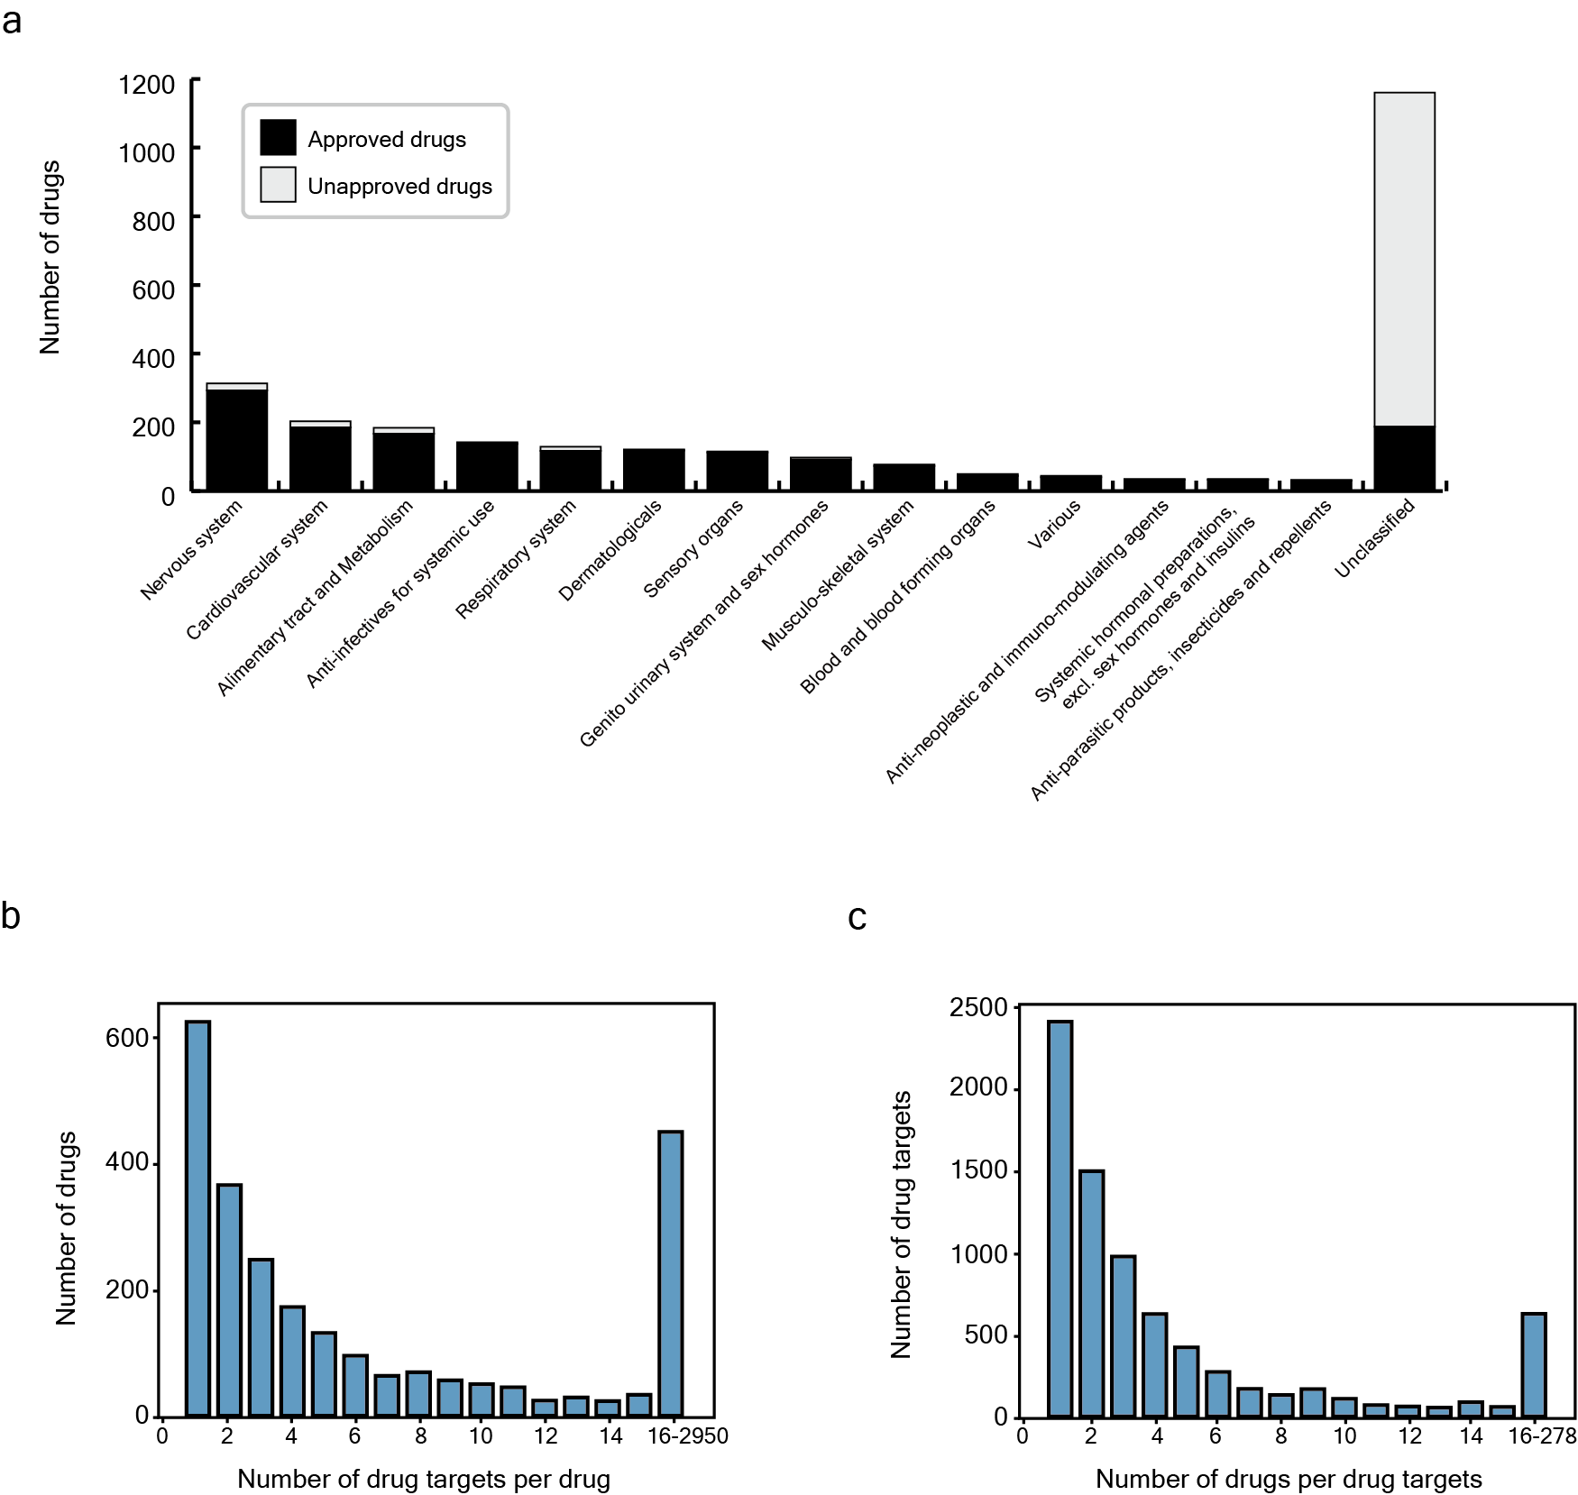
Fig. S11 Drug and target statistics. (a) The number of drugs by Anatomical Therapeutic Chemical code (ATC code). Black and gray bars represent the number of approved and unapproved drugs, respectively. (b–c) Histogram showing the statistics for drug-target relationships.

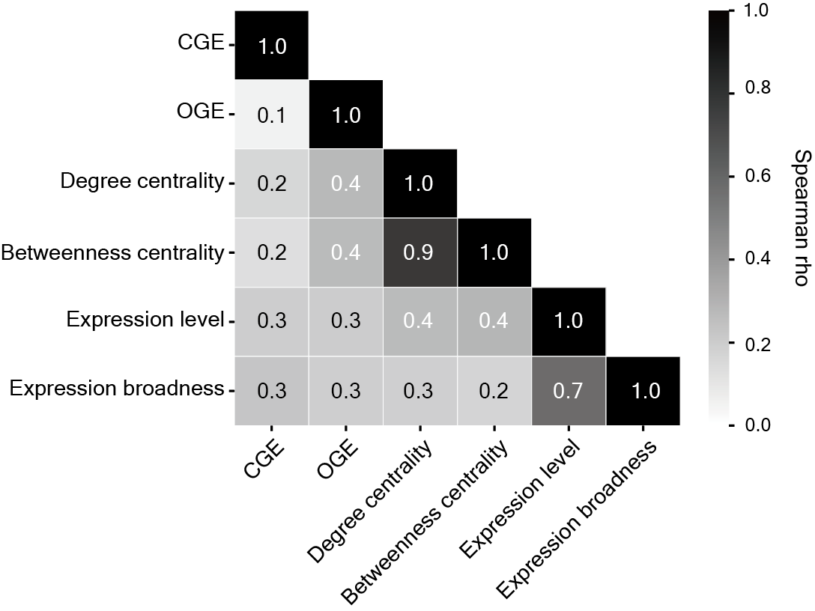
Fig. S12 Correlation between features. Pairwise correlations were calculated by Spearman rank correlation. The values denoted correlation coefficients.

