Supplementary Table 1. Comparison of postoperative variables
Variables |  | ITM  (n=154) | Control (n=142) | P-value
Hemodynamics
Use of vasopressor/inotropic use | POD0 | 14(9.1) | 10(7.0) | 0.519
 | POD1 | 7(4.5) | 2(1.4) | 0.176
 | POD2 | 5(3.2) | 3(2.1) | 0.725
 | POD3 | 1(0.6) | 0(0.0) | 1.000
Use of antihypertensive agents | POD0 | 48(31.2) | 55(38.7) | 0.172
 | POD1 | 72(46.8) | 67(47.2) | 0.941
 | POD2 | 90(58.4) | 86(60.6) | 0.710
 | POD3 | 93(60.4) | 92(64.8) | 0.435
Hypotensive eventª | POD0 | 0(0.0) | 0(0.0) | 1.000
 | POD1 | 1(0.6) | 1(0.7) | 1.000
 | POD2 | 1(0.6) | 2(1.4) | 0.609
 | POD3 | 0(0.0) | 0(0.0) | 1.000
Nausea/vomiting
Total metoclopramide (mg) | POD0 | 0[0-0] | 0[0-0] | 0.168
 | POD1 | 0[0-0] | 0[0-0] | 0.508
 | POD2 | 0[0-0] | 0[0-0] | 0.063
 | POD3 | 0[0-0] | 0[0-0] | 0.283
Use of other anti-emetic agents | POD0 | 8(5.2) | 0(0.0) | 0.007*
 | POD1 | 8(5.2) | 3(2.1) | 0.161
 | POD2 | 1(0.6) | 1(0.7) | 1.000
 | POD3 | 1(0.6) | 2(1.4) | 0.609
Pruritis
Total chlorpheniramine (mg) | POD0 | 0[0-0] | 0[0-0] | 0.089
 | POD1 | 4[0-4] | 4[0-4] | 0.169
 | POD2 | 4[0-4] | 4[0-4] | 0.376
 | POD3 | 0[0-0] | 0[0-0] | 0.010*
Use of other anti-pruritic agents | POD0 | 1(0.6) | 0(0.0) | 1.000
 | POD1 | 2(1.3) | 1(0.7) | 1.000
 | POD2 | 0(0.0) | 1(0.7) | 0.480
 | POD3 | 0(0.0) | 0(0.0) | 1.000
Recovery
Time to extubation^{b} (min) |  | 0[0-0] | 0[0-0] | 0.544
Re-operation for any reason |  | 6(3.9) | 2(1.4) | 0.286
Unplanned re-admission to ICU |  | 3(1.9) | 1(0.7) | 0.624
Re-intubation |  | 0(0.0) | 1(0.7) | 0.480
Postoperative dialysis within admission |  | 0(0.0) | 1(0.7) | 0.480
Length of hospital stay (days) |  | 21[17-27.25] | 21[17-26.25] | 0.992
Length of ICU stay (days) |  | 3[2-3] | 3[2-4] | 0.154
ICU stay > 3 days |  | 29(18.8) | 37(26.1) | 0.136
Major adverse cardiac & cerebrovascular event^{c} |  | 0(0.0) | 2(1.4) | 0.229
Values are median[interquartile range] or number of patients(%). ICU, intensive care unit; POD, postoperative day. ªHypotensive event is defined as systolic blood pressure<90mmHg or mean blood pressure<60mmHg. ^{b}Time to extubation is defined as minutes passed from the admission to intensive care unit to extubation. If extubated in operating room, it is counted as zero. ^{c}All-cause mortality, cerebro-vascular accident, myocardial infarction, any repeat revascularization.

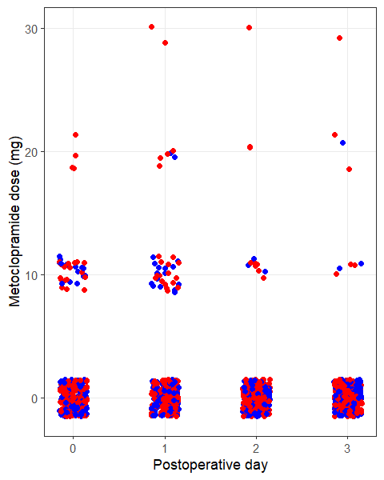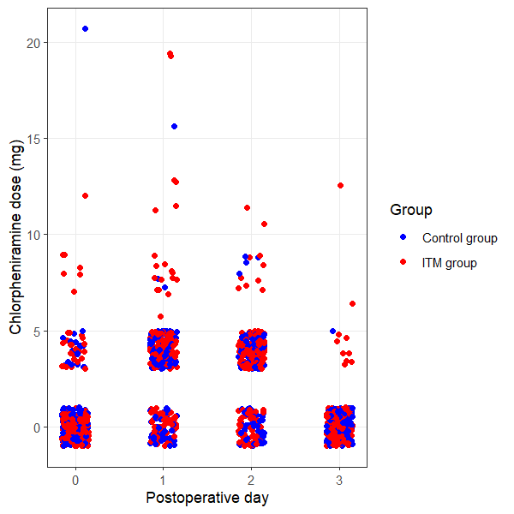
Supplementary Figure 1. Postoperative use of metoclopramide and chlorpheniramine

Supplementary Table 2. Comparison of graft function
Variables |  | ITM (n=154) | Control (n=142) | P-value
BUN (mg/dL) | POD0 | 27.55[19.60-40.40] | 29.80[21.88-37.93] | 0.504
 | POD1 | 17.00[12.53-22.53] | 17.55[13.20-22.03] | 0.795
 | POD2 | 15.60[11.00-19.53] | 16.10[11.88-22.85] | 0.242
 | POD3 | 15.95[11.93-20.18] | 17.00[12.75-23.20] | 0.112
Creatinine (mg/dL) | POD0 | 3.79[2.86-4.92] | 4.29[3.11-5.54] | 0.036
 | POD1 | 1.53[1.14-2.08] | 1.70[1.13-2.52] | 0.124
 | POD2 | 1.07[0.79-1.36] | 1.20[0.80-1.66] | 0.045
 | POD3 | 0.96[0.73-1.18] | 1.07[0.78-1.43] | 0.023
Estimated GFR, (mL/min/1.73m²) | POD0 | 15.40[11.18-21.30] | 14.50[10.08-18.60] | 0.053
 | POD1 | 44.70[33.20-60.10] | 40.40[27.98-57.15] | 0.100
 | POD2 | 68.80[53.43-87.33] | 61.60[44.88-85.98] | 0.035
 | POD3 | 77.50[63.38-94.08] | 70.85[53.30-70.85] | 0.017
Cellular rejection on biopsyª |  | 26(19.4) | 21(16.7) | 0.567
Values are median [interquartile range] or number of patients(%). BUN, blood urea nitrogen; GFR, glomerular filtration rate, POD, postoperative day. ªSome recipients did not receive kidney biopsy at the discretion of clinician (e.g., bleeding risk due to anticoagulant consumption). After exclusion of patients without biopsy results, the total number of patients for each group is 134 for ITM and 126 for control group.

Supplementary Table 3. Characteristics and short-term outcomes of delirious patients
Variables | Delirious  (n=14) | Non-delirious (n=282) | P-value
Age (yr) | 54.50[48.75-61.50] | 50[41-57] | 0.044*
Sex (male) | 8(57.1) | 173(61.3) | 0.753
BMI (kg/m²) | 25.46[21.49-26.93] | 22.99[20.75-25.91] | 0.148
Charlson Comorbidity Index | 0.5[0-1.5] | 0[0-1] | 0.387
Intrathecal morphine | 4(28.6) | 150(53.2) | 0.072
Cumulative NRS (POD 0-1) | 8[2.75-10.50] | 6[0.75-10] | 0.431
Cumulative opioid (POD 0-3) (IV MED mg) | 15[9.06-44.38] | 10[5-20] | 0.062
Days of sedative use | 0[0-2.25] | 0[0-0] | 0.012*
Number of sedative types used | 0[0-1.25] | 0[0-0] | 0.008*
Days of antipsychotic use | 1.5[0-3] | 0[0-1] | 0.005*
Number of antipsychotic types used | 1[0-2] | 0[0-1] | 0.004*
Re-operation for any reason | 0(0) | 8(2.8) | 1.00
Re-admission to ICU | 0(0) | 4(1.4) | 1.00
Postoperative dialysis within admission | 0(0) | 1(0.4) | 1.00
Length of hospital stay (days) | 18.5[16.75-25.75] | 21[17-27] | 0.329
Length of ICU stay (days) | 2.5[2-3] | 3[2-3] | 0.164
Major adverse cardiac & cerebrovascular event | 0(0) | 2(0.7) | 1.00
Cellular rejection on biopsy | 2(15.4) | 45(18.2) | 1.00
Values are median [interquartile range] or number of patients(%). NRS, numerical rating scale; POD, postoperative day. Asterisks (*) indicate statistically significant difference at P-value < 0.05.

