Supplementary Information for

The tropical Atlantic as a negative feedback on ENSO

Ingo Richter¹, Yu Kosaka², Hiroki Tokinaga³, Shoichiro Kido¹
¹Application Laboratory, Research Institute for Value-Added-Information Generation, Japan Agency for Marine-Earth Science and Technology, Yokohama, Japan
²Research Center for Advanced Science and Technology, University of Tokyo, Tokyo, Japan
³Research Institute for Applied Mechanics, Kyushu University, Kasuga, Japan

Climate Dynamics

Corresponding author address:
Ingo Richter
Application Laboratory, JAMSTEC, 3173-25 Showa-machi, Kanazawa-ku, Yokohama, Kanagawa 236-0001, Japan
E-mail: richter@jamstec.go.jp

Tables

Supplementary Table 1 | CMIP6 models used in Supplementary Fig. 1.
Model name | Country/ Territory | Atmospheric model | Ocean model | # Years
ACCESS-CM2 | Australia | UM 10.6, GA 7.1 config | MOM5 | 500
ACCESS-ESM1-5 | Australia | UM 7.3 | MOM5 | 1000
AWI-CM-1-1-MR | Germany | ECHAM6.3.04p1 | FESOM 1.4 | 500
BCC-CSM2-MR | China | BCC_AGCM3_MR | MOM4 | 600
BCC-ESM1 | China | BCC_AGCM3_LR | MOM4 | 451
CAMS-CSM1-0 | China | ECHAM5_CAMS | MOM4 | 250
CanESM5 | Canada | CanAM5 | NEMO3.4.1 | 1000
CESM2-WACCM | USA | CAM6 | POP2 | 499
CESM2 | USA | CAM6 | POP2 | 1200
CIESM | China | CAM5 | POP2 | 500
CMCC-ESM2 | Italy | CAM5 | NEMO3.6 | 500
CNRM-CM6-1-HR | France | Arpege 6.3 | NEMO3.6 | 300
CNRM-CM6-1 | France | Arpege 6.3 | NEMO3.6 | 500
CNRM-ESM2-1 | France | Arpege 6.3 | NEMO3.6 | 500
E3SM-1-0 | USA | EAM v1.0 | MPAS-Ocean v6 | 500
E3SM-1-1 | USA | EAM v1.1 | MPAS-Ocean v6 | 165
EC-Earth3-Veg | European countries | IFS cy36r4 | NEMO3.6 | 500
EC-Earth3 | European countries | IFS cy36r4 | NEMO3.6 | 501
FGOALS-f3-L | China | FAMIL2.2 | LICOM3.0 | 561
FGOALS-g3 | China | GAMIL2 | LICOM3.0 | 700
GISS-E2-1-G-CC | USA | GISS-E2.1 | GISS Ocean | 165
GISS-E2-1-G | USA | GISS-E2.1 | GISS Ocean | 851
GISS-E2-1-H | USA | GISS-E2.1 | HYCOM Ocean | 401
HadGEM3-GC31-LL | UK | MetUM-HadGEM3-GA7.1 | NEMO-HadGEM3-GO6.0 | 500
HadGEM3-GC31-MM | UK | MetUM-HadGEM3-GA7.1 | NEMO-HadGEM3-GO6.0 | 500
ICON-ESM-LR | Germany | ICON-A | ICON-O | 500
IITM-ESM | India | IITM-GFSv1 | MOM4.1 | 200
INM-CM5-0 | Russia | INM-AM5-0 | INM-OM5 | 1201
IPSL-CM6A-LR | France | LMDZ | NEMO-OPA | 1200
KACE-1-0-G | South Korea | MetUM-HadGEM3-GA7.1 | MOM4.1 | 150
KIOST-ESM | South Korea | GFDL-AM2.0 | MOM5 | 150
MCM-UA-1-0 | USA | R30L14 | MOM1.0 | 500
MIROC-ES2L | Japan | CCSR AGCM | COCO4.9 | 500
MIROC6 | Japan | CCSR AGCM | COCO4.9 | 800
MPI-ESM1-2-HR | Germany | ECHAM6.3 | MPIOM1.63 | 500
MRI-ESM2-0 | Japan | MRI-AGCM3.5 | MRI.COM4.4 | 401
NESM3 | China | ECHAM v6.3 | NEMO3.4 | 500
NorCPM1 | Norway | CAM-OSLO4.1 | MICOM1.1 | 500
NorESM1-F | Norway | CAM4 | MICOM | 200
NorESM2-LM | Norway | CAM-OSLO | MICOM | 501
SAM0-UNICON | Republic of Korea | CAM5.3 with UNICON | POP2 | 400
TaiESM1 | Taiwan | TaiAM1 | POP2 | 500
UKESM1-0-LL | UK | MetUM-HadGEM3-GA7.1 | NEMO-HadGEM3-GO6.0 | 750

Figures

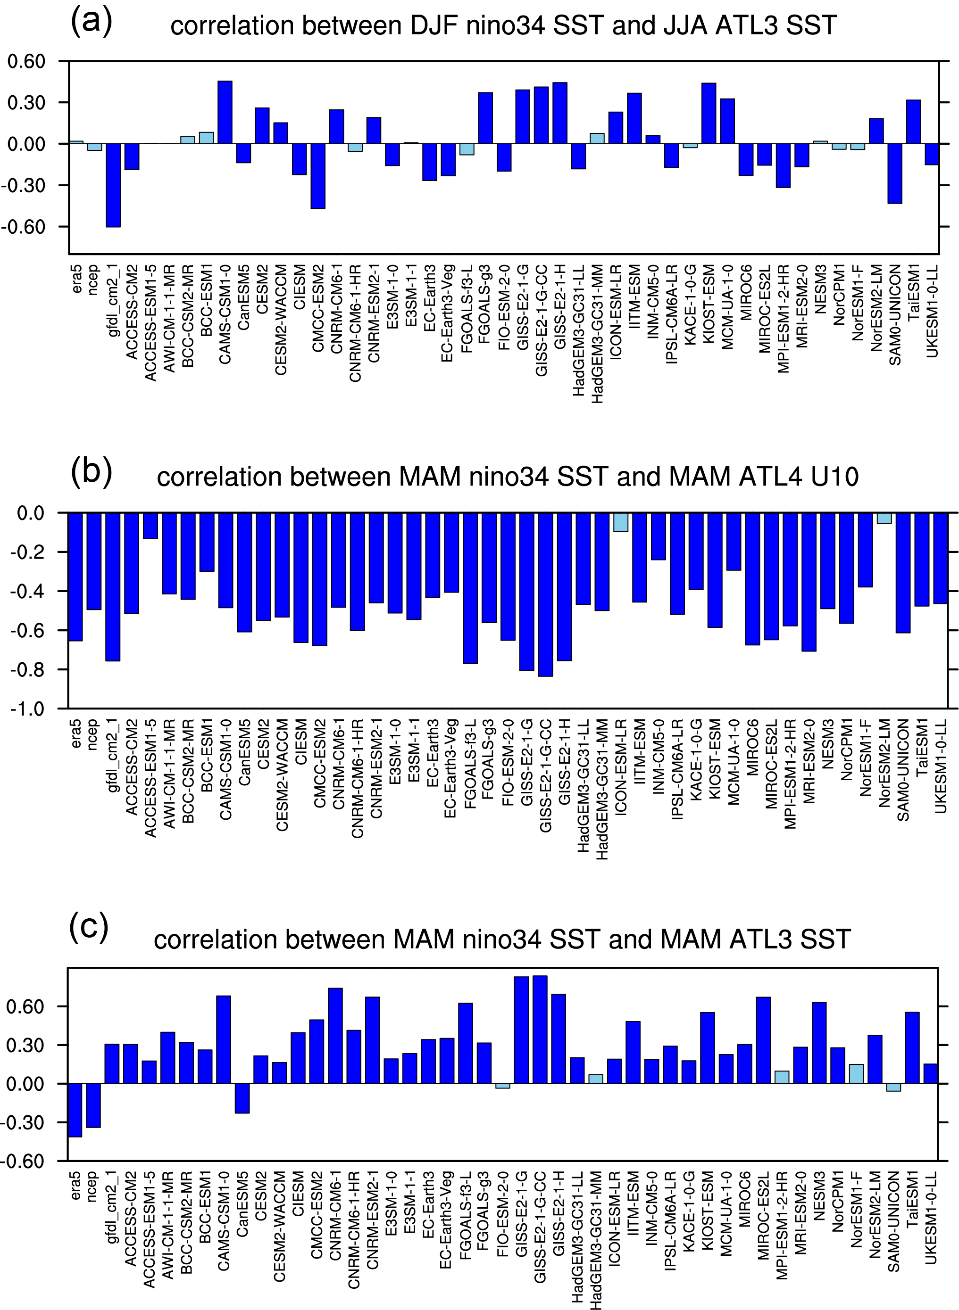

Supplementary Figure 1. Correlations between Pacific and Atlantic indices for ERA-5, NCEP/NCAR Reanalysis, and the GFDL CM2.1 CTRL0 simulation (first three bars from the left), as well as a set of 44 piControl simulations from CMIP6, as indicated by the x-axis labels. Correlations significant at the 95% value are shaded in dark blue, other values in light blue. The panels show the correlations of (a) DJF Niño 3.4 SST with subsequent JJA ATL3 SST, (b) MAM Niño 3.4 SST with MAM ATL4 near-surface zonal winds, and (c) MAM Niño 3.4 SST with MAM ATL3 SST. All indices are linearly detrended prior to calculating the correlation.

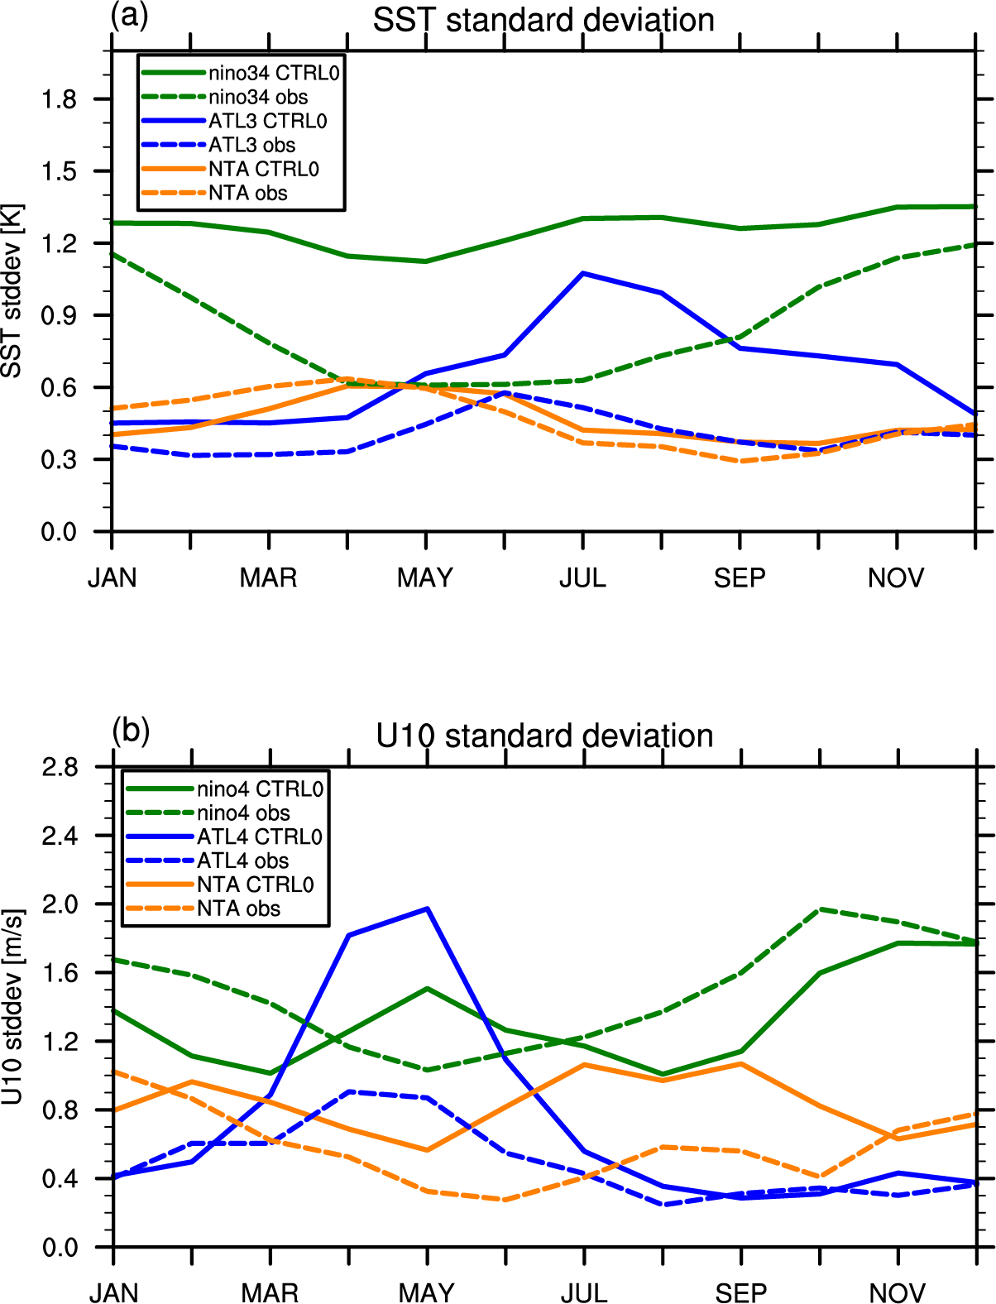

Supplementary Figure 2. Seasonally stratified standard deviations for the GFDL CM2.1 experiment CTRL0 (solid lines) and the ERA-5 reference (dashed lines) for (a) SST (K) in the Niño 3.4 (green line), ATL3 (blue line), and NTA (orange line), and (b) near-surface zonal wind (m/s) in the Niño 4 (green line), ATL4 (blue line), and NTA (orange line).

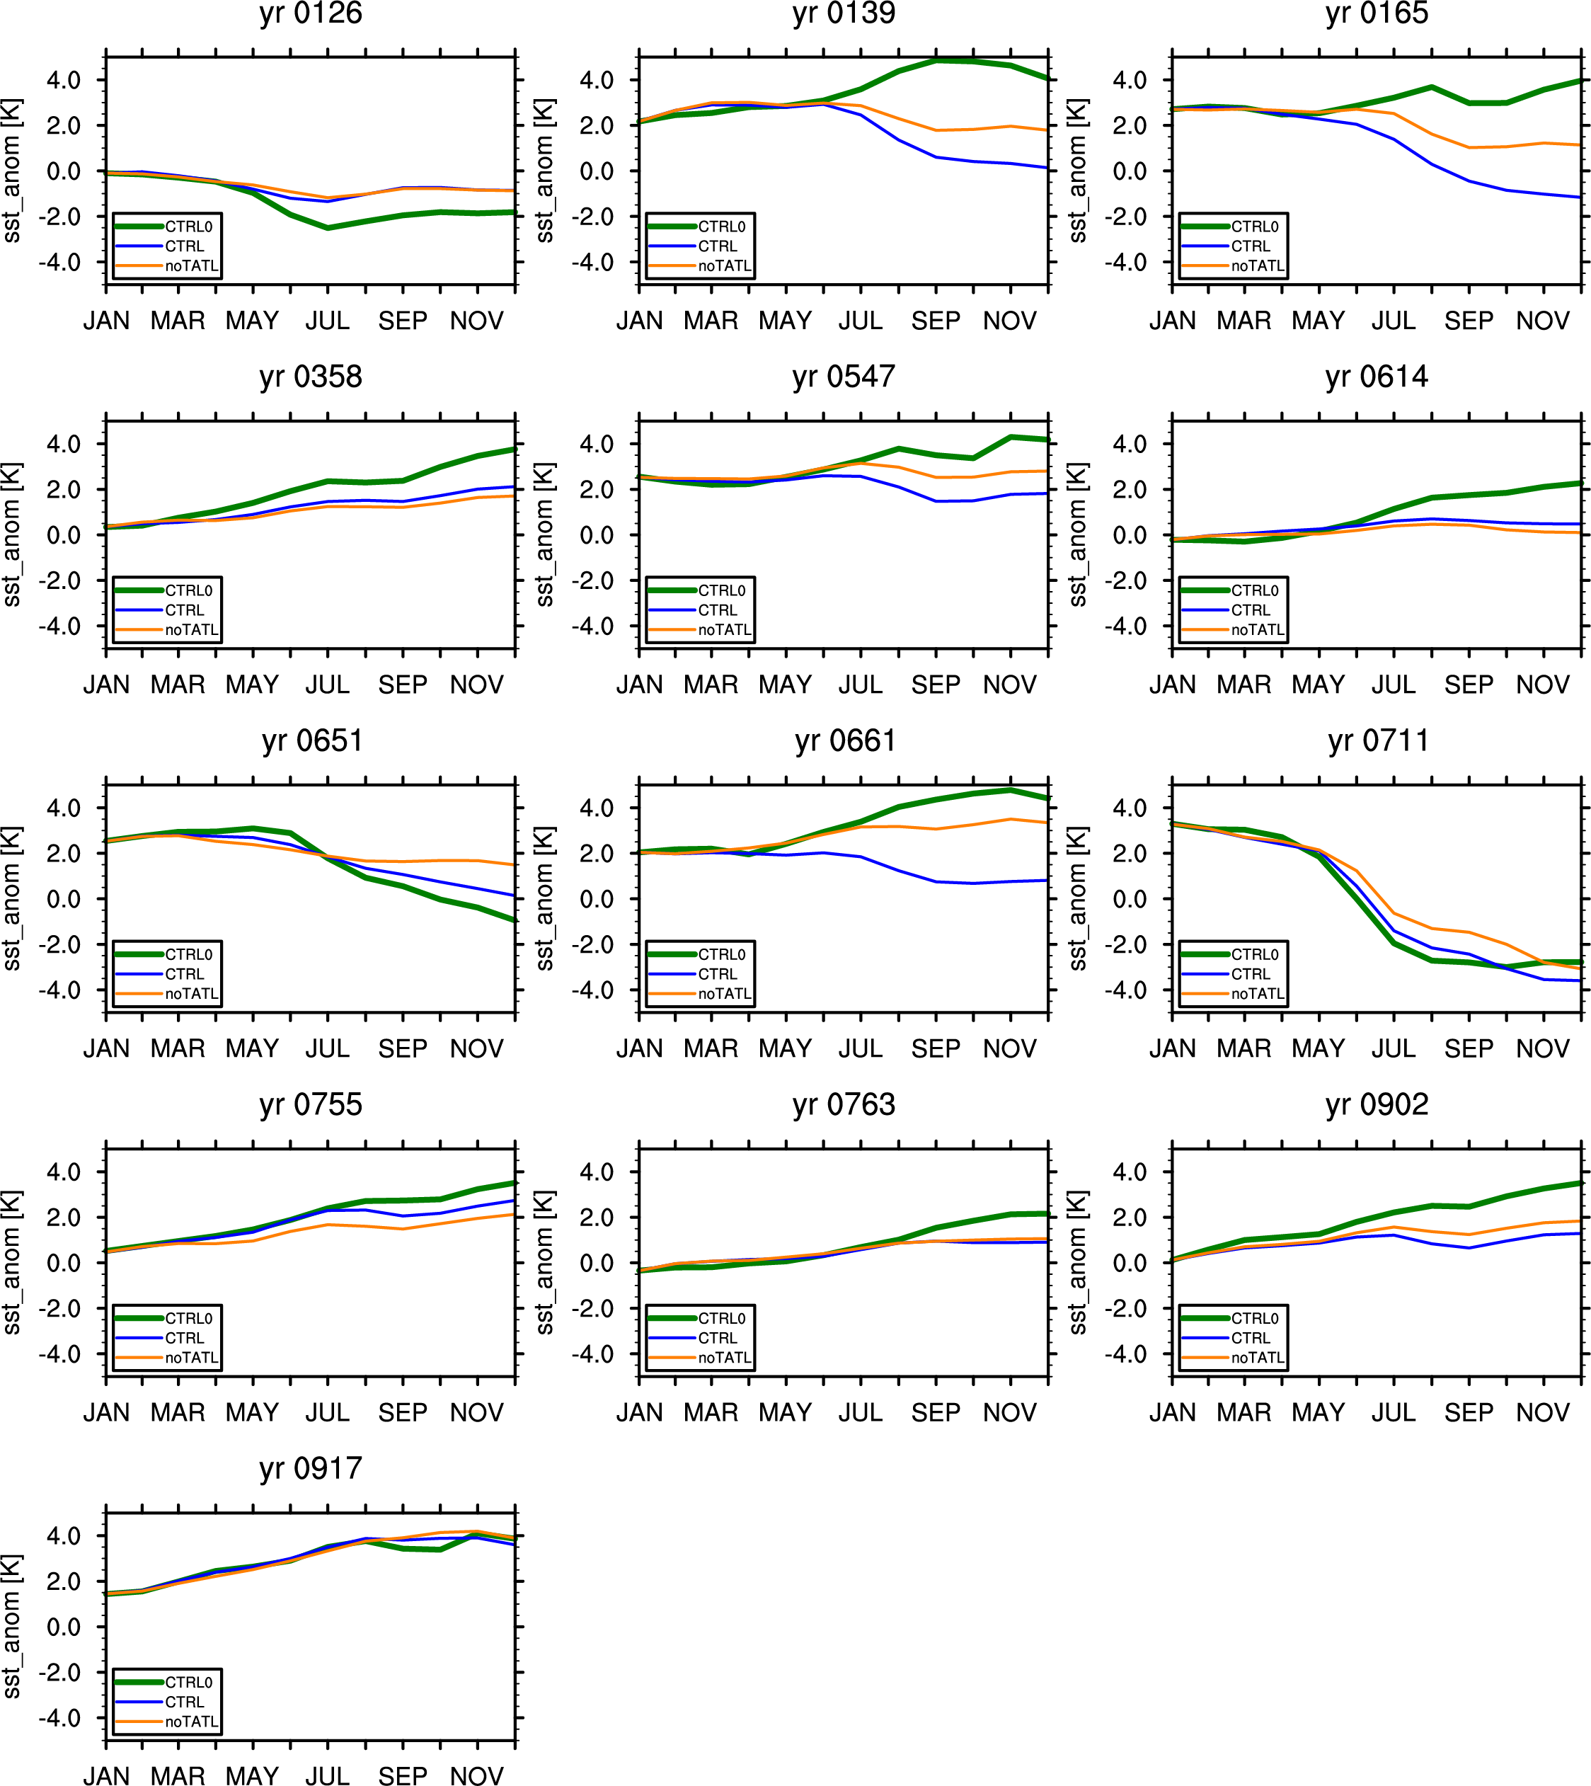

Supplementary Figure 3. Evolution of the Niño 3.4 index (K) in CTRL0 (green line), CTRL (blue line), and noTATL (orange line) for all initialization years. All predictions run from January 1 to December 31. For CTRL0, the free-running control simulation, the lines represent a single realization, while for CTRL and noTATL, the perfect model hindcast experiments, the lines represent the 20-member ensemble average. The prediction year is indicated at the top of each panel.

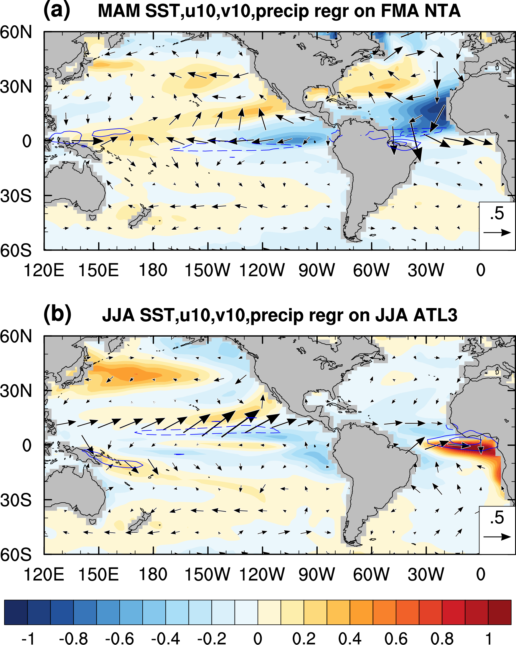

Supplementary Figure 4. Like Fig. 2 in the main text but with all values shown regardless of statistical significance.

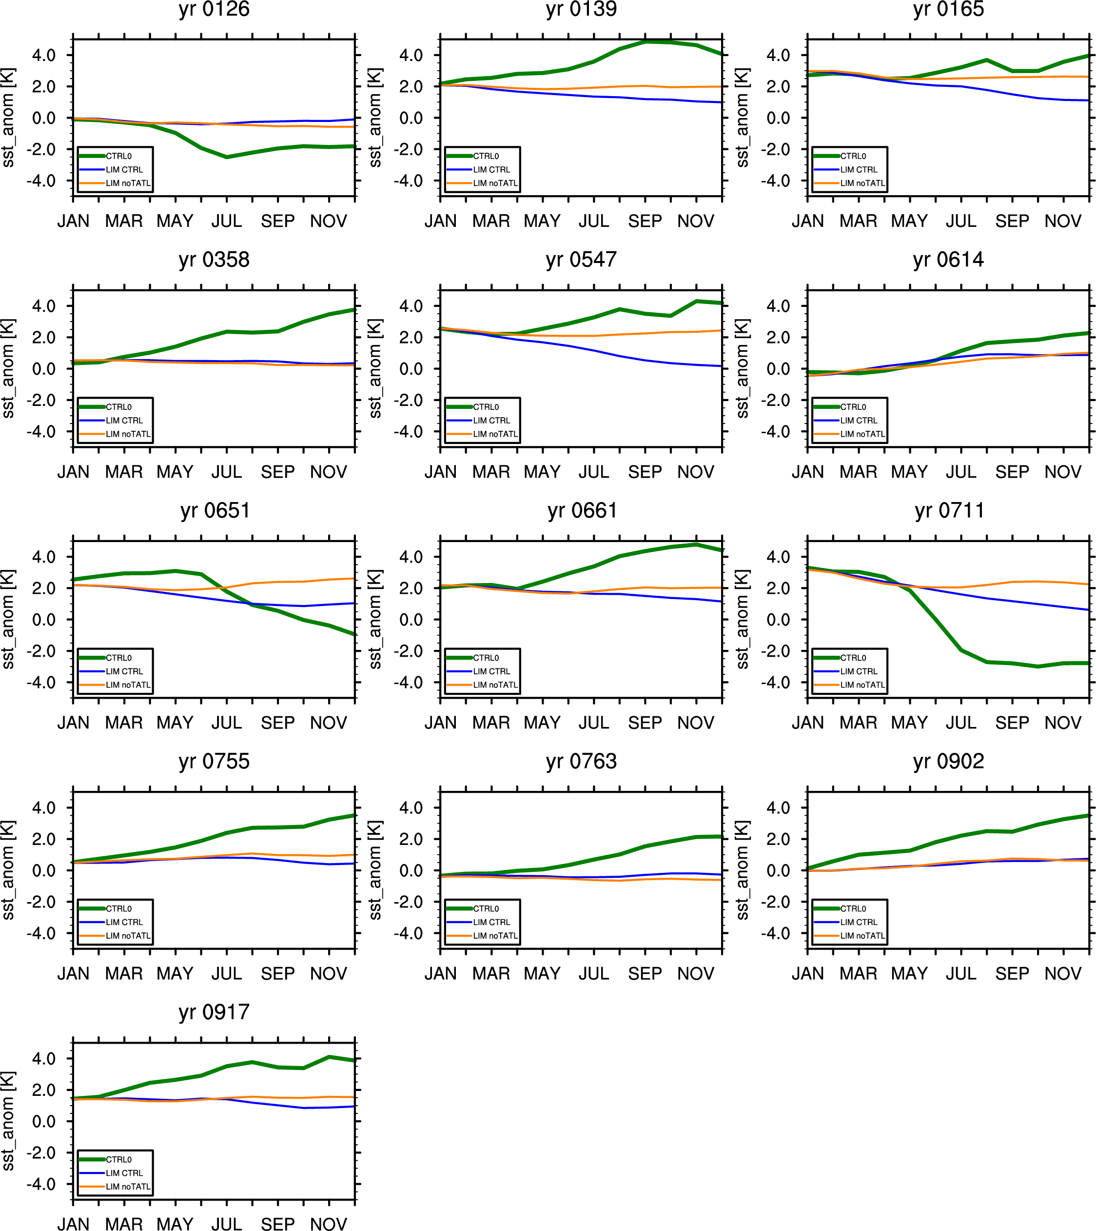

Supplementary Figure 5. Like Supplementary Fig. 3, but with the blue and orange lines showing LIM CTRL and LIM noTATL, respectively.

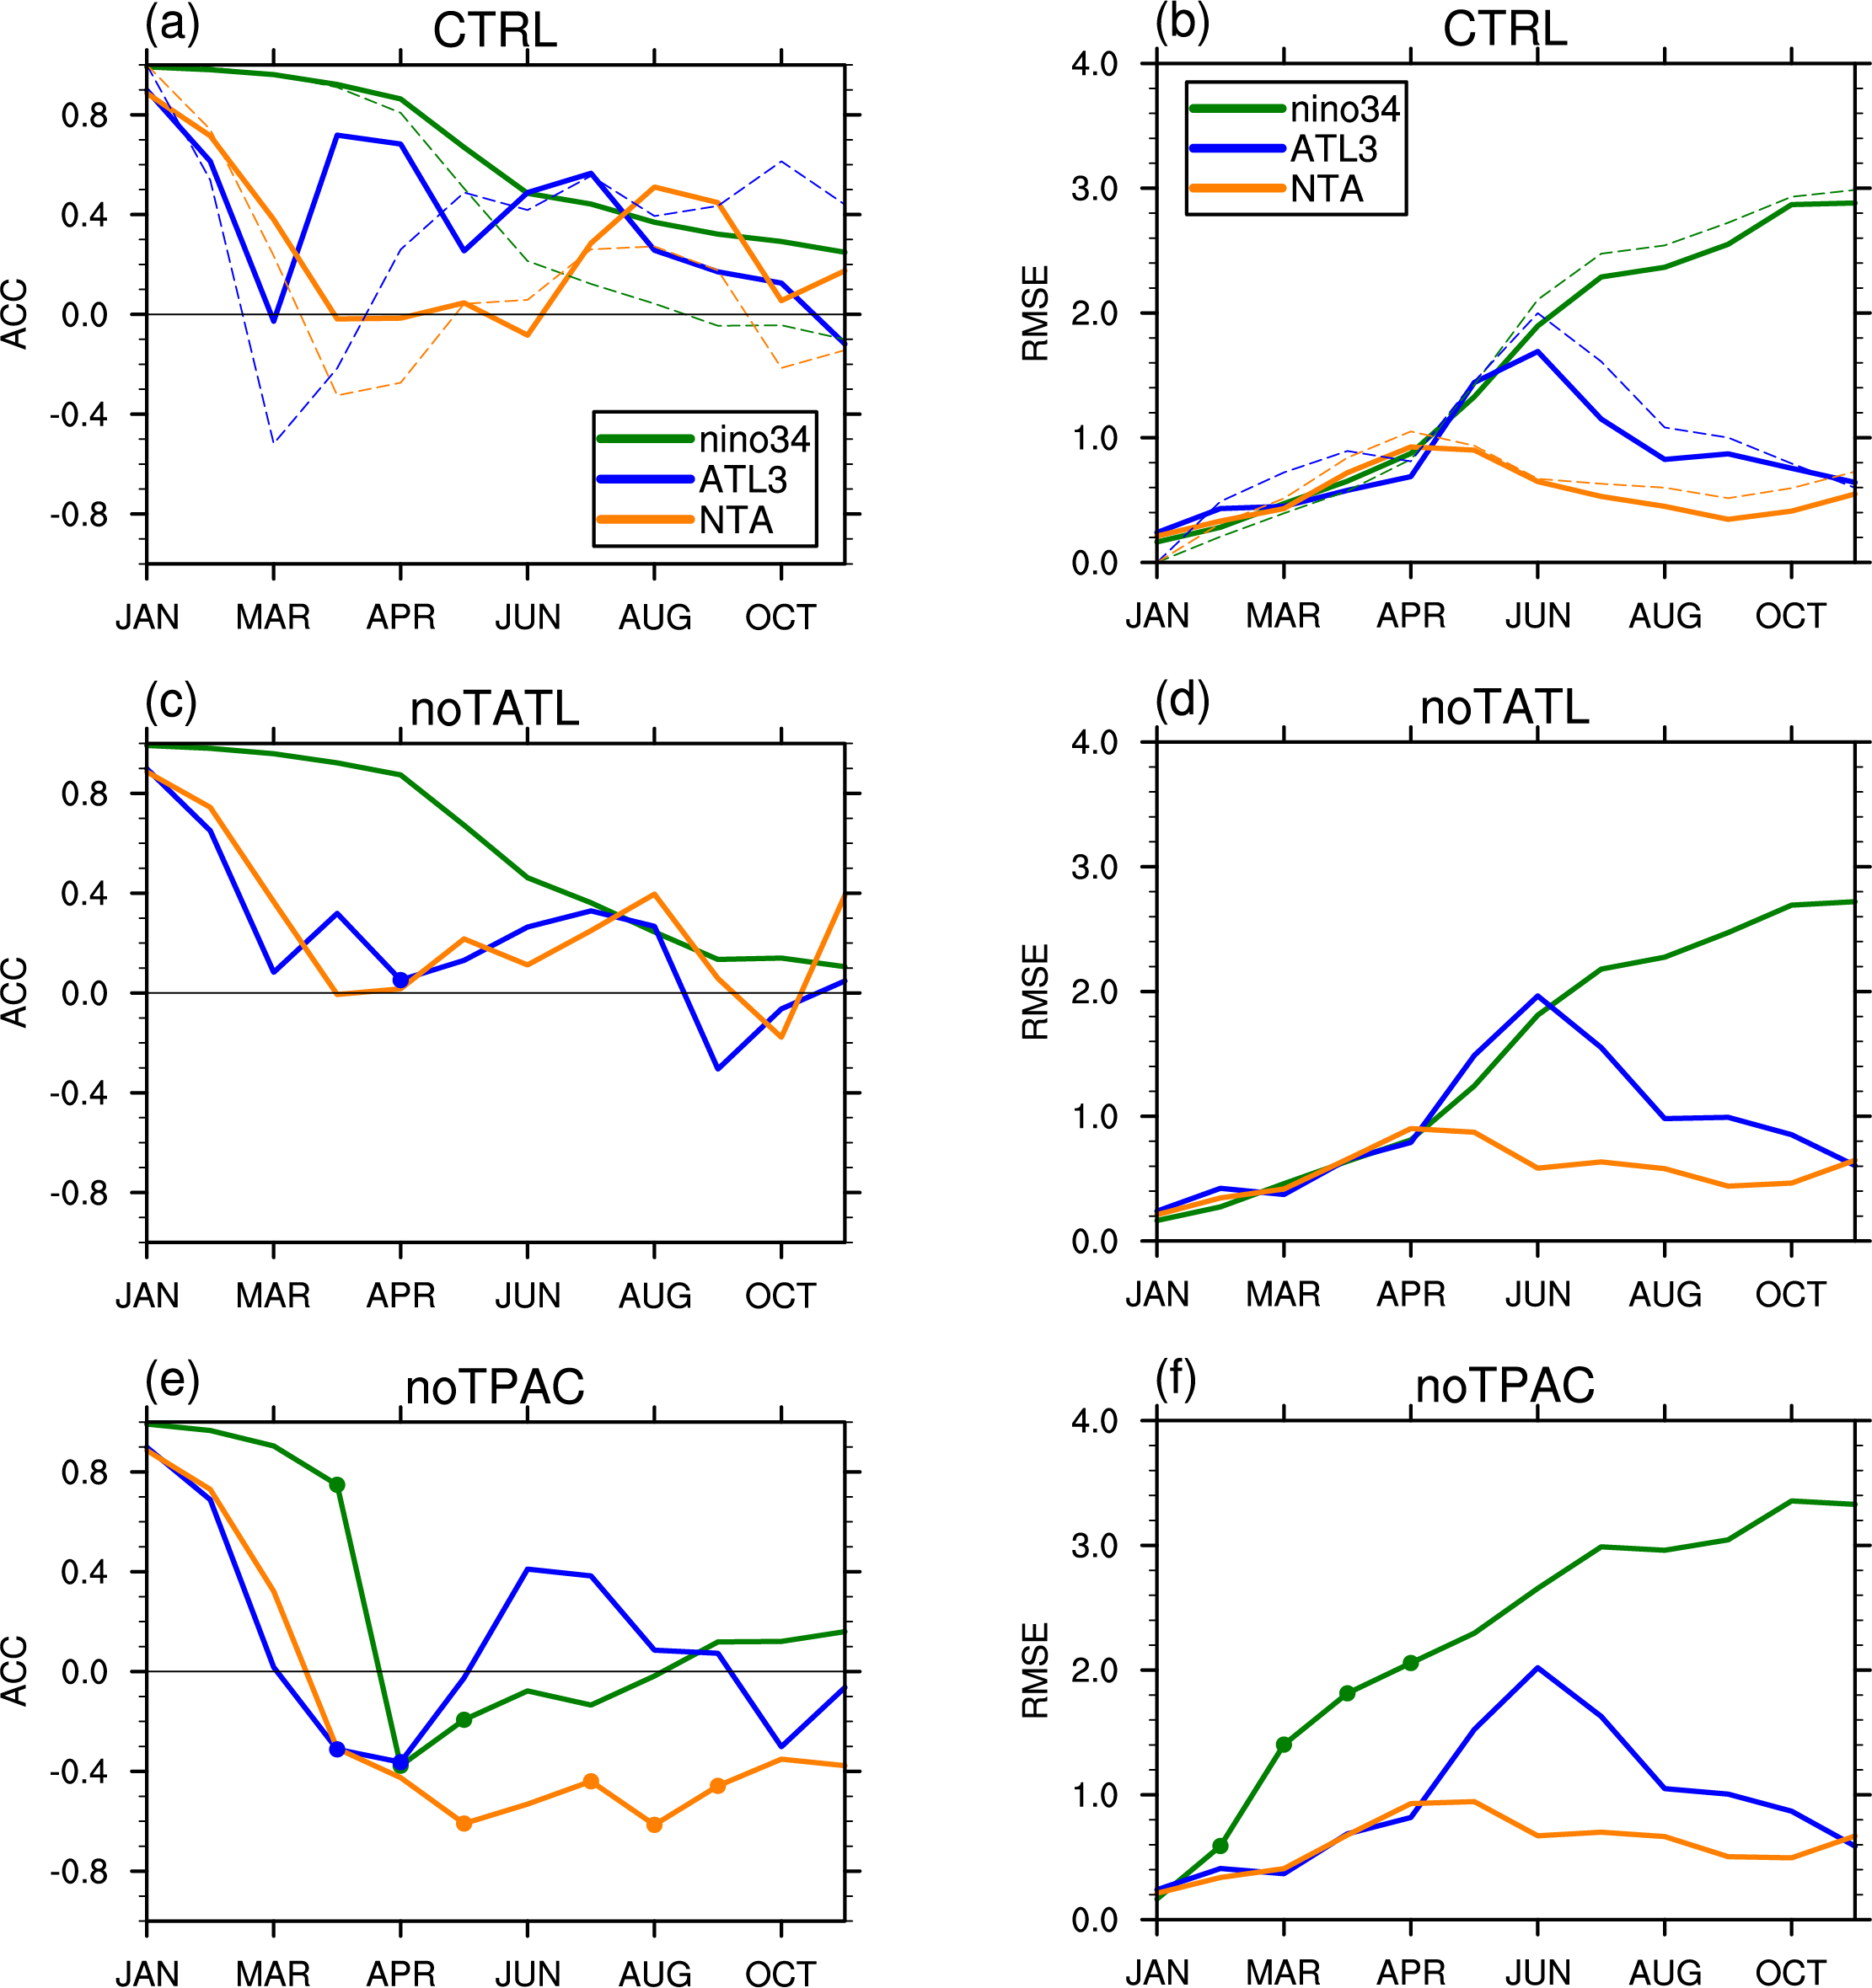

Supplementary Figure 6. a, c, e Like Fig. 9a, c, e, but for the LIM predictions. b, d, f Like Fig. 10a, c, e, but for the LIM predictions.

