Supporting Information
Disinfectant Stress Enhances Prokaryotic Symbiosis with Lysogenic Phages and Defense Systems Against Detrimental Phage Infection
Dan Huang¹, Juhong Chen², Zhou Jason Shi3, Jingqing Liu⁴, Pedro J.J. Alvarez⁵, Pingfeng Yu^{1,*}
¹ College of Environmental and Resource Sciences, Zhejiang University, Hangzhou, 310085, China
² Department of Biological Systems Engineering, Virginia Tech, Blacksburg, 24061, USA
³ Gladstone institutes, UCSF, San Francisco, 94158, USA
⁴College of Engineering and Architecture, Zhejiang University, Hangzhou, 310058, China
⁵ Department of Civil and Environmental Engineering, Rice University, Houston, 77005, USA
* Corresponding Author:
Pingfeng Yu
Email: yupf@zju.edu.cn
ORCID: 0000-0003-0402-773X
This supporting information includes 12 figures.
Fig. S1 Alpha diversity of phage communities in DWDS.
Fig. S2 Alpha diversity of prokaryotic communities in DWDS.
Fig. S3 Beta diversity of viral communities (PCoA) in DWDS.
Fig. S4 Beta diversity of prokaryotic communities (PCoA) in DWDS.
Fig. S5. Correlation between the concentration of residual chlorine and virus community abundance and type distribution.
Fig. S6 The prokaryotic composition in genus level in different DWDS.
Fig. S7 The proportion of broad and narrow host range phages predicted based on IMG/VR database and local DWDS metagenomic data.
Fig. S8 Relative abundance of AMGs associated with disinfectant detoxification in DWDS.
Fig. S9 Differential enrichment of prokaryotic metabolic genes related to biofilm formation, disinfectant resistance and nutrient metabolism between the two DWDS.
Fig. S10 correlation between antiviral system and virus community abundance and type distribution.
Fig. S11 The relative abundance of prokaryotic contigs with different RM subtype systems among all microbial contigs in DWDS.
Fig. S12 Correlation between subtypes of prokaryotic RM, CRISPR-Cas and BREX system, and virus community abundance and type distribution.
Fig. S13 The number of spacers per prokaryotic contig carrying CRISPR-Cas system in DWDS.

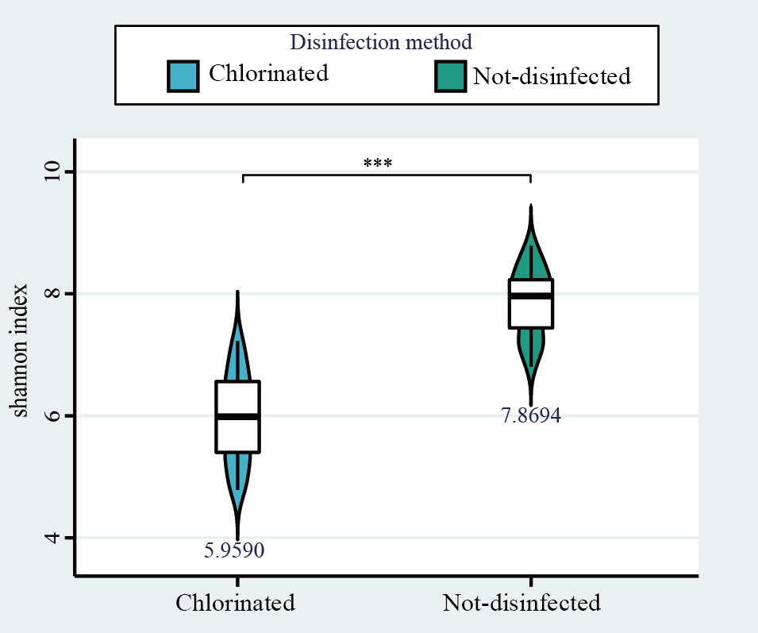
Figure S1. Alpha diversity of phage communities in DWDS with and without disinfectant. Asterisks (***) represent significant difference (P < 0.0001) based on Student’s T test.

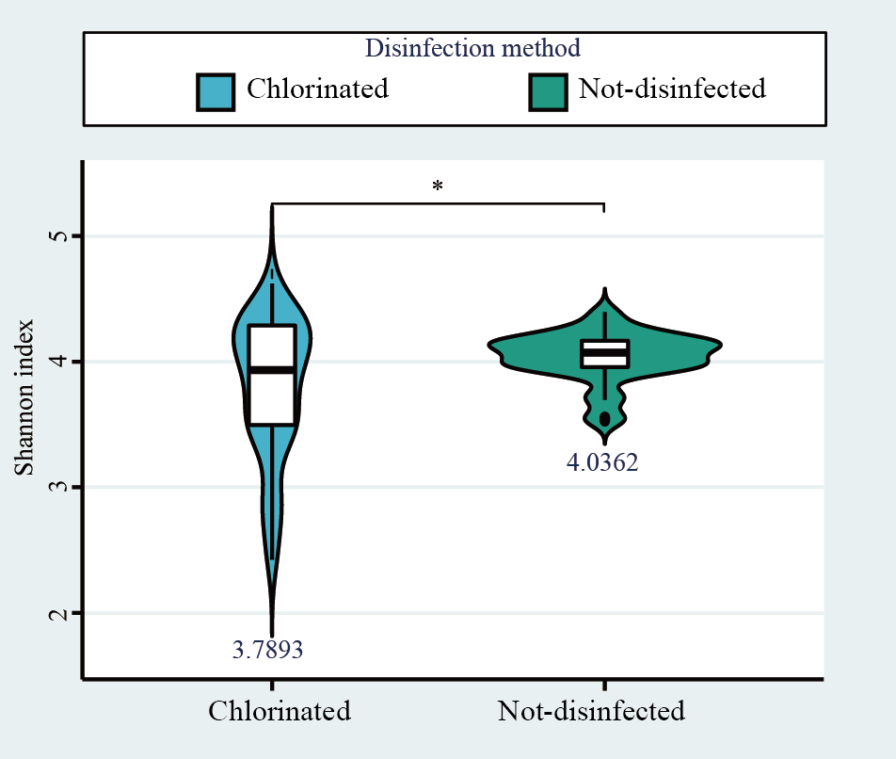
Figure S2. Alpha diversity of prokaryotic communities in DWDS with and without disinfectant. Asterisk (*) represents significant difference (P < 0.01) based on Student’s T test.

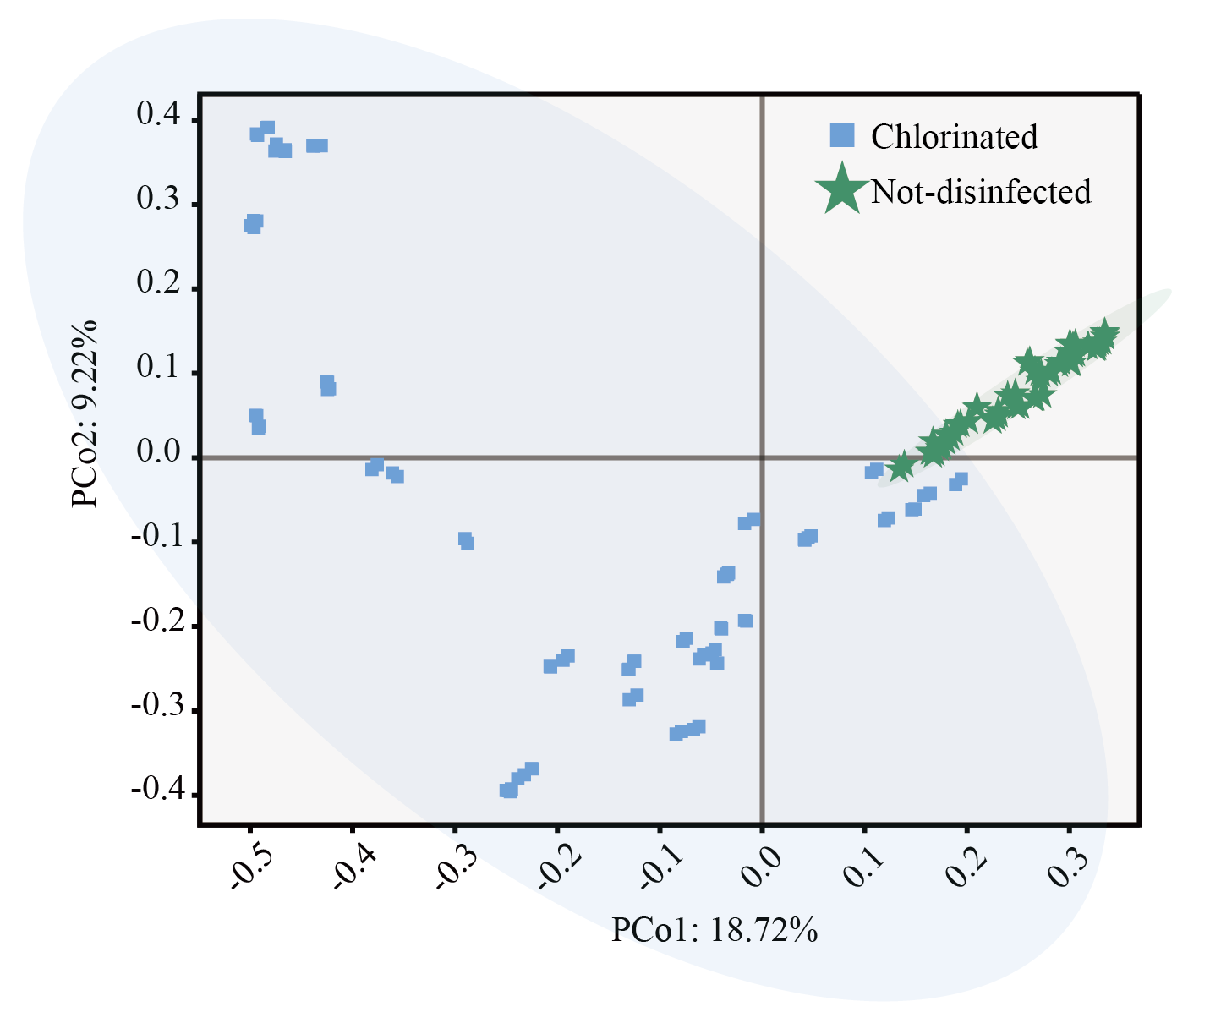
Figure S3. Beta diversity of phage communities (PCoA) in DWDS with and without residual disinfectant. PCo1 is 18.72% and PCo2 is 9.22% based on Bray-Curtis distance.

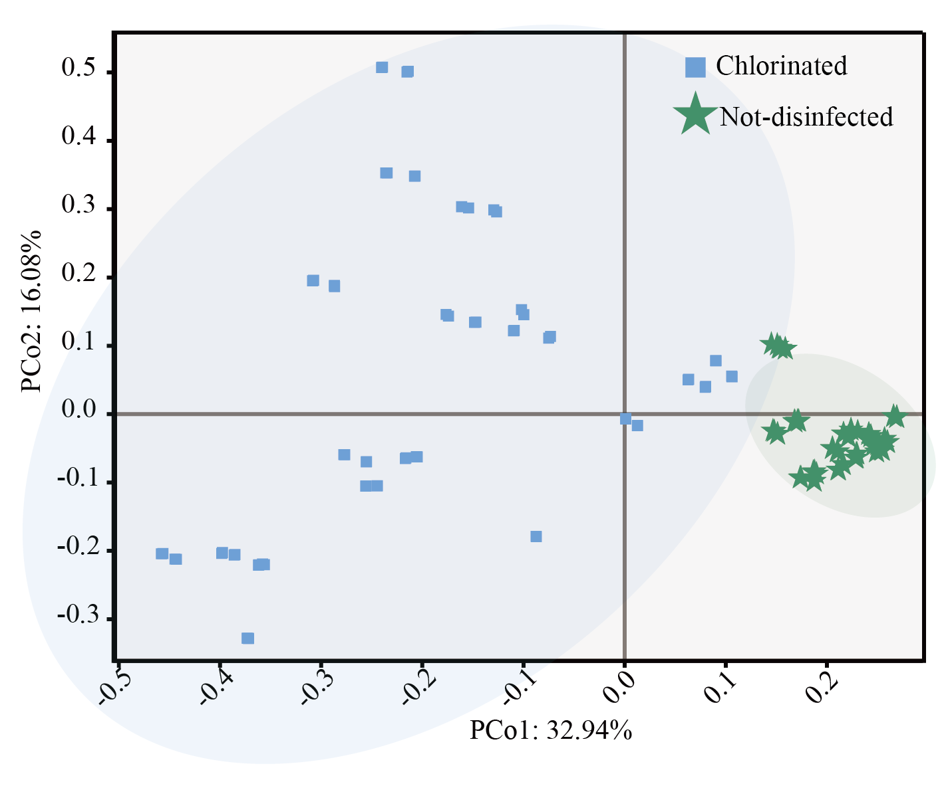
Figure S4. Beta diversity of prokaryotic communities (PCoA) in DWDS with and without residual disinfectant. PCo1 is 32.94% and PCo2 is 16.08% based on Bray-Curtis distance.
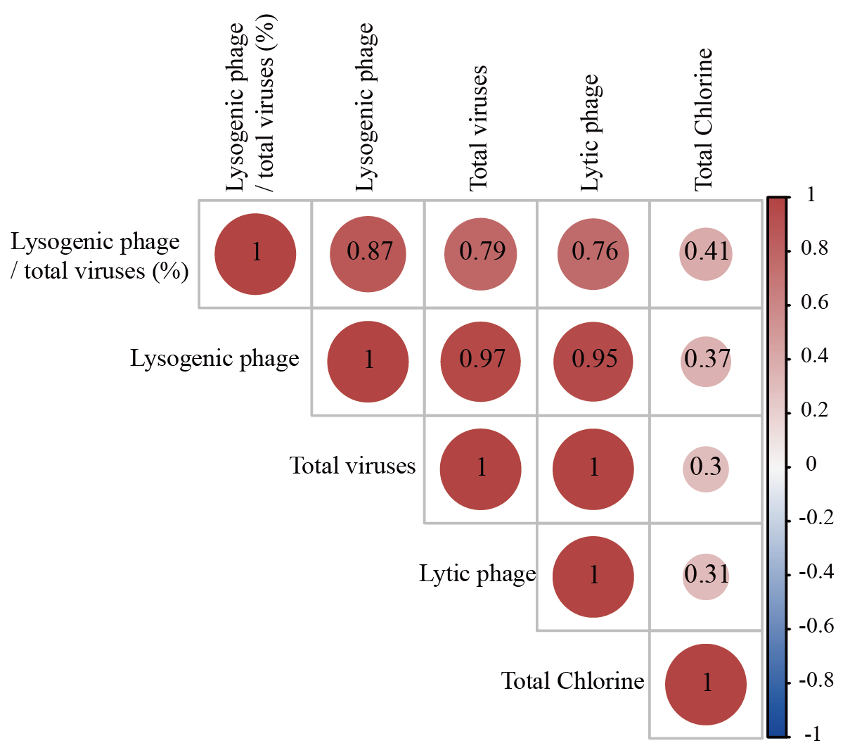
Figure S5. Correlation between the concentration of residual chlorine and virus community abundance and type distribution.

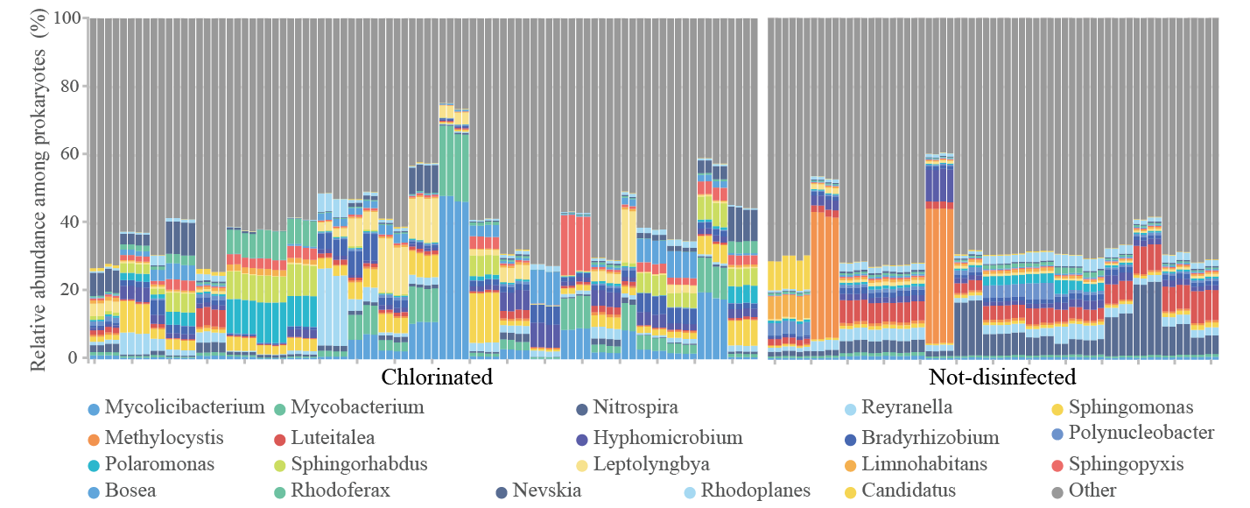
Figure S6. The prokaryotic profile in genus level in different DWDS.

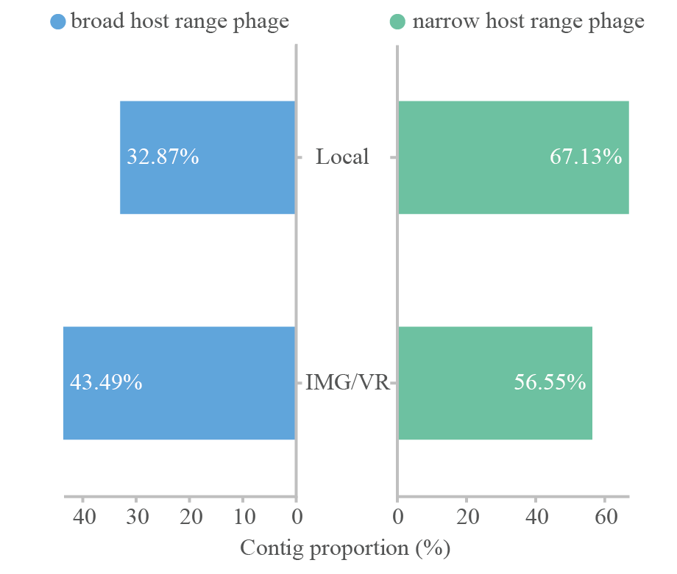
Figure S7. The proportion of broad and narrow host range phages predicted based on IMG/VR database (bottom) and local DWDS metagenomic data (top).
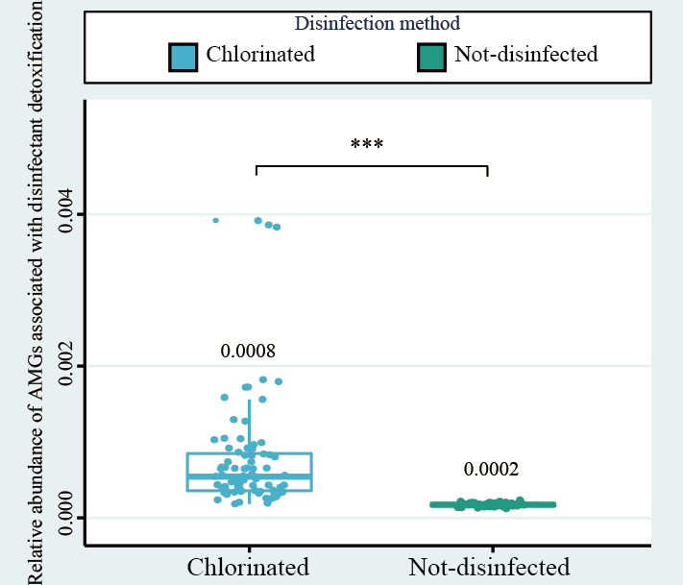
Figure S8. Relative abundance of AMGs associated with disinfectant resistance in DWDS with and without disinfectant. Asterisks (***) represent significant difference (P < 0.0001) based on Student’s T test.

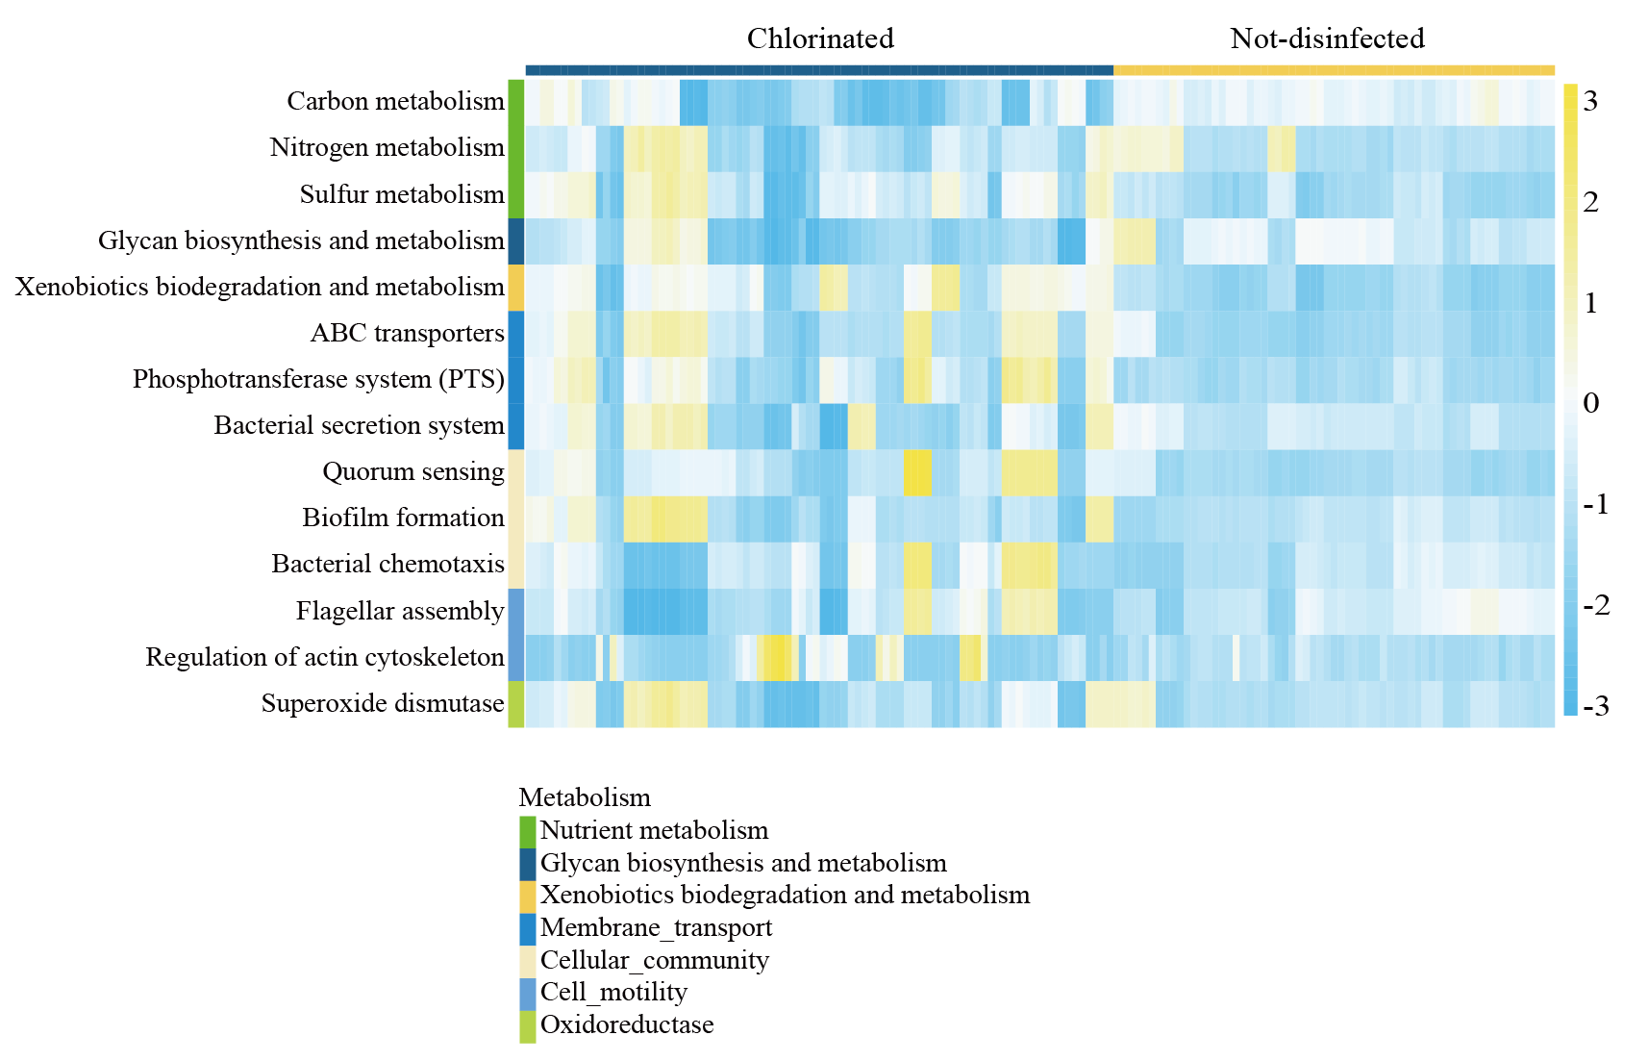
Figure S9. Differential enrichment of prokaryotic metabolic genes related to biofilm formation, disinfectant resistance and nutrient metabolism between the two DWDS. Heatmaps show the relative abundance (TPM) of differentially enriched genes with yellow for high abundance and blue for low abundance, and all data are normalized.

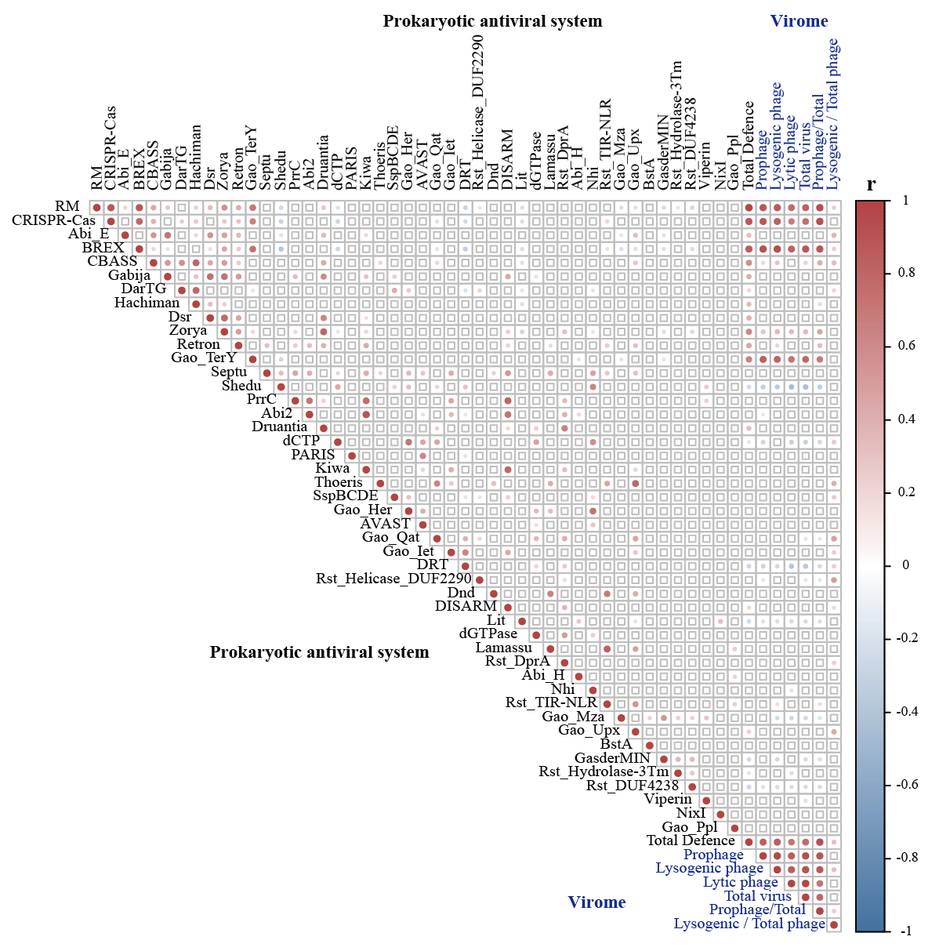
Figure S10. Correlation between antiviral system and virus community abundance and type distribution. Correlation analysis between antiviral systems and the relative abundance and lysogeny of viral communities. Blanks represent no correlation (P > 0.01), and others indicate that there is a correlation between the two (P < 0.01). Red circles represent positive correlations, while blue represent negative correlations. Red circles mean positive correlations, while blue represent negative correlations, and the value is r.

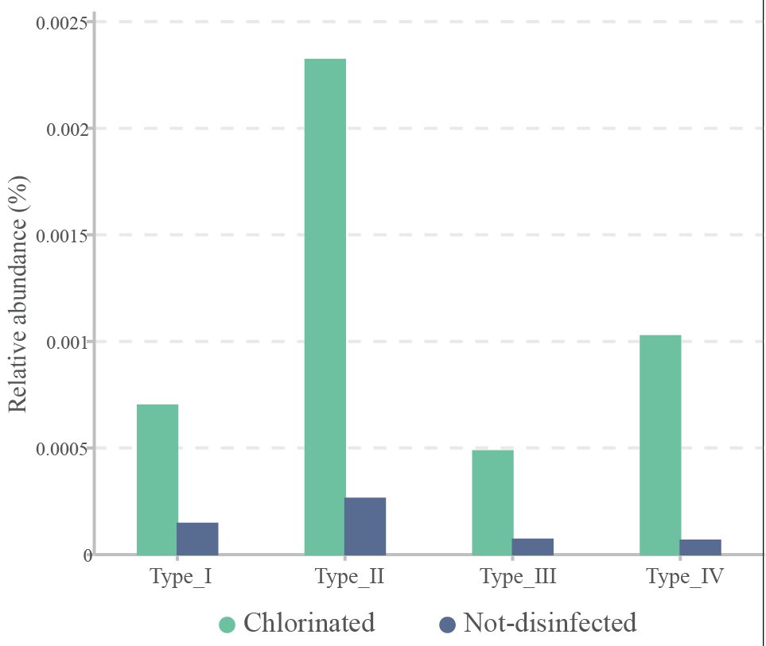
Figure S11. Relative abundance of prokaryotic contigs with different RM subtype systems among all microbial contigs in DWDS with and without residual disinfectant.

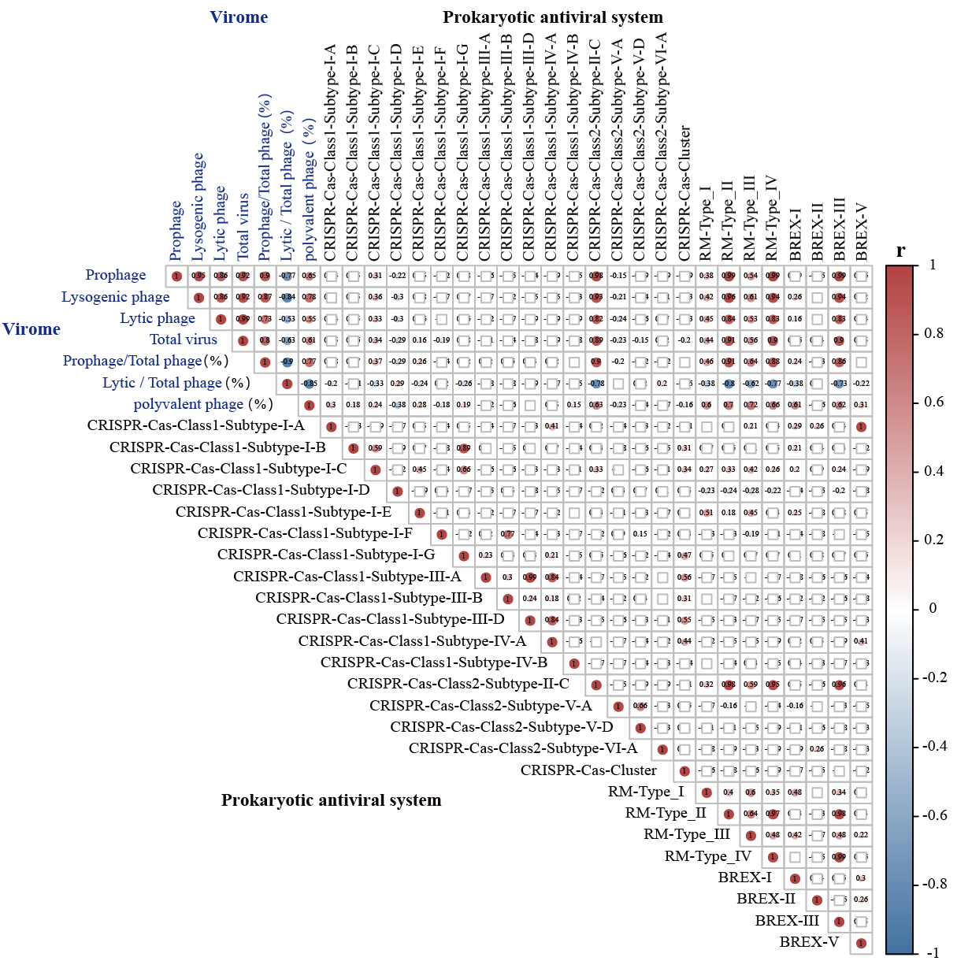
Figure S12. Correlation between subtypes of prokaryotic RM, CRISPR-Cas and BREX system, and virus community abundance and type distribution. Blanks represent no correlation (P > 0.01), and others indicate that there is a correlation between the two (P < 0.01). Red circles mean positive correlations, while blue represent negative correlations, and the value is r.

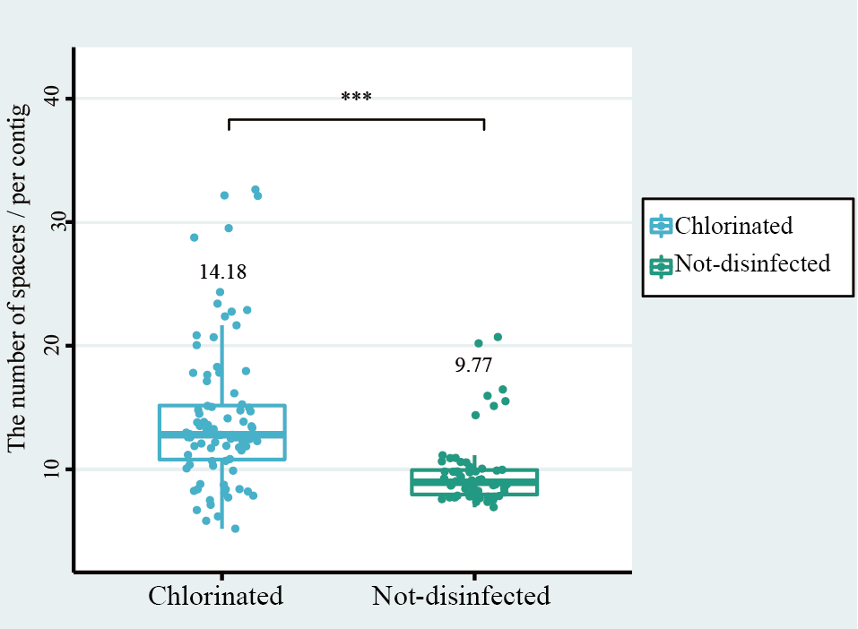
Figure S13. The number of spacers per prokaryotic contig carrying CISPR-Cas systems in DWDS with and without disinfectant. Asterisks (***) represent significant difference (P < 0.0001) based on Student’s T test.

