Supplementary Information
Molecular interaction between steroid sulfatases and formylglycine generating enzyme: A computational study with multiple mutations
Kanchan Kumari^{a,b,#}, Rashmi Rekha Samal ^{a,c,#}, Umakanta Subudhi ^{a,c,*}
ªDNA Nanotechnology & Application Laboratory, CSIR-Institute of Minerals & Materials Technology, Bhubaneswar 751013, Odisha.
^{b}Department of Molecular Biology, Umea University, Sweden.
^{c}Academy of Scientific & Innovative Research (AcSIR), New Delhi 110025, India.

*Corresponding Author: usubudhi@immt.res.in (Dr Umakanta Subudhi)
#Equal contribution

a
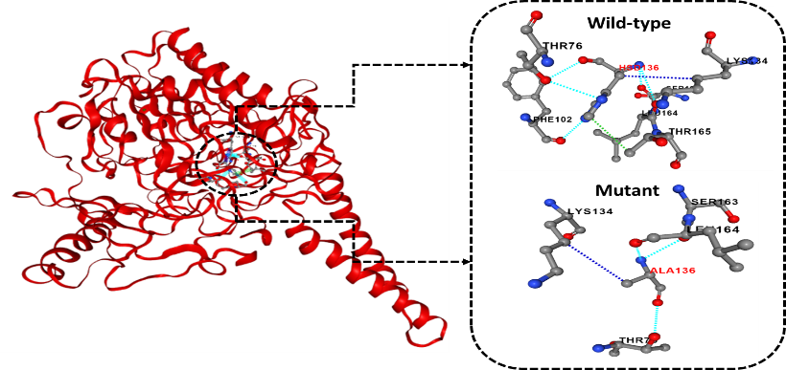
b
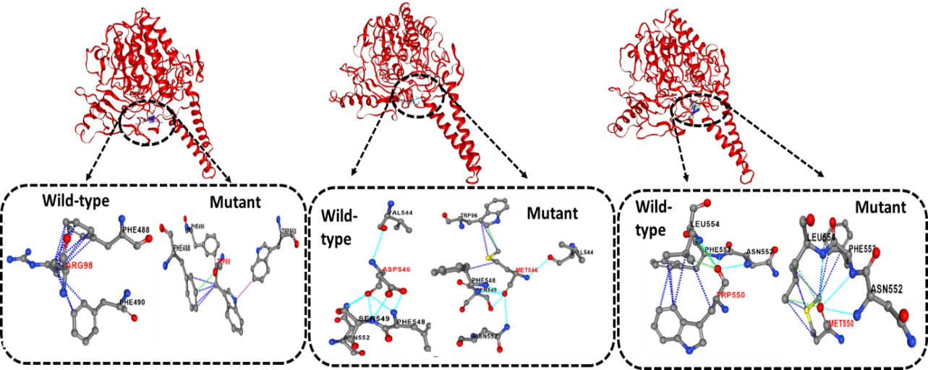
c
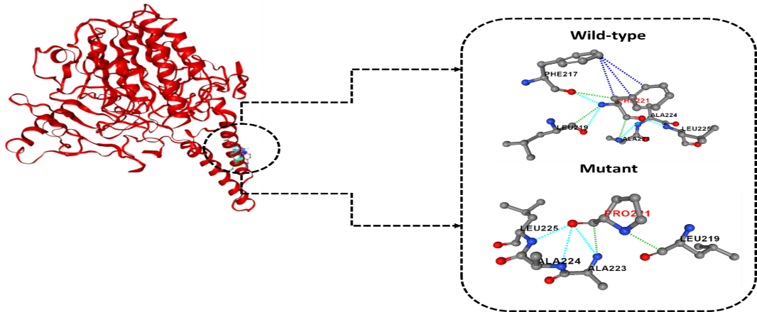
Figure S1. Prediction of mutant structures by substituting wild type amino acids in sulfatase group with mutant type: Figure displays in Ribbon diagram shows the structure of estrogen sulfatase group and dotted block circle represents the binding site within the structure and enlargement version shown in black dotted box where (a) represents the mutant structure of active site of estrogen sulfatase (b) mutant structure of three binding sites Arg98, Asp546 and Trp550 (c) mutant structure of residues that contributing the highest energy during interaction.
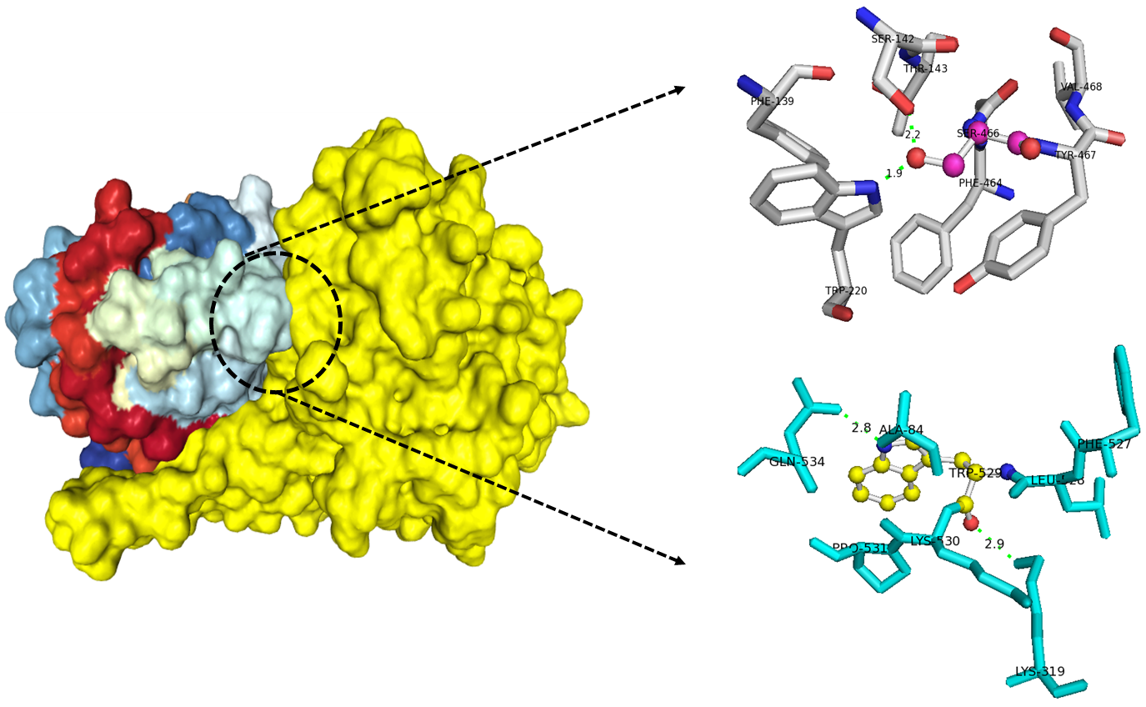
Figure S2. Interaction between mutant type, H136A of estrogen sulfates and FGE: Figure displays in solid surface shows the structure of estrogen sulfatase and FGE complex where dotted black circle represents the binding site within the structure. The structure represents in stick model (Gray and cyan color region) indicates the amino acid resides of FGE binding with estrogen sulfatase group which shown in ball and stick model.
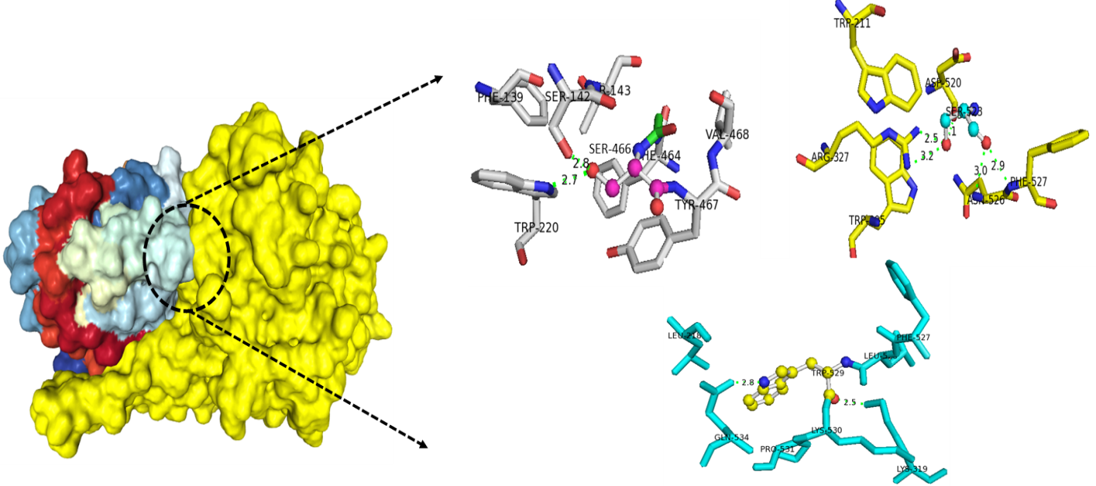
Figure S3. Interaction between mutant type, R98W of estrogen sulfates and FGE: Figure displays in solid surface shows the structure of estrogen sulfatase and FGE complex where dotted black circle represents the binding site within the structure. The structure represents in stick model (Gray, yellow and cyan color region) indicates the amino acid resides of FGE binding with estrogen sulfatase group which shown in ball and stick model.
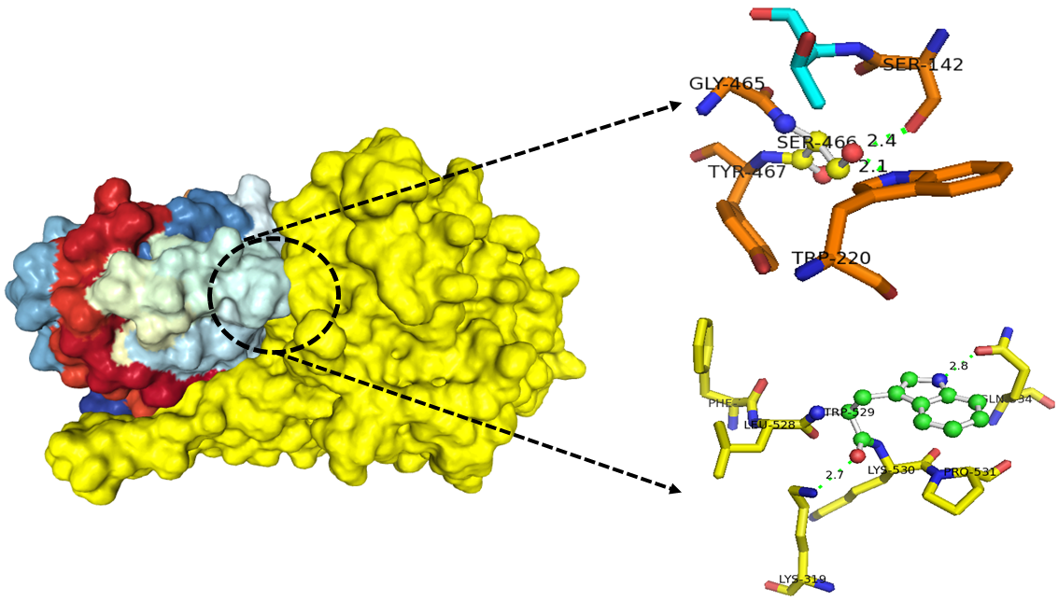
Figure S4. Interaction between mutant type, D546M of estrogen sulfates and FGE: Figure displays in solid surface shows the structure of estrogen sulfatase and FGE complex where dotted black circle represents the binding site within the structure. The structure represents in stick model (Orange and yellow color region) indicates the amino acid resides of FGE binding with estrogen sulfatase group which shown in ball and stick model.
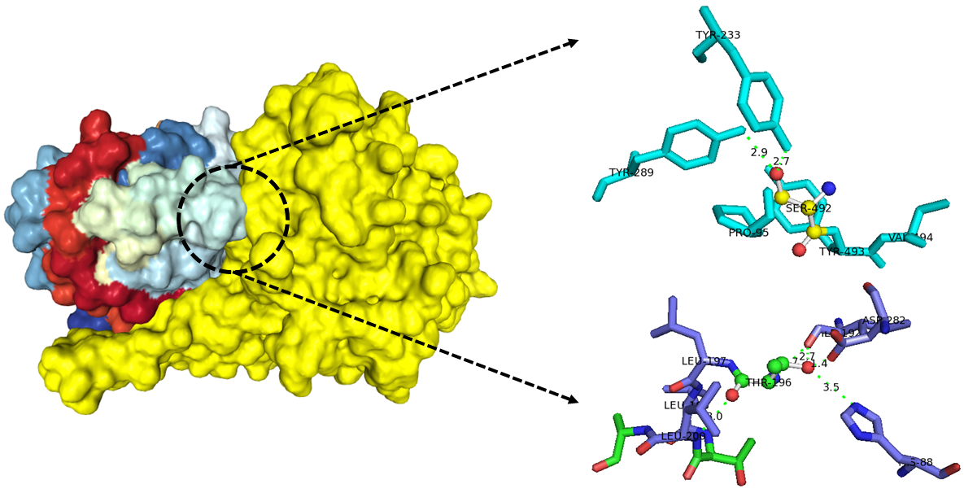
Figure S5. Interaction between mutant type, T550M of estrogen sulfates and FGE: Figure displays in solid surface shows the structure of estrogen sulfatase and FGE complex where dotted black circle represents the binding site within the structure. The structure represents in stick model (Cyan, blue and green color region) indicates the amino acid resides of FGE binding with estrogen sulfatase group which shown in ball and stick model.
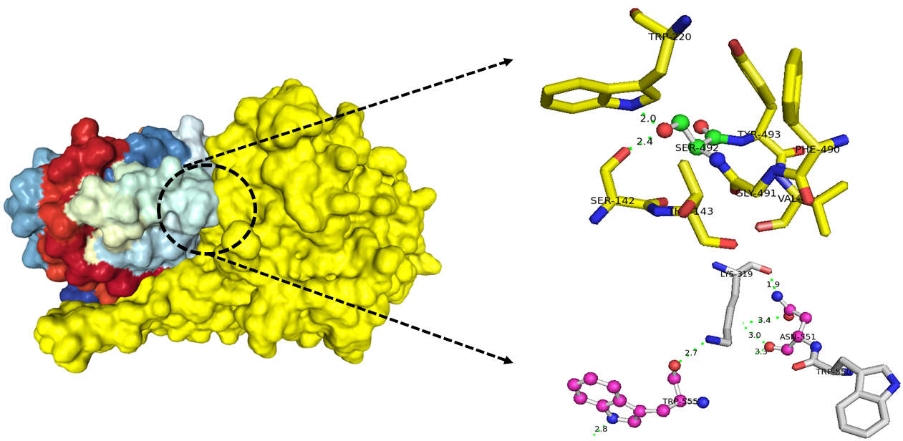
Figure S6. Interaction between mutant type, F221P of estrogen sulfates and FGE: Figure displays in solid surface shows the structure of estrogen sulfatase and FGE complex where dotted black circle represents the binding site within the structure. The structure represents in stick model (Yellow and gray color region) indicates the amino acid resides of FGE binding with estrogen sulfatase group which shown in ball and stick model.

Table S1. Mutational effects on protein stability: Identifying ideal substitution for mutation through CUPSAT Software
Active and binding site of Sulfatase group | Wild-type | Position | Mutant | Predicted ΔΔG value (kcal/mol)
Active site | HIS | 136 | ALA | -7.97
Binding site | ARG | 98 | TRP | -2.25
Binding site | ASP | 546 | MET | -2.86
Binding site | TRP | 550 | MET | -3.94
Highest energy/ residue | PHE | 221 | PRO | -1.86

Table S2. Interacting amino acid residues of estrogen sulfatase group and FGE.
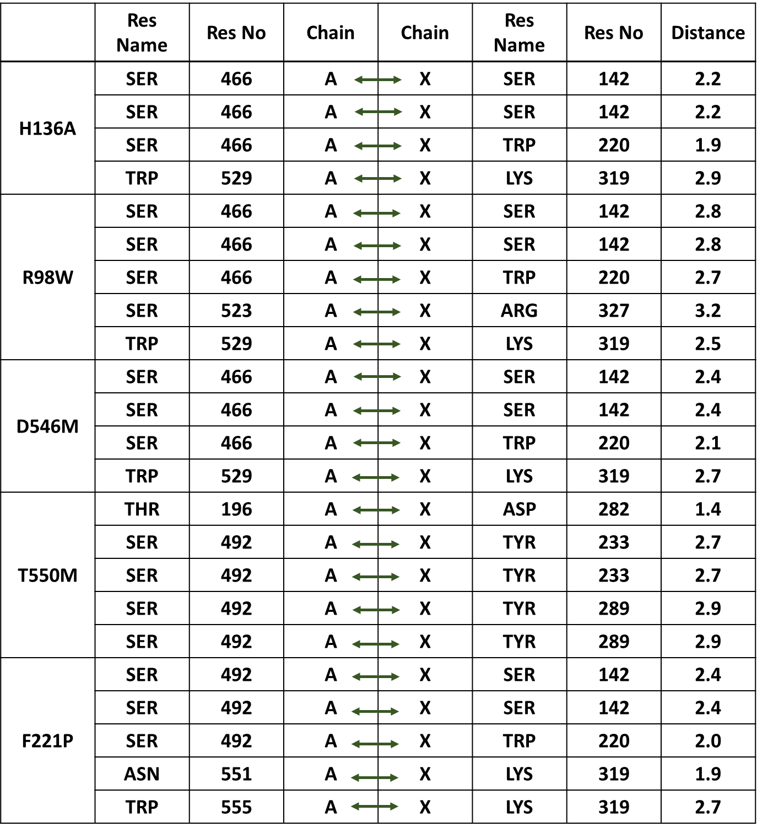

Table S3. Effect of mutation on binding affinity during Sulfatase and its mutant structures interaction with FGE group
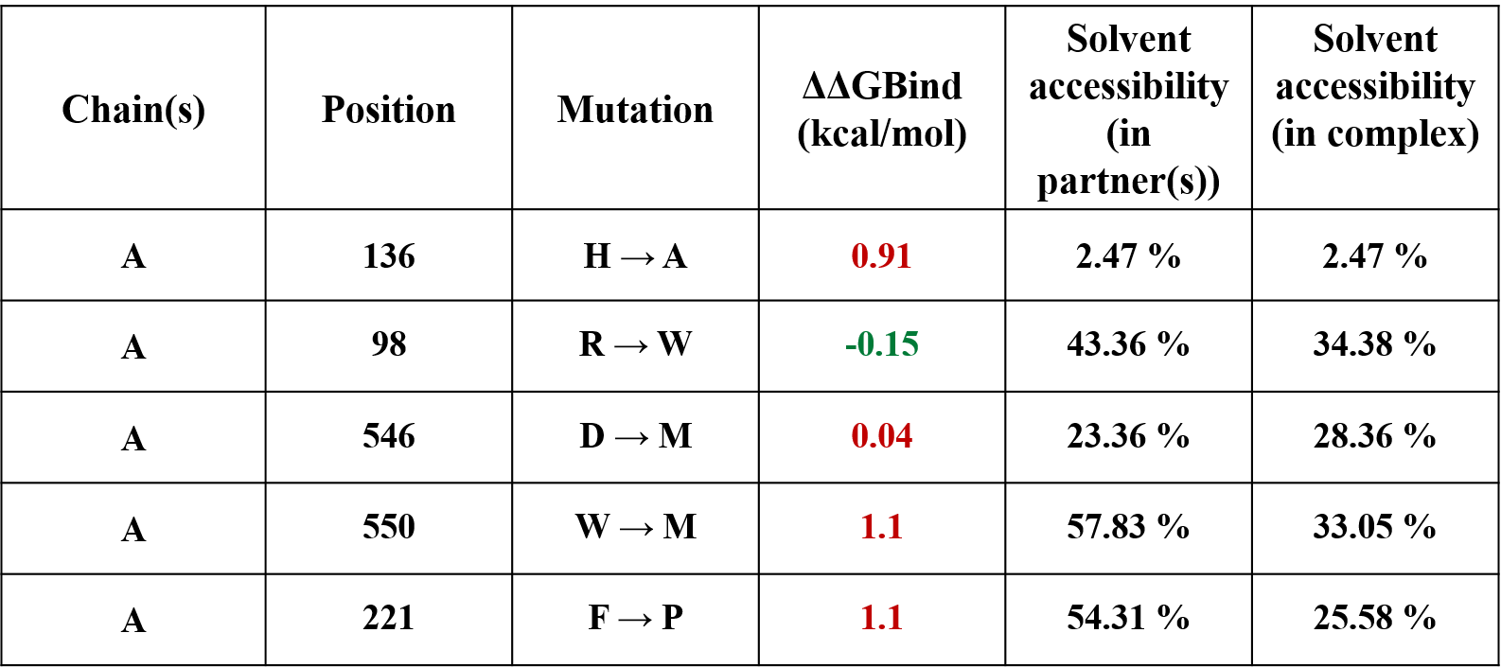
Mutation increases binding affinity Mutation decreases binding affinity

