Supplementary Materials 2 for
Pak2 is essential for meiotic progression and meiotic apparatus assembly in mouse oocytes
Juan Zeng^{1,2,3#}, Shiwei Wang^{4#}, Min Gao^{5#}, Dian Lu^{1,2}, Lu liu³, Diyu Chen^{1,2}, Weimin Fan^{1,2}, Zhiliang Xu ^{1,2}, Xiaofang Sun^{1,2}
*Corresponding author: xiaofangsun@gzhmu.edu.cn
This file includes:
Original Western blot image of Fig. 1B, Fig. 2A, Fig. 5B, Fig. 6A, Fig. 6B, Fig. 6C, Fig. 6D and Fig.S1A.

Pak2 GAPDH

Fig. 1. Subcellular localization and expression of Pak2 during oocyte maturation. (B) Expression of Pak2 during meiotic maturation at GV, pre-MI, MI, TI, and MII stages (the molecular mass of Pak2 is 58 kDa).

Pak2 GAPDH

Fig. 2. Pak2-knockdown (KD) adversely affects meiotic progression in oocytes. (A) KD of endogenous Pak2 protein after Pak2-siRNA injection was confirmed by western blot analysis.

Plk1

Pak2

GAPDH

Fig. 5. Pak2 is associated with centrosomal protein Plk1. (B) Plk1 protein levels in control and Pak2-KD oocytes.

Plk1

Pak2

Tubulin

Fig. 6. Pak2 protects Plk1 from APC/C^{Cdh1}-mediated degradation. (A) Plk1 protein levels in control, Pak2-KD, and Pak2-KD + MG132 oocytes. The blots were probed with Pak2, Plk1 and tubulin antibodies.

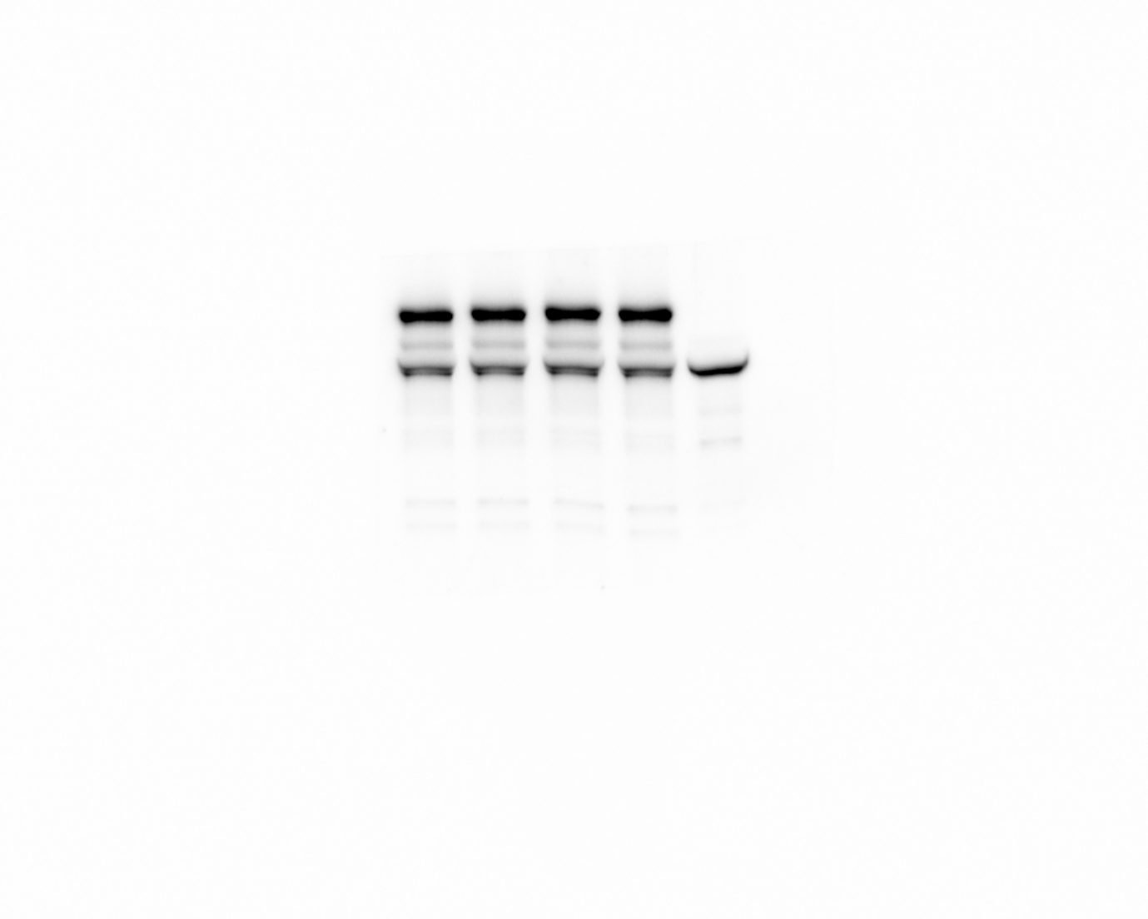
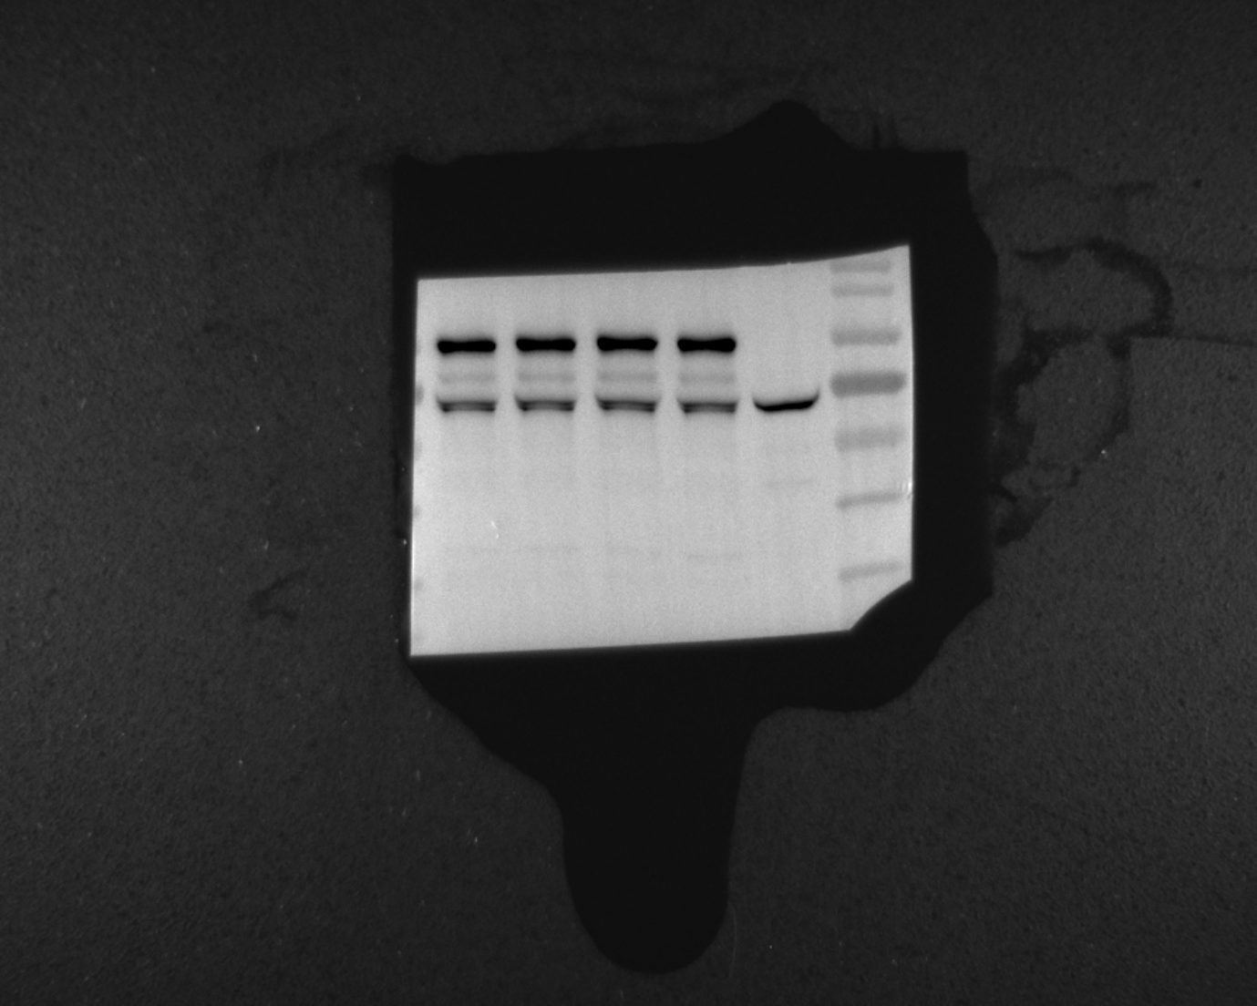

Myc-Plk1
Plk1

Tubulin

Fig. 6. Pak2 protects Plk1 from APC/C^{Cdh1}-mediated degradation. (B) Western blots show that the various mutant Plk1 proteins were expressed to a similar extent. The blots were probed with Plk1 and tubulin antibodies.

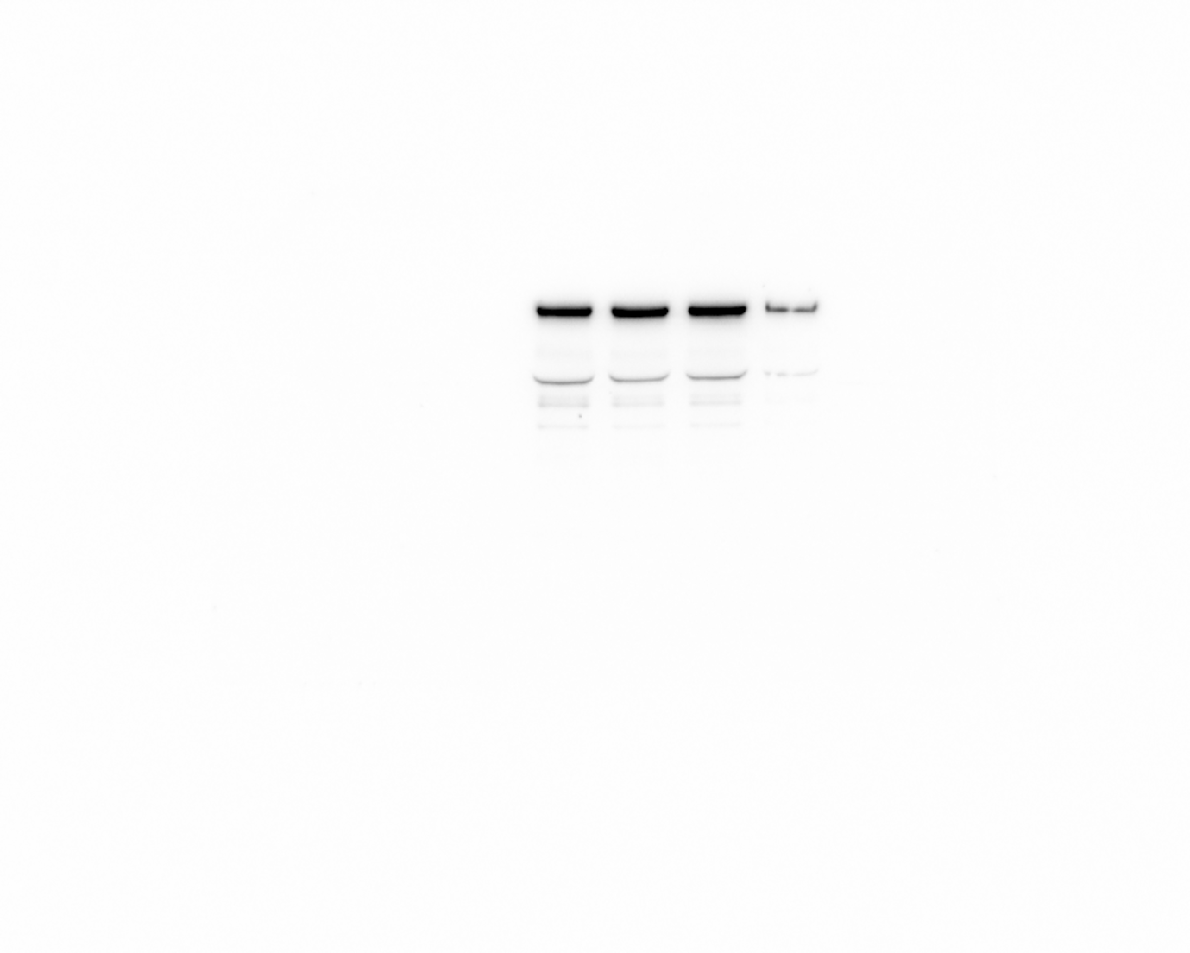Myc-Plk1

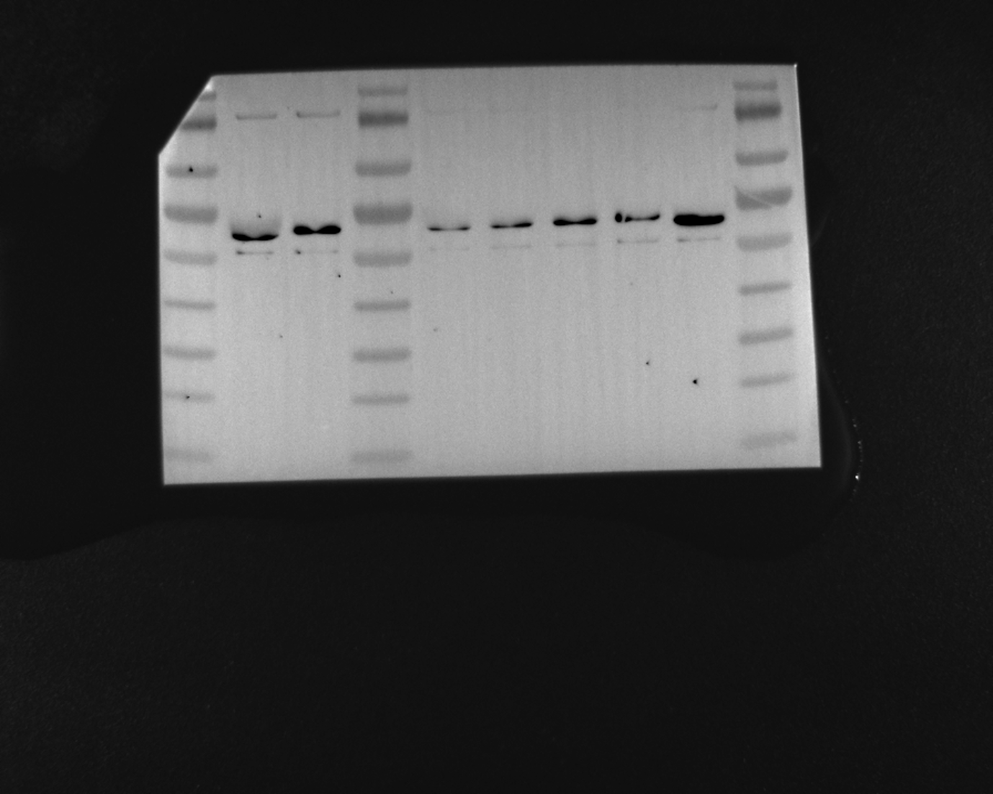

Pak2

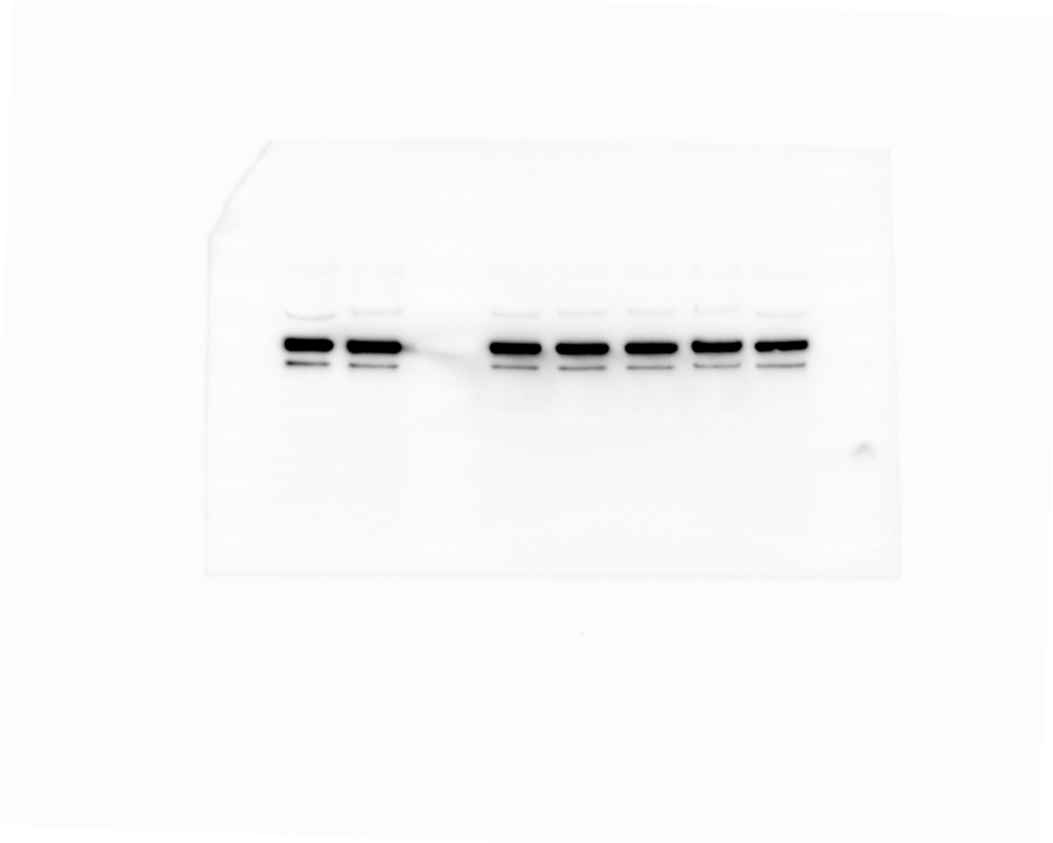

Tubulin

Fig. 6. Pak2 protects Plk1 from APC/C^{Cdh1}-mediated degradation. (C) Plk1 protein levels in control, Pak2-KD + Plk1-L340A, Pak2-KD + Plk1-R337A, Pak2-KD + T210D and Pak2-KD + Plk1-WT oocytes. The blots were probed with Myc, Pak2 and tubulin antibodies.

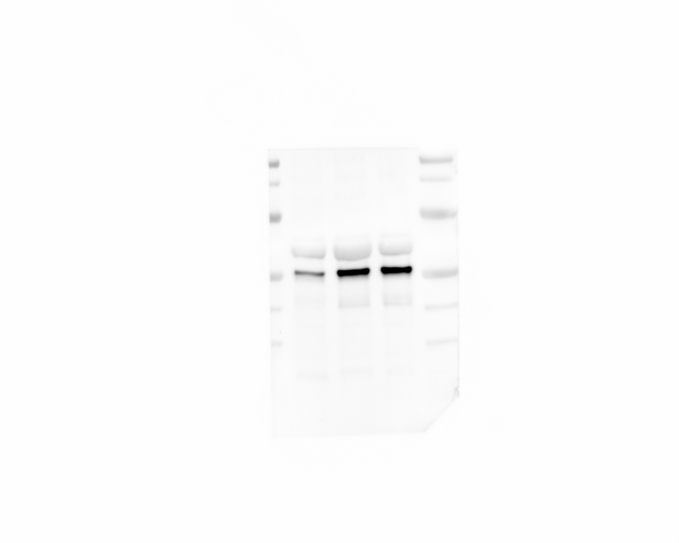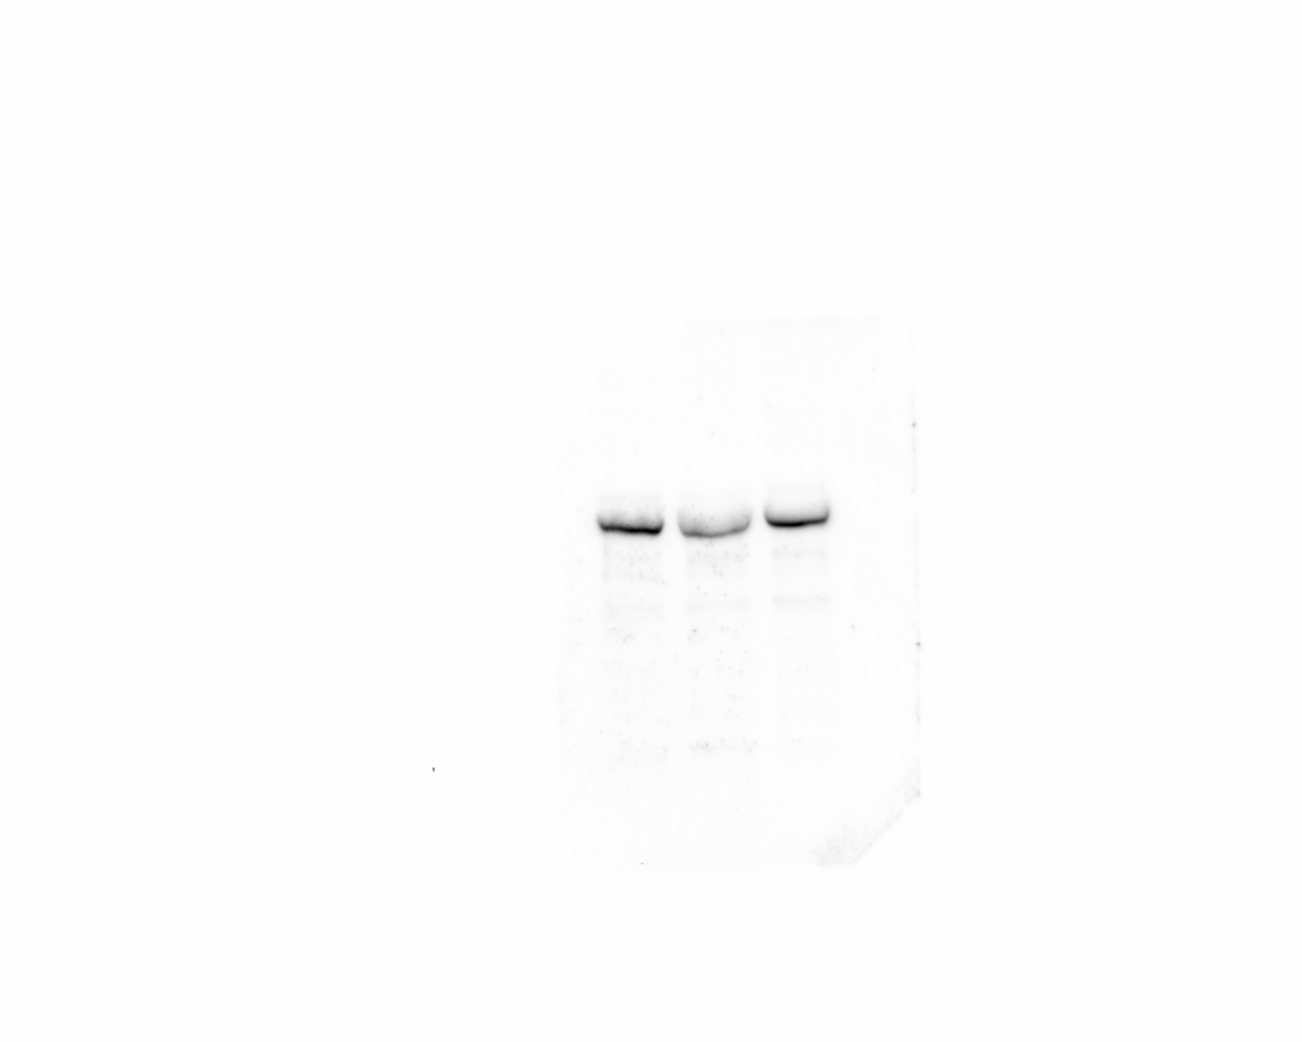Plk1

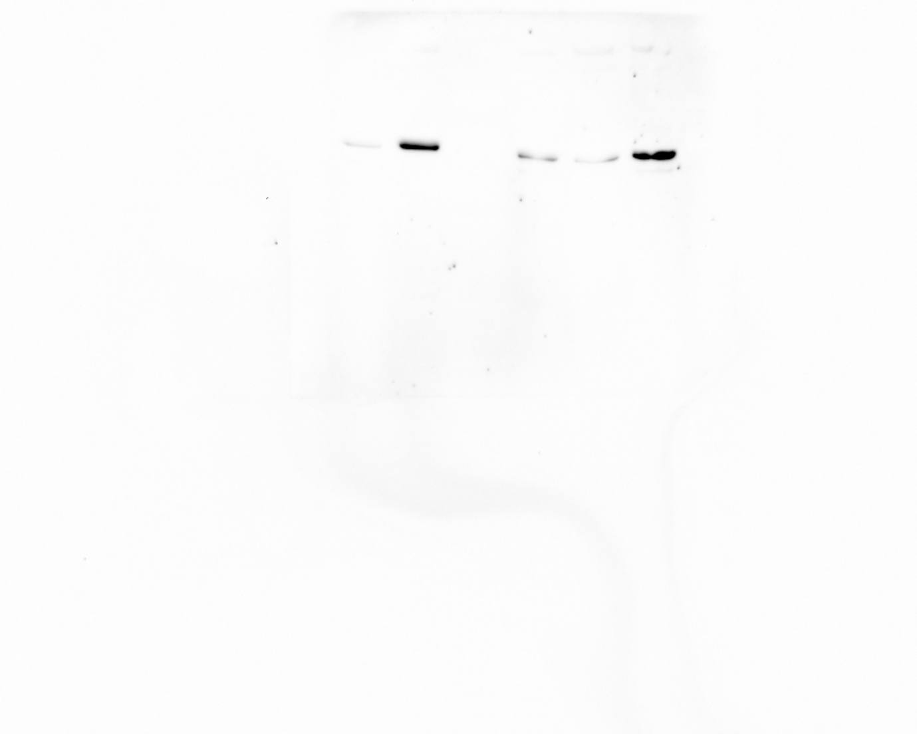Cdh1

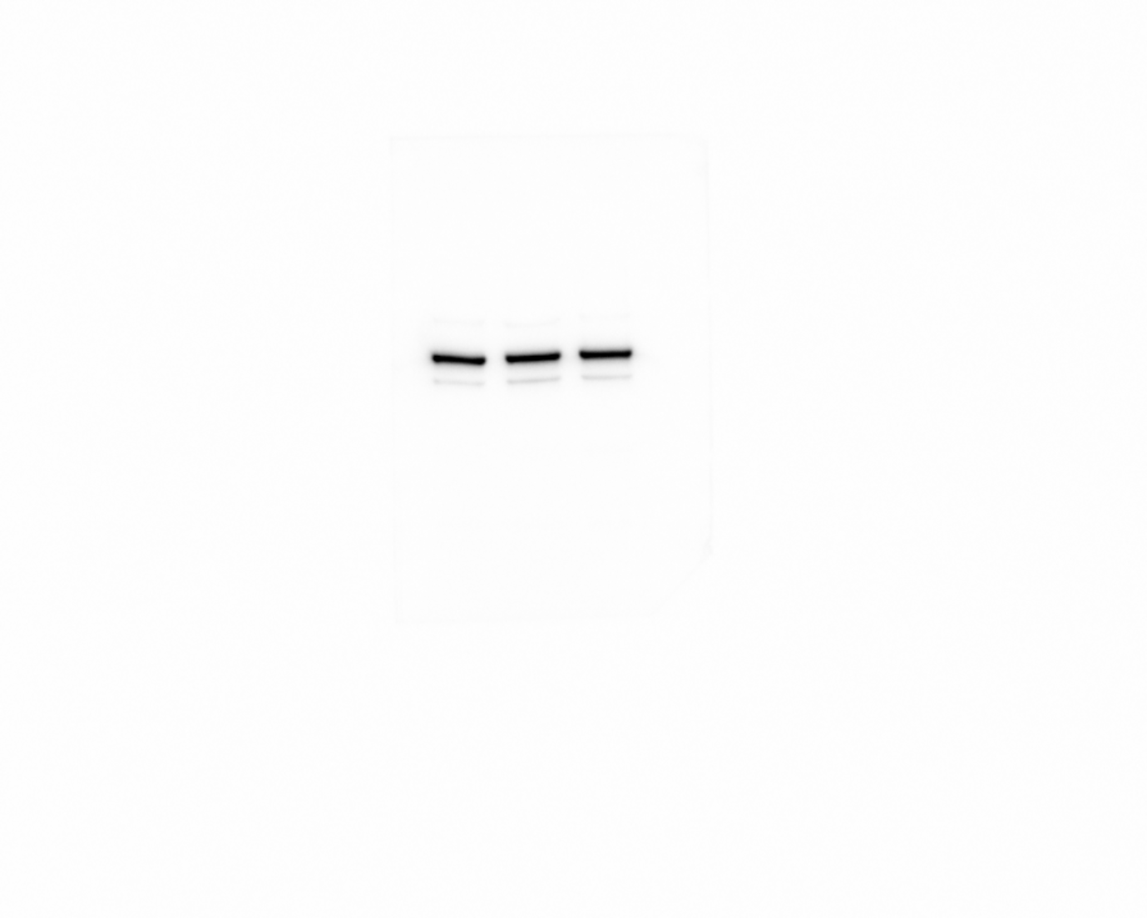Pak2

Tubulin

Fig. 6. Pak2 protects Plk1 from APC/C^{Cdh1}-mediated degradation. (D) Plk1 protein levels in control, Pak2-KD, and Pak2-KD + Cdh1-KD oocytes. The blots were probed with Pak2, Cdh1, Plk1 and tubulin antibodies.

Pak2

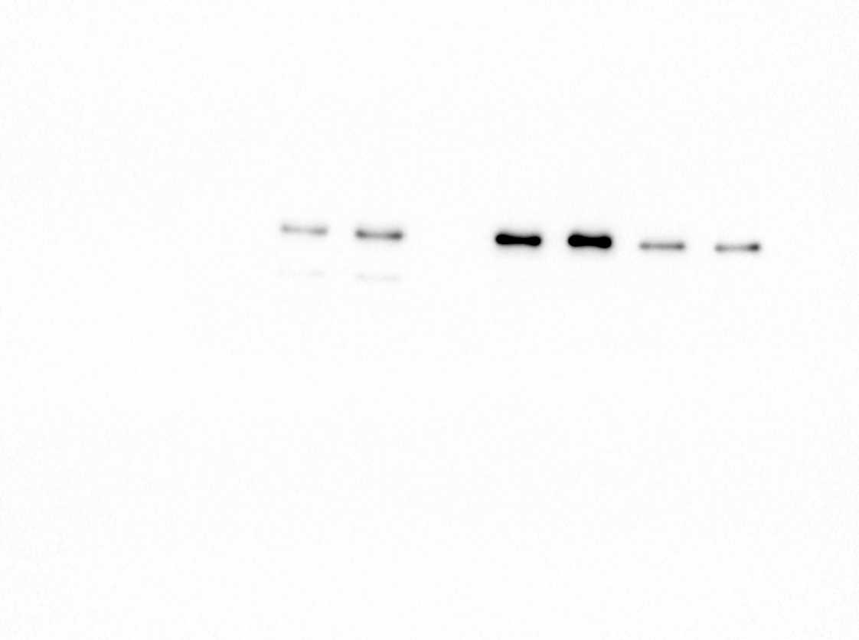

GAPDH

Fig. S1. Localization of Myc-Pak2 in mouse oocytes. (A) Representative western blot results show efficient overexpression of exogenous Pak2 protein.

