An efficient preparation and biocatalytic synthesis of novel C-glycosylflavonols kaempferol 8-C-glucoside and quercetin 8-C-glucoside by metabolic engineering of Escherichia coli
Yangbao Wu^{1,2}, Huan Wang^{1,2}, Yang Liu^{1,2}, Linguo Zhao^{1,2∗}, Jianjun Pei^{1,2∗}
¹ Jiangsu Co-Innovation Center of Efficient Processing and Utilization of Forest Resources, College of Chemical Engineering, Nanjing Forestry University, Nanjing 210037, China
² Jiangsu Key Lab of Biomass-Based Green Fuels and Chemicals, Nanjing 210037, China

SUPPORTING INFORMATION

Table S1 Physical properties of different macroporous resins used in this study.
Type | Polarity | Particle  (mm) | Surface Area(m²/g) | Average Pore Diameter (nm) | Water content (%)
NKA-9 | Strong polar | 0.3-1.25 | 500-550 | 10-12 | 65-75
DM301 | Semi-polar | 0.3-1.25 | 500-550 | 10-12 | 65-75
AB-8 | Weak-polar | 0.3-1.25 | 480-520 | 12-14 | 65-75
D101 | Non-polar | 0.3-1.25 | 550-600 | 9-10 | 65-75
HPD100 | Non-polar | 0.3-1.20 | 650-700 | 9-10 | 65-75
HP-20 | Non-polar | 0.3-1.25 | 550-600 | 10-12 | 65-75

Figure S1. HPLC analysis of kaempferol 8-C-glucoside production for 0 (a), 48 (b), and 120 h (c) of incubation and purified kaempferol 8-C-glucoside (d).

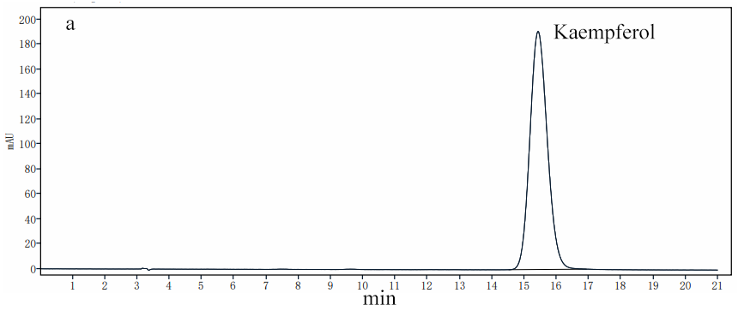
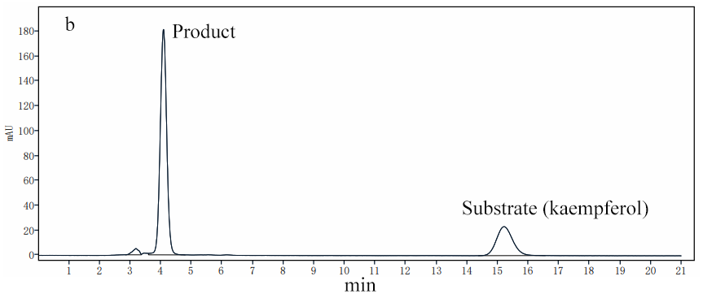
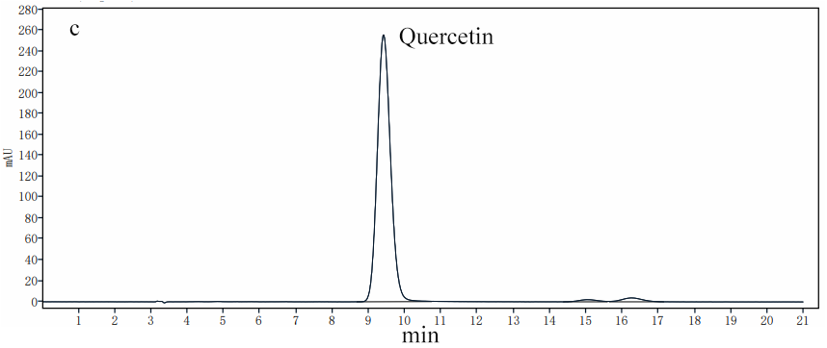
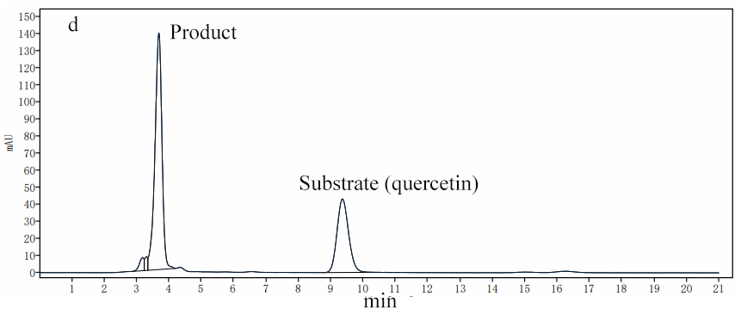
Figure S2. HPLC analysis of kaempferol 8-C-glucoside and quercetin 8-C-glucoside production in BL-TcCGT-I. (a) authentic kaempferol, (b) fermentation broth with kaempferol as substrate in BL-TcCGT-I, (c) authentic quercetin, (d) fermentation broth with quercetin as substrate in BL-TcCGT-I.

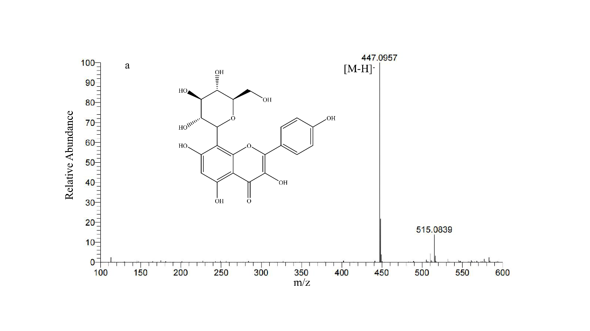
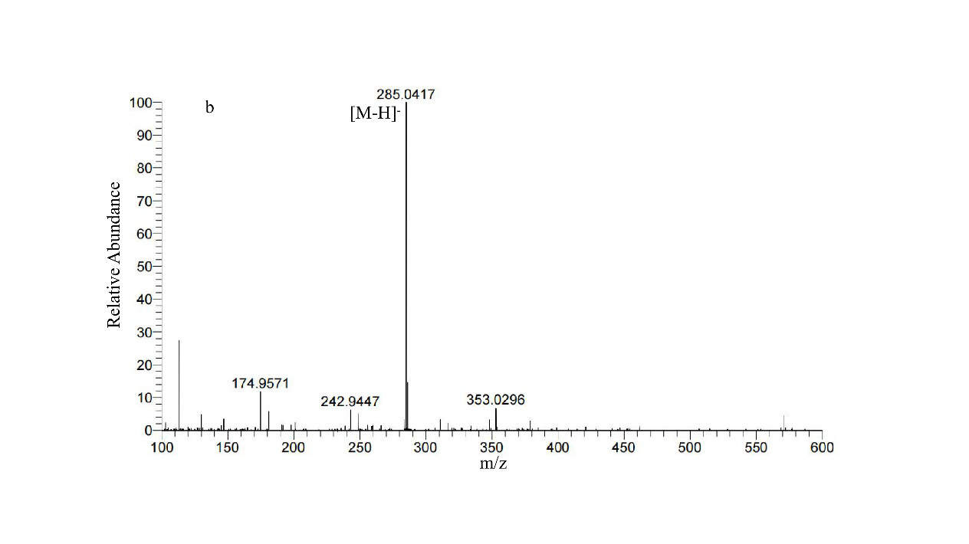
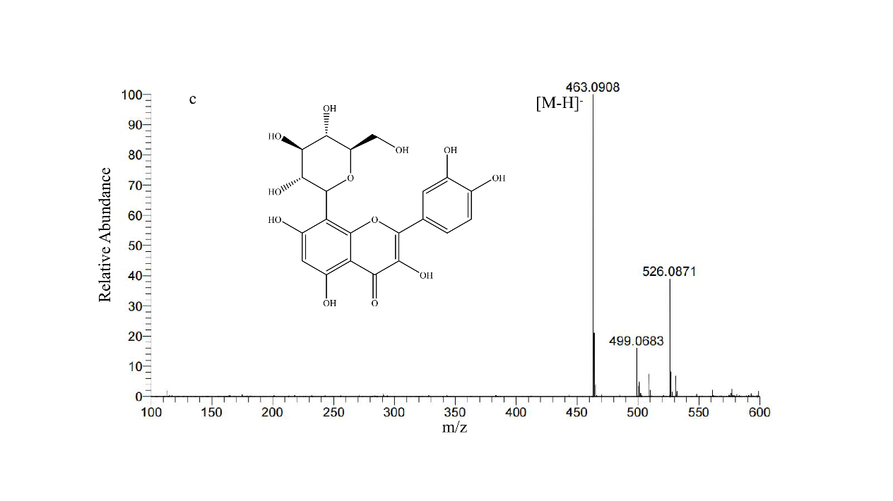
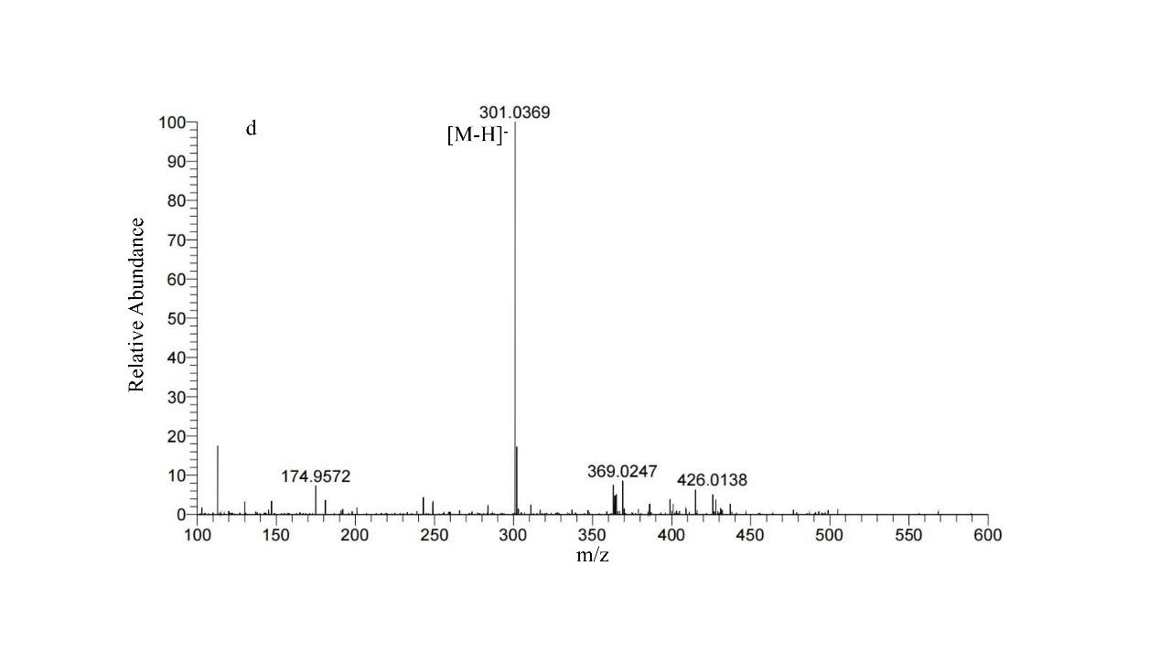
Figure S3. LC/MS analysis of kaempferol 8-C-glucoside and quercetin 8-C-glucoside production in BL-TcCGT-I. (a) kaempferol 8-C-glucoside, (b) kaempferol, (c) quercetin 8-C-glucoside, (d) quercetin.

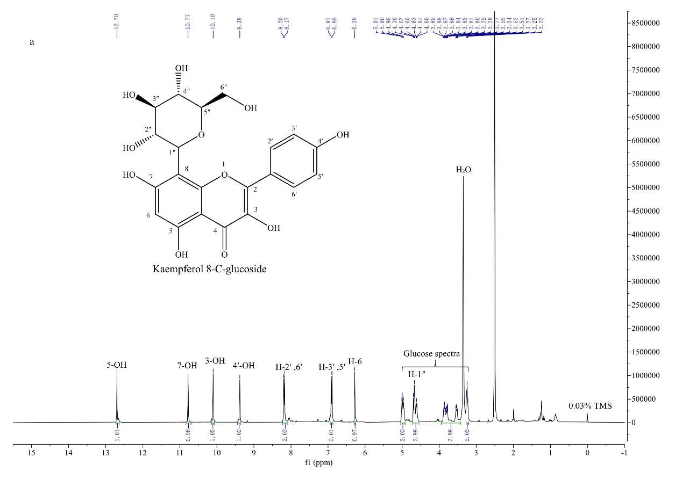

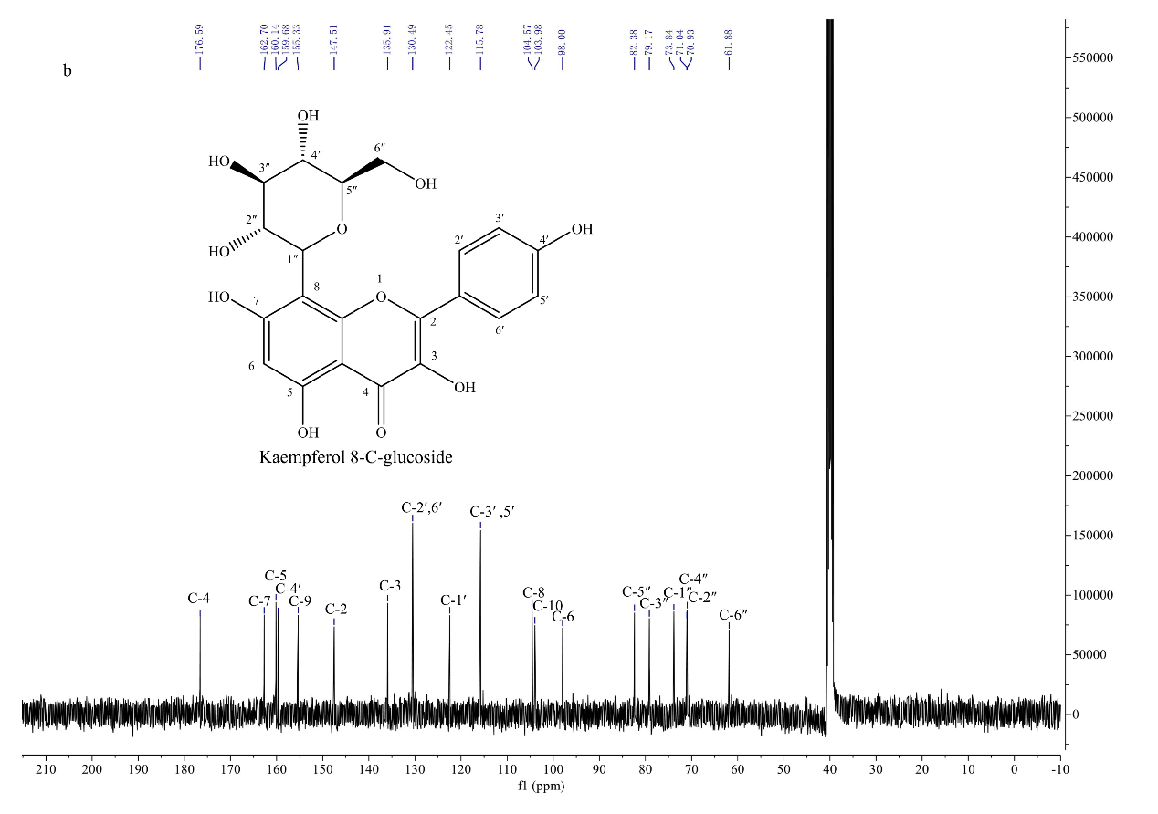

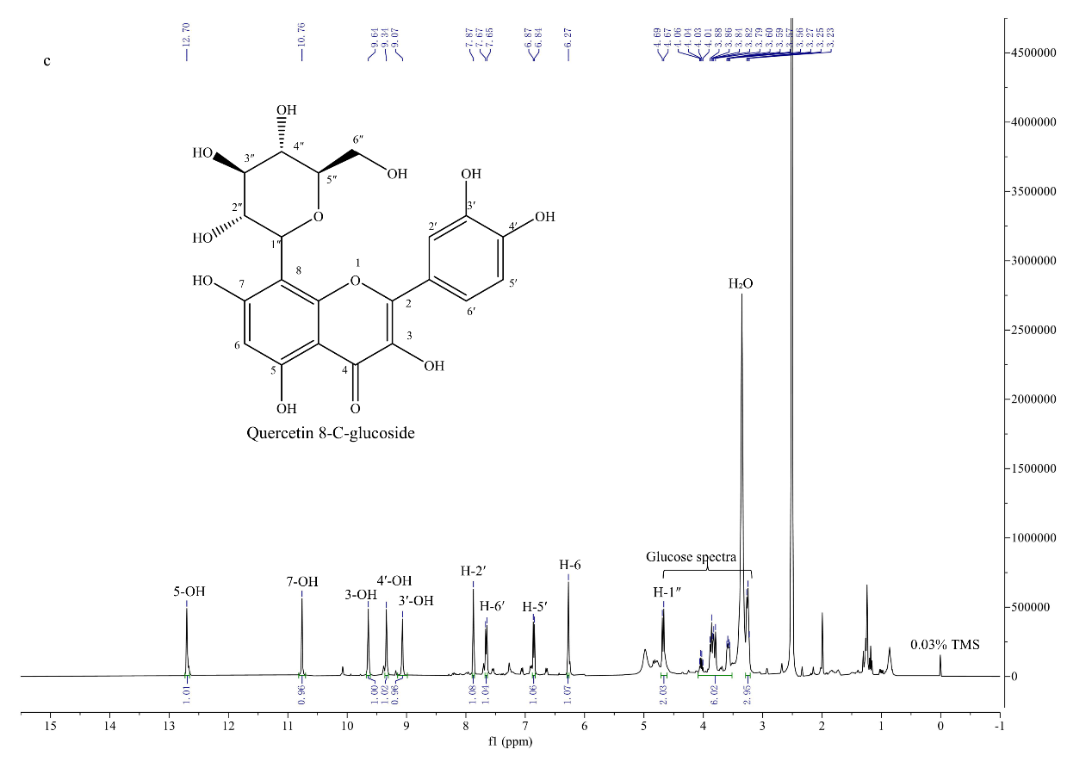

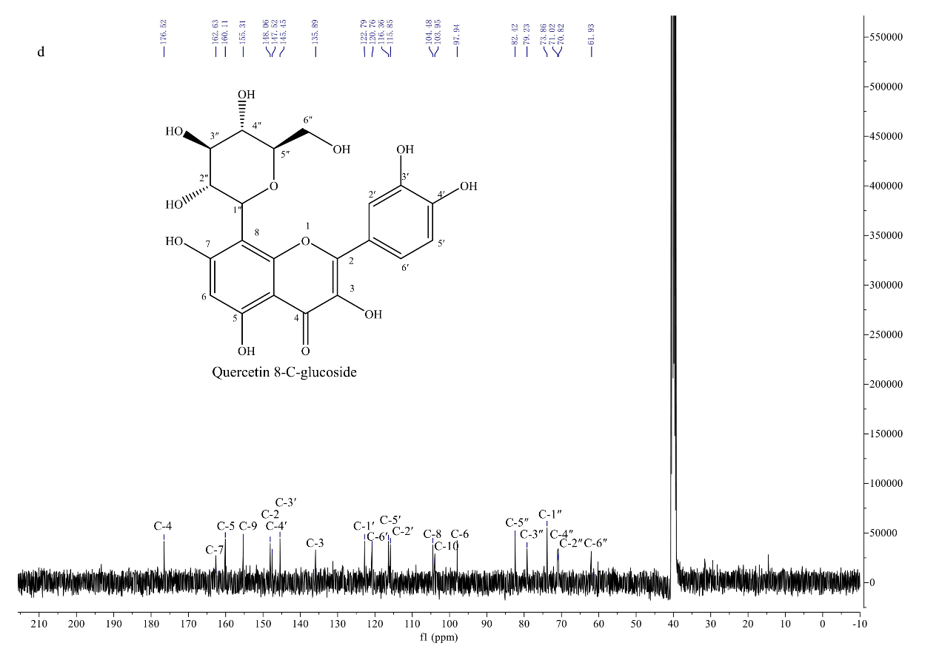

Figure S4. ¹H-NMR and ¹³C-NMR spectra of kaempferol 8-C-glucoside and quercetin 8-C-glucoside (400 MHz for ¹H-NMR and 101 MHz for ¹³C-NMR, DMSO-d₆, δ in ppm). (a) ¹H-NMR for kaempferol 8-C-glucoside, (b) ¹³C-NMR for kaempferol 8-C-glucoside, (c) ¹H-NMR for quercetin 8-C-glucoside, (d) ¹³C-NMR for quercetin 8-C-glucoside.

∗ Corresponding author: Corresponding author: Jianjun Pei. College of Chemical Engineering, Nanjing Forestry University, Nanjing 210037, China. Phone: +86-025-85427962. E-mail: peijj2000@sina.com.cn. Linguo Zhao. College of Chemical Engineering, Nanjing Forestry University, Nanjing 210037, China. Phone: +86-025-85427962. E-mail: njfu2302@163.com and lg.zhao@163.com.

