Supplementary Information

Mechanistic studies of a lipase unveil a dramatic effect of pH on the selectivity toward the hydrolysis of PET oligomers

Katarzyna Świderek,^{1,}* Susana Velasco-Lozano,² Miquel À. Galmés,¹ Ion Olazabal,³ Haritz Sardon,³ Fernando López-Gallego,^{2,4,}* Vicent Moliner^{1,}*

- BioComp Group, Institute of Advanced Materials (INAM), Universitat Jaume I, 12071 Castellón, Spain.
- Heterogeneous Biocatalysis Laboratory, Center for Cooperative Research in Biomaterials (CIC biomaGUNE), Basque Research and Technology Alliance (BRTA), Donostia San Sebastián, Spain
- POLYMAT, Department of Polymer Science and Technology, University of the Basque Country UPV/EHU, Manuel de Lardizabal, 3, 20018, Donostia, Spain
- IKERBASQUE, Basque Foundation for Science, 48013 Bilbao, Spain;

Content
Experimental results
Fig S1. SDS-PAGE gel 3
Fig S2. ¹H NMR BHET 4
Fig S3. Time courses of BHET hydrolysis with pH-controlled product formation. 5
Fig S4. UPLC-MS analysis of sample reactions at different pHs. 6
Fig S5. Kinetic parameters of soluble CALB 7
Fig S6. ¹H NMR enzymatic reaction sample at pH 5 using crude BHET 8
Fig S7. ¹H NMR enzymatic reaction sample at pH 9 using crude BHET 8
Fig S8. UPLC-MS analysis of sample reaction at pH 5 or 9 from crude BHET 9

Computational methods and results
Computational details 10
Fig S9. Schematic representation of the QM – MM partition. 12
Table S1. Parameters for BHET 16
Table S2. Paramaters for MHET. 18
Fig S10. pKa values of the titratable residues of CALB 20
Fig S11. Titratable curves for ionizable residues of CALB 21
Fig S12-15. Geometrical analysis of the interactions of selected residues of CALB 22
Fig S16. Interaction energies between BHET and CALB 24
Fig S17. Interaction energies between MHET and CALB 24
Fig S18-S19. M06-2X:AM1/MM Free energy surfaces 25
Fig S20. Reaction mechanism of the hydrolysis of the BHET/MHET 27
Table S3. Relative energies of all states for the hydrolyis of BHET at pH 5 and 9 28
Table S4-S5. Cartesian coordinates of the transition states optimized at M06-2X/MM 29
Table S6. ESP atomic charges 33
References 34

Experimental results
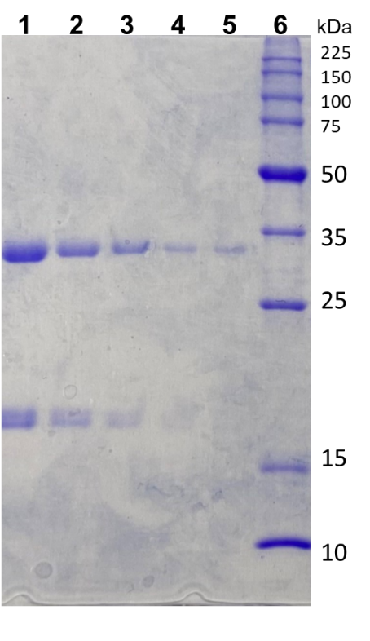
Fig S1. SDS-PAGE gel containing different concentrations of commercial preparation of CALB (33 kDa) and the molecular weight marker with known protein concentration (Promega). Lanes: 1 – 5 CALB (Dilutions 10, 20, 40, 80_{a} and 80_{b}, respectively), lane 6: molecular weight marker, all protein bands correspond to 0.1 mg/mL of protein unless 50 kDa band which contains 0.3 mg/mL.

Fig S2. ¹H NMR BHET on water: (300 MHz, Deuterium Oxide) δ 8.05 (s, 4H), 4.39 (t, 4H), 3.88 (t, 4H).

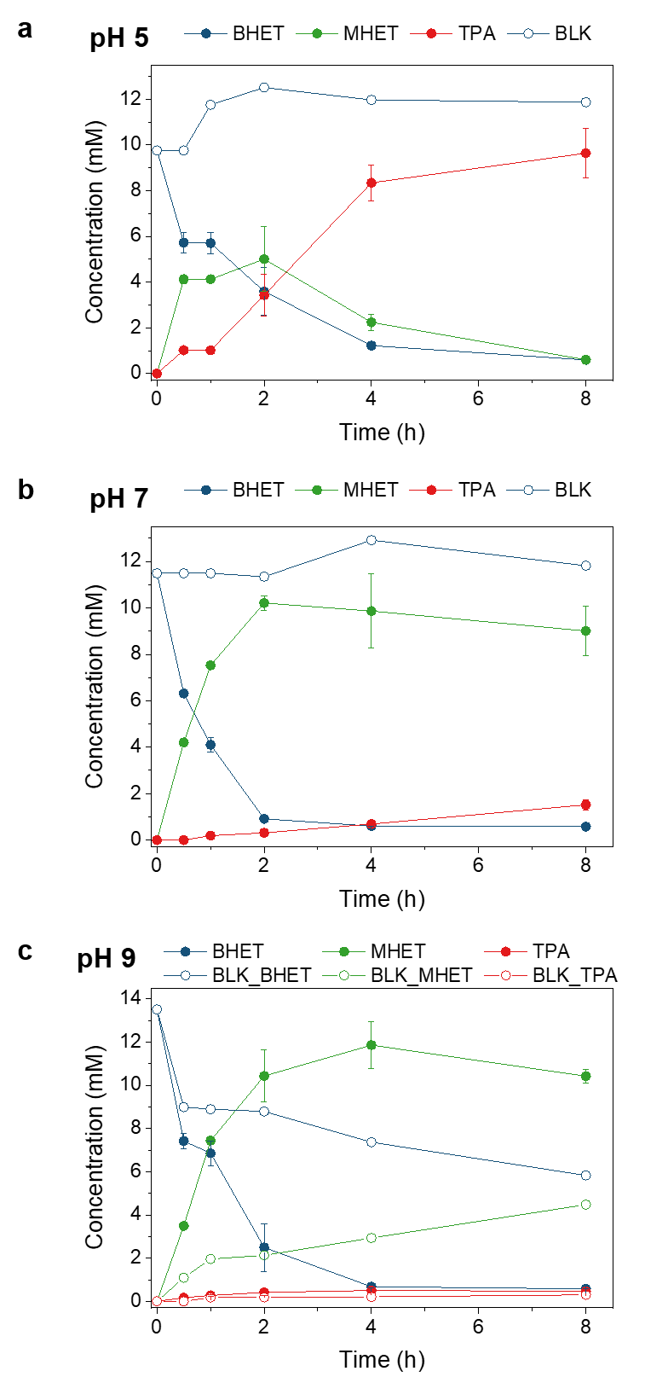
Fig. S3. Time courses of BHET hydrolysis with pH-controlled product formation. a, pH 5, b, pH 7, and c, pH 9. Filled circles represent enzymatic reaction products, while empty circles represent reaction products in the absence of the enzyme (blanks). In all cases, CALB (5.12 mg/mL) was mixed with 10 mM BHET in 100 mM buffered aqueous solution containing 10% DMSO and the reaction mix was incubated at 25 ºC.

Fig S4. UPLC-MS analysis of sample reactions at different pHs. Reaction with enzyme (blue line), reaction control without enzyme (red line). A) pH 5, B) pH 7 and C) pH 9. UPLC-MS spectra: D) MS analysis of peak 1, retained at 1.97 min corresponding to TPA. E) MS analysis of peak 2, retained at 2.92 min corresponding to MHET. F) MS analysis of peak 3, retained at 3.41 min corresponding to BHET.
Fig S5. Kinetic parameters of soluble CALB. In all cases, substrate (BHET or MHET) in 25 mM aqueous buffered solution at the specified pH and 10% DMSO.

Fig S6. ¹H NMR enzymatic reaction sample at pH 5 using crude BHET: (300 MHz, Deuterium Oxide, 298 K) δ 7.81 (S, 4H).

Fig S7. ¹H NMR enzymatic reaction sample at pH 9 using crude BHET: (300 MHz, D₂O, 298 K) δ 8.03 (d, J = 8.5 Hz, 2H), 7.86 (d, J = 8.6 Hz, 2H), 7.78 (s, 9H), 4.36 (t, 2H), 3.86 (t, 2H).

Fig S8. UPLC-MS analysis of sample reaction at pH 5 or 9 from crude BHET. Reaction with enzyme (blue line), reaction control without enzyme (red and orange line). A) pH 5, B) pH 9. Retention peaks: 1, retained at 1.97 min corresponding to TPA; 2, retained at 2.92 min corresponding to MHET; 3, retained at 3.41 min corresponding to BHET.

Computational Details
Model set up. Wild type Candida antarctica Lipase B (CALB) initial geometry was taken from PDB structure 1TCA. Systems were prepared where the protonation state of titratable residues was determined at pH equivalent to 5 and 9 using the semiempirical program PropKa ver. 3.0 3., and by getting the full titratable curves based on constant-pH employing hybrid non-equilibrium molecular dynamic and Monte Carlo (neMD/MC) simulations., as implemented as a Tcl plugin, namdcph, for use in conjunction with NAMD ver. 2.12. All neMD/MC simulations were carried out with the CHARMM36 force field. Constant-pH MD assays of the titration curves were performed on 55 pH values between 2.0 and 12.8 at intervals of 0.2 units and repeated five times. All simulations attempted protonation moves every 10 ps over 50 ns with switch times of 20 ps (i.e., 5000 neMD/MC cycles). The efficiency of sampling was improved by assigning inherent pKa values using the once originally predicted by PropKa software. The protonation states of Lys, Glu, and Asp residues of CALB were explored during these simulations thus obtaining complete titratable curves that provide a robust estimation of the protonation state for selected residues. In the case of the system at pH 5, three protonated residues were taken into account, Asp134, Glu81, and Glu 284. In the case of pH 9 all former aspartic and glutamic residues, and Lys136 were deprotonated. The only histidine, the catalytic His224, was treated as neutral with a hydrogen atom added in Nδ position. Moreover, three disulphide bridges between residues Cys22 and Cys64, Cys216 and Cys258, and Cys293 and Cys311 were defined. The substrates BHET and MHET were manually built in the active site, with the oxygen of the carbonyl properly placed in the oxyanion hole formed by Thr40 and Gln106. Afterwards, all missing hydrogen atoms were added to the structure and the system was solvated into a 100 × 80 × 80 Å³ pre-equilibrated box of TIP3P water molecules. Water molecules with an oxygen atom within 2.8 Å of any heavy atom were removed. In the case of the system with a protonation state equivalent to that observed at pH 5, the charge of the full system was positive so one chlorine ion was added for its neutralization. In the case of pH 9, on contrary three sodium ions were inserted. Systems used in the simulations were composed of 64,664 (4,627 belonging to the protein, 24 to the substrate, 1 ion and 60,012 to the water molecules) and 64,656 (4,623 of the protein, 24 of the substrate, 3 ions and 60,006 belonging to the water molecules) atoms for pH 5 and pH 9 respectively in the case of MHET, and 64,670 (4,627 belonging to the protein, 32 to the substrate, 2 ions and 60,009 for the water molecules) and 64,666 (4623 of the protein, 32 of the substrate, 2 ions and 60,009 belonging to the water molecules) atoms for pH 5 and pH 9 in the case of MHET.
After initial energy minimizations, the system was heated to 303 K with 0.1 K temperature increment and equilibrated during short (100 ps) NPT MD simulations, followed by non-accelerated classical 100 ns NVT MD simulations with AMBER force field, as implemented in NAMD software. The missing force field parameters for the substrates were generated using GAFF and the Antechamber tool (Supporting Information Table S1 and S2). Partial charges were computed using the Austin Model 1 (AM1) semiempirical Hamiltonian as implemented in Antechamber. During the 100 ns of NVT MD simulations, all atoms were free to move within periodic boundary conditions and cut-offs for nonbonding interactions with an internal cut-off of 14.5 Å and an external of 16 Å. In order to avoid diffusion of the substrate, a restrain in the position between the oxygen of the carbonyl and the oxyanion hole was applied. To maintain constant temperature the Langevin thermostat was applied.
The analysis of electrostatic and van der Waals interactions between the substrate and the protein during the MD was done using CPPTRAJ as implemented in Ambertools.
From the pH 5 and pH 9 MD simulations with BHET and from the one at pH 5 with MHET the most populated reactive structure was selected based on the distances of the reactions coordinates and was used to study the reaction mechanism using QM/MM methodologies.
QM/MM simulations. In present work, the standard additive hybrid QM/MM scheme was used to construct the total Hamiltonian, ${\hat{H}}_{QM/MM}$, where the total energy $E_{QM/MM}$is obtained as the sum of specific contributions, as presented in equation 1:
$E_{QM/MM}=\left\langle Ψ | \hat{H_{o}} | Ψ\right\rangle +\left(\sum{\left\langle Ψ | \frac{q_{MM}}{r_{e,MM}} | Ψ\right\rangle + \sum{\sum{\frac{Z_{QM}q_{MM}}{r_{QM,MM}}}}}\right)+E_{QM/MM}^{vdW}+E_{MM}$ (1)
where $E_{MM}$ is the energy of the MM subsystem term, $E_{QM-MM}^{vdW}$the van der Waals interaction energy between the QM and MM subsystems and $E_{QM-MM}^{elect}$includes both the Coulombic interaction of the QM nuclei ($Z_{QM}$) and the electrostatic interaction of the polarized electronic wave function ($q_{MM}$) with the charges of the protein ($q_{MM}$). The region described by quantum mechanics includes the side chains of the catalytic Ser105, His224 and Asp187 residues as well as the full substrate, and one water molecule, as shown in Fig. S9. Three-link atoms⁶⁰ were inserted where the QM/MM boundary intersected covalent bonds: these were placed between the Cα-Cβ for Ser105, His224 and Asp187. In the deacylation step, the leaving group was removed from the calculations.
The AM1 semiempirical Hamiltonian and the Minnesota Functional M06-2X, with the standard 6-31+G(d,p) basis set, were used to treat the QM sub-set of atoms corresponding to the substrate and the catalytic residues of the active site as implemented in Mopac and Gaussian 09, respectively. A water molecule was also included in the QM region for the deacylation step. The OPLS-AA and TIP3P classical force fields were used to treat the protein and the solvent water molecules, respectively, as implemented in the fDynamo library. The atom positions of all residues presented beyond 25 Å from the substrate were frozen and the same cut-offs as in MD simulations were applied for the nonbonding interactions. A first minimization of the full system was done using a combination of conjugate gradient and L-BFGS-B algorithms implemented in the fDynamo library.
Fig. S9. Schematic representation of the QM sub-set region (shadowed region). Black dots represent link atoms between QM and MM regions. The H-bond interactions between BHET substrate and the oxyanion hole, are shown as dashed lines.

Potential Energy Surfaces. Potential Energy Surfaces (PES) were explored by choosing and scanning the appropriate combination of internal coordinates (ξ_{i}) assuming their dominant role in the shape of the reaction coordinate. Thus, a combination of different distances was controlled during the exploration of all four chemical steps being part of the complete reaction path. In the first step of the reaction, the PES was generated by controlling the antisymmetric combination of the distance formed by OG and HG of Ser105, and the proton acceptor NE2 of His224, together with the forming of the bond between C1 of the substrate and OG of Ser105 were controlled, directing the acylation process. In the second step antisymmetric combination of nitrogen, NE2 atom and hydrogen HG, attached to His224 and this hydrogen atom and its acceptor, oxygen, O3 atom of the substrate, together with carbon-nitrogen (C1-O3) bond of a substrate were controlled. PES of the third step that starts the process of deacylation was generated by scanning the antisymmetric combination of distance between oxygen, O^{wat} atom of the water molecule and hydrogen, H^{wat} of the same molecule and the same hydrogen atom and nitrogen, NE2 atom of His224, together with a distance corresponding to the formation of the covalent bond between oxygen, O^{wat} from water and carbon, C1 atom of the substrate. The final, fourth step of the reaction is explored controlling the antisymmetric combination of distance between nitrogen, NE2 atom of His224 and hydrogen, H^{wat} atom and the same hydrogen atom and oxygen, OG atom of the Ser105, together with elongation distance between oxygen, OG atom of Ser105 and carbon, C1 atom of the substrate.
In order to explore all PESs, the harmonic constraint of 5000 kJ·mol⁻¹·Å⁻² was used to maintain the proper interatomic distances along the reaction coordinate, and a series of conjugate gradient optimizations and L-BFGS-B optimization algorithms were applied to obtain the final potential energy of the minimized constrained geometry. The QM sub-set of atoms was described by the AM1 semiempirical Hamiltonian. The distance evolution was controlled by applying a small size change of 0.1 Å when the distance between two heavy atoms was explored, or 0.05 Å when the transfer of light hydrogen atoms was involved.
A micro-macro iteration optimization algorithm, together with Baker’s algorithm, was used to localize, optimize, and characterize the transition states (TS) and structures using a Hessian matrix containing all the coordinates of the QM subsystem, whereas the gradient norm of the remaining movable atoms was maintained less than 0.25 kcal mol⁻¹ Å⁻¹. The Intrinsic Reaction Coordinate (IRC) was traced down from located TSs to the connecting valleys in mass-weighted Cartesian coordinates. And the same micro-macro iteration optimization algorithm was used to optimize reactant complex (RC), intermediates (Is) and product complex (PC). The existence of the saddle-points, as well as those located in minima, was confirmed by frequency calculation. Thus, for TS structures, only one imaginary value of frequency was registered, while for structures located in the minimum of the PESs no imaginary values were found.
Free Energy Surfaces. FESs were obtained, in terms of two-dimensional potential mean force (2D-PMF), for every step of the reaction using the Umbrella Sampling (US) approach, combined with the Weighted Histogram Analysis Method (WHAM). The procedure for the PMF calculation is straightforward and requires a series of molecular dynamics simulations in which the distinguished reaction coordinate variable, $ξ$, is constrained around particular values. The values of the variables sampled during the simulations are then pieced together to construct a distribution function from which the PMF is obtained as a function of the distinguished reaction coordinate (W($ξ$)). The PMF is related to the normalized probability of finding the system at a particular value of the chosen coordinate by eq 2:
$W\left(ξ\right)=C-kTln\int{ρ\left(r^{N}\right)δ\left(ξ\left(r^{N}\right)-ξ\right)dr^{N-1}}$ (2)
The activation free energy can be then expressed as:
$ΔG^{‡}\left(ξ\right)=W\left(ξ^{‡}\right)-\left[W\left(ξ^{R}\right)+G_{ξ}\left(ξ^{R}\right)\right]$ (3)
where the superscripts indicate the value of the reaction coordinate at the reactants (R), and the TS (‡), and $G_{ξ}\left(ξ^{R}\right)$ is the free energy associated with setting the reaction coordinate to a specific value at the reactant state. Normally this last term makes a small contribution, and the activation free energy is directly estimated from the PMF change between the maximum of the profile and the reactant’s minimum:
$ΔG^{‡}\left(ξ\right)≈W\left(ξ^{‡}\right)-W\left(ξ^{R}\right)=ΔW^{‡}\left(ξ\right)$ (4)
The selection of the reaction coordinate is usually trivial when the mechanism can be driven by a single internal coordinate or a simple combination (as the antisymmetric combination of two interatomic distances). However, this is not the case for all possible steps of the reaction subject of study in this paper where many coordinates are participating. Instead, we were compelled to obtain a much more computationally demanding 2D-PMF using two coordinates: $ξ$₁ and $ξ$₂. The 2D-PMF is related to the probability of finding the system at particular values of these two coordinates:
$W\left(ξ\right)=C^{'}-kTln\int{ρ\left(r^{N}\right)δ\left(ξ_{1}\left(r^{N}\right)-ξ_{1}\right)δ\left(ξ_{2}\left(r^{N}\right)-ξ_{2}\right)dr^{N-2}}$ (5)
To estimate the activation free energy from this quantity, we recovered one-dimensional PMF changes tracing a maximum probability reaction path on the 2D-PMF surface and integrating over the perpendicular coordinate.
Thus, a series of MD simulations were performed adding a constraint for the selected reaction coordinates with an umbrella force constant of 2500 kJ·mol⁻¹·Å⁻². In every window, QM/MM MD simulations were performed with a total of 5 ps of equilibration and 20 ps of production at 303 K using the Langevin-Verlet algorithm with a time step of 1 fs. Structures obtained in previously computed PESs were used as starting points for the MD simulations in every window.
Spline corrections. In order to improve lower quality results associated with the low-level semiempirical calculations, high-level corrections were applied using Density Functional Theory (DFT). As already described in the literature,, a correction term $S[ΔE_{LL}^{HL}\left(ξ_{1},ξ_{2}\right)]$ is interpolated to any value along reaction coordinates in the FES. A continuous energy function is used to obtain the corrected PMFs:
$E=E_{LL/MM}+S[ΔE_{LL}^{HL}\left(ξ_{1},ξ_{2}\right)]$ (6)
where S is the two-dimensional spline function and $ΔE_{LL}^{HL}$ is the difference between the energies obtained at low-level (LL) and high-level (HL) of the theory of the QM part. In this work the AM1 semiempirical Hamiltonian was used as the LL method, while the DFT method was selected for the HL energy calculation. In particular, HL energy calculations were performed by means of the hybrid M06-2X functional using the standard 6-31+G(d,p) basis set. These calculations were carried out using the Gaussian09 program.

Table S1. Atom types, charges (in a.u.) and parameters obtained after parametrization of BHET obtained using structure molecule structure optimized at AM1 level of theory and GAFF force field.
Atom name | Atom type | Charge | Atom name | Atom type | Charge
O6 | oh | -0.5988 | C19 | ca | -0.09025
HO6 | ho | 0.4055 | H39 | ha | 0.1635
C5 | c3 | 0.1124 | C18 | ca | -0.09025
H29 | h1 | 0.0402 | H38 | ha | 0.1635
H30 | h1 | 0.0402 | C17 | ca | -0.1026
C4 | c3 | 0.1379 | C23 | c | 0.6437
H31 | h1 | 0.0742 | O25 | o | -0.5365
H32 | h1 | 0.0742 | O24 | os | -0.4374
O3 | os | -0.4374 | C31 | c3 | 0.1379
C1 | c | 0.6437 | H1 | h1 | 0.0742
O2 | o | -0.5365 | H2 | h1 | 0.0742
C20 | ca | -0.1026 | C32 | c3 | 0.1124
C21 | ca | -0.09025 | H3 | h1 | 0.0402
C22 | ca | -0.09025 | H4 | h1 | 0.0402
H41 | ha | 0.1635 | O33 | oh | -0.5988
H40 | ha | 0.1635 | H5 | ho | 0.4055

MASS |  |  | DIHEDRAL
oh | 16.000 | 0.465 | h1-c3-c3-oh | 1 | 0.000 | 0.000 | -3.000
ho | 1.008 | 0.135 | h1-c3-c3-oh | 1 | 0.250 | 0.000 | 1.000
c3 | 12.010 | 0.878 | oh-c3-c3-os | 1 | 0.144 | 0.000 | -3.000
h1 | 1.008 | 0.135 | oh-c3-c3-os | 1 | 1.175 | 0.000 | 2.000
os | 16.000 | 0.465 | h1-c3-oh-ho | 3 | 0.500 | 0.000 | 3.000
c | 12.010 | 0.616 | c3-c3-oh-ho | 1 | 0.160 | 0.000 | -3.000
o | 16.000 | 0.434 | c3-c3-oh-ho | 1 | 0.250 | 0.000 | 1.000
ca | 12.010 | 0.360 | c3-c3-os-c | 1 | 0.383 | 0.000 | -3.000
ha | 1.008 | 0.135 | c3-c3-os-c | 1 | 0.800 | 180.000 | 1.000
BOND |  |  | h1-c3-c3-h1 | 9 | 1.400 | 0.000 | 3.000
ho-oh | 371.40 | 0.973 | h1-c3-c3-os | 1 | 0.000 | 0.000 | -3.000
c3-oh | 316.70 | 1.423 | h1-c3-c3-os | 1 | 0.250 | 0.000 | 1.000
c3-h1 | 330.60 | 1.097 | o -c -os-c3 | 1 | 2.700 | 180.000 | -2.000
c3-c3 | 300.90 | 1.538 | o -c -os-c3 | 1 | 1.400 | 180.000 | 1.000
c3-os | 308.60 | 1.432 | ca-c -os-c3 | 2 | 5.400 | 180.000 | 2.000
c -os | 390.80 | 1.358 | h1-c3-os-c | 3 | 1.150 | 0.000 | 3.000
c -o | 637.70 | 1.218 | os-c -ca-ca | 4 | 4.000 | 180.000 | 2.000
c -ca | 345.90 | 1.491 | c -ca-ca-ca | 4 | 14.500 | 180.000 | 2.000
ca-ca | 461.10 | 1.398 | c -ca-ca-ha | 4 | 14.500 | 180.000 | 2.000
ca-ha | 345.80 | 1.086 | o -c -ca-ca | 4 | 4.000 | 180.000 | 2.000
ANGLE |  |  | ca-ca-ca-ha | 4 | 14.500 | 180.000 | 2.000
h1-c3-oh | 50.900 | 110.260 | ca-ca-ca-ca | 4 | 14.500 | 180.000 | 2.000
c3-c3-oh | 67.500 | 110.190 | ha-ca-ca-ha | 4 | 14.500 | 180.000 | 2.000
c3-oh-ho | 47.400 | 107.260 | IMPROPER
c3-c3-h1 | 46.400 | 109.560 | ca-o -c -os | 1.1 | 180.0 | 2.0
c3-c3-os | 68.000 | 107.970 | c -ca-ca-ca | 1.1 | 180.0 | 2.0
h1-c3-h1 | 39.200 | 108.460 | ca-ca-ca-ha | 1.1 | 180.0 | 2.0
c -os-c3 | 63.300 | 115.980 | NONBON
h1-c3-os | 50.800 | 109.780 | oh | 1.7210 | 0.2104
o -c -os | 75.300 | 123.250 | ho | 0.0000 | 0.0000
ca-c -os | 69.300 | 112.440 | c3 | 1.9080 | 0.1094
c -ca-ca | 64.300 | 120.330 | h1 | 1.3870 | 0.0157
ca-c -o | 68.700 | 122.600 | os | 1.6837 | 0.1700
ca-ca-ca | 66.600 | 120.020 | c | 1.9080 | 0.0860
ca-ca-ha | 48.200 | 119.880 | o | 1.6612 | 0.2100
 |  |  | ca | 1.9080 | 0.0860
 |  |  | ha | 1.4590 | 0.0150

Table S2. Atom types, charges (in a.u.) and parameters obtained after parametrization of MHET obtained using structure molecule structure optimized at AM1 level of theory and GAFF force field.

Atom name | Atom type | Charge | Atom name | Atom type | Charge
O6 | oh | -0.6198 | C19 | ca | -0.0935
HO6 | ho | 0.4310 | H39 | ha | 0.1295
C5 | c3 | 0.1114 | C18 | ca | -0.1325
H29 | h1 | 0.0472 | H38 | ha | 0.1605
H30 | h1 | 0.0472 | C17 | ca | -0.0796
C4 | c3 | 0.1014 | C23 | c | 0.9042
H31 | h1 | 0.0632 | O24 | o | -0.8198
H32 | h1 | 0.0632 | O25 | o | -0.8198
O3 | os | -0.4439 | C22 | ca | -0.1325
C1 | c | 0.6667 | H41 | ha | 0.1605
O2 | o | -0.6000 | C21 | ca | -0.0935
C20 | ca | -0.1806 | H40 | ha | 0.1295

MASS |  |  | DIHEDRAL
oh | 16.000 | 0.465 | h1-c3-c3-oh | 1 | 0.000 | 0 | -3
ho | 1.008 | 0.135 | h1-c3-c3-oh | 1 | 0.250 | 0 | 1
c3 | 12.010 | 0.878 | oh-c3-c3-os | 1 | 0.144 | 0 | -3
h1 | 1.008 | 0.135 | oh-c3-c3-os | 1 | 1.175 | 0 | 2
os | 16.000 | 0.465 | h1-c3-oh-ho | 3 | 0.500 | 0 | 3
c | 12.010 | 0.616 | c3-c3-oh-ho | 1 | 0.160 | 0 | -3
o | 16.000 | 0.434 | c3-c3-oh-ho | 1 | 0.250 | 0 | 1
ca | 12.010 | 0.360 | c3-c3-os-c | 1 | 0.383 | 0 | -3
ha | 1.008 | 0.135 | c3-c3-os-c | 1 | 0.800 | 180 | 1
BOND |  |  | h1-c3-c3-h1 | 9 | 1.400 | 0 | 3
ho-oh | 371.400 | 0.973 | h1-c3-c3-os | 1 | 0.000 | 0 | -3
c3-oh | 316.700 | 1.423 | h1-c3-c3-os | 1 | 0.250 | 0 | 1
c3-h1 | 330.600 | 1.097 | o-c-os-c3 | 1 | 2.700 | 180 | -2
c3-c3 | 300.900 | 1.538 | o-c-os-c3 | 1 | 1.400 | 180 | 1
c3-os | 308.600 | 1.432 | ca-c-os-c3 | 2 | 5.400 | 180 | 2
c-os | 390.800 | 1.358 | h1-c3-os-c | 3 | 1.150 | 0 | 3
c-o | 637.700 | 1.218 | os-c-ca-ca | 4 | 4.000 | 180 | 2
c-ca | 345.900 | 1.491 | c-ca-ca-ha | 4 | 14.500 | 180 | 2
ca-ca | 461.100 | 1.398 | c-ca-ca-ca | 4 | 14.500 | 180 | 2
ca-ha | 345.800 | 1.086 | o-c-ca-ca | 4 | 4.000 | 180 | 2
ANGLE |  |  | ca-ca-ca-ha | 4 | 14.500 | 180 | 2
h1-c3-oh | 50.90 | 110.26 | ca-ca-ca-ca | 4 | 14.500 | 180 | 2
c3-c3-oh | 67.50 | 110.19 | ha-ca-ca-ha | 4 | 14.500 | 180 | 2
c3-oh-ho | 47.40 | 107.26 | IMPROPER
c3-c3-h1 | 46.40 | 109.56 | ca-o-c-os | 1.1 | 180 | 2
c3-c3-os | 68.00 | 107.97 | c-ca-ca-ca | 1.1 | 180 | 2
h1-c3-h1 | 39.20 | 108.46 | ca-ca-ca-ha | 1.1 | 180 | 2
c-os-c3 | 63.30 | 115.98 | ca-o-c-o | 1.1 | 180 | 2
h1-c3-os | 50.80 | 109.78 | NONBON
o-c-os | 75.30 | 123.25 | oh | 1.7210 | 0.2104
ca-c-os | 69.30 | 112.44 | ho | 0.0000 | 0.0000
c-ca-ca | 64.30 | 120.33 | c3 | 1.9080 | 0.1094
ca-c-o | 68.70 | 122.60 | h1 | 1.3870 | 0.0157
ca-ca-ha | 48.20 | 119.88 | os | 1.6837 | 0.1700
ca-ca-ca | 66.60 | 120.02 | c | 1.9080 | 0.0860
o-c-o | 77.90 | 130.25 | o | 1.6612 | 0.2100
 |  |  | ca | 1.9080 | 0.0860
 |  |  | ha | 1.4590 | 0.0150

Fig S10. pKa values of the titratable residues of CALB as derived from the PropKa ver. 3.0 3.
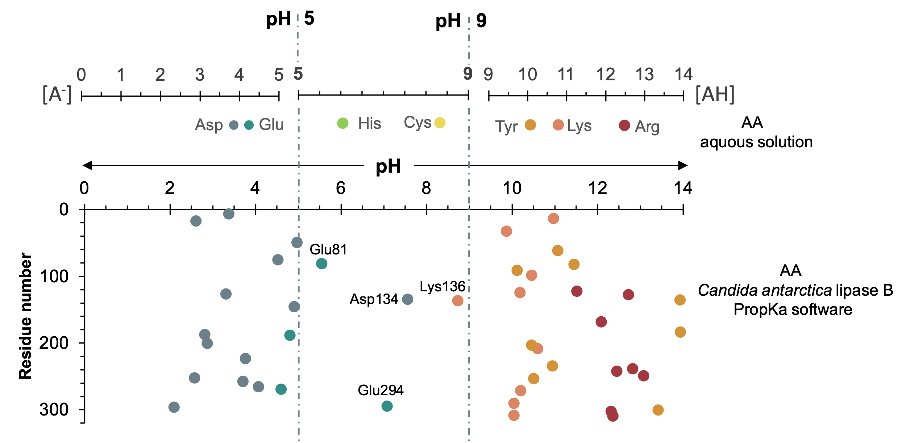

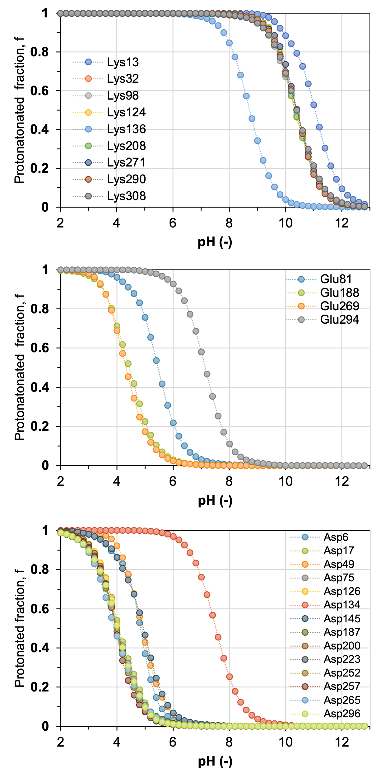
Fig. S11. Titratable curves for Lys residues (top panel), Glu residues (center panel) and Asp residues (bottom panel) of CALB, as obtained by means of the pH constant MD simulations.
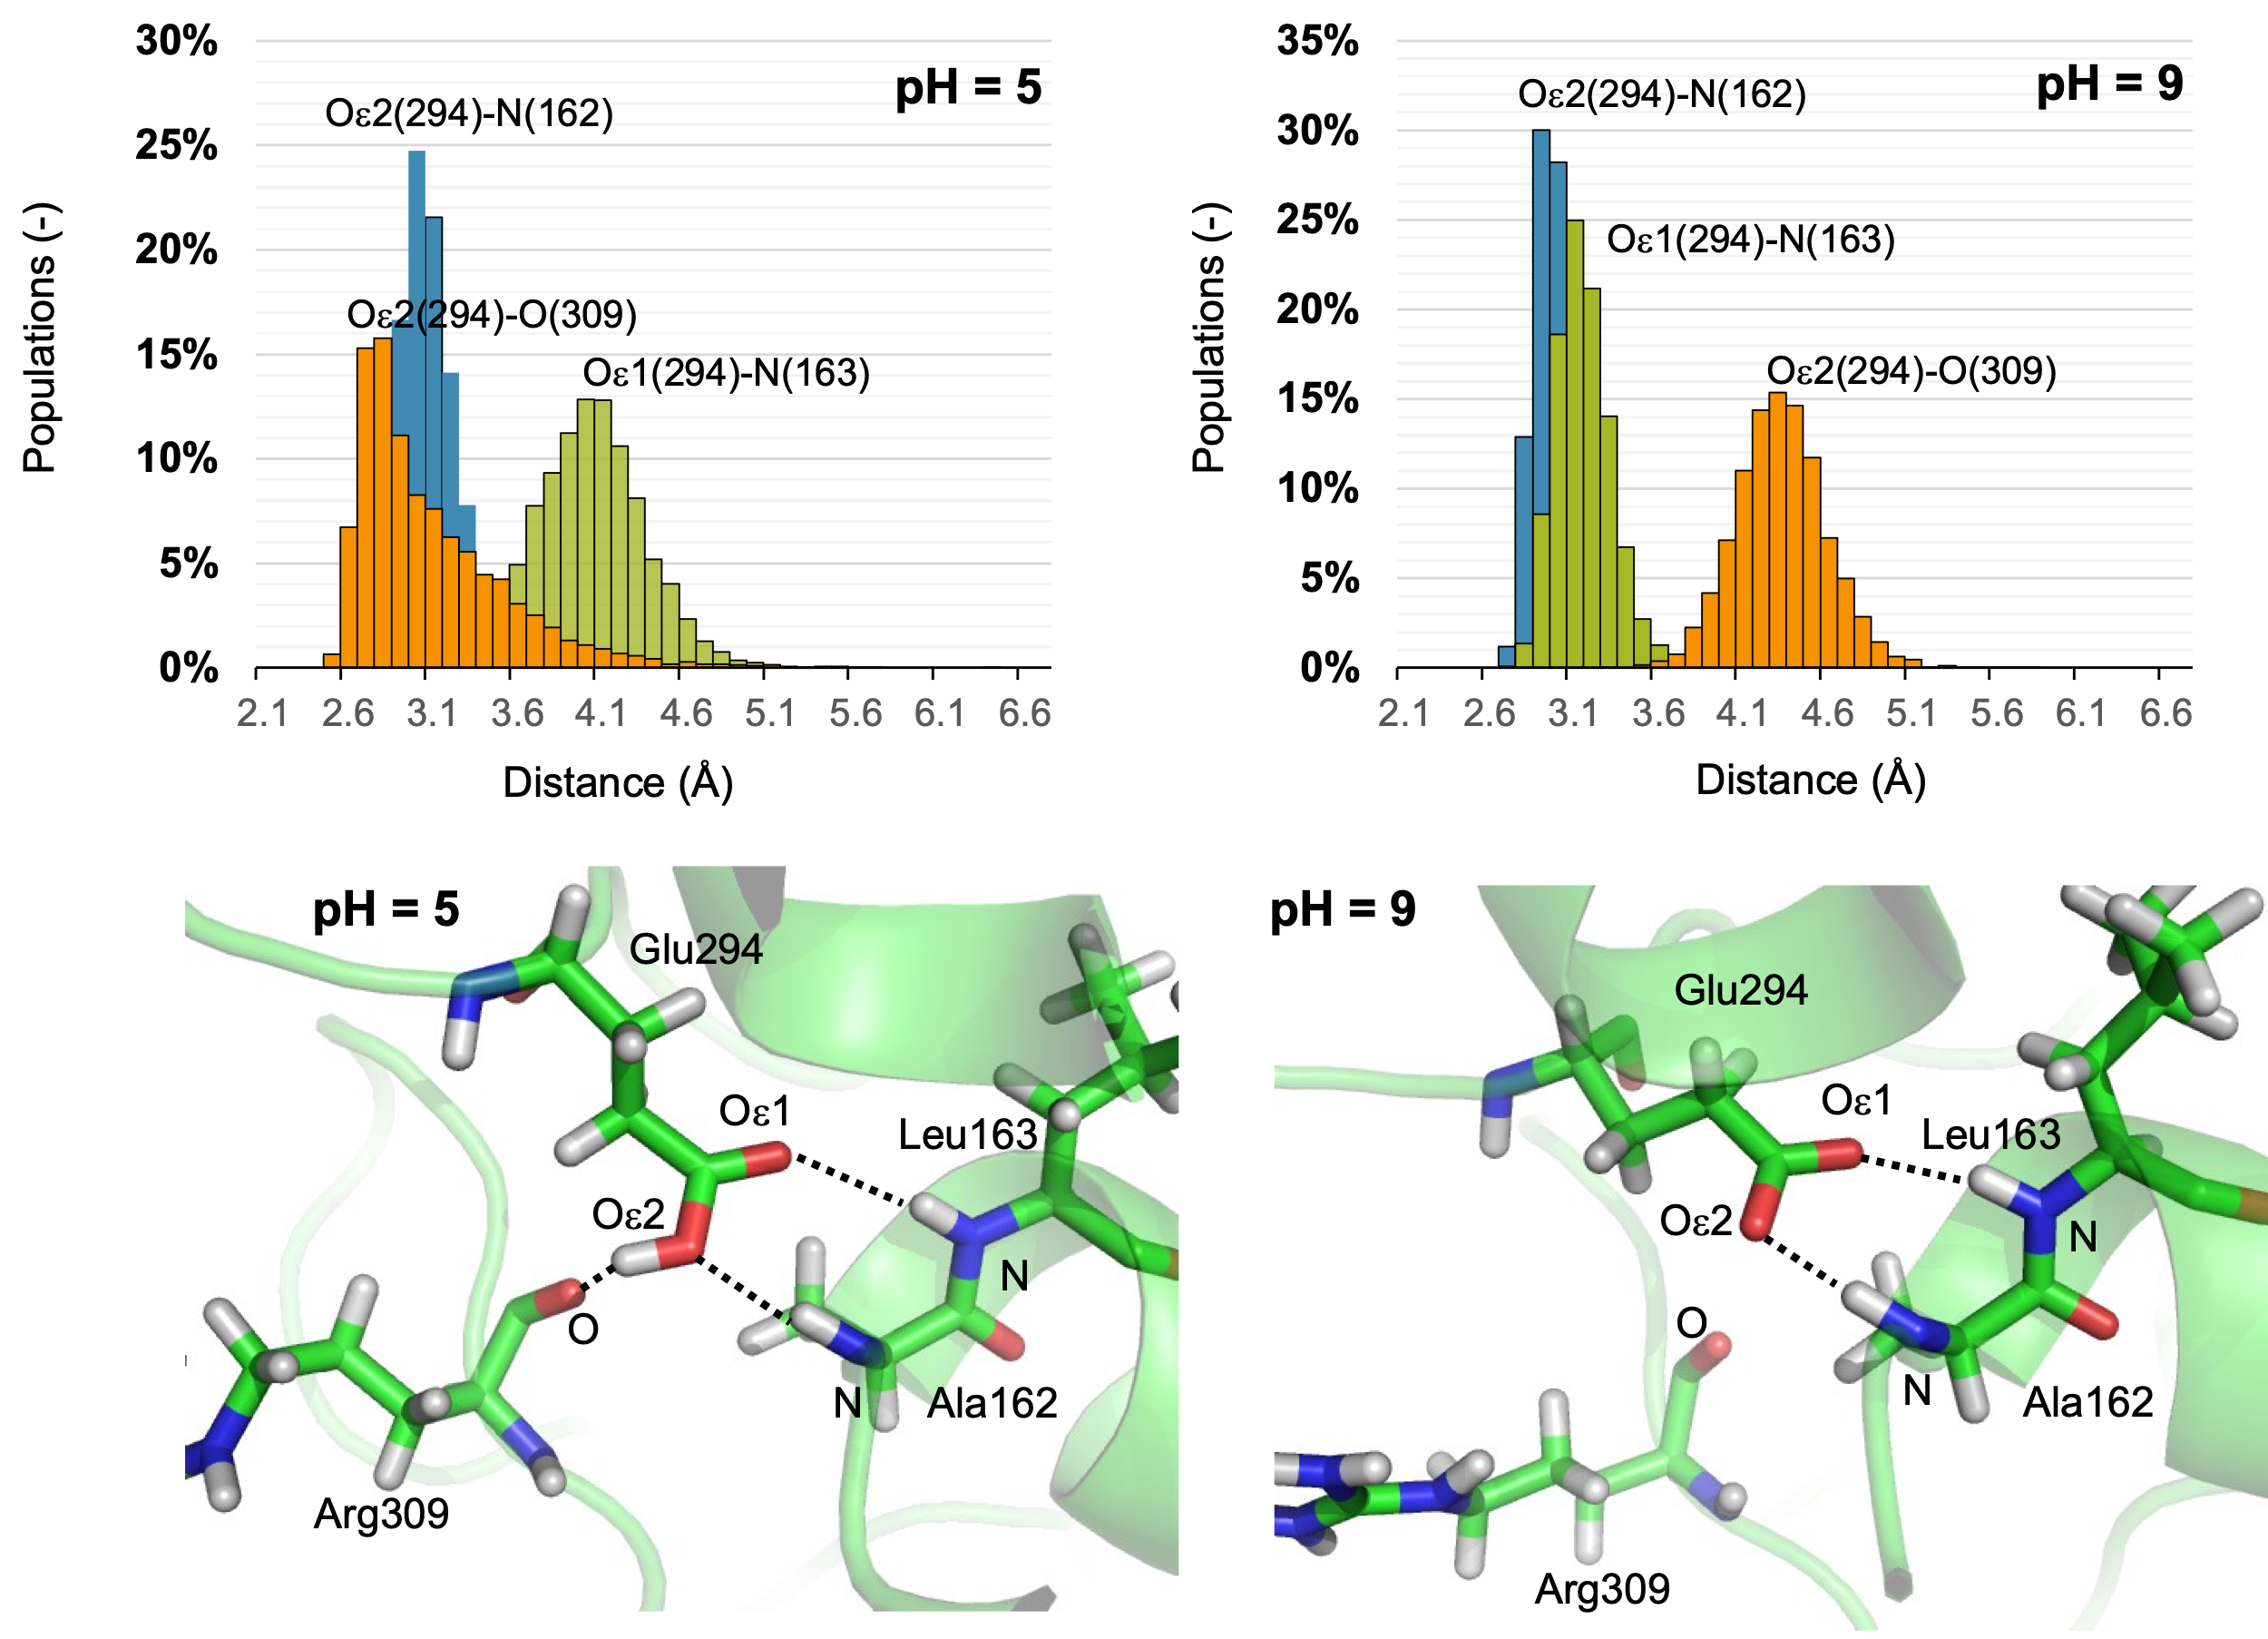

Fig. S12. Geometrical analysis of the pattern of interactions established between Glu294 and its surroundings at pH 5 and pH 9.

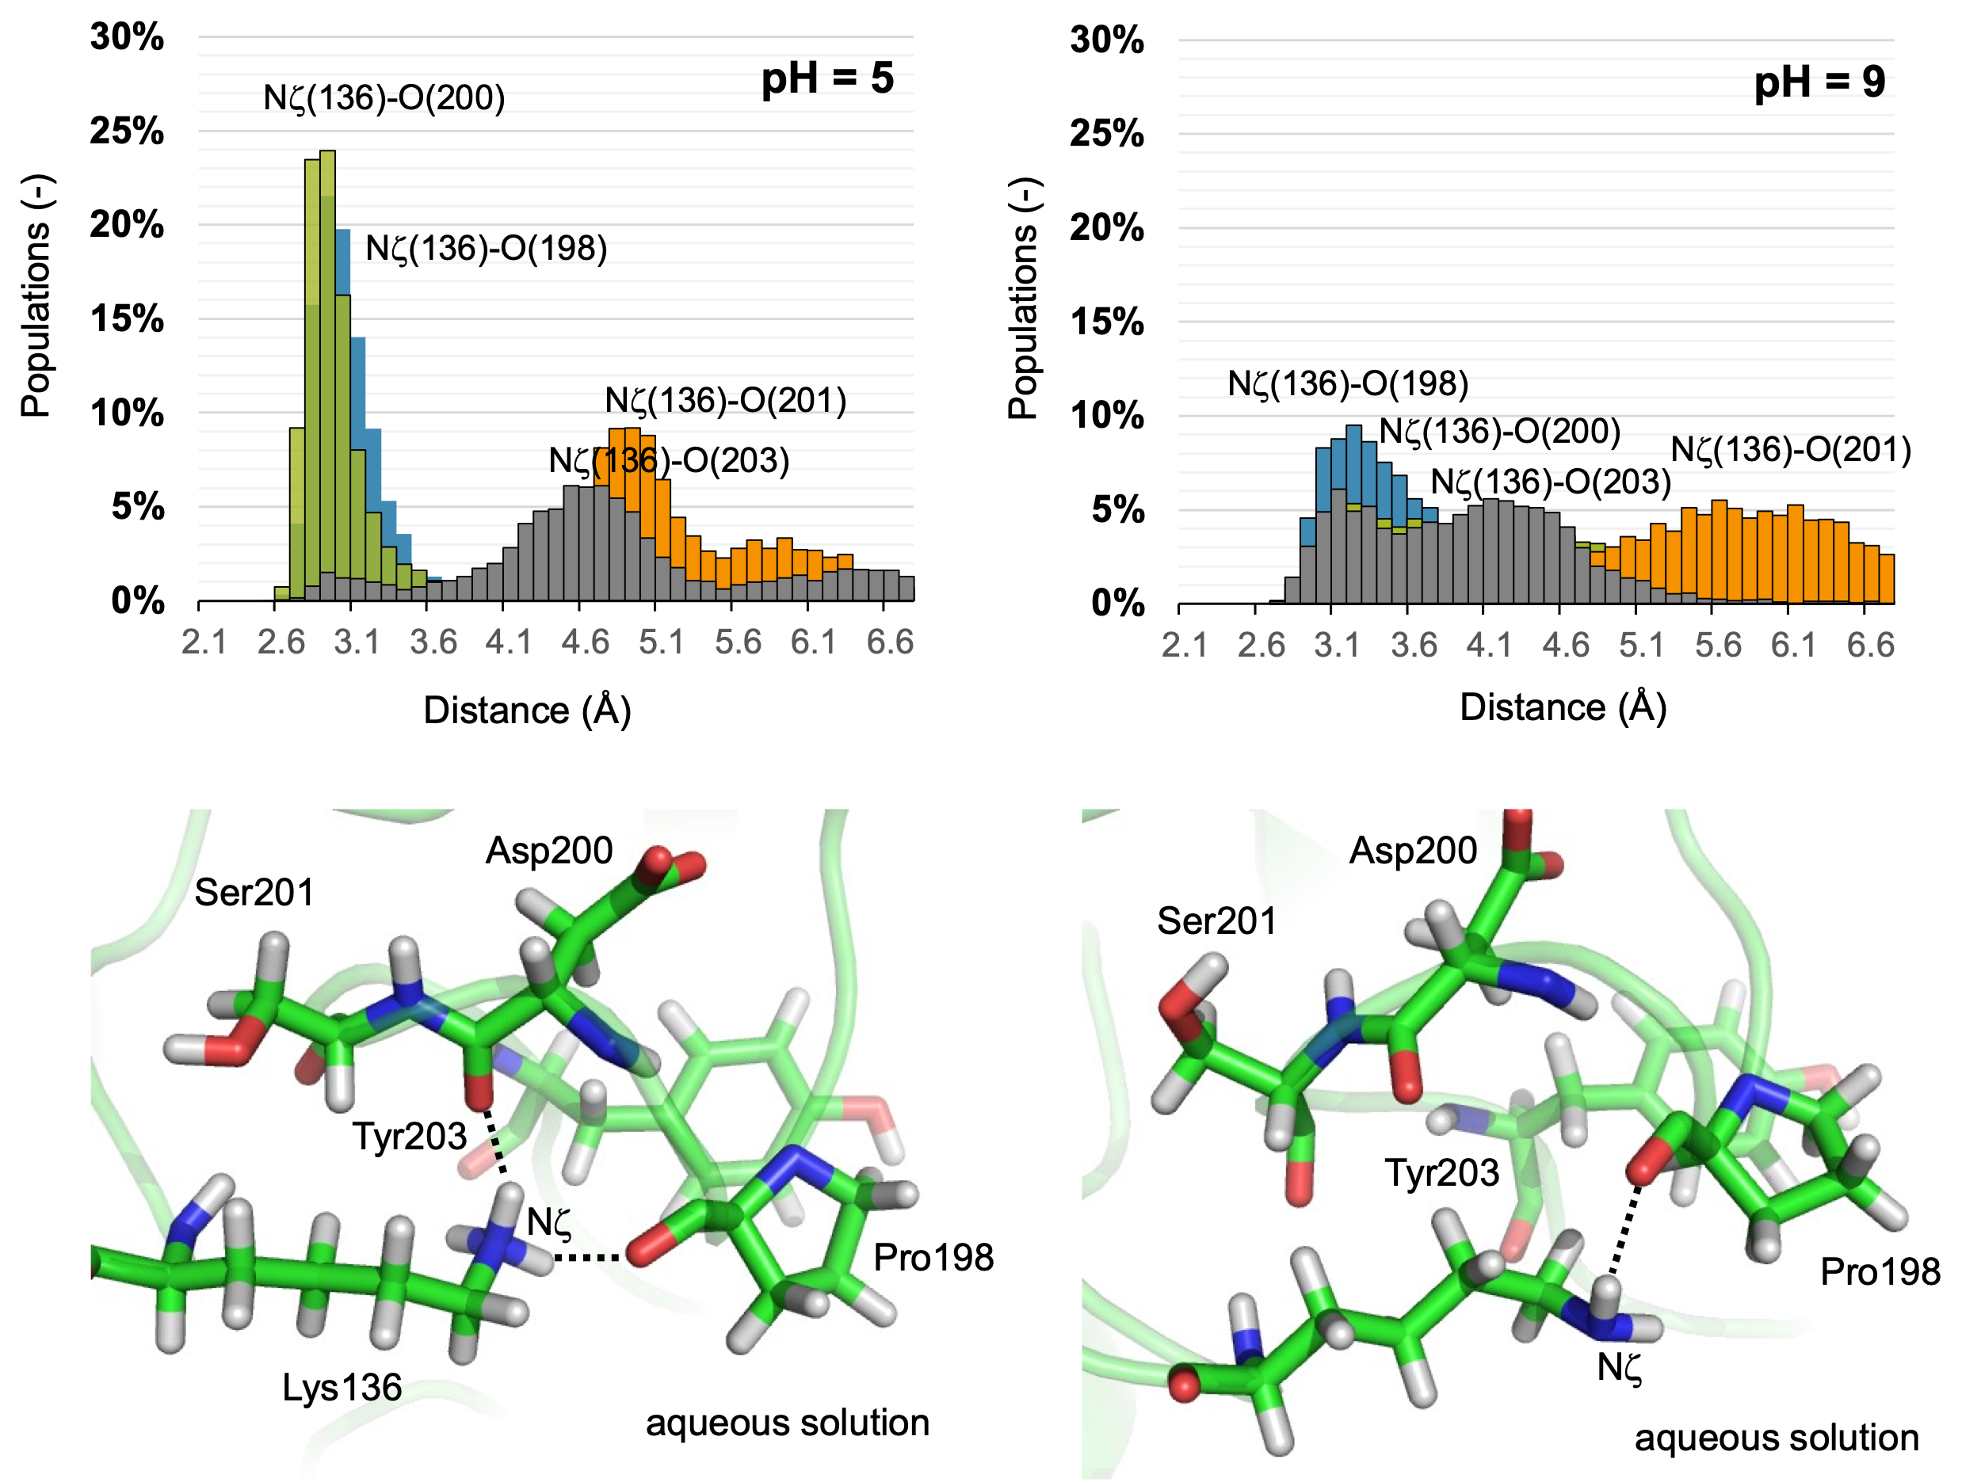
Fig. S13. Geometrical analysis of the pattern of interactions established between Lys136 and its surroundings at pH 5 and pH 9.

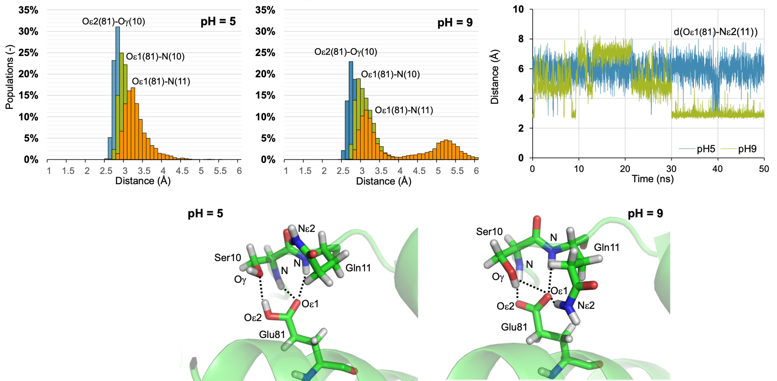
Fig. S14. Geometrical analysis of the pattern of interactions established between Glu81 and its surroundings at pH 5 and pH 9.

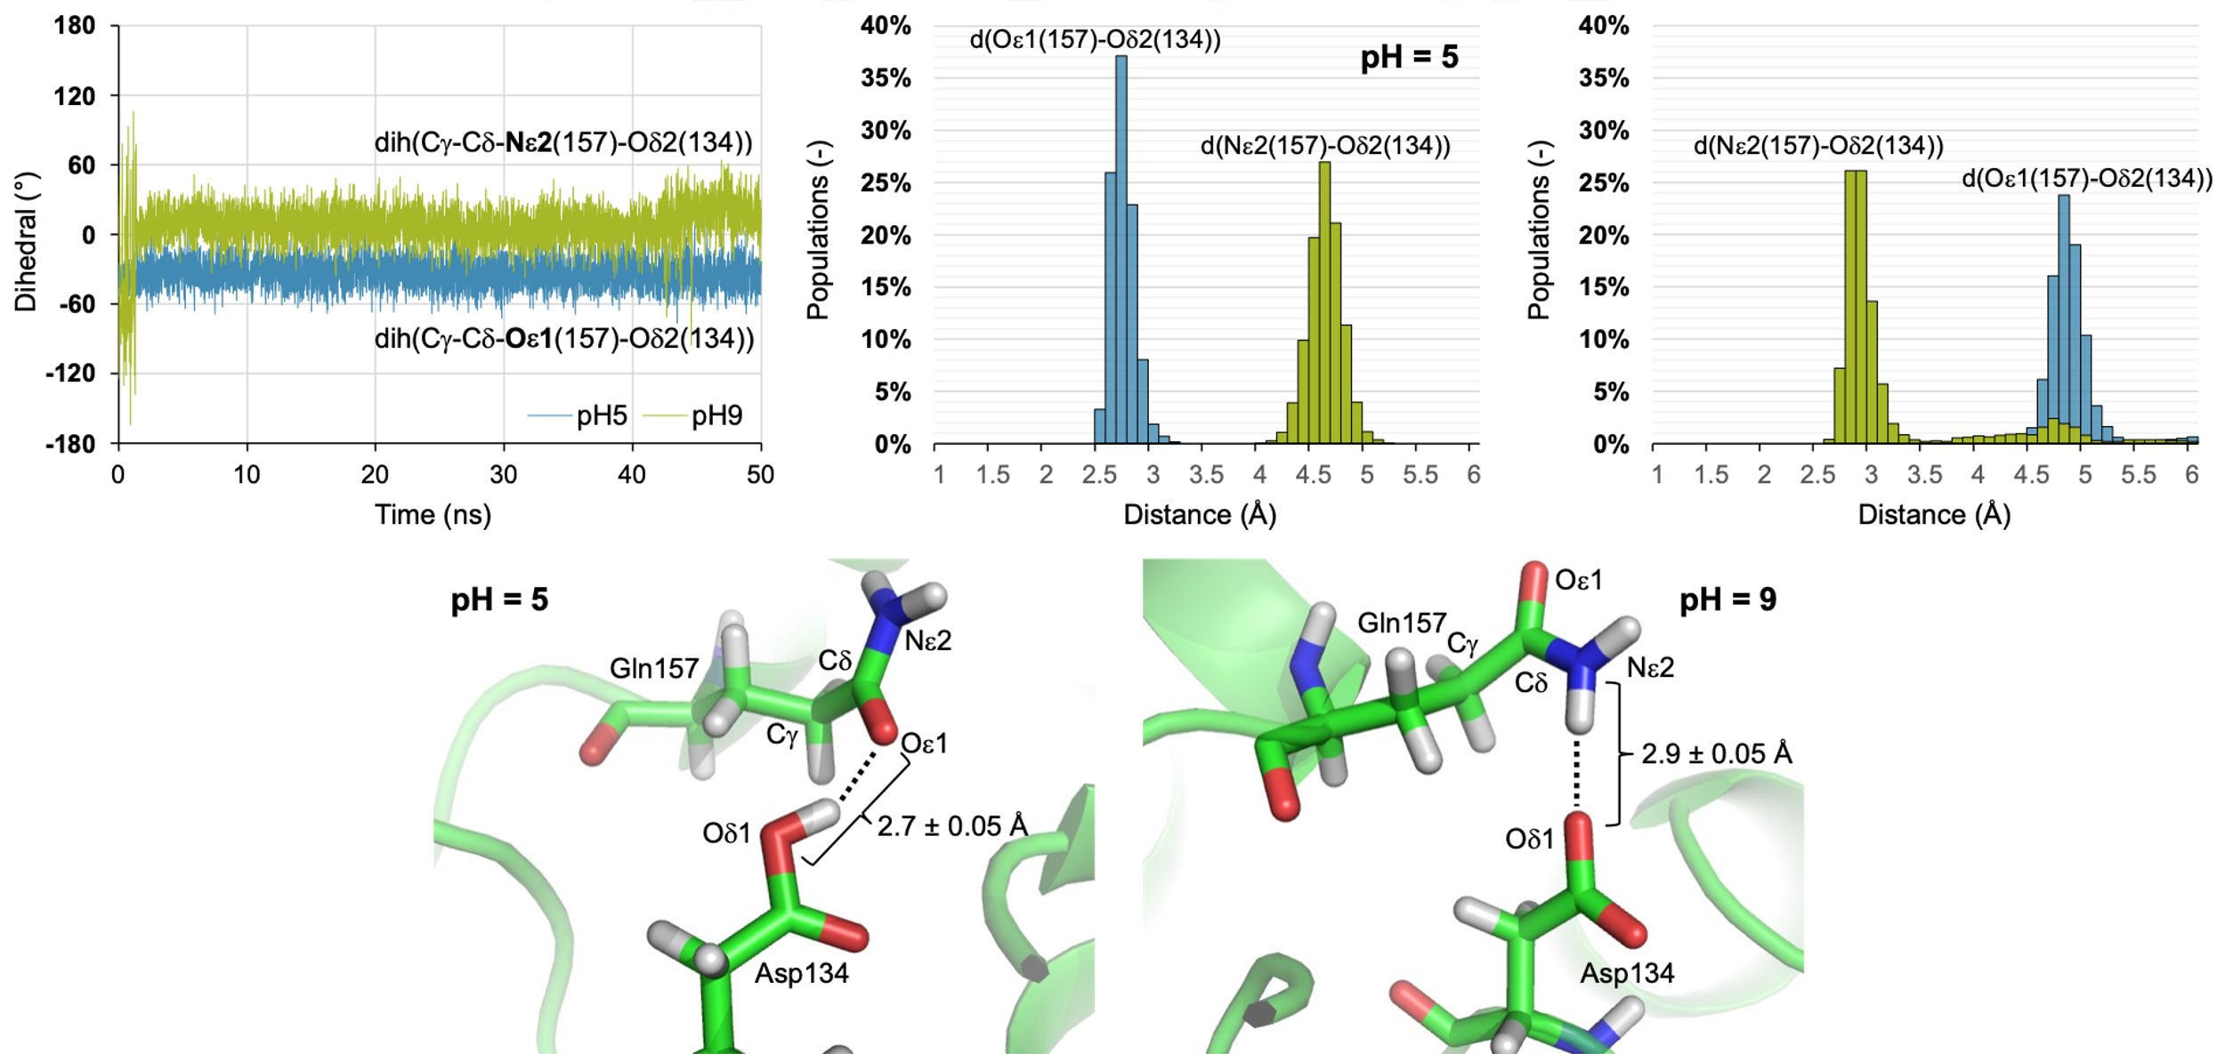

Fig S15. Geometrical analysis of the pattern of interactions established between Gln157 and its surroundings at pH 5 and pH 9.

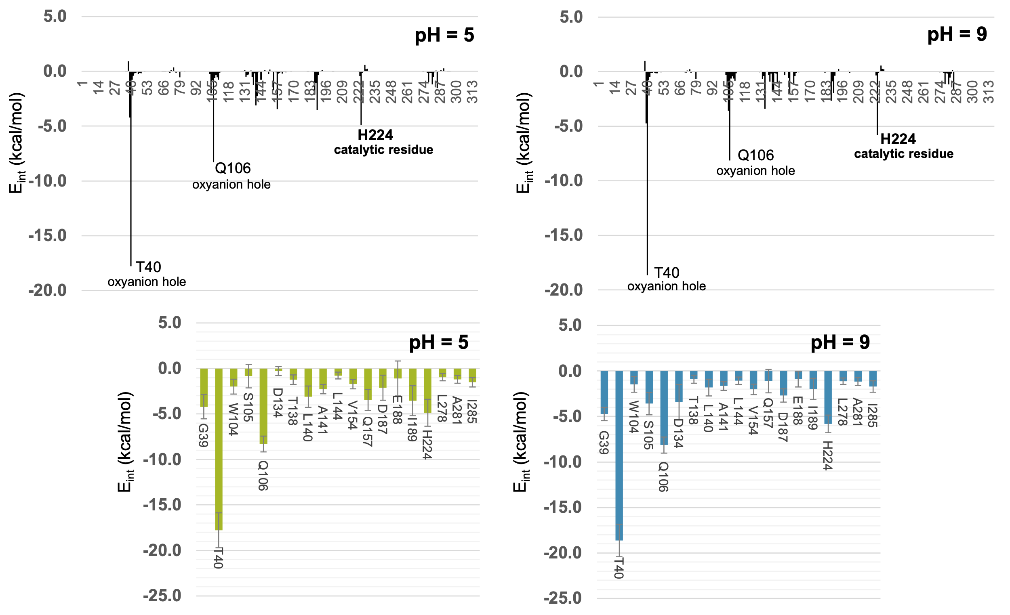
Fig. S16. Interactions between BHET and CALB, decomposed by per residue, obtained over 1000 snapshots generated during the 100 ns of classical MD simulations at pH 5 and at pH 9. Lower panels show those interactions with values larger than 1 kcal·mol-1, including standard deviations as error bars.

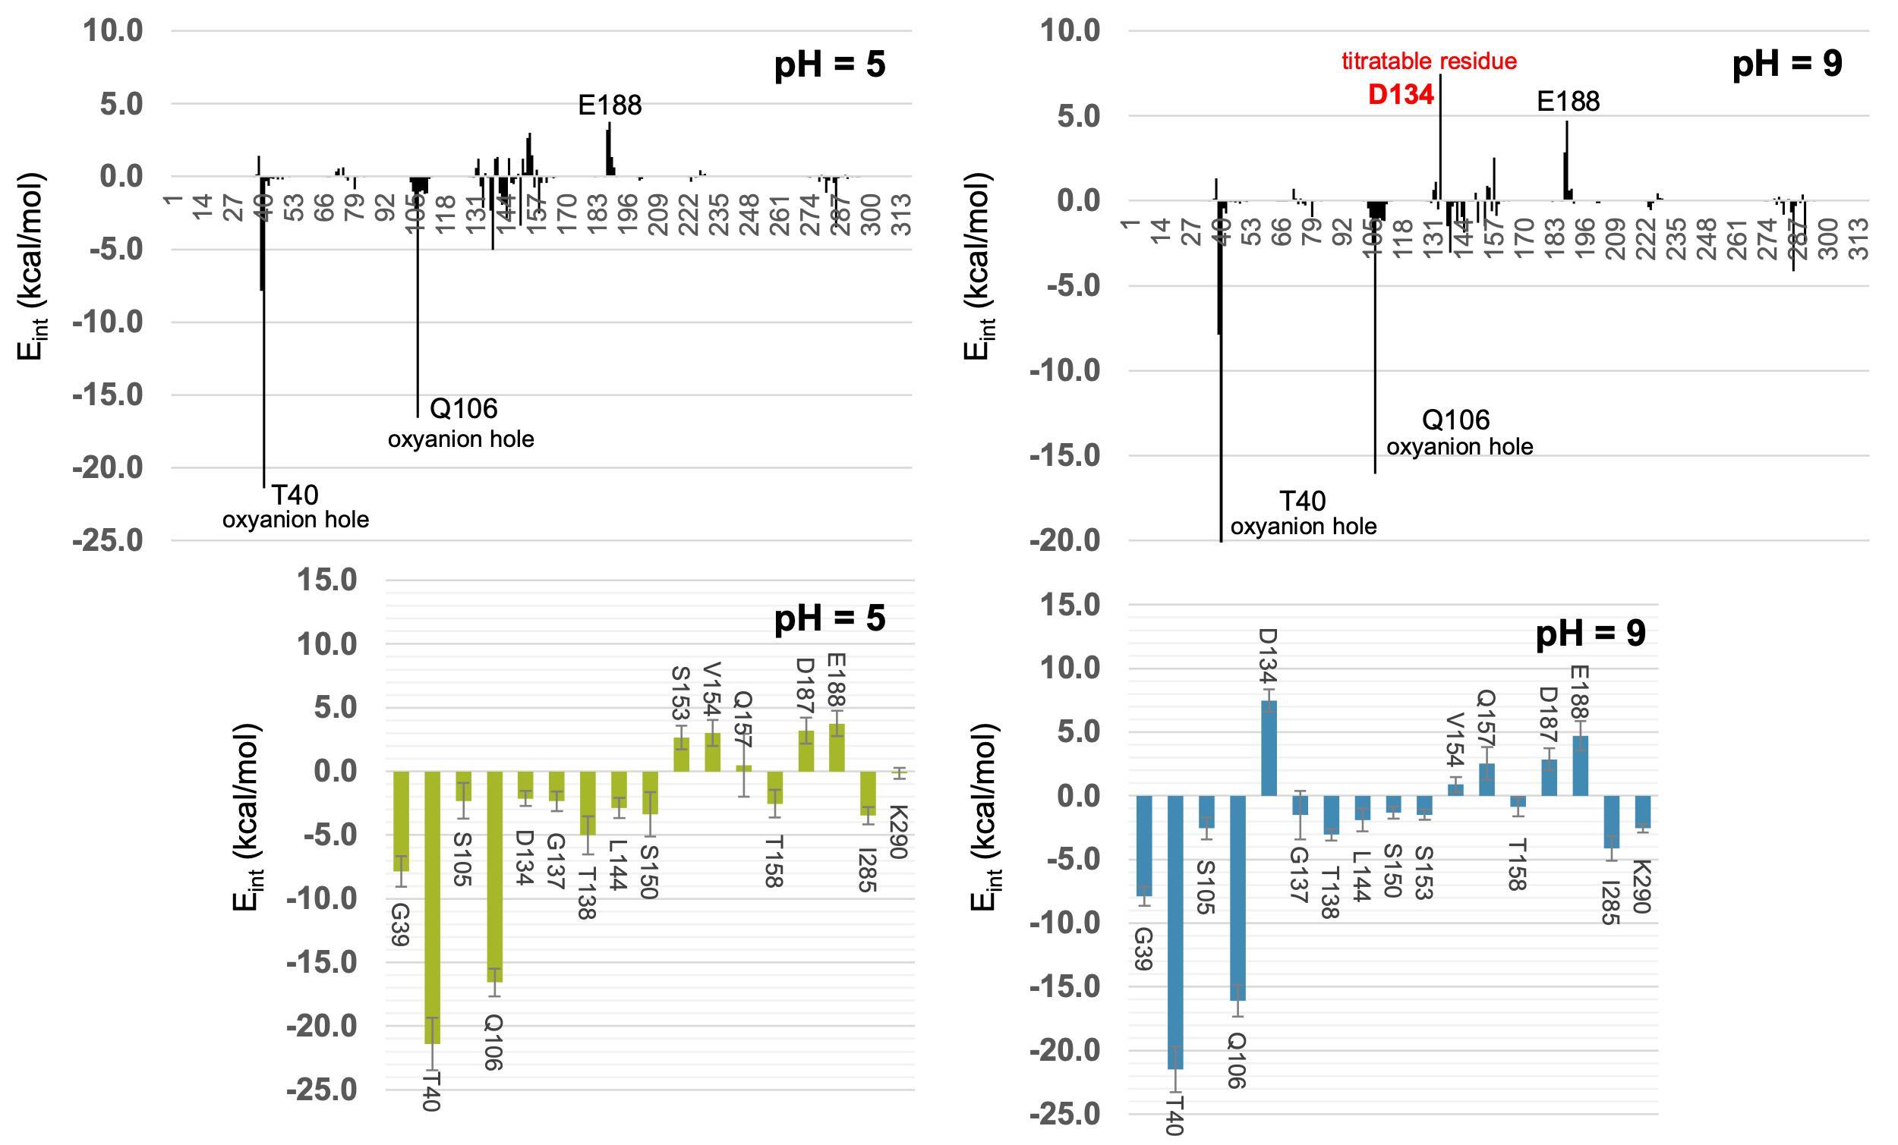
Fig. S17. Interactions between MHET and CALB, decomposed per residue, obtained over 1000 snapshots generated during the 100 ns of classical MD simulations at pH 5 and at pH 9. Lower panels show those interactions with values larger than 1 kcal·mol-1, including standard deviations as error bars.
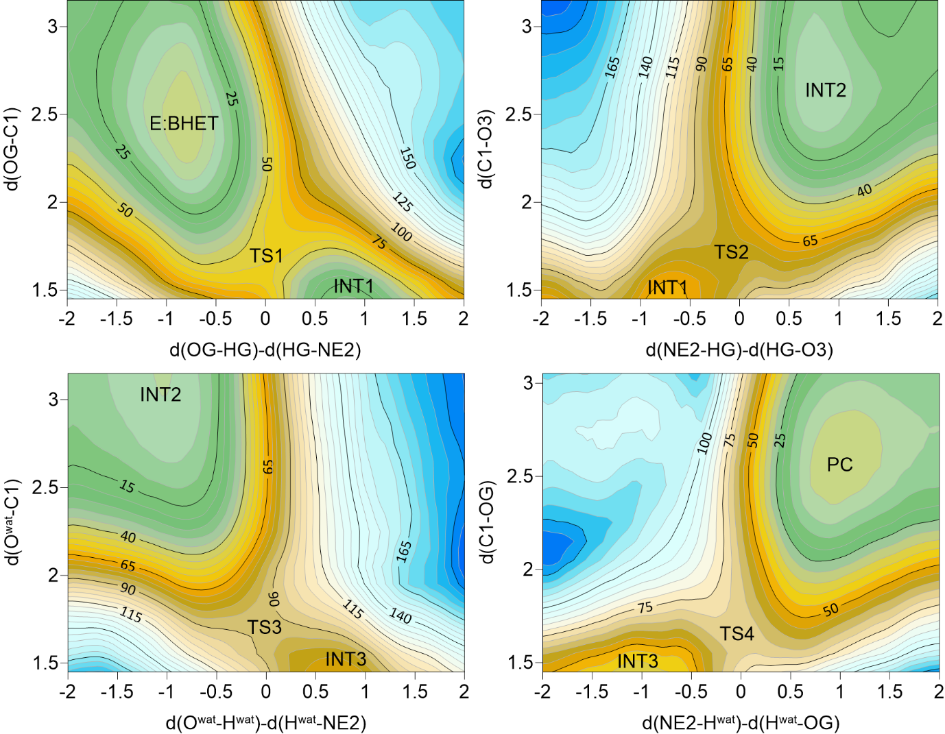
Fig. S18. M06-2X:AM1/MM free energy surfaces corresponding to the hydrolysis of BHET catalyzed by CALB at pH 5. Values of isoenergetic lines are in kJ·mol⁻¹ while values in axis are in Å.

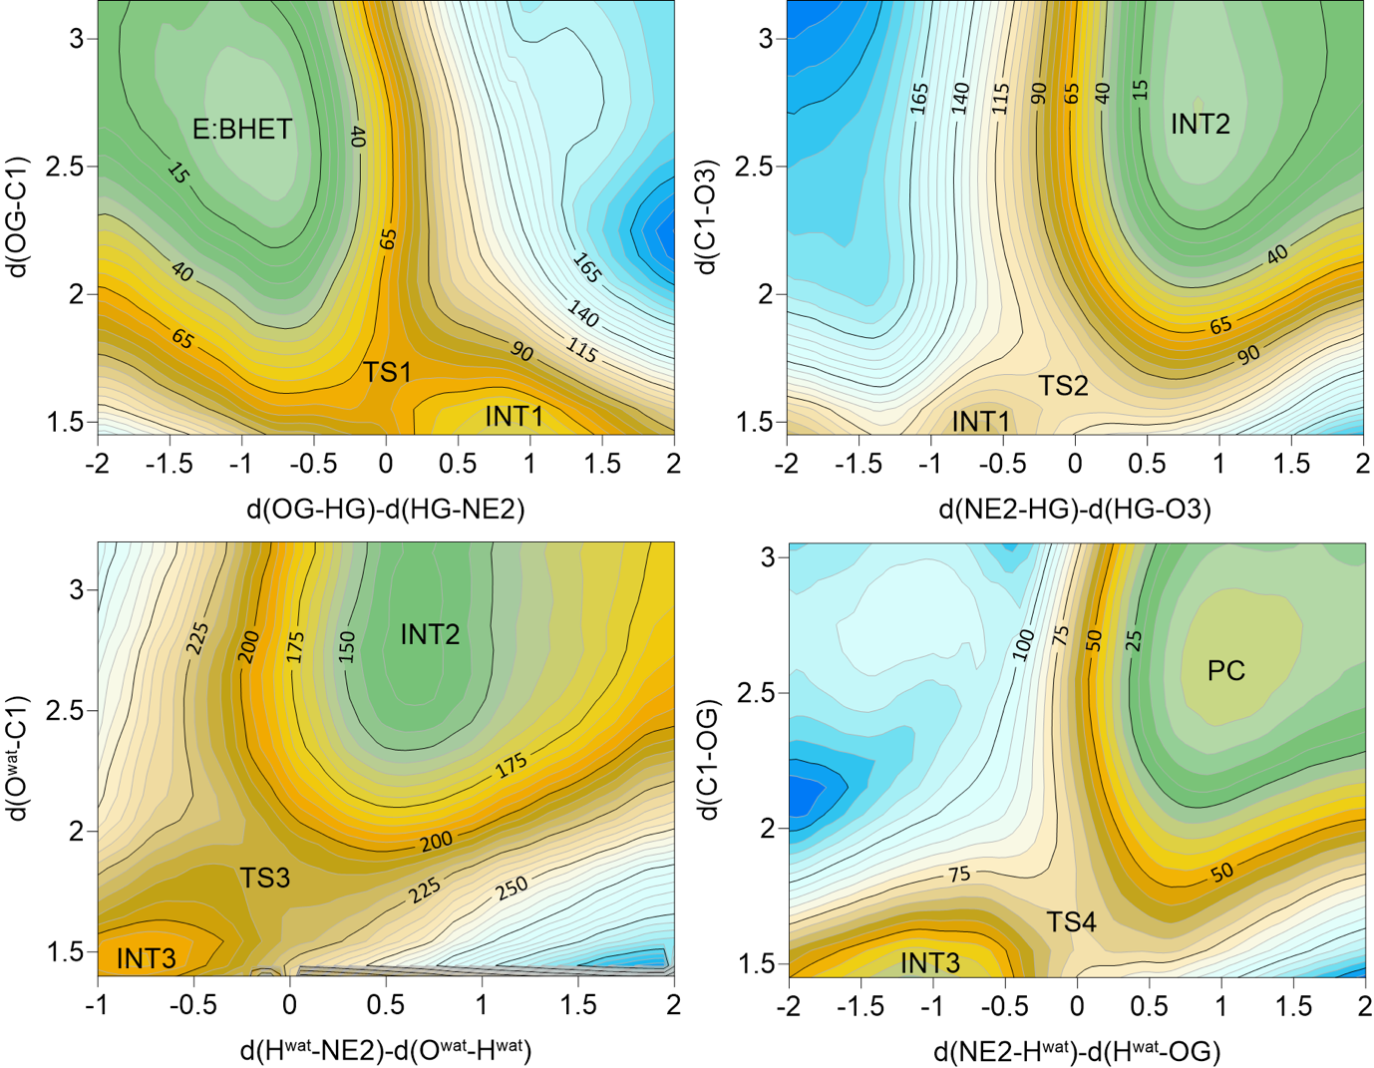

Fig. S19. M06-2X:AM1/MM free energy surfaces corresponding to the hydrolysis of BHET catalyzed by CALB at pH 9. Values of isoenergetic lines are in kJ·mol⁻¹ while values in axis are in Å.

Fig. S20. Schematic representation of the reaction mechanism of the hydrolysis of the BHET/MHET catalysed by CALB. Acylation step: the nucleophilic attack of Ser105 to the carbonyl followed by the breaking of the C-O bond is triggered by His224, rendering the acyl-enzyme complex and EG. Hydrolysis step: the nucleophilic attack of a water molecule followed by the resolution of the acyl-enzyme complex is triggered again by His224, yielding TPA as a product. For BHET R=COOCH₂CH₂OH while for MHET R=COO⁻.

Table S3. M06-2X:AM1/MM relative free energies of the states involved in the hydrolysis of BHET catalyzed by CALB at pH 5 and pH 9, derived from the FESs displayed in Figs S14 and S15 (PMF), and after including zero point vibrational energies corrections from structures optimized at M06-2X/MM level (PMF+ZPE). All values are reported in kcal·mol⁻¹.

PMF
 | RC | TS1 | I1 | TS2 | I2 | TS3 | I3 | TS4 | PC
pH 5 | 0.0 | 13.2 | 4.9 | 8.7 | -9.7 | 7.3 | 2.2 | 9.7 | -6.5
pH 9 | 0.0 | 17.0 | 11.0 | 14.6 | -11.2 | 6.9 | 1.3 | 10.5 | -6.1

PMF + ZPE
 | RC | TS1 | I1 | TS2 | I2 | TS3 | I3 | TS4 | PC
pH 5 | 0.0 | 9.3 | 4.5 | 6.9 | -9.7 | 5.3 | 3.2 | 7.4 | -4.8
pH 9 | 0.0 | 13.2 | 10.1 | 13.4 | -11.5 | 4.1 | 0.3 | 6.5 | -7.1

Table S4. Cartesian coordinates (in Å) of QM atoms and imaginary frequency (in cm⁻¹) for Transition State Structures for the hydrolysis of BHET catalyzed by CALB at pH 5, optimized at M06-2X/MM level.
Transition state 1 (ν‡ = 661.681i) |  |  |  |  | Transition state 2 (ν‡ = 297.576i)
 | Atom | x | y | z |  | Atom | x | y | z
1 | C | 47.349951 | 42.085696 | 45.607653 | 1 | C | 47.220548 | 42.111657 | 45.449273
2 | H | 48.225514 | 42.552510 | 46.073825 | 2 | H | 47.919830 | 42.443563 | 46.224219
3 | H | 46.917080 | 42.890002 | 44.988224 | 3 | H | 46.970751 | 42.998256 | 44.856722
4 | O | 46.448390 | 41.802008 | 46.685584 | 4 | O | 46.047149 | 41.594350 | 46.073049
5 | H | 47.145250 | 41.982482 | 48.102583 | 5 | H | 46.979411 | 42.601886 | 48.523818
6 | C | 50.307332 | 37.836605 | 54.013031 | 6 | C | 50.295083 | 37.840073 | 53.981728
7 | H | 51.378415 | 37.722644 | 53.839332 | 7 | H | 51.367176 | 37.716198 | 53.811441
8 | H | 49.842040 | 36.843836 | 54.013429 | 8 | H | 49.827360 | 36.847819 | 53.966327
9 | C | 49.676634 | 38.633334 | 52.855679 | 9 | C | 49.684837 | 38.634472 | 52.809496
10 | O | 48.476482 | 38.955386 | 52.879133 | 10 | O | 48.481033 | 38.953431 | 52.827418
11 | O | 50.446677 | 38.928392 | 51.874548 | 11 | O | 50.462600 | 38.925171 | 51.835502
12 | C | 49.183766 | 42.185582 | 52.623406 | 12 | C | 49.237068 | 42.120033 | 52.707349
13 | H | 48.783838 | 41.343361 | 53.198831 | 13 | H | 48.901635 | 41.228192 | 53.245959
14 | H | 48.682566 | 43.082386 | 53.000606 | 14 | H | 48.729579 | 42.976753 | 53.157986
15 | C | 48.727722 | 41.960694 | 51.157208 | 15 | C | 48.756937 | 41.995140 | 51.275965
16 | N | 49.025324 | 40.783679 | 50.498945 | 16 | N | 48.966649 | 40.884718 | 50.483547
17 | H | 49.580239 | 40.002642 | 50.933128 | 17 | H | 49.498110 | 40.050890 | 50.810421
18 | C | 48.436008 | 40.767821 | 49.299602 | 18 | C | 48.326692 | 41.041935 | 49.316569
19 | H | 48.505993 | 39.967724 | 48.576450 | 19 | H | 48.315157 | 40.323580 | 48.508291
20 | N | 47.747825 | 41.887956 | 49.104018 | 20 | N | 47.711027 | 42.220995 | 49.305382
21 | C | 47.925157 | 42.653392 | 50.263341 | 21 | C | 47.980759 | 42.830232 | 50.515408
22 | H | 47.447807 | 43.614541 | 50.378093 | 22 | H | 47.587230 | 43.800545 | 50.755258
23 | O | 43.594171 | 45.876867 | 48.516979 | 23 | O | 43.682960 | 45.977920 | 48.489586
24 | H | 43.218943 | 46.285188 | 47.713843 | 24 | H | 43.178775 | 46.502289 | 47.842551
25 | C | 45.005187 | 45.754105 | 48.396360 | 25 | C | 44.844818 | 45.481632 | 47.809477
26 | H | 45.439886 | 46.010051 | 49.370564 | 26 | H | 45.616478 | 46.259291 | 47.770875
27 | H | 45.393482 | 46.460742 | 47.656506 | 27 | H | 44.585599 | 45.199865 | 46.788961
28 | C | 45.460240 | 44.348402 | 48.030826 | 28 | C | 45.364522 | 44.240709 | 48.546842
29 | H | 46.557951 | 44.310325 | 48.055815 | 29 | H | 46.144588 | 44.551220 | 49.257693
30 | H | 45.057923 | 43.609001 | 48.732851 | 30 | H | 44.543715 | 43.822257 | 49.146172
31 | O | 45.040560 | 44.089899 | 46.703488 | 31 | O | 45.946333 | 43.259375 | 47.705880
32 | C | 44.701763 | 42.845667 | 46.255664 | 32 | C | 45.076616 | 42.548162 | 46.398643
33 | O | 44.568748 | 42.785484 | 45.020509 | 33 | O | 44.776379 | 43.403814 | 45.513686
34 | C | 43.781855 | 42.010800 | 47.123472 | 34 | C | 43.919502 | 41.833476 | 47.080990
35 | C | 42.855998 | 42.638767 | 47.965651 | 35 | C | 42.919910 | 42.561013 | 47.739939
36 | C | 41.873363 | 41.893413 | 48.614815 | 36 | C | 41.869678 | 41.904885 | 48.374162
37 | H | 41.161368 | 42.381805 | 49.272238 | 37 | H | 41.130936 | 42.467620 | 48.936334
38 | H | 42.888912 | 43.714428 | 48.114817 | 38 | H | 42.961147 | 43.645981 | 47.772935
39 | C | 43.698640 | 40.631211 | 46.916342 | 39 | C | 43.784369 | 40.448786 | 46.961988
40 | H | 44.418274 | 40.166285 | 46.252306 | 40 | H | 44.530701 | 39.894329 | 46.406977
41 | C | 42.704604 | 39.888562 | 47.544599 | 41 | C | 42.697972 | 39.794862 | 47.531940
42 | H | 42.618525 | 38.819709 | 47.371485 | 42 | H | 42.573180 | 38.722682 | 47.414724
43 | C | 41.793082 | 40.515508 | 48.403260 | 43 | C | 41.763515 | 40.513043 | 48.277640
44 | C | 40.754111 | 39.686711 | 49.080259 | 44 | C | 40.702562 | 39.741659 | 48.976911
45 | O | 40.471195 | 38.546267 | 48.782991 | 45 | O | 40.368763 | 38.610981 | 48.692985
46 | O | 40.159762 | 40.346777 | 50.094028 | 46 | O | 40.175831 | 40.422533 | 50.013197
47 | C | 39.069486 | 39.699186 | 50.767344 | 47 | C | 39.145540 | 39.765533 | 50.766723
48 | H | 38.559781 | 40.506440 | 51.295417 | 48 | H | 38.687168 | 40.562176 | 51.354607
49 | H | 38.391704 | 39.249996 | 50.035655 | 49 | H | 38.406852 | 39.330130 | 50.088499
50 | C | 39.566370 | 38.642226 | 51.741087 | 50 | C | 39.731789 | 38.695093 | 51.671909
51 | H | 38.737926 | 38.338242 | 52.386850 | 51 | H | 38.948236 | 38.321655 | 52.336256
52 | H | 39.932291 | 37.764745 | 51.199579 | 52 | H | 40.118114 | 37.862490 | 51.076327
53 | O | 40.588521 | 39.146824 | 52.598684 | 53 | O | 40.760748 | 39.217580 | 52.511286
54 | H | 41.406155 | 39.202423 | 52.090491 | 54 | H | 41.552559 | 39.343681 | 51.975323
55 | H | 50.161690 | 42.246544 | 52.823275 | 55 | H | 50.221860 | 42.213717 | 52.853666
56 | H | 50.200371 | 38.239431 | 54.922036 | 56 | H | 50.181708 | 38.238955 | 54.891694
57 | H | 47.707121 | 41.395650 | 44.978156 | 57 | H | 47.657763 | 41.417084 | 44.877948
Transition state 3 (ν‡ = 777.043i) |  |  |  |  | Transition state 4 (ν‡ = 1240.238i)
 | Atom | x | y | z |  | Atom | x | y | z
1 | C | 47.153964 | 42.041455 | 45.380072 | 1 | C | 47.334794 | 42.285743 | 45.621645
2 | H | 47.825885 | 42.344689 | 46.190704 | 2 | H | 48.192055 | 42.744516 | 46.121038
3 | H | 46.902039 | 42.936854 | 44.802557 | 3 | H | 46.875588 | 43.077091 | 45.022028
4 | O | 45.974177 | 41.469634 | 45.940862 | 4 | O | 46.416699 | 41.911928 | 46.672566
5 | H | 46.796672 | 42.649979 | 48.501259 | 5 | H | 47.049573 | 42.003181 | 47.892331
6 | C | 50.382535 | 37.912384 | 53.968168 | 6 | C | 50.286941 | 37.877167 | 53.992816
7 | H | 51.456613 | 37.861431 | 53.780650 | 7 | H | 51.358879 | 37.762413 | 53.823391
8 | H | 49.978992 | 36.893044 | 53.936528 | 8 | H | 49.820489 | 36.885242 | 53.975788
9 | C | 49.691518 | 38.682183 | 52.810872 | 9 | C | 49.667353 | 38.682658 | 52.834177
10 | O | 48.486539 | 38.979817 | 52.868587 | 10 | O | 48.469660 | 39.018440 | 52.860928
11 | O | 50.408006 | 38.955753 | 51.786736 | 11 | O | 50.438640 | 38.956867 | 51.849566
12 | C | 49.206883 | 42.219357 | 52.743494 | 12 | C | 49.177334 | 42.243070 | 52.505659
13 | H | 48.853360 | 41.347368 | 53.302594 | 13 | H | 48.750132 | 41.416123 | 53.082722
14 | H | 48.723696 | 43.097368 | 53.182372 | 14 | H | 48.685405 | 43.154822 | 52.858963
15 | C | 48.702401 | 42.085293 | 51.314678 | 15 | C | 48.724180 | 42.007973 | 51.035930
16 | N | 48.935215 | 40.976491 | 50.527487 | 16 | N | 48.983376 | 40.810235 | 50.399420
17 | H | 49.476106 | 40.148914 | 50.847009 | 17 | H | 49.524881 | 40.032519 | 50.839464
18 | C | 48.275064 | 41.110315 | 49.366529 | 18 | C | 48.378047 | 40.787352 | 49.204563
19 | H | 48.281678 | 40.380660 | 48.568356 | 19 | H | 48.431871 | 39.964877 | 48.505335
20 | N | 47.619642 | 42.264846 | 49.347202 | 20 | N | 47.713472 | 41.918101 | 48.986046
21 | C | 47.888935 | 42.887857 | 50.549957 | 21 | C | 47.930123 | 42.698471 | 50.129834
22 | H | 47.456568 | 43.845598 | 50.779874 | 22 | H | 47.490505 | 43.680105 | 50.224940
23 | H | 46.235973 | 43.938348 | 47.289885 | 23 | H | 45.574240 | 43.740542 | 47.971285
24 | O | 45.899293 | 43.130773 | 47.705129 | 24 | O | 45.231292 | 43.981235 | 47.100845
25 | C | 45.039288 | 42.404306 | 46.363630 | 25 | C | 44.900148 | 42.800460 | 46.417775
26 | O | 44.749911 | 43.354438 | 45.579552 | 26 | O | 44.700052 | 42.970107 | 45.185093
27 | C | 43.899449 | 41.691704 | 47.068769 | 27 | C | 43.892870 | 41.932032 | 47.161745
28 | C | 43.050541 | 42.407493 | 47.918532 | 28 | C | 42.999209 | 42.541235 | 48.048720
29 | C | 41.975886 | 41.775769 | 48.534136 | 29 | C | 41.970546 | 41.804328 | 48.631674
30 | H | 41.334603 | 42.323898 | 49.216367 | 30 | H | 41.278920 | 42.279763 | 49.318637
31 | H | 43.251406 | 43.454553 | 48.120875 | 31 | H | 43.090611 | 43.599618 | 48.278672
32 | C | 43.627302 | 40.351576 | 46.790688 | 32 | C | 43.726239 | 40.580550 | 46.838530
33 | H | 44.267688 | 39.807268 | 46.106261 | 33 | H | 44.402338 | 40.121239 | 46.124791
34 | C | 42.540486 | 39.719445 | 47.388976 | 34 | C | 42.699530 | 39.841442 | 47.418511
35 | H | 42.321167 | 38.676436 | 47.181161 | 35 | H | 42.561128 | 38.791600 | 47.174563
36 | C | 41.729099 | 40.420013 | 48.280839 | 36 | C | 41.824363 | 40.449457 | 48.327467
37 | C | 40.653290 | 39.663577 | 48.979402 | 37 | C | 40.765465 | 39.625726 | 48.981531
38 | O | 40.293572 | 38.543462 | 48.686718 | 38 | O | 40.462611 | 38.496185 | 48.665929
39 | O | 40.140089 | 40.348943 | 50.019340 | 39 | O | 40.187207 | 40.283220 | 50.006583
40 | C | 39.094495 | 39.714875 | 50.771675 | 40 | C | 39.113631 | 39.638789 | 50.707810
41 | H | 38.624303 | 40.528059 | 51.326580 | 41 | H | 38.582248 | 40.453884 | 51.201363
42 | H | 38.368893 | 39.257438 | 50.093899 | 42 | H | 38.449517 | 39.135267 | 49.999610
43 | C | 39.670402 | 38.673428 | 51.716294 | 43 | C | 39.654194 | 38.646106 | 51.724465
44 | H | 38.884775 | 38.330500 | 52.394680 | 44 | H | 38.844050 | 38.341855 | 52.392678
45 | H | 40.050794 | 37.815849 | 51.152402 | 45 | H | 40.047423 | 37.757900 | 51.218999
46 | O | 40.704147 | 39.216720 | 52.535037 | 46 | O | 40.665727 | 39.223099 | 52.546526
47 | H | 41.486567 | 39.347571 | 51.986126 | 47 | H | 41.459016 | 39.333221 | 52.009220
48 | H | 50.194348 | 42.292496 | 52.883364 | 48 | H | 50.151294 | 42.287372 | 52.728012
49 | H | 50.263376 | 38.266519 | 54.895740 | 49 | H | 50.177752 | 38.263858 | 54.908539
50 | H | 47.627266 | 41.380951 | 44.797217 | 50 | H | 47.678686 | 41.574673 | 45.008360

Table S5. Cartesian coordinates (in Å) of QM atoms and imaginary frequency (in cm⁻¹) for Transition State Structures for the hydrolysis of BHET catalyzed by CALB at pH 9, optimized at M06-2X/MM level.
Transition state 1 (ν‡ = 1214.242i) |  |  |  |  | Transition state 2 (ν‡ = 135.889i)
 | Atom | x | y | z |  | Atom | x | y | z
1 | C | 52.514488 | 45.258857 | 43.534152 | 1 | C | 52.222069 | 45.172088 | 43.616679
2 | H | 53.509230 | 45.201419 | 43.081111 | 2 | H | 53.283068 | 45.220160 | 43.328453
3 | H | 51.904755 | 45.866048 | 42.862888 | 3 | H | 51.678063 | 45.718761 | 42.839185
4 | O | 52.728203 | 46.031822 | 44.753150 | 4 | O | 52.068902 | 45.842699 | 44.865962
5 | H | 54.050610 | 46.116957 | 45.097828 | 5 | H | 54.709142 | 46.532328 | 45.063460
6 | C | 59.756868 | 43.168511 | 50.055409 | 6 | C | 59.717438 | 43.168911 | 50.038012
7 | H | 60.178809 | 42.318588 | 49.515096 | 7 | H | 60.138479 | 42.330802 | 49.477197
8 | H | 59.211265 | 42.772451 | 50.919483 | 8 | H | 59.184774 | 42.745845 | 50.897551
9 | C | 58.709058 | 43.840927 | 49.140403 | 9 | C | 58.651270 | 43.835049 | 49.149586
10 | O | 58.276207 | 44.987044 | 49.420837 | 10 | O | 58.243762 | 44.992854 | 49.417305
11 | O | 58.311295 | 43.180055 | 48.137538 | 11 | O | 58.206361 | 43.162105 | 48.168020
12 | C | 58.863011 | 46.384652 | 46.691209 | 12 | C | 59.066546 | 46.419188 | 46.785812
13 | H | 58.856923 | 46.262207 | 47.777996 | 13 | H | 59.085071 | 46.279526 | 47.869305
14 | H | 59.052238 | 47.442656 | 46.483860 | 14 | H | 59.309956 | 47.465250 | 46.580036
15 | C | 57.425683 | 46.054938 | 46.212962 | 15 | C | 57.648914 | 46.156627 | 46.324512
16 | N | 56.875494 | 44.804026 | 46.421546 | 16 | N | 56.991763 | 44.958962 | 46.554314
17 | H | 57.342150 | 44.072165 | 47.005619 | 17 | H | 57.390155 | 44.173339 | 47.159023
18 | C | 55.613163 | 44.788402 | 45.964373 | 18 | C | 55.763438 | 45.021465 | 46.041383
19 | H | 54.953124 | 43.933046 | 45.996434 | 19 | H | 55.006138 | 44.250069 | 46.063925
20 | N | 55.268946 | 45.972471 | 45.472251 | 20 | N | 55.592367 | 46.221670 | 45.491161
21 | C | 56.404151 | 46.778857 | 45.618657 | 21 | C | 56.755991 | 46.950951 | 45.654274
22 | H | 56.397869 | 47.813089 | 45.307843 | 22 | H | 56.844722 | 47.966191 | 45.302669
23 | O | 53.222955 | 51.076308 | 44.144323 | 23 | O | 52.935119 | 51.078949 | 44.249975
24 | H | 52.375440 | 51.222272 | 43.679425 | 24 | H | 52.168601 | 51.274420 | 43.671863
25 | C | 53.965524 | 50.047567 | 43.525851 | 25 | C | 53.797078 | 50.121641 | 43.670694
26 | H | 55.027285 | 50.307686 | 43.633511 | 26 | H | 54.810398 | 50.554819 | 43.687027
27 | H | 53.740204 | 49.986392 | 42.454313 | 27 | H | 53.532481 | 49.913776 | 42.628048
28 | C | 53.749591 | 48.672271 | 44.148305 | 28 | C | 53.877163 | 48.779707 | 44.414851
29 | H | 54.436511 | 47.957294 | 43.666864 | 29 | H | 54.872917 | 48.388988 | 44.124731
30 | H | 53.972689 | 48.704605 | 45.223849 | 30 | H | 53.896997 | 48.960936 | 45.500342
31 | O | 52.414774 | 48.291065 | 43.905423 | 31 | O | 52.940371 | 47.815043 | 44.016452
32 | C | 51.738432 | 47.365017 | 44.743040 | 32 | C | 51.700013 | 47.230251 | 44.720969
33 | O | 50.635393 | 47.033786 | 44.201314 | 33 | O | 50.680689 | 47.388515 | 43.939986
34 | C | 51.661588 | 47.839644 | 46.211539 | 34 | C | 51.544457 | 47.788663 | 46.154982
35 | C | 51.882570 | 49.193404 | 46.522107 | 35 | C | 51.672955 | 49.163182 | 46.418017
36 | C | 51.691084 | 49.681063 | 47.812369 | 36 | C | 51.529873 | 49.677206 | 47.703912
37 | H | 51.898816 | 50.723375 | 48.033828 | 37 | H | 51.690835 | 50.736124 | 47.884479
38 | H | 52.208267 | 49.888518 | 45.755975 | 38 | H | 51.906497 | 49.855136 | 45.618084
39 | C | 51.175282 | 46.993970 | 47.216754 | 39 | C | 51.148205 | 46.954234 | 47.208212
40 | H | 50.877545 | 45.958382 | 47.019425 | 40 | H | 50.908780 | 45.901589 | 47.050604
41 | C | 50.960885 | 47.491935 | 48.505318 | 41 | C | 50.948921 | 47.476394 | 48.488807
42 | H | 50.573537 | 46.827777 | 49.270522 | 42 | H | 50.621287 | 46.813317 | 49.282339
43 | C | 51.240563 | 48.827185 | 48.823724 | 43 | C | 51.183681 | 48.828378 | 48.762021
44 | C | 51.106884 | 49.282204 | 50.237261 | 44 | C | 51.106795 | 49.295100 | 50.172138
45 | O | 50.532871 | 48.675021 | 51.114997 | 45 | O | 50.572122 | 48.695010 | 51.080103
46 | O | 51.726256 | 50.470023 | 50.479913 | 46 | O | 51.740001 | 50.483866 | 50.385268
47 | C | 51.608259 | 50.993334 | 51.807473 | 47 | C | 51.675307 | 50.997138 | 51.719432
48 | H | 51.609152 | 52.082685 | 51.691615 | 48 | H | 51.710847 | 52.087183 | 51.615747
49 | H | 50.656633 | 50.677161 | 52.241918 | 49 | H | 50.724545 | 50.708407 | 52.174142
50 | C | 52.740212 | 50.575411 | 52.736288 | 50 | C | 52.814901 | 50.531575 | 52.617073
51 | H | 52.441541 | 50.855774 | 53.757907 | 51 | H | 52.526769 | 50.756971 | 53.654777
52 | H | 52.869372 | 49.490531 | 52.700783 | 52 | H | 52.943197 | 49.449891 | 52.523476
53 | O | 53.999101 | 51.153114 | 52.419513 | 53 | O | 54.072398 | 51.129155 | 52.322975
54 | H | 53.870459 | 52.084931 | 52.135403 | 54 | H | 53.933889 | 52.063479 | 52.063529
55 | H | 59.614316 | 45.829819 | 46.333856 | 55 | H | 59.762049 | 45.820661 | 46.388268
56 | H | 60.522198 | 43.726982 | 50.375376 | 56 | H | 60.479032 | 43.730792 | 50.360911
57 | H | 52.137811 | 44.333053 | 43.565797 | 57 | H | 51.940429 | 44.212568 | 43.615446
Transition state 3 (ν‡ = 482.209i) |  |  |  |  | Transition state 4 (ν‡ = 1241.800i)
 | Atom | x | y | z |  | Atom | x | y | z
1 | C | 52.160415 | 45.088722 | 43.651764 | 1 | C | 52.540276 | 45.216408 | 43.539535
2 | H | 53.239845 | 45.170291 | 43.478311 | 2 | H | 53.546676 | 45.153560 | 43.112930
3 | H | 51.671987 | 45.661695 | 42.856248 | 3 | H | 51.955233 | 45.847547 | 42.870481
4 | O | 51.848577 | 45.654763 | 44.923203 | 4 | O | 52.707585 | 45.922307 | 44.798513
5 | H | 54.558921 | 46.937712 | 45.091778 | 5 | H | 54.021761 | 46.027030 | 45.110074
6 | C | 59.749001 | 43.165123 | 49.992922 | 6 | C | 59.772735 | 43.165027 | 50.012943
7 | H | 60.185190 | 42.349804 | 49.409743 | 7 | H | 60.212496 | 42.337948 | 49.451738
8 | H | 59.206289 | 42.712215 | 50.830334 | 8 | H | 59.224030 | 42.737019 | 50.859319
9 | C | 58.685694 | 43.852252 | 49.103503 | 9 | C | 58.725445 | 43.845476 | 49.104694
10 | O | 58.297459 | 45.018769 | 49.375135 | 10 | O | 58.307088 | 44.998955 | 49.375275
11 | O | 58.225312 | 43.187538 | 48.131722 | 11 | O | 58.310041 | 43.173902 | 48.114148
12 | C | 59.104908 | 46.463969 | 46.743402 | 12 | C | 58.872296 | 46.390992 | 46.639684
13 | H | 59.104250 | 46.330102 | 47.827360 | 13 | H | 58.866827 | 46.303442 | 47.729372
14 | H | 59.390295 | 47.500725 | 46.537653 | 14 | H | 59.055610 | 47.443595 | 46.399452
15 | C | 57.672960 | 46.279112 | 46.271013 | 15 | C | 57.432345 | 46.042164 | 46.174163
16 | N | 56.944102 | 45.130001 | 46.508967 | 16 | N | 56.899044 | 44.789355 | 46.411292
17 | H | 57.299570 | 44.324120 | 47.066287 | 17 | H | 57.380383 | 44.068382 | 47.003847
18 | C | 55.699633 | 45.293113 | 46.032488 | 18 | C | 55.632035 | 44.752102 | 45.972961
19 | H | 54.903773 | 44.563122 | 46.087548 | 19 | H | 54.987296 | 43.886557 | 46.023098
20 | N | 55.578606 | 46.498411 | 45.492862 | 20 | N | 55.264355 | 45.922703 | 45.465201
21 | C | 56.802043 | 47.126342 | 45.627079 | 21 | C | 56.393581 | 46.744309 | 45.579936
22 | H | 56.956372 | 48.135218 | 45.276605 | 22 | H | 56.374121 | 47.770558 | 45.243721
23 | H | 53.360944 | 48.335907 | 44.313170 | 23 | H | 53.602002 | 48.246196 | 44.537215
24 | O | 53.370599 | 47.413632 | 44.607695 | 24 | O | 52.800503 | 48.137202 | 44.007237
25 | C | 51.787133 | 47.048693 | 44.897915 | 25 | C | 51.872497 | 47.329918 | 44.723187
26 | O | 51.085569 | 47.574464 | 43.967235 | 26 | O | 50.796971 | 47.156764 | 44.060262
27 | C | 51.565795 | 47.603075 | 46.307196 | 27 | C | 51.718405 | 47.794343 | 46.181791
28 | C | 51.812354 | 48.970568 | 46.519037 | 28 | C | 51.999842 | 49.133971 | 46.501481
29 | C | 51.620831 | 49.543792 | 47.768696 | 29 | C | 51.762315 | 49.631263 | 47.781459
30 | H | 51.847378 | 50.592458 | 47.931600 | 30 | H | 52.000077 | 50.663372 | 48.017524
31 | H | 52.172894 | 49.589406 | 45.698916 | 31 | H | 52.398697 | 49.805828 | 45.745534
32 | C | 51.062273 | 46.830694 | 47.352292 | 32 | C | 51.153158 | 46.970568 | 47.162678
33 | H | 50.736599 | 45.792008 | 47.214792 | 33 | H | 50.824952 | 45.945417 | 46.962647
34 | C | 50.847028 | 47.414037 | 48.604548 | 34 | C | 50.913421 | 47.472002 | 48.444099
35 | H | 50.448877 | 46.806090 | 49.410062 | 35 | H | 50.477589 | 46.816795 | 49.191597
36 | C | 51.152199 | 48.756439 | 48.832061 | 36 | C | 51.231605 | 48.796244 | 48.770103
37 | C | 51.044353 | 49.271466 | 50.220751 | 37 | C | 51.058818 | 49.251891 | 50.180592
38 | O | 50.491052 | 48.699301 | 51.135618 | 38 | O | 50.450775 | 48.646410 | 51.034979
39 | O | 51.672932 | 50.464066 | 50.404400 | 39 | O | 51.684751 | 50.430398 | 50.442591
40 | C | 51.628856 | 50.991854 | 51.732538 | 40 | C | 51.552897 | 50.946233 | 51.772420
41 | H | 51.663898 | 52.080075 | 51.615824 | 41 | H | 51.519763 | 52.035327 | 51.661487
42 | H | 50.685916 | 50.707853 | 52.205931 | 42 | H | 50.612183 | 50.598465 | 52.206697
43 | C | 52.785803 | 50.526057 | 52.605967 | 43 | C | 52.698945 | 50.552032 | 52.693979
44 | H | 52.529084 | 50.769113 | 53.647983 | 44 | H | 52.401590 | 50.831714 | 53.716293
45 | H | 52.897385 | 49.441044 | 52.523051 | 45 | H | 52.842256 | 49.468402 | 52.662999
46 | O | 54.040842 | 51.101694 | 52.266022 | 46 | O | 53.948364 | 51.142341 | 52.367436
47 | H | 53.907251 | 52.036933 | 51.998265 | 47 | H | 53.813039 | 52.072871 | 52.079365
48 | H | 59.790228 | 45.842579 | 46.363652 | 48 | H | 59.625695 | 45.828074 | 46.299811
49 | H | 60.503570 | 43.717820 | 50.346688 | 49 | H | 60.527860 | 43.721398 | 50.359696
50 | H | 51.896175 | 44.125650 | 43.600097 | 50 | H | 52.145173 | 44.297882 | 43.553815

Table S6: ESP atomic charges (in a.u.) computed on the M06-2X/MM optimized geometries along the reaction profile using the CHelpG method.

hydrolysis of BHET at pH 5
 | C1_{subs} | O3_{subs} | O2_{subs} | NE2_{His224} | OG_{Ser105} | O_{wat}
RC | 0.543 | -0.383 | -0.731 | -0.284 | -0.594 | n.a
TS1 | 0.683 | -0.472 | -0.815 | -0.010 | -0.822 | n.a
INT1 | 0.861/0.646 | -0.615/-0.510 | -1.031/-0.943 | 0.042/0.092 | -0.711/-0.485 | n.a
TS2 | 0.598 | -0.532 | -0.879 | 0.068 | -0.442 | n.a
INT2 | 0.688/0.729 | -0.617/n.a | -0.754/-0.774 | -0.231/-0.319 | -0.394/-0.417 | n.a/-0.707
TS3 | 0.672 | n.a | -0.903 | -0.112 | -0.486 | -0.736
INT3 | 0.857/0.968 | n.a | -1.045/-1.018 | -0.084/-0.024 | -0.631/-0.799 | -0.830/-0.704
TS4 | 0.957 | n.a | -0.908 | 0.037 | -0.680 | -0.687
PC | 0.689 | n.a | -0.735 | -0.244 | -0.538 | -0.538

hydrolysis of BHET at pH 9
 | C1_{subs} | O3_{subs} | O2_{subs} | NE2_{His224} | OG_{Ser105} | O_{wat}
RC | 0.478 | -0.414 | -0.736 | -0.257 | -0.489 | n.a
TS1 | 0.728 | -0.587 | -0.940 | 0.062 | -0.483 | n.a
INT1 | 0.838/0.838 | -0.635/-0.650 | -1.035/-1.021 | 0.177/0.072 | -0.594/-0.544 | n.a
TS2 | 1.005 | -0.603 | -1.075 | 0.053 | -0.636 | n.a
INT2 | 0.755/0.809 | -0.445/n.a | -0.810/-0.838 | -0.259/-0.273 | -0.356/-0.341 | n.a/-0.815
TS3 | 0.763 | n.a | -0.985 | -0.001 | -0.480 | -0.726
INT3 | 0.787/0.959 | n.a | -1.038/-1.057 | 0.007/0.053 | -0.510/-0.688 | -0.783/-0.738
TS4 | 0.867 | n.a | -0.964 | 0.073 | -0.554 | -0.725
PC | 0.808 | n.a | -0.826 | -0.283 | -0.727 | -0.509

References

Uppenberg, J., Morgens, H., Shamkant, P. & Alwyn, J. T. The Sequence, Crystal Structure Determination and Refinement of Two Crystal Forms of Lipase B from Candida Antarctica. Structure 2, 293–308 (1994).
Olsson, M. H. M., Søndergaard, C. R., Rostkowski, M. & Jensen, J. H. PROPKA3: Consistent Treatment of Internal and Surface Residues in Empirical pKa predictions, J. Chem. Theory Comput. 7, 525–537 (2011).
Olsson, M. H. M., Søndergaard, C. R., Rostkowski, M. & Jensen, J. H. PROPKA3: Consistent Treatment of Internal and Surface Residues in Empirical pKa predictions, J. Chem. Theory Comput. 7, 525–537 (2011).
Mongan, J., Case, D. A. & McCammon, J. A. Constant pH Molecular Dynamics in Generalized Born Implicit Solvent, J. Comput. Chem. 25, 2038–2048 (2004).
Radak, B. K. et al. Constant-pH Molecular Dynamics Simulations for Large Biomolecular Systems, J. Chem. Theory Comput. 13, 5933–5944 (2017).
Phillips, J. C. et al. Scalable Molecular Dynamics with NAMD. J. Comput. Chem. 26, 1781–1802 (2005).
Huang, J. & MacKerell Jr, A. D. CHARMM36 all-atom additive protein force field: validation based on comparison to NMR data. J Comput. Chem. 30, 2135-2145 (2013).
Zhang, W. E. I. et al. A Point-Charge Force Field for Molecular Mechanics Simulations of Proteins Based on Condensed-Phase. J. Comput. Chem. 24, 1999–2012 (2003).
Phillips, J. C. et al. Scalable Molecular Dynamics with NAMD. J. Comput. Chem. 26, 1781–1802 (2005).
Wang, J., Wolf, R. M., Caldwell, J. W., Kollman, P. A. & Case, D. A. Development and Testing of a General Amber Force Field. J. Comput. Chem. 25, 1157–1174 (2004).
Wang, J., Wang, W., Kollman, P. A. & Case, D. A. Automatic Atom Type and Bond Type Perception in Molecular Mechanical Calculations. J. Mol. Graphics Modell. 25, 247–260 (2006).
Dewar, M. J. S., Zoebisch, E. G., Healy, E. F. & Stewart, J. J. P. Development and Use of Quantum Mechanical Molecular Models. 76. AM1: A New General Purpose Quantum Mechanical Molecular Model. J. Am. Chem. Soc. 107, 3902–3909 (1985).
Grest, G. S. & Kremer, K. Molecular Dynamics Simulation for Polymers in the Presence of a Heat Bath. Phys. Rev. A. 33, 3628–3631 (1986).
Roe, D. R. & Cheatham, III, T. E. PTRAJ and CPPTRAJ: Software for Processing and Analysis of Molecular Dynamics Trajectory Data. J. Chem. Theory Comput. 9, 3084–3095 (2013).
Case, D. A. et al. Amber 2021. University of California: San Francisco 2021.
Zhao, Y. & Truhlar, D. G. The M06 Suite of Density Functionals for Main Group Thermochemistry, Thermochemical Kinetics, Noncovalent Interactions, Excited States, and Transition Elements: Two New Functionals and Systematic Testing of Four M06-Class Functionals and 12 Other Function, Theor. Chem. Acc. 120, 215–241 (2008).
Stewart, J. J. P. Quantum Chemistry Program Exchange 455. 1996, 6.
Frisch, M. J. et al. Gaussian 09, Revision E.01. Gaussian, Inc.: Wallingford, CT 2009.
Jorgensen, W. L., Maxwell, D. S. & Tirado-Rives, J. Development and Testing of the OPLS All-Atom Force Field on Conformational Energetics and Properties of Organic Liquids. J. Am. Chem. Soc. 118, 11225–11236 (1996).
Jorgensen, W. L., Chandrasekhar, J., Madura, J. D., Impey, R. W., & Klein, M. L. Comparison of Simple Potential Functions for Simulating Liquid Water, J. Chem. Phys. 79, 926–935 (1983).
Field, M. J., Albe, M., Bret, C., Proust-De Martin, F. & Thomas, A. The Dynamo Library for Molecular Simulations Using Hybrid Quantum Mechanical and Molecular Mechanical Potentials. J. Comput. Chem. 21, 1088–1100 (2000).
Byrd, R. H., Lu, P., Nocedal, J. & Zhu, C. A Limited Memory Algorithm for Bound Constrained Optimization. SIAM J. Sci. Comput. 16, 1190–1208 (1995).
Turner, A. J., Moliner, V. & Williams, I. H. Transition-State Structural Refinement with GRACE and CHARMM: Flexible QM/MM Modelling for Lactate Dehydrogenase. Phys. Chem. Chem. Phys. 1, 1323–1331 (1999).
Martí, S., Moliner, V. & Tuñón, I. Improving the QM/MM Description of Chemical Processes: A Dual Level Strategy to Explore the Potential Energy Surface in Very Large Systems. J. Chem. Theory Comput. 1, 1008–1016 (2005).
Baker, J., Kessi, A. & Delley, B. The Generation and Use of Delocalized Internal Coordinates in Geometry Optimization. J. Chem. Phys. 105, 192–212 (1996).
Baker, J. Constrained Optimization in Delocalized Internal Coordinates. J. Comput. Chem. 18, 1079–1095 (1997).
Roux, B. The Calculation of the Potential of Mean Force Using Computer-Simulation. Comput. Phys. Commun. 91, 275–282 (1995)
Roux, B. The Calculation of the Potential of Mean Force Using Computer-Simulation. Comput. Phys. Commun. 91, 275–282 (1995).
Torrie, G. M. & Valleau, J. P. Non-Physical Sampling Distibutions in Monte-Carlo Free-Energy Estimation - Umbrella Sampling. J. Comput. Phys. 23, 187–199 (1977).
Kumar, S., Rosenberg, J. M., Bouzida, D., Swendsen, R. H. & Kollman, P. A. The Weighted Histogram Analysis Method for Free‐energy Calculations on Biomolecules. I. The Method. J. Comput. Chem. 13, 1011–1021 (1992).
Verlet, L. Computer “Experiments” on Classical Fluids. I. Thermodynamical Properties of Lennard-Jones Molecules. Phys. Rev. 159, 98–103 (1967).
Ruiz-Pernía, J. J., Silla, E., Tuñón, I., Martí, S. & Moliner, V. Hybrid QM/MM Potentials of Mean Force with Interpolated Corrections. J. Phys. Chem. B 108, 8427–8433 (2004).
Ruiz-Pernía, J. J., Silla, E., Tuñón, I. & Martí, S. Hybrid Quantum Mechanics/Molecular Mechanics Simulations with Two-Dimensional Interpolated Corrections: Application to Enzymatic Processes. J. Phys. Chem. B 110, 17663–17670 (2006).

