Supplementary Information Text

Supporting Methods
Chemicals
Optima- and high performance liquid chromatography (HPLC)-grade reagents (water, acetonitrile (ACN), methanol (MeOH), isopropanol, acetic acid, formic acid) were purchased from Fisher Scientific. Ammonium acetate was purchased from Sigma-Aldrich. The AccQTag Ultra derivatization kit was purchased from Waters. Chemical reference standards and isotopically labeled internal standards and vendors are listed in Supplemental Table 1.

Triple Quadrupole liquid chromatography tandem mass spectrometry (LC-MS/MS) Method for Quantitative Analysis of Biologic Amines
Protein precipitation with cold methanol was employed for all plasma, calibration standards (CAL) and quality control (QC) samples. Samples were derivatized as described previously (1) using the AccQTag Ultra kit (Waters). In brief, samples were thawed at room temperature, and 50 µl sample was prepared by adding 25 µl internal standard solution and 150 µl methanol (-20 ˚C) to precipitate plasma proteins. Samples were vortex-mixed for 5 min and spun at 18,500 x g for 5 min at 4 ˚C. Derivatization of sample extracts were carried out by transferring 10 µl of the supernatant onto a 96 well plate containing 70 µl of AccQTag Ultra Borate Buffer, followed by an addition of 20 µl of AccQTag Ultra Derivatization Reagent. Samples were briefly mixed and heated to 55 ˚C for 10 minutes then transferred to the autosampler (4 ˚C) for injection. Analysis was performed using 2 µl derivatized sample on an Agilent 1290 ultra-high-performance liquid chromatography system (UHPLC) coupled to an Agilent G6490 Triple Quadrupole Mass Spectrometer (Agilent Technologies Santa Clara, CA) run in dynamic Multiple-Reaction-Monitoring (dMRM) mode. Analyte separation was achieved on an Acquity UPLC HSS T3, 1.8µm, 2.1 x 150mm (Waters) column using water and ACN both with 0.1% formic acid as mobile phases A and B, respectively. The chromatographic gradient is shown in Table S1. MS detection was carried out using electrospray ionization in positive ion mode. Information about the detection of analytes is shown in Supplemental Table 8. Agilent MassHunter Quantitative Analysis software (version B.06.00) was used to quantify analytes based on area-under-the-response-curve. Stable isotope labeled internal standards were used for each analyte to account for variations in the matrix. Samples with analytes below the lowest calibration level standard were reported as 0.00 concentration. Samples with analytes above the highest calibration level standard were reanalyzed at an appropriate dilution using water:methanol (1:1).

Triple Quadrupole LC-MS/MS Method for Quantitative Analysis of Unpolar Microbiome Metabolites
Protein precipitation with cold methanol (-20 ˚C) was employed for all plasma, CAL and QC samples. Samples were thawed on ice, and 50 µl sample was used for the analysis. A 25 µl internal standard mix aliquot was added to the sample, and proteins were precipitated by addition of 150 µl MeOH (20 ˚C). Samples were vortex-mixed for 5 min followed by centrifugation at 18,500 x g for 5 min at 4 ˚C. A 100 ul aliquot of the supernatant was transferred to a 96well plate for injection (1-2 µl). Multiple reaction monitoring (MRM) analysis was performed on a liquid chromatography (LC) mass spectrometry (MS) system consisting of an Agilent 1290 ultra-high performance liquid chromatography system (UHPLC) coupled to an Agilent G6490 Triple Quadrupole Mass Spectrometer (Agilent Technologies Santa Clara, CA). Agilent MassHunter Quantitative Analysis software (version B.06.00) was used for the quantitative LC-MS data analysis. Chromatographic separation was performed using an Acquity UPLC BEH C18, 1.8µm, 2.1 x 100mm (Waters). Column temperature was maintained at 30 ˚C. The mobile phase was composed of A) 0.1% acetic acid in 5mM ammonium acetate and B) 0.1% acetic acid in acetonitrile. The details for the stepped gradient elution are shown in Supplemental Table 9. The six-minute chromatographic gradient ran at a flow rate of 0.3 ml / min, and MS detection was carried out using electrospray ionization in both positive and negative ion modes. Information about the detection of analytes is shown in SD Table 1. To account for matrix effects, stable isotope labeled (SIL) internal standards were used for each analyte. Samples with analytes below the lowest calibration level standard were reported as 0.00 concentration. Samples with analytes above the highest calibration level standard were re-analyzed at an appropriate dilution using water:methanol (50:50).

Triple Quadrupole LC-MS/MS Method for Quantitative Analysis of Plasma Organic Acid Metabolites
Protein precipitation with cold methanol -20 ˚C was used for all plasma, CAL and QC samples. Samples were thawed on ice, and 50 µl sample was used for the analysis. A 25 µl internal standard mix aliquot was added to the sample and proteins were precipitated by addition of 150µl MeOH (-20 ˚C) and vortex-mixed for 5 min followed by centrifugation at 18,500 x g for 5 minutes at 4 ˚C. An aliquot of the supernatant (100 µl) was transferred to a 96well plate, and 1-2 µl was injected onto a Acquity UPLC HSS T3, 1.8μm, 2.1 x 150mm (Waters). Multiple reaction monitoring (MRM) analysis was performed on a liquid chromatography (LC) mass spectrometry (MS) system consisting of an Agilent 1290 ultra-high performance liquid chromatography system (UHPLC) coupled to an Agilent G6490 Triple Quadrupole Mass Spectrometer (Agilent Technologies Santa Clara, CA). Mobile phase A was 0.2% formic acid in water and mobile phase B was 0.2% formic acid in acetonitrile. A stepped gradient elution was performed as shown in Supplemental Table 10. of 0.35 ml / min. The eight-minute chromatographic gradient ran at a flow rate of 0.35 ml / min with the column kept at 30 ˚C. MS detection was carried out using electrospray ionization in both positive and negative ion modes. Information about the detection of analytes is shown in Supplemental Table 1. To mitigate matrix effects, stable isotope labeled internal standards were used for each analyte. Agilent MassHunter Quantitative Analysis software (version B.06.00) was used to quantify analytes based on area-under-the-response-curve. Samples with analytes below the lowest calibration level standard were reported as 0.00 concentration. Samples with analytes above the highest calibration level standard were re-analyzed at an appropriate dilution using water:methanol (50:50).

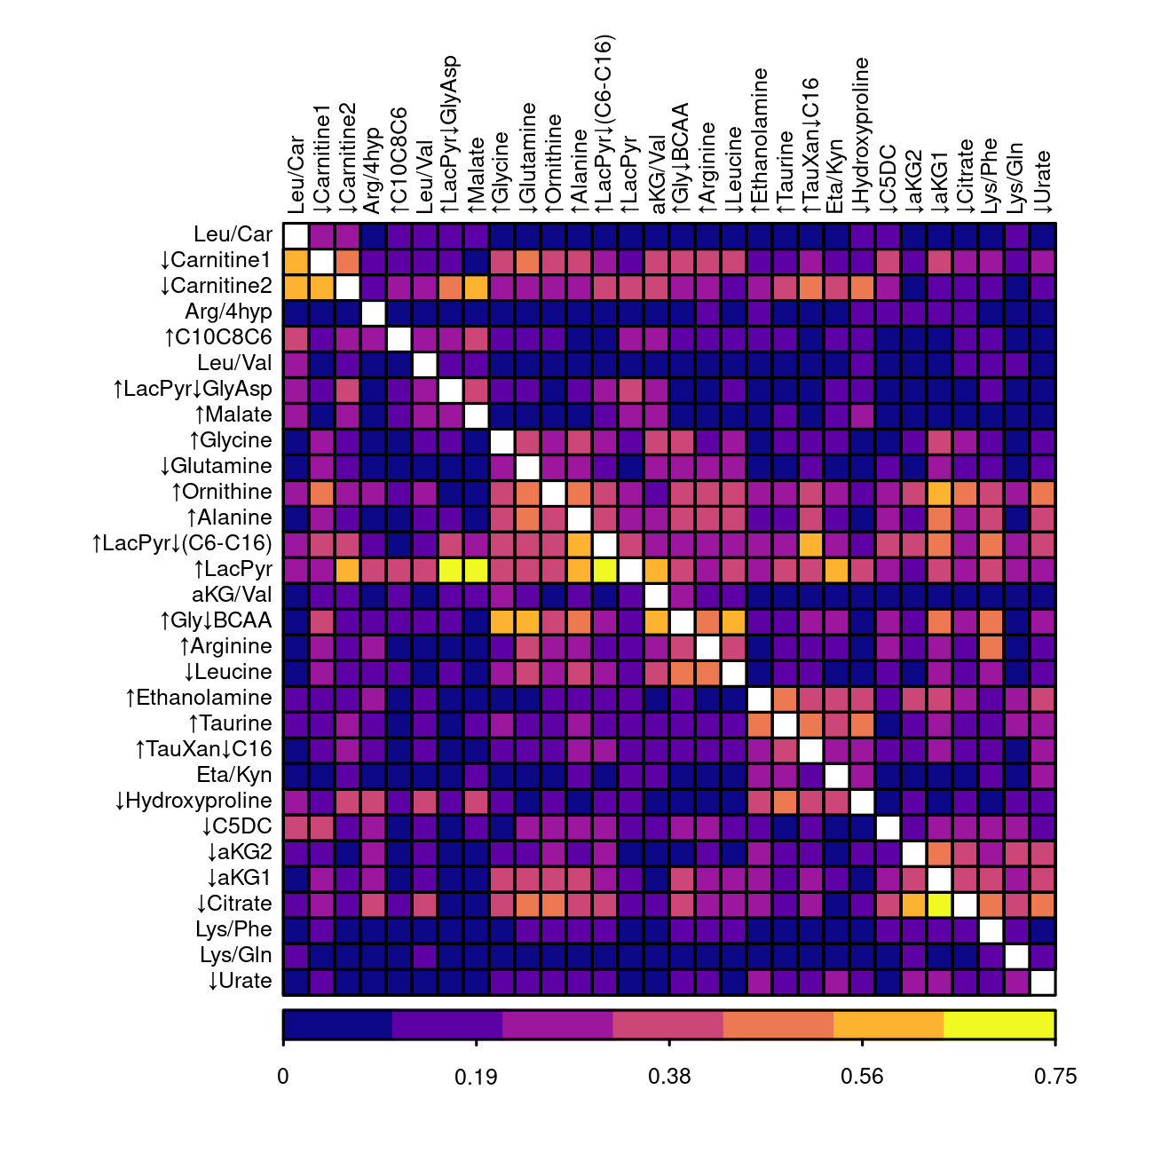

Figure S1. Heatmap of the similarity of metabotype clusters based on the cooccurrence of participants displaying a metabotype cluster phenotype. The cooccurrence is presented as the conditional probability p(Column ∩ Row/Column) of exhibiting a metabotype cluster in the row given exhibiting the metabotype cluster in the column. The analysis provides a visualization for how frequently metabotype clusters phenotypes appear together and suggests complex metabolic phenotypes are present within some individuals. The color scale indicates the conditional probability. Clusters are ordered using hierarchical clustering to simplify the visualization.
Supplemental Table 8. Elution Gradient for the Amine Liquid Chromatography Method
Time (min) | Flow (mL / min) | % A | % B
0 | 0.6 | 95.5 | 4.5
2.5 | 0.6 | 90 | 10
5 | 0.6 | 72 | 28
5.1 | 0.6 | 4.5 | 95.5
6.2 | 0.6 | 4.5 | 95.5
6.21 | 0.6 | 95.5 | 4.5
7.5 | 0.6 | 95.5 | 4.5
Supplemental Table 9. Elution Gradient for the Plasma Organic Acid Liquid Chromatography Method
Time (min) | Flow (mL / min) | % A | % B
0 | 0.35 | 3 | 97
3.5 | 0.35 | 3 | 97
4.5 | 0.35 | 60 | 40
5.5 | 0.35 | 60 | 40
5.6 | 0.35 | 3 | 97
8 | 0.35 | 3 | 97

Supplemental Table 10. Elution Gradient for the Unpolar and Microbiome Liquid Chromatography Method
Time (min) | Flow (mL / min) | % A | % B
0 | 0.3 | 90 | 10
4 | 0.3 | 0 | 100
5 | 0.3 | 0 | 100
5.1 | 0.3 | 90 | 10
6 | 0.3 | 90 | 10

SupTables.xlsx (separate file).

The supplemental tables 1 through 8 are found in the excel file and each is referenced in the manuscript. Each tab contains a table with a footer describing the contents.

SI References

1. A. M. Smith, et al., Amino Acid Dysregulation Metabotypes: Potential Biomarkers for Diagnosis and Individualized Treatment for Subtypes of Autism Spectrum Disorder. Biol. Psychiatry 85, 345–354 (2019).

