Supplementary Information for

Heteroepitaxial van der Waals semiconductor superlattices

Gangtae Jin, ^{1,2,†} Chang-Soo Lee,^{1,2,†} Odongo F. N. Okello,² Suk-Ho Lee,^{1,2} Min Yeong Park,^{1,2} Soonyoung Cha,¹ Seung-Young Seo,^{1,2} Gunho Moon, ^{1,2} Dong-Hwan Yang,² Cheolhee Han,^{1,2} Hyungju Ahn,³ Jekwan Lee,⁴ Hyunyong Choi,⁴ Jonghwan Kim,^{1,2} Si-Young Choi,² and Moon-Ho Jo^{1,2,*}

¹Center for Artificial Low Dimensional Electronic Systems, Institute for Basic Science (IBS), Pohang 37673, Korea, ²Department of Materials Science and Engineering, Pohang University of Science and Technology (POSTECH), Pohang 37673, Korea, ³Pohang Accelerator Laboratory, Pohang 37673, Korea, ⁴Department of Physics & Astronomy, Seoul National University, Seoul 08826, Korea
†These authors contributed equally to this work, *To whom correspondence should be addressed: mhjo@postech.ac.kr, (M.-H. Jo)

Contents:
Supplementary Note
Supplementary Figs. 1 to 17
Supplementary Tables 1 and 2
References (1-12)

Supplementary Note for Supplementary Fig. 2, 3, 7 and 9
Optimization of ML-by-ML growth of the heteroepitaxial vdW SLs
(i) ML templates with preferred in-plane crystal orientations: Preparation of the ML templates (MoS₂ and WS₂) with large grains and preferred orientations is critical for minimizing the local nucleation at the grain boundaries (GBs), as we experimentally confirmed as follows. First, we prepared two different MoS₂ ML templates: (i) one with smaller grains (~ 400 nm) of random in-plane orientations (because it was grown on SiO₂/p⁺-Si substrates), and (ii) the other with larger grains (~ 1 μm) of preferred orientations (because it was grown on c-sapphire substrates). (i) When we have grown the 2nd WS₂ MLs on such template MLs, we found that local nucleations at random GBs. (ii) However, the 2nd WS₂ MLs with the highly preferred in-plane orientations (0° or 60° GBs), the nucleation is spatially uniform, leading to the ML-by-ML growth mode. This is due to the fact that the boundary energies (γ) are strongly orientation-dependent, where there are local minima at 0° or 60° GBs with the appreciable difference from other orientations between 0° and 60°^{1,2}. We have achieved such preferentially orientated MoS₂ ML templates on c-sapphire substrates, as in optical microscope images and AFM images (Supplementary Fig. 9). At the growth of 750 °C, both of MoS₂ and WS₂ crystals were aligned on the step (0.4 nm height) and terrace terrains of c-sapphire substrates, then were gradually merged into continuous ML films. We also verified that at the 60° GB, the mirror twin boundaries are formed along the armchair directions, as in HAADF-STEM images (Fig. 3g and Supplementary Fig. 14). Thereby, we conclude that a key factor for maintaining coherent ML-by-ML heteroepitaxy is the preferred orientation in the 1st ML templates.
(ii) Partial pressure controls of metal precursors for ML-by-ML growth: To suppress the unwanted overgrowth for ML-by-ML heteroepitaxy, the partial pressure of metal precursors during MOCVD growth must be fine-tuned to maximize the growth anisotropy, promoting the slow lateral growth.^{3,4,5}. For such growth optimization, we have conducted a series of growth as varying the partial pressure of metal precursor (W(CO)₆) for WS₂/MoS₂ and WSe₂/WS₂ growth (Supplementary Fig. 2 and Supplementary Fig. 7). At the fixed other growth parameters such as growth temperature, the total pressure, we controlled the partial pressure of M(CO)₆ (p_{M(CO)6} , M: Mo, W). Then, p_{M(CO)6} can be expressed as,
$$p_{{M(CO)}_{6}}=\frac{\frac{p_{vap{M(CO)}_{6}}}{p_{can{M(CO)}_{6}}} × m_{{M(CO)}_{6}}}{m_{tot}}×p_{tot}$$
, where p_{vapM(CO)6} is the vapor pressure of M(CO)₆, p_{canM(CO)6} is the pressure of canister containing M(CO)₆, m_{M(CO)6} is the flow rate of M(CO)₆, m_{tot} is the total flow rate of process gas in reactors, and p_{tot} is the total pressure in the reactor during the MOCVD growth^{6,7}. For the growth of 2nd WS₂ MLs on 1st MoS₂ ML (Supplementary Fig. 2), the p_{W(CO)6} was regulated from 3.3×10⁻⁶ (Supplementary Fig. 2a) to 7.2×10⁻⁷ torr (Supplementary Fig. 2d). When the p_{W(CO)6} is set at the higher partial pressure, the formation of WS₂ bilayers prevails. By gradually lowering the p_{W(CO)6}, the ML growth without unwanted overgrowth was established. Similar growth patterns were observed during the growth of the 2nd WSe₂ MLs on 1st WS₂ ML (Supplementary Fig. 7). The optimized partial pressure of W(CO)₆, 3.2×10⁻⁸ torr (p₀) for WSe₂/WS₂ SLs.
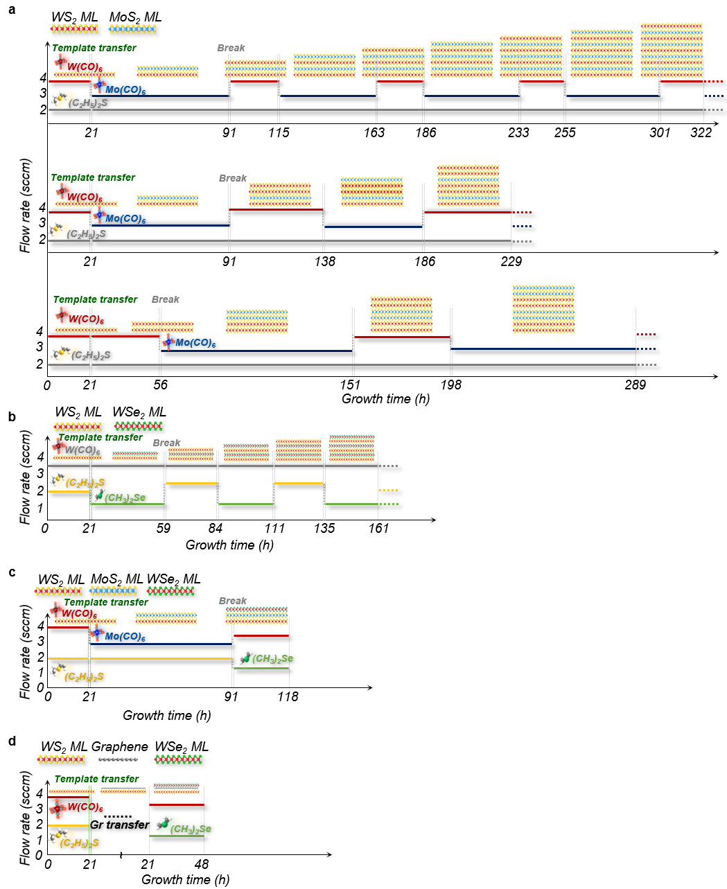
Supplementary Fig. 1. Flow rate modulations of MO precursors during the MOCVD heteroepitaxial growth of vdW SLs. a-d, Flow rate profiles of MO precursors for MoS₂/WS₂ SLs with 1:1 periodicity (top, also in Fig. 1c), MoS₂/WS₂ SLs with 1:2 periodicity (middle, also Fig. 2a), MoS₂/WS₂ SLs with 2:2 periodicity (bottom, also Fig. 2b) (a), 1:1 WSe₂/WS₂ SLs in Fig. 2c (b), WSe₂/MoS₂/WS₂ trilayers in Fig. 2d (c), WSe₂/Graphene/WS₂ trilayers in Fig. 2e (d).
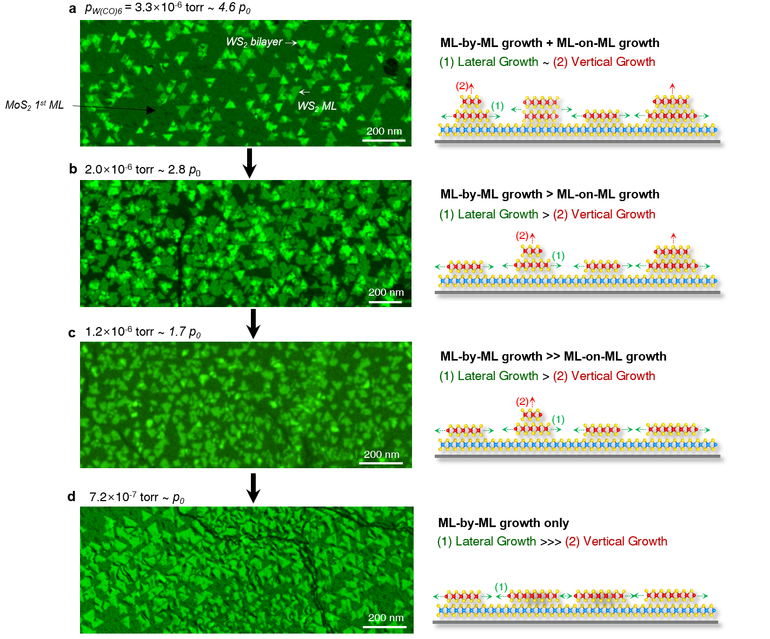
Supplementary Fig. 2. Partial pressure dependent growth behaviors for ML-by-ML heteroepitaxy of WS₂ on MoS₂ ML. a-d, False-colour DF-TEM images and the corresponding schematics of growth models at the total pressure of 4.6 p₀ (a), 2.8 p₀ (b), 1.7 p₀ (c), and p₀ (d), where optimized partial pressure (p₀) is ~ 7.2 × 10⁻⁷ torr for the ML-by-ML growth without unwanted overgrowth.

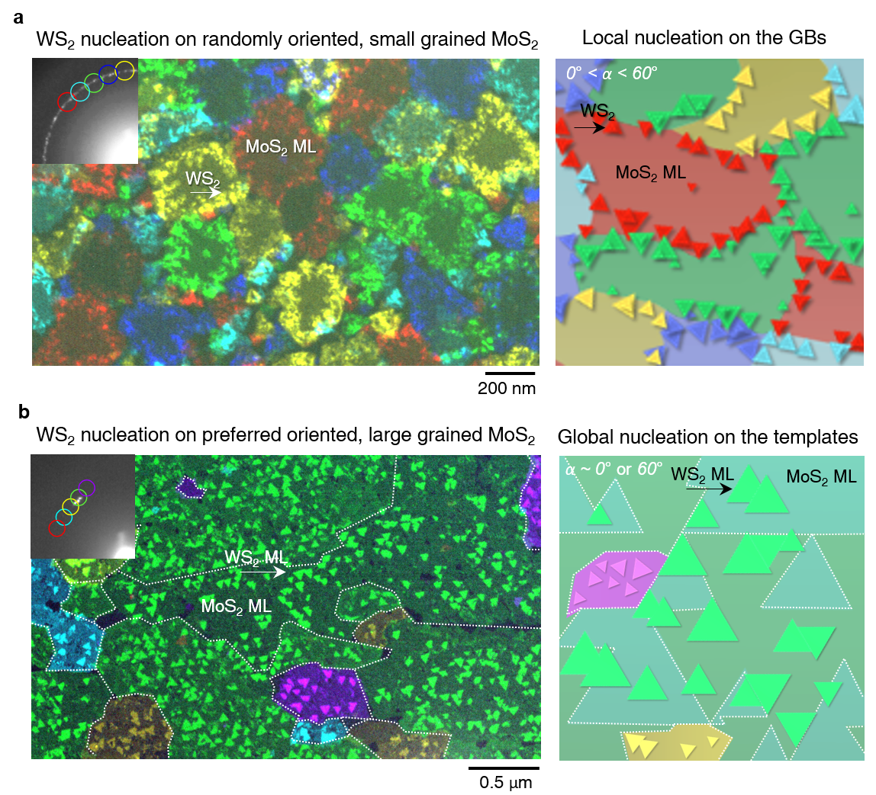
Supplementary Fig. 3. Global vs local nucleation of the 2nd WS₂ MLs on the different 1st MoS₂ ML templates. a, False-colour DF-TEM images (left) with the corresponding SAED patterns (inset) and the schematics of local nucleations of the 2nd WS₂ MLs on the 1st MoS₂ ML templates with randomly oriented, small grains of ~ 400 nm (right). b, False-colour DF-TEM images (left) with the corresponding SAED patterns (inset) and the schematics of global nucleations of the 2nd WS₂ MLs on the 1st MoS₂ ML templates with highly oriented, larger grains of ~ 1 μm (right).

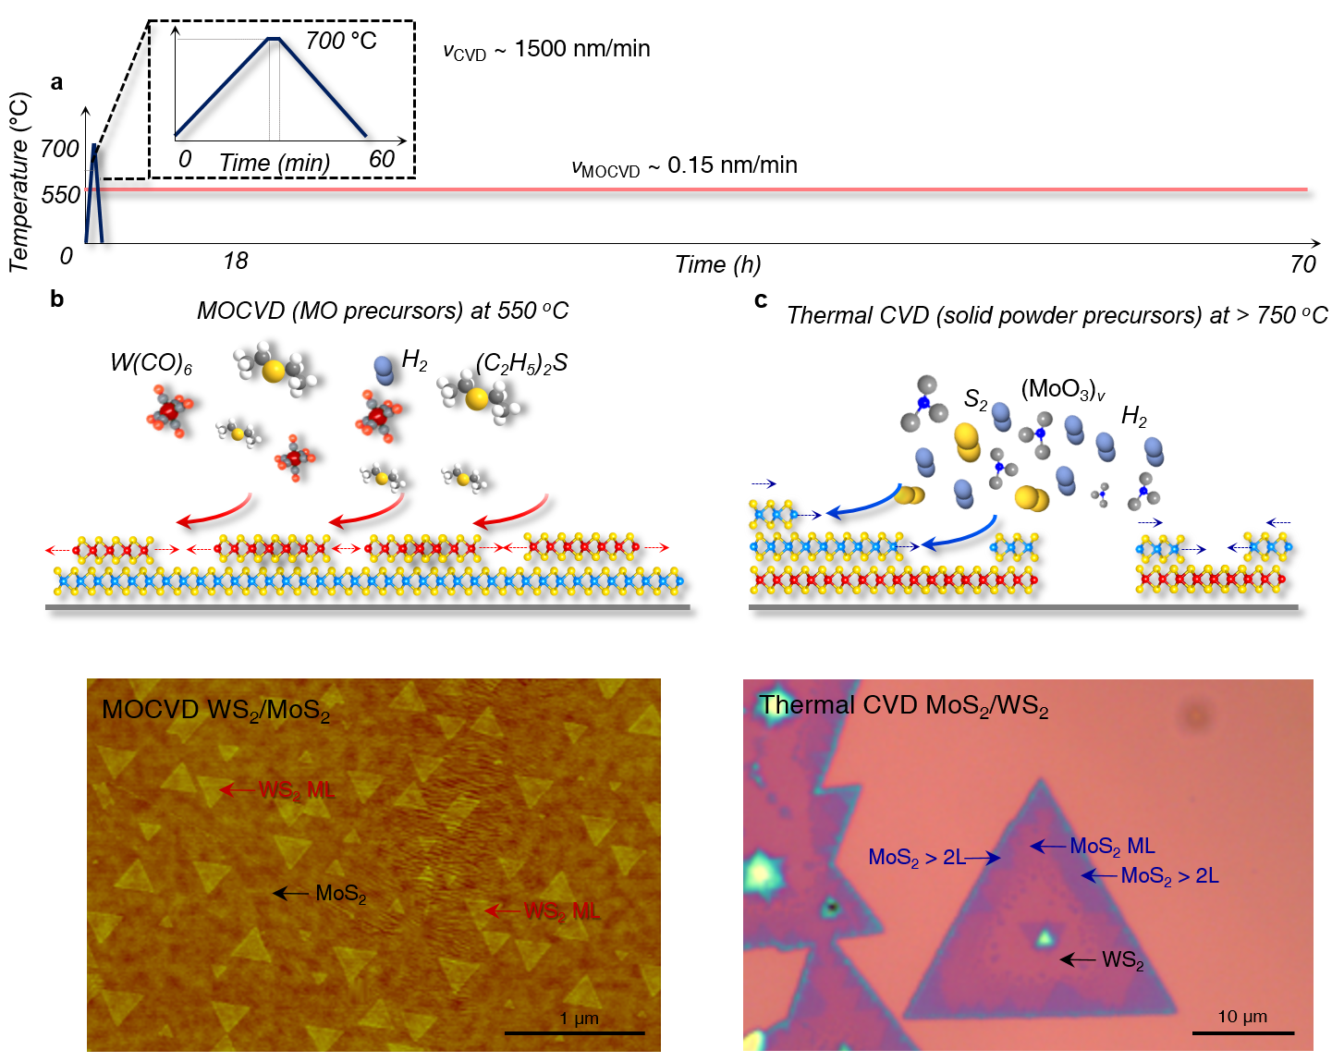
Supplementary Fig. 4. Differences in growth kinetics and growth patterns of MOCVD and Thermal CVD. a, Growth temperature profiles during our MOCVD and a typical thermal CVD method. b,c, Schematics of the growth patterns (top) and images displaying different growth modes in the MOCVD WS₂/MoS₂ (b) and the thermal CVD MoS₂/WS₂ (c). By employing MO precursors, which can be thermally decomposed at low temperatures of 550 °C, the lateral growth rate (ν_{growth}) is ~ 0.15 nm/min, and it is ten thousand times slower than that of the thermal CVD of 1500 nm/min. This kinetics-controlled vdW epitaxy in the near-equilibrium limit in MOCVD enables to achieve accurate ML-by-ML stacking^{4,8,9}.

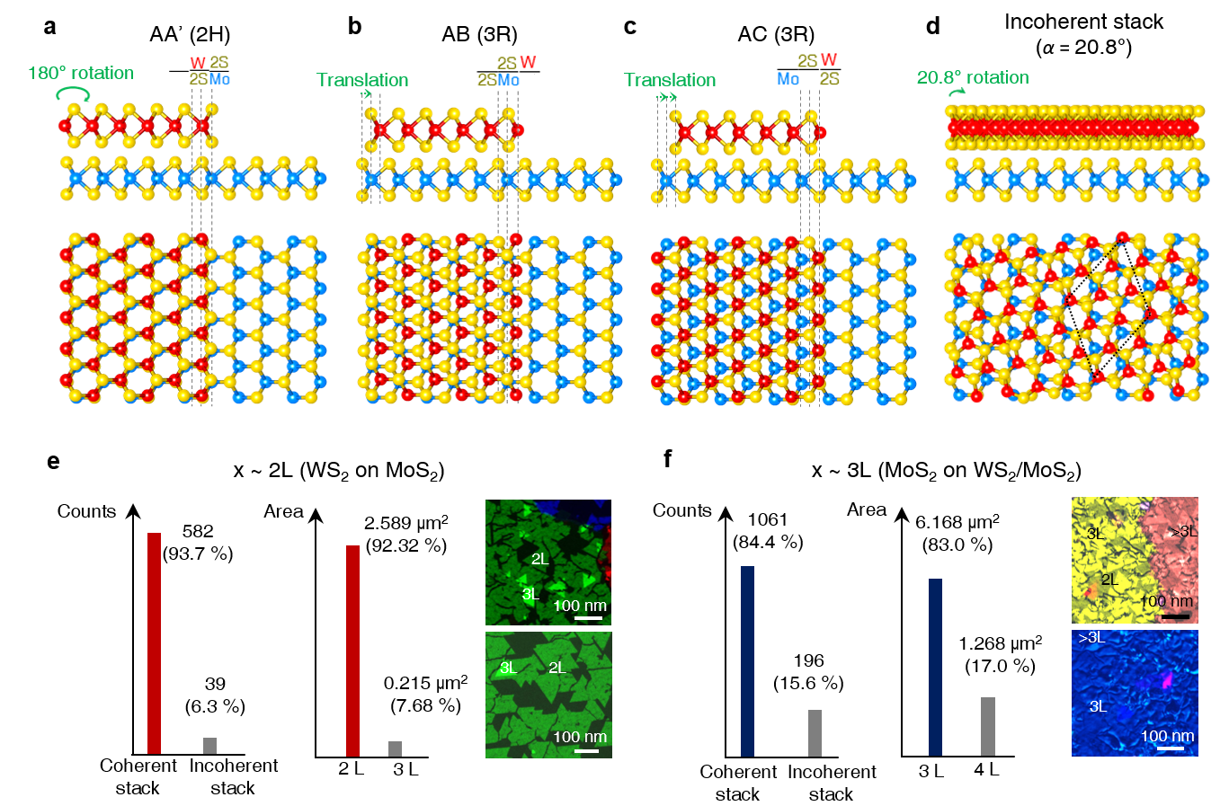
Supplementary Fig. 5. Classification and areal distributions of the stacking polytypes WS₂/MoS₂ bilayers. a-d, Atomic models of AA' (2H) stacking sequence (a), AB (3R) stacking sequence (b), AC (3R) stacking sequence (c), and incoherent stack with a random rotation angle (α) of 20.8° (d). e,f, Areal coverage of coherent vs incoherent stacked WS₂/MoS₂ bilayers (e), qMoS₂/WS₂/MoS₂ trilayers (f) with the representative examples of false-colour DF-TEM images. We defined the notations of thermodynamically stable stacking sequences in the bilayer WS₂/MoS₂ systems according to the ref. 10. Therein, AA' stacking corresponds to 2H-phase with inversion symmetry between two layers, where the transition metals of the second layer are stacked on the chalcogens of the first layer. AB stacking corresponds to 3R-phase without inversion symmetry between two layers, where the chalcogens of the second layer are stacked on the transition metals of the first layer. Similarly, in AC stack, the transition metals of the second layer are stacked on chalcogens of the first layer, which is slightly translated by one third of the lattice constant from AB stack.

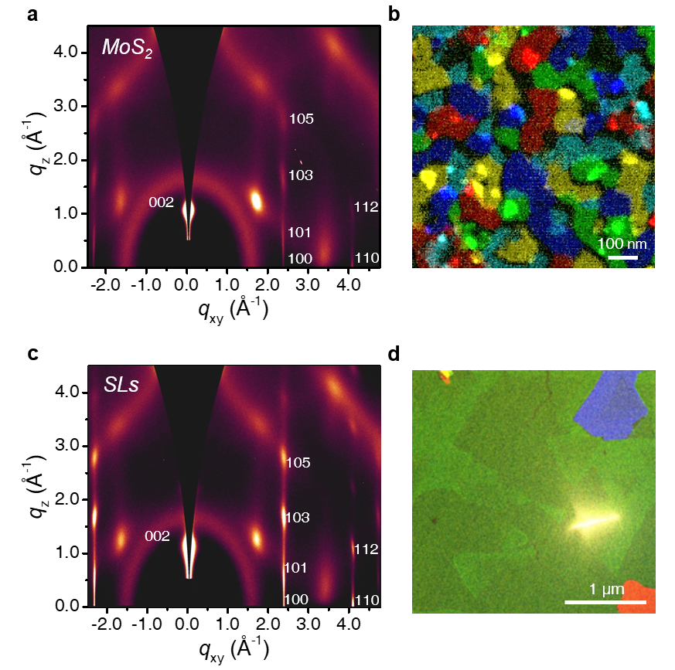
Supplementary Fig. 6. 2D GI-WAXD patterns of homoepitaxial MoS₂ and heteroepitaxial MoS₂/WS₂ SLs. a, The 2D pattern of GI-WAXD obtained from homoepitaxial MoS₂ 9Ls. b, False-colour DF-TEM image of the MoS₂ ML template for MoS₂ 9Ls growth (the grain size of ~ 80 to 100 nm) with random orientation. c, The 2D pattern of GI-WAXD (also used in Fig. 1g) obtained from heteroepitaxial MoS₂/WS₂ SLs. d, False-colour DF-TEM image of the WS₂ ML template for MoS₂/WS₂ SLs (the grain size of ~ a few micrometer) with preferred orientations.

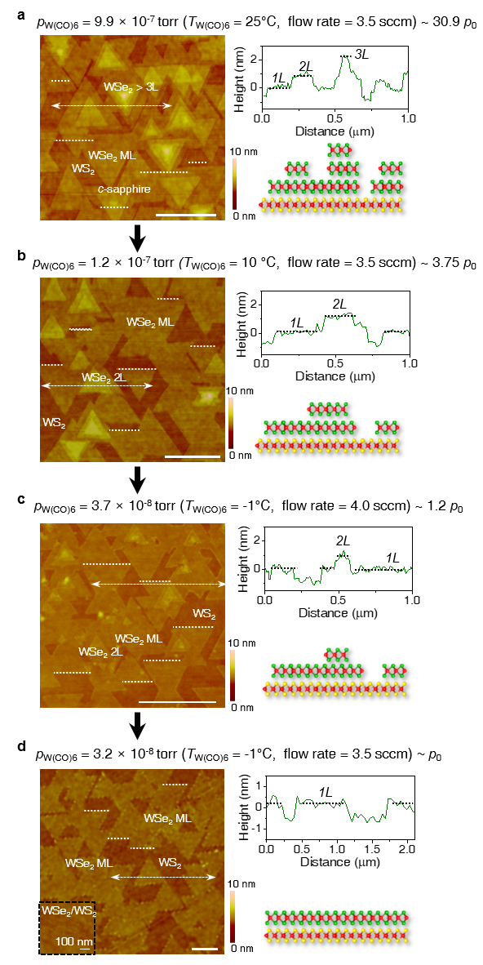
Supplementary Fig. 7. Partial pressure dependent growth behaviors for ML-by-ML heteroepitaxy of WSe₂ on WS₂ ML. a-d, AFM images of each growth batch (left), and the height profiles along the dashed lines (upper right) and the schematics of each nucleation and growth model (lower right) at the MO precursor partial pressures of 30.9 p₀ (a), 3.75 p₀ (b), 1.2 p₀ (c), and p₀ (d). Scale bars, 0.5 μm. The inset image in d is the AFM image captured from fully covered WSe₂/WS₂.
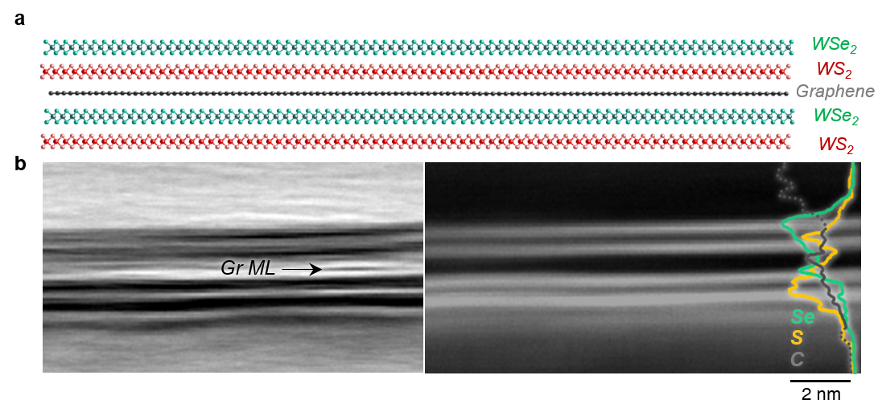
Supplementary Fig. 8. Heteroepitaxial WSe₂/WS₂ SLs with ex-situ graphene insertion. a, Atomic model of WSe₂/WS₂/graphene/WSe₂/WS₂ SLs and b, the corresponding BF-STEM image (left) and HAADF-STEM image (right) with EDX spectra (right, inset). After the initial growth of WSe₂/WS₂ bilayer, graphene was manually transferred onto the bilayers, followed by the sequential growth of another WSe₂/WS₂ bilayers on graphene/WSe₂/WS₂. The EDX spectra show clear peaks for C-K_{α} edges between each WSe₂/WS₂ SL verified in layer-resolved peaks for S-K_{α} and Se-K_{α}. Manually transferred graphene ML can be observed in between each WSe₂/WS₂ SL in the BF-STEM image.

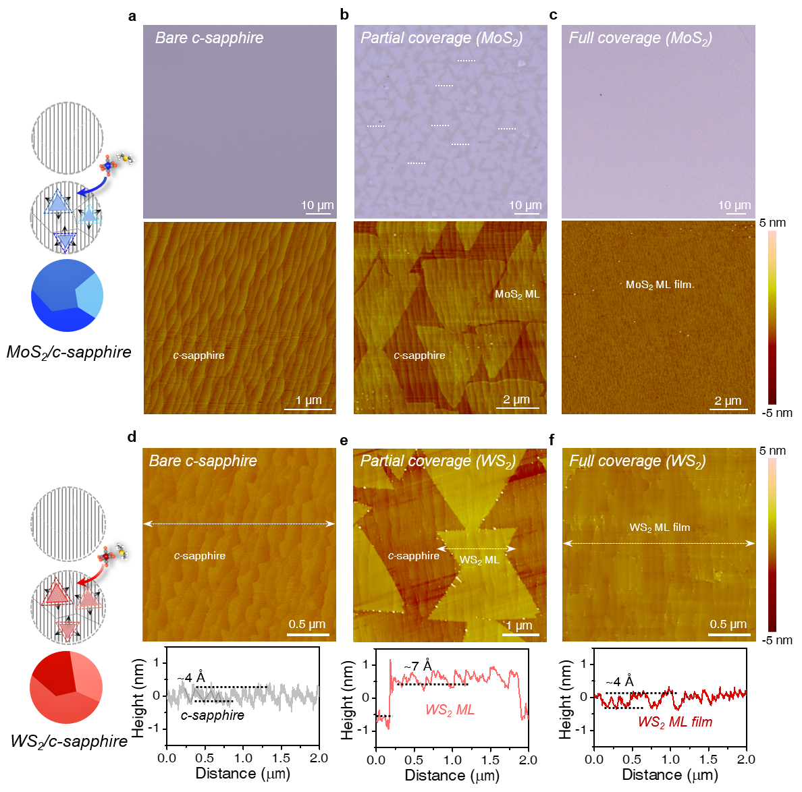
Supplementary Fig. 9. Epitaxial growth of MoS₂ and WS₂ ML templates on c-sapphire substrates. a-c, (Top) Optical microscope images of bare c-sapphire substrates (a), partially covered MoS₂ MLs with the preferred orientations of either 0° or 60° (b), and fully covered MoS₂ ML films (c). (Bottom) the corresponding AFM images. (Left) Growth scheme of epitaxial MoS₂ ML templates. d-f, (Top) AFM images of bare c-sapphire substrates (d), partially covered WS₂ MLs with the preferred orientations of 0° or 60° (e), and fully covered WS₂ ML films (f). (Bottom) The height profiles along the dashed lines. (Left) Growth scheme of epitaxial WS₂ ML templates.

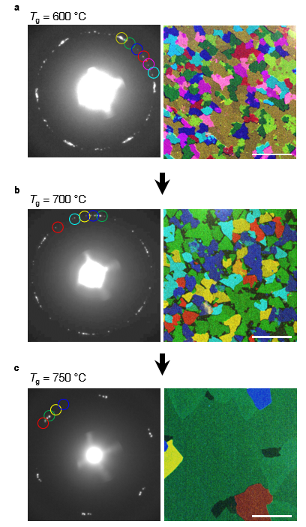
Supplementary Fig. 10. Grain sizes and preferred crystal orientations of epitaxial MoS₂ ML templates on c-sapphire substrates. a-c, SAED patterns and the corresponding DF-TEM images collected from epitaxial MoS₂ ML templates on c-sapphire substrates at the growth temperature of 600 °C (a), 700 °C (b), and 750 °C (c). Scale bars, 1 μm. Our epitaxial growth of ML templates with preferred crystal orientations of either 0° or 60°) was optimized at 750 °C¹¹.

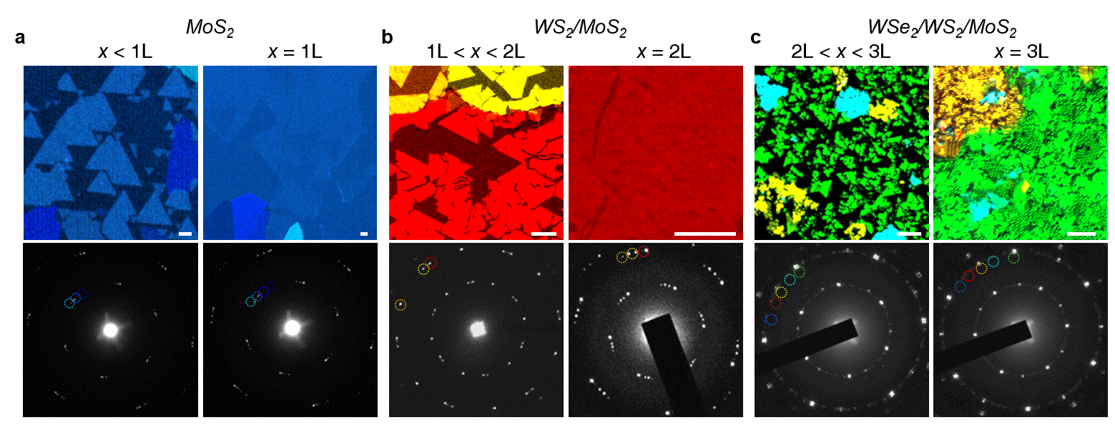
Supplementary Fig. 11. ML-by-ML heteroepitaxy of WSe₂/WS₂/MoS₂ trilayers with preferred orientations. a-c, False-colour DF-TEM images and the corresponding SAED patterns for partial (left) and full (right) coverages of MoS₂ MLs (a), WS₂/MoS₂ bilayers (b), and WSe₂/WS₂/MoS₂ trilayers (c). Scale bars, 100nm. DF-TEM images were constructed from the (10$\overline{1}$0) diffraction peak for MLs and (11$\overline{2}$0) diffraction peak for bilayers and trilayers.

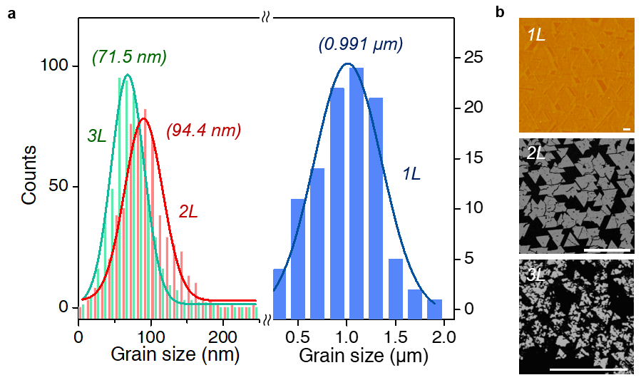
Supplementary Fig. 12. Grain size distribution of the 1st, 2nd and 3rd ML in WSe₂/WS₂/MoS₂ trilayers. a, Histogram of grain size distributions of the 1st MoS₂ MLs (blue), the 2nd WS₂/MoS₂ bilayers (red), the 3rd WSe₂/WS₂/MoS₂ trilayers (green). The average grain size is getting smaller as the stacking proceeds. b, We estimate the grain size of each ML from the AFM height images of the 1st MoS₂ ML (top) and DF-TEM images for the 2nd WS₂/MoS₂ (middle) and the 3rd WSe₂/WS₂/MoS₂ (bottom). Scale bars, 0.5 μm. We define the grain size as one of the sides of the triangular facets from the trigonal symmetry of TMDC MLs.

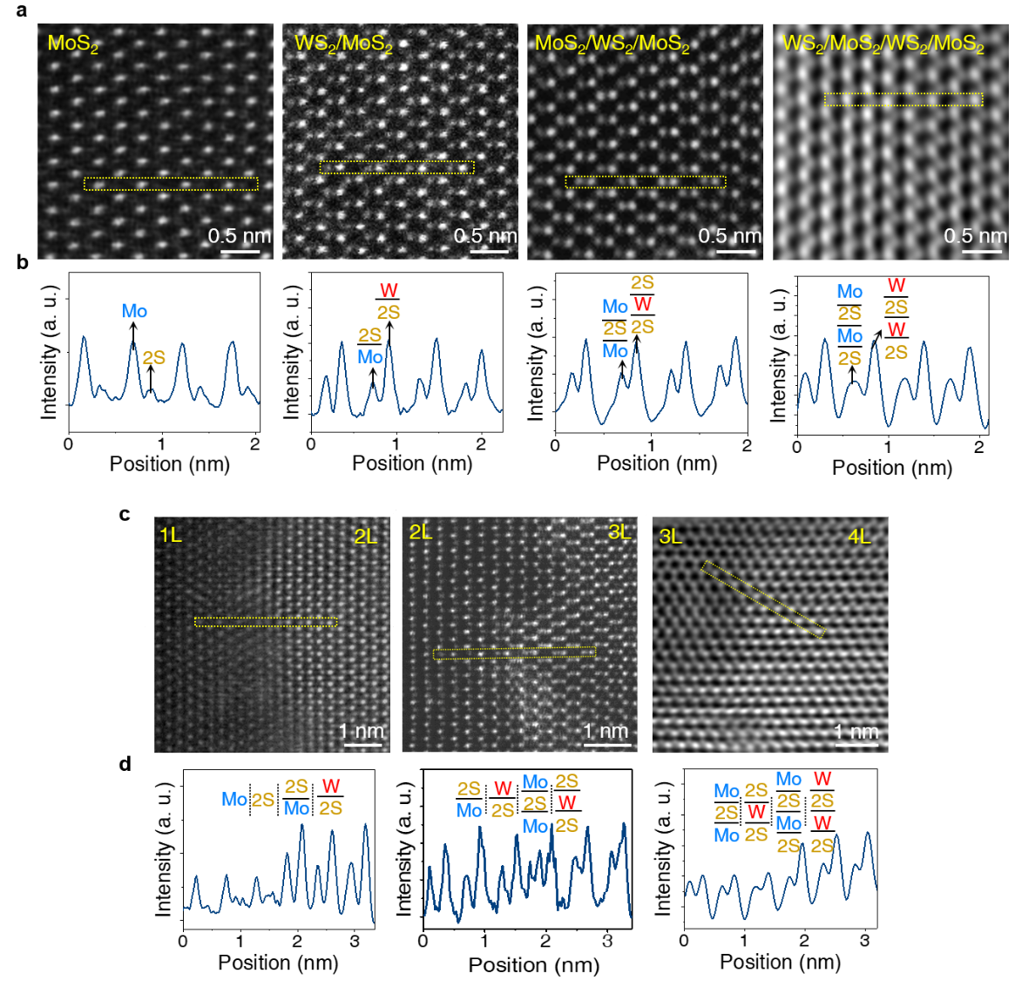
Supplementary Fig. 13. AA' stacked (WS₂/MoS₂)_{n} SLs with n = 1-4. a, (From left to right) Atomic-resolution HAADF-STEM images at n = 1, 2, 3, and 4. Therein AA' stacks were most abundant in our SLs. b, (From left to right) The Z-contrast line profiles taken from the marked regions in a. c, (From left to right) Atomic-resolution HAADF-STEM images at n = 1.5, 2.5, and 3.5. d, (From left to right) The Z-contrast line profiles taken from the marked regions in c. Piling up the ML stacks alternately, the vertical atomic configurations vary with the corresponding Z-intensity of SLs. The intensity ratios depicted as arrows in b are 2.966:1 for n = 1, 1:2.193 for n = 2, 1:1.517 for n = 3, and 1:2.193 for n = 4. The γ ratios in Z^{γ} are 1.85 for n = 1, 1.72 for n = 2, 1.86 for n = 3, and 1.72 for n = 4.

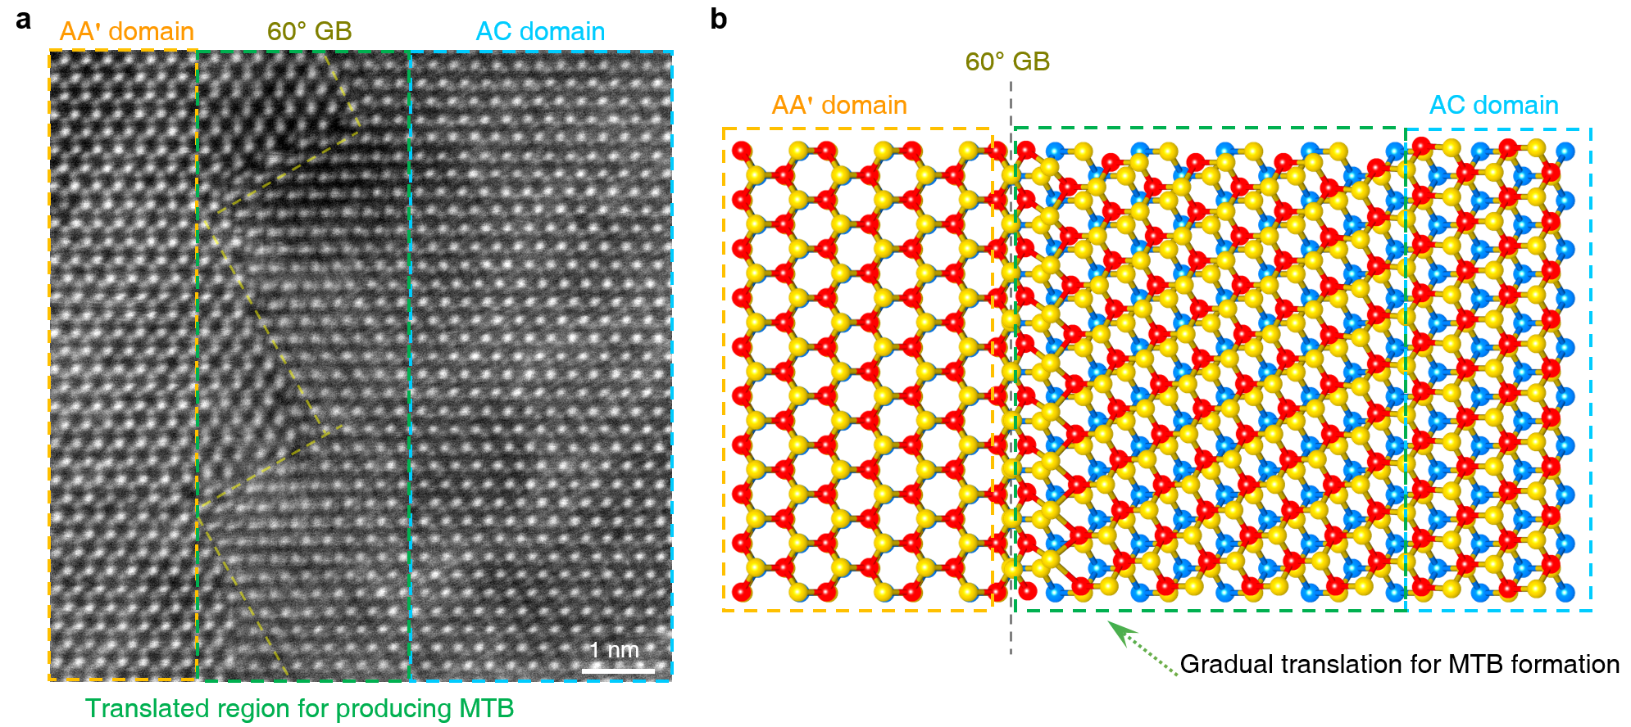
Supplementary Fig. 14. Mirror twin boundary between AA' and AC stacked domains. a, HAADF-STEM images of 60° GBs between AA' stacks and AC stacks. b, Atomic configurations for mirror twin boundaries between AA' and AC stacks. The AC stacked domain is gradually translated to the AB domain to form the mirror twin boundaries for minimizing boundary energies.

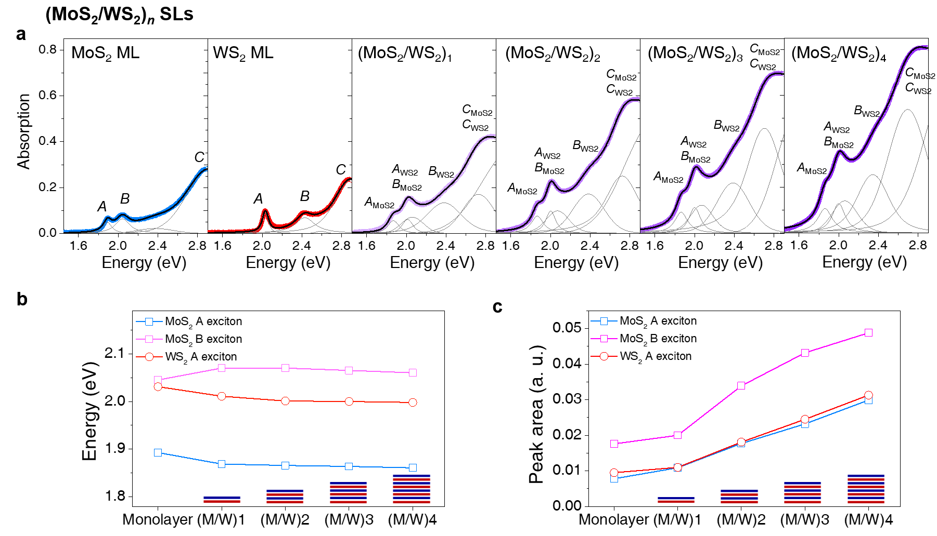
Supplementary Fig. 15. Peak deconvolution of optical absorption spectra in the (MoS₂/WS₂)_{n} SLs with n = 1-4. a, Fitting of room temperature absorption spectra of MoS₂ ML (blue circle), WS₂ ML (red circle), and (MoS₂/WS₂)_{n} SLs (purple circle), with Voigt function. Contributions by A, B, and C exciton series (gray), are fitted individually in the plot with cumulative fits (black). b,c, Exciton energies (b) and peak areas (c) for individual MLs and SLs analyzed from absorption spectra. As the bilayer stack numbers (n) increased, the positions for A-exciton for MoS₂ and WS₂ in (MoS₂/WS₂)_{n} SLs are gradually redshifted with respect to the exciton peak of the individual MLs by dielectric screening effect¹². Similarly, the peak area for A-exciton and B-excition of MoS₂ and WS₂ in (MoS₂/WS₂)_{n} SLs is additively increased. The beam diameter was about 1 mm.

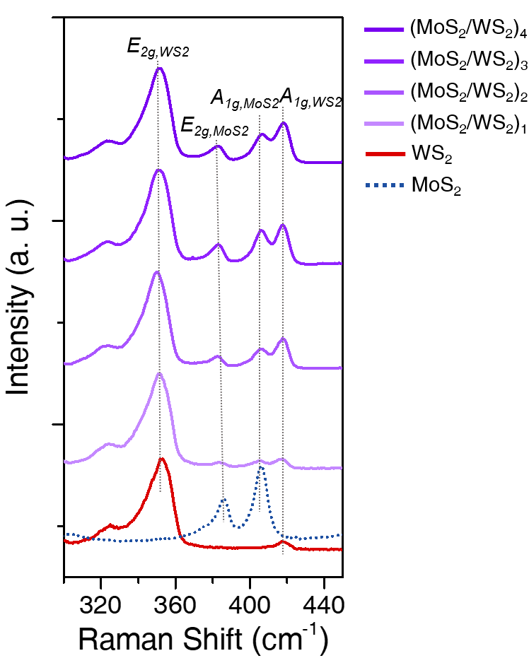
Supplementary Fig. 16. Raman scattering spectra obtained from (MoS₂/WS₂)_{n} SLs. Raman spectra measured at room temperature from (MoS₂/WS₂)_{n} SLs with n = 1-4. Each characteristic Raman peak remains at the constant position, indicating that each ML is intact during the heteroepitaxial stacking.

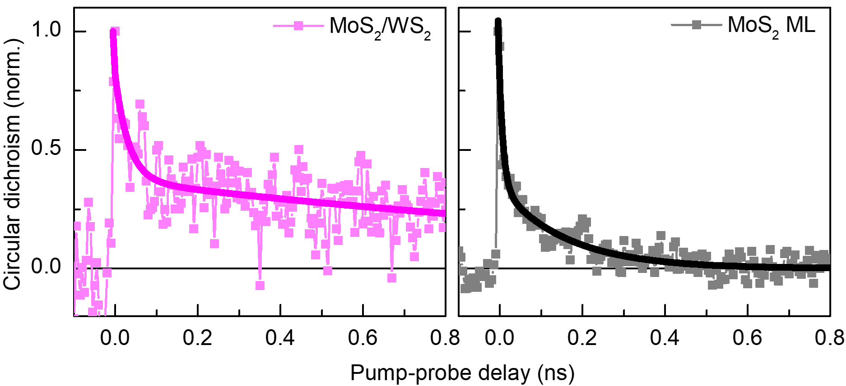
Supplementary Fig. 17. Extended lifetime of the valley-polarized carrier in WS₂/MoS₂ bilayers. Time-resolved circular dichroism responses in MoS₂/WS₂ bilayers (left, magenta), compared to that of MoS₂ ML (right, black).
Sample | Plane (hkl) | q_{z} (Å⁻¹) | Out-of-plane interplanar distance (d₍₀₀₂₎) (Å) | FWHM (Å⁻¹) | Out-of-plane coherence length (L_{c}) (Å)
Superlattices | (103) | 1.530 | 6.16 | 0.2699 | 18.63
Superlattices | (105) | 2.533 | 6.20 | 0.2921 | 17.21
Superlattices | (107) | 3.544 | 6.20 | 0.4230 | 11.89
MoS₂ | (103) | 1.527 | 6.17 | 0.3385 | 14.85
MoS₂ | (105) | 2.534 | 6.20 | 0.4198 | 11.97
MoS₂ | (107) | 3.442 | 6.39 | 0.4815 | 10.44
Supplementary Table 1. Crystalline characteristics of heteroepitaxial MoS₂/WS₂ SLs and homoepitaxial MoS₂ 9Ls along the out-of-plane direction at q_{xy} = 2.3 Å⁻¹.

Sample | Plane (hkl) | q_{xy} (Å⁻¹) | In-plane interplanar distance (d₍₁₀₀₎) (Å) | FWHM (Å⁻¹) | In-plane coherence length (L_{c}) (Å)
Superlattices | (100) | 2.304 | 2.73 | 0.038 | 131.21
Superlattices | (110) | 3.980 | 2.73 | 0.042 | 120.34
Superlattices | (200) | 4.595 | 2.74 | 0.054 | 92.64
MoS₂ | (100) | 2.304 | 2.73 | 0.044 | 114.97
MoS₂ | (110) | 3.973 | 2.73 | 0.058 | 86.53
Supplementary Table 2. Crystalline characteristics of heteroepitaxial MoS₂/WS₂ SLs and homoepitaxial MoS₂ 9Ls along the in-plane direction at q_{z} = 0 Å⁻¹.

References
1. Zou, X., Liu, Y., & Yakobson, B. I. Predicting Dislocations and Grain Boundaries in Two-Dimensional Metal-Disulfides from the First Principles. Nano Lett. 13, 253-258 (2013).
2. Taha, D., Mkhonta, S. K., Elder, K. R., & Huang, Z.-F. Grain Boundary Structures and Collective Dynamics of Inversion Domains in Binary Two-Dimensional Materials. Phys. Rev. Lett. 118, 255501 (2017).
3. Kang, K. et al. High-mobility three-atom-thick semiconducting films with wafer-scale homogeneity. Nature 520, 656–660 (2015).
4. Jin, G. et al. Atomically thin three-dimensional membranes of van der Waals semiconductors by wafer-scale growth. Sci. Adv. 5, eaaw3180 (2019).
5. Kim, H., Ovchinnikov, D., Deiana, D., Unuchek, D., & Kis, A. Suppressing Nucleation in Metal–Organic Chemical Vapor Deposition of MoS₂ Monolayers by Alkali Metal Halides. Nano. Lett. 17, 5056-5063 (2017).
6. Garner, M.L. & Chandra, D. Low-Temperature Vapor Pressures of W-, Cr-, and Co-Carbonyls. J. Phase Equilibria, 16, 24-29 (1995).
7. Karlson, U., Frankenberger, Jr. W. T., & Spencer, W. F. Physicochemical properties of dimethyl selenide and dimethyl diselenide. J. Chem. Eng. Data 39, 608-610 (1994).
8. Heo, H. et al. Rotation-Misfit-Free Heteroepitaxial Stacking and Stitching Growth of Hexagonal Transition-Metal Dichalcogenide Monolayers by Nucleation Kinetics Controls. Adv. Mater. 27, 3803–3810 (2015).
9. Li, F. et al. Rational Kinetics Control toward Universal Growth of 2D Vertically Stacked Heterostructures. Adv. Mater. 31, 1901351 (2019).
10. Yan, A. et al. Identifying different stacking sequences in few-layer CVD-grown MoS₂ by low-energy atomic-resolution scanning transmission electron microscopy. Phys. Rev. B. 93, 041420(R) (2016).
11. Lin, Y.-C. et al. Realizing Large-Scale, Electronic-Grade Two Dimensional Semiconductors. ACS Nano, 12, 965-975 (2018).
12. Raja, A. et al. Coulomb engineering of the bandgap and excitons in two-dimensional materials. Nat. Commun. 8, 15251 (2017).

