Supplemental Materials for:

Full Title: A trispecific Ab directed to HIV-1 and T cells activates and eliminates latently-infected cells in HIV/SHIV infections

Wanwisa Promsote¹, Ling Xu^{2,3}, Jason Hataye¹, Giulia Fabozzi¹, Kylie March¹, Cassandra G. Almasri¹, Megan E. Demouth¹, Sarah E. Lovelace¹, Chloe Adrienna Talana¹, David Ambrozak¹, Jochen Beninga², Erco Rao², Norbert Furtmann², Joerg Birkenfeld², Elizabeth McCarthy¹, John-Paul Todd¹, Costas Petrovas¹, Mark Connors⁴, Andrew H. Hebert², Jeremy Beck², Junqing Shen², Bailin Zhang², Mikhail Levit², Ronnie Wei^{2,3}, Zhi-yong Yang^{2,3}, Amarendra Pegu¹, John R. Mascola¹, Gary J. Nabel^{2,3}, and Richard A. Koup¹

Affiliations:
¹Vaccine Research Center, National Institute of Allergy and Infectious Diseases, National Institutes of Health, Bethesda, MD, USA.
²Sanofi, 640 Memorial Dr., Cambridge MA, 02139, USA
³ModeX Therapeutics Inc., 22 Strathmore Road, Natick, MA 01760, USA
⁴NIAID, NIH, Bethesda, MD, 20892, USA
*Correspondence to: rkoup@nih.gov, gary.nabel@modextx.com

SUPPLEMENTAL FIGURES

Supplemental Figure 1. N6/αCD3-αCD28 enhances the HIV-specific T cell activation. Expression of intracellular IFN-γ by CD4⁺ and CD8⁺ T cells activated by N6/αCD3-αCD28. Enriched human T cells were co-cultured with either uninfected (HIV env-) or HIV-infected CEM (HIV env+) cells in the presence of 2nM of the indicated T cell engagers and Brefeldin A for 16 hours. The T cells were then stained with antibodies against IFN-γ and the percentage of T cells expressing IFN-γ was measured using flow cytometry.

Supplemental Figure 2. N6/αCD3-αCD28 induces HIV reactivation of latently-infected CD4⁺ T cells and enhances effector CD8⁺ T cells of ART-suppressed PBMC cells. Ex vivo latency reversing assay was performed in which sorted autologous CD4⁺ and CD8⁺ T cells from peripheral blood mononuclear cells (PBMCs) of antiretroviral therapy (ART)-treated donors were co-cultured (1:1) and treated with N6/αCD3-αCD28 or control constructs in the presence of ART for 7 days without the addition of any other cytokines or stimuli. On day 3, 5, and 7, cells from the co-culture were collected and assessed for the activation and proliferation of latently-infected CD4⁺ and CD8⁺ T cells by flowcytometry. The CD4⁺ and CD8⁺ T cells were stained with antibodies against CD69, Ki67, granzyme B and viability marker, and the percentage of lived/dead (A) and activated proliferating (B) CD4⁺ and CD8⁺ T cells were measured using flow cytometry.

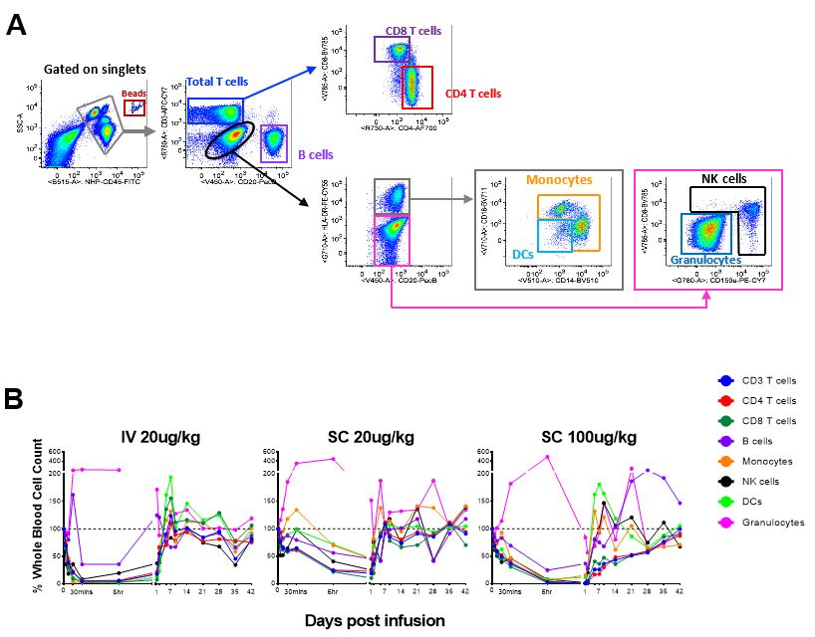

Supplemental Figure 3. In vivo administration of N6/αCD3-αCD28 results in redistribution of periphery immune cells of naive rhesus macaques. (A) Gating strategy for flow cytometry analysis of whole blood staining to evaluate immune cell redistribution in periphery. (B) Flow cytometry immunophenotyping analysis showing transient distribution of circulating immune cell subsets following administration of N6/αCD3-αCD28 via intravenous or subcutaneous at the dose of 20 µg kg⁻¹ or 100 µg kg⁻¹
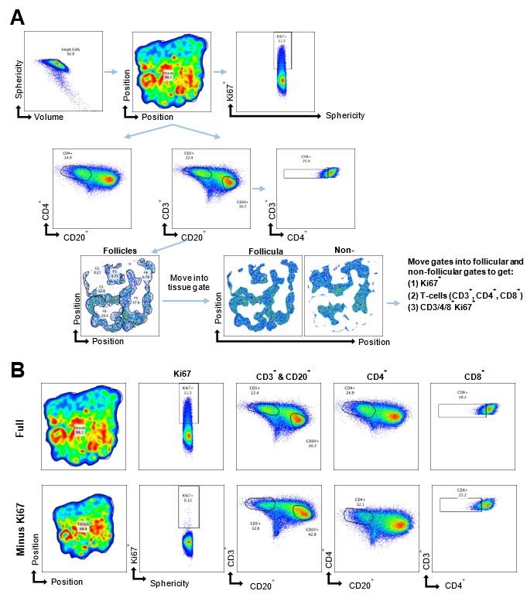

Supplemental Figure 4. Gating strategy for quantitative tissue spatial analysis to characterize how the N6/αCD3-αCD28 administered subcutaneously stimulated cell proliferation/late immune activation via Ki67 activation in lymph node tissue.
Supplemental Figure 5. Immune activation in lymph nodes of naïve rhesus macaques after subcutaneous administration N6/αCD3-αCD28 using multiplexed confocal imaging. Quantification of Ki67-activated CD3⁺ T cells, CD4⁺ T cells and CD8⁺ T cells normalized to whole lymph node area (mm²) from animals received N6/αCD3-αCD28 via subcutaneous administration at 20ug kg⁻¹ and 100ug kg⁻¹ on days-7, 1 and day 14 post antibody are shown. Ki67-activated CD8⁺ T cells were significantly induced in the follicular area at day 14 in the animals administered the 100 µg kg⁻¹ dose compared to those that received 20 µg kg⁻¹ dose.

SUPPLEMENTAL TABLES
Supplementary Table 1. HIV-1 infected donors on anti-retroviral therapy
Donor | Year of HIV diagnosis | Year started therapy | ARVs | Day of visit | CD4 T cell count/l of blood | Plasma viral load (copies/ml)
1 | 1991 | Unknown | TAF/FTC/ATV/DTG/COBI | 7/27/2017 | 731 | 122
2 | 2012 | Unknown | TAF/FTC/EVG/COBI | 9/6/2017 | 752 | <20
3 | 1984 | Unknown | ABC/3TC/ATV | 6/17/2008 | 352 | 361

Supplementary Table 2. Antibodies used in flow cytometry
Marker | Fluorochrome | Clone | Supplier
CCR7 | AF700 | 150503 | BD Biosciences
CD3 | APC-Cy7 | SP34-2 | BD Biosciences
CD4 | BUV661 | SK3 | BD Biosciences
CD8 | BV570 | RPA-T8 | Biolegend
CD14 | BV510 | M5E2 | Biolegend
CD16 | BUV496 | 3G8 | BD Biosciences
CD16 | BV510 | 3G8 | Biolegend
CD20 | BUV737 | 2H7 | BD Biosciences
CD20 | BV510 | 2H7 | Biolegend
CD28 | ECD | CD28.2 | Beckman Coulter
CD69 | BV605 | FN50 | Biolegend
CD95 | PECy5 | DX2 | BD Biosciences
CD107a | BV650 | H4A3 | Biolegend
CXCR5 | PECy7 | MU5UBEE | eBioscience
DCM | Zombie UV | - | Biolegend
DCM | Aqua | - | Invitrogen
HLA-DR | PECy5.5 | TU36 | Life Technologies
IFNγ | FITC | B27 | BD Biosciences
MIP-1β | PE | D21-1351 | BD Biosciences
NKG2A | APC | REA110 | MACS Miltenyi Biotec
PD-1 | BV711 | EH12.2H7 | Biolegend
TNF | BV785 | Mab11 | Biolegend

