Supplementary
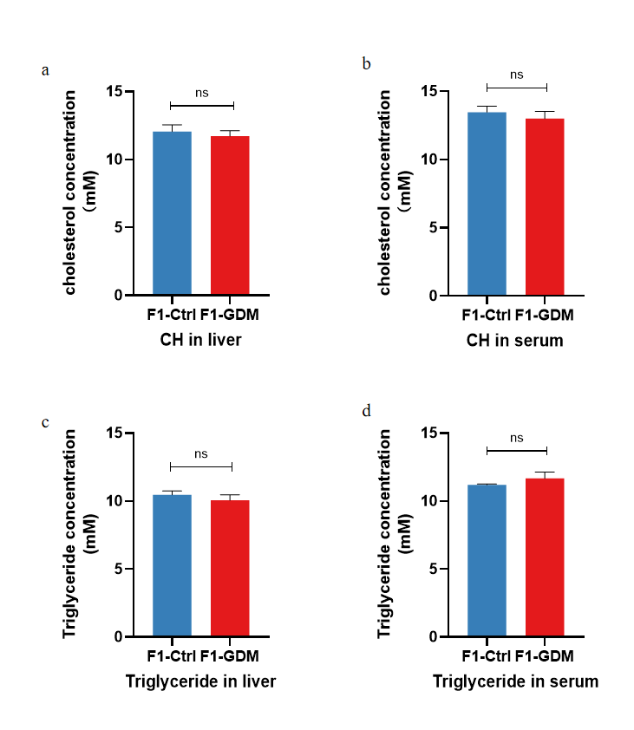
Supplementary Figure 1:(a) The cholesterol concentration in liver tissue of 12-week-old offspring;(b) The cholesterol concentration in serum of 12-week-old offspring;(c) The triglyceride concentration in liver tissue of 12-week-old offspring;(d) The triglyceride concentration in serum of 12-week-old offspring.

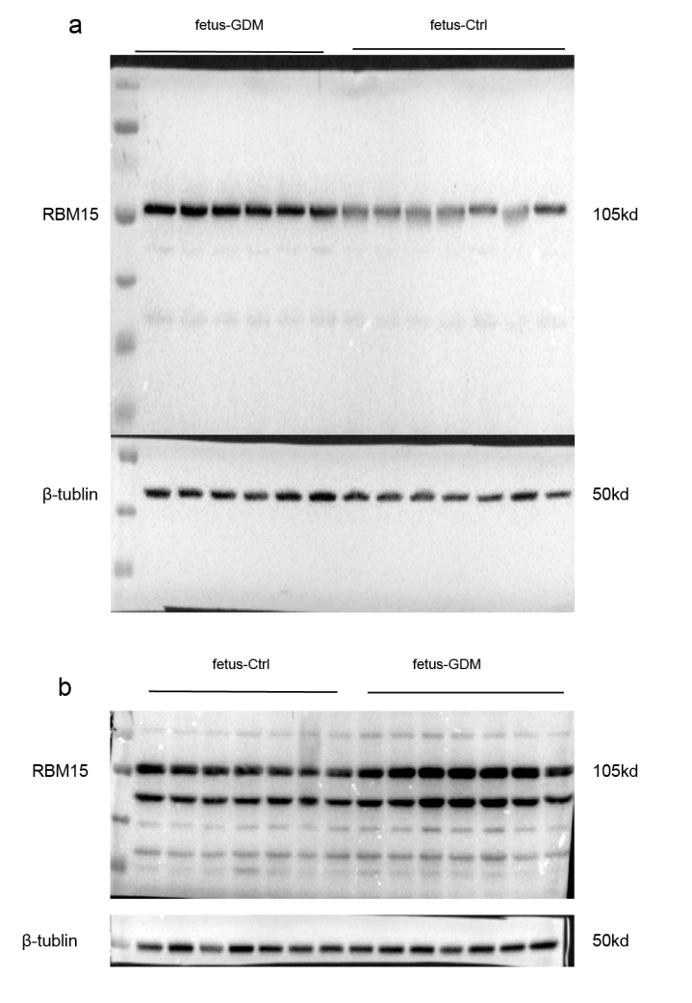
Supplementary Figure 2: (a) Original Western blots of Figure 3g. (b) Original Western blots of Figure 3h.

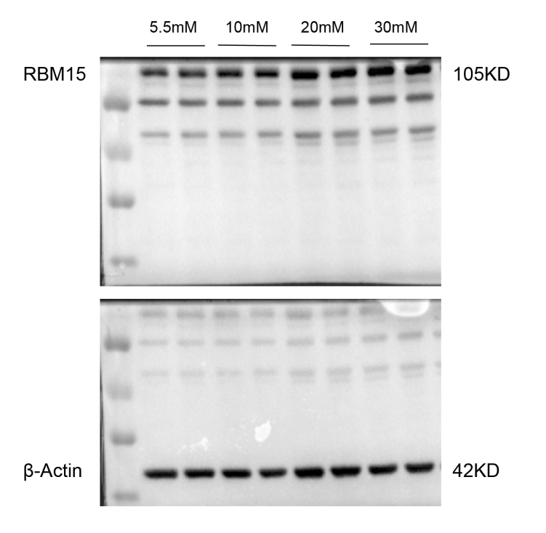
Supplementary Figure3: Original Western blots of Figure 5a.

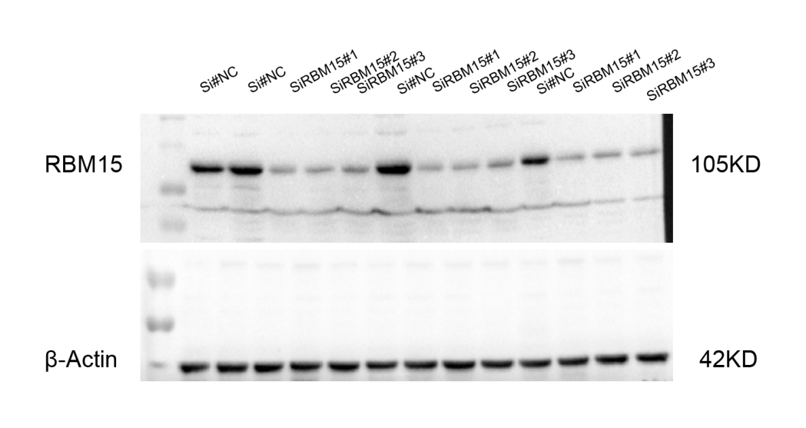
Supplementary Figure 4: Original Western blots of Figure 5b.

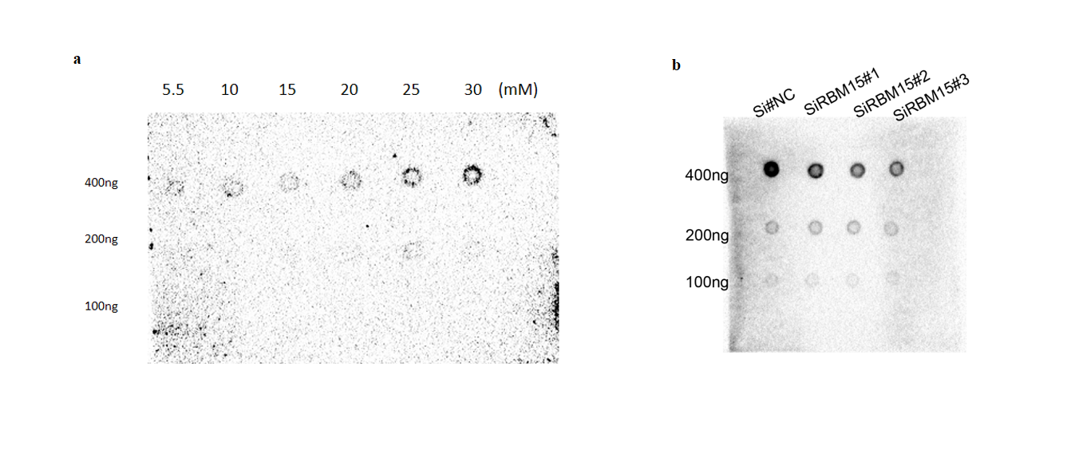
Supplementary Figure 5：(a): Original dot blots of Figure 5c.(b)
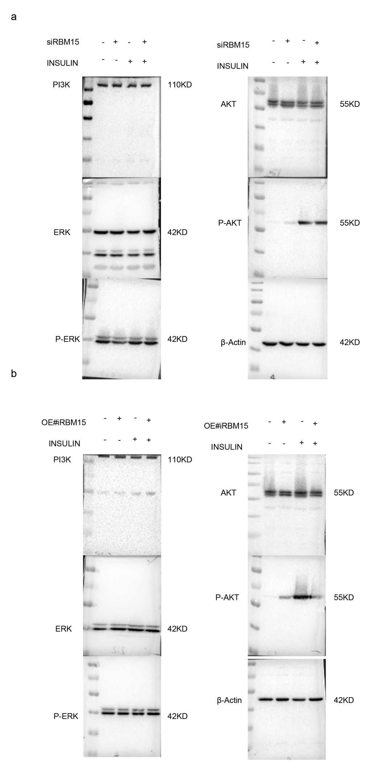
Supplementary Figure 6: (a)Original Western blots of Figure 5f. (b) Original Western blots of Figure 5g.

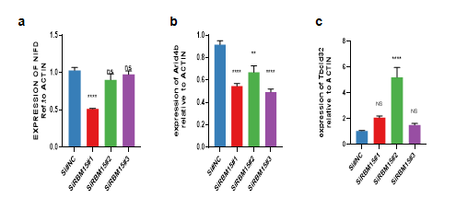Supplementary figure 7: (a)mRNA expression of NIFD after knockdown of RRBM15;(b) mRNA expression of Arid4b after knockdown of RRBM15;(c) )mRNA expression of Tbcld32after knockdown of RRBM15.

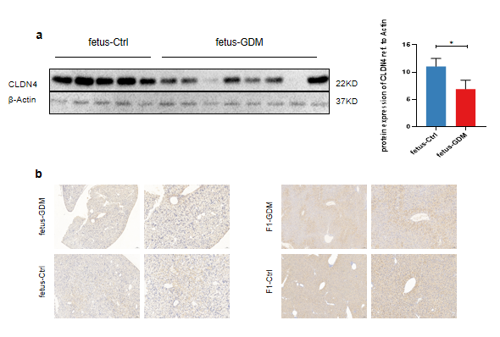
Supplementary figure 8: (a) The protein level of CLDN4 in offspring liver of GDM (n=8) and control (n=5); (b) immunohistochemistry of CLDN4 for the liver of GD18.5 fetus and 12-weeks offspring.

