Supplementary Information for
NH₃ emissions over Europe during COVID-19 were modulated by changes in atmospheric chemistry
Ondřej Tichý¹, Marit Svendby Otervik², Sabine Eckhardt², Yves Balkanski³, Didier Hauglustaine³, Nikolaos Evangeliou^{2,}*

¹ The Czech Academy of Sciences, Institute of Information Theory and Automation, Prague, Czech Republic.
² NILU - Norwegian Institute for Air Research, 2007 Kjeller, Norway.
³ Laboratoire des Sciences du Climat et de l’Environnement (LSCE), CEA-CNRS-UVSQ, 91191, Gif-sur-Yvette, France.

* Corresponding authors: N. Evangeliou (Nikolaos.Evangeliou@nilu.no)

Supplementary Figures
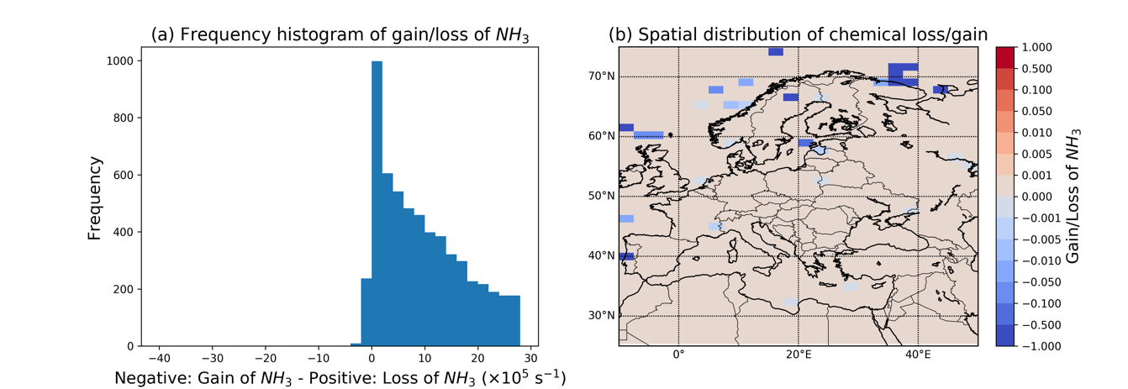
Supplementary Figure S 1. (a) Frequency distribution of gain (negative values) and loss of atmospheric ammonia in the inversion domain (10°W–50°E, 25°N–75°N) during the study period (January – June 2020). Only the altitudes where satellite ammonia has an influence in the inversion were considered (~1018-619 hPa). The distribution shows that shift of the equilibrium reaction with nitric acid towards production of gaseous ammonia is a rather rare event and could be omitted. (b) Spatial projection of the occurrences of loss and gain of atmospheric ammonia in the inversion domain during the study period (January – June 2020). Most of the pixels where gain of atmospheric ammonia occurs are located in marine regions, for which ammonia emissions were not constrained. In our simulations, the pixels were gain of ammonia occurs were set to zero, as if neither gain nor loss of ammonia occurred.

Supplementary Figure S 2. Locations and timeseries concentrations of nitrogen at stations from AMoN (North America, EANET (Southeastern Asia) and EMEP (Europe) networks used for validation. Forward and backward modelled concentrations of FLEXPART averaged for the temporal resolution of the observations are shown together with the respective concentrations from the Eulerian LMDz-OR-INCA using emissions from EGG^{1–3}. A very good agreement for all modelled concentrations is apparent that indicates the robust approach of our assumption that atmospheric ammonia is most often chemically depleted.

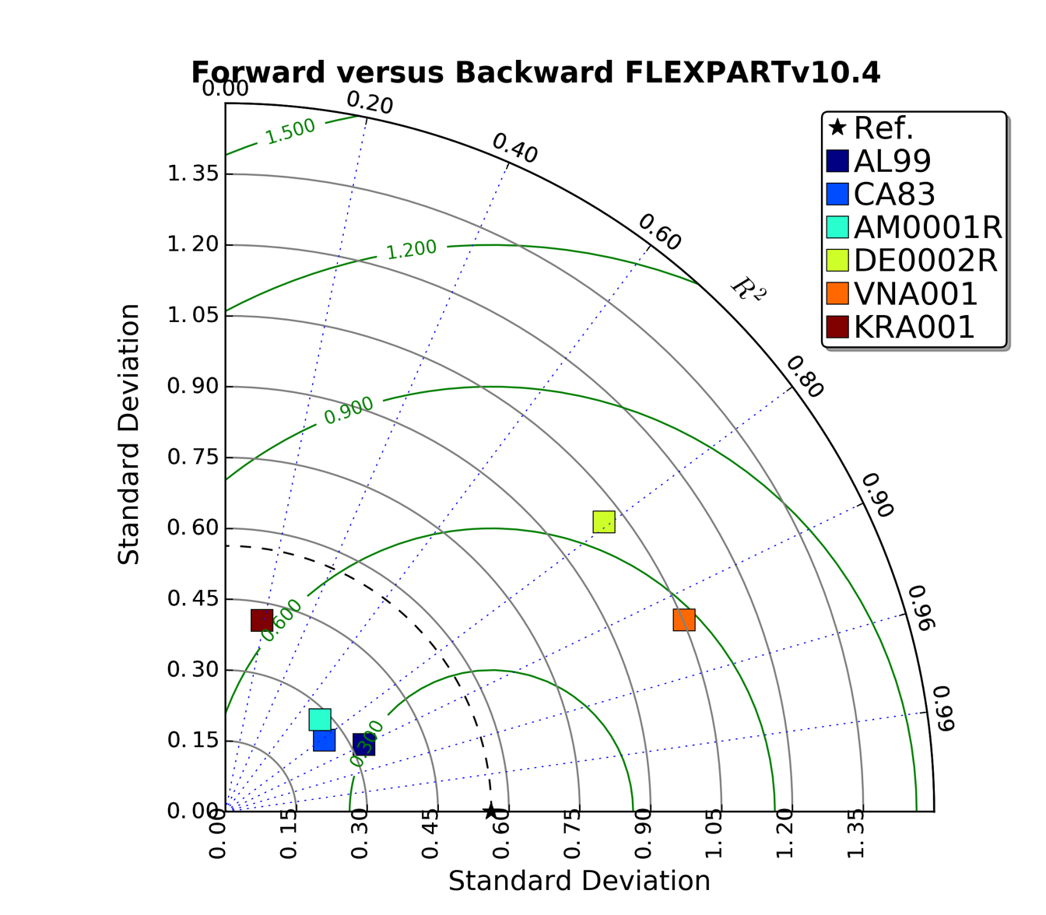
Supplementary Figure S 3. Taylor diagram of modelled concentrations of ammonia with FLEXPARTv10.4 in forward and backward mode using emissions from EGG^{1–3}. The diagram shows the Pearson’s correlation coefficient (gauging similarity in pattern between the forward and backward simulated concentrations) that is related to the azimuthal angle (blue contours); the standard deviation of modelled concentrations is proportional to the radial distance from the origin (black contours) and the centered RMSE of modelled concentrations is proportional to the distance from the reference standard deviation (green contours). In most cases, forward and backward simulated concentrations are associated with Pearson’s correlation coefficient above 0.7, and low standard deviations (<1 μg N m-3) and RMSEs (<0.7 μg N m-3), which implies the coherence of the two versions.

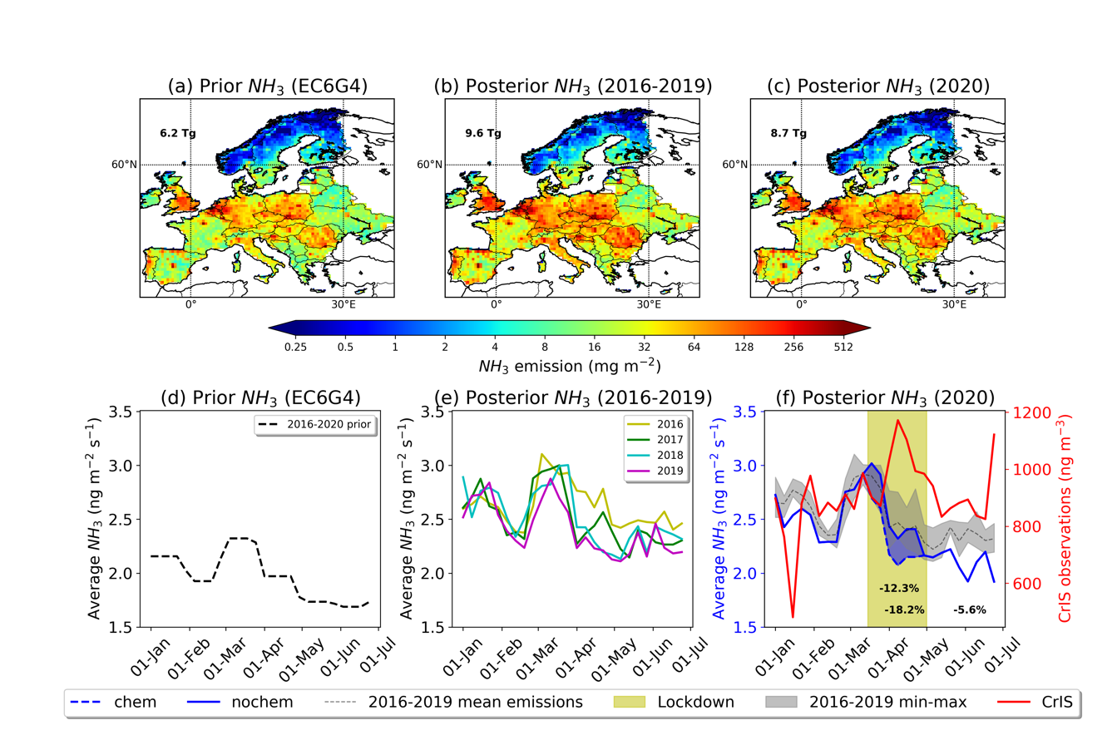
Supplementary Figure S 4. (a) Total a priori emissions of ammonia over Europe for the inversion period (January – June) from EC6G4. The total emitted amount is equal to 6.2 Tg. (b) Total a posteriori emissions of ammonia over Europe for the inversion period (January – June). The emissions are an average of respective inversions for years 2016 – 2019 and amount 9.6 Tg. (c) Total posterior emissions of ammonia over Europe in 2020 (8.7 Tg). (d). Timeseries of weekly-average prior emissions of ammonia over Europe (January to June) from EC6G4. (e) Timeseries of weekly-average posterior emissions of ammonia over Europe for years 2016–2019 (January to June). (f) Timeseries of weekly-average posterior emissions of ammonia over Europe in 2020. Separate calculations for the effect of reduced chemical reactions (dashed blue line) versus changes in the atmospheric levels (straight blue line) during the lockdown period (light yellow) are plotted together with the CrIS observations averaged over Europe (red line) and minimum, mean and maximum ammonia emissions in previous years (2016–2019). Single top number shows the change in ammonia emissions during the 2020 lockdown as compared to the same period the years before (-12.3%), whereas the two bottom ones show the respective changes in ammonia emissions during the 2020 lockdown as compared to the period before lockdown (-18.2%), and during period after lockdown finished compared to the lockdown period (-5.6%).

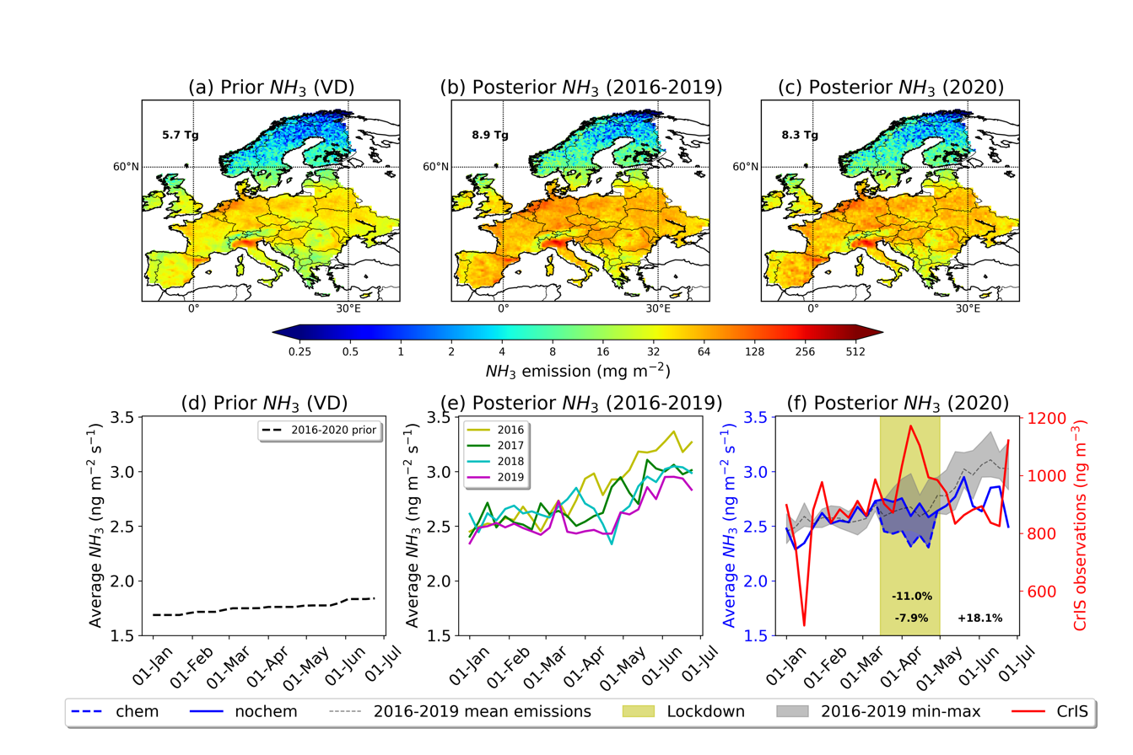
Supplementary Figure S 5. (a) Total a priori emissions of ammonia over Europe for the inversion period (January – June) from the VD inventory. The total emitted amount is equal to 5.7 Tg. (b) Total a posteriori emissions of ammonia over Europe for the inversion period (January – June). The emissions are an average of respective inversions for years 2016 – 2019 and amount 8.9 Tg. (c) Total posterior emissions of ammonia over Europe in 2020 (8.3 Tg). (d). Timeseries of weekly-average prior emissions of ammonia over Europe (January to June) from VD. (e) Timeseries of weekly-average posterior emissions of ammonia over Europe for years 2016–2019 (January to June). (f) Timeseries of weekly-average posterior emissions of ammonia over Europe in 2020. Separate calculations for the effect of reduced chemical reactions (dashed blue line) versus changes in the atmospheric levels (straight blue line) during the lockdown period (light yellow) are plotted together with the CrIS observations averaged over Europe (red line) and minimum, mean and maximum ammonia emissions in previous years (2016–2019). Single top number shows the change in ammonia emissions during the 2020 lockdown as compared to the same period the years before (-11.0%), the two bottom ones show the respective changes in ammonia emissions during the 2020 lockdown as compared to the period before lockdown (-7.9%), and the period after lockdown finished compared to the lockdown period (+18.1%).

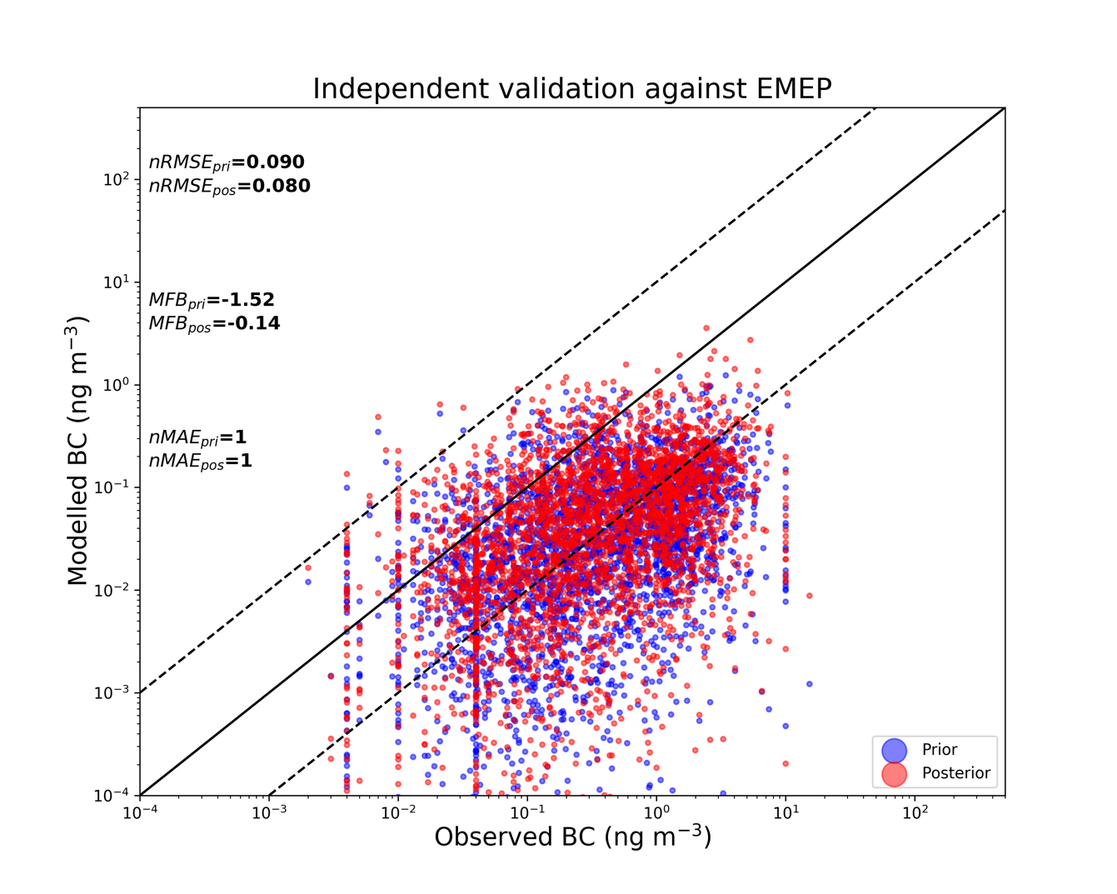
Supplementary Figure S 6. Scatter plots of prior and posterior ammonia concentrations against independent observations (observations that were not included in the inversion framework) from EMEP network from January to June 2020. Three statistical measures (nRMSE, MFB and nMAE) were used to assess the performance of the inversion.

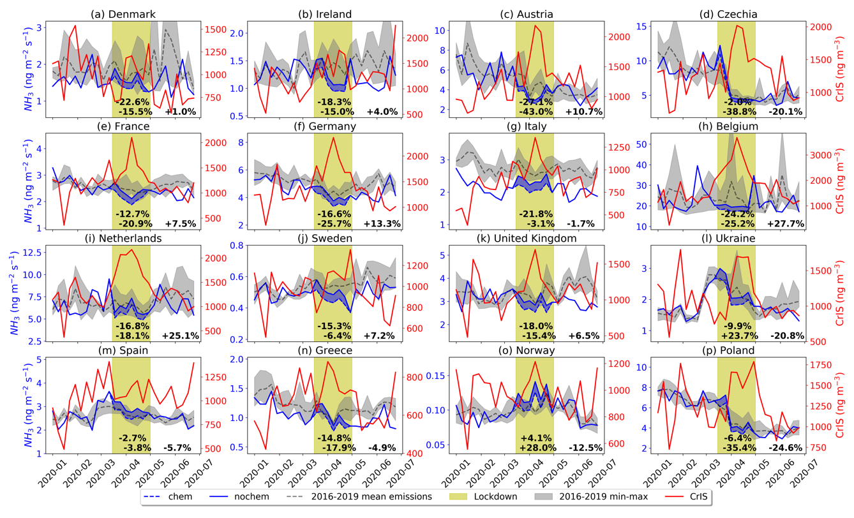
Supplementary Figure S 7. Timeseries of weekly-average posterior emissions of ammonia over different European countries in 2020 using EC6G4 as a priori emissions. Separate calculations for the effect of reduced chemical reactions (dashed blue line) versus changes in the atmospheric levels (straight blue line) during the lockdown period (light yellow) are plotted together with the CrIS observations averaged for each country (red line) and minimum, mean and maximum ammonia emissions in previous years (2016–2019). The single top number shows the change in ammonia emissions during the 2020 lockdown as compared to the same period the years before (2016-2019), whereas the two bottom numbers show the change in ammonia emissions during the 2020 lockdown as compared to the period before the lockdown, and during the period after lockdown finished compared to the lockdown period (known as rebound period). The definition of the countries plotted here is shown in Extended Data Fig. 5.

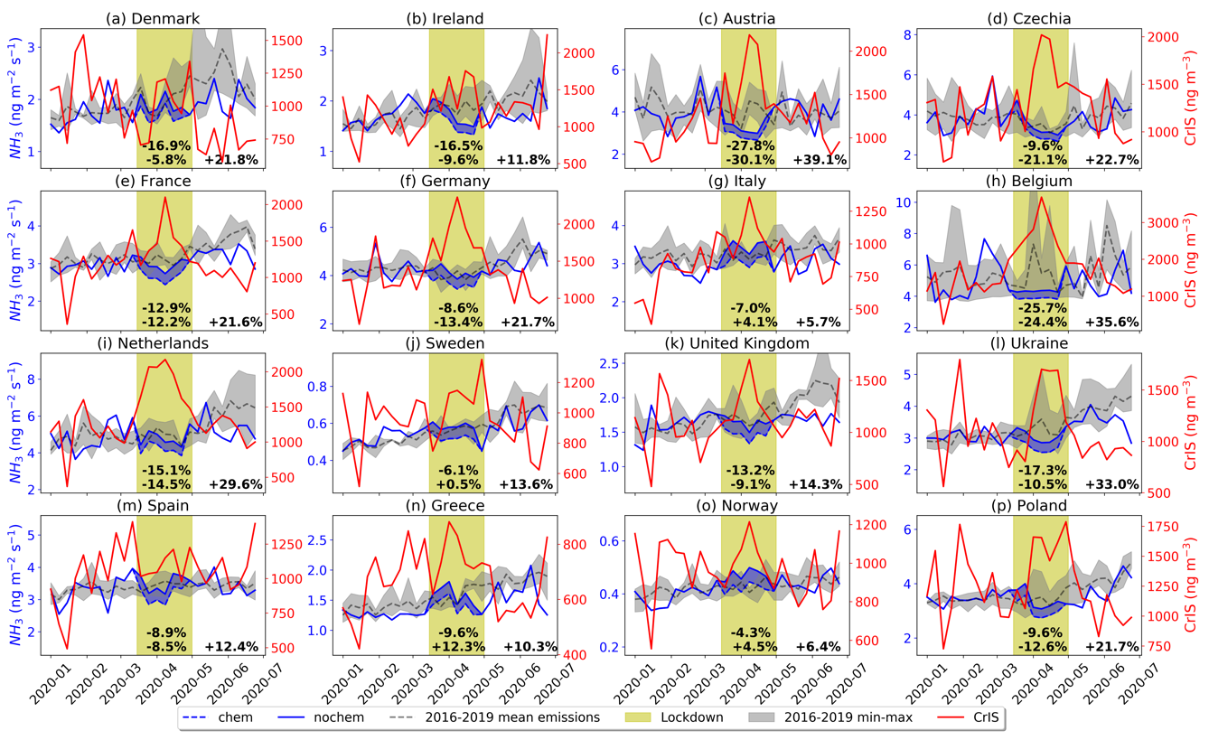
Supplementary Figure S 8. Timeseries of weekly-average posterior emissions of ammonia over different European countries in 2020 using VD as a priori emissions. Separate calculations for the effect of reduced chemical reactions (dashed blue line) versus changes in the atmospheric levels (straight blue line) during the lockdown period (light yellow) are plotted together with the CrIS observations averaged for each country (red line) and minimum, mean and maximum ammonia emissions in previous years (2016–2019). The single top number shows the change in ammonia emissions during the 2020 lockdown as compared to the same period the years before (2016-2019), whereas the two bottom numbers show the change in ammonia emissions during the 2020 lockdown as compared to the period before the lockdown, and during the period after lockdown finished compared to the lockdown period (known as rebound period). The definition of the countries plotted here is shown in Extended Data Fig. 5.

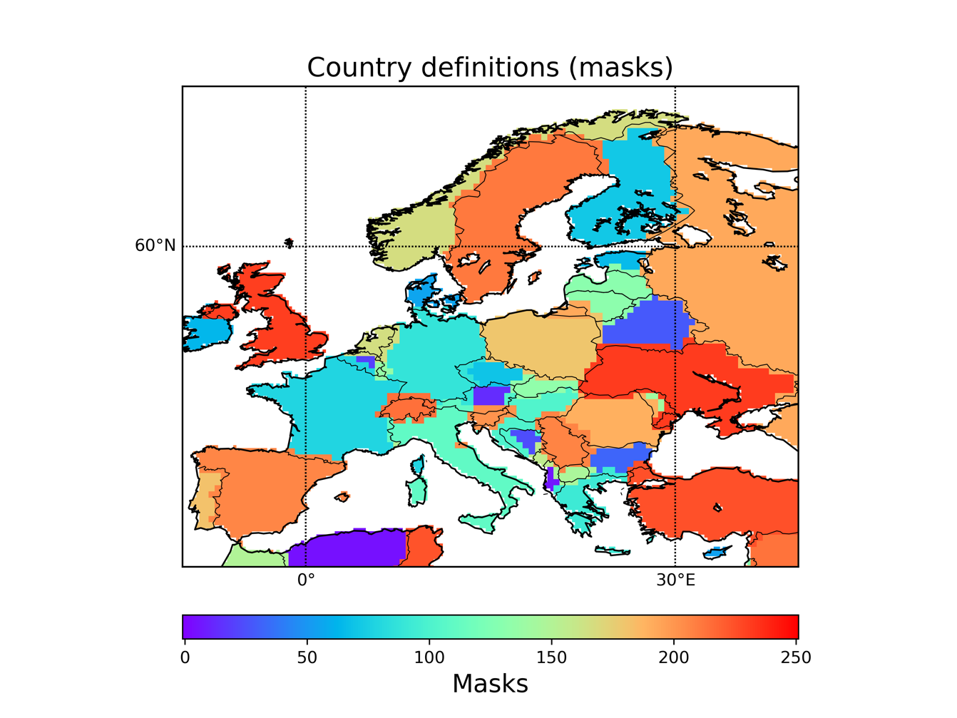
Supplementary Figure S 9. Country masks used to calculate emissions of ammonia over different European countries, namely Austria, Belgium, Denmark, Finland, France, Germany, Greece, Iceland, Ireland, Italy, Luxembourg, Netherlands, Norway, Portugal, Spain, Sweden, Switzerland, Turkey, United Kingdom, Albania, Belarus, Bosnia and Herzegovina, Bulgaria, Croatia, Cyprus, Czechia, Estonia, Hungary, Latvia, Lithuania, Malta, Poland, Republic of Moldova, Romania, Slovakia, Slovenia, North Macedonia, Ukraine, Serbia (Russian Federation was excluded from the study).

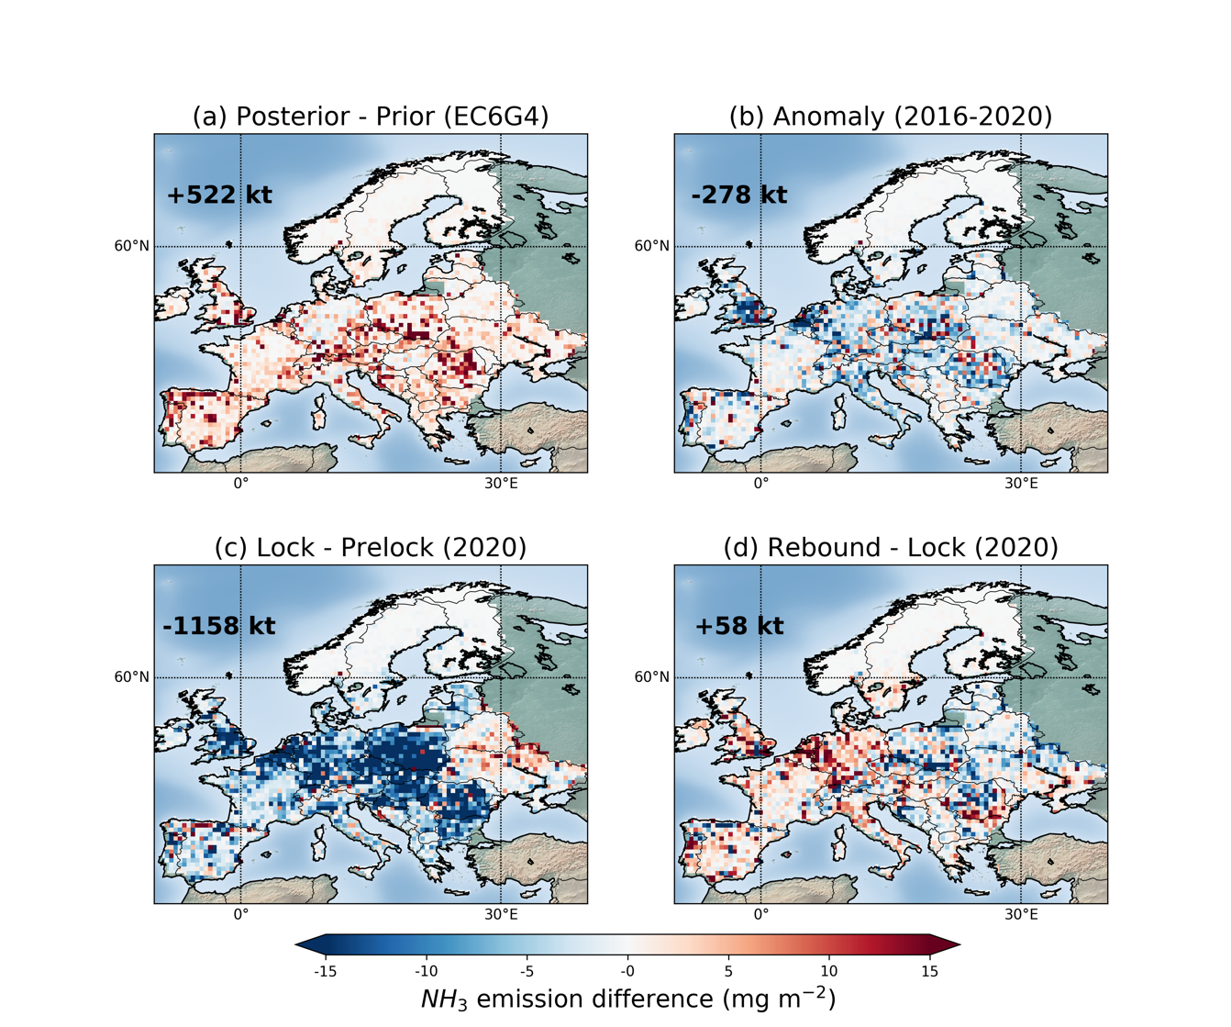
Supplementary Figure S 10. (a) Difference of posterior from prior emissions of ammonia during the European lockdowns of 2020 (15 March – 30 April). The results were calculated from inversions using a priori emissions from EC6G4. (b) Posterior emission anomalies of ammonia during the 2020 lockdowns against the 2016-2019 period (for the lockdown period) over Europe computed from posterior emissions from inversions using a priori emissions from EC6G4. Difference in ammonia emissions (c) during the 2020 lockdowns (15 March – 30 April, Lock) from the period before (1 January – 14 March) and (d) after the 2020 lockdowns (1 May – 31 June, Reb) from the period during the 2020 lockdowns (15 March – 30 April, Lock) using EC6G4 as the prior inventory.

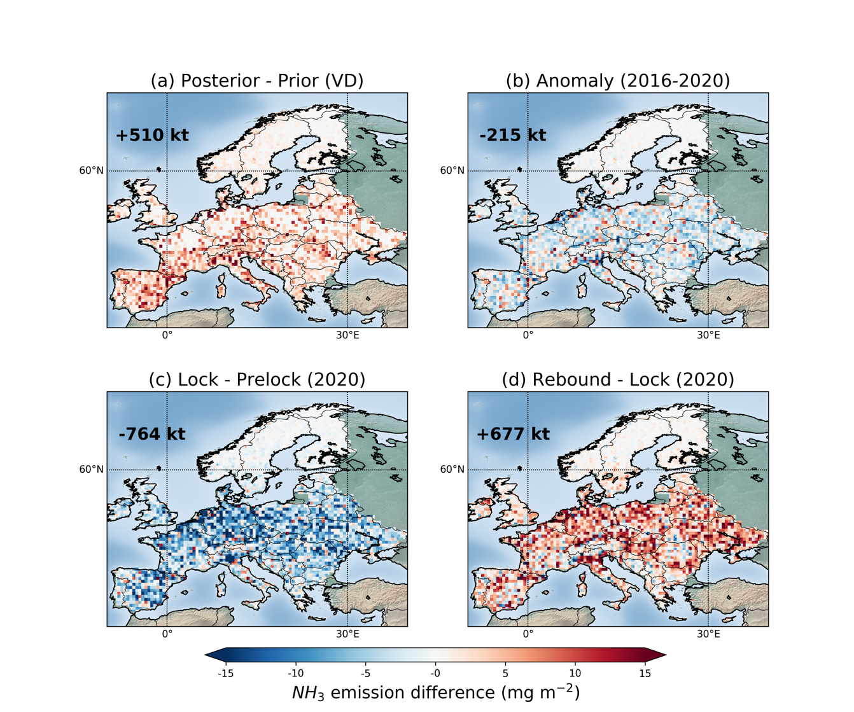
Supplementary Figure S 11. (a) Difference of posterior from prior emissions of ammonia during the European lockdowns of 2020 (15 March – 30 April). The results were calculated from inversions using a priori emissions from EC6G4. (b) Posterior emission anomalies of ammonia during the 2020 lockdowns against the 2016-2019 period (for the lockdown period) over Europe computed from posterior emissions from inversions using a priori emissions from EC6G4. Difference in ammonia emissions (c) during the 2020 lockdowns (15 March – 30 April, Lock) from the period before (1 January – 14 March) and (d) after the 2020 lockdowns (1 May – 31 June, Reb) from the period during the 2020 lockdowns (15 March – 30 April, Lock) using VD as the prior inventory.

References
1. Bouwman, A. F. et al. A global high-resolution emission inventory for ammonia. Global Biogeochem. Cycles 11, 561–587 (1997).
2. Klimont, Z. et al. Global anthropogenic emissions of particulate matter including black carbon. Atmos. Chem. Phys. 17, 8681–8723 (2017).
3. Giglio, L., Randerson, J. T. & van der Werf, G. R. Analysis of daily, monthly, and annual burned area using the fourth-generation global fire emissions database (GFED4). J. Geophys. Res. Biogeosciences 118, 317–328 (2013).

