TABLE I
the number of samples belonging to each class in the maximum dataset
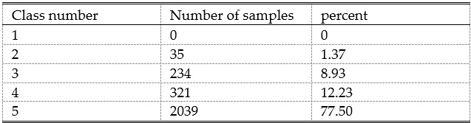
TABLE II
sparse class classification accuracy in maximum dataset
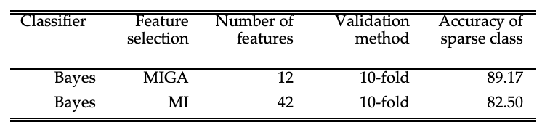
TABLE III
classification accuracy of NON-SPARSE classes in the maximum dataset
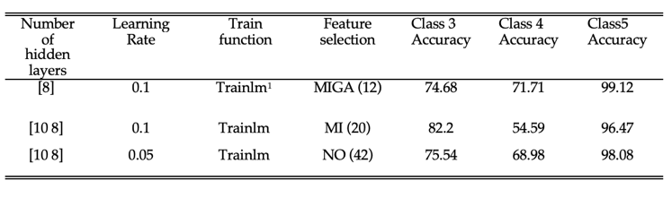

TABLE IV
The number of samples belonging to each class in the MEAN dataset
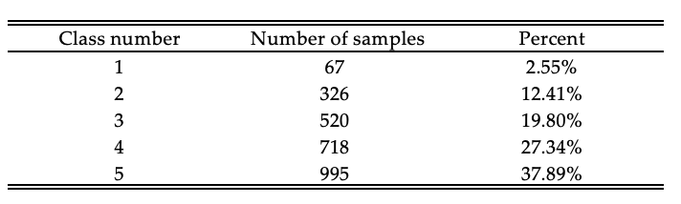
TABLE V
Sparse classification accuracy in MEAN dataset
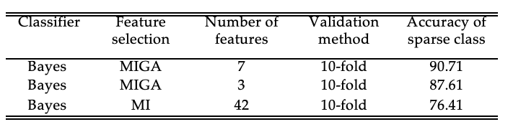
TABLE VI
NON-SPARSE Classification accuracy in MEAN dataset
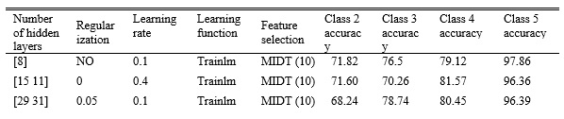

TABLE VII
The number of samples belong to each class in the MIN dataset
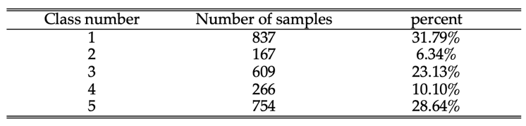

TABLE VIII
Sparse classification accuracy in the MIN dataset
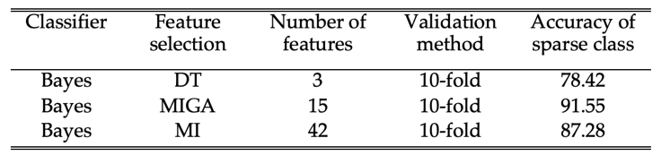
TABLE IX
NON-SPARSE Classification accuracy in the MIN dataset
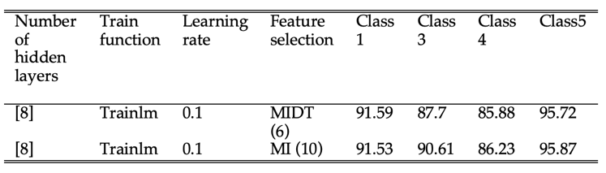
TABLE X
12 QoS features selected for constructing the decision tree
variable | Quantity | unit
X1 | Line quality | MOS
X2 | Line performance | MOS
X3 | Attainable bitrate mean download | b/s
X4 | Attainable bitrate mean upload | b/s
X5 | Actual bitrate mean download | b/s
X6 | Actual bitrate mean upload | b/s
X7 | SNR mean download | dB
X8 | SNR mean upload | dB
X9 | Delay mean download | ms
X10 | Delay mean upload | ms
X11 | Attenuation mean download | dB
X12 | Attenuation mean upload | dB
b/s = bits per second, ms = milli second, MOS = Mean Opinion Score

TABLE XI
the rules extracted from decision tree for maximum database
Rule number | Rule description | QoE
1 | If (x1 < 2) and (x2 < 3.5) | 1
2 | If (2 < x1 < 3.5) and (x2 < 3.5) and (x 9 > 2.8) | 2
3 | If (3.5 < x1 < 4.5) and (4 < x2) and (4577.5 < x4) and (16293.5 < x5) and (38.705 < x12) | 3
4 | If (5.5 < x1) and (x4 < 3409) and (4.5 < x5) and (26 < x8) and (27.65 < x10) and  (3.985 < x12 < 4.095) | 4
5 | If (5.5 < x1) and (5.5 < x2) and (x3 < 1051.5) and (3409 < x4 < 11024.5) and (10.15 < x6) and  (26 < x8) and (15.5 < x9) and (19.85 < x10) and  (3.985 < x12 < 4.095) | 5

TABLE XII
the rules extracted from decision tree for mean database
Rule number | Rule description | QoE
1 | If (x1 < 2.5) and (x2 < 4.5) and (1991.5 < x4) and (x9 < 18.835) | 1
2 | If (x1 < 2.5) and (x2 < 4.5) and (x4 < 1091.5) and (x5 < 5493.5) and (43.415 < x8) and (x10 < 30.9) | 2
3 | If (3.5 < x1 < 4.5) and (2.5 < x2 < 3.5) and  (515 < x4) and (x6<12.2) and (8.32 < x7) and  (x8 < 16.575) | 3
4 | If (3.5 < x1 < 5.5) and (4.5 < x2) and (1853 < x3) and (x4 < 5493.5) and (972.5 < x6) and (8.21 < x7) and (x8 < 22.06) and (x10 < 32.775) | 4
5 | If (5.5 < x1) and (5.5 < x2) and (36.09 < x6) and (41.775 < x8) | 5
TABLE XIII
the rules extracted from decision tree for min database
Rule number | Rule description | QoE
1 | If (x1 < 1.5) and (11073 < x3) and (1243 < x4) and (x7 < 8.91) and (x9 < 87.35) | 1
2 | If (3 < x1 < 4.5) and (x2 < 4.5) and (x4 < 11733) and (6918 < x5) and (x7 < 15.16) and  (2.24 < x8 < 15.085) | 2
3 | If (3.5 < x1 < 4.5) and (2.5 < x2 < 3.5) and (515 < x4) and (x6 < 12.2) and (8.32 < x7) and  (x8 < 16.575) | 3
4 | If (4.5 < x1 < 5.5) and (x2 < 5) and  (2850.5 < x3<4936.5) and (x10 < 16.045) | 4
5 | If (5.5 < x1) and (5.5 < x2) and (962 < x3) and (1360.5 < x4) and (21.9 < x6) and (23.295 < x7) | 5

TABLE XIV
different sla programs
SLA LEVEL | MAX SCORE | MEAN SCORE | MIN SCORE
GOLD1 | 5 | 5 | 5
GOLD2 | 5 | 5 | 4
SILVER1 | 5 | 4 | 4
SILVER2 | 5 | 4 | 3
BRONZE1 | 4 | 3 | 3
BRONZE1 | 4 | 3 | 2

TABLE XV
the rules extracted for the max, mean, and min databases and gold1 program rule
RULE | Rule description
Max QoE score | If (5.5 < x1) and (5.5 < x2) and (x3 < 1051.5) and (3409 < x4 < 11024.5) and (10.15<x6) and (26 < x8) and (15.5 < x9) and (19.85 < x10) and  (3.985 < x12 < 4.095)
Mean QoE score | If (5.5 < x1) and (5.5 < x2) and  (36.09 < x6) and (41.775 < x8)
Min QoE score | If (5.5 < x1) and (5.5 < x2) and (962 < x3) and (1360.5 < x4) and (21.9 < x6) and (23.295 < x7)
Gold 1 | If (5.5 < x1) and (5.5 < x2) and (962 < x3 <1051.5) and (3409 < x4 <11024.5) and (36.09 < x6) and (x7 < 23.295) and (41.775 < x8)

