Additional Files/Supplementary Materials for

PLCG2 variant p.P522R – associated with healthy aging- may reduce the aging of the human immune system

Annieck M. Diks^{1,2}, Cristina Teodosio^{1,3}, Bas de Mooij¹, Rick J. Groenland¹, Brigitta A.E. Naber¹, Inge F. de Laat¹, Sandra A. Vloemans¹, Susan Rohde², Marien I. de Jonge⁴, Linda Lorenz², Debbie Horsten², Jacques J.M. van Dongen^{1,3,*}, Magdalena A. Berkowska^{1†}, Henne Holstege^{2†*}

† These authors contributed equally to this work.
* Correspondence clinical work: H. Holstege (H.Holstege@amsterdamumc.nl)
* Correspondence laboratory work: J.J.M. van Dongen (J.J.M.van_Dongen@lumc.nl)

This file includes:

Supplementary Text
Figs. S1 to S5
Tables S1 to S4

Supplementary Text
Translated questionnaire to include donor in Cohort II
Of note, this file was translated by the authors for the sole purpose of transparency.

General health evaluation*
Are you currently, or were you in the past diagnosed with:
- Hypertension?
  - If so, please specify age and medication
- Diabetes type 2?
  - If so, please specify age and medication
- Cardiovascular issues?
  - If so, please specify the type of issue (cardiovascular infarct, angina pectoris, arrhythmia, cardiac valve issue, cardiovascular failure, other: ...)
  - Please indicate if you were treated by a specialist and which treatment was received
- A brain infarct?
  - If so, please specify (Cerebrovascular attack, Transcient Ischemic Attack or ‘other’)
  - If so, please specify age
  - Please indicate if you were treated by a specialist
- An autoimmune disease
  - If so, please specify which autoimmune disease
  - If so, please specify age
  - (medication is recorded later in the questionnaire)
- Osteoporosis
  - If so, please specify age
- A tumor or cancer
  - If so, please specify the type of tumor/cancer
  - If so, please specify age at time of tumor/cancer
  - If so, please specify which treatment was received
- Do you have any allergies?
  - If so, please specify

Gastro-intestinal Health*
- Do you currently experience diarrhea?
  - If so, please specify date of onset
- Do you currently experience Irritable Bowel Disease (IBD)?
  - If so, please specify date of onset
- Are you diagnosed with Colitus Ulcerosa?
  - If so, please specify date of onset
  - If so, are you currently experiencing an episode?
- Are you currently diagnosed with any other gastro-intestinal disease?
  - If so, is diarrhea one of the symptoms?
- Are you currently diagnosed with a stomach ulcer?
  - If so, please specify date of onset

Additional questions to determine if a person was eligible for blood donation within a short timeframe**
- Do you currently experience an (active) infection?
  - If so, please specify which type of infection
- Did you experience an (active) infection during the past three months?
  - If so, please specify which type of infection
  - If so, please specify the date and duration of the infection
- Have you been diagnosed with SARS-CoV2 infection?
  - If so, please specify the date
  - If so, please indicate the last day of symptoms
- Has someone in your household been diagnosed with SARS-CoV2 infection?
  - If so, please specify the date
  - If so, please indicate the last day of symptoms
- Has one of your direct caregivers been diagnosed with SARS-CoV2 infection?
  - If so, please specify the date
  - If so, please indicate the last day of symptoms
- When living in an elderly home; have there been SARS-CoV2 infections in the elderly home?
  - If so, please specify the date
- Did you receive a vaccination in the past 6 months?
  - If so, please specify type of vaccine and date of vaccination
- Did you receive a vaccination in the past 3 weeks?
  - If so, please specify type of vaccine and date of vaccination
- Do you have any vaccination planned soon?
  - If so, please specify date
- Are you currently a blood donor, or were you until very recently a blood donor?
  - If so, please specify which timeframe and date of last blood donation
- Did you undergo major surgery in the past month?
  - If so, please specify
- Do you experience another health conditions that was not discussed in this questionnaire?

Use of medication and vitamins*
- Do you currently use antibiotics?
  - If so, please specify which antibiotics and what timeframe
- Do you currently use corticosteroids?
  - If so, please specify which corticosteroids and what timeframe
- Do you currently use other medication?
  - If so, please specify which and what timeframe
- Do you currently use vitamin supplements?
  - If so, please specify which vitamins and what timeframe

* Most sections in this questionnaire were part of the general questionnaire asked upon inclusion in cohort I. However, for inclusion into Cohort II, these were asked once again in combination with an additional set of questions, as indicated in this text with a double asterisk (**).

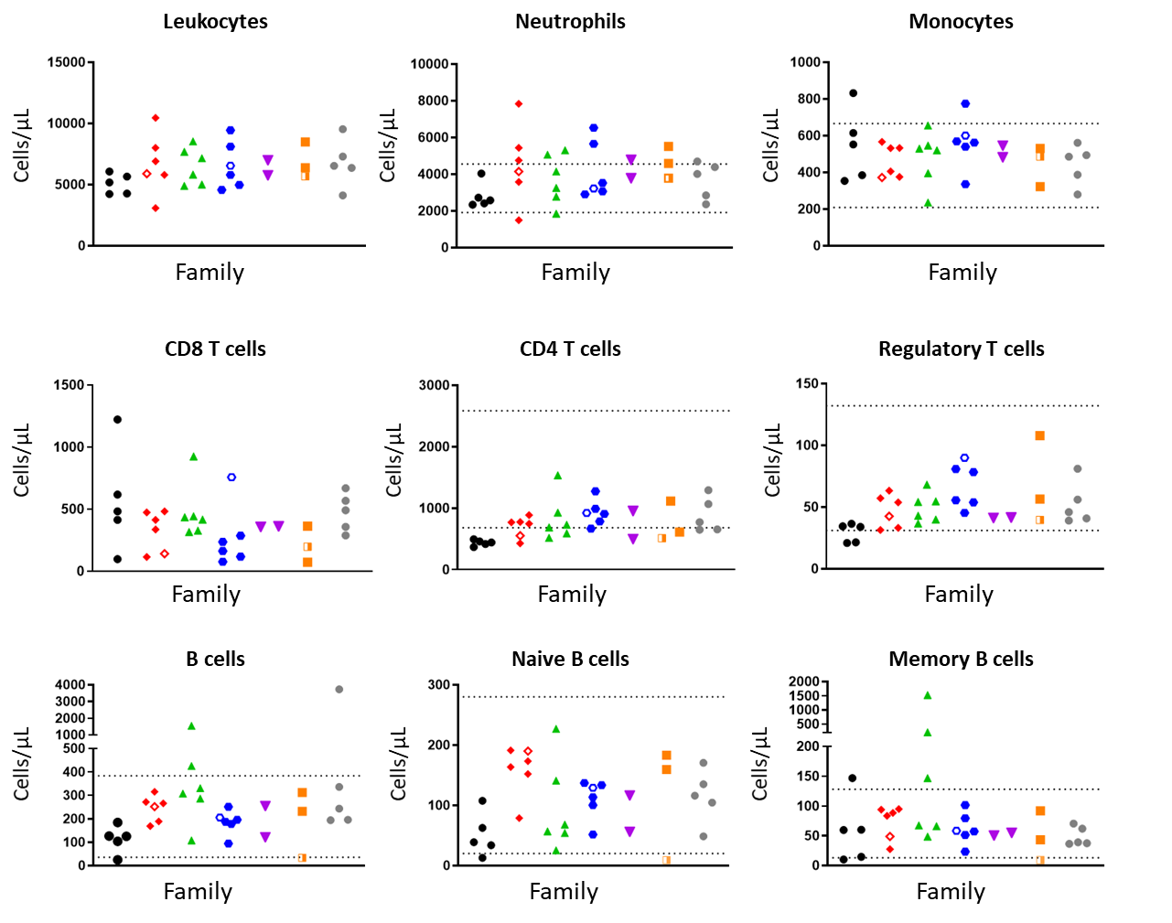

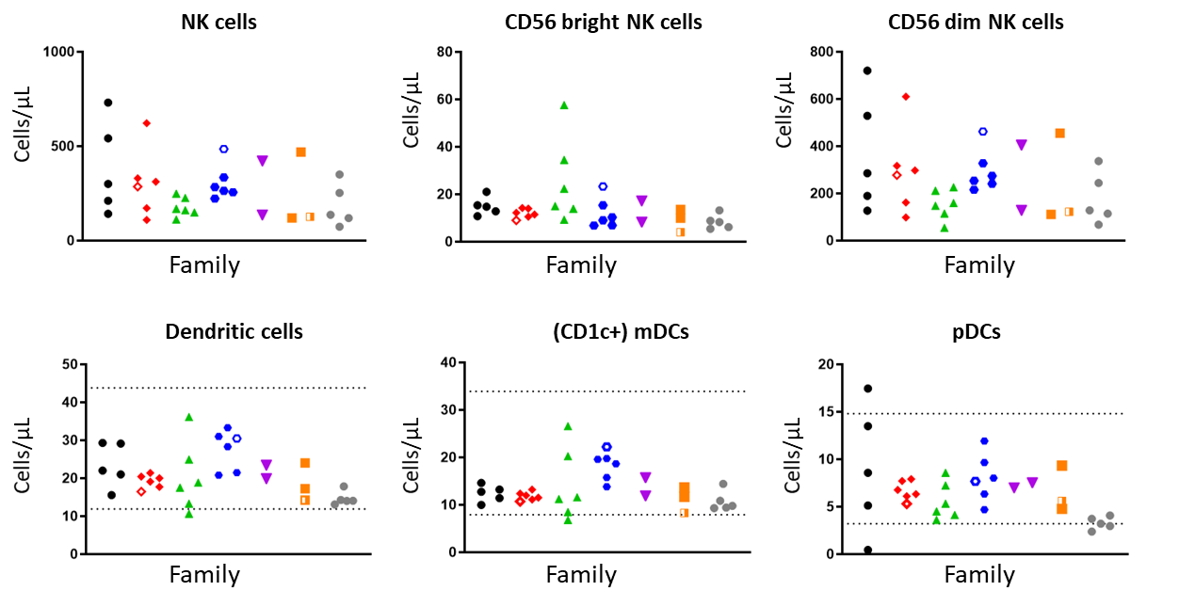

Fig. S1.

Impact of genetic background on numbers of circulating immune cells. Each color and symbol indicate members of one family. Fully open symbols represent a centenarian. Semi-open symbol (orange) represents a sibling of a centenarian. Dashed lines indicate the available age-matched reference values produced with flow cytometry panels highly similar to the panels used in this study (earlier or later prototypes of these panels). For B- and T-cell subsets, reference lines indicate a cohort aged 60-79 years. For innate myeloid populations, reference lines indicate a cohort >55 years old. In plots without dashed lines, no published reference values from highly similar flow cytometry panels were available.

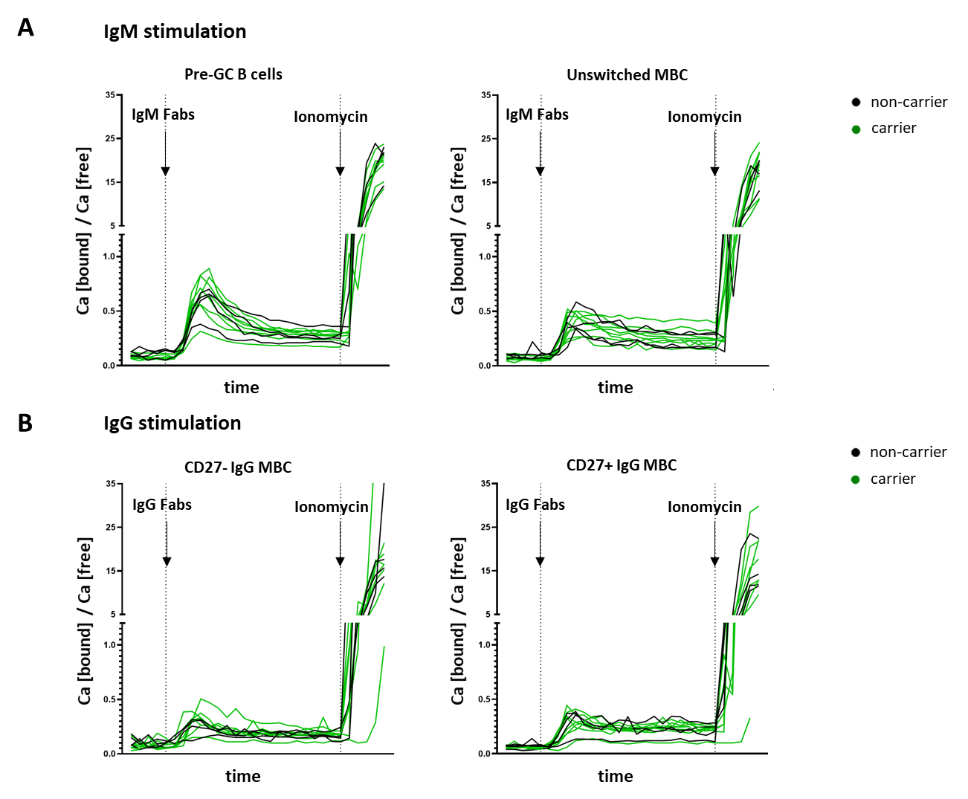

Fig. S2.

Results of the pilot study to evaluate the calcium flux upon stimulation of the B-cell receptor (BCR) with IgG and IgM Fab fragments. (A) Measurement of calcium release (‘flux’) after B-cell stimulation with IgM Fabs in pre-GC B cells (CD27-IgA-IgG-) or unswitched memory B cells (CD27+IgA-IgG-). (B) Measurement of calcium release (‘flux’) after B-cell stimulation with IgG Fabs in CD27- IgG+ memory B cells (CD27-IgD-IgA-) or CD27+IgG+ memory B cells (CD27+IgD-IgA-). Ionomycin was added to calculate maximum calcium release. N=14. Pre-GC; pre-Germinal Center, MBC; memory B cell.

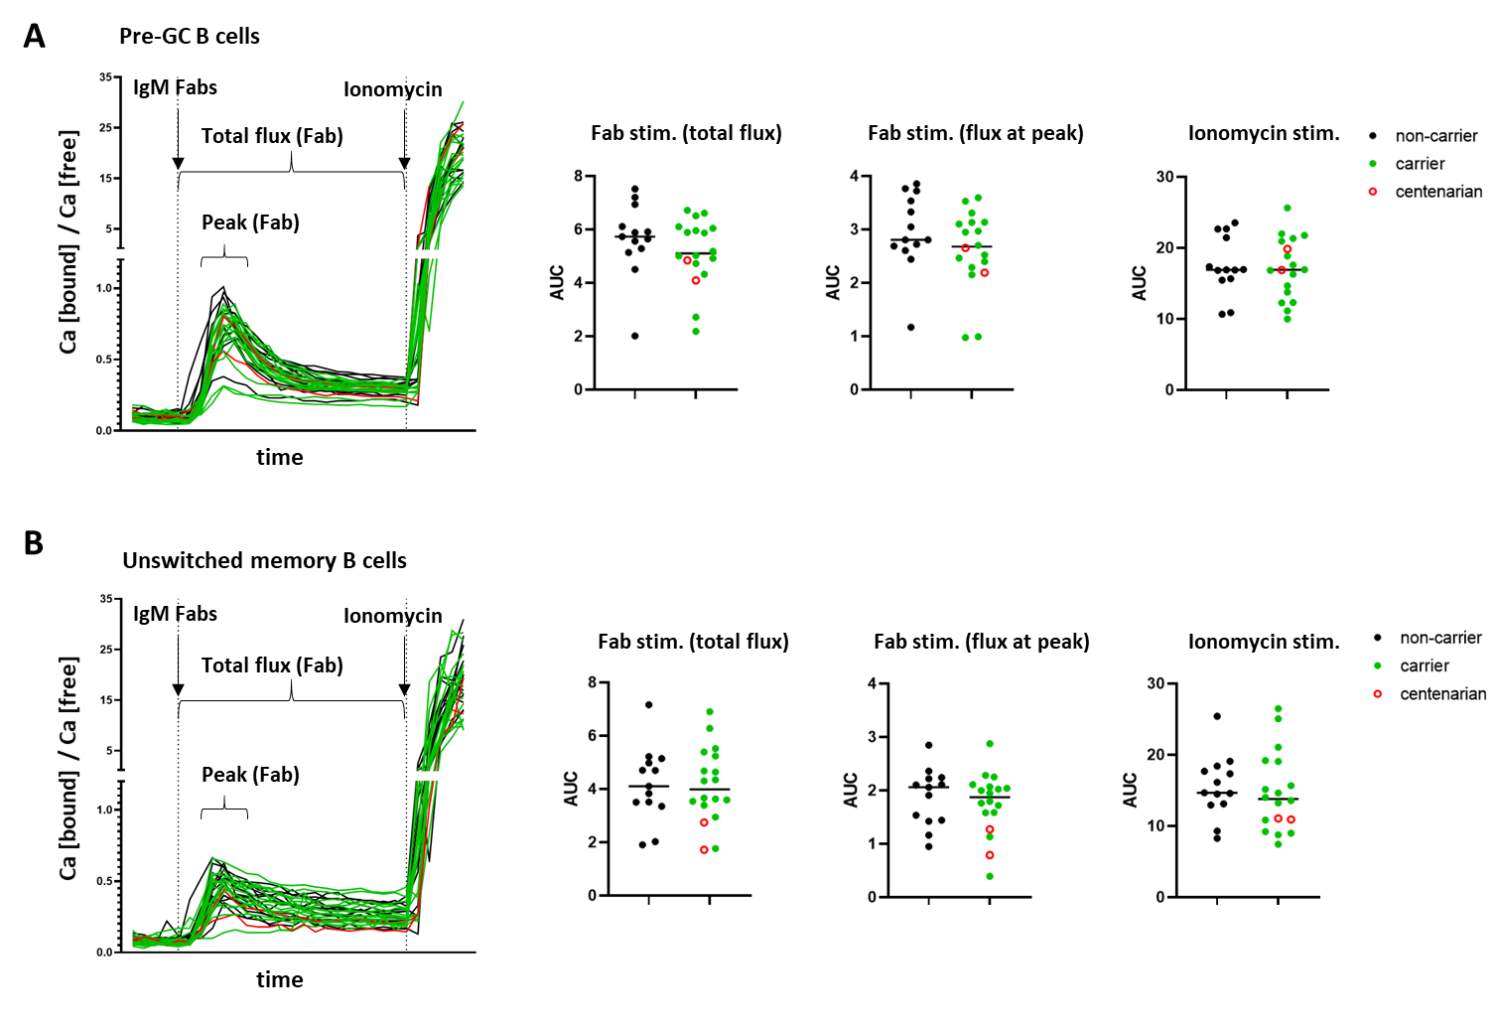

Fig. S3. Assessment of B-cell activation in all p.P522R carriers and non-carriers upon BCR stimulation. Measurement of calcium release (‘flux’) after B-cell stimulation with IgM Fabs in pre-GC B cells (CD27-IgG-IgA-) (A) or unswitched memory B cells (CD27+IgG-IgA-) (B) in cohort I. Ionomycin was added to calculate maximum calcium release. Differences between carriers and non-carriers were evaluated by comparing the area under the curve (AUC) of the total Fab stimulation (from stimulation until the moment ionomycin was added, ~ 10 min, flux intensity and duration), the peak of the response after Fab stimulation (the 5 highest points after the Fabs were added to the cells; flux intensity), and after ionomycin was added (to determine the maximum flux). AUC was calculated only for points that were higher than baseline value (unstimulated sample). N=31 (two samples were lost due to technical failure). No significant differences were observed. Pre-GC; pre-Germinal Center.

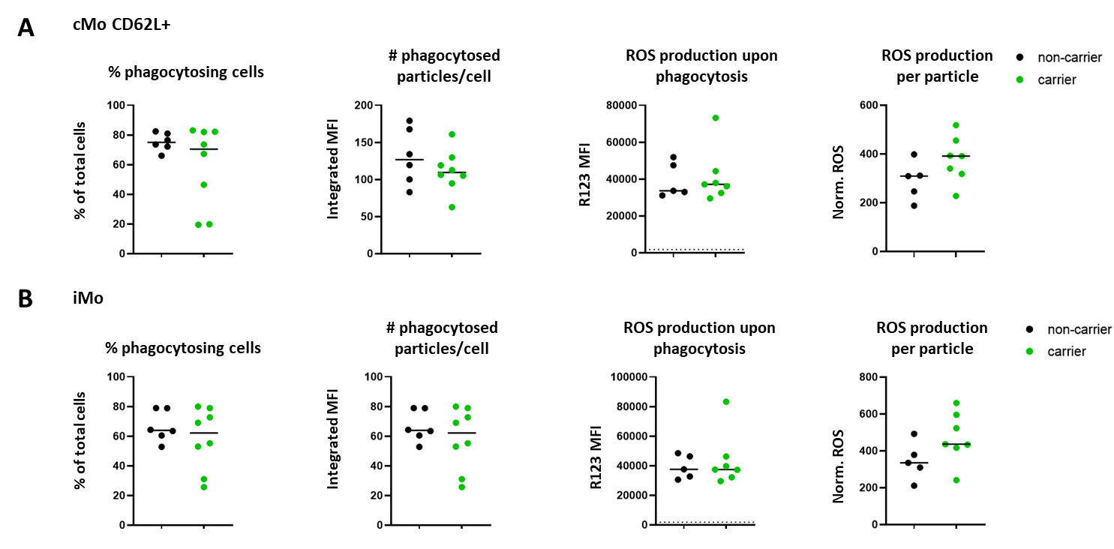

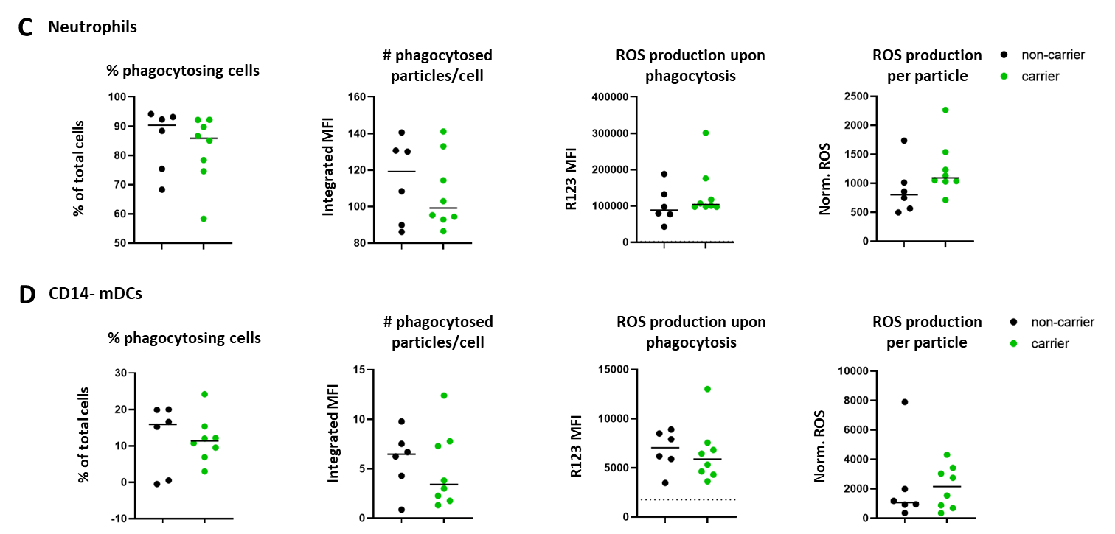

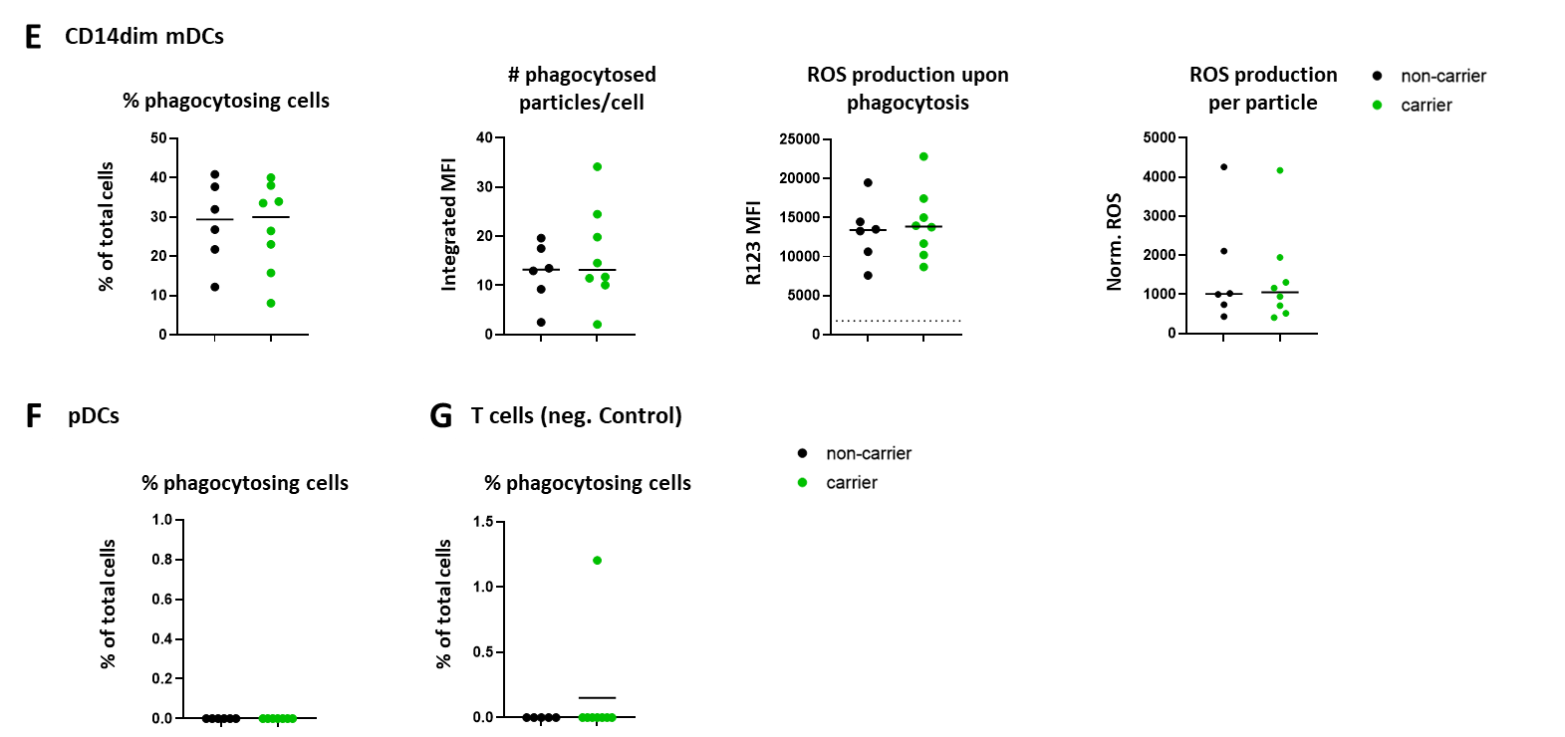

Fig. S4. (on previous page)

Phagocytosis and ROS production in innate immune cell subsets after stimulation with pHRodo™ Green E. coli Bioparticles (FcR/PLCγ2-dependent stimulation). To evaluate the outcome of the phagocytosis assays, three different readouts were used per population: % of cells that were phagocytosing, the average amount of particles phagocytosed per cell, and the ROS production upon phagocytosis. These three readouts were further combined into one value: the normalized ROS. These values are presented for the CD62L+ classical monocyte (cMo) subset (A), intermediate monocytes (iMo) (B), neutrophils (C) CD14- and CD14dim myeloid dendritic cells (mDCs) (D,E), and non-phagocytosing plasmacytoid dendritic cells (pDCs) (F). Lastly, the outcomes for T cells (negative control) are shown (G). Mann-Whitney test was used to evaluate differences between carriers and non-carriers, but no statistically significant differences were found. N=14. In two donors, monocytes could not be divided into subsets due to absence of a differentiating antibody in the prepared antibody cocktail, therefore, in panel A and B, only 5 non-carriers and 7 carriers are shown. Dashed lines indicate the background level of ROS (ROS production in negative control population; T cells). All outcomes were corrected for background or baseline activation by subtracting the value of the control (incubated on ice) from the activated (incubated at 37°C) sample. Negative values (caused by higher background in control samples than activated samples in cell populations that did not perform phagocytosis) were set to 0.

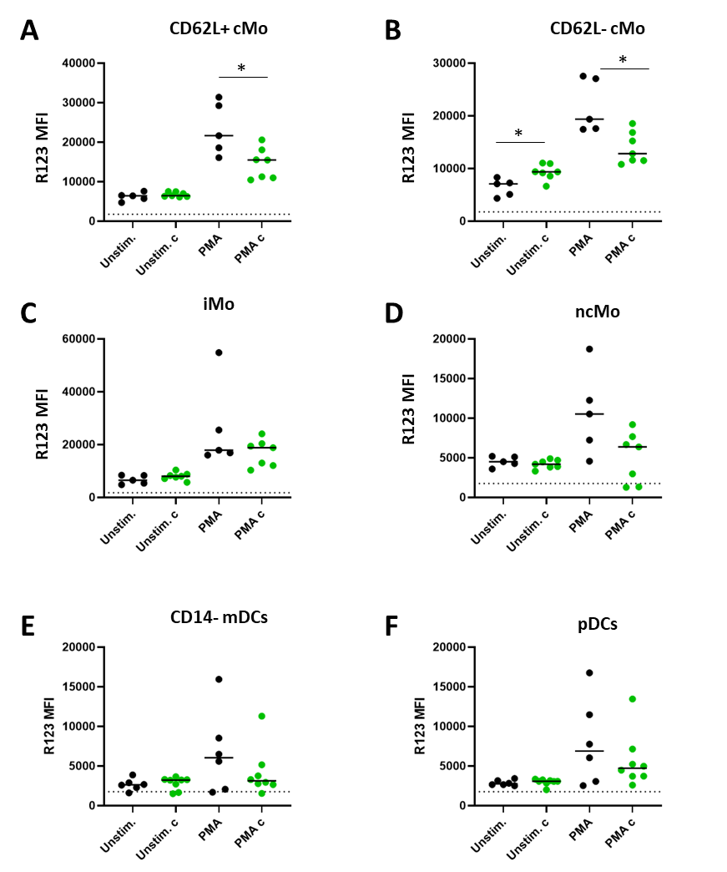

Fig. S5.

ROS generation in innate immune cell subsets in p.P522R carriers and non-carriers upon stimulation with PMA (FcR/PLCγ2-independent stimulation). N=14. In two donors, monocytes could not be divided into subsets due to absence of an antibody in the prepared antibody cocktail, therefore, in panel A-D, only 5 non-carriers and 7 carriers are shown. Dashed lines indicate the background level of ROS (ROS production in negative control population; T cells). All outcomes were corrected for background or baseline activation by subtracting the value of the control (incubated on ice) from the activated (incubated at 37°C) sample.

Table S1.
Description of all included families and additional donors

Family | M/F | Carrier/  non carrier | Age range (min-max)
Family 1 | 4/1 | 3/2 | 63-75 years
Additional: sibling of the centenarian | F | Carrier | 94 years
Family 2 | 3/2 | 1/4 | 62-83 years
Family 3 | 2/4 | 5/1 | 67-79 years
Family 4 | 1/1 | 1/1 | 72-74 years
Additional: the centenarian | F | Carrier | 103 years
Family 5 | 2/3 | 2/3 | 66-75 years
Additional: the centenarian | F | Carrier | 103 years
Family 6 | 1/1 | 1/1 | 65-81 years
Family 7 | 1/4 | 2/3 | 59-78 years
Additional donor 1 | F | Carrier | 71 years
Additional donor 2 † | M | Carrier | 69 years
Additional donor 3 | F | Non-carrier | 71 years
M= male, F= female
† As an exception, one donor (carrier) was included from a family with history of healthy aging, but the parent was not yet a centenarian (93 years old at time of inclusion)

Table S2. Overview of the flow cytometry panels that were used in this study (table continues on the next pages).

Flow cytometry panel | Antibody |  | clone | provider | titer (ul) | Surface stain |  | Intracellular stain
BIGH panel (B-cell and plasma cell panel) | CD27 BV421 |  | M-T27156 | BD | 2 | x
10*10^6 cells stained | IgM BV510 |  | MHM-88 | BioLegend | 2 | x |  | x
 | CD62L BV605 |  | DREG-56 | BioLegend | 5 | x
EuroFlow protocols used: | CD24 BV650 |  | ML5 | BD | 5 | x
1. Bulk lysis | CD21 BV711 |  | B-Ly4 | BD | 5 | x
2. Intracellular stain (Fix & Perm) | CD19 BV786 |  | SJ25C1 | BD | 4 | x
Official reference for the BIGH panel:  Blanco E, Pérez-Andrés M, Arriba-Méndez S, et al. Age-associated distribution of normal B-cell and plasma cell subsets in peripheral blood. JACI 2018;141(6):2208-2219. e2216.  Diks AM, Versteegen P, Teodosio C, et al. Age and Primary Vaccination Background Influence the Plasma Cell Response to Pertussis Booster Vaccination. Vaccines. 2022;10(2):136.  Patent filed by Van Dongen et al. Means and Methods for Multiparameter Cytometry-Based Leukocyte Subsetting. P119646NL00 (2019). PCT/NL2020/050688, priority date 5 November 2019. | Ig Subclasses kit (CAT: CYT-IGS-1) |  | n/a | Cytognos | 25 | x |  | x
 | CD20 PE CF594 |  | 2H7 | BD | 2.5 (1:10) | x
 | CD138 PE-Cy7 |  | MI15 | BioLegend | 5 | x
 | CD5 PE-Cy7 |  | LIF7F12 | BD | 6 | x
 | IgD APC |  | IA6-2 | BD | 4 | x |  | x
 | CD38 APC H7 |  | HB7 | BD | 3 | x
DC-Monocyte panel (dendritic cell- monocyte panel) | CD141 BV421 |  | 1A4 | BD | 2.5 | x |  | no intracellular staining
10*10^6 cells stained | CD45 OC515 |  | GA90 | Cytognos | 10 | x
 | CD62L BV605 |  | DREG-56 | BioLegend | 5 | x
EuroFlow protocols used: | HLA-DR BV711 |  | G46-6 | BD | 2.5 | x
1. Bulk lysis | CD16 BV786 |  | 3G8 | BD | 5 | x
Official reference for the IMC panel:  Van der Pan et al., manuscript in review, Frontiers in Immunology.  Patent filed by Van Dongen et al. Means and Methods for Multiparameter Cytometry-Based Leukocyte Subsetting. P119646NL00 (2019). PCT/NL2020/050688, priority date 5 November 2019. | CD1c BB515 |  | F10/21A3 | BD | 5 | x
 | CD36 PerCP Cy5.5 |  | CLB-IVC7 | Immunostep | 10 | x
 | SLAN PE |  | DD.1 | Miltenyi | 10 | x
 | FcERI PE |  | AER-37 | Thermo Fischer | 5 | x
 | CD33 PE-Cy7 |  | P67.6 | BD | 5 | x
 | CD300 (IREM2) APC |  | UP-H2 | Immunostep | 10 | x
 | CD303 APC |  | AC144 | Miltenyi | 10 | x
 | CD14 APC H7 |  | M5E2 | BD | 5 | x
 | BV buffer |  | n/a | BD | 50 | x
CD4T panel (CD4 T cells) | CD27 BV421 |  | M-T27156 | BD | 2 |  | x |  | no intracellular staining
100ul peripheral blood stained | CD45RA BV510 |  | HI100 | BD | 2.5 |  | x |  | no intracellular staining
 | CD62L BV650 |  | DREG-56 | BioLegend | 2.5 |  | x |  | no intracellular staining
EuroFlow protocols used: | CD127 BV711 |  | HIL7RM21 | BD | 5 |  | x |  | no intracellular staining
1. Stain Lyse Wash | CD3 BV786 |  | SK7 | BD | 1 |  | x |  | no intracellular staining
Official reference for the CD4T panel:  Botafogo V, Pérez-Andres M, Jara-Acevedo M, et al. Age distribution of multiple functionally relevant subsets of CD4+ T cells in human blood using a standardized and validated 14-color EuroFlow immune monitoring tube. Frontiers in immunology. 2020;11:166.  Patent filed by Van Dongen et al. Means and Methods for Multiparameter Cytometry-Based Leukocyte Subsetting. P119646NL00 (2019). PCT/NL2020/050688, priority date 5 November 2019. | CD25 VioBright FITC |  | 4E3 | Milentyi | 10 |  | x |  | no intracellular staining
 | CCR10 PerCP Cy5.5 |  | 1B5 | BD | 2.5 |  | x |  | no intracellular staining
 | CXCR3 PE |  | 1C6/CXCR3 | BD | 10 |  | x |  | no intracellular staining
 | CCR6 PE-CF594 |  | 11A9 | BD | 5 |  | x |  | no intracellular staining
 | CCR4 PE-Cy7 |  | L291H4 | BioLegend | 1 |  | x |  | no intracellular staining
 | CXCR5 APC |  | 51505 | R&D | 10 |  | x |  | no intracellular staining
 | CD4 APC H7 |  | SK3 | BD | 5 |  | x |  | no intracellular staining
CYTOX panel (CD8 cytotoxic T-cell panel) | CD27 BV421 |  | M-T27156 | BD | 2 |  | x
100ul peripheral blood stained | CD45RA BV510 |  | HI100 | BD | 2.5 |  | x
 | CD62L BV650 |  | DREG-56 | BioLegend | 2.5 |  | x
EuroFlow protocols used: | CD16 BV711 |  | 3G8 | BD | 2.5 |  | x
1. Stain Lyse | CD3 BV786 |  | SK7 | BD | 1 |  | x
2. Intracellular stain (Fix & Perm) | CD57 FITC |  | HNK1 | BD | 10 |  | x
Official reference for the CYTOX panel:  Patent filed by Van Dongen et al. Means and Methods for Multiparameter Cytometry-Based Leukocyte Subsetting. P119646NL00 (2019). PCT/NL2020/050688, priority date 5 November 2019. | CD28 PerCP Cy5.5 |  | CD28.2 | BioLegend | 5 |  | x
 | Granzyme B PE |  | GB11 | Sanquin | 15 |  | - |  | x
 | CD8 PE-CF594 |  | RPAT8 | BD | 1 |  | x
 | TCRgd PE-Cy7 |  | 11F2 | BD | 1 |  | x
 | CD56 APC H7 |  | HCD56 | BioLegend | 5 |  | x
Flow cytometry panel | Antibody | clone | provider | titer (ul) | Surface stain | Intracellular stain
PLCγ2 panel | CD27 BV421 | M-T27156 | BD | 2 | x
2.5 * 10^5 cells stained | IgM BV510 | MHM-88 | Biolegend | 2 | x
 | CD45 BV650 | ML5 | BD | 20 | x
EuroFlow protocols used: | CD19 BV786 | SJ25C1 | BD | 4 | x
1. Bulk lysis | IgA FITC | IS11-8E10 | Miltenyi | 1 | x
2. Intracellular stain (Fix & Perm) | IgD PerCP Cy5.5 | IA6-2 | Biolegend | 5 | x
 | IgG PE | G18-145 | BD | 20 | x
 | CD20 PE CF594 | 2H7 | BD | 2.5 (1:10) | x
 | CD3 PE Cy7 | SK7 | BD | 5 | x
 | CD138 PE Cy7 | MI15 | Biolegend | 5 | x
 | PLCg2 APC | REA488 | Miltenyi | 15 | - | x
 | CD16 AF700 | 3G8 | BD | 5 | x
 | CD38 APC H7 | HB7 | BD | 3 | x
Perfect Count | CD45 OC515 | GA90 | Cytognos | 5 | x | no intracellular staining
50μl peripheral blood stained | CD19 BV786 | SJ25C1 | BD | 4 | x | no intracellular staining
EuroFlow protocol used: PerfectCount | CD3 APC | SK7 | BD | 2.5 | x | no intracellular staining

Flow cytometry panel | Antibody | clone | provider | titer (ul) | Surface stain | Intracellular stain
PLCγ2 Phosphorylation | CD20 PE Cy7 | 2H7 | BD | 5 | x
2.5 * 10^5 cells stained | CD3 FITC | SK7 | BD | 20 | x
 | CD16 BV510 | 3G8 | BD | 10 | x
Custom protocol; see Methods section | CD27 BV421 | M-T271 | BD | 2 | x
 | Zombie NIR™ Fixable Viability Kit | n/a | Biolegend | 1 (1:10) | x
 | pPLCg2 APC | REA341 | Miltenyi | 10 | - | x
 | IgG PE | G18-145 | BD | 10 | - | x
 | IgA PE | IS11-8E10 | Miltenyi | 4 | - | x
Caflux | Zombie NIR™ Fixable Viability Kit | n/a | Biolegend | 1 (1:10) | x | No intracellular staining
2.5 * 10^5 thawed peripheral blood mononuclear cells (PBMCs) stained | IgA FITC | IS11-8E10 | Miltenyi | 1 | x | No intracellular staining
 | IgG PE | G18-145 | BD | 10 | x | No intracellular staining
Custom protocol; see Methods section | IgD PerCP Cy5.5 | IA6-2 | Biolegend | 5 | x | No intracellular staining
Custom protocol; see Methods section | CD20 PE-Cy7 | 2H7 | BD | 5 | x | No intracellular staining
Custom protocol; see Methods section | CD27 BV421 | M-T271 | BD | 2 | x | No intracellular staining

Flow cytometry panel | Antibody | clone | provider | titer (ul) | Surface stain | Intracellular stain
PhagoBURST + Phagocytosis assay | CD141 BV421 | 1A4 | BD Biosciences | 2.5 | x | No intracellular staining
200ul peripheral blood stained | CD15 BV510* | W6D3 | BD biosciences | 15 | x | No intracellular staining
 | CD19 BV605 | HIB19 | Biolegend | 5 | x | No intracellular staining
Custom protocol; see Methods section | CD62L BV650 | DREG-56 | Biolegend | 2.5 | x | No intracellular staining
Custom protocol; see Methods section | HLA DR BV786 | G46-6 | Bd Biosciences | 2.5 | x | No intracellular staining
Custom protocol; see Methods section | CD16 BV786 | 3G8 | BD biosciences | 5 | x | No intracellular staining
Custom protocol; see Methods section | SLAN PE | DD.1 | Miltenyi | 5 | x | No intracellular staining
Custom protocol; see Methods section | CD36 PerCP Cy5.5 | CLB-IVC7 | Immunostep | 10 | x | No intracellular staining
Custom protocol; see Methods section | CD33 PE Cy7 | P67.6 | BD biosciences | 5 | x | No intracellular staining
Custom protocol; see Methods section | CD14 PE CF594 | MOP9 | BD biosciences | 5 | x | No intracellular staining
Custom protocol; see Methods section | IREM-2 APC | UP-H2 | Immunostep | 10 | x | No intracellular staining
Custom protocol; see Methods section | CD303 APC | AC144 | Miltenyi | 5 | x | No intracellular staining
Custom protocol; see Methods section | CD45 AF700 | HI30 | BD biosciences | 5 | x | No intracellular staining
Custom protocol; see Methods section | CD3 APC H7 | SK7 | BD Biosciences | 5 | x | No intracellular staining
Custom protocol; see Methods section | BV buffer | n/a | BD Biosciences | 50 | x | No intracellular staining
* CD15 BV510 only used in phagoBURST assay

Table S3. Control and assay tubes measured in the phagocytosis experiment.

 | Wash | Stain | Stimulus | Inc. at 37°C | Lyse
Control 1 | + | - | - | - | +
Control 2 | + | + | - | - | +
Control 3 | + | + | - | + | +
Control 4 (no cells, pHRodo™ Green E. coli bioparticles only) | - | - | + | - | -
Control 5 | + | + | + | - | +
Assay tube (n=2) | + | + | + | + | +
Inc. = incubation of the sample, Lyse = lysis of erythrocytes

Table S4. Control and assay tubes measured when detection production of reactive oxygen species (ROS).

 | Wash | Stain | Stimulus | Inc. at 37°C | Lyse
Control 1 | + | - | - | - | +
Control 2 | + | + | - | + | +
Control 3 (for FcR-dependent stim, n=2) | + | + | E. coli | - | +
Control 4 (for FcR-independent stim, n=2) | + | + | PMA | - | +
Assay tube (FcR-dependent, n=2) | + | + | E. coli | + | +
Assay tube (FcR-independent, n=2) | + | + | PMA | + | +
Inc. = incubation of the sample, Lyse = lysis of erythrocytes, PMA = Phorbol 12-Myristate 13-acetate

