Table1. Top10 journals in terms of publications from 2009 to 2022
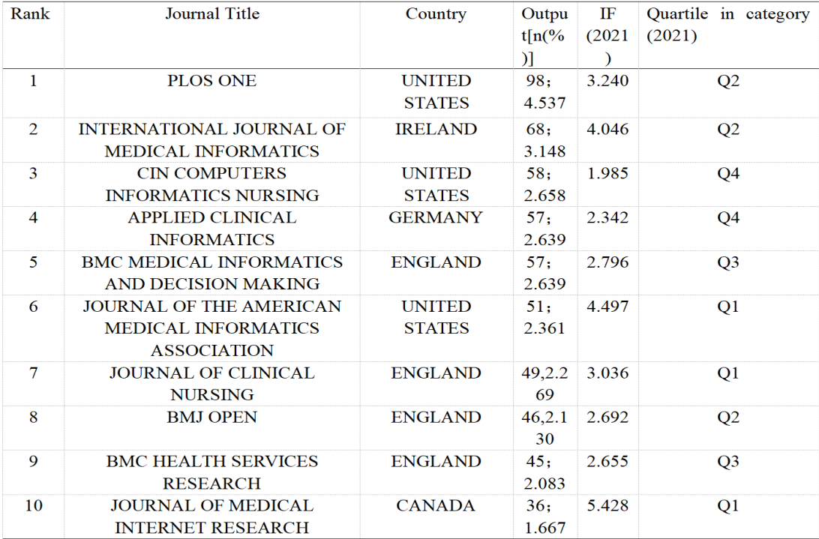

Table 2. The top 10 references analysis related to CDSSs research in nursing

