Supplementary information for
All-dielectric Huygens’ meta-waveguides for resonant integrated photonics

Y. Denizhan Sırmacı^{1,2*}, Angela Barreda Gomez^{1,2}, Thomas Pertsch², Jens H. Schmid^{3*}, Pavel Cheben^{3*} and Isabelle Staude^{1,2*}

¹Friedrich-Schiller-Universit¨at Jena, Institute of Solid State Physics, Max-Wien-Platz 1, Jena, 07743, Germany.
²Friedrich-Schiller-Universit¨at Jena, Institute of Applied Physics, Abbe Center of Photonics, Albert Einstein Str. 15, Jena, 07743, Germany.
³National Research Council of Canada, Ottawa, K1A 0R6, Ontario, Canada.

*Corresponding author E-mail: yunus.denizhan.sirmaci@uni-jena.de

Comparison of field profiles of isolated Huygens’ scatterers and their 1D arrays
We compared the field profiles of plane-wave-illuminated single isolated Huygens’ scatterers (Fig. S1 (a-c)) with the Bloch mode of the infinite 1D array of Huygens’ scatterers (Fig. S1 (d-f)) at a wavelength of 1550 nm. The field profiles are almost identical. Note that, because of the Floquet-Bloch boundary conditions, we observed symmetrical field profiles in the case of the 1D array of scatterers, while the single isolated scatterer exhibits an asymmetry in the propagation direction due to the plane wave illumination and associated retardation effects. The mode profiles clearly underpin that the spatial properties of the single-particle resonances are well preserved in the infinite arrays.

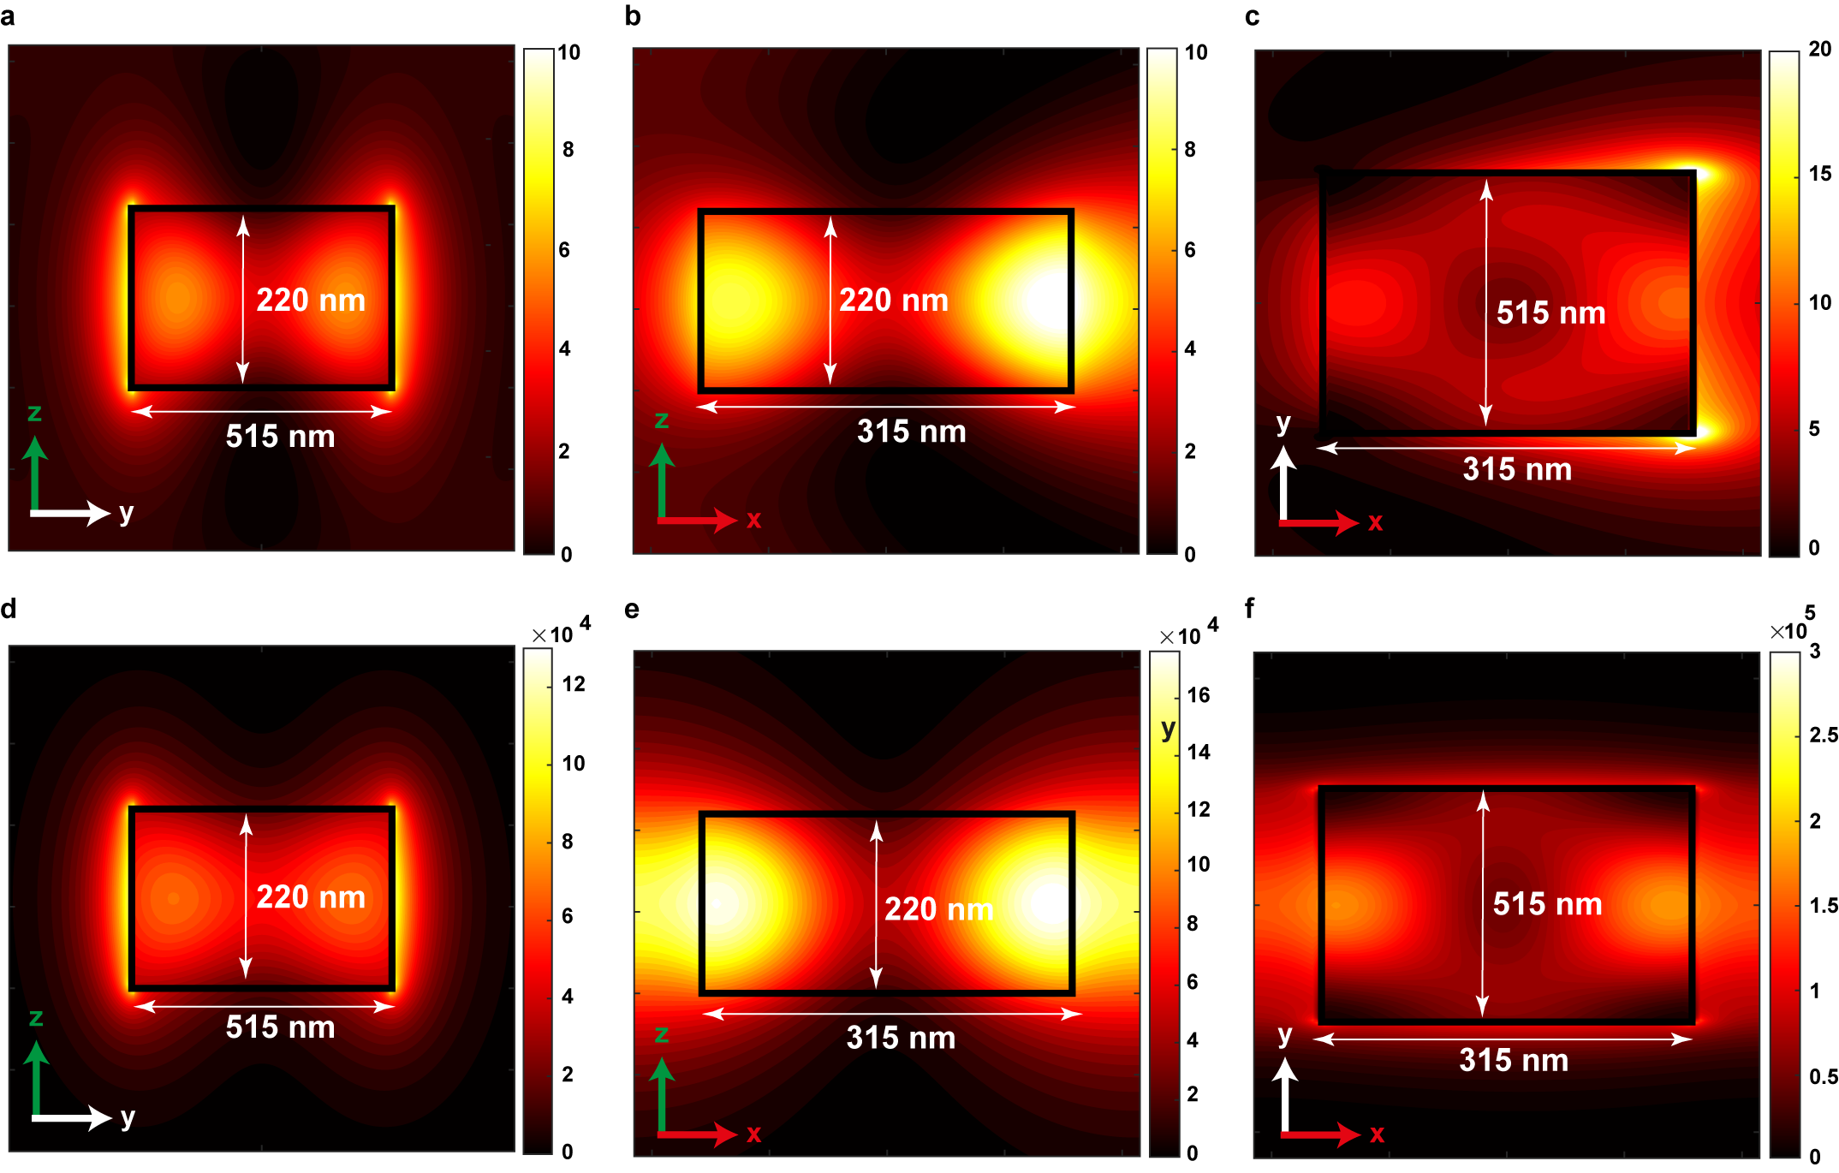

Fig. S1. Electric field intensity profiles of Huygens’ scatterers. The top row (a-c) represents the single isolated scatterer while bottom row (d-f) shows the 1D array of Huygens’ scatterers. a and d: y-z cross-section; b and e: x-z cross-section (side view); c and f: x-y cross-section (top-view). Please refer to Fig. 1a for the coordinate axis orientation.

Asymmetric power splitters

The power splitting ratio realized by the Huygens’ splitters can readily be adjusted by the dispacement of the input waveguide section in the y-direction. In Fig. S2, we show calculated electric field intensities at 1550 nm of three splitters featuring different shifts of the input Huygens’ meta-waveguide. As a reference, Fig. S2a shows a dvice with 50:50 splitting ratio (no shift), Fig. S2b shows the electric field intensity for a Huygens’ splitter when the input waveguide section is shifted by 40 nm, and Fig. S2c shows the case for a shift of 80 nm. We didn’t observe any difference in the total transmitted power. However, the splitting ratio changed from 50:50 (no shift) to 60:40 (40 nm shift) and 75:25 (80 nm shift).
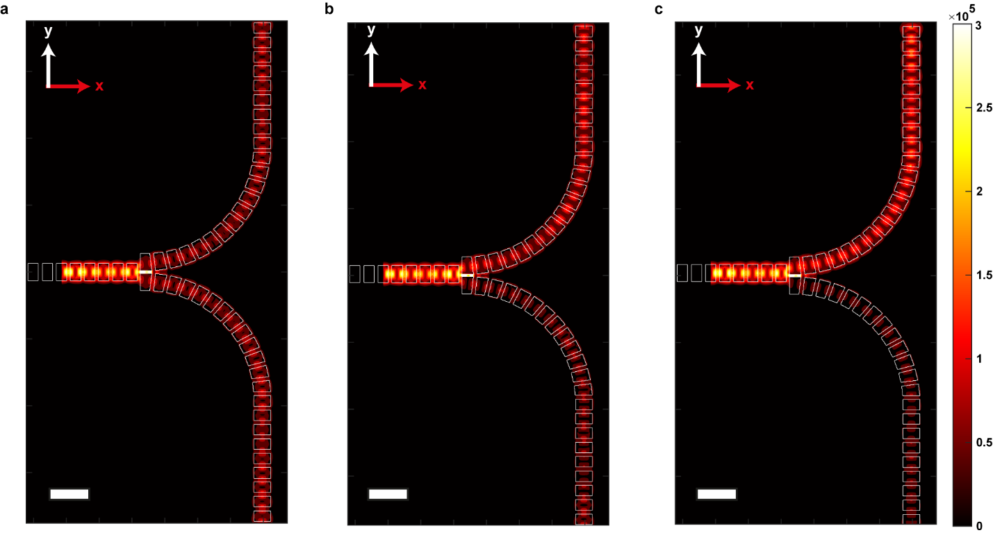
Fig. S2. Calculated electric field intensities of Huygens’ splitters with different degrees of lateral asymmetry. a No lateral shift (50:50 splitting ratio), b 40 nm shift (60:40 splitting ratio), and c 80 nm shift (75:25 splitting ratio). The scale bar represents 1 μm.

