Table S1. Ratio of remote versus face-to-face consultations by ICD-10 diagnostic group, in 2020.
Diagnosis | 2020 remote/F2F ratio
Feeding and eating disorders | 0.19
Obsessive compulsive and related disorders | 0.18
Depressive disorders | 0.16
Anxiety disorders | 0.15
Bipolar and related disorders | 0.15
Trauma and stressor related disorders | 0.15
Personality disorders | 0.14
Neurodevelopmental disorders | 0.13
Schizophrenia spectrum and other psychotic disorders | 0.10
Substance related and addictive disorders | 0.09
Unspecified mental disorder* | 0.18
Other diagnosis | 0.15
ND | 0.12
Total | 0.13
*Provisional diagnosis

Figure S1. Ratio of remote versus face-to-face consultations by age range and gender, in 2020. The difference between males and females is statistically significant (p <0.001) in any age range.
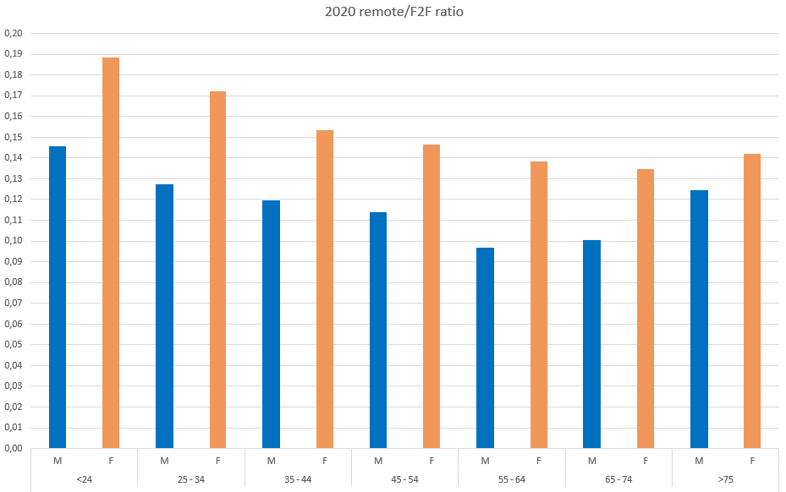

Figure S2. Ratio of remote versus face-to-face consultations by ICD-10 diagnostic group and gender, in 2020. The difference between males and females is statistically significant (p <0.001) in any ICD-10 diagnostic group except for Neurodevelopmental disorders.
