SUPLEMENTARY INFORMATION

PALLADIUM NANOPARTICLES ON MODIFIED CELLULOSE AS A NOVEL CATALYST FOR LOW TEMPERATURE GAS REACTIONS.

Esteban Gioriaª, Chiara Signoriniª, María Claudia Taleb^{b}, Arne Thomas^{c}, Magdolna R. Mihályi^{d}, Laura Gutierrez^{a,}*
ª Institute of Research on Catalysis and Petrochemistry, INCAPE, (FIQ, UNL-CONICET), Santiago del Estero, 2829, 3000, Santa Fe, Argentina
^{b} Instituto de Tecnología Celulósica (ITC), Facultad de Ingeniería Química (FIQ), Universidad Nacional del Litoral (UNL), 3000 Santa Fe, Argentina.
^{c} Technische Universität Berlin, Fakultät II, Institut für Chemie: Funkstionmaterialen, Sekretariat BA2, Hardenbergstraße 40, 10623 Berlin, Germany.
^{d} Institute of Materials and Environmental Chemistry, Green Chemistry Research Group, Research Centre for Natural Sciences, 1117 Budapest, Hungary.
Corresponding Author *e-mail: lbgutier@fiq.unl.edu.ar

S.1. Macroscopic aspect of Solucell, Solucell.Pd, CMFE and CMFE.Pd fibers
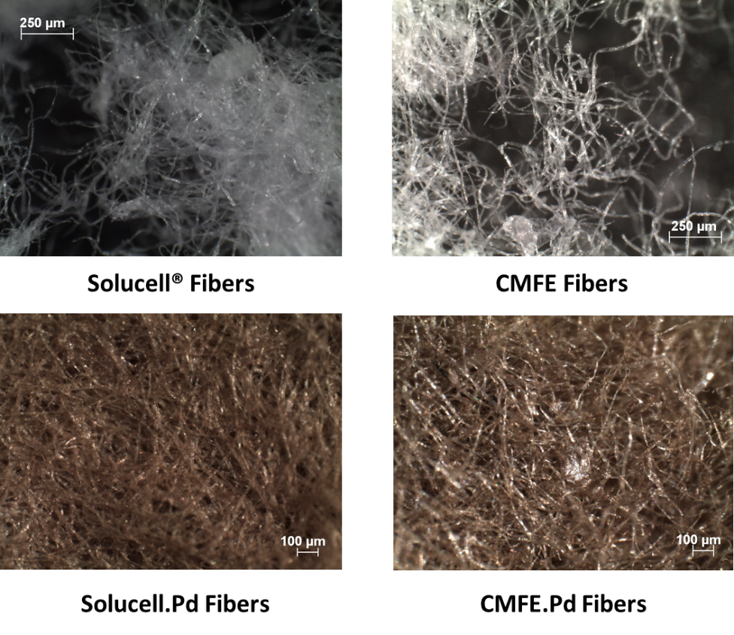
Figure S.1. Macroscopic aspect of Solucell, Solucell.Pd, CMFE and CMFE.Pd fibers under optical stereomicroscope.

