Supplementary Information
On Asymmetric Internal Hemispheric Variability in the Ocean in 2005-2015
Saurabh Rathore et al.
Corresponding author: Saurabh Rathore (saurabh.rathore@utas.edu.au)
Supplementary Table ST1. CMIP5 Model with Pre-industrial Control Simulation Length. CMIP5 models used in this study and the length (years) of their pre-industrial control simulations.
Model | Modelling Centre | Pi-control Length (yr)
ACCESS 1-0 (Bi et al., 2013 | CSIRO-BoM | 500
bcc-csm1-1 (Xiao-Ge et al., 2013 | BCC | 500
CCSM4 (Gent et al., 2011) | NCAR | 1051
CMCC-CM (Scoccimarro et al., 2011) | Centro Euro-Mediterraneo per I Cambiamenti Climatici | 330
CNRM-CM5 (Voldoire et al., 2013) | Centre National de Recherches Meteorologiques | 850
CSIRO-Mk3-6-0 (Jeffrey et al., 2013) | CSIRO-QCCCE | 500
EC-EARTH (Prodhomme et al., 2016) | EC-EARTH | 452
GFDL-ESM2G (Dunne et al., 2012) | NOAA/GFDL | 500
MPI-ESM-LR (Jungclaus et al., 2013) | MPI for Meteorology | 1000
MRI-CGCM3 (Yukimoto et al., 2012) | Meteorological Research Institute (MRI) | 500
NorESM1-M (Bentsen et al., 2013) | Norwegian Climate Centre (NCC) | 501
NASA-GISS-E2RCC (Schmidt et al., 2014) | National Aeronautics and Space Administration | 251
FGOALS-g2 (Li et al., 2013) | Chinese Academy of Sciences | 750
MIROC-ESM (Watanabe et al., 2011) | JAMSTEC, University of Tokyo, NIES | 630
CanESM2 (Chylek et al., 2011) | Canadian Centre for Climate Modelling and Analysis | 996
HadGEM2-CC (Martin et al., 2011) | Met Office Hadley Centre | 240
CESM1/CAM5 (Hurrell et al., 2013) | National Center for Atmospheric Research | 319
FIO-ESM (Qiao et al., 2013) | First Institute of Oceanography | 800
BNU-ESM (Ji et al., 2014) | Beijing Normal University | 559
IPSL-CM5A-MR (Dufresne et al., 2013) | Institut Pierre Simon Laplace | 300

Supplementary Table ST2. Climate indices. List of climate indices used in the study with their sources.
Index | Source
Niño 3.4 | http://www.esrl.noaa.gov/psd/gcos_wgsp/Timeseries/Nino34/
IOD | https://www.esrl.noaa.gov/psd/gcos_wgsp/Timeseries/DMI/
PDO | https://www.esrl.noaa.gov/psd/gcos_wgsp/Timeseries/PDO/
AMO | https://www.esrl.noaa.gov/psd/gcos_wgsp/Timeseries/AMO/
SAM | http://www.nerc-bas.ac.uk/icd/gjma/sam.html
MEI | https://www.esrl.noaa.gov/psd/data/correlation/mei.data
IPO | https://www.esrl.noaa.gov/psd/data/timeseries/IPOTPI/
NAO | http://iridl.ldeo.columbia.edu/SOURCES/.Indices/.CPC_Indices/.NHTI/.NAO/dods

Supplementary Table ST3. Cross-covariance between the constant, time trend term and the 8 different climate indices are shown in the table below. The relative importance of each term and resolution of each of the parameters in the multiple linear regression equation (equation 4) can be seen, along with the cross-correlations between each of these parameters.
 |  |  |  | Indices Covariance
 | C | t | $${Niño}_{1}$$ | $$DMIHI$$ | $${Niño}_{2}$$ | $$SAMHI$$ | $$NAOHI$$ | $$NAOLO$$ | $$PDOLO$$ | $$AMOLO$$
C | 0
t | 0 | 8.53
$${Niño}_{1}$$ | 0 | 0.4 | 1.07
$$DMIHI$$ | 0 | 0.38 | 0.44 | 0.77
$${Niño}_{2}$$ | 0 | -0.65 | -0.04 | -0.04 | 0.96
$$SAMHI$$ | 0 | 0.05 | -0.08 | -0.07 | -0.06 | 0.78
$$NAOHI$$ | 0 | 0.17 | -0.18 | -0.07 | -0.06 | 0 | 1.11
$$NAOLO$$ | 0 | 1.37 | 0.10 | 0.07 | -0.19 | 0.02 | 0.06 | 0.96
$$PDOLO$$ | 0 | 1.03 | 0.24 | 0.06 | -0.19 | 0.05 | 0.04 | 0.87 | 1.07
$$AMOLO$$ | 0 | -0.30 | 0.02 | 0.00 | 0.03 | 0.01 | -0.01 | 0.01 | 0.05 | 0.04

Supplementary Table ST4. Multicollinearity check. Variance Inflation Factor (VIF) and tolerance of the indices used for multi-linear regression.
 | VIF | Tolerance
t | 2.35 | 0.43
$${Niño}_{1}$$ | 1.53 | 0.65
$$DMIHI$$ | 1.36 | 0.74
$${ Niño}_{2}$$ | 1.10 | 0.91
$$SAMHI$$ | 1.04 | 0.96
$$NAOHI$$ | 1.04 | 0.96
$$NAOLO$$ | 4.79 | 0.21
$$PDOLO$$ | 5.04 | 0.20
$$AMOLO$$ | 2.08 | 0.48

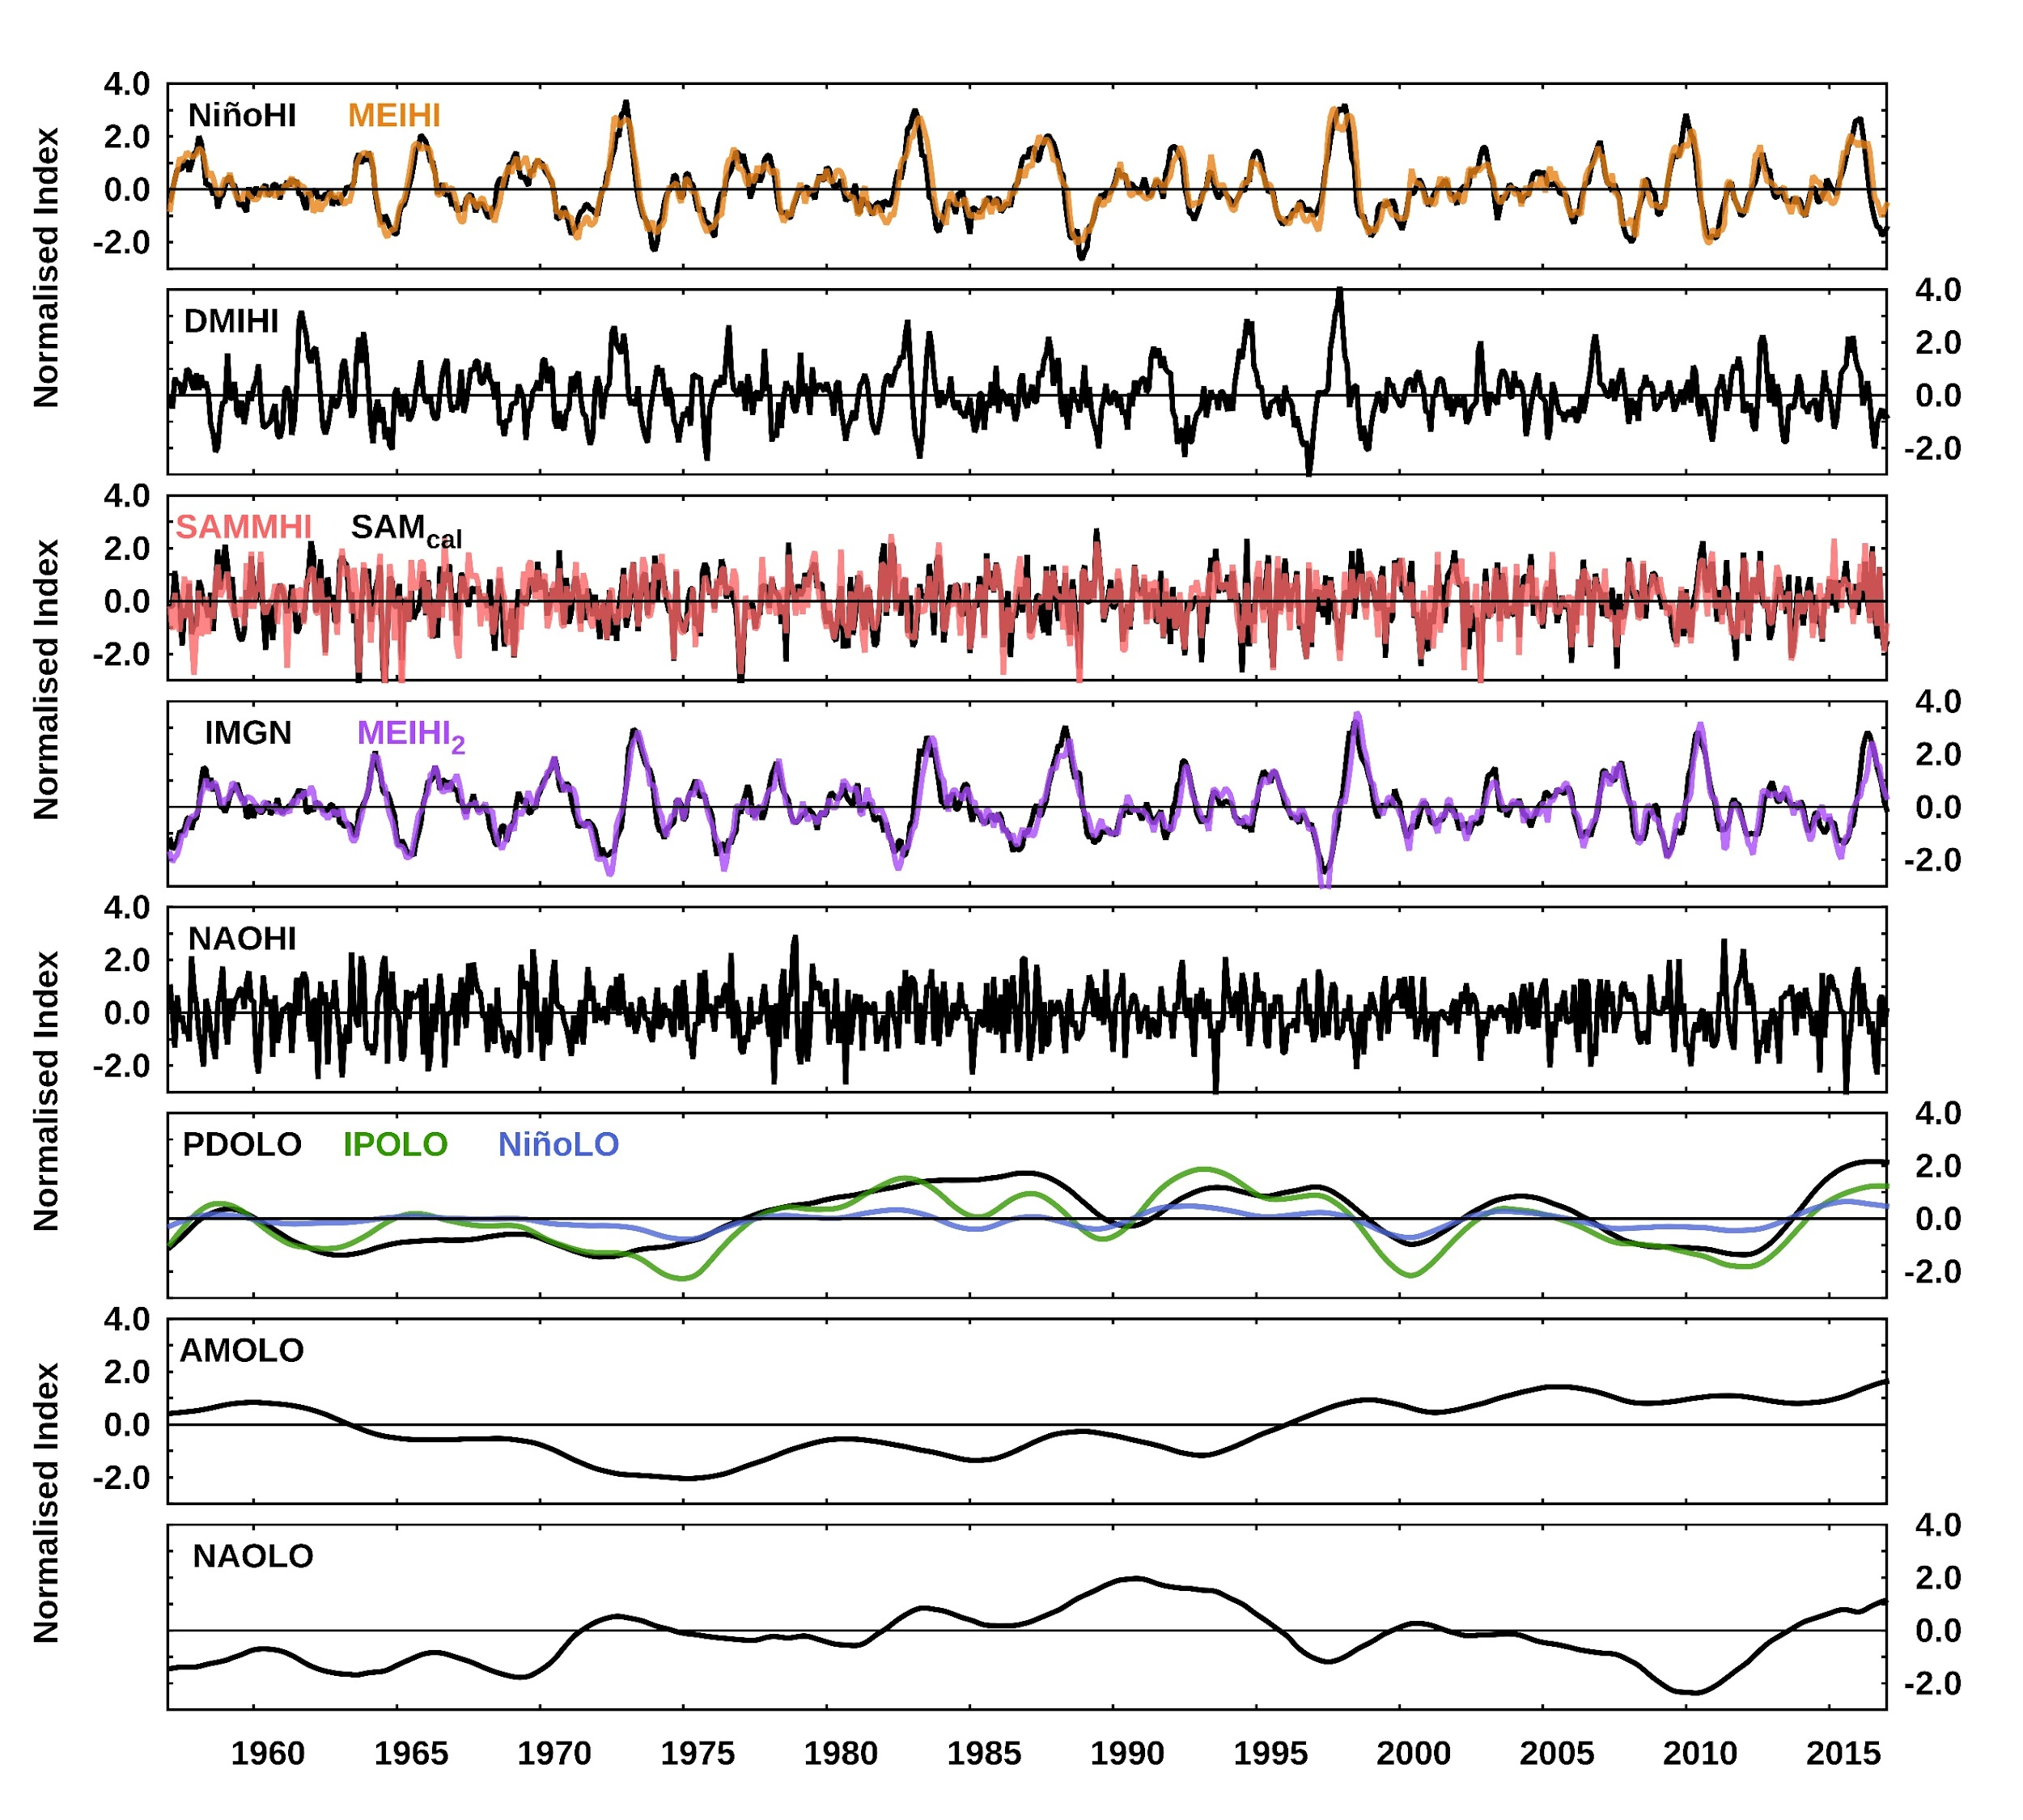

Supplementary Figure S1. Normalised monthly time series of the high frequency indices of Niño 3.4 index (NiñoHI), Multivariate ENSO index (MEIHI), Indian Ocean Dipole (DMIHI), Marshall’s index of Southern Annular Mode (SAMMHI), calculate SAM index SAM_{cal}, Imaginary part of Hilbert transform of Niño₁ (IMGN) and MEIHI (MEIHI₂), North Atlantic Oscillation (NAOHI), Low frequency indices of Pacific Decadal Oscillation (PDOLO), Interdecadal Pacific Oscillation index (IPOLO), Niño 3.4 index (NiñoLO), Atlantic Multidecadal Oscillation (AMOLO), North Atlantic Oscillation (NAOLO).

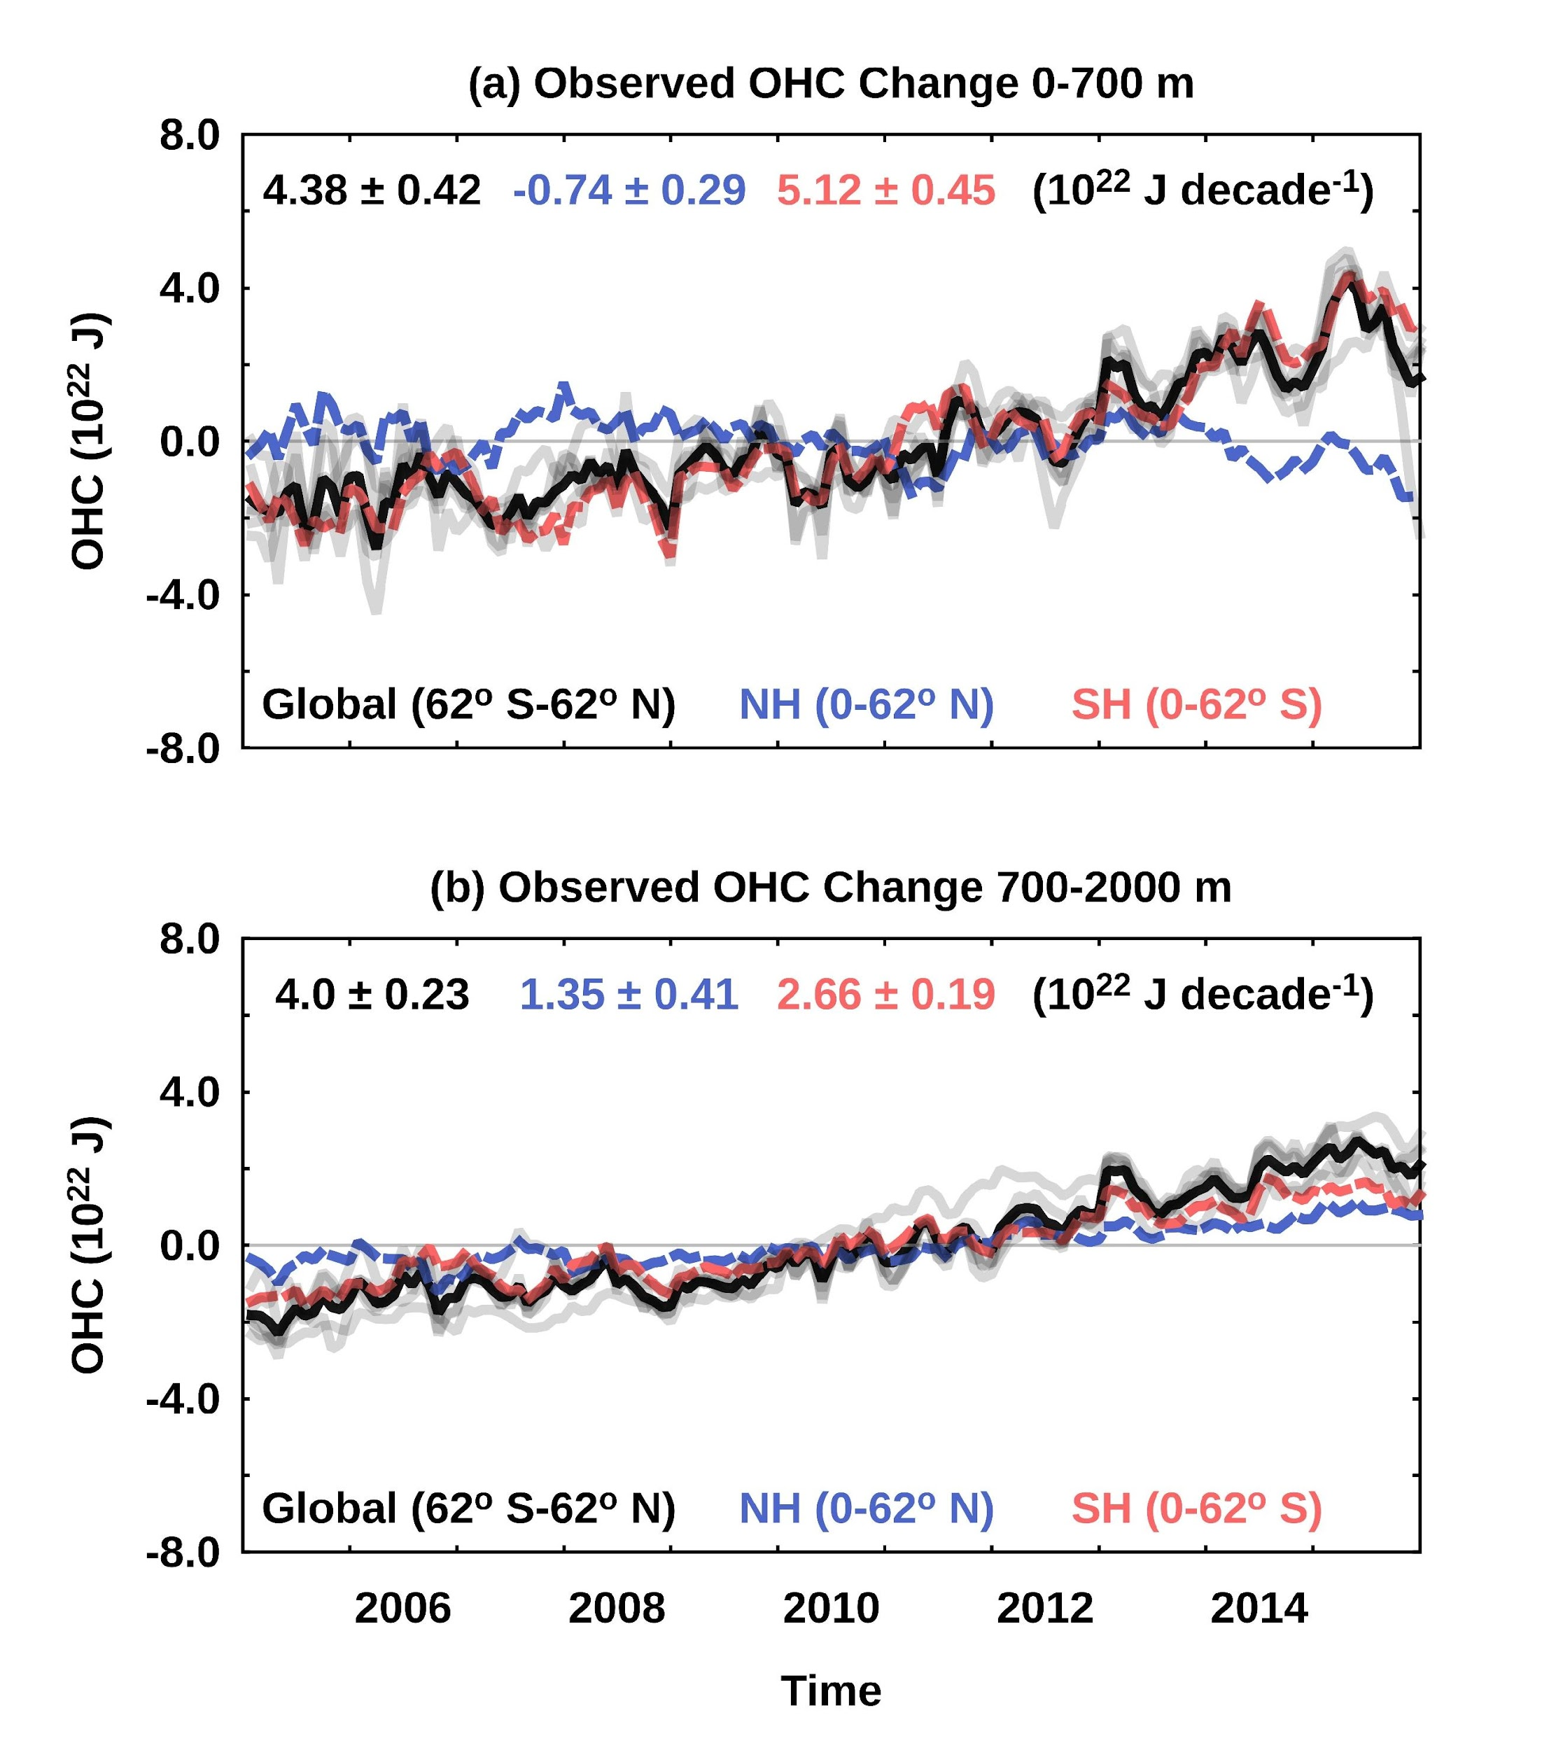

Supplementary Figure S2. Monthly temporal variations of OHC change (2005-2015) from the mean (thick) of six products (grey) for global ocean (Global, black), southern hemisphere (red) and northern hemisphere (blue) with their respective trends (10²² J decade⁻¹) in top for (a) 0-700 m and (b) 700-2000 m.

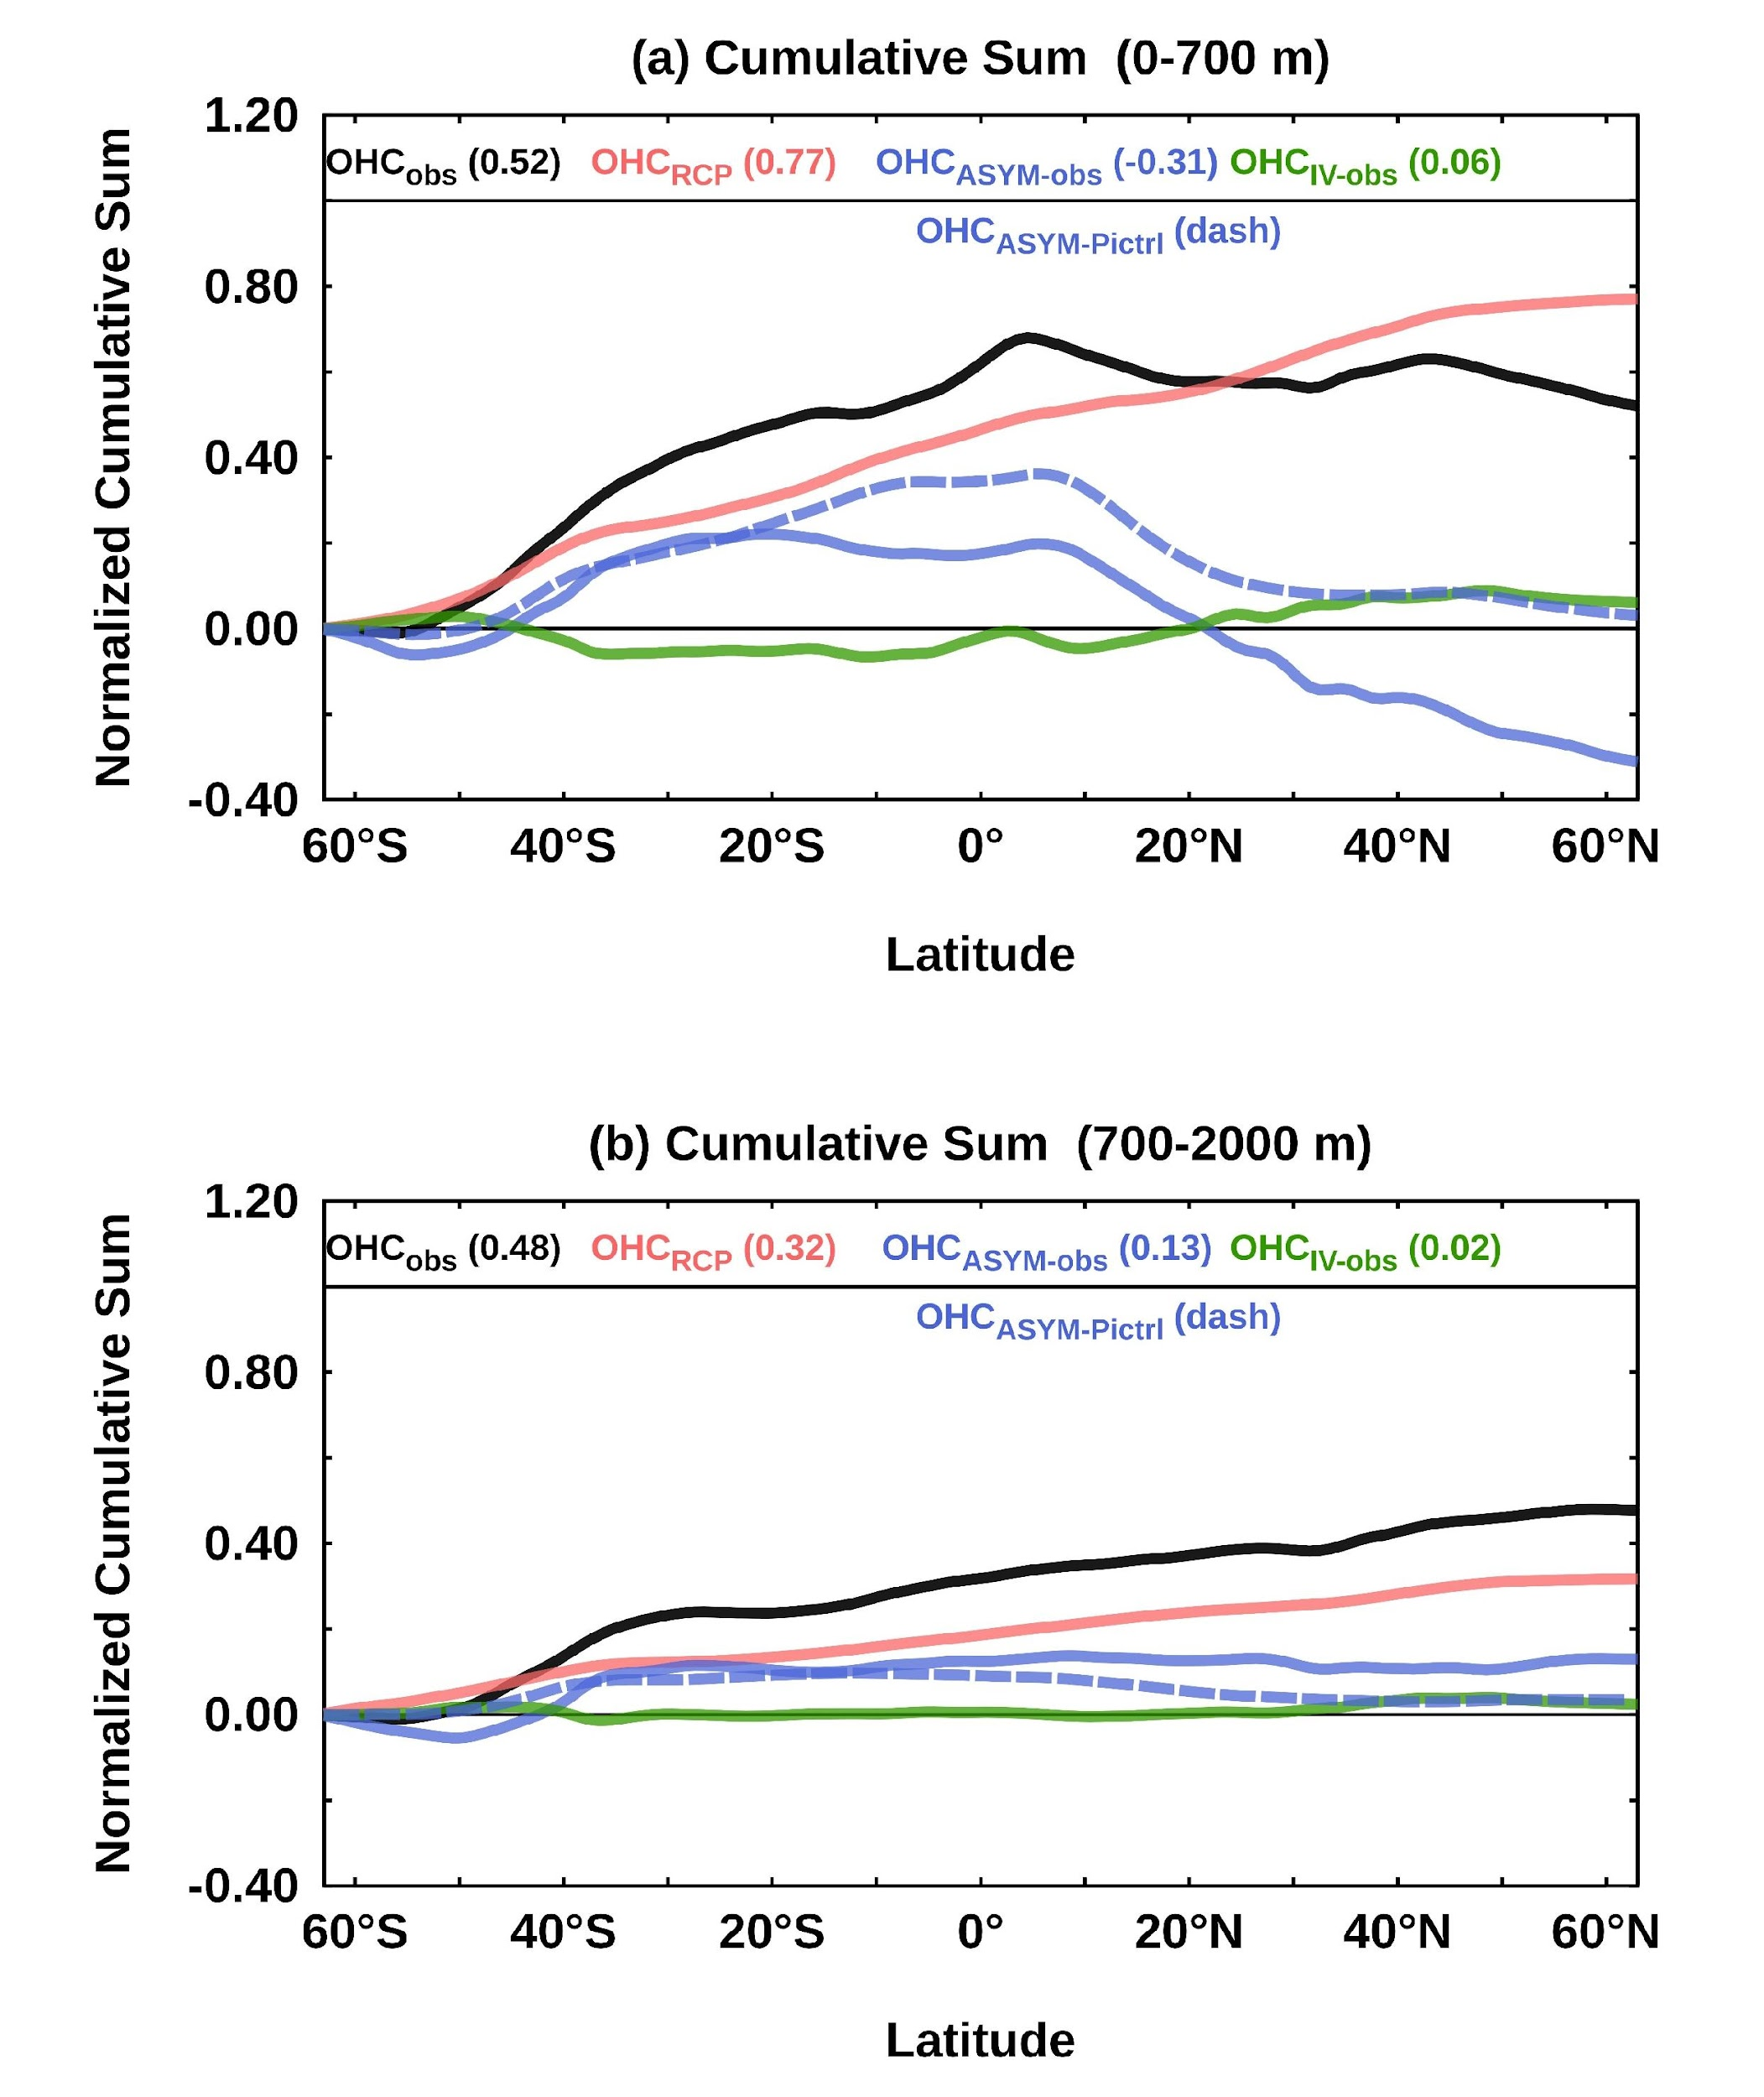

Supplementary Figure S3. Normalized cumulative sum of OHC trend from observation (black), MMM of CMIP5 simulation (red), Observed Asymmetric residual trend (thick blue), Asymmetric residual trend from MMM of CMIP5 simulation (dash blue), Observed common climate mode trend (thick green) with their contribution in parenthesis for (a) 0-700 m and (b) 700-2000 m. The normalized value is the total ocean heat content for the 0-2000 m layer for observation over this period (at northern boundary).

