Appendix 1. Regression of MNMDI and Hydrothermal principal components bands
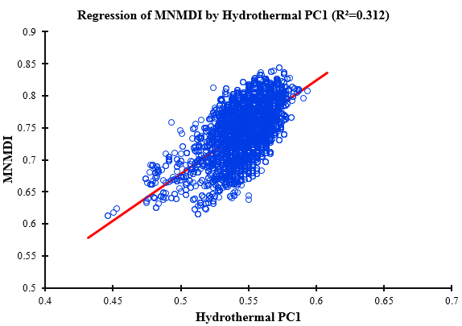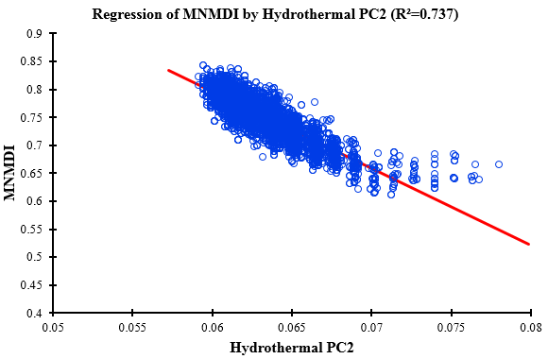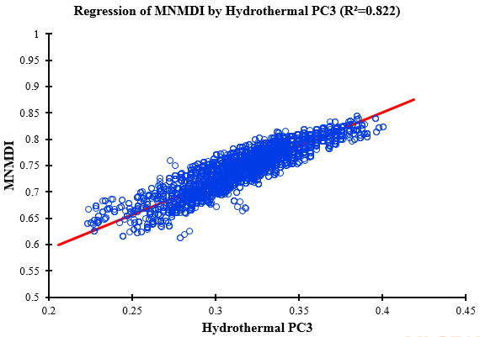

Appendix 2. Rainfall data for 1948-2018 (Green) and 2019 (Orange)
 | Zone 1 |  | Zone 2 |  | Zone 3 |  | Zone 4 |  | Zone 5 |  | Zone 6 |  | Zone 7 |  | Zone 8 |  | Zone 9 |  | Zone 10
 | R | D | R | D | R | D | R | D | R | D | R | D | R | D | R | D | R | D | R | D
Jun. | 350 | 27 | 350 | 25 | 352 | 28 | 352 | 25 | 369 | 25 | 361 | 25 | 377 | 25 | 389 | 24 | 358 | 26 | 369 | 27
Jul. | 550 | 24 | 555 | 26 | 554 | 24 | 577 | 24 | 609 | 26 | 587 | 25 | 618 | 27 | 573 | 26 | 590 | 25 | 612 | 25
Aug. | 617 | 25 | 620 | 25 | 648 | 25 | 650 | 26 | 654 | 28 | 658 | 28 | 688 | 29 | 687 | 31 | 679 | 30 | 692 | 27
Sept. | 592 | 28 | 600 | 28 | 590 | 26 | 611 | 28 | 625 | 28 | 600 | 28 | 589 | 29 | 644 | 29 | 666 | 30 | 617 | 30
Oct. | 378 | 26 | 377 | 26 | 392 | 23 | 379 | 25 | 391 | 24 | 398 | 24 | 395 | 23 | 412 | 23 | 445 | 25 | 400 | 24
Jun. | 363 | 24 | 360 | 24 | 355 | 24 | 360 | 26 | 355 | 24 | 358 | 25 | 377 | 25 | 374 | 25 | 370 | 24 | 370 | 24
Jul. | 546 | 25 | 583 | 25 | 535 | 24 | 579 | 24 | 579 | 26 | 600 | 26 | 557 | 27 | 548 | 28 | 571 | 25 | 577 | 25
Aug. | 613 | 28 | 615 | 28 | 630 | 28 | 642 | 28 | 637 | 29 | 641 | 29 | 688 | 30 | 669 | 30 | 643 | 29 | 690 | 29
Sept. | 597 | 30 | 580 | 28 | 581 | 28 | 594 | 28 | 618 | 30 | 617 | 30 | 615 | 29 | 644 | 29 | 621 | 30 | 633 | 29
Oct. | 372 | 24 | 379 | 20 | 381 | 20 | 377 | 19 | 374 | 19 | 377 | 20 | 395 | 20 | 393 | 21 | 392 | 21 | 404 | 24
R=rainfall in millimeters and D=rainy days.

