Supplementary files

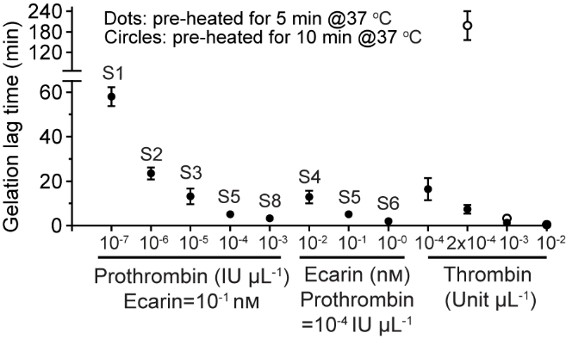
Figure S1. Gelation lag time of the fibrin networks formed by the snake venom-controlled and thrombin-initiated systems. Gelation lag time was obtained from rheological measurements and defined as the time when the storage modulus G' of the network reached 5 Pa during polymerization. Ecarin/prothrombin was pre-heated at 37 °C for 5 min, while thrombin was pre-heated at 37 °C for either 5 min (dots) or 10 min (circles) before initiation. For gelation lag time analysis, data from different batches of fibrinogen were included and shown as mean ± SD. Some data do not show an error bar due to a subtle variation.

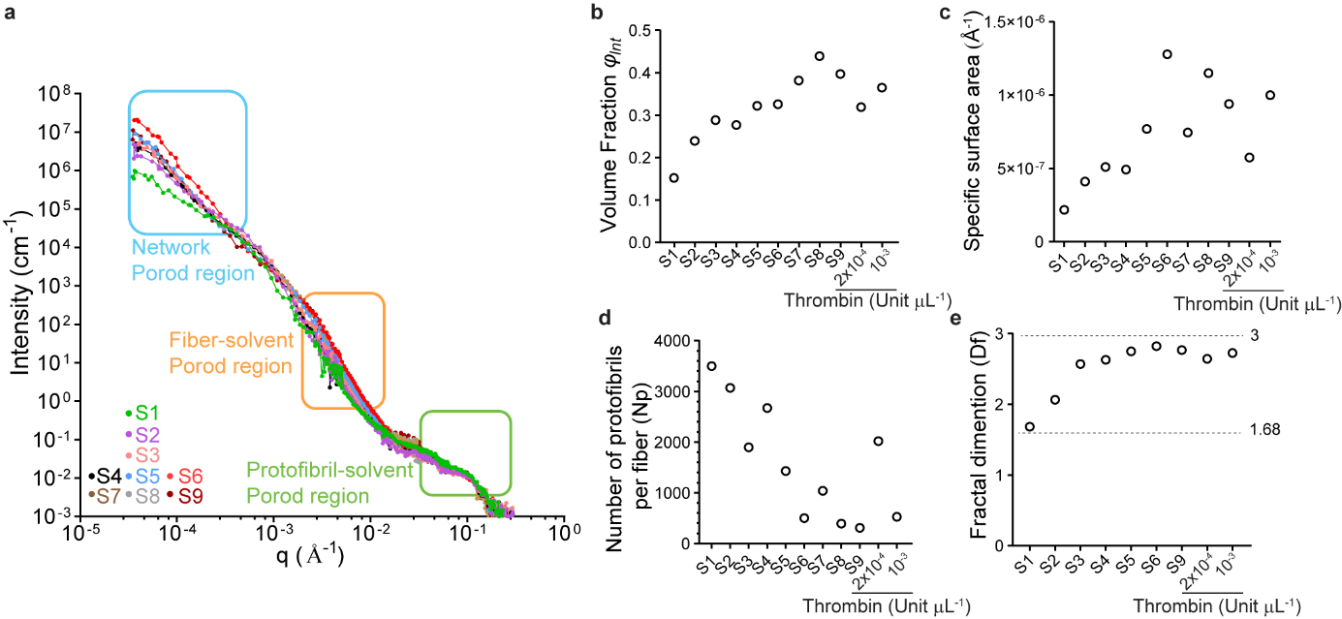
Figure S2. SANS/USANS data of the snake venom-controlled and thrombin-initiated systems. a) Combined neutron scattering profiles of the snake venom-controlled fibrin networks (S1–S9) dissolved in 90% D₂O are shown. The scattering from three Porod regions (highlighted within the rectangles) was fitted and analyzed to yield details on the corresponding associated structures. b) Fiber density was determined from the volume fraction ($φ_{Int}$) of the protofibrils within fibers. c) Fiber surface area was determined by the specific surface area ($S_{v}$) by invariant analysis. d) The average number of protofibrils per fiber (Np) was analyzed using the diameter and volume fraction data. e) Fibrin branching was determined by fractal dimension ($D_{f}$) using fractal analysis. All fractal dimension values are between 1.68 and 3 indicated by dashed lines, while $D_{f}=$1.68 (5/3) is the signature value for fully unbranched swollen coils in the Porod region and $D_{f}$ approaches 3 for branched networks.

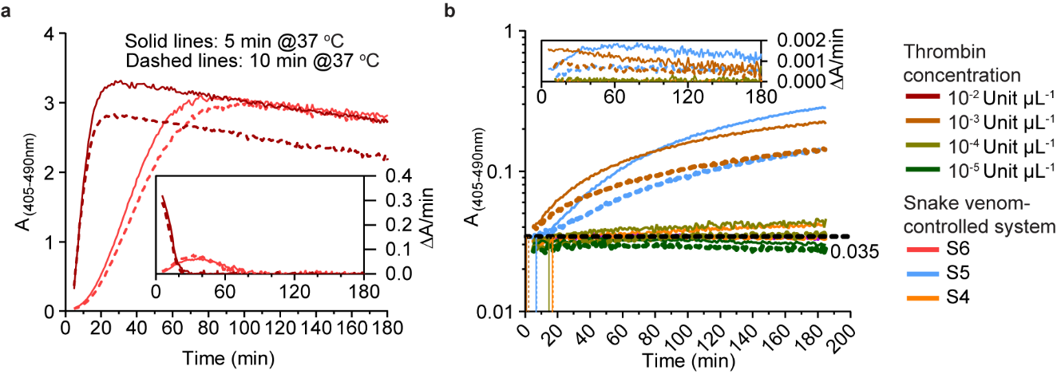
Figure S3. Cleavage activity of the snake venom-controlled and thrombin-initiated systems. a, b) Cleavage absorbance reading A_{(405-490nm)} and cleavage rate ΔA/min (insets) curves of thrombin (at 10⁻⁵ Unit μL⁻¹, 10⁻⁴ Unit μL⁻¹, 10⁻³ Unit μL⁻¹, and 10⁻² Unit μL⁻¹) and ecarin/prothrombin (S4, S5, and S6) systems measured using a chromogenic substrate assay (S2238). Thrombin or ecarin/prothrombin was either pre-heated at 37 °C for 5 min (solid lines) or 10 min (dashed lines) before initiation. The time points when the absorbance reading reached the threshold ~0.0035 were detected and labeled as vertical lines.

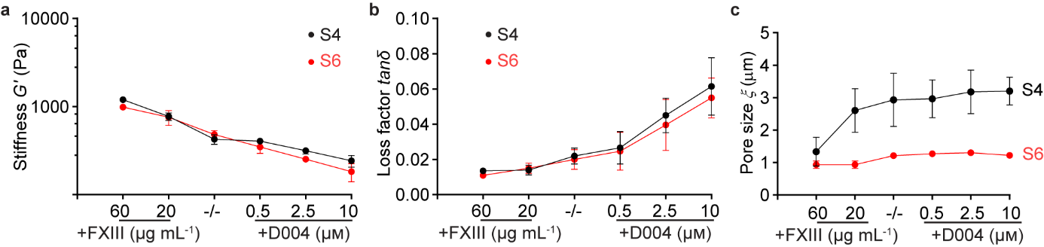
Figure S4. Influence of the addition of pFXIII and D004 on the mechanical properties and pore size of fibrin networks. a–c) Tuning of mechanical properties including matrix stiffness (a) and loss factor (b) and pore size of the networks S4 and S6 formed from the same batch (B4a in Table S1) of fibrinogen by addition of different concentrations of pFXIII and D004. The network without any addition (-/-) was set as control. Data are shown as mean value ± SD.

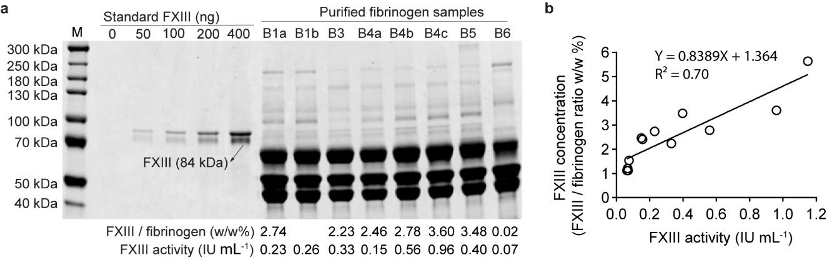
Figure S5. FXIII variation in different fibrinogen samples. a) FXIII concentration in different batches of purified fibrinogen samples was quantified by reducing SDS-PAGE as the weight fraction in fibrinogen (w/w%). The standard FXIII protein (84 kDa, black arrow) served as a control. Quantified values of FXIII concentrations are listed below each batch and compared with the FXIII activity measured by FXIII activity assays. FXIII activity was tested at 4 mg mL⁻¹ of fibrinogen and expressed as the activity per 1 mg mL⁻¹ of fibrinogen. All data are shown as mean values. b) Relationship between FXIII concentration and FXIII activity in different batches of purified fibrinogen samples. A linear relationship was detected by linear regression analysis.

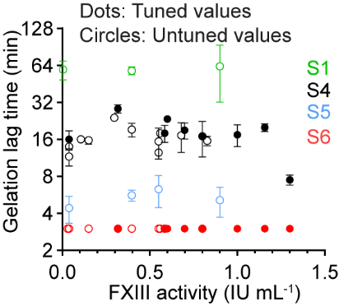
Figure S6. Relationship between the endogenous FXIII activities of different batches of fibrinogen and the gelation lag time of the formed fibrin networks. Both the original untuned values (circles) and tuned values (dots) of gelation lag times of different fibrin networks were plotted as a function of endogenous FXIII activities of different batches of fibrinogen. Data are shown as mean values ± SD.

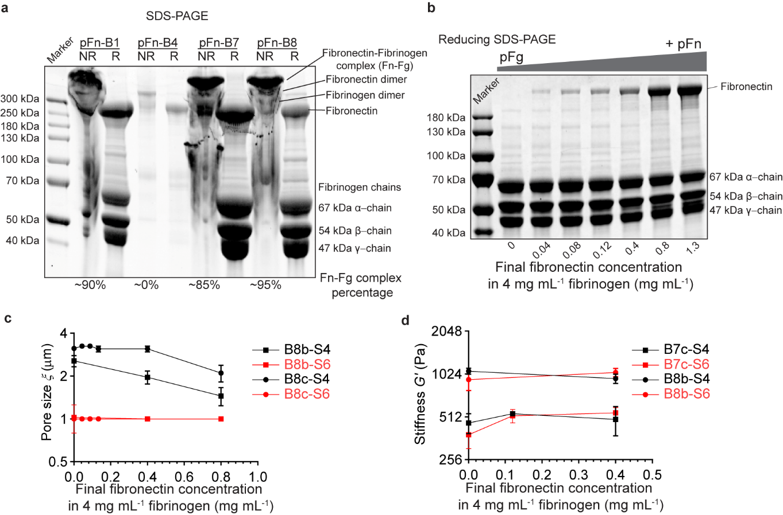
Figure S7. Influence of addition of fibronectin on fibrin pore size and stiffness. a) Characterization of different batches of purified fibronectin (pFn) products by either reducing (R) or non-reducing (NR) SDS-PAGE. Different bends including fibronectin-fibrinogen complex (Fn-Fg), fibronectin dimers, fibrinogen dimers, and fibronectin monomers were labeled according to the individual molecular weight. The percentage of Fn-Fg complex in the final purified fibronectin products was calculated by semi-quantitative analysis. pFn-B8 was selected for fibronectin addition in this study as the high purity (~95%) of the Fn-Fg complex, which yields incorporated fibronectin in final fibrin networks. b) Final concentration of fibronectin in the final fibrinogen (4 mg mL⁻¹) was tuned by the addition of different ratios of pFn to pFg. The final concentration of fibronectin was detected by reducing SDS-PAGE and semi-quantitative analysis. pFg, purified fibrinogen. pFn, purified fibronectin. c, d) Influence of addition of purified fibronectin on the fibrin pore size (c) and matrix stiffness (d). Two networks (S4 and S6) formed from different batches of purified fibrinogen were detected.

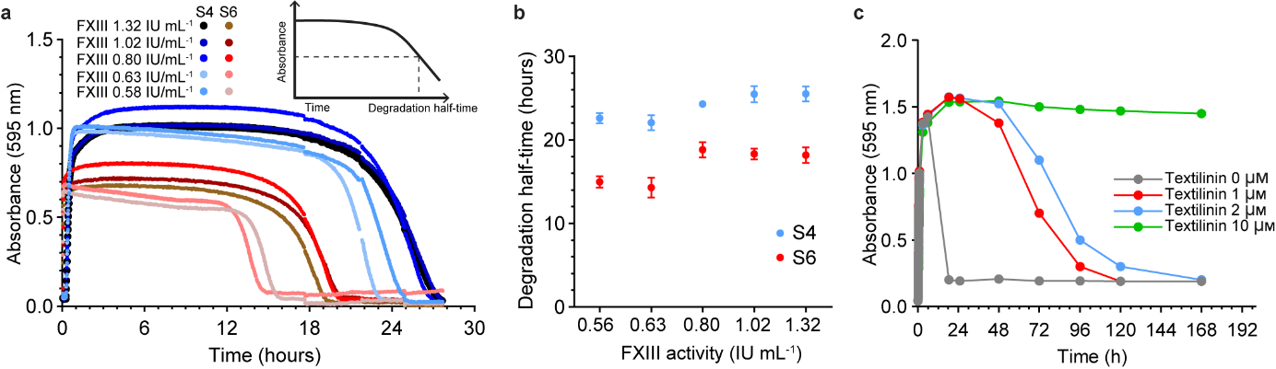
Figure S8. Long-term stability of the fibrin networks controlled by textilinin. Characterization of degradation of fibrin networks (S4 and S6) with different FXIII activities (tuned by the addition of pFXIII or D004) measured by turbidimetry. Representative absorbance curves of the fibrin networks (S4 and S6) with different FXIII activity are shown in (a). Degradation half-time is defined as the time when absorbance reading decreases to half of its maximum value. b) Degradation half-time of the formed S4 and S6 networks obtained from 3 replicates. Data are shown as mean value ± SD. c) Long-term stability of fibrin networks (S4 and S6) was determined by absorbance reading as a function of increasing concentrations of textilinin (0–10 µm).
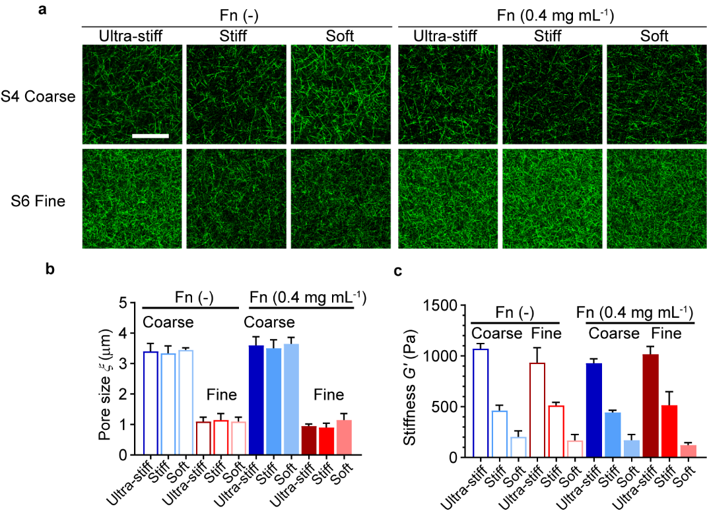
Figure S9. Biophysical details of fibrin networks used for cell experiments. a) Confocal microscopy images of the fibrin networks (S4 and S6) with different stiffness tuned by the addition of D004 with or without 0.4 mg mL⁻¹ of fibronectin. Images are shown as single z-frame with an area of 290 µm × 290 µm. Scale bar, 100 µm. b, c) Either pore size (b) or bulk stiffness (c) of these networks were measured and shown as mean value ± SD.

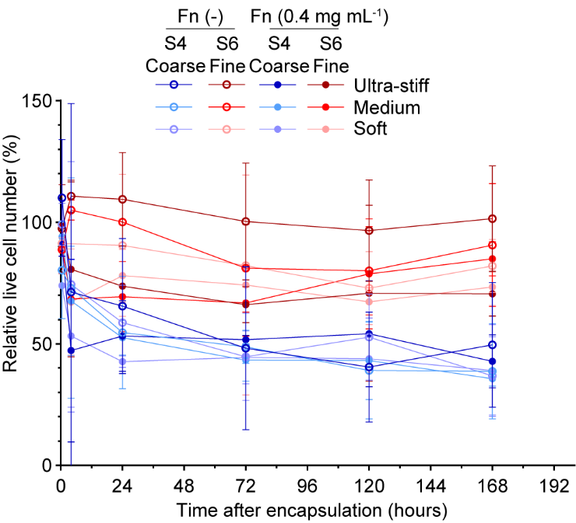
Figure S10. Cell growth curve for fibroblasts in different fibrin networks. Live cell number (Calcein+) was counted for the fibroblasts in different fibrin networks from 1 hour to 7 days after encapsulation. n=3. Data are shown as mean value ± SD. Cell number for fibroblasts in stiff S6 network on day 1 served as control 100%.

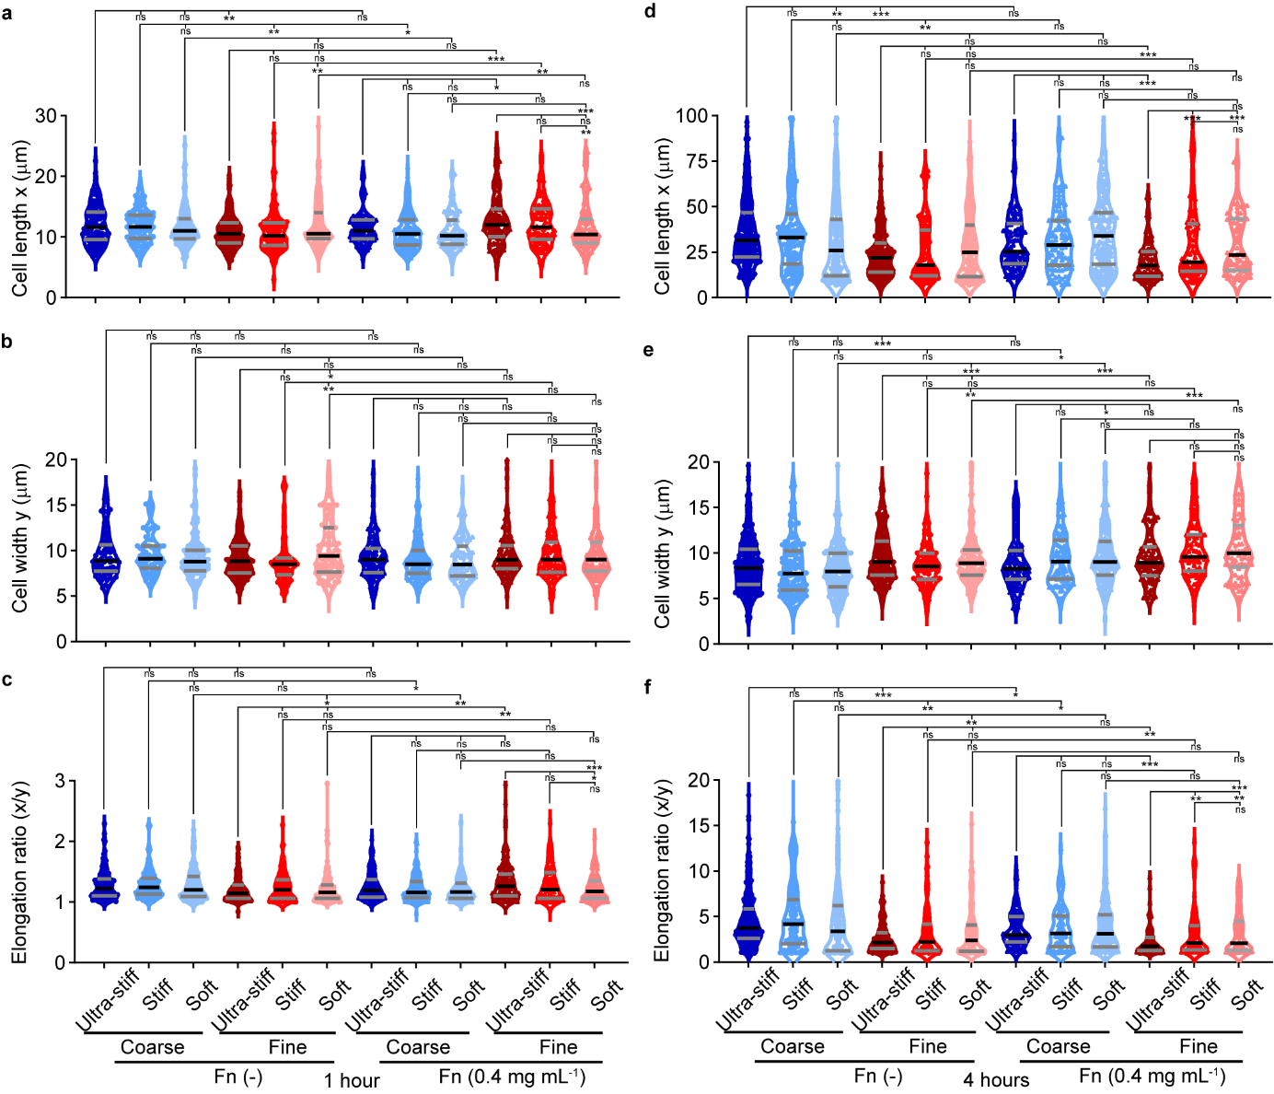
Figure S11. Morphological analysis of fibroblasts in different fibrin networks. a–h) Cell length, cell width, and elongation ratio of individual fibroblasts grown in different fibrin networks were measured and plotted at early timepoints including 1 hour (a–c) and 4 hours (d–f) after encapsulation. Data were shown as violin plots. n=3, two-tailed Wilcoxon signed-rank test. *p < 0.05, **p < 0.01, ***p < 0.001. ns, not significant.

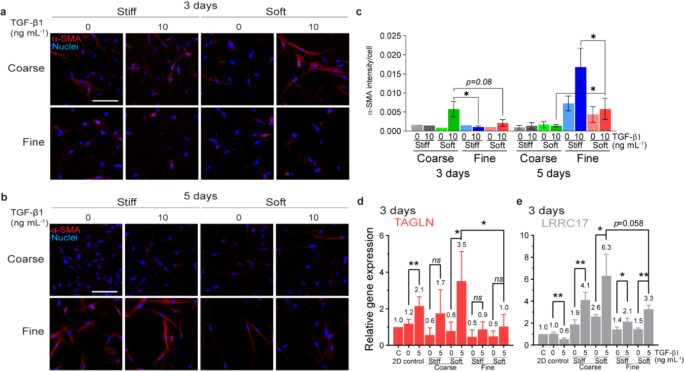
Figure S12. Transient fibroblast differentiation was detected by α-SMA and gene expressions. a, b) Confocal microscopy images of fibroblasts with α-SMA immunostaining (red) 3 days (a) or 5 days (b) after encapsulation. Images are shown as a maximum image projection (290 µm × 290 µm area with 20 µm thickness). Scale bar, 100 µm. c) Quantification of the α-SMA expression in different networks. Statistical analysis was performed by one-way ANOVA. n=5. ns, not significant. *p < 0.05. d, e) Myofibroblast-specific gene expression (TAGLN and LRRC17) analysis of fibroblast after 3 days of encapsulation. n=4.

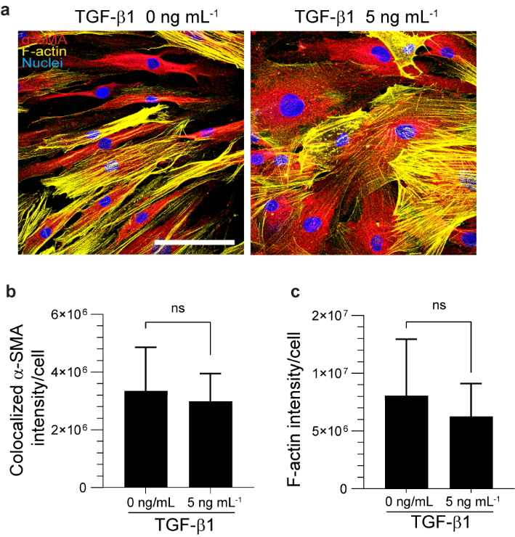
Figure S13. 2D control of fibroblast differentiation. a) Confocal microscopy images of the fibroblasts cultured on 2D plates 7 days after treatment of TGF-β1. Both α-SMA (red) and F-actin (yellow) were stained. Images are shown as a maximum image projection (290 µm × 290 µm area with 20 µm thickness). Scale bar, 100 µm. b, c) Fluorescence intensity analysis of the α-SMA immunostaining (b) and the F-actin staining (c) shown in a. No significant difference in α-SMA or F-actin was detected by t-test between the TGF-β1-treated and untreated samples. ns, not significant.

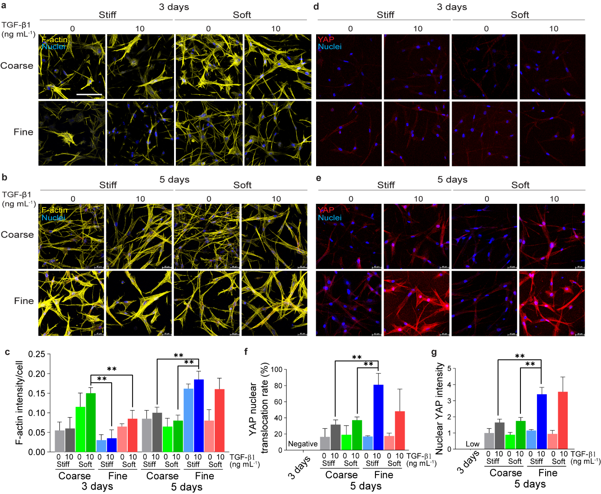
Figure S14. Fibroblast F-actin expression and YAP nuclear translocation 3 days and 5 days after encapsulation. a–c) Confocal microscopic images of the fibroblasts with F-actin staining (yellow) 3 days (a) or 5 days (b) after encapsulation. Statistical analysis was performed by one-way ANOVA (c). ns, not significant. *p < 0.05. d–g) Confocal microscopic images of the fibroblasts with YAP immunostaining (red) 3 days (d) or 5 days (e) after encapsulation. Quantification of YAP nuclear translocation rate (f) or Nuclear YAP intensity (g) was analyzed by one-way ANOVA. **p < 0.01. All the images are shown as a maximum image projection (290 µm × 290 µm area with 40 µm thickness). Scale bar, 100 µm.
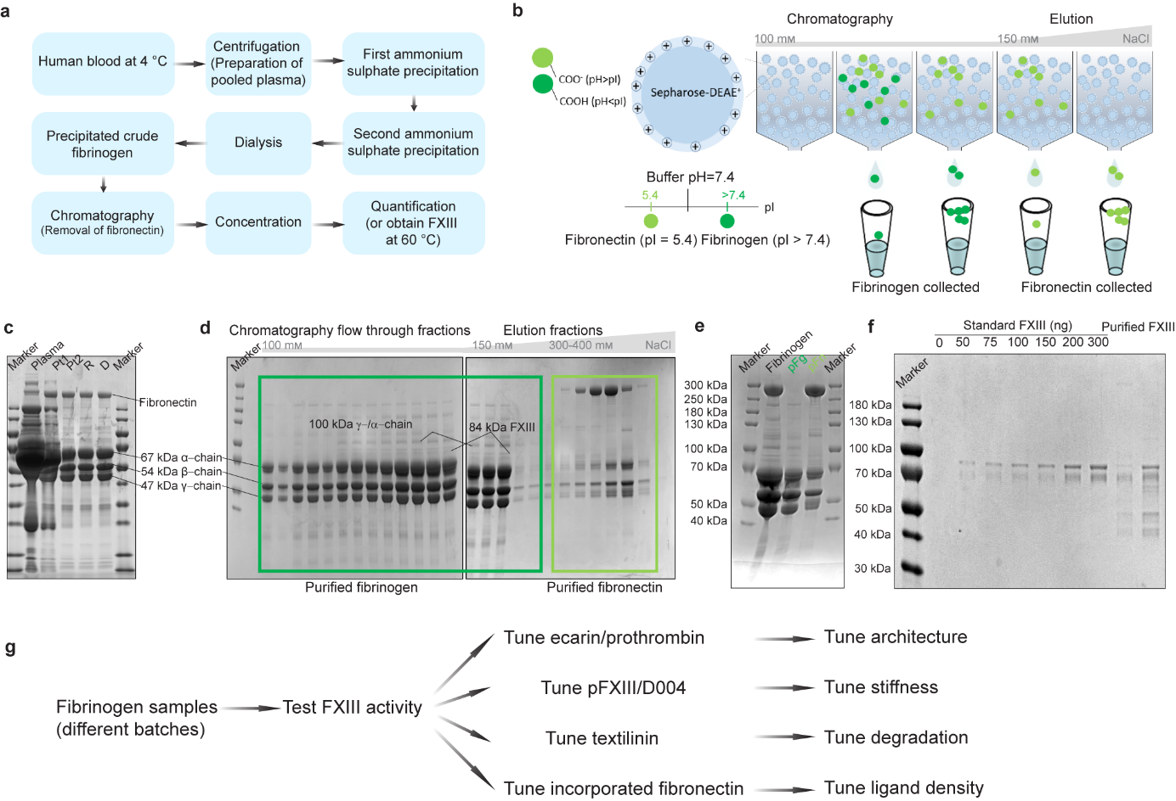
Figure S15. Summary of fibrinogen purification and quantification methods. a) An overview of the fibrinogen, fibronectin, and FXIII purification protocol from the pooled human plasma. b) Schematic of the DEAE-Sepharose chromatography to collect fibrinogen and the removal of fibronectin. Under pH 7.4, fibrinogen (shown in dark green), with an isoelectric point (pI) higher than 7.4, has a positive charge and does not bind to the DEAE-Sepharose resin; it can be collected in the flow-through. The pI of fibronectin (shown in light green) is around 5.4. Fibronectin has a negative charge and binds to the resin at pH 7.4. By increasing the concentration of NaCl, the counter ions Cl⁻ deplete the charge on the fibronectin and result in the release of fibronectin (or fibrinogen-fibronectin complex). Therefore, fibronectin is collected in the elution buffer. c–e) Fibrinogen fractions quantification evaluated by reducing SDS-PAGE. Fibrinogen fractions during precipitation (c), elution (d), and after concentrating the fractions are shown in the dark green rectangle for purified fibrinogen (pFg) or in the light green rectangle for purified fibronectin (pFn) (e). Pt, fibrinogen pellet. f) Reducing SDS-PAGE images of the purified FXIII. g) Protocols to achieve reproducibility and tunability of biophysical properties of fibrin networks formed from different batches of fibrinogen samples. Reproducibility is achieved after characterizing endogenous FXIII activity of each fibrinogen sample. Tunability of biophysical properties of fibrin including architecture, stiffness, degradation, and ligand density is achieved by tuning ecarin/prothrombin, pFXIII/D004, textilinin, and incorporated fibronectin, individually.

Table S1. Batch information is listed with FXIII activity and FXIII concentration.

Batch No. | FXIII activity (IU mL⁻¹) | FXIII concentration (FXIII/Fibrinogen ratio w/w%)
B1a | 0.23 | 2.74
B1b | 0.26 | Not detected
B2 | Not detected | 0.12
B3 | 0.33 | 2.23
B4a | 0.15 | 2.46
B4b | 0.56 | 2.78
B4c | 0.96 | 3.60
B4d | 0.84 | Not detected
B5 | 0.40 | 3.48
B6 | 0.07 | 0.02
B7a | 0.04 | 1.12
B7b | 0.07 | 1.12
B7c | 0.39 | 2.54
B7d | 1.15 | 5.64
B8a | 0.68 | Not detected
B8b | 0.80 | Not detected
B8c | 1.73 | Not detected

