SUPPLEMENTARY INFORMATION

Three-level hierarchical micro/nanostructures on bopolymers by injection moulding using low cost polymeric inlays

C. Sáez-Comet ª, O. Muntada ^{b}, N. Lozano ª, E. Fontdecabaª, P. Sousa^{c}, J. Llobet^{b}, F.Perez-Murano ^{b} Jordi Puiggali^{d}, L. J. del Valle^{d}
*Corresponding author: csaezcomet@gmail.com; Francesc.Perez@csic.es

Silicon mould fabrication

The silicon mould consists of a 3-level hierarchical structure that is periodically repeated all across a 100 mm silicon wafer. The dimensions and periodicity of the elements in each level are shown in Table S1.

Table S1. Dimensions of the three levels of the hierarchical array in the silicon mould. 1L stands for the lower level, 2L the middle one and 3L the top level.
Pattern | Lateral feature size (μm) | Pitch (μm) | Height (μm)
1L | 0.6 | 1.58 | 0.5
2L | 6 | 15.8 | 4.8
3L | 35 | 107.44 | 26.9

The overall process to fabricate the silicon mould is depicted in figure S1 and it consists of three sequences of photolithography and reactive ion etching.

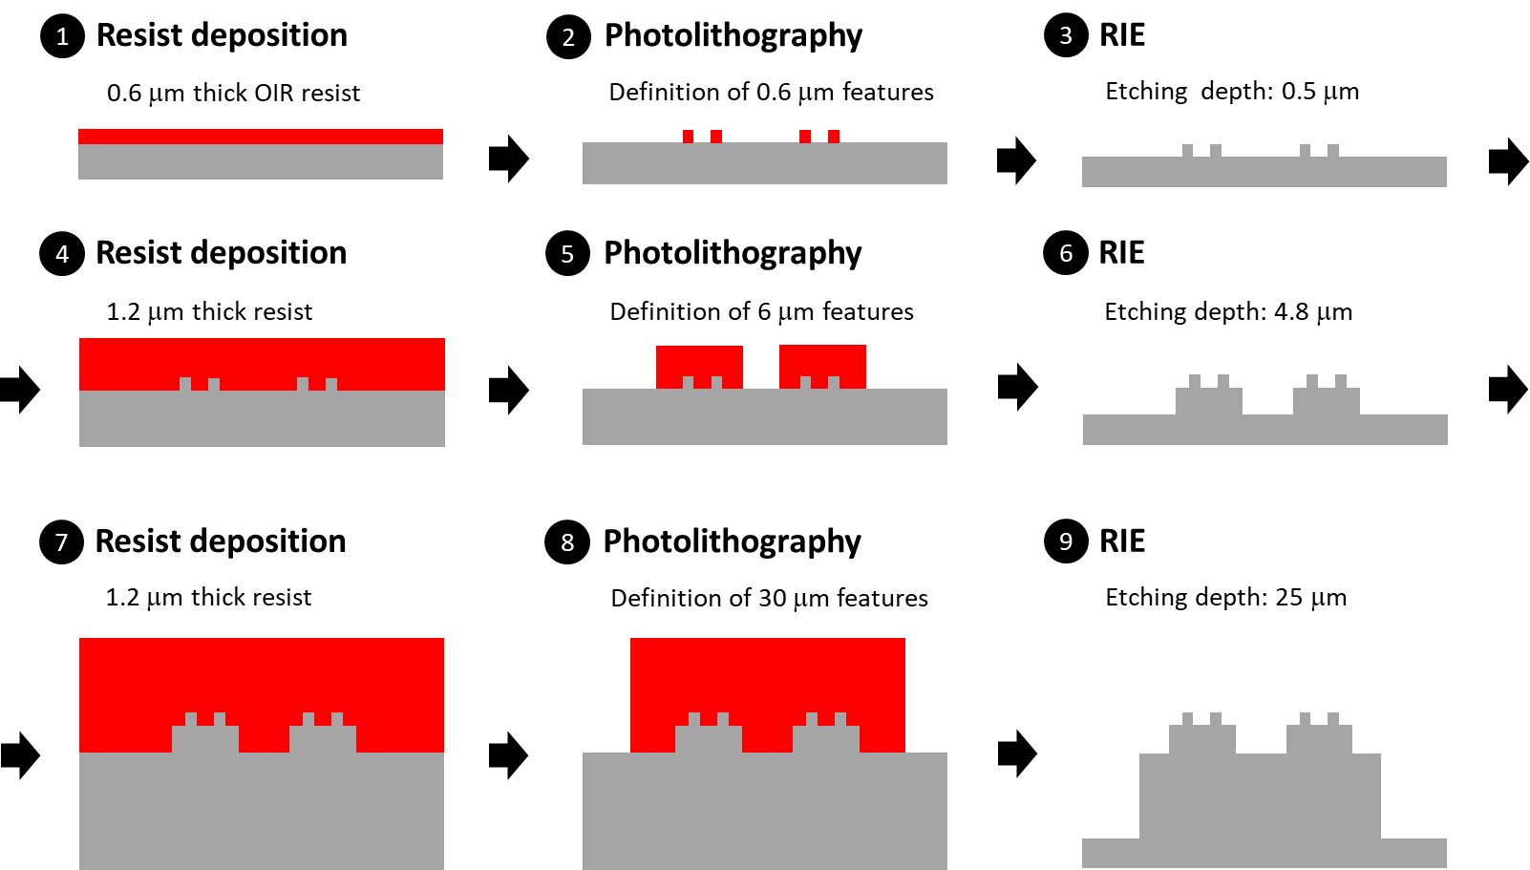
Fig. S1 Fabrication of the silicon mould containing 3-level hierarchical structures. Pattern 1L: steps 1-3; pattern 2L: steps 4-6; pattern 3L: steps 7-9

As the dimensions of the final patterns are below 0.5 μm, we have used a step-and-repeat i-line photolithography system (Nikon NSR-2205i12D). We expose consecutive areas of 3.4 mm x 3.4 mm minimizing the stitching by a careful alignment procedure. Each of these areas contains a continuous arrays of structures according to the dimensions in Table S1.

The process starts with the deposition of a 0.6 μm thick OiR resist (FujiFilm) and a first photolithography exposition with the aim of defining the common alignment marks for the fabrication of all 3 levels. The marks are placed in two separated locations, approximately 1 cm from the wafer edge and are the key element for the sequential fabrication of each level while maintaining the correct alignment.

After the first exposition, the resist is developed and the 1L pattern is exposed in the same resist as the alignment marks. The area of each 1L repeating unit is 3.4 mm x 3.4 mm, so after each exposition the sample is displaced 3.4 mm precisely in order to maintain the periodicity between the features of one repeating unit and the following.

The resist is developed after the exposure of 1L. Then, a 500 nm depth silicon reactive ion etching (RIE) process is performed using an Alcatel 601E system with a modified Bosch process.

The 1st level structures (1L) are now covered with 1.2 μm thick HiPR 6512 (FujiFilm) resist, which is exposed with the 2L structures/features/element/component. In order to place them exactly in concordance with the position of the 1L features, the mask is positioned using the same exterior alignment marks as for the first level. Next, the exposition is repeated all across the wafer maintaining the periodicity of the features and the resist is developed.

The fabrication of the second level concludes with a 4.8 μm etching (deep RIE) of the 2L features. Note that during this etching step the previously defined 1L features remain protected by the resist. The fabrication of the 3L features is then performed in a similar manner. The first step is to protect the 1L and 2L features with the same 1.2 μm photoresist. Then the 3L repeating units are exposed with the reference of the exterior alignment marks and a constant periodicity. Once exposed, the motives are developed and etched ~25μm with a deep RIE. Figure S2 shows SEM image of the silicion mould.

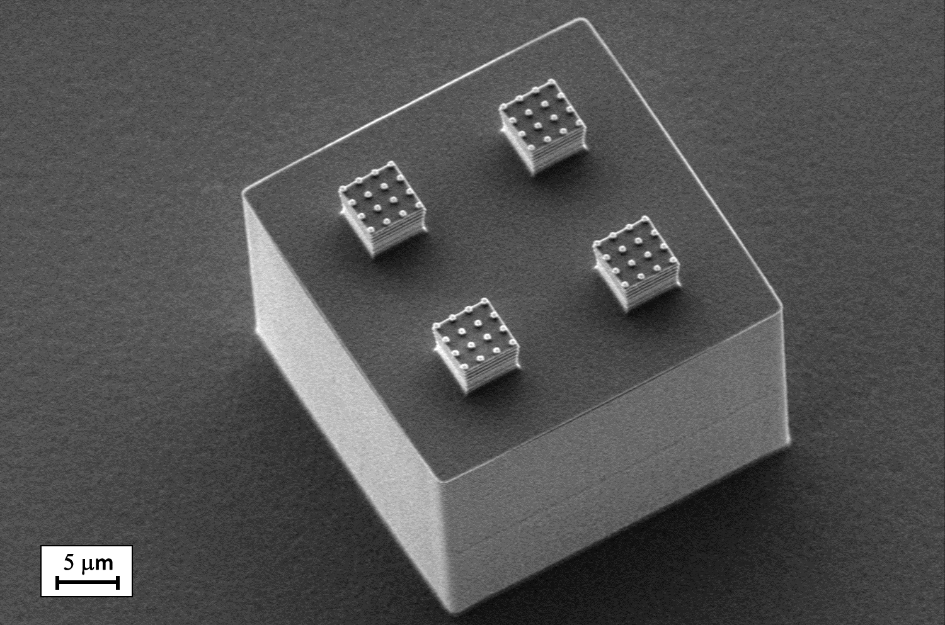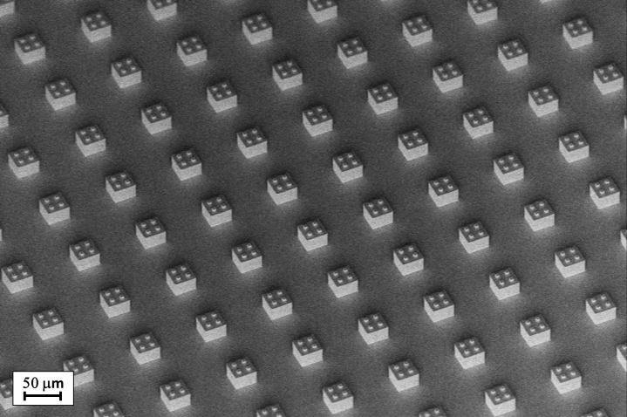
Fig. S2 (Left) SEM image of one of the 3-level structures of the silicon master mould.
(Right) The basic structure is periodically repeated all across a 100 mm wafer.

Replication on polymeric films (inlays)

Step 1: silicon to PMMA
The process starts by applying an anti-sticking layer made of Teflon on the surface of the silicon master mould. Next, the mould is replicated into a 250 μm thick PMMA foil (GoodFellow) by means of thermal nanoimprint lithography in a Eitre® 8 system (Obducat). The first step consisted of heating the sample until it reaches 150 ºC and keeping it under that temperature during 100s. Then a pressure of 40 bar was applied during 300 s, followed bythe demoulding was step, which was performed at 80 ºC.

Step 2: PMMA to PDMS
The next step is to replicate the PMMA copy into a Polydimethylsiloxane (PDMS) slab. The preparation of the PDMS (Sylgard® 184, Dow) follows the standard method: the base and the curing agent are mixed in a 10:1 ratio and the mixture was poured inside a recipient over the patterned PMMA foil. The mixture is degassed during 20 min in order to remove air bubbles and cured at stove during 1h at 80ºC. Finally, the fully cured PDMS is released.

Step 3: PDMS to OrmoStamp®
The PDMS slab is then replicated into OrmoStamp® using Plexiglas® PET films as a substrate.
The PDMS slab is placed on a hotplate at 50 ºC and uncured OrmoStamp® is spread evenly over the surface with the help of a spatula. Then, the PET foil is gently pressed against the PDMS and cured with UV light (wavelength = 365 nm; time = 120 s; power = 11 mW/cm²). A soft post-bake is then performed at 50ºC during 10 min. After the release, an anti-sticking silanitzation treatment (Trichloro(1H,1H,2H,2H-perfluorooctyl)silane) is applied to the OrmoStamp + PET plastic inlay during 10 min (figure S3).

Mould Insert

The insert provided the adequate flatness, leaving the micro/nano textured face of the film exposed towards the interior of the cavity at a reduced depth of 1.25 mm with respect to the mould-insert surface. Also, below the films, an additional uncoated PC 200 mm film was used to enhance its mechanical support during the injection cycles. Thus, the injected specimen (a squared plate of 70 x 70 x 2.6 mm) has an elevation of 23 mm x 62 mm height that is centered on the specimen, on top of which the texture is replicated. Both insert and a replicated part representation can be seen in next figure.

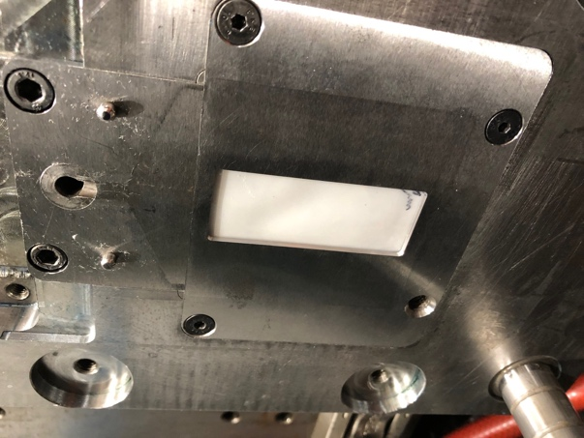 | 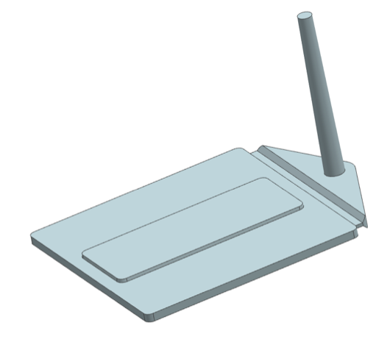
  - Fig. S3 Details of the injection mould insert and the model of the injected part to be obtained.

Quality of the replication

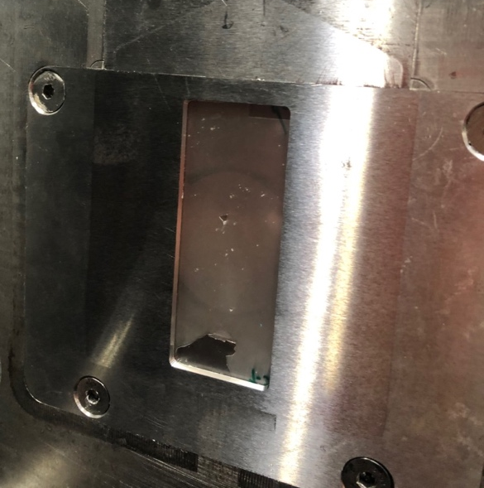
  - Fig. S4 Details of the deterioration of the inlay films after various injection shots, showing coating delamination at its lower section.

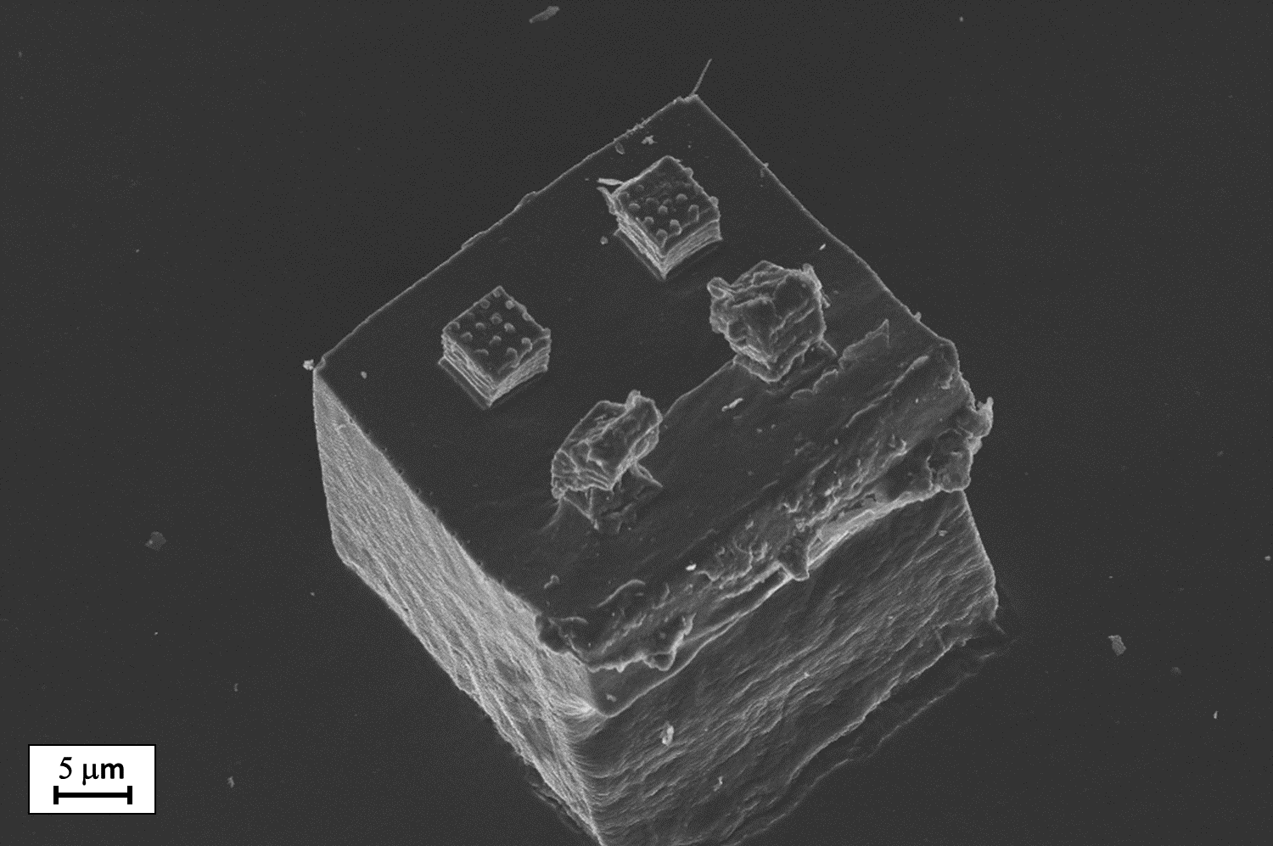 | 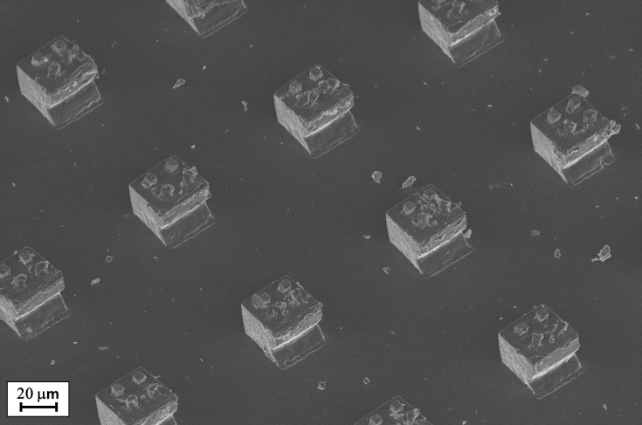
  - Fig.S5 SEM images of deformed micro/nano structures (left) and zone (right) on a PP injected part.

