Fig 1. The algorithm of PWH group and HIV-negative group receiving the
MVC-COV1901 protein vaccines.

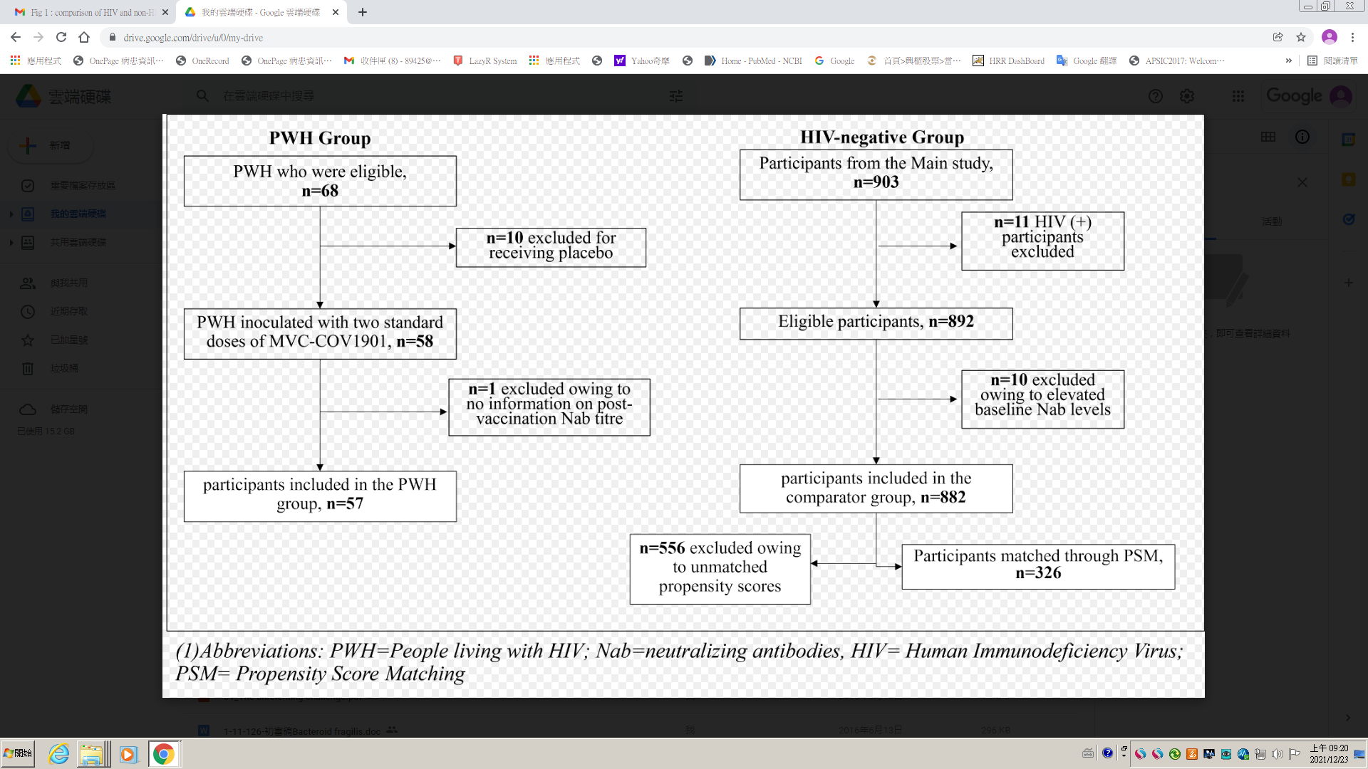

Figure 2. Propensity scores for people who living with HIV, and comparing unmatched participants from main study, and comparing controls with matched propensity score.
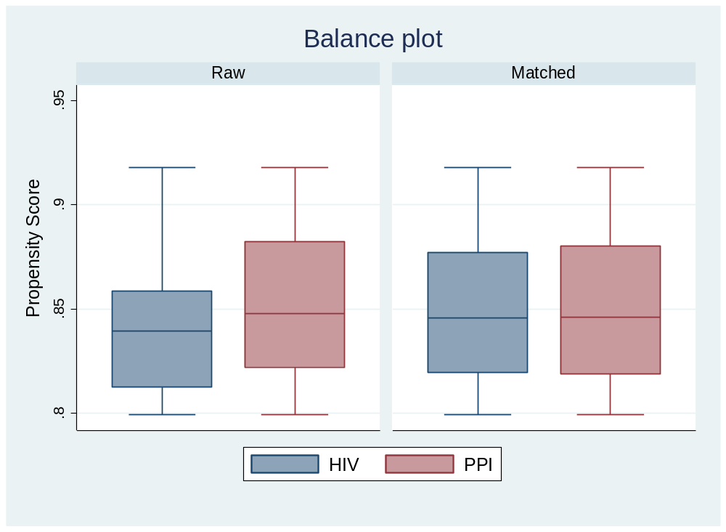

Fig 3. Correlation analysis for CD4+ T cell counts with post vaccination neutralization antibody titers.

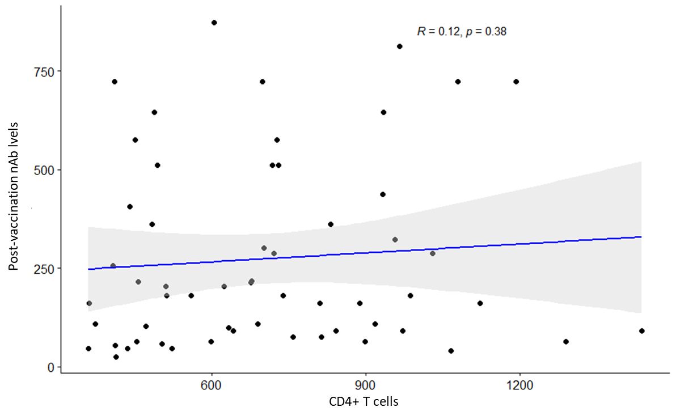

Table 1. Correlation analysis for HIV classification stage with post vaccination neutralization antibody titers.
Correlation between CD4 T cell counts and Post vaccination Nab

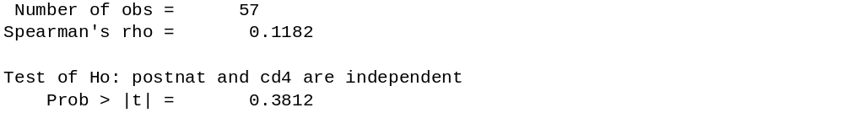

Comparison of CD4 T cell counts (350-500 vs >500)

Item | CD4 T cell counts |  |  |  | p-value
Item | 350-500 (n=16) |  | >500 (n=41) |  | p-value
Item | Median | IQR | Median | IQR | p-value
Post-vaccination Nab | 188.27 | 399.92 | 181.02 | 271.53 | 0.696
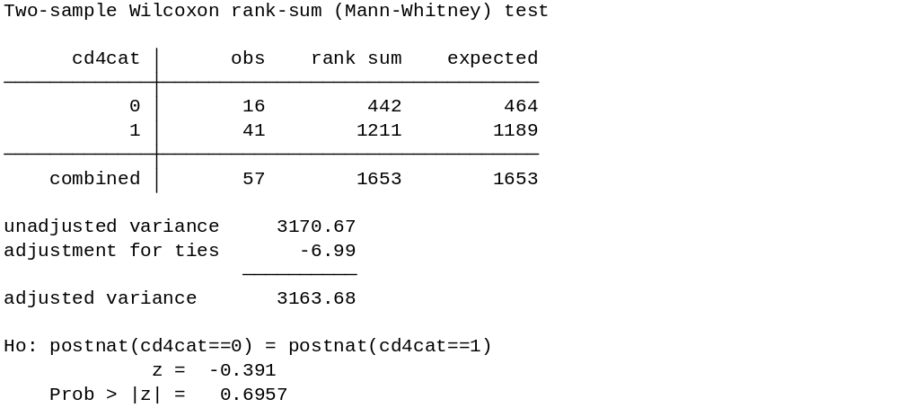

Table 2. Demographic characteristics for people who are living with HIV and controls with matched propensity scores.
Item\MVC lot | MVC-COV1901 | MVC-COV1901 | p-value
Item\MVC lot | (HIV positive) | Main Study | p-value
‧Age (years)
N (Missing) | 57 (0) | 326 (0) | 0.058
Mean (SD) | 38.6 (13.1) | 42.8 (14.9) | 0.058
Median (IQR) | 36 (19.0) | 41 (23.0) | 0.058
Q1~Q3 | 27.0~46.0 | 30.0~53.0 | 0.058
Min~Max | 23.0~72.0 | 23.0~72.0 | 0.058
‧Gender
N (Missing) | 57 (0) | 326 (0) | 1.000
Male | 54 (94.7%) | 310 (95.1) | 1.000
Female | 3 (5.3%) | 16 (4.9) | 1.000
‧BMI (kg/m²)
N (Missing) | 57 (0) | 326(0) | 0.167
Mean (SD) | 25.3 (4.9) | 25.9(4.02) | 0.167
Median (IQR) | 24.5 (6.2) | 25.4 (5.12) | 0.167
Q1~Q3 | 21.9~28.04 | 23.2~28.3 | 0.167
Min~Max | 18.7~39.2 | 16.6~40.5 | 0.167
‧BMI group
N (Missing) | 57 (0) | 326 (0) | 0.413
<30 kg/m² | 46 (80.7%) | 277 (84.97) | 0.413
>=30 kg/m² | 11 (19.3%) | 49 (15.03) | 0.413
‧Comorbidity Category
N (Missing) | 57 (0) | 326(0) | 0.160
Yes | 6 (10.5%) | 59 (18.1) | 0.160
No | 51 (89.5%) | 267 (81.9) | 0.160
(1) Abbreviations: N=number of subjects in PPI population; SD=standard deviation; Q1=first quartile (25th percentile); Q3=third quartile (75th percentile); IQR=interquartile range; BMI=Body Mass Index; HIV=Human Immunodeficiency Virus.

Table 3. Comparison of wild type SARS-CoV-2 neutralizing antibody geometric mean titers between people who are living with HIV and controls with matched propensity scores.

Item\MVC lot | MVC-COV1901 | MVC-COV1901
Item\MVC lot | HIV positive (n=57) | Main Study (n=326)
Nab titer (GMT) in IU/mL | 143.48 | 442.97
95% CI of Nab titer | 115.4~178.3 | 412.5~475.7
 | Main/HIV
Nab titer Ratio | 3.09
95% CI of Nab titer Ratio | 2.5~3.9
Adjusted Nab titer (GMT) in IU/mL | 138.53 | 445.70
95% CI of Adjusted Nab titer | 116.2~165.1 | 414.3~479.5
 | Main/HIV
Adjusted Nab titer Ratio | 3.22
95% CI of Adjusted Nab titer Ratio | 2.6~4.1
* estimated using ANCOVA model where sex, age, BMI category, and comorbidity profile are covariates
Abbreviations: CI=confidence interval; GMT: geometric mean titers;HIV=Human Immunodeficiency Virus.

