Supplemental material

eTable 1. Estimation of the population eligible for the Comprehensive Health Check of the Fukushima Health Management Survey in March 2011.

eFigure 1. The study population in the Comprehensive Health Check of the Fukushima Health Management Survey.

eFigure 2. Changes in the Comprehensive Health Check of the Fukushima Health Management Survey, by gender and age group

eTable 1. Estimation of the population eligible for the Comprehensive Health Check of the Fukushima Health Management Survey in March 2011.
Municipal district | Age group
Municipal district | 20 – 24 yrs | 25 – 29 yrs | 30 – 34 yrs | 35 – 37 yrsª
Tamura City | 1,674 | 1,919 | 1,831 | 1,129
Minami-Soma City | 2,479 | 3,322 | 4,157 | 2,788
Kawamata Town | 555 | 695 | 744 | 486
Hirono Town | 216 | 284 | 292 | 175
Naraha Town | 308 | 332 | 419 | 246
Tomioka Town | 708 | 950 | 1001 | 692
Kawauchi Village | 94 | 128 | 126 | 64
Ohkuma Town | 534 | 730 | 764 | 493
Futaba Town | 271 | 347 | 392 | 241
Namie Town | 761 | 1,094 | 1,136 | 667
Katsurao Village | 68 | 65 | 76 | 33
Iitate Village | 209 | 295 | 264 | 178
Part of Date City^{b} | 16 | 18 | 21 | 15

Data were obtained from the Fukushima Prefecture Population Survey conducted in March 2011 (https://www.pref.fukushima.lg.jp/sec/11045b/15859.html).
ªThe population between 35 and 37 years was estimated based on the population between 35 and 39 years old.
^{b}A part of Date City was designated as an evacuation zone, where 413 people lived according to the 81st Disaster Control Meeting of the Date City on July 1, 2011. (The meeting minutes are available at https://www.city.fukushima-date.lg.jp/uploaded/attachment/1664.pdf). We estimated the population in the evacuation zone in Date City using the population of the same city classified by age group.

eFigure 1. Study population in the Comprehensive Health Check of the Fukushima Health Management Survey.
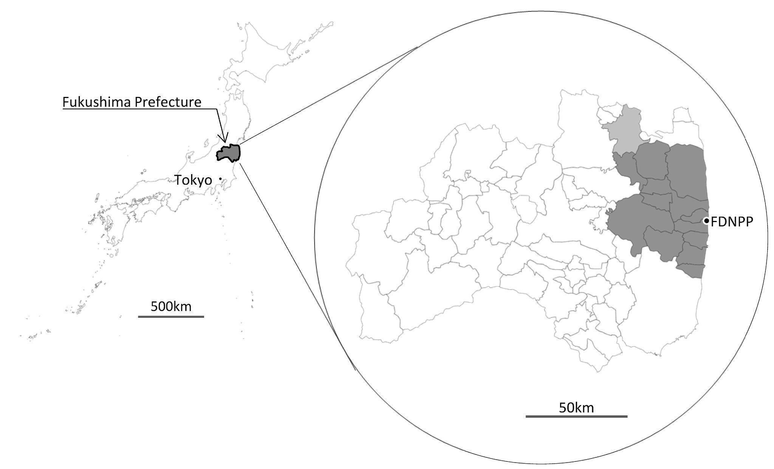

The cohort of Comprehensive Health Check of the Fukushima Health Management Survey is shown geographically. Residents in the municipalities around the Fukushima Daiichi Nuclear Power Plant (FDNPP), consisting of Tamura and Minami-soma cities, and Kawamata, Hirono, Naraha, Tomioka, Kawauchi, Ohkuma, Futaba, Namie, Katsurao, and Iitate villages (dark areas in the map), participated in the health checkup. Residents in a part of Date City (gray area) were also eligible for the Comprehensive Health Check.

eFigure 2. Changes in the Comprehensive Health Check of the Fukushima Health Management Survey, by gender and age group

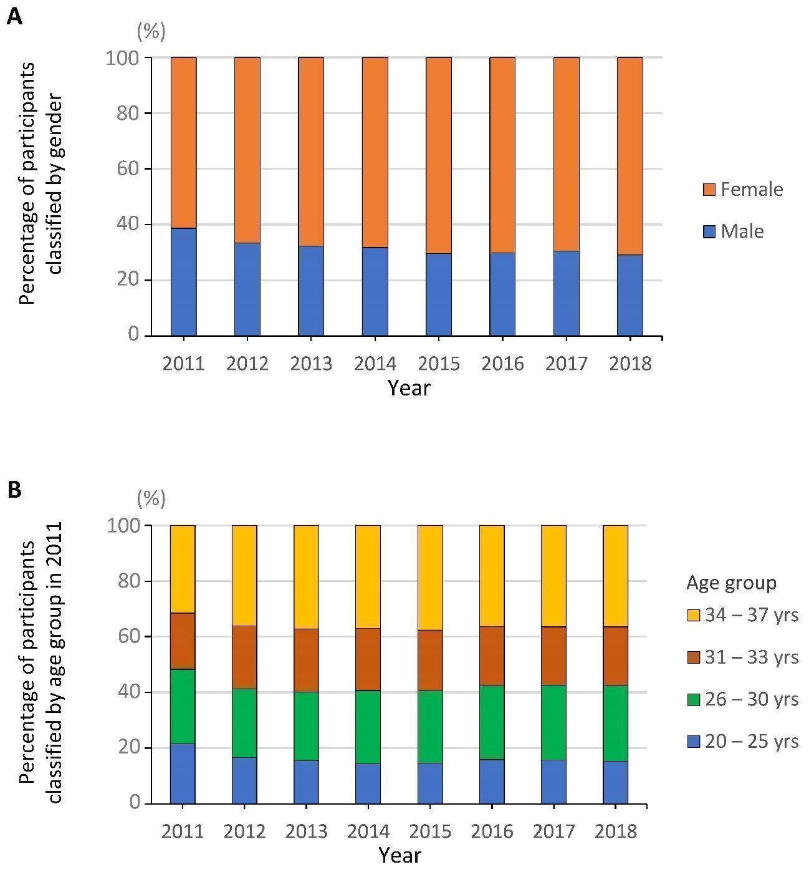
The annual changes classified by gender (A) and age group in the 2011 survey (B) are shown for the Comprehensive Health Check of the Fukushima Health Management Survey.

