Supplementary Figure 1
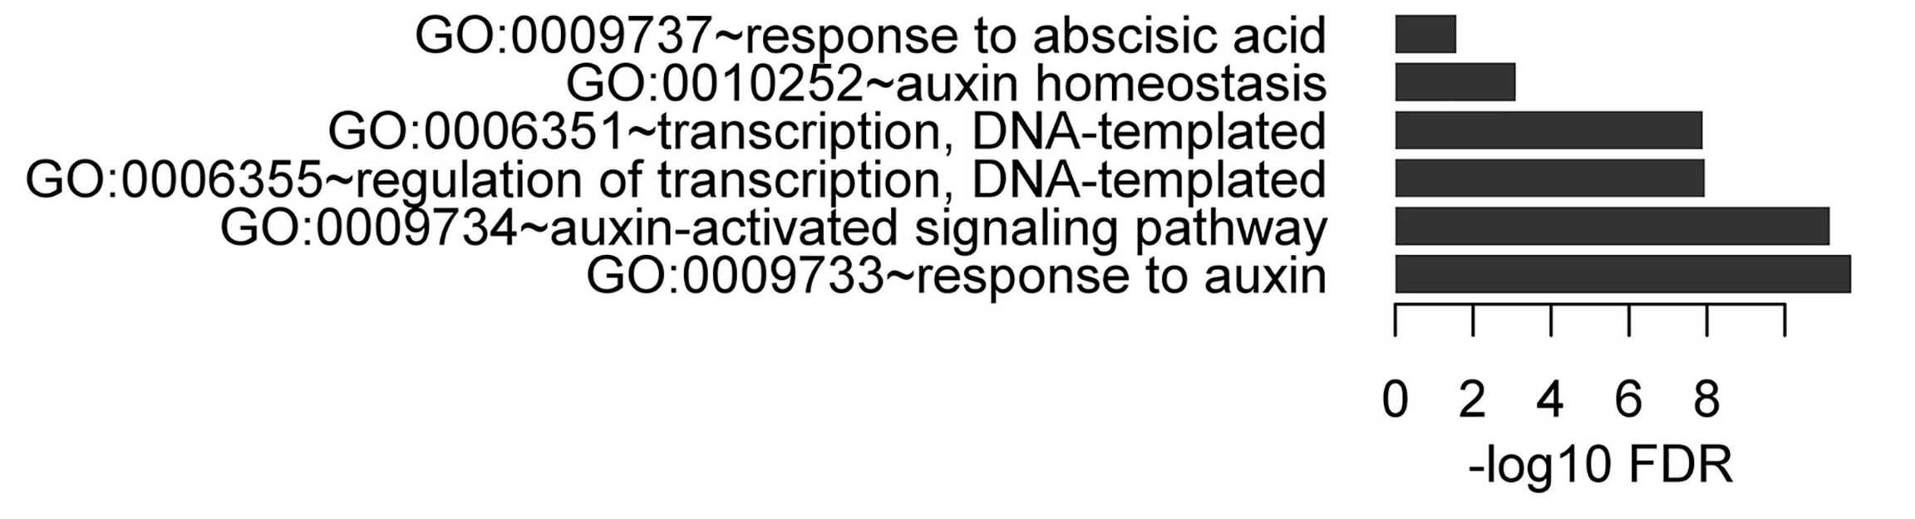
Gene Ontology (GO) analysis indicates the 230 common gene targets by both activator and repressor ARFs are highly enriched in auxin response genes.
Supplementary Figure 2
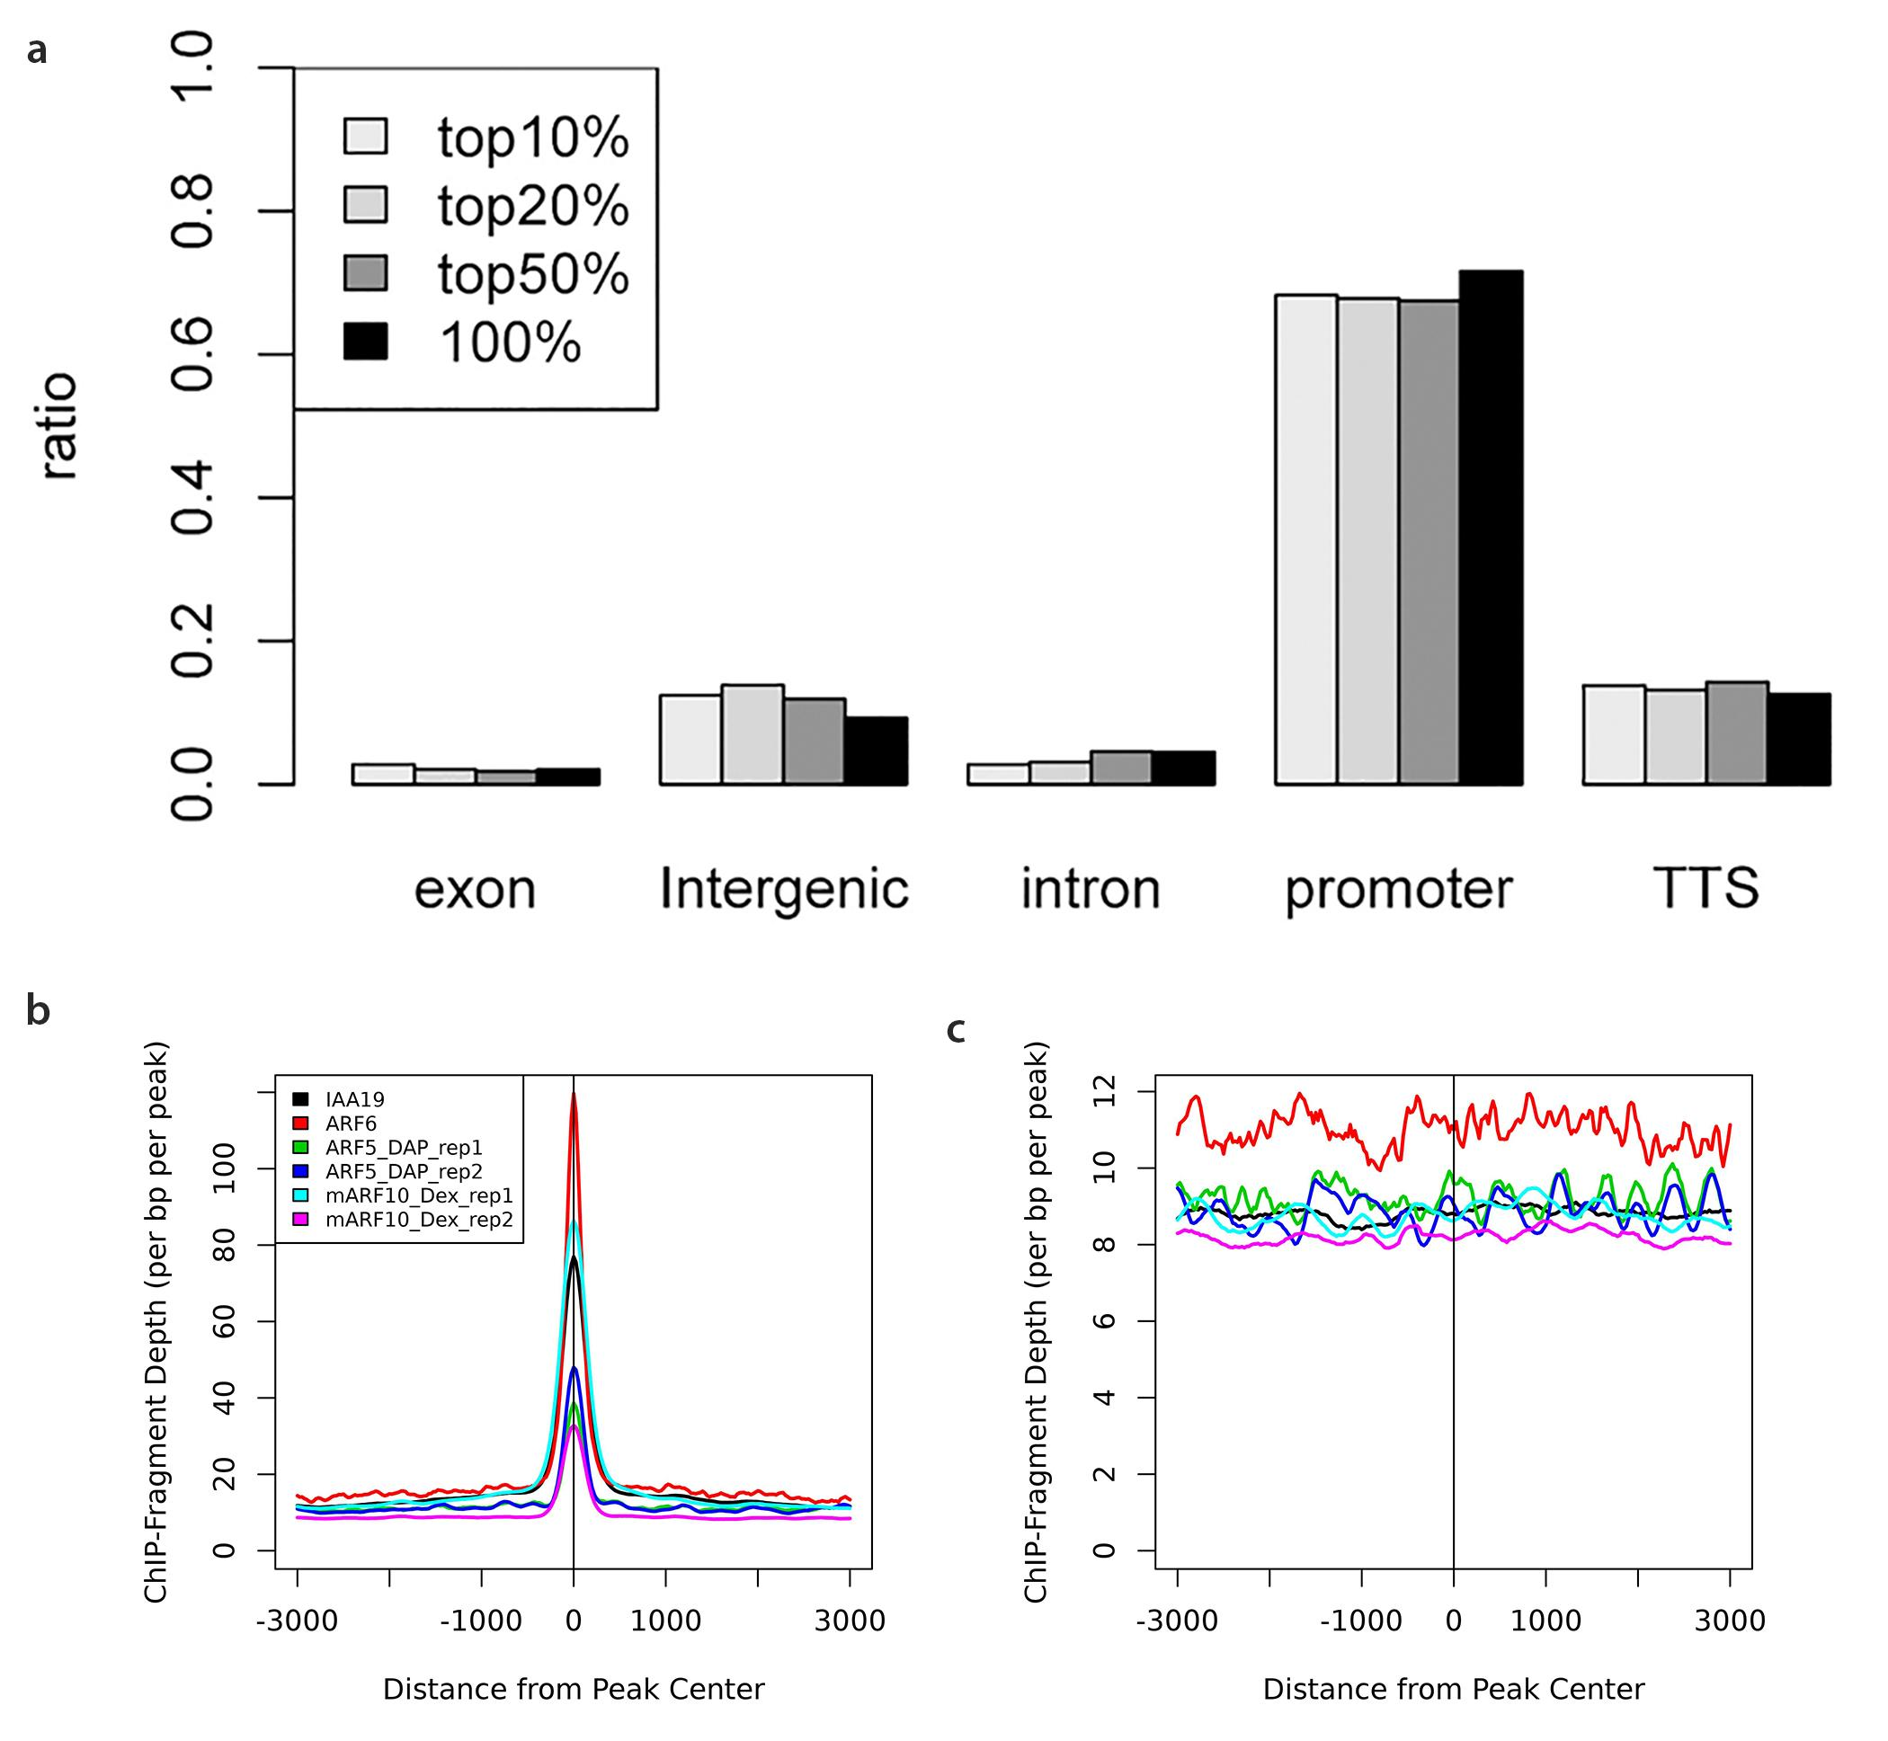

IAA19:YPet ChIP-seq analyses. (a) IAA19:YPet total peak locations ranked by peak score. Definition: promoter = -3000,100 of TSS; TTS = -100, 1000 of TTS. (b-c) Statistical analyses on the overlap of unfiltered peaks (b) Enriched read density of IAA19:YPet and ARF6, ARF5_DAP, mARF10 on IAA19:YPet peaks. (c) Non-enriched reads density of IAA19:YPet and ARF6, ARF5_DAP, mARF10 on randomly shuffled IAA19:YPet peaks.
Supplementary Figure 3
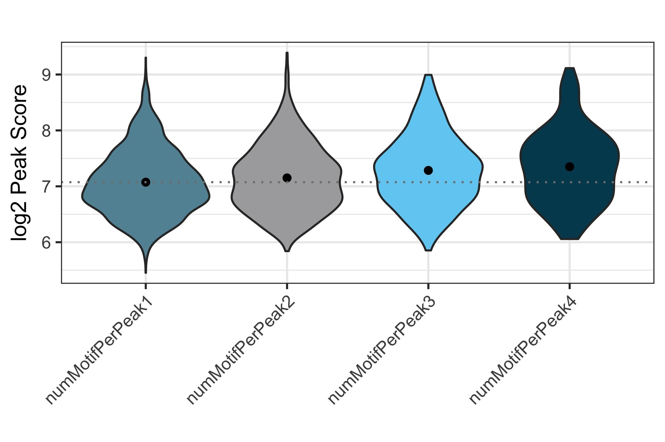
Positive correlation between ARF binding to their targets and the number of motifs per peak. The dotted line indicates the median peak score. The number followed by numMotifPerPeak is the number of motifs per peak.
Supplementary Figure 4
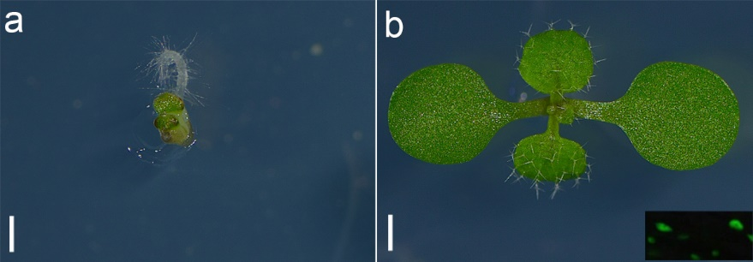
The introduction of a second transgene did not cause gene silencing of GFP-mARF10. (a) mARF10 on LS + 10 µM Dex showing yellow and stunt mARF10 phenotype. (b) IAA19(msg2-1)/mARF10 on LS + 10 µM Dex. mARF10 phenotype was rescued by IAA19(msg2-1). Insert shows the expression of GFP-mARF10. Scale bar = 0.5 mm.

Supplementary Figure 5

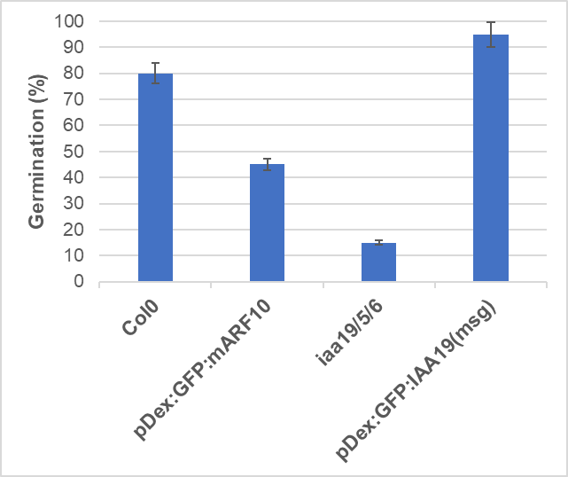
ABA resistance assay for wild type (Col0), iaa19/5/6 triple mutant, and dexamethasone (Dex) inducible mARF10 and IAA19(msg2-1). ABA concentration 0.5 µM, Dex 10 µM. Seeds were treated at 4◦C in dark for 3 days in dark and at 22◦C for 5 days under light conditions. The radicle protrusion called sense stricto germination was defined in a previous study (63).

Supplementary Data 1 Summary of 18 ChIP-seq datasets with max peak scores.xlsx
Supplementary Data 2 ChIP-seq Motifs of ARFs and IAAs with p-value.xlsx

