Supplementary Material
A COMPARATIVE STUDY FOR DETERMINATION OF 10-HDA IN VARIOUS INDIAN ROYAL JELLY SAMPLES USING HPLC, HPTLC, AND LC-MS-MS TECHNIQUES

This Supplementary material deals with results obtained during the development and validation of HPLC, HPTLC, and LC-MS-MS Methods. Table S1 describes the linearity and range of the HPLC method with concentrations, time of retention, area and area ratio concerning internal standard, which was used to plot the linearity curve and determined the regression equation. Table S2 represents the trueness of the method determined through 3 quality control levels LQC, MQC, and HQC. Table S3 represents method precision which was observed by injecting a standard solution of 6µg/ml six times. Table S4, Table S9, and Table S13 represent the concentration of 10-HDA present in the Indian royal jelly samples collected from 3 different regions of India and was estimated by spiking different concentrations which were prepared by using working standard solutions by HPLC,HPTLC and LC-MS Method respectively. Table S5 described the linearity and range of 10-HDA obtained when10 µL content of 10-60 µg/mL standard solution was applied over the HPTLC plate as a band and the chromatography was done. Concentration ng/spot represents the amount of sample applied on plates. Table S6 describes the accuracy aspects of the HPTLC method, 50%, 100%, and 150% of the target concentration were estimated for the recovery data by utilizing the calibration curve. Table S7 demonstrated the repeatability of the target concentration (200 ng) and detected % RSD values of the developed HPTLC method. Table S8 represents the systems suitability parameters like mobile phase composition, saturation time and development distance. These variations reflected that the chromatographic method is robust enough to detect. Table S10 describes the linearity and range established between concentration and peak area in the range of 10-500 µg/ML. Table S11 demonstrated the repeatability of the target concentration (100 µg/mL) and showed the % RSD values. Table S12 represents the percentage recovery which shows the trueness of the LC-MS method. Table S13. Demonstrated the quantification of 10-HDA from IRJ samples through LC-MS Method. Fig.S1. Shows linearity plot of area versus concentration of 10-HDA estimated through HPLC, HPTLC and LC-MS method. Fig.S2 represent overlay Chromatogram of 10-HDA by HPLC method. Fig.S3 represents the densitogram and chromatogram for assay, accuracy, LOD and LOQ respectively of HPTLC Method. Fig.S4 represents LC-MS graphics of the10-HDA compound.
Table S1. Linearity and range of 10-HDA estimated through HPLC.
Concentration | Peak Name | tR | Area | Area Ratio
(µg/ml)
0.5 | 10-HDA | 6.075 | 44439 | 0.148
0.5 | IS | 14.042 | 300815 | 0.148
1 | 10-HDA | 6.067 | 88697 | 0.271
1 | IS | 14.042 | 326909 | 0.271
2 | 10-HDA | 6.067 | 367059 | 0.58
2 | IS | 14.042 | 315507 | 0.58
4 | 10-HDA | 6.075 | 179071 | 1.163
4 | IS | 14.058 | 308723 | 1.163
6 | 10-HDA | 6.042 | 535168 | 1.715
6 | IS | 13.958 | 313694 | 1.715
8 | 10-HDA | 6.033 | 756778 | 2.425
8 | IS | 13.933 | 308313 | 2.425
10 | 10-HDA | 6.067 | 887877 | 3.002
10 | IS | 14.042 | 295726 | 3.002
20 | 10-HDA | 2.642 | 38792 | 5.966

Table S2. Accuracy data of HPLC Method.
Quality control Level | Mean Area Ratio | SD of Area Ratio | % CV | % Recovery
LQC | 1.3468 | 0.0201 | 1.489 | 101.32
MQC | 2.0528 | 0.0154 | 0.7515 | 102.77
HQC | 2.2846 | 0.0261 | 1.1407 | 97.53
(n=3)

Table S3. HPLC Method Precision results.
Parameters | Intraday | Inter-day
Parameters | Intraday | Day 1 | Day 2 | Day 3
SD | 0.00327 | 0.0063 | 0.32 | 0.04
% RSD | 0.1907 | 1.01 | 1.3 | 1.605
(n=6)

Table S4. HPLC data representing quantification of IRJ.
Samples | Amount of IRJ sample µg/ml | Actual Amount Spiked µg/ml | Mean Area Ratio | SD | % CV | Average | % Content Accuracy
IRJ I | 100 | 110 | 0.6442 | 0.01274 | 1.977 | 2.2195 | 2.02
IRJ II | 100 | 98 | 0.6817 | 0.01267 | 1.859 | 2.2668 | 2.31
IRJ III | 100 | 101 | 0.464 | 0.00874 | 1.884 | 1.3075 | 1.295
IRJ IV | 30 | 29 | 0.5653 | 0.00552 | 0.977 | 1.8262 | 6.297
IRJ IV | 60 | 58 | 1.1312 | 0.00554 | 0.49 | 3.6999 | 6.379
(N=5)
Table S5. Linearity and Range of 10-HDA estimated through HPTLC
Concentration (ng/spot) | Rf | Area (mV)
100 | 0.6 | 911.4
200 | 0.6 | 1399.4
300 | 0.61 | 2040.4
400 | 0.6 | 2571.1
500 | 0.6 | 3078.1
600 | 0.6 | 3642.2

Table S6. HPTLC Method accuracy results.
Quality Level | Mean Area of Sample | SD | % RSD | % Accuracy
LQC | 3208 | 19.5449 | 0.60933 | 100.395
MQC | 4019 | 47.7869 | 1.18907 | 103.472
HQC | 4514 | 34.4548 | 0.76329 | 98.7314
(N=3)
Table S7. Precision data is estimated through HPTLC Method.
Parameters | Intraday | Inter-day
Parameters | Intraday | Day 1 | Day 2 | Day 3
SD | 15.34 | 10.76 | 13.48 | 15.8
% RSD | 1.005 | 0.703 | 0.877 | 1.03
(N=6)
Table S8. Robustness results were observed for HPTLC Method.
Parameters |  | Rf value | Area (AU) | Rf |  |  | Area
 |  | Rf value | Area (AU) | Mean | SD | % CV | Mean | SD | % CV
Mobile Phase (v/v/v) | 4.5:2:3.5 | 0.59 | 2028 | 0.605 | 0.011 | 1.767 | 2032.6 | 35.892 | 1.766
Mobile Phase (v/v/v) | 4.5:2:3.5 | 0.59 | 1984
Mobile Phase (v/v/v) | 4.5:2:3.5 | 0.6 | 1998
Mobile Phase (v/v/v) | 4.5:2:3.5 | 0.61 | 2007
Mobile Phase (v/v/v) | 5.5:2:2.5 | 0.61 | 2064
Mobile Phase (v/v/v) | 5.5:2:2.5 | 0.62 | 2042
Mobile Phase (v/v/v) | 5.5:2:2.5 | 0.61 | 2092 | 0.608 | 0.007 | 1.164 | 2052.5 | 18.237 | 0.889
Mobile Phase (v/v/v) | 5.5:2:2.5 | 0.61 | 2046
Mobile Phase (v/v/v) | 05:02:03 | 0.6 | 2056
Mobile Phase (v/v/v) | 05:02:03 | 0.6 | 2040
Mobile Phase (v/v/v) | 05:02:03 | 0.61 | 2039
Mobile Phase (v/v/v) | 05:02:03 | 0.6 | 2041
Chamber Saturation Time | 25 Min | 0.6 | 1998 | 0.6 | 0.011 | 1.782 | 2031.4 | 20.556 | 1.012
Chamber Saturation Time | 25 Min | 0.59 | 2014
Chamber Saturation Time | 25 Min | 0.58 | 2038
Chamber Saturation Time | 25 Min | 0.61 | 2067
Chamber Saturation Time | 30 Min | 0.61 | 2034
Chamber Saturation Time | 30 Min | 0.6 | 2022
Chamber Saturation Time | 30 Min | 0.6 | 2042 | 0.604 | 0.007 | 1.232 | 2029.1 | 15.056 | 0.742
Chamber Saturation Time | 30 Min | 0.61 | 2036
Chamber Saturation Time | 35 Min | 0.61 | 1999
Chamber Saturation Time | 35 Min | 0.59 | 2020
Chamber Saturation Time | 35 Min | 0.61 | 2034
Chamber Saturation Time | 35 Min | 0.6 | 2046
Development Distance | 75mm | 0.61 | 2122 | 0.601 | 0.008 | 1.388 | 2067.6 | 40.338 | 1.951
Development Distance | 75mm | 0.61 | 2087
Development Distance | 75mm | 0.61 | 2132
Development Distance | 75mm | 0.6 | 2034
Development Distance | 80 mm | 0.59 | 2036
Development Distance | 80 mm | 0.6 | 2043
Development Distance | 80 mm | 0.6 | 2046 | 0.589 | 0.008 | 1.417 | 2024.1 | 25.261 | 1.248
Development Distance | 80 mm | 0.59 | 2041
Development Distance | 85 mm | 0.58 | 1984
Development Distance | 85 mm | 0.58 | 2041
Development Distance | 85 mm | 0.59 | 1990
Development Distance | 85 mm | 0.58 | 2012

Table S9. Quantification of 10-HDA from IRJ by HPTLC Method.
IRJ Samples | Mean Area | SD | % CV | Mean % Content
IRJ I | 5286.03 | 31.84 | 0.602 | 2.140 ±0.014
IRJ II | 5923.63 | 61.36 | 1.036 | 2.537 ±0.028
IRJ III | 2602.5 | 20.49 | 0.787 | 1.366 ±0.012
IRJ IV | 4440.1 | 76.67 | 1.727 | 6.134 ±0.23

Table S10. LC-MS area response for linearity and range.

Concentration (µg/mL) | Area response
0.010 | 1633
0.025 | 2059
0.050 | 2833
0.100 | 4264
0.250 | 8329
0.500 | 15416

.
Table S11. Precision data for LC-MS
Parameters | Intraday | Inter-day
Parameters | Intraday | Day 1 | Day 2 | Day 3
AREA | 4240 | 4205 | 4367 | 4178
AREA | 4165 | 4189 | 4194 | 4120
AREA | 4264 | 4167 | 4210 | 4234
AREA | 4187 | 4283 | 4287 | 4256
AREA | 4127 | 4118 | 4254 | 4275
AREA | 4197 | 4192 | 4262 | 4213
SD | 55.590 | 60.331 | 68.995 | 63.260
% RSD | 1.325 | 1.439 | 1.619 | 1.502

Table S12. Accuracy data for LC-MS
Quality control Level (%) | Area | Mean Area | SD | RSD | % Recovery
 | 12534
50 | 12843 | 12747.33 | 185.08 | 1.45 | 100.46
 | 12865
 | 14021
100 | 14234 | 14338.00 | 161.59 | 1.13 | 101.54
 | 14338
 | 17016
150 | 16484 | 16774.33 | 269.32 | 1.61 | 98.95
 | 16823

Table S13. Estimation of 10-HDA from IRJ samples through LC-MS Method.
IRJ Samples | Mean Concentration Injected (mg) | Area | Mean Area | SD | % CV | Mean % Content
 |  | 9411 |  |  |  | 1.993
IRJ I | 11.34 | 9389 | 9407 | 16.37 | 0.174 | 1.993
 |  | 9421 |  |  |  | 1.993
 |  | 10031 |  |  |  | 2.175
IRJ II | 11.072 | 10242 | 10205 | 159.20 | 1.560 | 2.175
 |  | 10343 |  |  |  | 2.175
 |  | 7874 |  |  |  | 1.261
IRJ III | 14.988 | 7728 | 7838 | 97.14 | 1.239 | 1.261
 |  | 7912 |  |  |  | 1.261
 |  | 9189 |  |  |  | 6.071
IRJ IV | 3.63 | 9166 | 9178 | 11.59 | 0.126 | 6.071
 |  | 9180 |  |  |  | 6.071

a
c
b

Fig.S1 a, b, and c, are the Linearity curve of 10-HDA estimated through HPLC, HPTLC and LC-MS Methods

Fig.S2 Overlay Chromatogram of 10-HDA showed a precision of HPLC method.

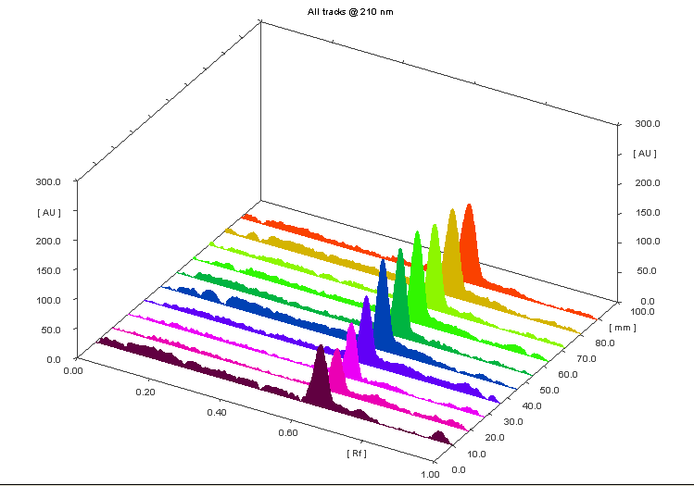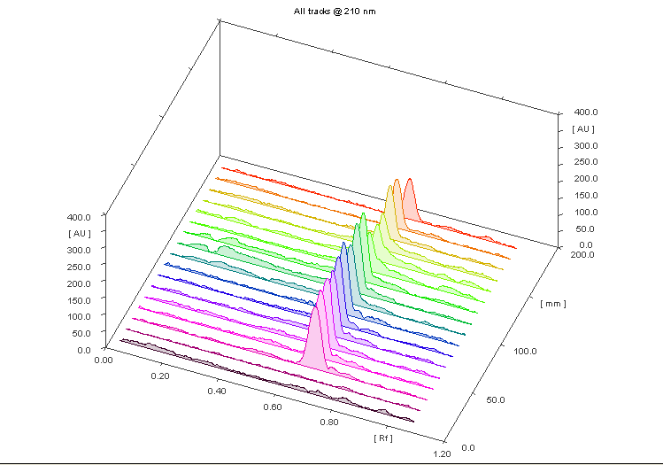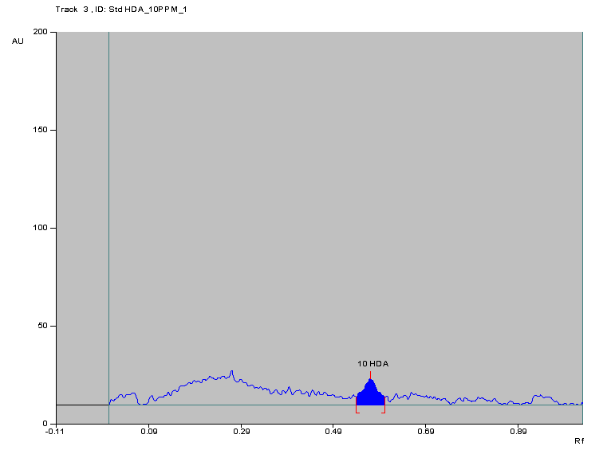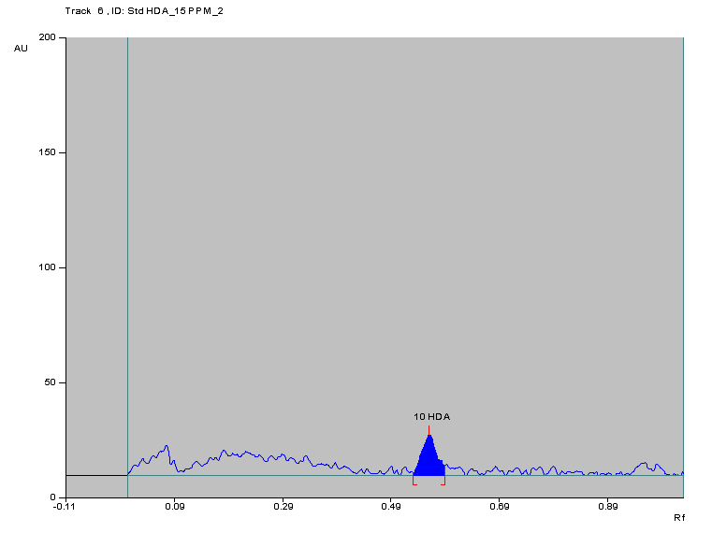
a
b
c
d
Fig.S3 a, b, c, and d represents the assay, accuracy, LOD and LOQ respectively of HPTLC Method.

Fig.S4 Represents graphics of the10-HDA compound.

