Supplementary Information

N,P co-doped carbocatalyst from olive pomace obtained by catalytic hydrothermal carbonization for efficient dye degradation via persulfate-based advanced oxidation process

Faiçal El Ouadrhiri^{a*}, Abderrazzak Adachiª, Majda Elyemni^{b}, Abdelilah Bayout^{f}, Anouar Hmamouª, Ahmed Bendaoudª, Abdelhadi Lhassani^{d}, Mehdi Chaouchª, Mehmet A. Oturan^{c}, Amal Lahkimiª
ªLaboratory of Engineering, Molecular Organometallic Materials and Environment, Faculty of Sciences Dhar El Mehraz, Sidi Mohamed Ben Abdellah University, Fez, Morocco.
^{b} Laboratory of Biotechnology, Faculty of Sciences Dhar El Mehraz, Sidi Mohamed Ben Abdellah University, Fez, Morocco.
^{c} Université Gustave Eiffel, Laboratoire Géomatériaux et Environnement, EA 4508, 77454 Marne-la-Vallée, Cedex 2, Franced
^{d} Laboratory of Processes, Materials and Environment, Faculty of Sciences and Technology, Sidi Mohamed Ben Abdellah University, Fez, Morocco
^{f} Institut Charles Gerhardt, Departement materiaux poreux et hybrides, Montpellier, France.

Corresponding author Email: Faical.elouadrhiri@usmba.ac.ma

MATERIAL AND METHOD:
2.2 Synthesis of doped carbocatalysts
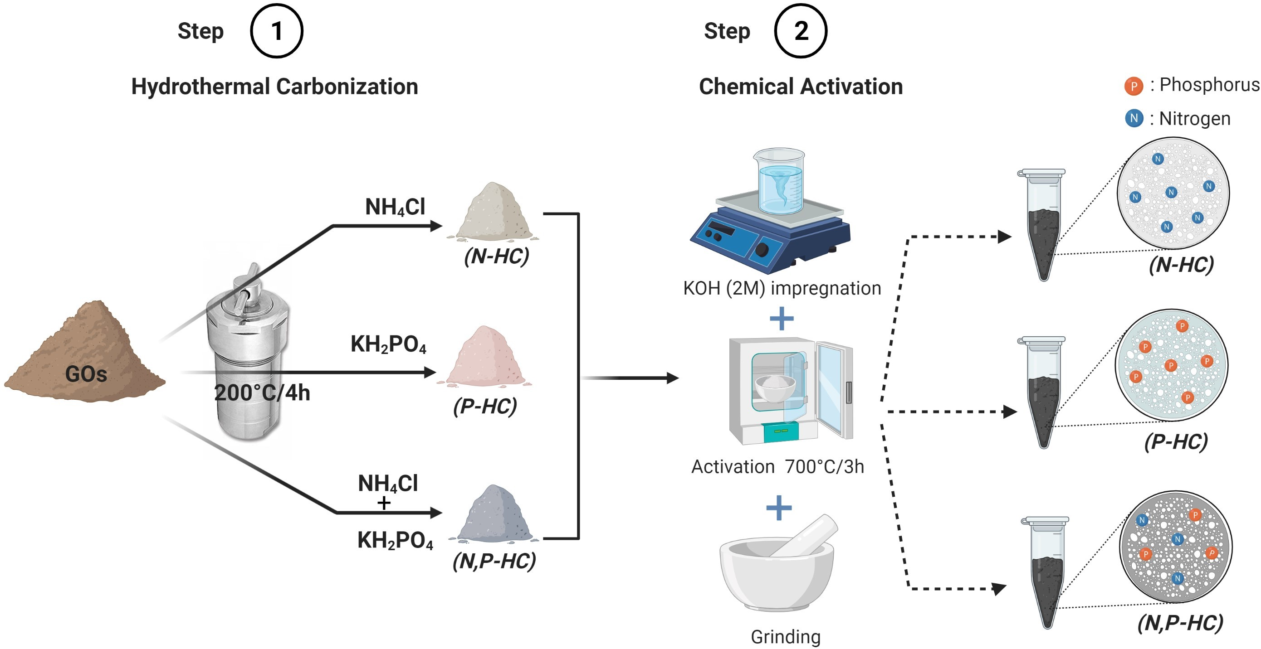

Figure S1. Synthesis process of N-HC, P-HC and N,P-HC doped materials.
2.3 Characterization of the synthesized materials
pH_{PZC} determination by the pH Drift method:
In detail, in a series of 9 Erlenmeyer flasks, a volume V=50 mL of an aqueous solution of 0.01M NaCl was added. Then in each flask the pH was adjusted to an initial value noted pHinitial equal: 2, 3, 4, 5, 6, 7, 8, 9, 10 by the addition of 0.5M HCl or 0.5M NaOH. after the initial pH stabilized, a mass of 0.5 g of carbocatalyst was added to each Erlenmeyer flask and stirred for 24 hours. finally, the final pH noted pHfinal was measured and plotted against the initial pH. The pH_{pzc} of the carbocatalyst is the point where the curve crosses the line pH_{initial} = pH_{final}.
Table S1: Equations used in the calculation of RhB adsorption on HC, N-HC, P-HC, N,P-HC.
Utility | Equation | reference
Pseudo-First Order | $$ln⁡(Q_{e}-Q_{t}) = ln {(Q}_{e}) - K_{1}.t$$ | (Ho and McKay, 1999)
Pseudo-Second Order | $$t.Q_{t} =\frac{ t}{Q_{e}}+\frac{1}{K^{2}.Q_{e}^{2}}$$ | (Simonin, 2016)
Modele de Langmuir (linear Form) | $$\frac{1}{Q_{e}}=\frac{1}{\left(K_{L}Q_{max}\right).C_{e}}+\frac{1}{Q_{max}}$$ | (Langmuir, 1916)
Modele de Freundlich (Liniar form) | $$ln{ (Q}_{e})= \frac{1}{n_{F}}\ln{(C_{e})}+\ln{{(K}_{F})}$$ | (Liu et al., 2019)
Arrhenius équation | $$Ln(K)=Ln(A) - \frac{Ea}{RT}$$ | (Tomer and Biswas, 2020)

C₀ (mg.L⁻¹) and C_{e,t} (mg.L⁻¹) are the initial and equilibrium concentrations respectively. m (g) is the mass of carbocatalyst V (L) is the volume of Dye. Q_{e} is the equilibrium quantity. K_{L} (L.mg-1) is a direct measure of the adsorption intensity.Q_{max} is the maximum adsorption capacity. K_{F} ((mg.g⁻¹)(L.mg⁻¹)^{1/n}) is the adsorption capacity. (1/n_{F}): is the intensity of adsorption for 1/n_{F}=0 irreversible, 1/n_{F}>1 unfavorable and for 0<1/n_{F}<1 the adsorption is favorable.
RESULT AND DISCUSSION:
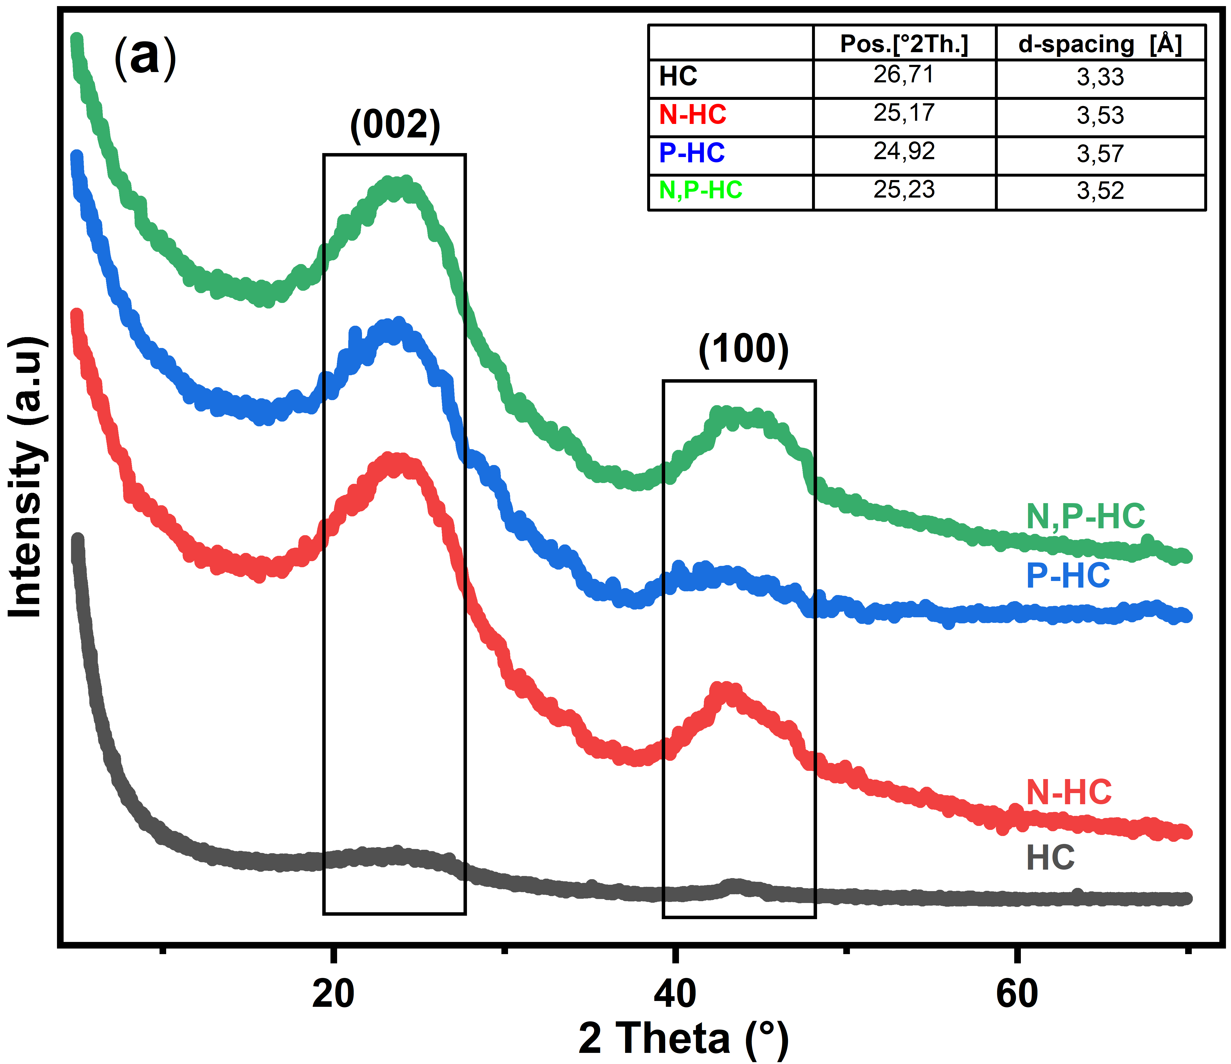

Figure S2: (a) pore size distribution (b) XRD patterns of the samples (c) FTIR spectra of the prepared carbocatalyst

Figure S3 : (a) deconvolution of high-resolution N1s peak, (b) P2p peak of the N,P-HC
Table S2: elemental composition from EDX analysis and the XPS Results Peak-Fitting C_{1s}, N_{1s}, O_{1s}, P_{2s} Spectra of the N-HC, P-HC and N,P-HC.
 | SEM-EDX analysis (Mass %) |  |  |  |  | XPS analysis (at.%)
 | C | O | P | S | N | C | O | N | P
N-HC | 80.97 | 10.01 | 0 | 0.4 | 3.68 | 85.14 | 10.74 | 4.08 | 0.04
P-HC | 82.6 | 8.85 | 3.33 | 0.32 | 0.02 | 86.82 | 9.38 | 0.11 | 3.69
N,P-HC | 83.91 | 8.03 | 1.98 | 0.47 | 2.12 | 87.02 | 8.58 | 2.29 | 2.11

Table S3: Parameter of the Langmuir and Freundlich isotherms for RhB adsorption at 25°C.
 |  | HC | N | P | N,P
Langmuir | Q_{m} (mg/g) | 238.1 | 158.73 | 135.13 | 172.41
Langmuir | K_{L} (L/mg) | 0.004 | 0.0056 | 0.007 | 0.008
Langmuir | R² | 0.92 | 0.83 | 0.90 | 0.82
Freundlich | K_{F} (mg/g.(1/mg)) | 2.57 | 1.22 | 0.64 | 2.01
Freundlich | 1/n_{F} | 0.72 | 0.82 | 0.93 | 0.73
Freundlich | R² | 0.943 | 0.937 | 0.928 | 0.901

Figure S4: (a) (b) the PFO model,(c) the PSO model, (b) correlation between(I_{D}/I_{G}) and (Q_{m}/S_{BET}). Experimental conditions: [RhB]₀ =50 mg L⁻¹, , [PDS] = 4 mM, pH=7, [Cat] = 0.3 g L⁻¹

Figure S5: (a) kapp and TOF (b) activation energy of samples (c) KI and K2Cr2O4 quenching study and (d) kapp for the quenching tests. Experimental conditions: pH : 7.05, T = 30 °C, [RhB]0 = 50 mg L-1, [H2O2] =[PDS] = 4 mM, [Cat] =0.3 g L-1.
Carbocatalysts | Pollutants | AOPs applications | Heteroatomes amounts at.% | Préparation méthode | Removal efficiency | TOF (min⁻¹) | Ref.
N-doped CXs from sucrose (NCX900 (0,2g/L) | BPA (20mg/L) | PDS (0,5mM) | C (92,3 at.%)  O (5,15 at.%)  N (2,55 at.%) | HTC : 160°C/10h +  Annealing 900°C, 2h, N₂ atmosphere | 100%(60min), pH=6,5 | 0.081min-1/(0,2g/L)=  0,405 | (Liang et al., 2021)
N-doped biochar from wood residue(2g.l) | AO7 (10mg/L) | PMS (0,4g/L) | N (12,1 w/w%) | Pyrolysis: 800°C/2h | 100%(30min), pH=3-4 | 0.342 min−1/0,1g/L=  3,42 | (Zaeni et al., 2020)
N,S-co-doped Biochar from nanocellulose (0,2g.l) | SMX (20 μM) | PMS (0,8mM) | - | Pyrolysis: 900°C/1h, N₂ atmosphere | 90%(60min)  pH=5,4 | 0,0464 min⁻¹ – 0,3g= 0,154 | (Xu et al., 2021)
N-doped hydrochar from pinewood (0,2g/L) | BPA(20 μM) | PMS(2mM) | C (84,1 at.%)  O (6,51 at.%)  N (9,39 at.%) | HTC: 180°C/24H + Annealing at 600°C/1h/ N₂ atmosphere | 100% (180min), pH=6-6,5 | 0,0657 min⁻¹ – 0,2g= 0,328 | (Yu et al., 2020)
sludge-derived carbon (0,4g/L) | BPA (20mg/L) | PMS(0,4g/L) | C (41,79 at.%)  O (49,49 at.%)  N (1,63 at.%) | HTC: 190°C/8h + Pyrolysis at 600°C/3h/ Ar atmosphere | 100% (20min), pH=7,06 | 0,3134 – 0,4= 0,7835 | (Hu et al., 2020)
N-doped biochar from Spirulina residue | SMX (20mg/) | PDS(6mM) | C (74,54 at.%)  O (7,98, at.%)  N (6,13 at.%) | Pyrolysis: 900°C/90min/N₂ atmosphere + post-treatement (5M HCl) | 100% (45min) | - | (Ho et al., 2019)
N-doped biochar from Wetland plants (0,2g/L) | OG (50mg/L)  SMX (20mg/L)  BPA (20mg/L) | PDS (2mM) | C (87,78 at.%)  O (10,46 at.%)  N (1,76 at.%) | Pyrolysis: 900°C/90min/ N₂ atmosphere | OG=100% (60min), pH=9,5  SMX=100%(20min)  BPA=100%(20min) | 0,039 - 0,2 = 0,192(OG)  0,214 – 0,2 = 1,07 (SMX)  0,184 – 0,2 = 0,92 (BPA) | (Zhu et al., 2018)
N,S-co-doped biochar from wood shavings (0,2g/L) | MB (8mg/L) | PMS (0,4g/L) | C (70,56 at.%)  O (7,96 at.%)  N (20,92 at.%)  S (0,56 at.% | Pyrolysis: 800°C/2h | >95%(30min) | 0,202 – 0,2 = 1,01 | (Oh et al., 2021)
N,S-codoped biochar from Rice Straw (1g/L) | MET (5mg/L) | PMS (4mM) | C (89,62 at.%)  O (6,69 at/%)  N (1,78 at.%)  S (1,91 at.%) | Impregnation-pyrolysis process: 1000°C/4h/ N₂ atmosphere | 80% (120min)  pH = 6.0 | 0,0190 – 1g/L= 0,019min⁻¹ | (Ding et al., 2020)
N-doped biochar from Rice Straw (1g/L) | MET (5mg/L) | PMS (4mM) | C (87,59 at.%)  O (7,63 at/%)  N (4,39 at.%) | Impregnation-pyrolysis process: 1000°C/4h/ N₂ atmosphere | 100% (120min) | 0,0238 – 1g/L= 0,0238min⁻¹ | (Ding et al., 2020)
N-doped graphitic porous carbon from almond shells | OG (100mg/L) | PDS(4mM) | C (91,93 at.%)  O (3,04 at/%)  N (2,03 at.%) | Impregnation-pyrolysis process: 300°C/2h + 900°C/4h, N₂ atmosphere | 98% (30min) | 0,068 – 0,2g/L = 0,34 min⁻¹ | (Anfar et al., 2020)
B-doped biochar from Wheat Straw | SMX (20mg/L) | PDS (6mM) | C (62,69 at.%)  O (25,05 at/%)  N (1,72 at.%)  B (4,32 at.%) | Impregnation-Pyrolysis process: 900°C/2h + KOH activation/900°C/2h + post-treatement (HCl) | 94% (120min)  pH=6,3 | 0,0689 – 0,05 = 1,378 min⁻¹ | (Liu et al., 2020)
N,P-co-doped hydrochar from Olive Pomace(0.2g/L) | RhB (50mg/L) | PDS (4mM) | C (87.02 at.%)  O (8.58 at/%)  N (2.29 at.%)  P (2.11 at.%) | Catalyzed HTC: 200°C/2h + KOH activation/700°C/3h + HCl Washing | 100% (40min), pH=7,05 | 0.275 min⁻¹ | This study
Tableau S4: comparison of some carbocatalyseurs preparation and performance degradation

