Supporting Information

Contents
1 Supplementary Methods: Operational definitions of events of interest 3
1.1 Falls and Fractures 3
1.2 Aspiration Pneumonia 5
1.2.1 Serious Hospitalized Infection 5
1.2.2 Parenteral Anti-infective Use 5
1.3 Health Care Utilization 6
1.4 Death 7
2 References 31

Tables
Table S-1. Comorbidities of Patients With Dementia-Related Psychosis 8
Table S-2. Comedication Use Among Patients With Dementia-Related Psychosis by Type of Dementia 10
Table S-3. Health Care Utilization in Patients With Dementia-Related Psychosis Assessed in the Year Before and Not Including the Index Date 11
Table S-4. Incidence Rates of Events of Interest in Patients With Dementia-Related Psychosis, by Type of Dementia 12
Table S-5. Characteristics of Initial Antipsychotic Treatment in Patients With Dementia-Related Psychosis by Type of Dementia 23

Figures
Figure S-1. Variable Assessment Windows Relative to the Study Index Date, Overall DRP Cohort 2
Figure S-2. Mean Cumulative Counts for Each Event of Interest in Patients With Dementia-Related Psychosis 15
Figure S-3. Antipsychotic Treatment Status Over Follow-up in Patients With Dementia-Related Psychosis, by Type of Dementia 25

- Variable Assessment Windows Relative to the Study Index Date, Overall DRP Cohort

DRP = dementia-related psychosis; HCU = health care utilization.
Note: figure template available at www.repeatinitiative.org
ª Chronic cardiovascular disease, cerebrovascular diseases, hypertension, diabetes mellitus (type 1 or 2), hyperlipidemia, malignancies, chronic kidney disease and other renal disorders, liver disease, chronic obstructive pulmonary disease, osteoporosis, psychiatric disorders, Charlson Comorbidity Index score, acetylcholinesterase inhibitors, antidepressants, anxiolytics, sedatives, drugs used in opioid dependence.
^{b} Use of skilled nursing facility; use of home health care services; cardiovascular events; diseases of arteries, arterioles, and capillaries; falls and fractures; aspiration pneumonia; upper respiratory tract infections; lower respiratory tract infections; urinary tract infections; severe sepsis; serious hospitalized infections; overall frailty index; antihypertensives; cholesterol-lowering medications; anticoagulants; treatments for Parkinson’s disease; anti-inflammatory drugs; bronchodilators; osteoporosis treatments; oral anti-infectives; parenteral anti-infectives; hospitalizations; emergency department visits; clinic visits.
^{c} End of study (December 31, 2018); disenrollment from Medicare Part A, B, or D; diagnosis of a bipolar or schizophrenic condition; or death.

Supplementary Methods: Operational definitions of events of interest

Falls and Fractures
All falls and fractures diagnosed for each person were identified during follow-up. Multiple events per patient were included in analyses. Falls and fractures were evaluated both together as a composite outcome and separately as distinct outcomes.
Falls were identified by ICD-9-CM or ICD-10-CM diagnosis codes for falls occurring in any diagnosis position in Medicare MedPAR, outpatient, or physician billing claims. Repeated codes for falls occurring within the 7 days after and not including the date of an identified fall were assumed to be part of the same event and were not considered separately.
Falls were evaluated in a patient up to 7 days before the index date to ensure that falls occurring after the index date were new events. Falls were identified in the 12 months before the index date as a descriptive comorbidity.
Fractures were identified by diagnosis codes from inpatient, outpatient, or physician billing claims for a fracture (occurring in any diagnosis position) at a specific anatomic site with a procedure code (ICD-9-CM procedure, ICD-10-PCS, or CPT) for a fracture repair occurring in a window from 7 days before to 7 days after the date of the fracture diagnosis (days [−7, 7]). The earlier date of the fracture diagnosis or repair was considered the event date. Each fracture diagnosis and repair code were categorized by anatomic site (skull, vertebrae, trunk, upper limb, hand/wrist/finger, pelvis, hip, femur, lower leg, foot/ankle/toe). Procedure codes for a fracture repair at an unspecified site were included in the procedure code lists for all other sites and could be paired with any site-specific fracture diagnosis. If unspecified fracture diagnosis codes were identified, they were paired with a site-specific repair procedure code for the site to be determined.
All fractures at the same site within the period from “fracture date + 1 day” to “fracture date + 365 days” were considered part of the same event.
Fractures were not reported as individual, site-specific events; only overall fractures were reported. However, after the occurrence of a site-specific fracture, the patient was not at risk to experience a fracture at the same site within the following 12 months. Fractures at different sites were considered distinct events even if occurring within the same year; however, additional claims for fractures at multiple sites were considered as one event if the claims occurred within a 7-day window following and not including the day of the initial fracture. The earliest date denoting a fracture within the 8-day period (the date of the first claim and the following 7 days) was considered the date of occurrence in the analyses of fractures.
The 12 months before, but not including, the index date were evaluated for fracture events to ensure identification of new-onset events after the index date and define recurrent site-specific fractures; fractures in the 12 months before the index date were also used as descriptive comorbidities.
Falls and overall fracture occurrences were also evaluated as one composite outcome. All individual fall and fracture events were considered in the analysis. However, if a fall and a fracture event occurred within 7 days of each other (days [0, 7]), they were considered part of the same outcome event for the composite outcome only. The earliest date denoting a fall or fracture within the 8-day period was considered the date of occurrence in the composite falls/fractures analyses.

Aspiration Pneumonia
Aspiration pneumonia was defined as a diagnosis code for aspiration pneumonia on an inpatient, emergency department, outpatient, or physician claim. Aspiration pneumonia codes were specific to pneumonia that is attributed to inhalation of food or vomit and is thus separate from codes used to indicate the presence of bacterial or viral pneumonia [1]. In a validation study in Medicare beneficiaries in California, when compared with clinical evidence and physician notes, this singular diagnosis code had a positive predictive value (PPV) of 90.6% [2].

Serious Hospitalized Infection
A broader definition of “serious hospitalized infection” was identified as an inpatient diagnosis of meningitis, encephalitis, cellulitis, endocarditis, pneumonia, pyelonephritis, septic arthritis, osteomyelitis, bacteremia, tuberculosis, atypical mycobacteria, cryptococcosis, or aspergillosis. Serious hospitalized infections may have overlapped with the specific infection subtypes described previously. Previous validation studies of these definitions of serious hospitalized infections have demonstrated high PPVs [3, 4].

Parenteral Anti-infective Use
Receipt of injectable or intravenous anti-infectives was also considered. Parenteral anti-infective use was considered as a count of the number of outpatient or inpatient intravenous agent treatment episodes administered or the count of pharmacy-dispensed prescriptions for injectable or intravenous anti-infectives identified in the Part D pharmacy claims during the appropriate follow-up window specified in the study design. Parenteral procedures on consecutive days were considered part of the same treatment episode. Pharmacy dispensing of parenteral dosage forms was also identified in Part D pharmacy claims for at-home administration.

Health Care Utilization
The following aspects of a patient’s health care utilization were identified during follow-up:
- Skilled nursing facility services, identified from the Medicare MedPAR files with an indicator of a skilled nursing facility stay. Admissions were assessed in both of the following forms:
- The number of unique, skilled nursing facility admissions
- The number of days during follow-up spent in a skilled nursing facility
- Home health care episodes, identified from the Medicare Home Health billing claims. Home health care was assessed through both of the following forms:
- The number of unique home health care episodes
- The number of days during follow-up with a home health care episode
- Hospitalizations, identified as the number of unique days with an inpatient admission, identified from inpatient events in the Medicare MedPAR files
- The number of unique inpatient hospitalization admissions
- The number of days during follow-up spent in an inpatient hospitalization
- Emergency department visits, identified as the number of unique days with an emergency department visit from the Medicare MedPAR files where emergency room charge amount was greater than $0 or in the outpatient file where the revenue center code indicated an emergency department visit

Death
A patient’s date of death was identified in Medicare enrollment information.

- Comorbidities of Patients With Dementia-Related Psychosis
Comorbidity | AD  N = 150,375 | PDD  N = 49,004 | DLB  N = 15,263 | FTD  N = 4,382 | VD  N = 60,132 | Unspecified dementia  N = 269,291
Assessed at any point before and not including the index date, %
Chronic cardiovascular disease | 88.6 | 88.9 | 87.5 | 83.5 | 92.2 | 88.0
Cerebrovascular disease | 75.1 | 77.1 | 75.3 | 75.2 | 85.4 | 69.6
Hypertension and hypertensive heart disease | 96.5 | 95.7 | 94.9 | 93.6 | 98.1 | 96.3
Diabetes | 33.1 | 34.9 | 31.8 | 32.5 | 40.7 | 33.9
Hyperlipidemia | 94.3 | 94.3 | 93.4 | 93.7 | 95.4 | 93.5
Malignancies | 36.7 | 39.6 | 38.0 | 36.2 | 37.4 | 37.2
Chronic kidney disease and other renal disorders | 42.8 | 42.5 | 40.3 | 36.1 | 49.3 | 43.6
Liver disease | 24.1 | 25.5 | 23.8 | 24.1 | 25.7 | 25.0
Chronic obstructive pulmonary disease | 59.0 | 57.3 | 54.0 | 52.6 | 62.8 | 61.2
Osteoporosis | 56.2 | 49.0 | 45.3 | 48.2 | 53.1 | 51.7
Mood disorders | 62.1 | 64.4 | 62.8 | 64.0 | 66.9 | 54.3
Anxiety disorders | 57.3 | 59.1 | 56.3 | 59.1 | 60.7 | 54.0
Other psychiatric disorders (eating disorders, substance abuse, or unspecified mental/psychiatric disorders) | 21.8 | 20.9 | 19.7 | 24.2 | 26.2 | 24.5
Assessed during the year before and not including the index date, %
Cardiovascular events
Ischemic heart disease | 10.3 | 11.3 | 10.7 | 9.8 | 13.4 | 12.6
Diseases of arteries, arterioles, and capillaries (including peripheral arterial disease) | 41.0 | 42.3 | 40.5 | 38.3 | 47.6 | 38.7
Falls and/or fractures | 33.6 | 38.5 | 38.3 | 31.4 | 36.0 | 30.4
Aspiration pneumonia | 3.7 | 5.3 | 5.9 | 3.8 | 5.2 | 3.4
Infections
Upper respiratory tract infections | 10.6 | 10.9 | 9.9 | 10.5 | 10.9 | 11.2
Lower respiratory tract infections | 21.0 | 22.2 | 21.5 | 18.1 | 25.2 | 22.6
Urinary tract infections | 46.8 | 46.8 | 46.7 | 41.7 | 50.3 | 41.0
Severe sepsis | 5.7 | 6.3 | 6.6 | 4.7 | 7.5 | 6.2
Serious, hospitalized infections | 16.9 | 18.6 | 18.6 | 14.9 | 21.2 | 18.6
AD = Alzheimer’s disease; DLB = dementia with Lewy bodies; FTD = frontotemporal dementia; PDD = Parkinson’s disease dementia; VD = vascular dementia.

- Comedication Use Among Patients With Dementia-Related Psychosis by Type of Dementia
Comedications | AD  N = 150,375 | PDD  N = 49,004 | DLB  N = 15,263 | FTD  N = 4,382 | VD  N = 60,132 | Unspecified dementia  N = 269,291
Assessed at any point before and not including the index date, %
Acetylcholinesterase inhibitors | 58.7 | 36.2 | 50.2 | 54.2 | 43.6 | 15.0
Antidepressants | 60.2 | 62.3 | 61.7 | 64.6 | 62.4 | 51.3
Anxiolytics | 10.9 | 10.4 | 9.0 | 10.0 | 11.2 | 10.1
Sedatives | 15.6 | 18.7 | 16.3 | 15.7 | 16.3 | 17.2
Drugs used in opioid dependence | 1.0 | 1.3 | 0.9 | 0.8 | 1.0 | 1.3
Assessed during the year before and not including the index date, %
Antihypertensives | 70.7 | 67.5 | 63.9 | 65.3 | 76.6 | 75.9
Cholesterol-lowering medications | 50.3 | 50.8 | 49.6 | 51.9 | 56.8 | 53.4
Anticoagulants | 23.8 | 25.9 | 24.0 | 22.2 | 32.0 | 28.2
Treatments for Parkinson’s disease | 7.5 | 60.4 | 59.2 | 11.1 | 6.4 | 3.0
Anti-inflammatory drugs | 25.1 | 29.4 | 27.3 | 25.6 | 24.8 | 30.6
Osteoporosis treatment | 9.1 | 8.4 | 8.0 | 7.9 | 7.7 | 9.1
Bronchodilators | 12.3 | 14.0 | 12.9 | 13.4 | 13.2 | 15.0
Oral anti-infectives | 48.8 | 51.1 | 49.0 | 47.3 | 50.3 | 49.6
Parenteral anti-infectives | 12.4 | 14.9 | 14.2 | 13.2 | 13.4 | 14.3
AD = Alzheimer’s disease; DLB = dementia with Lewy bodies; FTD = frontotemporal dementia; PDD = Parkinson’s disease dementia; VD = vascular dementia.
- Health Care Utilization in Patients With Dementia-Related Psychosis Assessed in the Year Before and Not Including the Index Date
 | AD  N = 150,375 | PDD  N = 49,004 | DLB  N = 15,263 | FTD  N = 4,382 | VD  N = 60,132 | Unspecified dementia  N = 269,291
No. of hospitalizations ª , Mean (SD) | 1 (1.2) | 1 (1.2) | 1 (1.2) | 1 (1.1) | 1 (1.3) | 1 (1.3)
No. of emergency department visits ^{b}, Mean (SD) | 2 (2.0) | 2 (2.1) | 2 (2.1) | 2 (2.1) | 2 (2.2) | 2 (2.2)
No. of unique days on which a clinic visit occurred ^{c}, Mean (SD) | 8 (7.5) | 11 (8.6) | 10 (8.2) | 10 (8.5) | 8 (7.7) | 10 (8.3)
AD = Alzheimer’s disease; DLB = dementia with Lewy bodies; FTD = frontotemporal dementia; MedPAR = Medicare Provider Analysis and Review; PDD = Parkinson’s disease dementia; SD = standard deviation; VD = vascular dementia.
ª Defined as the number of unique hospital admissions evaluated in the Medicare MedPAR files.
^{b} Identified as the number of unique days with an emergency department visit from the Medicare MedPAR files where emergency room charge amount was > $0 or in the Outpatient file where the revenue center code indicated an emergency department visit.
^{c} Evaluated using outpatient and physician billing claims.

- Incidence Rates of Events of Interest in Patients With Dementia-Related Psychosis, by Type of Dementia
Outcome | No. of patients ª | No. of events | Person-years | Incidence rate per 100 person-years (95% CI) ^{b}
Composite falls/fractures
Alzheimer’s disease | 64,673 | 136,702 | 242,064.21 | 56.47 (56.17-56.77)
Parkinson’s disease dementia | 22,315 | 51,671 | 78,096.11 | 66.16 (65.59-66.73)
Dementia with Lewy bodies | 6,798 | 15,242 | 23,007.23 | 66.25 (65.20-67.30)
Frontotemporal dementia | 1,809 | 3,909 | 6,905.14 | 56.61 (54.84-58.38)
Vascular dementia | 24,425 | 51,095 | 88,705.65 | 57.60 (57.10-58.10)
Dementia, unspecified | 115,511 | 248,816 | 499,324.95 | 49.83 (49.63-50.03)
Aspiration pneumonia
Alzheimer’s disease | 16,807 | 22,909 | 243,244.12 | 9.42 (9.30-9.54)
Parkinson’s disease dementia | 7,399 | 10,951 | 78,376.57 | 13.97 (13.71-14.23)
Dementia with Lewy bodies | 2,423 | 3,698 | 23,056.87 | 16.04 (15.52-16.56)
Frontotemporal dementia | 470 | 671 | 6,935.97 | 9.67 (8.94-10.41)
Vascular dementia | 7,506 | 10,482 | 89,005.90 | 11.78 (11.55-12.00)
Dementia, unspecified | 26,864 | 35,818 | 501,836.12 | 7.14 (7.06-7.21)
Serious hospitalized infection
Alzheimer’s disease | 46,964 | 67,254 | 239,912.70 | 28.03 (27.82-28.24)
Parkinson’s disease dementia | 16,679 | 24,983 | 77,305.46 | 32.32 (31.92-32.72)
Dementia with Lewy bodies | 5,101 | 7,615 | 22,754.90 | 33.47 (32.71-34.22)
Frontotemporal dementia | 1,229 | 1,733 | 6,859.58 | 25.26 (24.07-26.45)
Vascular dementia | 19,770 | 29,236 | 87,587.91 | 33.38 (33.00-33.76)
Dementia, unspecified | 93,088 | 139,802 | 494,068.96 | 28.30 (28.15-28.44)
Intravenous anti-infective episodes
Alzheimer’s disease | 29,217 | 47,729 | 244,751.85 | 19.50 (19.33-19.68)
Parkinson’s disease dementia | 11,186 | 19,552 | 79,112.90 | 24.71 (24.37-25.06)
Dementia with Lewy bodies | 3,179 | 5,443 | 23,308.17 | 23.35 (22.73-23.97)
Frontotemporal dementia | 813 | 1,284 | 6,981.52 | 18.39 (17.39-19.40)
Vascular dementia | 11,518 | 19,838 | 89,711.41 | 22.11 (21.81-22.42)
Dementia, unspecified | 63,514 | 112,870 | 504,198.55 | 22.39 (22.26-22.52)
Skilled nursing facility admissions
Alzheimer’s disease | 68,756 | 119,062 | 230,002.96 | 51.77 (51.47-52.06)
Parkinson’s disease dementia | 23,307 | 43,055 | 74,144.63 | 58.07 (57.52-58.62)
Dementia with Lewy bodies | 7,158 | 12,907 | 21,815.06 | 59.17 (58.14-60.19)
Frontotemporal dementia | 1,749 | 2,961 | 6,643.09 | 44.57 (42.97-46.18)
Vascular dementia | 29,161 | 52,597 | 83,313.56 | 63.13 (62.59-63.67)
Dementia, unspecified | 124,771 | 229,327 | 479,305.54 | 47.85 (47.65-48.04)
Hospital admissions
Alzheimer’s disease | 103,304 | 230,808 | 240,101.15 | 96.13 (95.74-96.52)
Parkinson’s disease dementia | 34,026 | 82,694 | 77,442.26 | 106.78 (106.05-107.51)
Dementia with Lewy bodies | 10,550 | 24,978 | 22,777.42 | 109.66 (108.30-111.02)
Frontotemporal dementia | 2,903 | 6,449 | 6,843.27 | 94.24 (91.94-96.54)
Vascular dementia | 42,049 | 98,460 | 87,624.40 | 112.37 (111.66-113.07)
Dementia, unspecified | 195,471 | 487,412 | 494,916.70 | 98.48 (98.21-98.76)
Home health care episodes
Alzheimer’s disease | 56,021 | 111,964 | 220,124.93 | 50.86 (50.57-51.16)
Parkinson’s disease dementia | 21,635 | 45,818 | 68,626.48 | 66.76 (66.15-67.38)
Dementia with Lewy bodies | 6,476 | 13,482 | 20,269.45 | 66.51 (65.39-67.64)
Frontotemporal dementia | 1,683 | 3,413 | 6,272.16 | 54.42 (52.59-56.24)
Vascular dementia | 21,707 | 43,460 | 80,171.56 | 54.21 (53.70-54.72)
Dementia, unspecified | 114,532 | 229,512 | 455,493.34 | 50.39 (50.18-50.59)
Emergency department visits
Alzheimer’s disease | 122,695 | 443,305 | 244,751.85 | 181.12 (180.59-181.66)
Parkinson’s disease dementia | 40,339 | 162,033 | 79,112.90 | 204.81 (203.82-205.81)
Dementia with Lewy bodies | 12,529 | 48,616 | 23,308.17 | 208.58 (206.73-210.43)
Frontotemporal dementia | 3,529 | 12,734 | 6,981.52 | 182.40 (179.23-185.56)
Vascular dementia | 48,629 | 179,600 | 89,711.41 | 200.20 (199.27-201.12)
Dementia, unspecified | 228,026 | 930,745 | 504,198.55 | 184.60 (184.22-184.97)
Death
Alzheimer’s disease | 84,452 | 84,452 | 244,751.85 | 34.51 (34.27-34.74)
Parkinson’s disease dementia | 26,400 | 26,400 | 79,112.90 | 33.37 (32.97-33.77)
Dementia with Lewy bodies | 8,839 | 8,839 | 23,308.17 | 37.92 (37.13-38.71)
Frontotemporal dementia | 2,118 | 2,118 | 6,981.52 | 30.34 (29.05-31.63)
Vascular dementia | 32,997 | 32,997 | 89,711.41 | 36.78 (36.38-37.18)
Dementia, unspecified | 135,033 | 135,033 | 504,198.55 | 26.78 (26.64-26.92)
CI = confidence interval.
ª Number of unique patients experiencing an event.
^{b} Confidence intervals were based on the Wald statistic.

- Mean Cumulative Counts for Each Event of Interest in Patients With Dementia-Related Psychosis
- Falls and Fractures
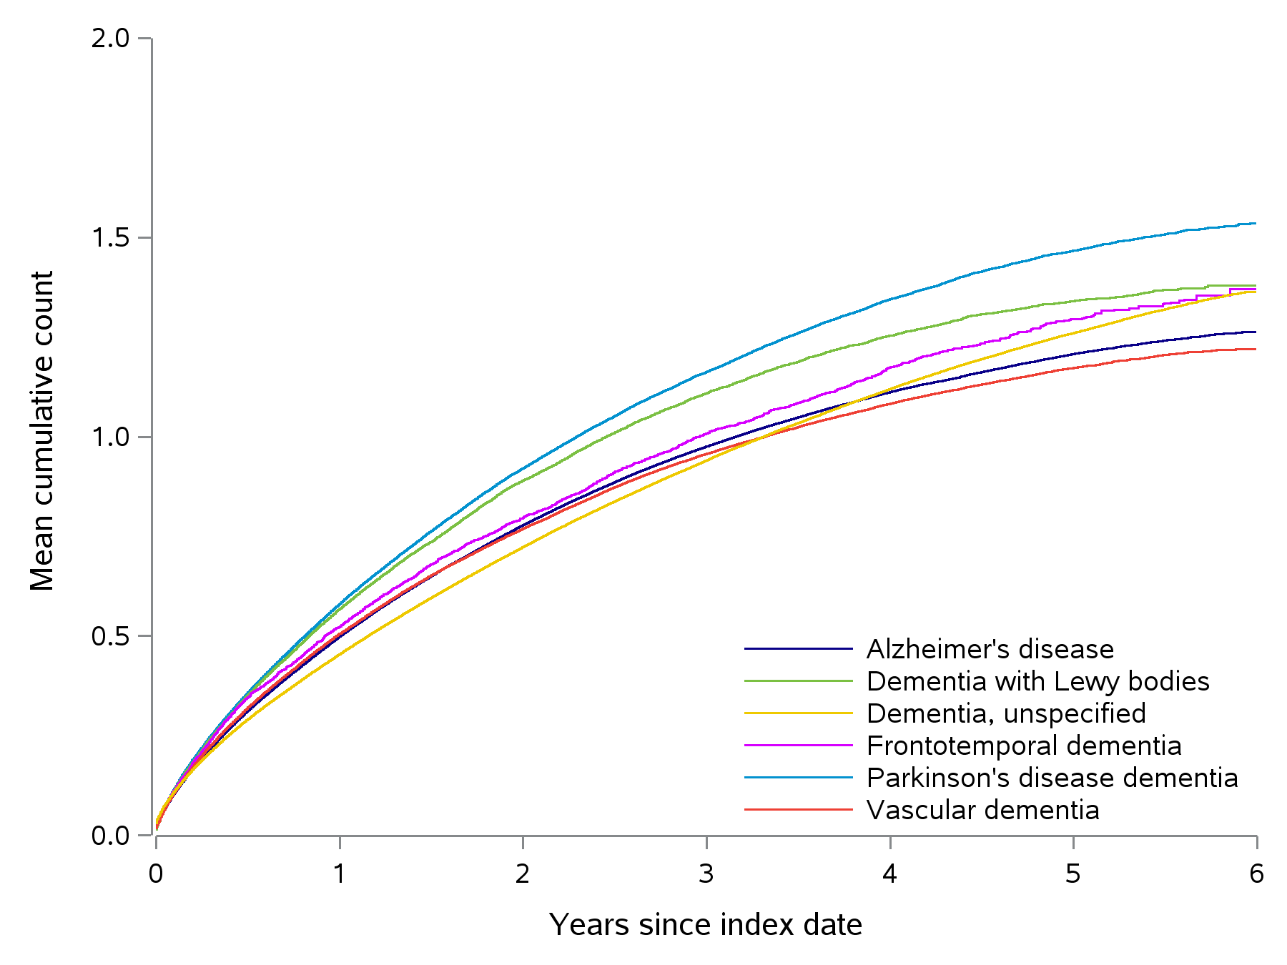
CI = confidence interval.
Alzheimer's disease: 6-year mean cumulative count = 1.3 (95% CI, 1.2-1.3)
Dementia with Lewy bodies: 6-year mean cumulative count = 1.4 (95% CI, 1.3-1.4)
Dementia, unspecified: 6-year mean cumulative count = 1.4 (95% CI, 1.4-1.4)
Frontotemporal dementia: 6-year mean cumulative count = 1.4 (95% CI, 1.3-1.5)
Parkinson's disease dementia: 6-year mean cumulative count = 1.5 (95% CI, 1.5-1.6)
Vascular dementia: 6-year mean cumulative count = 1.2 (95% CI, 1.2-1.2)

- Aspiration Pneumonia
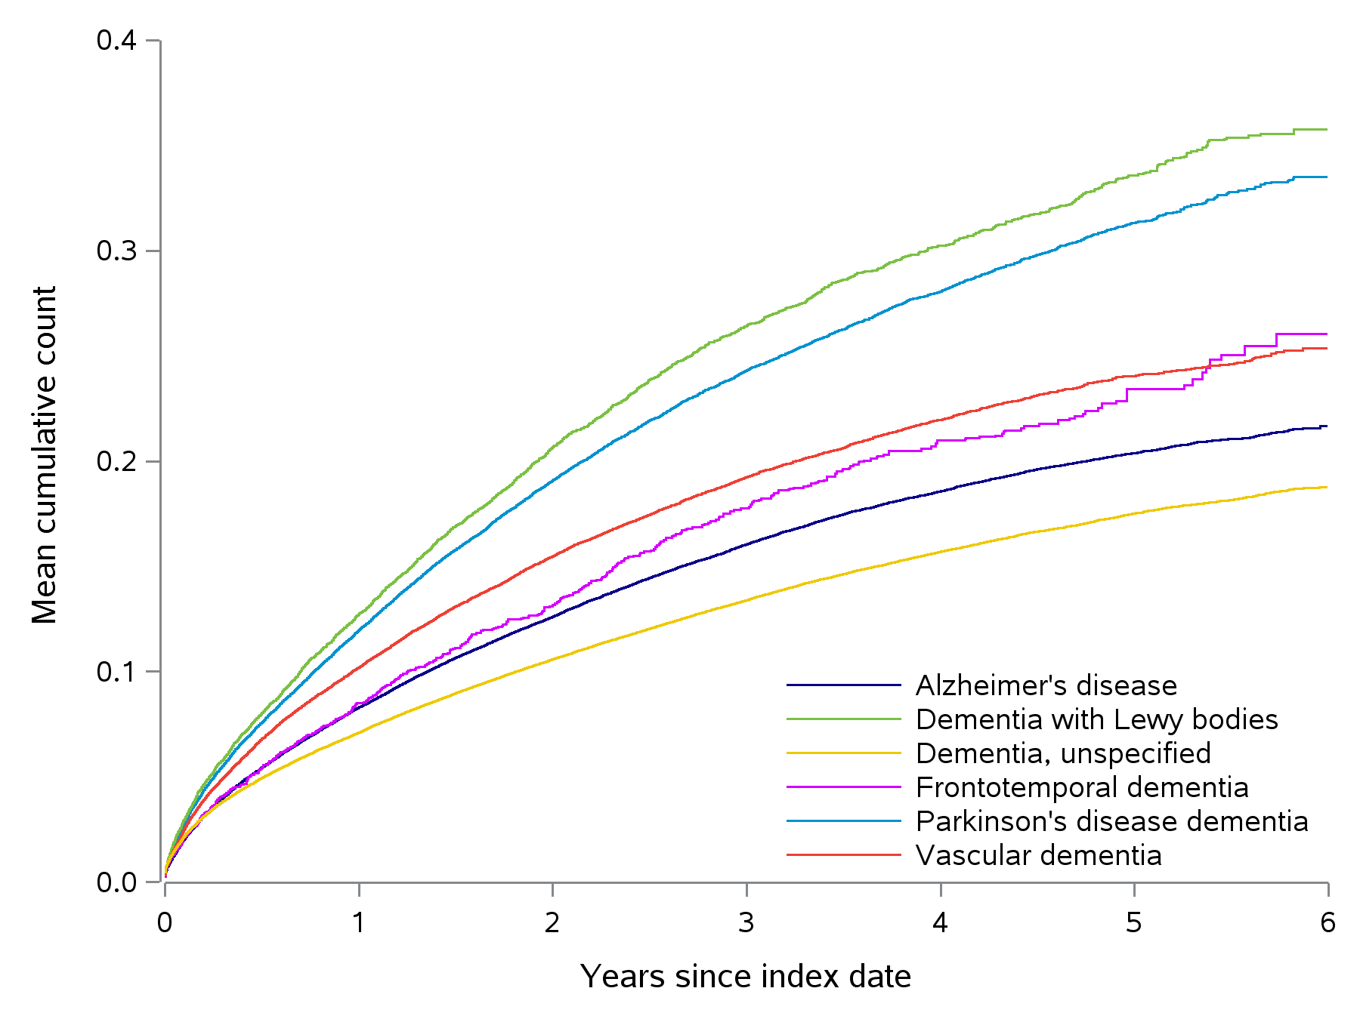

CI = confidence interval.
Alzheimer's disease: 6-year mean cumulative count = 0.2 (95% CI, 0.2-0.2)
Dementia with Lewy bodies: 6-year mean cumulative count = 0.4 (95% CI, 0.3-0.4)
Dementia, unspecified: 6-year mean cumulative count = 0.2 (95% CI, 0.2-0.2)
Frontotemporal dementia: 6-year mean cumulative count = 0.3 (95% CI, 0.2-0.3)
Parkinson's disease dementia: 6-year mean cumulative count = 0.3 (95% CI, 0.3-0.3)
Vascular dementia: 6-year mean cumulative count = 0.3 (95% CI, 0.2-0.3)

- Serious Hospitalized Infections
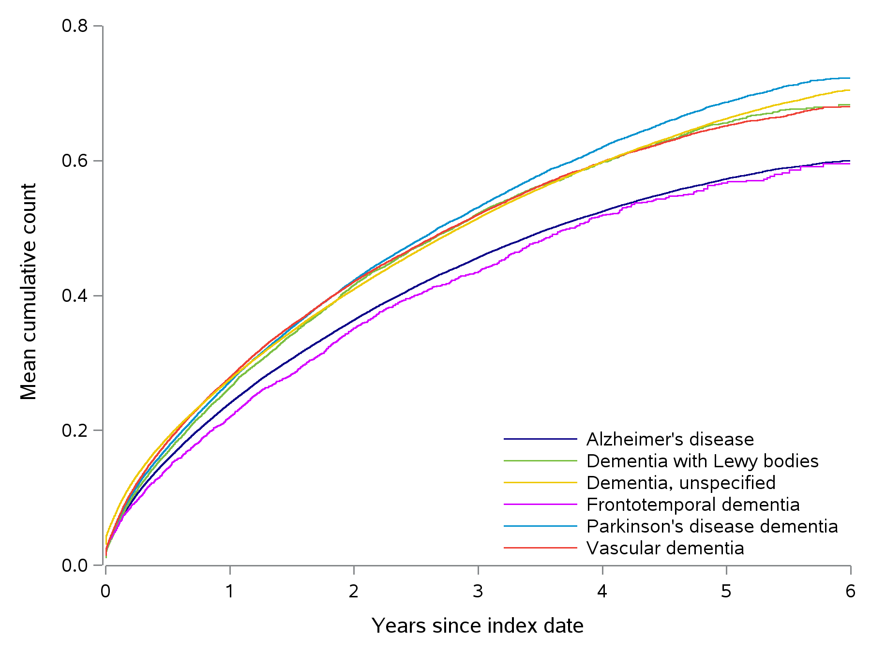
CI = confidence interval.
Alzheimer's disease: 6-year mean cumulative count = 0.6 (95% CI, 0.6-0.6)
Dementia with Lewy bodies: 6-year mean cumulative count = 0.7 (95% CI, 0.7-0.7)
Dementia, unspecified: 6-year mean cumulative count = 0.7 (95% CI, 0.7-0.7)
Frontotemporal dementia: 6-year mean cumulative count = 0.6 (95% CI, 0.6-0.6)
Parkinson's disease dementia: 6-year mean cumulative count = 0.7 (95% CI, 0.7-0.7)
Vascular dementia: 6-year mean cumulative count = 0.7 (95% CI, 0.7-0.7)

- Parenteral Anti-infective Treatments
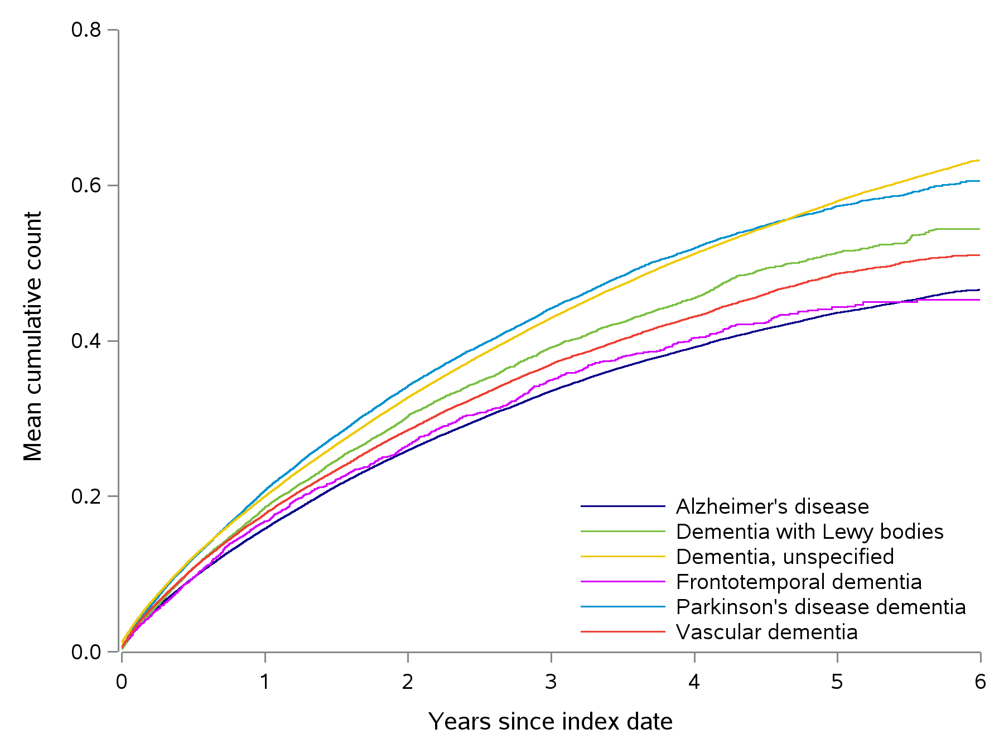
CI = confidence interval.
Alzheimer's disease: 6-year mean cumulative count = 0.5 (95% CI, 0.5-0.5)
Dementia with Lewy bodies: 6-year mean cumulative count = 0.5 (95% CI, 0.5-0.6)
Dementia, unspecified: 6-year mean cumulative count = 0.6 (95% CI, 0.6-0.6)
Frontotemporal dementia: 6-year mean cumulative count = 0.5 (95% CI, 0.4-0.5)
Parkinson's disease dementia: 6-year mean cumulative count = 0.6 (95% CI, 0.6-0.6)
Vascular dementia: 6-year mean cumulative count = 0.5 (95% CI, 0.5-0.5)

- Skilled Nursing Facility Stays
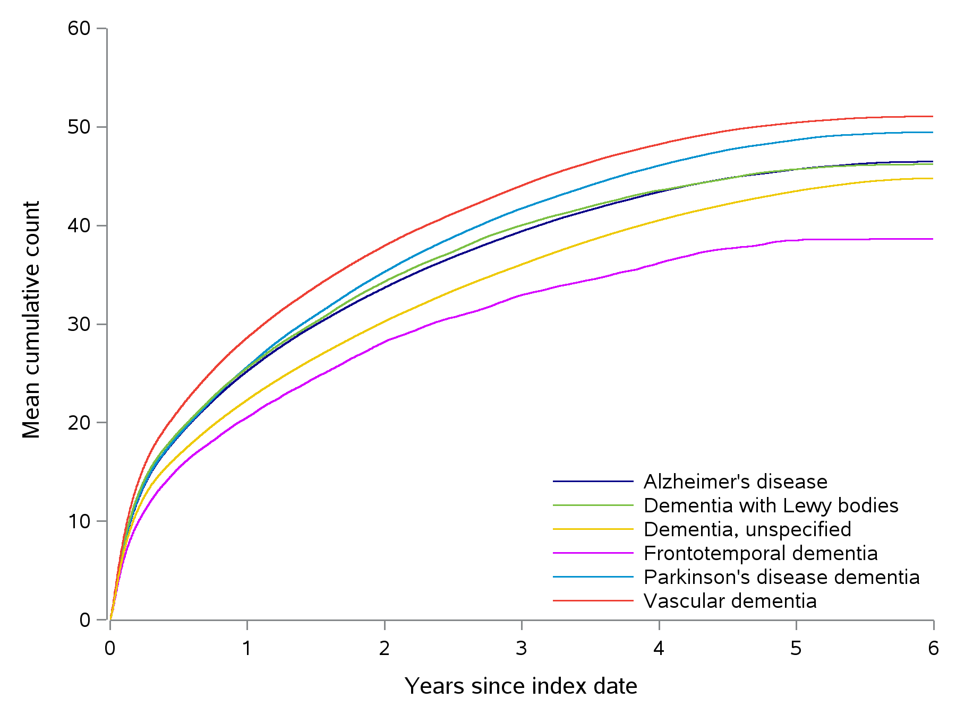
CI = confidence interval.
Alzheimer's disease: 6-year mean cumulative count = 46.5 (95% CI, 45.9-47.0)
Dementia with Lewy bodies: 6-year mean cumulative count = 46.2 (95% CI, 44.5-47.6)
Dementia, unspecified: 6-year mean cumulative count = 44.8 (95% CI, 44.3-45.1)
Frontotemporal dementia: 6-year mean cumulative count = 38.7 (95% CI, 35.8-42.4)
Parkinson's disease dementia: 6-year mean cumulative count = 49.5 (95% CI, 48.3-50.5)
Vascular dementia: 6-year mean cumulative count = 51.1 (95% CI, 50.3-52.2)

- Days of Inpatient Hospital Stays
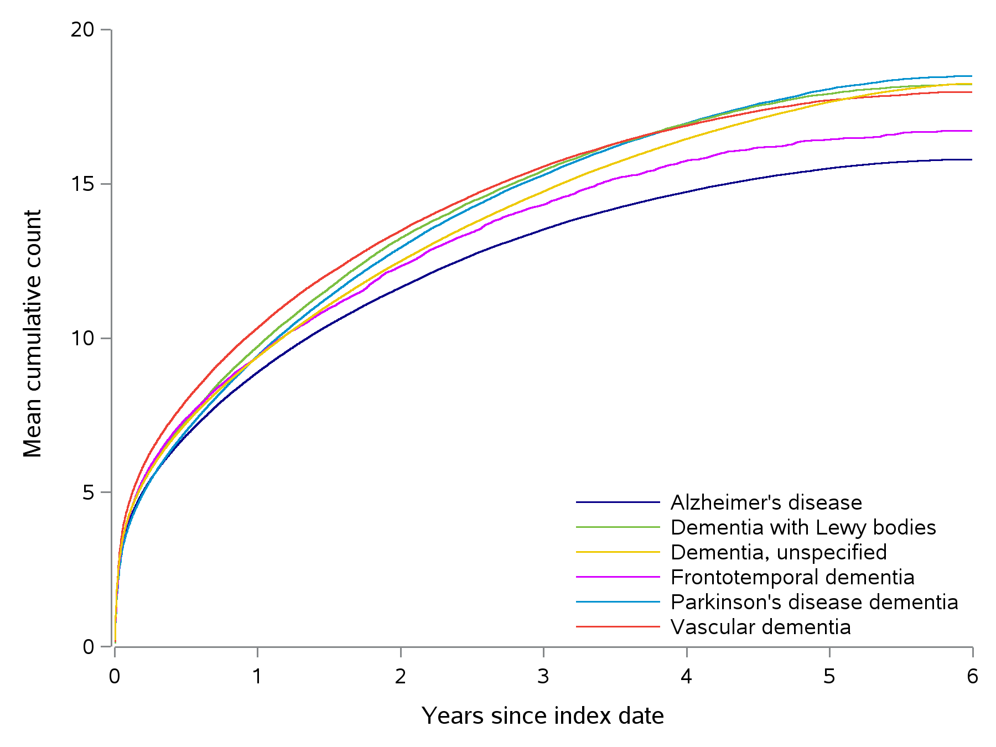
CI = confidence interval.
Alzheimer's disease: 6-year mean cumulative count = 15.8 (95% CI, 15.7-16.0)
Dementia with Lewy bodies: 6-year mean cumulative count = 18.2 (95% CI, 17.8-18.7)
Dementia, unspecified: 6-year mean cumulative count = 18.2 (95% CI, 18.1-18.4)
Frontotemporal dementia: 6-year mean cumulative count = 16.7 (95% CI, 16.0-17.5)
Parkinson's disease dementia: 6-year mean cumulative count = 18.5 (95% CI, 18.2-18.8)
Vascular dementia: 6-year mean cumulative count = 18.0 (95% CI, 17.8-18.2)

- Home Health Care Episodes
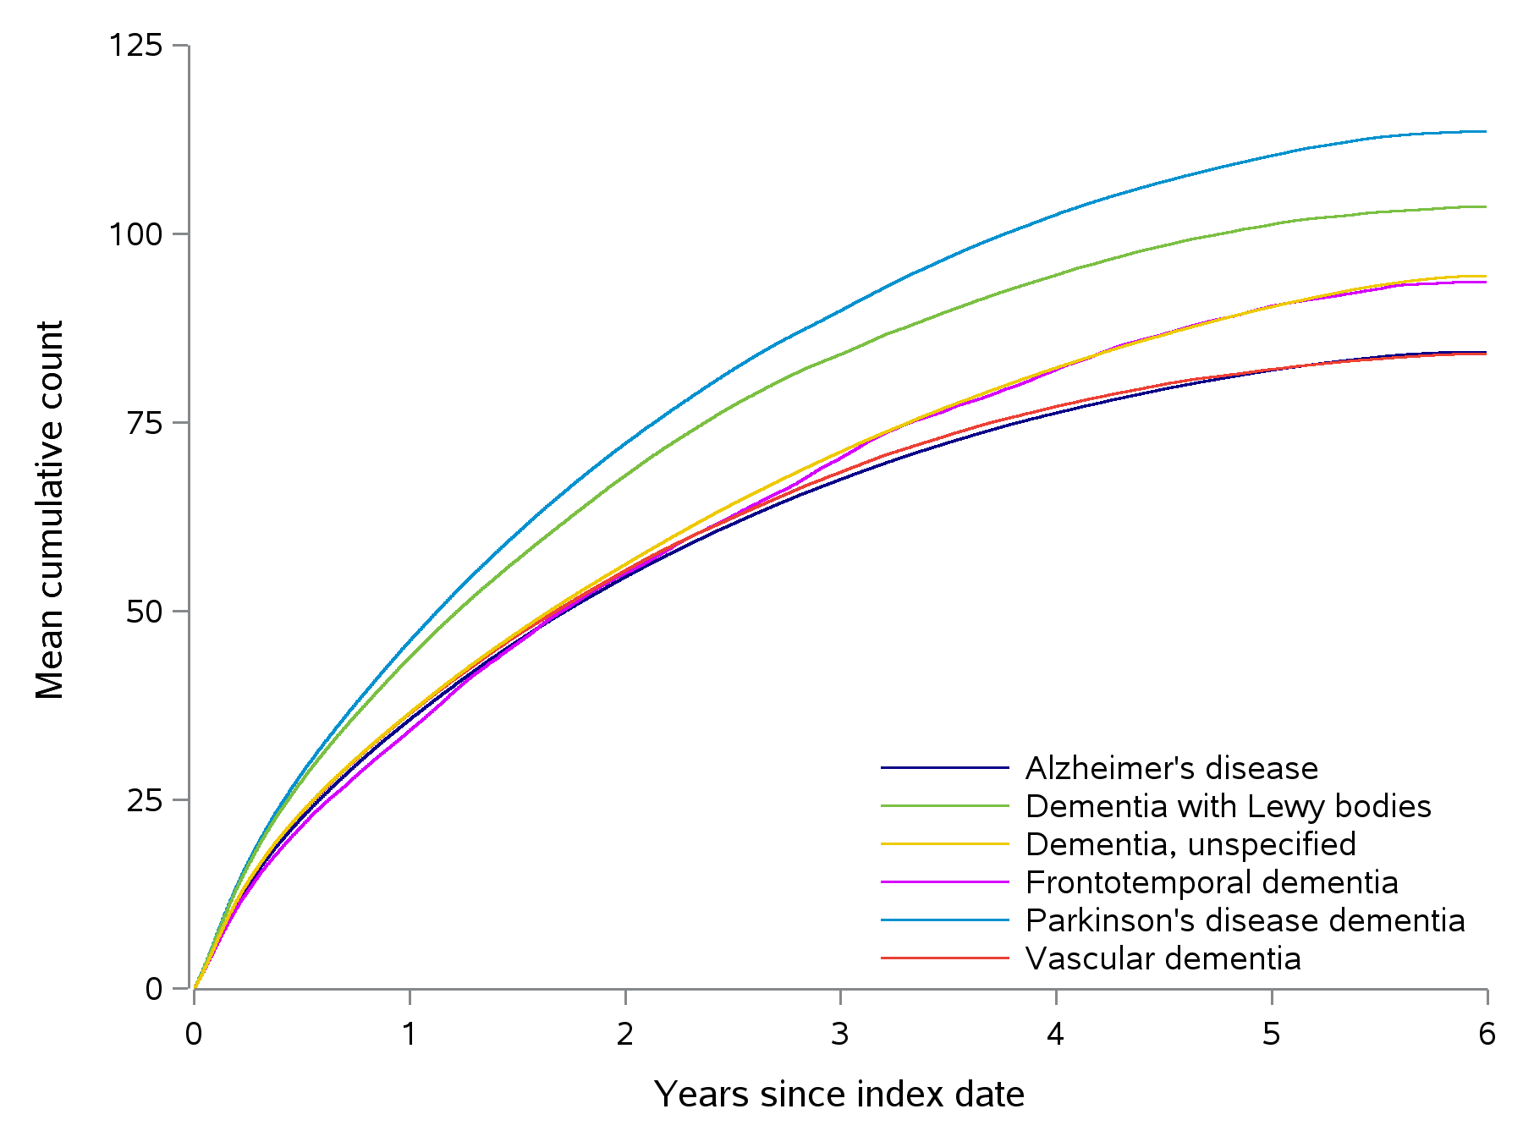
CI = confidence interval.
Alzheimer's disease: 6-year mean cumulative count = 84.4 (95% CI, 83.2-85.6)
Dementia with Lewy bodies: 6-year mean cumulative count = 103.6 (95% CI, 100.2-108.0)
Dementia, unspecified: 6-year mean cumulative count = 94.4 (95% CI, 93.5-95.4)
Frontotemporal dementia: 6-year mean cumulative count = 93.6 (95% CI, 85.6-102.5)
Parkinson's disease dementia: 6-year mean cumulative count = 113.5 (95% CI, 111.2-115.9)
Vascular dementia: 6-year mean cumulative count = 84.1 (95% CI, 82.3-86.0)

- Emergency Department Visits
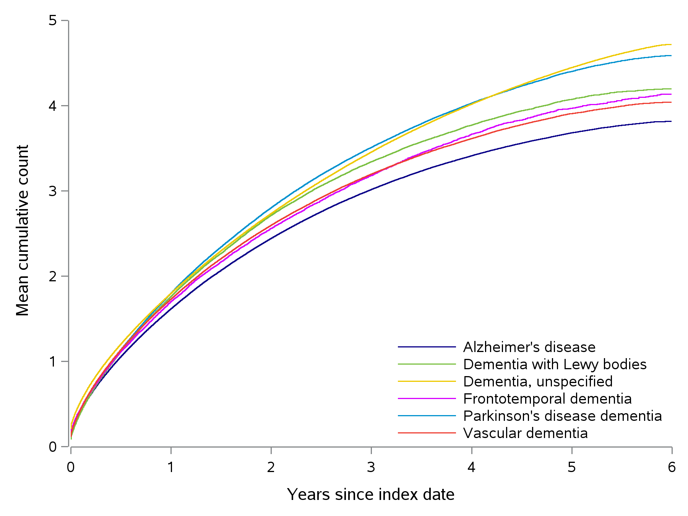
CI = confidence interval.
Alzheimer's disease: 6-year mean cumulative count = 3.8 (95% CI, 3.8-3.8)
Dementia with Lewy bodies: 6-year mean cumulative count = 4.2 (95% CI, 4.1-4.3)
Dementia, unspecified: 6-year mean cumulative count = 4.7 (95% CI, 4.7-4.7)
Frontotemporal dementia: 6-year mean cumulative count = 4.1 (95% CI, 3.9-4.4)
Parkinson's disease dementia: 6-year mean cumulative count = 4.6 (95% CI, 4.5-4.6)
Vascular dementia: 6-year mean cumulative count = 4.0 (95% CI, 4.0-4.1)

- Characteristics of Initial Antipsychotic Treatment in Patients With Dementia-Related Psychosis by Type of Dementia
Comedication | AD  N = 150,375 | PDD  N = 49,004 | DLB  N = 15,263 | FTD  N = 4,382 | VD  N = 60,132 | Unspecified dementia  N = 269,291
Time to treatment initiation with any antipsychotic after index date
Mean (SD), days | 198 (317.6) | 218 (329.7) | 181 (293.8) | 178 (315.1) | 180 (301.4) | 278 (395.7)
Type of antipsychotic initially prescribed, n (%)
Clozapine | 18 (0.0) | 40 (0.3) | 16 (0.3) | <11 | <11 | <11
Quetiapine | 24,219 (49.0) | 9,389 (63.3) | 3,413 (65.4) | 834 (52.5) | 8,667 (46.9) | 29,373 (46.3)
Olanzapine | 5,664 (11.5) | 990 (6.7) | 397 (7.6) | 173 (10.9) | 2,275 (12.3) | 6,880 (10.9)
Risperidone | 12,784 (25.9) | 2,095 (14.1) | 746 (14.3) | 367 (23.1) | 4,773 (25.8) | 15,838 (25.0)
Aripiprazole | 1,513 (3.1) | 366 (2.5) | 118 (2.3) | 59 (3.7) | 663 (3.6) | 2,569 (4.1)
Brexpiprazole | 21 (0.0) | <11 | <11 | 0 (0.0) | <11 | 29 (0.0)
Pimavanserin | 227 (0.5) | 893 (6.0) | 247 (4.7) | <11 | 62 (0.3) | 52 (0.1)
Other atypical antipsychotic | 261 (0.5) | 54 (0.4) | 16 (0.3) | 11 (0.7) | 110 (0.6) | 285 (0.4)
Haloperidol | 4,236 (8.6) | 798 (5.4) | 257 (4.9) | 122 (7.7) | 1,643 (8.9) | 5,759 (9.1)
Other conventional antipsychotic | 1,221 (2.5) | 342 (2.3) | 74 (1.4) | 32 (2.0) | 523 (2.8) | 3,344 (5.3)
Strength, mean (SD), mg
Clozapine | 33 (22.3) | 28 (13.3) | 27 (6.3) | NR | 36 (22.4) | 47 (38.4)
Quetiapine | 34 (28.7) | 32 (23.9) | 32 (25.6) | 34 (28.3) | 35 (31.1) | 33 (25.7)
Olanzapine | 4 (2.7) | 4 (2.8) | 4 (2.5) | 5 (3.4) | 4 (2.7) | 4 (2.8)
Risperidone | 0 (0.4) | 0 (0.4) | 0 (0.4) | 1 (0.4) | 1 (0.4) | 0 (0.4)
Aripiprazole | 4 (3.7) | 4 (3.1) | 4 (3.0) | 4 (2.6) | 5 (3.4) | 4 (3.5)
Brexpiprazole | 1 (0.5) | 1 (0.6) | NR | NR | 1 (0.6) | 1 (0.4)
Pimavanserin | 19 (5.1) | 18 (4.6) | 18 (4.1) | 17 (0.0) | 19 (6.0) | 19 (5.1)
Other atypical antipsychotic | 27 (18.8) | 28 (24.2) | 15 (13.1) | 33 (22.2) | 27 (18.9) | 25 (17.6)
Haloperidol | 1 (1.4) | 1 (1.5) | 2 (1.6) | 2 (1.5) | 1 (1.3) | 1 (1.4)
Other conventional antipsychotic | 10 (11.7) | 10 (5.1) | 10 (5.3) | 13 (11.5) | 11 (11.8) | 10 (6.5)
AD = Alzheimer’s disease; DLB = dementia with Lewy bodies; FTD = frontotemporal dementia; NR = not reported; SD = standard deviation; PDD = Parkinson’s disease dementia; VD = vascular dementia.
- Antipsychotic Treatment Status Over Follow-up in Patients With Dementia-Related Psychosis, by Type of Dementia
- Alzheimer’s Disease
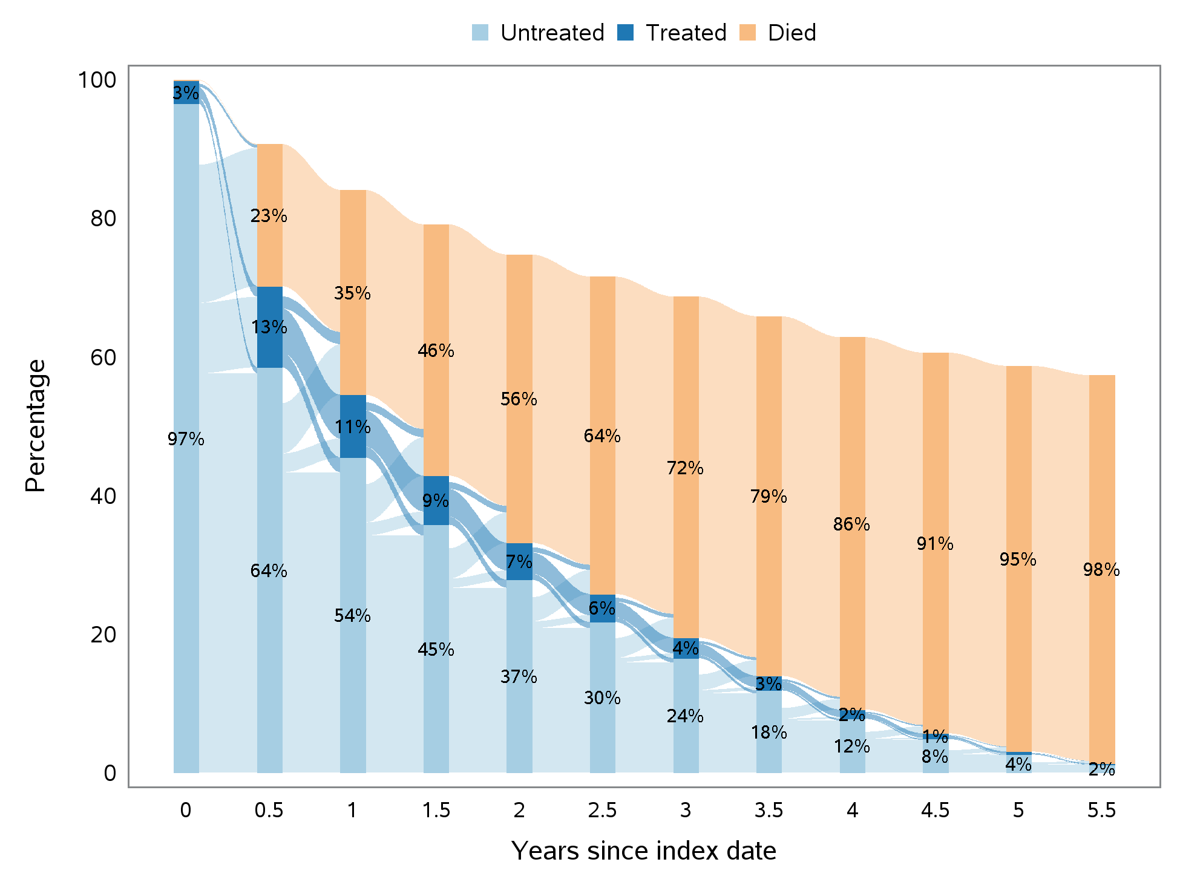

- Parkinson’s Disease Dementia
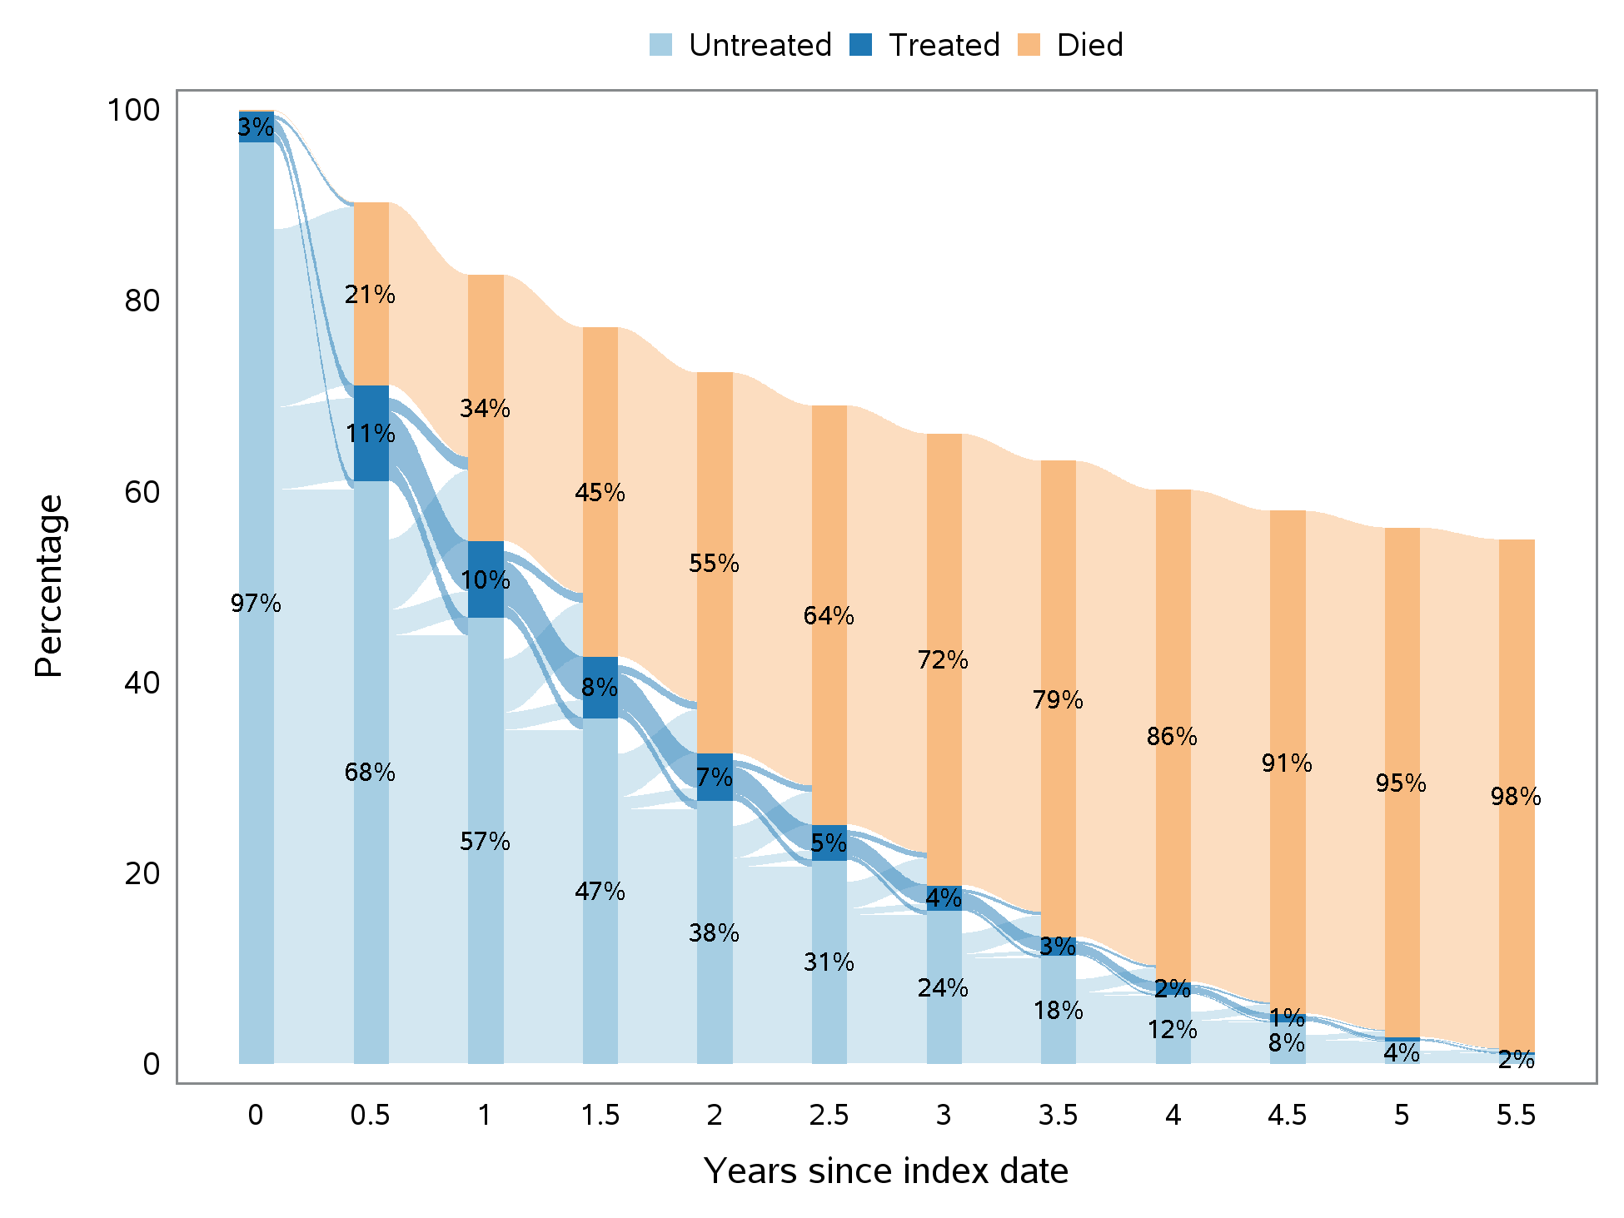

- Dementia With Lewy Bodies
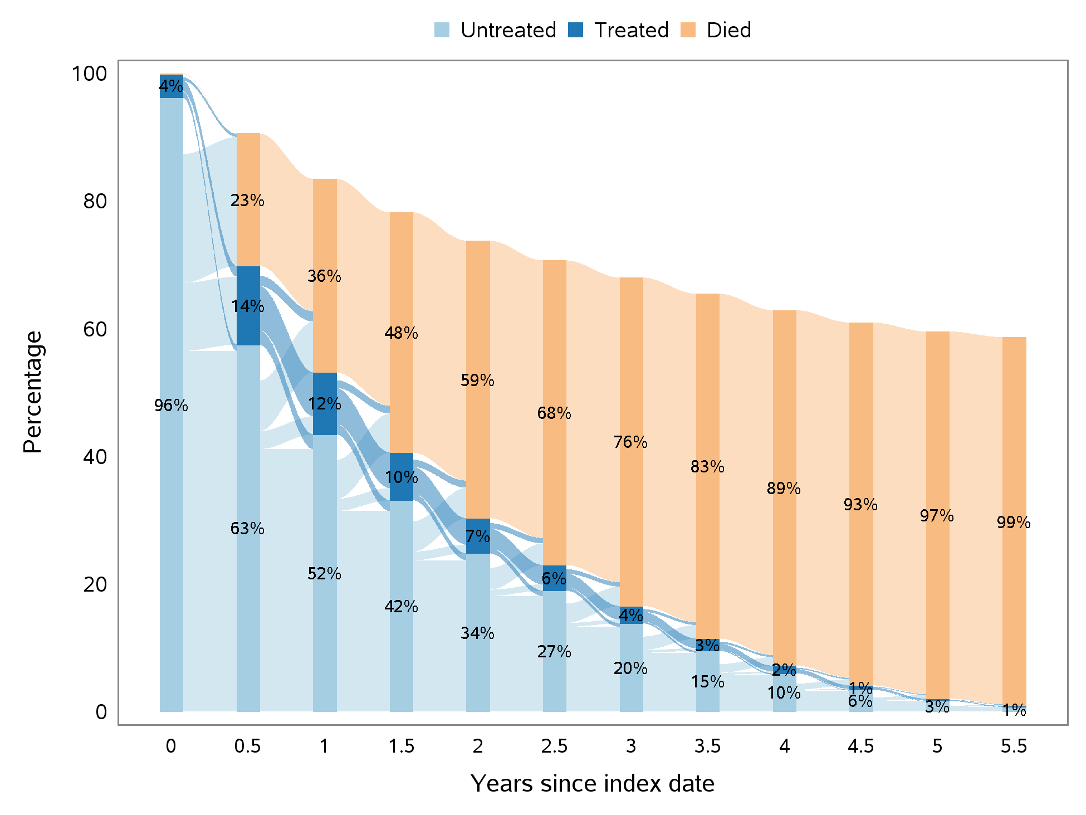

- Frontotemporal Dementia
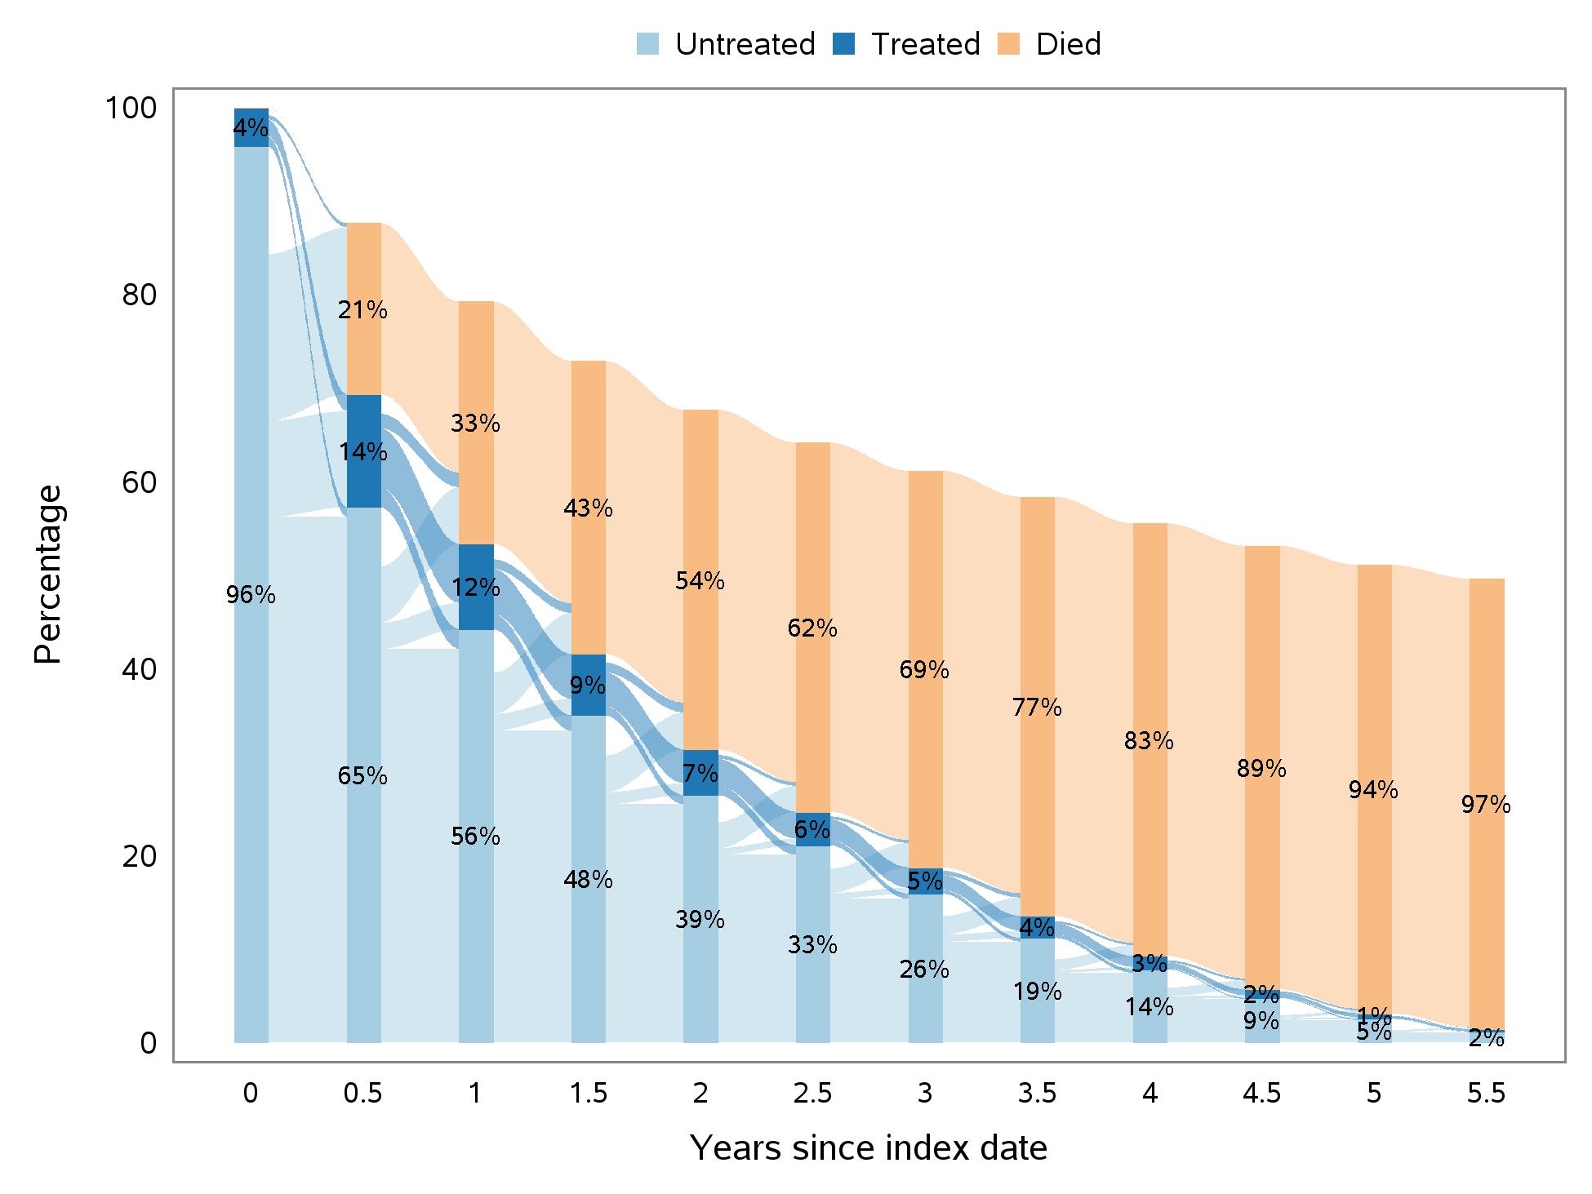

- Vascular Dementia
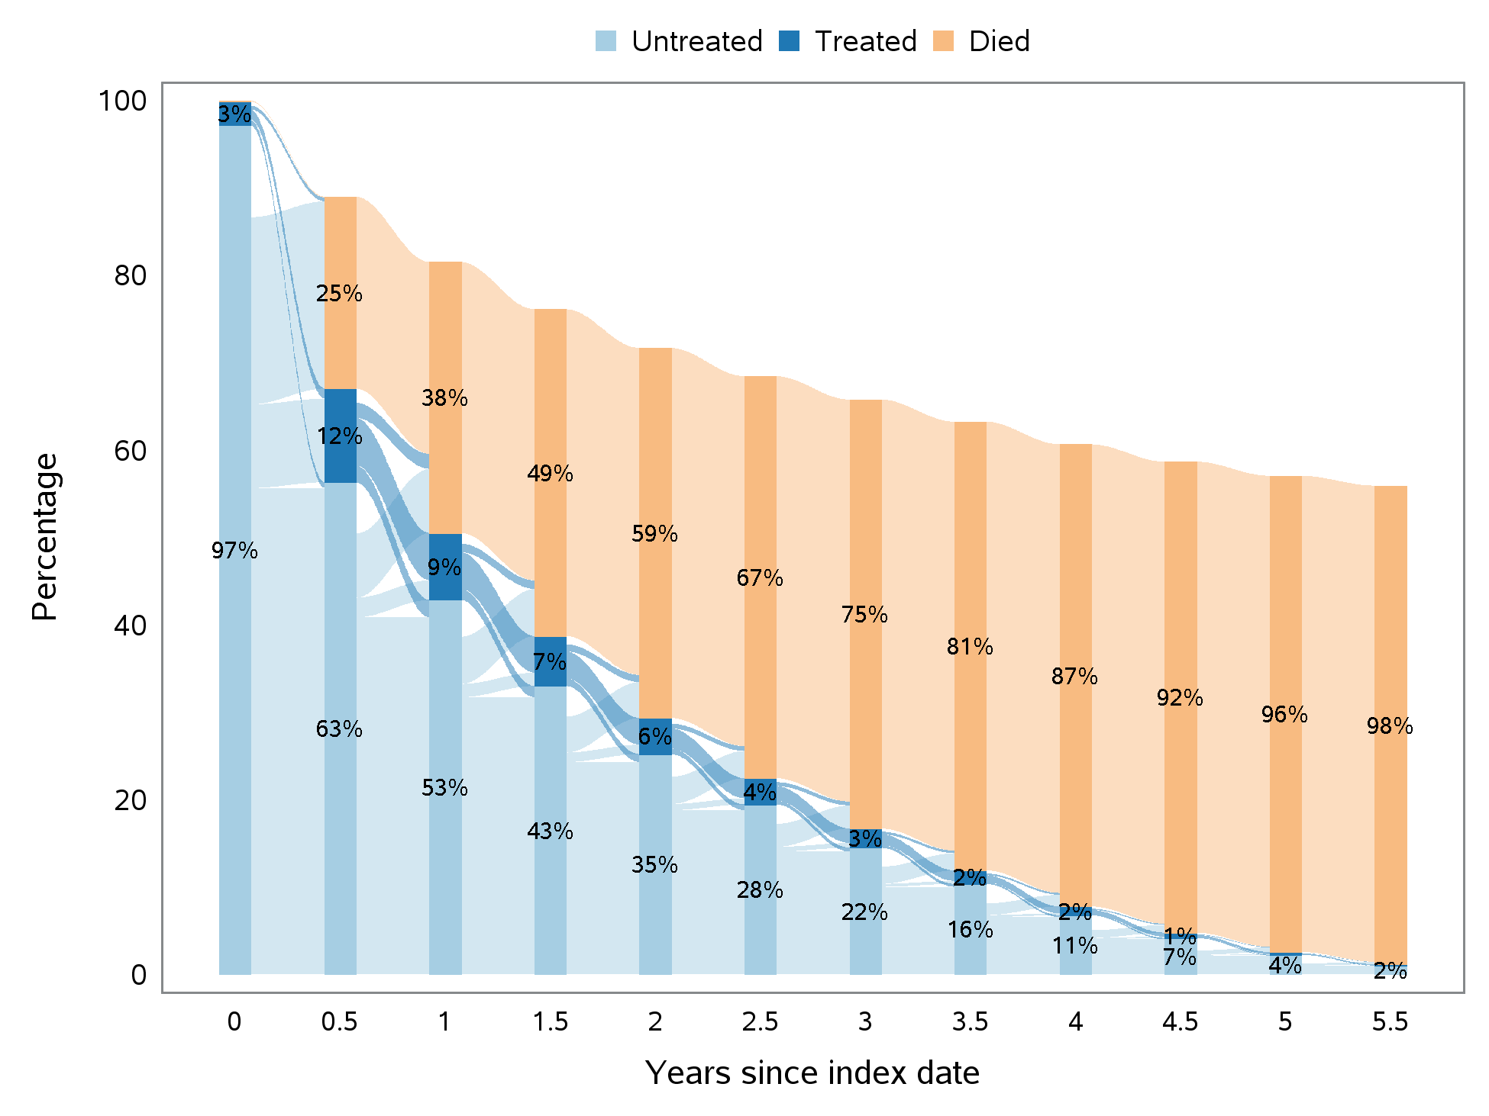

- Dementia, Unspecified
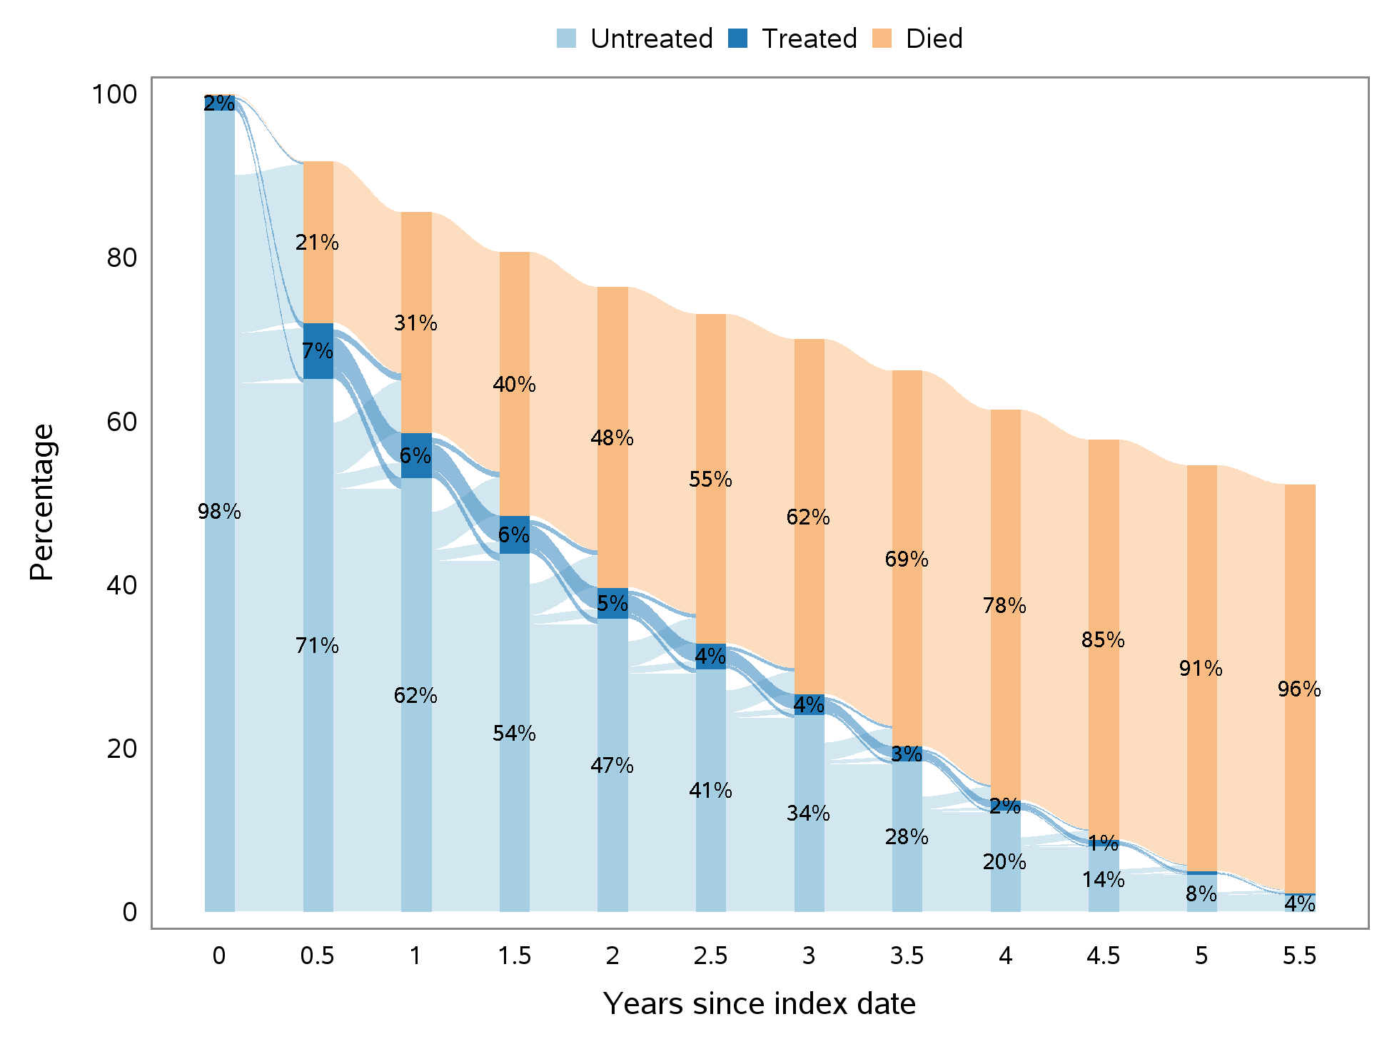

References
1. Xu B, Boero IJ, Hwang L, et al. Aspiration pneumonia after concurrent chemoradiotherapy for head and neck cancer. Cancer. 2015 Apr 15;121(8):1303-11.
2. McCarthy EP, Iezzoni LI, Davis RB, et al. Does clinical evidence support ICD-9-CM diagnosis coding of complications? Med Care. 2000 Aug;38(8):868-76.
3. Schneeweiss S, Robicsek A, Scranton R, Zuckerman D, Solomon DH. Veteran's affairs hospital discharge databases coded serious bacterial infections accurately. J Clin Epidemiol. 2007 Apr;60(4):397-409.
4. Wiese AD, Griffin MR, Stein CM, et al. Validation of discharge diagnosis codes to identify serious infections among middle age and older adults. BMJ open. 2018;8(6):e020857-e.

ICD-9-CM = International Classification of Diseases, 9th Revision, Clinical Modification.
ICD-10-CM = International Classification of Diseases, 10th Revision, Clinical Modification.
ICD-10-PCS = International Classification of Diseases, Tenth Revision, Procedure Coding System.
CPT = Current Procedural Terminology.

