Authors Biography
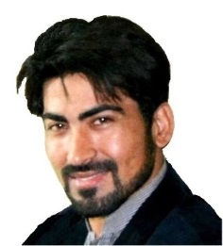
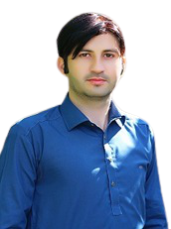
Khalid Zaman received his MS and BS Degrees in Computer Science from The University of Agriculture Peshawar (2019) and Khyber Pakhtunkhwa Agriculture University Peshawar-Pakistan (2015), respectively. He worked at The University of Agriculture as a student researcher from 2016-2019. During MS Degree he has completed research in Computer Networks, especially in Routing Protocols in Wireless Sensor Networks and Drone Networks. Now, his is currently Ph.D Seiner Scholar in Chang’an University xi'an, China. He has published one paper in MPDI Journal and many paper submitted to different journals. He was Senior Scholar of ORIC (Office of Research and Innovation Centre) for one and a half year at Iqra National University (INU) Peshawar, Pakistan. Six Months Job in Department of Economics, University of Wah, Quaid Avenue, Wah Cantt, Pakistan. Khalid Zaman’s research specialties/interests include Wireless Networks, Sensor Networks, Cloud Computing, Digital Signal Processing, Image Processing, Radio Propagation Models, Deep Learning and Unmanned Aerial Networks.
Altaf Hussain received his BS and MS degrees in Computer Science from University of Peshawar, Pakistan (2013) and The University of Agriculture Peshawar, Pakistan (2017) respectively. He worked at The University of Agriculture as a Scholar Research Scholar from 2017-2019. His recent approach is PhD in Computer Science & Technology. He has served as a Lecturer in Computer Science Department in Govt Degree College Lal Qilla Dir L, KPK Pakistan from 2020-2021. He worked as a Research Assistant with the Department of Accounting & Information Systems, College of Business and Economics, Qatar University, Doha, Qatar. His research interest includes Deep Learning, Wireless Networks, Sensor Networks, Radio Propagation Models, and Unmanned Aerial Vehicular Ad-hoc Networks (UAVANETs).
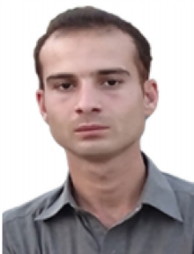
Tariq Hussain received the M.S. degree with the Institute of computer sciences and information technology the agriculture university Pesha-war in 2019. and B.S. degree from University of Malakand Pakistan, in 2015, Now he is a Doctoral student at School of Computer Science and Information Engineering, Zhejiang Gongshang University Hang-zhou China. His research interests are Big Data, Internet of Thangs and Cloud

