Supplementary data
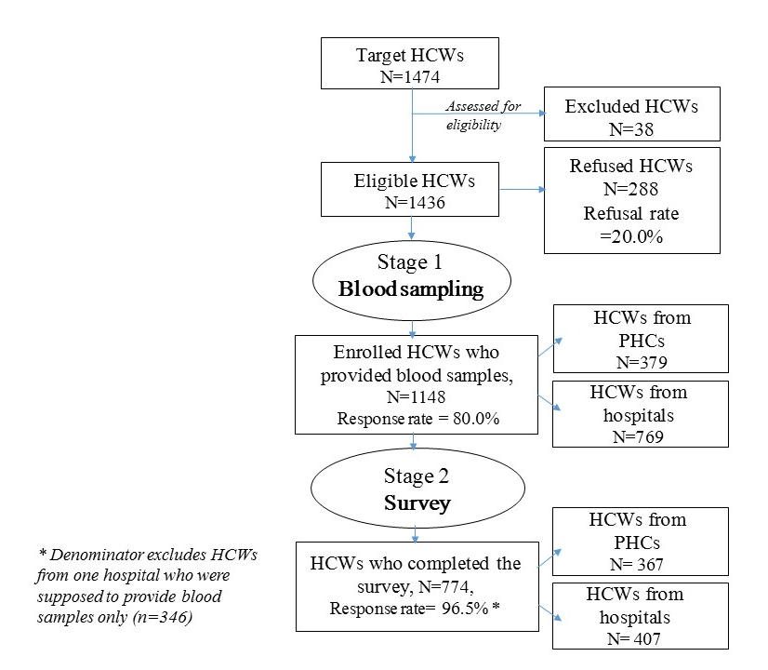
Figure 1. Flow-chart of the study participant’s enrollment process

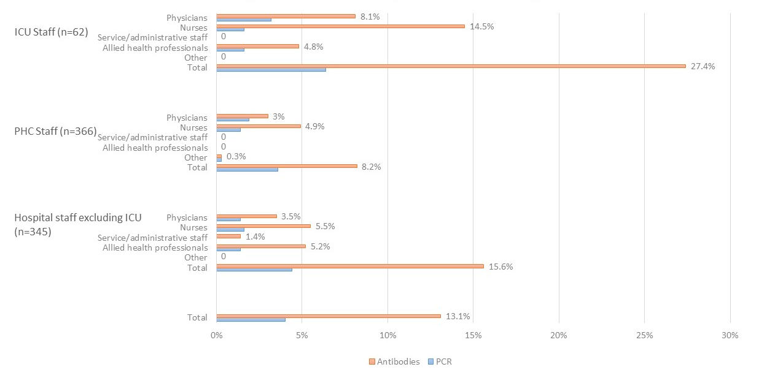
Figure 2. The prevalence of SARS COV-2 antibodies and previously PCR confirmed COVID-19 diagnosis among the healthcare workers by their work location and job function

