Flexible parametric methods for calculating life expectancy in small populations
Supplementary Material

Box S1: Formula for calculating life expectancy using flexible parametric methods
The hazard function, h(t), is defined as the rate of failure between t and Δt (i.e. a miniscule time period), conditional on the individual not experiencing the event of interest by time t. The cumulative hazard function, H(t), is the integral of the hazard function, h(t), over the entire distribution of t (i.e. time 0 and time t). The baseline cumulative hazard function is given below.

$$H_{0}\left(t\right)=\int_{u=0}^{t}{h_{0}\left(u\right)du}$$

This can be modelled using a parametric form (details below), and the cumulative hazard function is modified to allow for covariate effects using the formula below:

$$H_{i}\left(t\right)=H_{0}\left(t\right)\exp\left(x_{i}β\right)$$

Where H₀(t) represents the cumulative hazard function at baseline, $x_{i}β$ represents the linear predictor, with $β$ representing the log hazard ratios and $x_{i}$ the covariate values for the i^{th} individual.

The survival function, S(t), is the probability that an individual will survive beyond time t, Pr(T>t), and has a relationship with the cumulative hazard function, as below:

$$S\left(t | x_{i}\right)=exp⁡(-H_{0}\left(t\right)\exp\left(x_{i}β\right))=exp⁡(-(H_{i}\left(t\right))$$

For flexible parametric methods, the (log) baseline cumulative hazard function is extended using restricted cubic splines to capture the shape of the hazard functions more flexibly (233-235). For example, the whole cumulative hazard function using restricted cubic splines with six knots (i.e. 4df) is defined by:

$$\ln\left[H\left(t | x_{i}\right)\right]=γ_{0}+γ_{1}{z_{1i}+γ_{2}z_{2i}+γ_{3}z_{3i}+γ_{4}z_{4i} {+ x}_{i}}β$$

Where $γ_{0}+γ_{1}{z_{1i}+γ_{2}z_{2i}+γ_{3}z_{3i}}$ $+ γ_{4}z_{4i}$ represents the log cumulative baseline hazard, $β$represents the log hazard ratio, $x_{i}$ represents the covariate values for the i^{th} individual, and z represents the spline basis function for ln(t) for the i^{th} individual (see Royston & Parmar 2002 for mathematical details (227)).

Additional years expected to live from a given age, a, to a maximum age, w, can be estimated fitting a flexible parametric model using age as the time scale and integrating under the survival function curve to age w, scaled by the survival function (i.e. proportion live) at age a using the formula below.

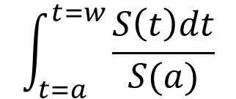
Box S2: Stata code for calculating life expectancy
* Fully stratified model
* this is the filename that has split by intellectual disability status and been stset
* _t=0 represents 10 years old
use "filename", clear

* run flexible parametric models
* ID = intellectual disability status; T2DM = T2DM status
stpm2 if ID==0&T2DM==1&_t>=10, knots(25 50 75) bknots(5 100) scale(h) knscale(centile)
estimates store ID0T2DM1
stpm2 if ID==0&T2DM==0&_t>=10, knots(25 50 75) bknots(5 100) scale(h) knscale(centile)
estimates store ID0T2DM0
stpm2 if LD==1&T2DM==1&_t>=10, knots(25 50 75) bknots(5 100) scale(h) knscale(centile)
estimates store ID1T2DM1
stpm2 if ID==1&T2DM==0&_t>=10, knots(25 50 75) bknots(5 100) scale(h) knscale(centile)
estimates store ID1T2DM0

quietly {
* note – this is for ages 40–99 years old
forvalues age=30/89 {
capture drop agename
capture drop _LE`age'*
gen age`age'=`age' in 1
estimates restore ID0T2DM1
* the predictions can be captured here to allow for the rare occasion where confidence intervals cannot be calculated (shown for this sub-sample only)
capture predictnl _LE_ID0t2dm1`age'=log(predict(rmst tmin(`age') tmax(100)) / predict(surv timevar(age`age'))), ci(_LE_ID0t2dm1_lci`age' _LE_ID0t2dm1_uci`age')
if `c(rc)'==498 {
capture predictnl _LE_ID0t2dm1`age'=predict(rmst tmin(`age') tmax(100)) / predict(surv timevar(age`age'))
gen _LE_ID0t2dm1_lci`age'=.
gen _LE_ID0t2dm1_uci`age'=.
}
else {
replace _LE_ID0t2dm1`age'=exp(_LE_ID0t2dm1`age')
replace _LE_ID0t2dm1_lci`age'=exp(_LE_ID0t2dm1_lci`age')
replace _LE_ID0t2dm1_uci`age'=exp(_LE_ID0t2dm1_uci`age')
}
capture predictnl _LE_ID0t2dm0`age'=log(predict(rmst tmin(`age') tmax(100)) /
predict(surv timevar(age`age'))), ci(_LE_ID0t2dm0_lci`age' _LE_ID0t2dm0_uci`age')
replace _LE_ID0t2dm0`age'=exp(_LE_ID0t2dm0`age')
replace _LE_ID0t2dm0_lci`age'=exp(_LE_ID0t2dm0_lci`age')
replace _LE_ID0t2dm0_uci`age'=exp(_LE_ID0t2dm0_uci`age')
estimates restore ID1T2DM1
capture predictnl _LE_ID1t2dm1`age'=log(predict(rmst tmin(`age') tmax(100)) /
predict(surv timevar(age`age'))), ci(_LE_ID1t2dm1_lci`age' _LE_ID1t2dm1_uci`age')
replace _LE_ID1t2dm1`age'=exp(_LE_ID1t2dm1`age')
replace _LE_ID1t2dm1_lci`age'=exp(_LE_ID1t2dm1_lci`age')
replace _LE_ID1t2dm1_uci`age'=exp(_LE_ID1t2dm1_uci`age')
capture predictnl _LE_ID1t2dm0`age'=log(predict(rmst tmin(`age') tmax(100)) /
predict(surv timevar(age`age'))), ci(_LE_ID1t2dm0_lci`age' _LE_ID1t2dm0_uci`age')
replace _LE_ID1t2dm0`age'=exp(_LE_ID1t2dm0`age')
replace _LE_ID1t2dm0_lci`age'=exp(_LE_ID1t2dm0_lci`age')
replace _LE_ID1t2dm0_uci`age'=exp(_LE_ID1t2dm0_uci`age')
}
}

Table S1 RECORDª checklist (Reporting of studies conducted using observational routinely-collected data; https://www.record-statement.org/checklist.php)
 | Item No. | STROBE items | Location in manuscript where items are reported |  | RECORD items | Location in manuscript where items are reported
Title and Abstract
 | 1 | (a) Indicate the study’s design with a commonly used term in the title or the abstract | CPRD mentioned in the abstract | p.2 | RECORD 1.1: The type of data used should be specified in the title or abstract. When possible, the name of the databases used should be included. | CPRD mentioned in the abstract | p.2
 | 1 | (b) Provide in the abstract an informative and balanced summary of what was done and what was found | See abstract | p.2 | RECORD 1.2: If applicable, the geographic region and timeframe within which the study took place should be reported in the title or abstract. | England and one-year period (2012) both mentioned in the abstract. | p.2
 |  |  |  |  | RECORD 1.3: If linkage between databases was conducted for the study, this should be clearly stated in the title or abstract | Linked mortality data referred to in the abstract. | p.2
Background rationale | 2 | Explain the scientific background and rationale for the investigation being reported | See background | p.4
Objectives | 3 | State specific objectives, including any prespecified hypotheses | See end of background section | p.4
Methods
Study Design | 4 | Present key elements of study design early in the paper | See Data sources (Methods) | p.6
Setting | 5 | Describe the setting, locations, and relevant dates, including  periods of recruitment, exposure, follow-up, and data collection | See Data sources (Methods) | p.6
Participants | 6 | (a) Cohort study - Give the eligibility criteria, and the sources and methods of selection of participants. Describe methods of follow-up  Case-control study - Give the eligibility criteria, and the sources and methods of case ascertainment and control selection. Give the rationale for the choice of cases and controls  Cross-sectional study - Give the eligibility criteria, and the sources and methods of selection of participants | See Data sources and Statistical analyses | p.6–7 | RECORD 6.1: The methods of study population selection (such as codes or algorithms used to identify subjects) should be listed in detail. If this is not possible, an explanation should be provided. | All codes are listed in the supplementary material
Participants | 6 | (b) Cohort study For matched studies, give matching criteria and number of exposed and unexposed  Case-control study - For matched studies, give matching criteria and the number of controls per case | N/A |  | RECORD 6.2: Any validation studies of the codes or algorithms used to select the population should be referenced. If validation was conducted for this study and not published elsewhere, detailed methods and results should be provided. | Codes were identified from searches of the literature, free-text searching of Read code descriptions and clinical opinion, referred to in the reference provided but also listed in the supplementary material.
 |  |  |  |  | RECORD 6.3: If the study involved linkage of databases, consider use of a flow diagram or other graphical display to demonstrate the data linkage process, including the number of individuals with linked data at each stage. | Not specified for this article – but available from other publications cited as part of this programme of work. | -
Variables | 7 | Clearly define all outcomes, exposures, predictors, potential confounders, and effect modifiers. Give diagnostic criteria, if applicable. | See Data sources | p.6 | RECORD 7.1: A complete list of codes and algorithms used to classify exposures, outcomes, confounders, and effect modifiers should be provided. If these cannot be reported, an explanation should be provided. | See supplementary material.
Data sources/ measurement | 8 | For each variable of interest, give sources of data and details of methods of assessment (measurement).  Describe comparability of assessment methods if there is more than one group | See Data sources | p.6
Bias | 9 | Describe any efforts to address potential sources of bias | Analysis adapted to allow intellectual disability to change over time to avoid immortal time bias (see Statistical analyses) | p.7
Study size | 10 | Explain how the study size was arrived at | Convenience sample of all people with intellectual disabilities and a random sample of people without - See Data sources | p.6
Quantitative variables | 11 | Explain how quantitative variables were handled in the analyses. If applicable, describe  which groupings were chosen, and why | Binary variables allowed to change over time. Age as the timescale. See Statistical analyses. | p.7
Statistical methods | 12 | (a) Describe all statistical methods, including those used to control for confounding | See Statistical analyses | p.7
Statistical methods | 12 | (b) Describe any methods used to examine subgroups and interactions | See Statistical analyses. | p.7
Statistical methods | 12 | (c) Explain how missing data were addressed | N/A
Statistical methods | 12 | (d) Cohort study - If applicable, explain how loss to follow-up was addressed  Case-control study - If applicable, explain how matching of cases and controls was addressed  Cross-sectional study - If applicable, describe analytical methods taking account of sampling strategy | Left and right censoring described in the Statistical analyses section. | p.7
Statistical methods | 12 | (e) Describe any sensitivity analyses
Data access and cleaning methods |  |  |  |  | RECORD 12.1: Authors should describe the extent to which the investigators had access to the database population used to create the study population. | This is an established research database that has been quality assessed and checked for internal validity. Relevant papers have been cited in Data sources | p.6
Data access and cleaning methods |  |  |  |  | RECORD 12.2: Authors should provide information on the data cleaning methods used in the study. | Relevant codes have been described for this study and how they were used (supplementary material). Data cleaning was minimal because measurements/ results were not used for this analysis.
Linkage |  |  |  |  | RECORD 12.3: State whether the study included person-level, institutional-level, or other data linkage across two or more databases. The methods of linkage and methods of linkage quality evaluation should be provided. | Person-level linkage was used for this analysis as specified in the methods | p.6
Results
Participants | 13 | (a) Report the numbers of individuals at each stage of the study (e.g., numbers potentially eligible, examined for eligibility, confirmed eligible, included in the study, completing follow-up, and analysed) | Please see Data sources for initial data selection criteria (from 2000–2019) and subsequent restriction to 2012 only (Statistical analysis) | p.6–7 | RECORD 13.1: Describe in detail the selection of the persons included in the study (i.e., study population selection) including filtering based on data quality, data availability and linkage. The selection of included persons can be described in the text and/or by means of the study flow diagram. | See Data sources for initial data selection criteria (from 2000–2019) and subsequent restriction to 2012 only (Statistical analysis). Also Table 2. | p.6–7
Participants | 13 | (b) Give reasons for non- participation at each stage. | Individuals moving status (intellectual disability and T2DM) and any individuals excluded from different phases of the analyses are described in the footnotes of the tables and figures | p.6–7 |  |  | p.6–7
Participants | 13 | (c) Consider use of a flow diagram | Available on request |  |  |  | p.6–7
Descriptive data | 14 | (a) Give characteristics of study participants (e.g., demographic, clinical, social) and information on exposures and potential confounders | See Table 1 | p.6–7
Descriptive data | 14 | (b) Indicate the number of participants with missing data for each variable of interest | N/A
Descriptive data | 14 | (c) Cohort study - summarise follow-up time (e.g., average and total amount) | Individuals only followed up for a period of one year (maximum)
Outcome data | 15 | Cohort study - Report numbers of outcome events or summary measures over time  Case-control study - Report numbers in each exposure category, or summary measures of exposure  Cross-sectional study - Report numbers of outcome events or summary measures | See Table 1 | p.6–7
 | 16 | (a) Give unadjusted estimates and, if applicable, confounder- adjusted estimates and their precision (e.g., 95% confidence interval). Make clear which confounders were adjusted for and why they were included | Different methods are compared in the manuscript and confidence intervals are provided across all life expectancy estimates. | p.6–7
 | 16 | (b) Report category boundaries when continuous variables were categorized | N/A
 | 16 | (c) If relevant, consider translating estimates of relative risk into absolute risk for a meaningful time period | Life expectancy estimates provide absolute life years lost, although this was not the prime focus of this methodological work. | -
Other analyses | 17 | Report other analyses done— e.g., analyses of subgroups and interactions, and sensitivity analyses | Sensitivity analyses are described in the supplementary material.
Discussion
Key results | 18 | Summarise key results with  reference to study objectives | See first paragraph of Discussion | p.10
Limitations | 19 | Discuss limitations of the study, taking into account sources of potential bias or imprecision.  Discuss both direction and magnitude of any potential bias | See second paragraph of Discussion. | p.10 | RECORD 19.1: Discuss the implications of using data that were not created or collected to answer the specific research question(s). Include discussion of misclassification bias, unmeasured confounding, missing data, and changing eligibility over time, as they pertain to the study being  reported. | The data used for this study were not collected by the researchers but the data have been quality assessed and checked for internal validity as part of the CPRD’s quality control procedures. Relevant papers have been cited in Data sources. The issues of immortal time bias have been addressed by treating the exposure as an age-dependent covariate. This methodological work does not seek to explore the relationship between life expectancy and intellectual disability – rather, to explore flexible parametric methods as an approach to calculating life expectancy and how knot placements may be adapted for smaller populations. | -
Interpretation | 20 | Give a cautious overall interpretation of results considering objectives, limitations, multiplicity of analyses, results from similar studies, and other relevant evidence | See Discussion | p.10–11
Generalisability | 21 | Discuss the generalisability (external validity) of the study results | See last paragraph of Discussion. | p.10–11
Other Information
Funding | 22 | Give the source of funding and the role of the funders for the present study and, if applicable, for the original study on which the present article is based | See Competing Interests & Acknowledgements | p.3
Accessibility of protocol, raw data, and programming  code |  |  |  |  | RECORD 22.1: Authors should provide information on how to access any supplemental information such as the study protocol, raw data, or programming code. | The CPRD’s ISAC study protocol ID is listed and available to view on-line (Data Sources). Raw data are not available and an explanation is given for this in the Data sharing statement. | p.3,6
Checklist is protected under Creative Commons Attribution (CC BY) licence.
ª Reference: Benchimol EI, Smeeth L, Guttmann A, Harron K, Moher D, Petersen I, Sørensen HT, von Elm E, Langan SM, the RECORD Working Committee. The REporting of studies Conducted using Observational Routinely-collected health Data (RECORD) Statement. PLoS Medicine 2015; 2(10): e1001885. https://doi.org/10.1371/journal.pmed.1001885

Table S2 Diagnostic and classification codes for intellectual disabilities and T2DM
Primary care Read codes for intellectual disability diagnoses
From clinical, referral or tests data
Read Code | Read Code Description
C31yX00 | Disorder of glycoprotein metabolism, unspecified
C372000 | Hypoxanthine-guanine-phosphoribosyltransferase deficiency
C372011 | Lesch - Nyhan syndrome
C372300 | Lesch-Nyhan syndrome
C372z00 | Other disorder of purine or pyrimidine metabolism NOS
E141000 | Active disintegrative psychoses
E141100 | Residual disintegrative psychoses
E141z00 | Disintegrative psychosis NOS
Eu70000 | [X]Mld mental retard with statement no or min impairm behav
Eu70100 | [X]Mld mental retard sig impairment behav req attent/treatmt
Eu70y00 | [X]Mild mental retardation, other impairments of behaviour
Eu70z00 | [X]Mild mental retardation without mention impairment behav
Eu71000 | [X]Mod mental retard with statement no or min impairm behav
Eu71100 | [X]Mod mental retard sig impairment behav req attent/treatmt
Eu71y00 | [X]Mod retard oth behav impair
Eu71z00 | [X]Mod mental retardation without mention impairment behav
Eu72000 | [X]Sev mental retard with statement no or min impairm behav
Eu72100 | [X]Sev mental retard sig impairment behav req attent/treatmt
Eu72y00 | [X]Severe mental retardation, other impairments of behaviour
Eu72z00 | [X]Sev mental retardation without mention impairment behav
Eu73000 | [X]Profound ment retrd wth statement no or min impairm behav
Eu73100 | [X]Profound ment retard sig impairmnt behav req attent/treat
Eu73y00 | [X]Profound mental retardation, other impairments of behavr
Eu73z00 | [X]Prfnd mental retardation without mention impairment behav
Eu7y000 | [X]Oth mental retard with statement no or min impairm behav
Eu7y100 | [X]Oth mental retard sig impairment behav req attent/treatmt
Eu7yy00 | [X]Other mental retardation, other impairments of behaviour
Eu7yz00 | [X]Other mental retardation without mention impairment behav
Eu7z000 | [X]Unsp mental retard with statement no or min impairm behav
Eu7z100 | [X]Unsp mentl retard sig impairment behav req attent/treatmt
Eu7zy00 | [X]Unspecified mental retardatn, other impairments of behav
Eu7zz00 | [X]Unsp mental retardation without mention impairment behav
Eu81400 | [X]Moderate learning disability
Eu81500 | [X]Severe learning disability
Eu81600 | [X]Mild learning disability
Eu81700 | [X]Profound learning disability
Eu81800 | [X]Specific learning disability
Eu81z00 | [X]Developmental disorder of scholastic skills, unspecified
Eu81z11 | [X]Learning disability NOS
Eu81z12 | [X]Learning disorder NOS
Eu81z13 | [X]Learn acquisition disab NOS
Eu84112 | [X]Mental retardation with autistic features
Eu84200 | [X]Rett's syndrome
Eu84300 | [X]Other childhood disintegrative disorder
Eu84311 | [X]Dementia infantalis
Eu84312 | [X]Disintegrative psychosis
Eu84313 | [X]Heller's syndrome
Eu84400 | [X]Overactive disorder assoc mental retard/stereotype movts
P22yz00 | Other reduction deformity of brain NOS
PJ33100 | Deletion of long arm of chromosome 18
PJ33111 | 18p- syndrome
PJ33200 | Deletion of short arm of chromosome 18
PJ33211 | 18q- syndrome
PJ33300 | Smith-Magenis syndrome
PJ33400 | Jacobsen syndrome
PJ33500 | Greig cephalopolysyndactyly syndrome
PJ33700 | 3p deletion syndrome
PJ33800 | Chromosome 4q deletion syndrome
PJ33900 | Langer-Giedion syndrome
PJ33A00 | Kleefstra syndrome
PJ50000 | Trisomy 6
PJ50100 | Trisomy 7
PJ50200 | Trisomy 8
PJ50300 | Trisomy 9
PJ50400 | Trisomy 10
PJ50500 | Trisomy 11
PJ50600 | Trisomy 12
PJ50700 | Other trisomy C syndromes
PJ50800 | Trisomy 22
PJ50w00 | Whole chromosome trisomy, meitotic nondisjunction
PJ50x00 | Whole chromosome trisomy, mosaicism
PJ50x11 | Whole chromosome trisomy, mitotic nondisjunction
PJ50y00 | Other specified whole chromosome trisomy syndrome
PJ50z00 | Whole chromosome trisomy syndrome NOS
PJ51000 | Major partial trisomy
PJ51100 | Minor partial trisomy
PJ51200 | 10q partial trisomy syndrome
PJ51300 | Trisomy 4p syndrome
PJ51400 | Trisomy 9p syndrome
PJ51500 | 15q partial trisomy syndrome
PJ51z00 | Partial trisomy syndrome NOS
PJ52300 | Triploidy
PJ52400 | Polyploidy
PJ52z00 | Trisomy of autosomes NEC NOS
PJyy200 | Fragile X chromosome
PJyy400 | Fragile X syndrome
PKy6100 | Cockayne syndrome
PKy9300 | Prader - Willi syndrome
PKyz.11 | Cockayne's syndrome
PKyz511 | Angelman syndrome
PKyz700 | Angelman's syndrome
Pyu0200 | [X]Other reduction deformities of brain
Pyu0300 | [X]Other specified congenital malformations of brain
PyuA000 | [X]Oth specif trisomies & partial trisomies of autosomes
R034y11 | [D]Global retardation
ZL1B500 | Under care of psychiatrist for mental handicap
918e.00 | On learning disability register
C031.00 | Goitrous cretin
C0A..00 | Congenital iodine deficiency syndrome
C0A0.00 | Congenital iodine-deficiency syndrome, neurological type
C0A1.00 | Congenital iodine-deficiency syndrome, myxoedematous type
C301.00 | Phenylketonuria
C372.00 | Other disorders of purine and pyrimidine metabolism
C377.00 | Disorders of glycoprotein metabolism
E141.00 | Disintegrative psychosis
E3..00 | Mental retardation
E30..00 | Mild mental retardation, IQ in range 50-70
E31..00 | Other specified mental retardation
E310.00 | Moderate mental retardation, IQ in range 35-49
E311.00 | Severe mental retardation, IQ in range 20-34
E312.00 | Profound mental retardation with IQ less than 20
E31z.00 | Other specified mental retardation NOS
E3y..00 | Other specified mental retardation
E3z..00 | Mental retardation NOS
Eu7..00 | [X]Mental retardation
Eu70.00 | [X]Mild mental retardation
Eu71.00 | [X]Moderate mental retardation
Eu72.00 | [X]Severe mental retardation
Eu73.00 | [X]Profound mental retardation
Eu7y.00 | [X]Other mental retardation
Eu7z.00 | [X]Unspecified mental retardation
P01..00 | Craniorachischisis
P02..00 | Iniencephaly
P22..00 | Reduction deformities of brain
P224.00 | Arhinencephaly
P225.00 | Holoprosencephaly
P22y.00 | Other specified reduction deformities of brain
P22z.00 | Reduction deformities of brain NOS
PJ0..00 | Down's syndrome - trisomy 21
PJ00.00 | Trisomy 21, meiotic nondisjunction
PJ02.00 | Trisomy 21, translocation
PJ0z.00 | Down's syndrome NOS
PJ1..00 | Patau's syndrome - trisomy 13
PJ10.00 | Trisomy 13, meiotic nondisjunction
PJ11.00 | Trisomy 13, mosaicism
PJ12.00 | Trisomy 13, translocation
PJ1z.00 | Patau's syndrome NOS
PJ2..00 | Edward's syndrome - trisomy 18
PJ20.00 | Trisomy 18, meiotic nondisjunction
PJ21.00 | Trisomy 18, mosaicism
PJ22.00 | Trisomy 18, translocation
PJ2z.00 | Edward's syndrome NOS
PJ30.00 | Antimongolism syndrome
PJ31.00 | Cri-du-chat syndrome
PJ32.00 | Deletion of short arm of chromosome 4
PJ3z.00 | Monosomies and deletions from the autosomes NOS
PJ50.00 | Whole chromosome trisomy syndromes
PJ51.00 | Partial trisomy syndromes
PJ52.00 | Trisomies of autosomes NEC
PJ9..00 | Mowat-Wilson syndrome
PK5..00 | Tuberous sclerosis
PKy4.00 | William syndrome
ZS34.00 | Developmental disorder of scholastic skill
E3...00 | Mental retardation
C03..11 | Cretinism
C372.11 | Lesch - Nyhan syndrome
E141.11 | Heller's syndrome
E30..11 | Educationally subnormal
E310.11 | Imbecile
E312.11 | Idiocy
Eu70.11 | [X]Feeble-mindedness
Eu71.11 | [X]Moderate mental subnormality
Eu72.11 | [X]Severe mental subnormality
Eu73.11 | [X]Profound mental subnormality
Eu7z.11 | [X]Mental deficiency NOS
PJ0..11 | Mongolism
PJ01.11 | Trisomy 21, mitotic nondisjunction
PJ02.11 | Partial trisomy 21 in Down's syndrome
PJ0z.11 | Trisomy 21 NOS
PJ11.11 | Trisomy 13, mitotic nondisjunction
PJ12.11 | Partial trisomy 13 in Patau's syndrome
PJ1z.11 | Trisomy 13 NOS
PJ21.11 | Trisomy 18, mitotic nondisjunction
PJ22.11 | Partial trisomy 18 in Edward's syndrome
PJ2z.11 | TRISOMY 18 NOS
PJ30.11 | Deletion of long arm of chromosome 21
PJ31.11 | Deletion of short arm of chromosome 5
PJ32.11 | Wolff - Hirschorn syndrome
PKy0.11 | Prader-Willi Syndrome
ZS34.11 | Learning disability
C03z.12 | Cretinism
E30..12 | Feeble-minded
Eu70.12 | [X]Mild mental subnormality
Eu7z.12 | [X]Mental subnormality NOS
PJ0..12 | Trisomy 21
PKy0.12 | Prader-Willi syndrome
E30..13 | Moron
PJ0..13 | Trisomy 22
8Ce6.00 | Preferred place of care - learning disability unit
9HB..00 | Learning disabilities administration status
9HB0.00 | Learning disabilities health action plan declined
9HB1.00 | Learning disabilities health action plan offered
9HB2.00 | Learning disabilities health action plan reviewed
9HB3.00 | Learning disabilities health assessment
9HB4.00 | Learning disabilities health action plan completed
9HB5.00 | Learning disabilities annual health assessment
9HB6.00 | Learning disabilities annual health assessment declined
9HB7.00 | Did not attend learning disabilities annual health assessmnt
9hL..00 | Exception reporting: learning disability quality indicators
9hL0.00 | Exc learn disability quality indicators: informed dissent
9hL1.00 | Exc learn disability quality indicators: patient unsuitable
9mA..00 | Learning disability annual health check invitation
9mA0.00 | Learning disability annual health check verbal invitation
9mA1.00 | Learning disability annual health check telephone invitation
9mA2.00 | Learning disability annual health check letter invitation
9mA2000 | Learning disability annual health check invtation 1st letter
9mA2100 | Learning disability annual health check invtation 2nd letter
9mA2200 | Learning disability annual health check invtation 3rd letter
9Nh4.00 | Under care of community learning disability team
9HB6.11 | Learning disabilities annual health check declined
9HB7.11 | Did not attend learning disabilities annual health check
13Z3.00 | Low I.Q.
69DB.00 | Learning disability health examination
94Z9.00 | Preferred place of death: learning disability unit
6664 | Mental handicap problem
Primary care Read codes for T2DM
From clinical, referral or tests data
Read Code | Read Code Description
66A3.00 | Diabetic on diet only
66A4.00 | Diabetic on oral treatment
66Ao.00 | Diabetes type 2 review
66At.00 | Diabetic dietary review
66At100 | Type II diabetic dietary review
66At111 | Type 2 diabetic dietary review
66AV.00 | Diabetic on insulin and oral treatment
66AY.00 | Diabetic diet - good compliance
9OLE.00 | Attended DESMOND structured programme
9OLG.00 | Attended XPERT diabetes structured education programme
9OLK.00 | DESMOND diabetes structured education programme completed
9OLL.00 | XPERT diabetes structured education programme completed
C100100 | Diabetes mellitus, adult onset, no mention of complication
C100111 | Maturity onset diabetes
C100112 | Non-insulin dependent diabetes mellitus
C101100 | Diabetes mellitus, adult onset, with ketoacidosis
C102100 | Diabetes mellitus, adult onset, with hyperosmolar coma
C103100 | Diabetes mellitus, adult onset, with ketoacidotic coma
C105100 | Diabetes mellitus, adult onset, + ophthalmic manifestation
C106100 | Diabetes mellitus, adult onset, + neurological manifestation
C107.00 | Diabetes mellitus with peripheral circulatory disorder
C107100 | Diabetes mellitus, adult, + peripheral circulatory disorder
C107200 | Diabetes mellitus, adult with gangrene
C107400 | NIDDM with peripheral circulatory disorder
C109.00 | Non-insulin dependent diabetes mellitus
C109.11 | NIDDM - Non-insulin dependent diabetes mellitus
C109.12 | Type 2 diabetes mellitus
C109.13 | Type II diabetes mellitus
C109000 | Non-insulin-dependent diabetes mellitus with renal comps
C109011 | Type II diabetes mellitus with renal complications
C109012 | Type 2 diabetes mellitus with renal complications
C109100 | Non-insulin-dependent diabetes mellitus with ophthalm comps
C109111 | Type II diabetes mellitus with ophthalmic complications
C109112 | Type 2 diabetes mellitus with ophthalmic complications
C109200 | Non-insulin-dependent diabetes mellitus with neuro comps
C109211 | Type II diabetes mellitus with neurological complications
C109212 | Type 2 diabetes mellitus with neurological complications
C109300 | Non-insulin-dependent diabetes mellitus with multiple comps
C109312 | Type 2 diabetes mellitus with multiple complications
C109400 | Non-insulin dependent diabetes mellitus with ulcer
C109411 | Type II diabetes mellitus with ulcer
C109412 | Type 2 diabetes mellitus with ulcer
C109500 | Non-insulin dependent diabetes mellitus with gangrene
C109511 | Type II diabetes mellitus with gangrene
C109512 | Type 2 diabetes mellitus with gangrene
C109600 | Non-insulin-dependent diabetes mellitus with retinopathy
C109611 | Type II diabetes mellitus with retinopathy
C109612 | Type 2 diabetes mellitus with retinopathy
C109700 | Non-insulin dependent diabetes mellitus - poor control
C109711 | Type II diabetes mellitus - poor control
C109712 | Type 2 diabetes mellitus - poor control
C109900 | Non-insulin-dependent diabetes mellitus without complication
C109911 | Type II diabetes mellitus without complication
C109912 | Type 2 diabetes mellitus without complication
C109A00 | Non-insulin dependent diabetes mellitus with mononeuropathy
C109A11 | Type II diabetes mellitus with mononeuropathy
C109B00 | Non-insulin dependent diabetes mellitus with polyneuropathy
C109B11 | Type II diabetes mellitus with polyneuropathy
C109B12 | Type 2 diabetes mellitus with polyneuropathy
C109C00 | Non-insulin dependent diabetes mellitus with nephropathy
C109C11 | Type II diabetes mellitus with nephropathy
C109C12 | Type 2 diabetes mellitus with nephropathy
C109D00 | Non-insulin dependent diabetes mellitus with hypoglyca coma
C109D11 | Type II diabetes mellitus with hypoglycaemic coma
C109D12 | Type 2 diabetes mellitus with hypoglycaemic coma
C109E00 | Non-insulin depend diabetes mellitus with diabetic cataract
C109E11 | Type II diabetes mellitus with diabetic cataract
C109E12 | Type 2 diabetes mellitus with diabetic cataract
C109F00 | Non-insulin-dependent d m with peripheral angiopath
C109F11 | Type II diabetes mellitus with peripheral angiopathy
C109F12 | Type 2 diabetes mellitus with peripheral angiopathy
C109G00 | Non-insulin dependent diabetes mellitus with arthropathy
C109G11 | Type II diabetes mellitus with arthropathy
C109G12 | Type 2 diabetes mellitus with arthropathy
C109H00 | Non-insulin dependent d m with neuropathic arthropathy
C109H11 | Type II diabetes mellitus with neuropathic arthropathy
C109H12 | Type 2 diabetes mellitus with neuropathic arthropathy
C109J00 | Insulin treated Type 2 diabetes mellitus
C109J11 | Insulin treated non-insulin dependent diabetes mellitus
C109J12 | Insulin treated Type II diabetes mellitus
C109K00 | Hyperosmolar non-ketotic state in type 2 diabetes mellitus
C10D.00 | Diabetes mellitus autosomal dominant type 2
C10D.11 | Maturity onset diabetes in youth type 2
C10ER00 | Latent autoimmune diabetes mellitus in adult
C10F.00 | Type 2 diabetes mellitus
C10F.11 | Type II diabetes mellitus
C10F000 | Type 2 diabetes mellitus with renal complications
C10F011 | Type II diabetes mellitus with renal complications
C10F100 | Type 2 diabetes mellitus with ophthalmic complications
C10F111 | Type II diabetes mellitus with ophthalmic complications
C10F200 | Type 2 diabetes mellitus with neurological complications
C10F211 | Type II diabetes mellitus with neurological complications
C10F300 | Type 2 diabetes mellitus with multiple complications
C10F311 | Type II diabetes mellitus with multiple complications
C10F400 | Type 2 diabetes mellitus with ulcer
C10F411 | Type II diabetes mellitus with ulcer
C10F500 | Type 2 diabetes mellitus with gangrene
C10F511 | Type II diabetes mellitus with gangrene
C10F600 | Type 2 diabetes mellitus with retinopathy
C10F611 | Type II diabetes mellitus with retinopathy
C10F700 | Type 2 diabetes mellitus - poor control
C10F711 | Type II diabetes mellitus - poor control
C10F900 | Type 2 diabetes mellitus without complication
C10F911 | Type II diabetes mellitus without complication
C10FA00 | Type 2 diabetes mellitus with mononeuropathy
C10FA11 | Type II diabetes mellitus with mononeuropathy
C10FB00 | Type 2 diabetes mellitus with polyneuropathy
C10FB11 | Type II diabetes mellitus with polyneuropathy
C10FC00 | Type 2 diabetes mellitus with nephropathy
C10FC11 | Type II diabetes mellitus with nephropathy
C10FD00 | Type 2 diabetes mellitus with hypoglycaemic coma
C10FD11 | Type II diabetes mellitus with hypoglycaemic coma
C10FE00 | Type 2 diabetes mellitus with diabetic cataract
C10FE11 | Type II diabetes mellitus with diabetic cataract
C10FF00 | Type 2 diabetes mellitus with peripheral angiopathy
C10FF11 | Type II diabetes mellitus with peripheral angiopathy
C10FG00 | Type 2 diabetes mellitus with arthropathy
C10FG11 | Type II diabetes mellitus with arthropathy
C10FH00 | Type 2 diabetes mellitus with neuropathic arthropathy
C10FH11 | Type II diabetes mellitus with neuropathic arthropathy
C10FJ00 | Insulin treated Type 2 diabetes mellitus
C10FJ11 | Insulin treated Type II diabetes mellitus
C10FK00 | Hyperosmolar non-ketotic state in type 2 diabetes mellitus
C10FK11 | Hyperosmolar non-ketotic state in type II diabetes mellitus
C10FL00 | Type 2 diabetes mellitus with persistent proteinuria
C10FL11 | Type II diabetes mellitus with persistent proteinuria
C10FM00 | Type 2 diabetes mellitus with persistent microalbuminuria
C10FM11 | Type II diabetes mellitus with persistent microalbuminuria
C10FN00 | Type 2 diabetes mellitus with ketoacidosis
C10FN11 | Type II diabetes mellitus with ketoacidosis
C10FP00 | Type 2 diabetes mellitus with ketoacidotic coma
C10FP11 | Type II diabetes mellitus with ketoacidotic coma
C10FQ00 | Type 2 diabetes mellitus with exudative maculopathy
C10FQ11 | Type II diabetes mellitus with exudative maculopathy
C10FR00 | Type 2 diabetes mellitus with gastroparesis
C10P100 | Type II diabetes mellitus in remission
C10P111 | Type 2 diabetes mellitus in remission
C10y100 | Diabetes mellitus, adult, + other specified manifestation
L180600 | Pre-existing diabetes mellitus, non-insulin-dependent
ZC2CA00 | Dietary advice for type II diabetes
Hospital ICD-10 (version 10 of International Classification of Diseases) codes for T2DM
ICD-10 Code | ICD-10 code Description
E11 | Type 2 diabetes mellitus
T2DM: Type 2 diabetes mellitus

Figure S1 Comparison between bootstrapped confidence intervals and log-transformed confidence intervals at ages 80–99 years in people with intellectual disabilities
Method 1: fully stratified

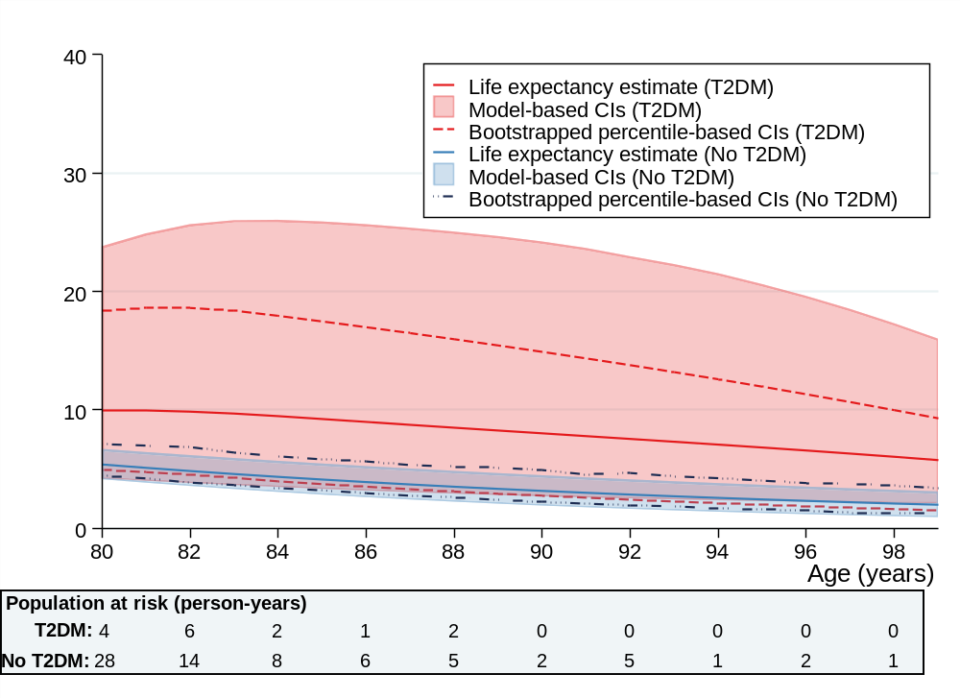
T2DM: Type 2 diabetes; CI: confidence intervals
The model included n=46 individuals with intellectual disabilities aged 80+ years and T2DM [n=1 aged 99+ years] and n=158 with intellectual disabilities without T2DM [none aged 99+ years]

Figure S2 Comparison between bootstrapped confidence intervals and log-transformed confidence intervals at ages 80–99 years in people with intellectual disabilities
Method 2: partially stratified

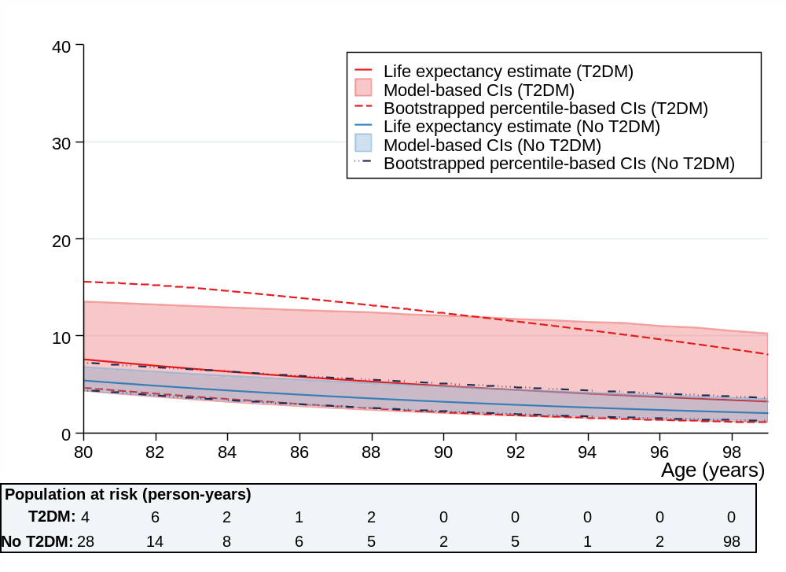
T2DM: Type 2 diabetes; CI: confidence intervals
The model included n=46 individuals with intellectual disabilities aged 80+ years and T2DM [n=1 aged 99+ years] and n=158 with intellectual disabilities without T2DM aged 80+ years [none aged 99+ years]

Figure S3 Comparison between bootstrapped confidence intervals and log-transformed confidence intervals at ages 80–99 years in people with intellectual disabilities
Method 3: modelled covariates, age interactions
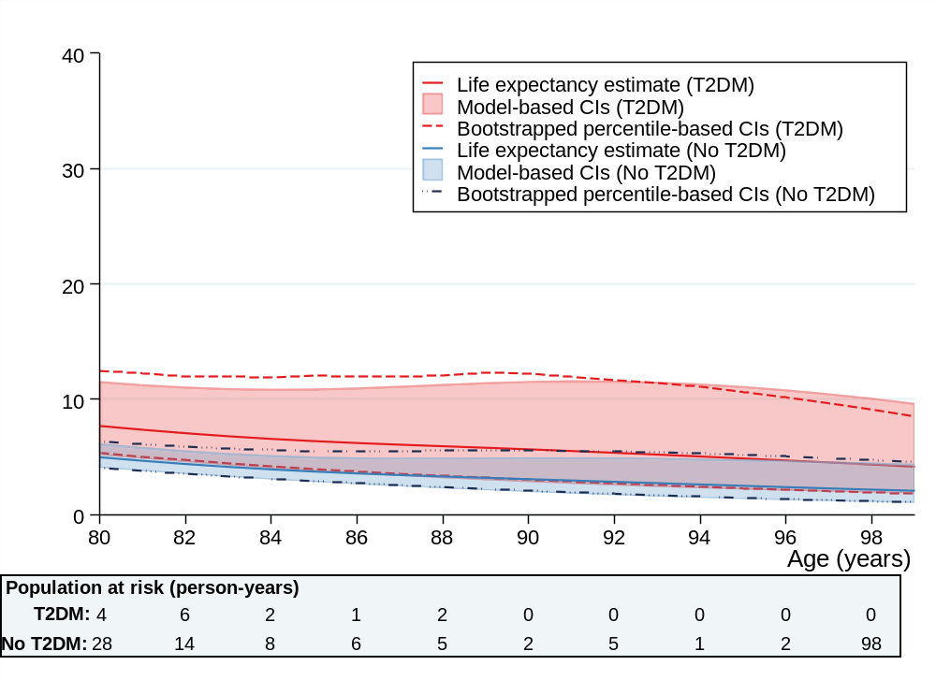
T2DM: Type 2 diabetes; CI: confidence intervals
The model included n=46 individuals with intellectual disabilities and T2DM [n=1 aged 99+ years] and n=158 with intellectual disabilities without T2DM [none aged 99+ years]. It also borrowed power from the cohort without intellectual disabilities (n= 26,619 aged 80+ years; n=233 aged 99+ years]

Figure S4 Comparison between bootstrapped confidence intervals (percentile and normal) and flexible parametric methods at ages 95–105 in people without intellectual disabilities
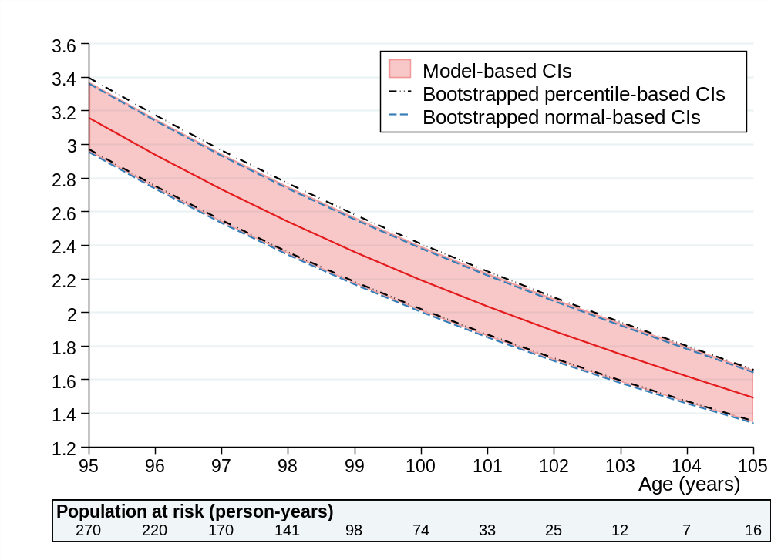
CI: confidence intervals

