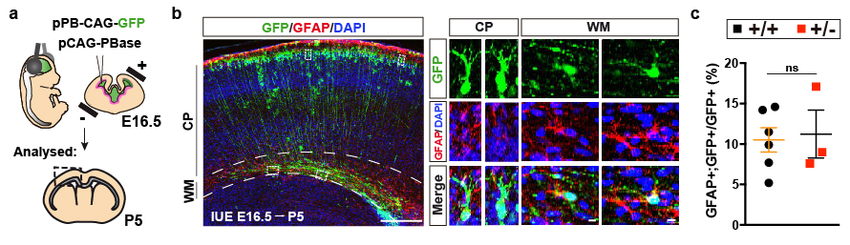

Fig S1. Differentiation of dorsal Dyrk1a^{+/-} neural progenitors into astroglial cells. (a) Schematic representation of the in-utero electroporation of E16.5 Dyrk1a^{+/+} (+/+) and Dyrk1a^{+/-} (+/-) embryos to evaluate the astroglial competence of dorsal ventricular zone progenitors. The electroporated plasmids containing the Piggybase transposase (pCAG-PBase) and transposon-specific inverted terminal repeat sequences (pPB-CAG-GFP) are indicated. (b) Representative coronal section from a P5 control brain immunostained for GFAP (red) and with the nuclei labelled by DAPI (blue) showing the astroglia progeny (GFAP⁺;GFP⁺ cells) of the electroporated progenitors in the cortical plate (CP) and white matter (WM, defined by the dashed lines). The right panels show magnifications of representative double-labelled cells (boxed cells) in the CP and WM. Scale bars: 500 μm and 10 μm (magnification panels). (c) Percentage (mean ± SEM) GFP⁺ cells expressing GFAP (GFAP⁺;GFP⁺ cells/total GFP⁺ cells). The values correspond to individual brains: ns, not significant, Student’s t test.

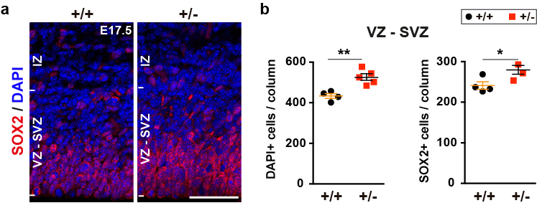

Fig S2. The number of neural progenitors in the dorsal proliferative region of Dyrk1a^{+/-} brains during the neurogenic/gliogenic switch. (a) Representative images of the dorsal telencephalon of E17.7 Dyrk1a^{+/+} (+/+) and Dyrk1a^{+/-} (+/-) brains stained for SOX2 (red), and with the nuclei labelled by DAPI (blue): VZ-SVZ, ventricular and subventricular zones; IZ, intermediate zone. (b) mean (± SEM) of the total cells (lefts) and SOX2 labelled cells (right) quantified in the ventricular and subventricular zones (VZ-SVZ) of 200 μm wide columns. The values correspond to individual brains: *P <0.05 and **P<0.01, Student’s t-test. Scale bar: 50 μm.

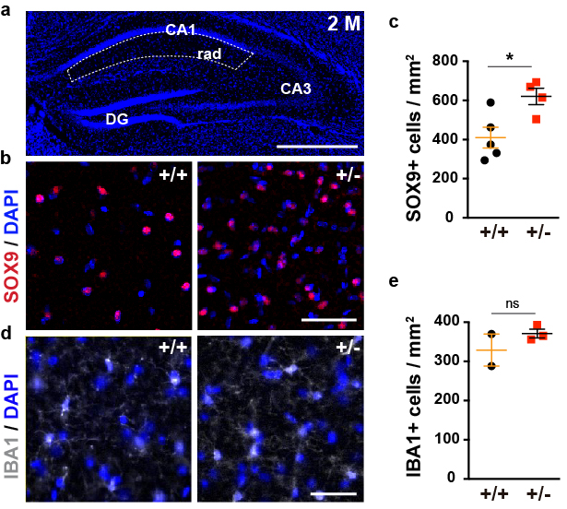

Fig S3. Increased numbers of SOX9 labelled astrocytes in the hippocampus of adult Dyrk1a^{+/-} mice. (a) Image of a coronal brain section of a Dyrk1a^{+/+} (+/+) hippocampus with the nuclei labelled by DAPI (blue). The dashed lines define the stratum radiatum layer (rad): CA1, CA (cornu ammonis) area 1; CA3, CA area 3; GD, dentate gyrus. (b,d) Representative images of the rad of 2-month-old +/+ and Dyrk1a^{+/-} (+/-) mice stained for SOX9 (red, b) and IBA1 (grey, d), and with the nuclei labelled with DAPI. (c,e) Density (mean ± SEM) of SOX9⁺ (c) and IBA1⁺ cells (e) in the rad of +/+ and +/- brains. The values correspond to individual animals and were obtained by counting cells in squares of approximately 0.25 mm²: ns, not significant; *P<0.05, Mann Whitney U test. Scale bar: 500 μm (a) and 50 μm (b).

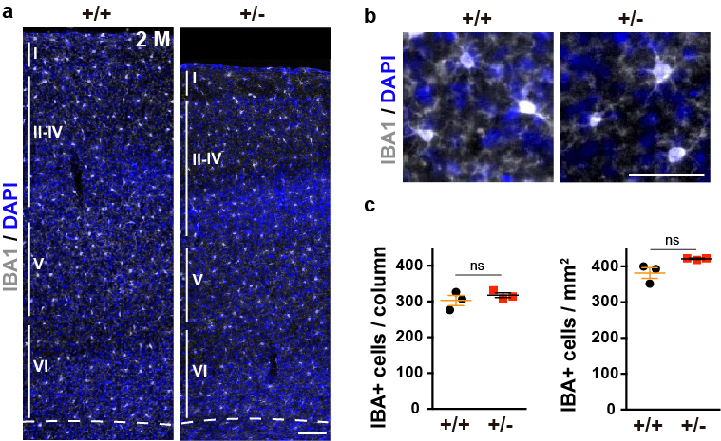

Fig S4. Normal expression of the IBA1 microglia marker in the cerebral cortex of adult Dyrk1a^{+/-} mice. (a) Representative images of the neocortex of 2-month-old Dyrk1a^{+/+} (+/+) and Dyrk1a^{+/-} (+/-) animals stained for IBA1 (grey) and with the nuclei labelled with DAPI (blue) indicating the position of layers I to VI. (b) Magnifications showing the staining pattern of cortical IBA1+ cells. (c) Mean number (± SEM, left) and mean density (± SEM, right) of IBA1⁺ cells quantified in 500 μm wide columns from layers I to VI. The values correspond to individual animals: ns=not significant, Student’s t-test. Scale bar: 100 μm (a) and 50 μm (b).

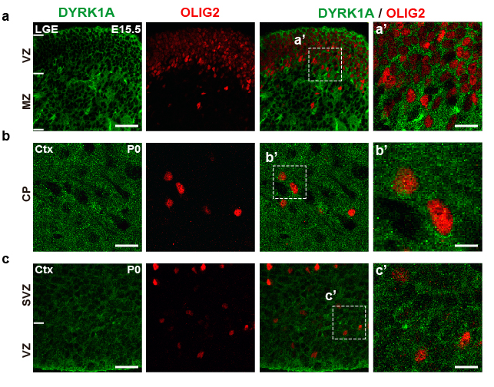

Fig S5. DYRK1A is expressed in ventral and dorsal oligodendroglial precursor cells. (a) Representative images of the lateral ganglionic eminence (LGE) of E15.5 embryos stained for DYRK1A (green) and OLIG2 (red): VZ, ventricular zone; MZ, marginal zone. Magnification of boxed areas (a’) shows OLIG2⁺ progenitors delaminating from the VZ and expressing DYRK1A. (b, c) Representative images of the cortical plate (CP in b) and proliferative regions (ventricular and subventricular zones: VZ and SVZ in c) in the dorsal telencephalon of P0 mice stained for DYRK1A and OLIG2. b’ and c’ are magnifications of the dashed box areas. Scale bar: 150 μm (a), 50 μm (magnification a’); 25 μm (b and c), 50 μm (magnification b’ and c’).

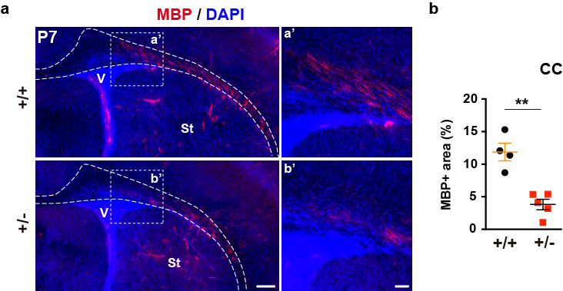

Fig. S6. Reduced myelin basic protein (MBP) expression in the corpus callosum of postnatal Dyrk1a^{+/-} mice. (a) Representative images of P7 Dyrk1a^{+/+} (+/+) and Dyrk1a^{+/-} (+/-) coronal brain sections stained for MBP (red), with the nuclei labelled by DAPI (blue), and magnifications of the dashed box areas in a’ and b’. Dashed lines define the corpus callosum: St, striatum. (b) Percentage (mean ± SEM) of the area of the CC labelled for MBP in +/+ and +/- sections. The values correspond to individual animals: **P<0.01, Student’s t-test. Scale bar: 25 μm (a); 50 μm (magnifications a’ and b’).

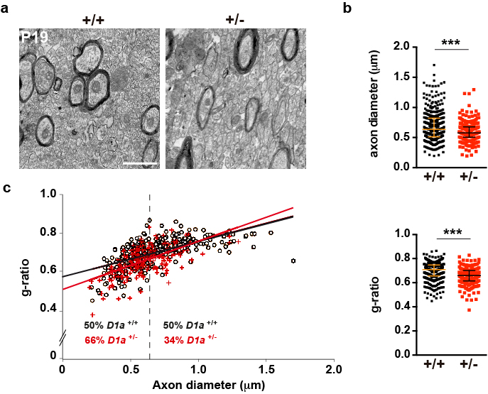

Fig S7. Ultrastructural alterations to the corpus callosum of postnatal Dyrk1a^{+/-} mice. (a) Representative electron micrographs of the P19 corpus callosum in +/+ and +/- mice. Scale bar: 1 μm. (b) Median value of the axon diameter (± interquartile range) for each genotype. (c) Scatter plot of the g-ratios of individual fibres relative to their respective axon diameter. The dashed line indicates the median axon diameter in +/+ mice and the numbers on either side of this line reflects the percentage of axons below (left) or above (right) this value for each genotype, and the median value of the g-ratio (± interquartile range) for each genotype. The values in b and c were obtained from 398 (+/+) and 200 (+/-) axons (n=2-3 animals each genotype): ***P<0.001, Mann-Whitney test.

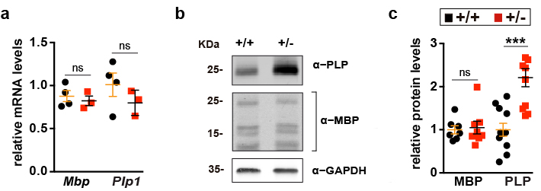

Fig S8. Altered PLP levels in the cerebral cortex of adult Dyrk1a^{+/-} mice. (a) Mbp and Plp1 mRNA expression relative to the levels of Ppia in the cerebral cortex of 2-month-old (2 M) Dyrk1a^{+/+} (+/+) and Dyrk1a^{+/-} (+/-) mice arbitrarily set as 1. (b) Representative immunoblots of extracts prepared from the cerebral cortex of 2 M mice probed with the antibodies indicated. (c) The MBP and PLP protein was normalized to GAPDH and expressed relative to the controls, and the values (mean ± SEM) in a and c correspond to individual animals: ns, not significant; ***P<0.001, Student’s t-test.

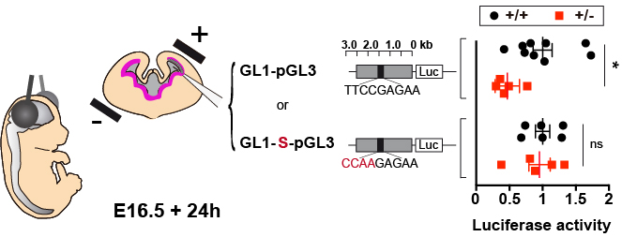

Fig S9. Altered STAT3 activity in the dorsal telencephalon of Dyrk1a^{+/-} embryos during the neurogenic/gliogenic switch. Scheme of the in utero electroporation experiment performed in E16.5 +/+ and +/- embryos, and of the luciferase (Luc) reporter plasmids used to evaluate STAT3 activity in apical progenitors. The grey boxes in these plasmids indicate the GFAP promoter sequences and the black boxes the STAT3 binding site. The mutated STAT3 binding site in GL1-S-pGL3 is indicated in red. The plot on the right shows the mean (± SEM) Luciferase values relative to the Renilla values in the dorsal telencephalon of +/+ and +/- embryos 24h after electroporation. WT values were arbitrarily set as 1 and the values correspond to individual embryos: ns=not significant; *P<0.05, Student’s t-test.

