Supplementary Information for
Effect of ATG12–ATG5-ATG16L1 autophagy E3 complex on the ability of LC3/GABARAP proteins to induce vesicle tethering and fusion

Marina N. Iriondo^{1,2}, Asier Etxaniz^{1,2}, Yaiza R. Varela^{1,2}, Uxue Ballesteros^{1,2}, Melisa Lázaro³, Mikel Valle³, Dorotea Fracchiolla⁴, Sascha Martens⁴, L. Ruth Montes^{1,2}, Félix M. Goñi^{1,2}, Alicia Alonso^{1,2&}

This file includes:
Supp. Fig. 1-8
Supp. Table 1

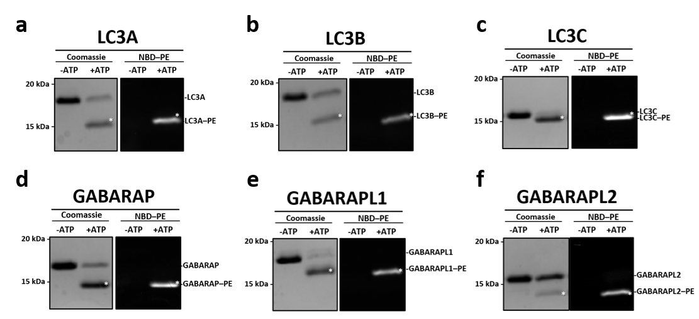
Supp. Fig. 1. The faster migrating band observed after ATP addition represents the lipidated LC3/GABARAP protein. a-f In vitro LC3/GABARAP lipidation assay: 0.5 µM ATG7, 1 µM ATG3, 0.1 µM E3 and 5 µM of the indicated LC3/GABARAP-protein member were mixed with 0.4 mM LUVs (ePC:DOPE:PI:DOG:NBDtail-PE (33:45:10:2:10 mol ratio)). Each reaction mixture was incubated at 37°C for 30 min, run on 15% SDS-PAGE gels, and visualized by Commassie Brilliant Blue staining (left panels) or using a VersaDoc MP 4000 Imaging System to detect NBD-PE fluorescence (right panels). Only the faster migrating band (*) showed fluorescence.

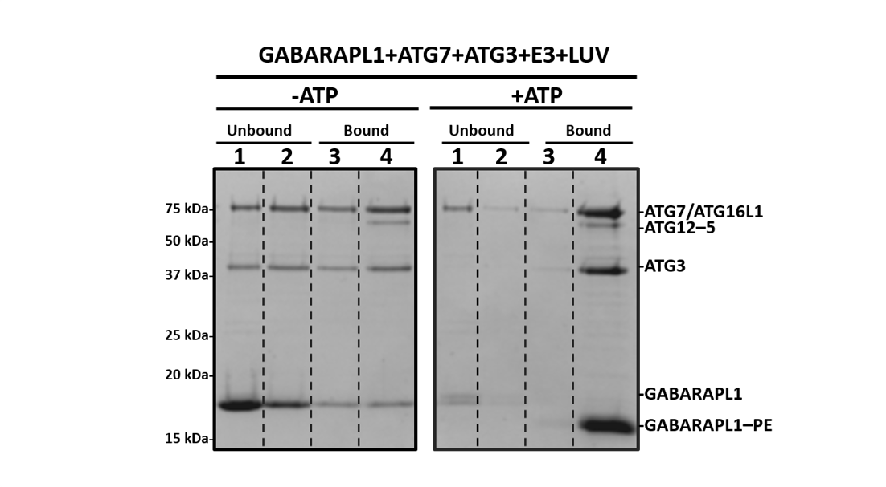
Supp. Fig. 2. Membrane interaction of the lipidation machinery increases in the presence of ATP. SDS-PAGE/Coomassie Brilliant Blue-stained gels of the fractions obtained from a vesicle flotation assay of the proteins that form the lipidation machinery in the absence (left) or presence (right) of ATP. Protein found in fractions 3+4 was taken as bound protein. Protein and lipid concentrations were increased by 5-fold in order to detect E3 complex in the gels. 2.5 µM ATG7, 5 µM ATG3, 0.5 µM E3 and 25 µM of GABARAPL1 were incubated with 2 mM LUVs (ePC:DOPE:PI:DOG (33:55:10:2 mol ratio)) at 37°C for 30 min in the absence or presence of ATP.

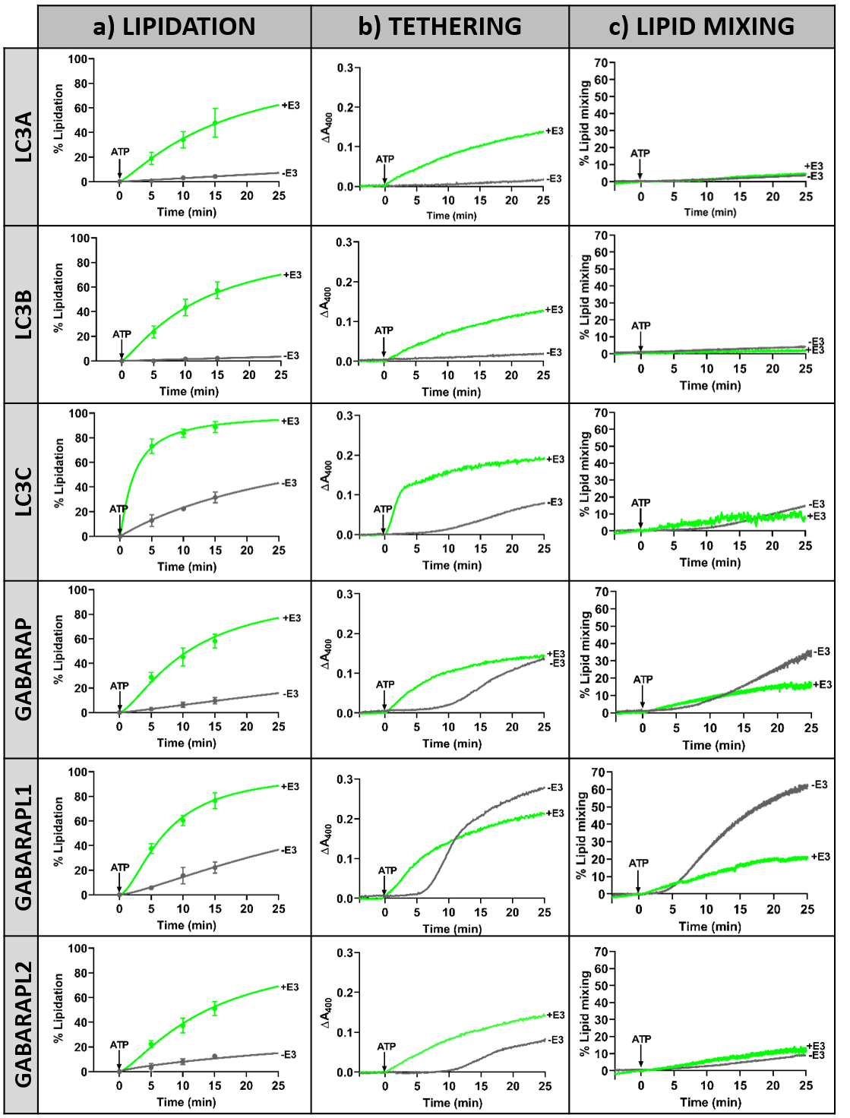
Supp. Fig. 3. Comparative summary of LC3/GABARAP-protein lipidation, tethering and lipid mixing kinetics in the absence and presence of E3 complex. Data from Figure 2, Figure4 and Figure 5 were redrawn in order to allow an easier comparison of the results in this study. a Lipidation kinetics of LC3/GABARAP proteins after ATP addition in the absence (grey) and in the presence (green) of E3 complex. b Tethering kinetics of each LC3/GABARAP-family member after ATP addition in the absence (grey) and in the presence (green) of E3 complex. c Lipid mixing kinetics of LC3/GABARAP proteins after ATP addition in the absence (grey) and in the presence (green) of E3 complex.

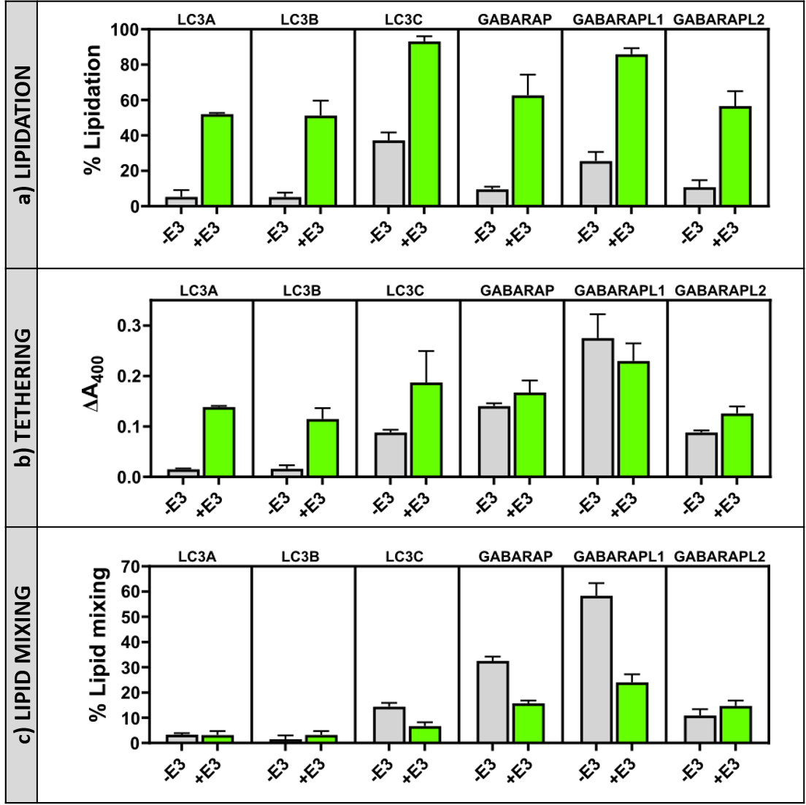
Supp. Fig. 4. Effect of E3 complex on LC3/GABARAP-protein lipidation and the subsequent vesicle tethering and lipid mixing 25 min after ATP addition. a Final lipidation levels in the absence (grey) and presence (green) of E3 complex. b Extent of vesicle tethering induced by LC3/GABARAP proteins in the absence (grey) and presence (green) of E3 complex. c Extent of lipid mixing induced by LC3/GABARAP proteins in the absence (grey) and presence (green) of E3 complex. Data are means ± SD (n = 3).

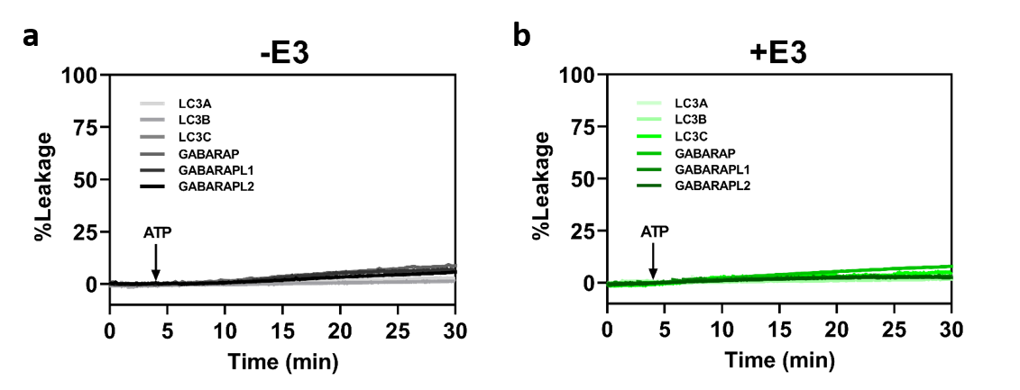
Supp. Fig. 5. Lipidated LC3/GABARAP proteins did not induce vesicle permeabilization neither in the absence nor in the presence of E3 complex. Membrane vesicle content leakage analysis induced by lipidated LC3/GABARAP proteins in the absence and presence of the E3 complex was monitored by the ANTS/DPX leakage assay. 0.4 mM LUVs containing co-encapsulated ANTS and DPX were mixed with 0.5 µM ATG7, 1 µM ATG3, and 5 µM of the pertinent LC3/GABARAP-family member and ATP was added after 4 min. 100% leakage signal was obtained by adding 1% Triton X-100. Contents leakage in the absence (a) or in the presence (b) of E3 complex.

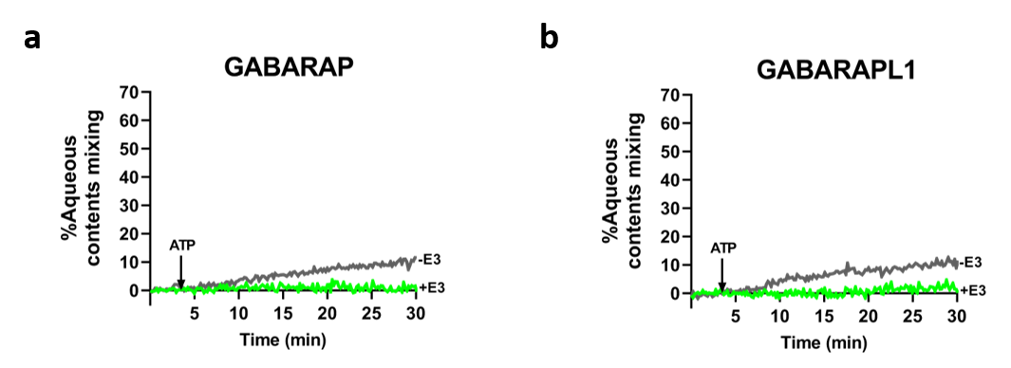
Supp. Fig. 6. E3 decreases the low aqueous content mixing activity of GABARAP and GABARAPL1. Representative curves of aqueous contents mixing activities induced by lipidated GABARAP (a) and GABARAPL1 (b) in the absence (-E3, grey) and presence (+E3, green) of the E3 complex was monitored by the ANTS/DPX mixing assay. 0.4 mM ANTS and DPX liposomes (1:1) were mixed with 0.5 µM ATG7, 1 µM ATG3, and 5 µM of the pertinent LC3/GABARAP-family member, ATP was added after 4 min. 100% mixing was determined using LUVs containing co-encapsulated ANTS and DPX.

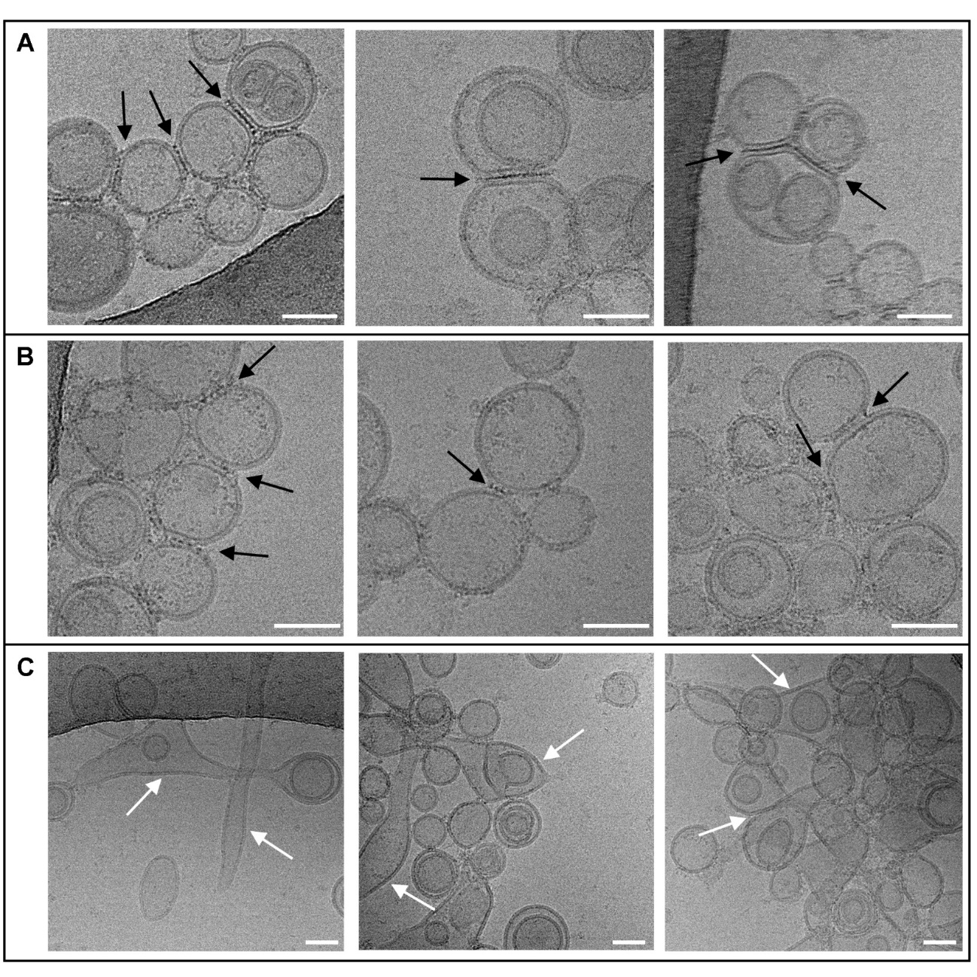
Supp. Fig. 7. GABARAPL1 ability to tether and fuse vesicles in the absence of E3 complex, analyzed by cryo-EM. A gallery of cryo-EM images obtained under the condition “-E3, +ATP”. 0.5 µM ATG7, 1 µM ATG3, and 5 µM GABARAPL1 were mixed with 0.4 mM LUVs (ePC:DOPE:PI:DOG (33:55:10:2 mol ratio)) and, after ATP addition, they were incubated at 37°C for 90 min. Arrows point to the specific structures observed. a Examples of structures evocative of aggregation or hemifusion (“triple parallel lines”). b Examples of structures evocative of hemifusion (intervesicular discontinuous lines). c Examples of structures evocative of fusion (sheets). Bar = 50 nm.

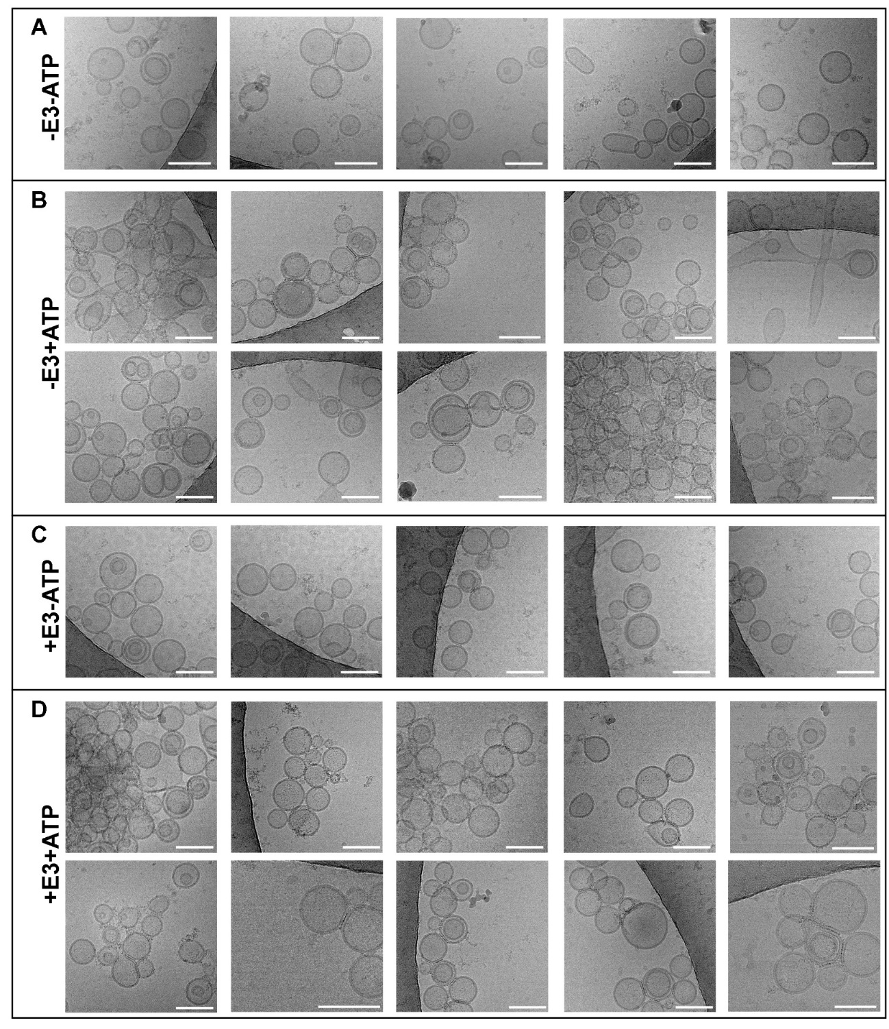
Supp. Fig. 8. GABARAPL1 ability to tether and fuse vesicles in the absence and presence of E3 complex analyzed by cryo-EM. Additional cryo-EM images of the four conditions analyzed in Figure 7. 0.5 µM ATG7, 1 µM ATG3, and 5 µM GABARAPL1 were mixed with 0.4 mM LUVs (ePC:DOPE:PI:DOG (33:55:10:2 mol ratio)), in the absence (-E3) or presence (+E3) of 0.1 µM E3 complex and, after addition of buffer (-ATP) or ATP (+ATP), they were incubated at 37°C for 90 min. (A-D) Cryo-EM images of liposomes after reconstituting GABARAPL1 conjugation reaction. a In the absence of E3 and ATP. b In the absence of E3 but in the presence of ATP. c In the presence of E3 but in the absence of ATP. d In the presence of both E3 and ATP. Bar = 100 nm.

Supp. Table 1. List of protein constructs used in this work: vector, expression system, detailed protein encoded, and reference study
