Supporting Information for
Advanced adjustable ionic conductivity of polybenzimidazole membranes with arrayed two-dimensional AlOOH nanosheets for water electrolysis
Zhi Qiu ^{a,b} , Lihua Wang ^{a,*}, Min He ª ,Yanbin Yun ^{b,*}
a Key Laboratory of science and technology on high-tech polymer materials, Institute of Chemistry, Chinese Academy of Sciences, Beijing, 100190, PR China. *E-mail: wanglh@iccas.ac.cn
b College of Environmental Science and Engineering, Beijing Forestry University, Beijing 100083, PR China. *E-mail: yunyanbin316@bjfu.edu.cn

Characterization

The porosity of the membrane
The membrane was immersed in 1-butanol for 2 h and then weighed after wiping off the 1-butanol on the surface with tissue paper. The porosity of the membrane was calculated as follows:
$Ε=\frac{M_{w}-M_{d}}{ρ×S×l}$ (1)
where Mw and Md are the mass of the wet and dried membrane, respectively; ρ is the density of 1-butanol; S is the surface area of the dried membrane; l is the thickness of the dried membrane.

Water uptake (WU), Swelling ratio (SR) and Hydrophilic
The water uptake (WU) and swelling ratio (SR) was determined using the following method. The membrane samples were immersed in deionized water at room temperature for 24 h; After 24h, each membrane was removed from the deionized water, and its surface was dried with tissue paper. Next, the sample was weight to obtain the wet weight (W _{wet}) and size (L _{wet}）of wet membranes, Then dried under vacuum at 100 ℃ for 12 h to obtain the dry weight (W _{dry}) and size (L _{dry}）of the dry membranes.
The water uptake (WU), swelling ratio (SR) were calculated by equations (2), (3) and (4):
$WU\left(\%\right)=\left(\frac{W_{wet}-W_{dry}}{W_{dry}}\right)×100\%$ (2)
$SR\left(\%\right)=\left(\frac{L_{wet}-L_{dry}}{L_{dry}}\right)×100\%$ (3)
The static water contact angles of the γ-AlOOH-PBI porous composite membranes were measured by a video-supported contact angle measuring instrument (OCA 20, Dataphysics, Germany) using a sessile drop method.

Results and discussion
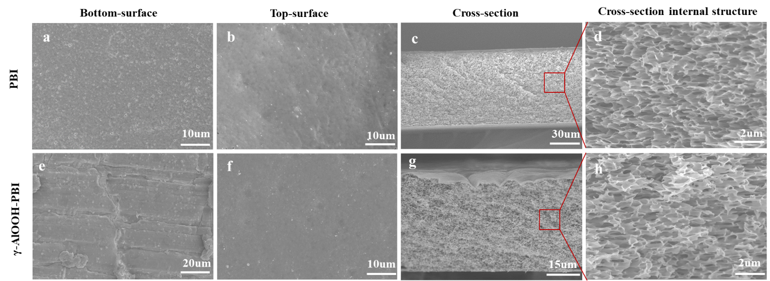
Fig. S1. SEM morphology of pristine PBI membranes and γ-AlOOH-PBI composite membranes.

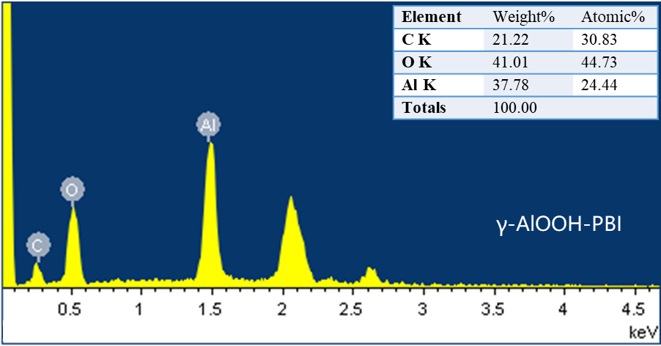
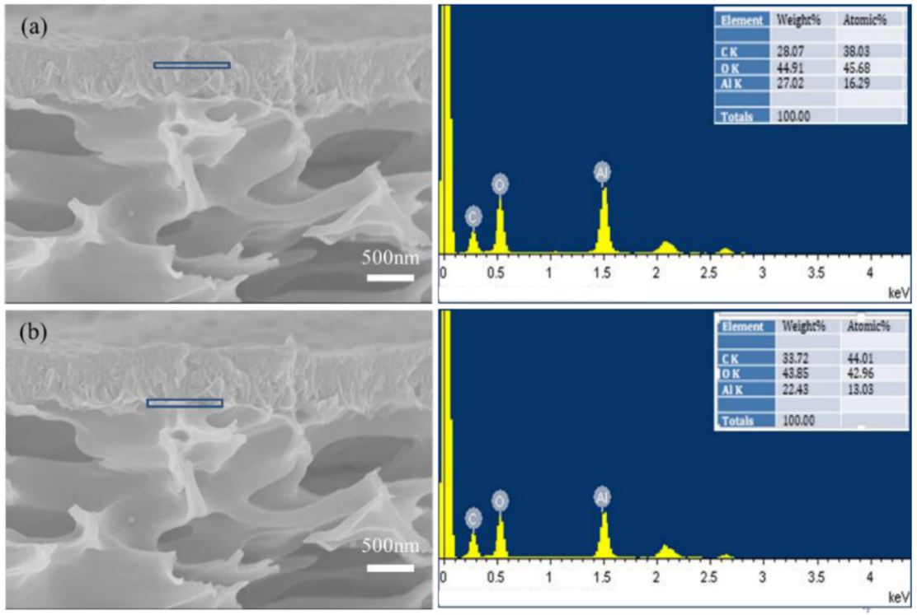
Fig. S2. EDS of γ-AlOOH PBI composite membranes and γ-AlOOH nanosheets a) γ-AlOOH nanosheet layers structure in the middle; b) γ-AlOOH nanosheet layers structure at the interface with the membrane

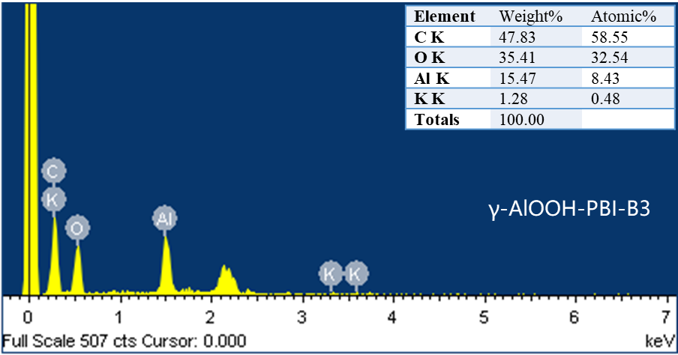
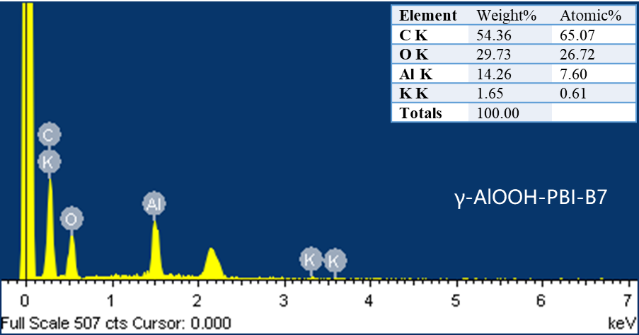
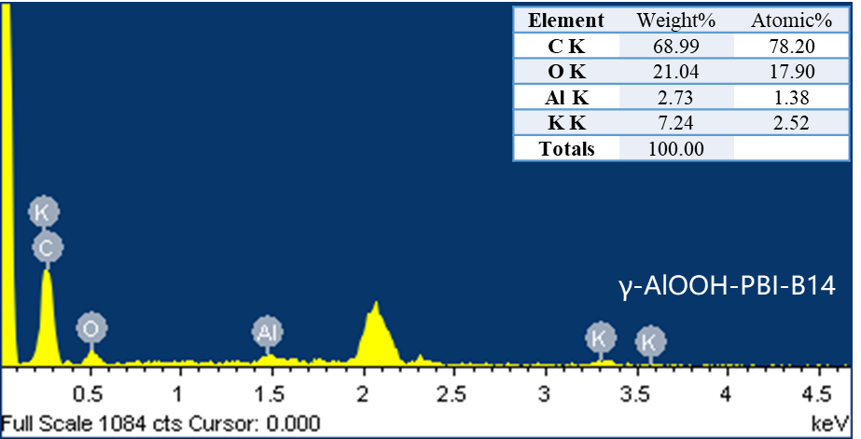
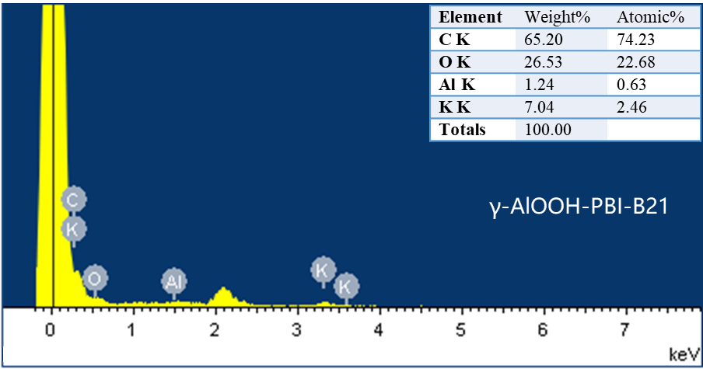
Fig. S3. EDS of γ-AlOOH PBI composite membranes with different days of alkali immersion. B3, B7, B14, B21 are soaking days, respectively

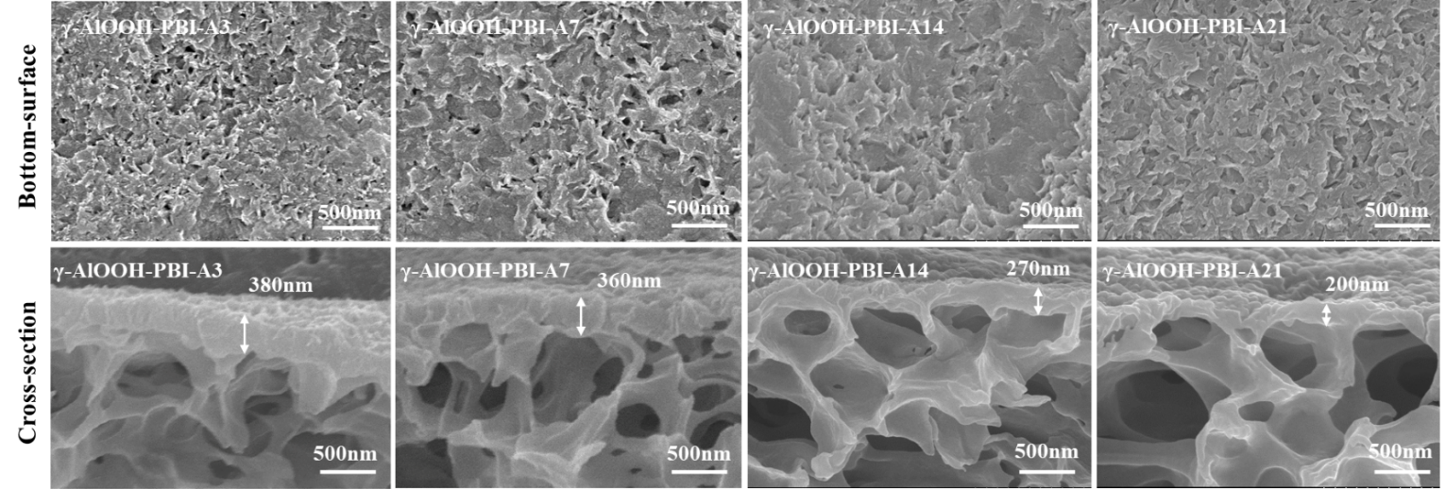
Fig.S4. SEM morphology of pristine PBI membranes and γ-AlOOH PBI composite membranes with different days of Acid immersion. A3, A7, A14, A21 are soaking days in in acid solution, respectively

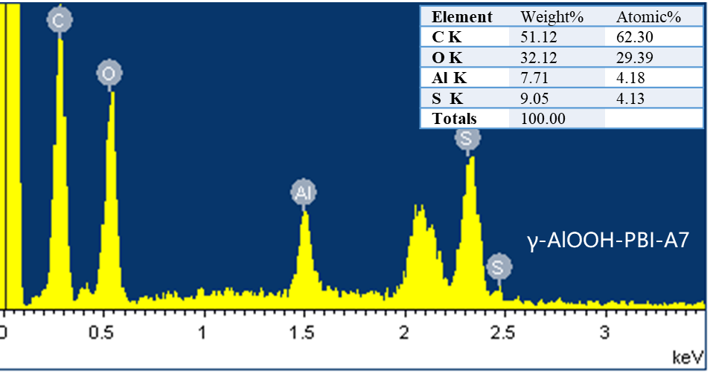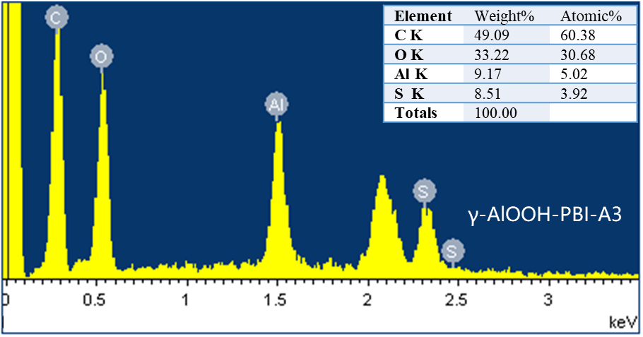
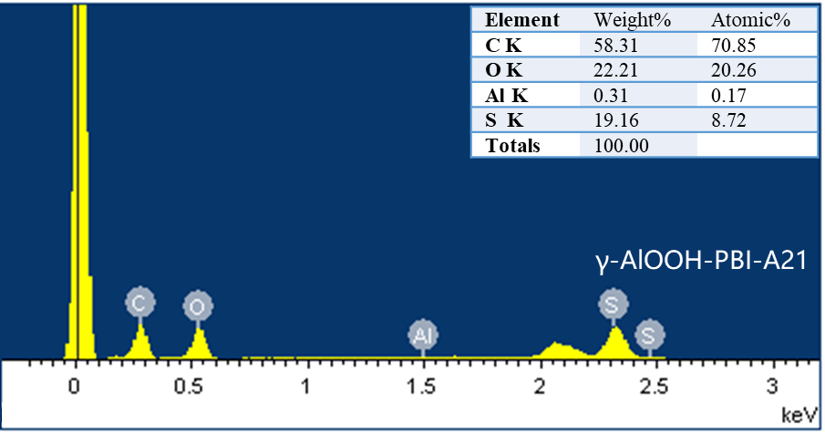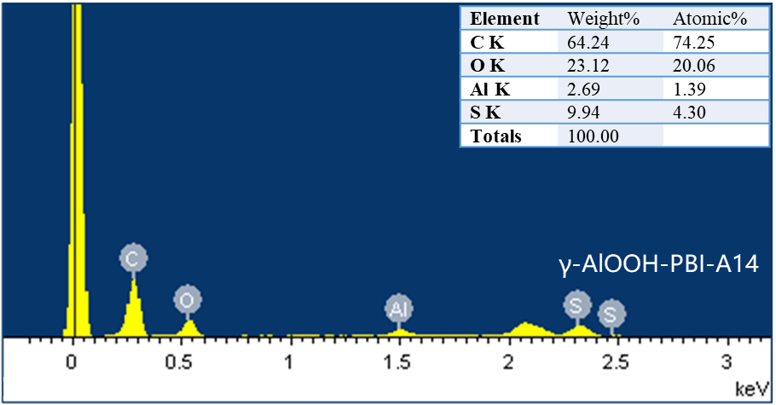
Fig. S5. EDS of pristine PBI membranes and γ-AlOOH PBI composite membranes with different days of acid immersion. A3, A7, A14, A21 are soaking days, respectively
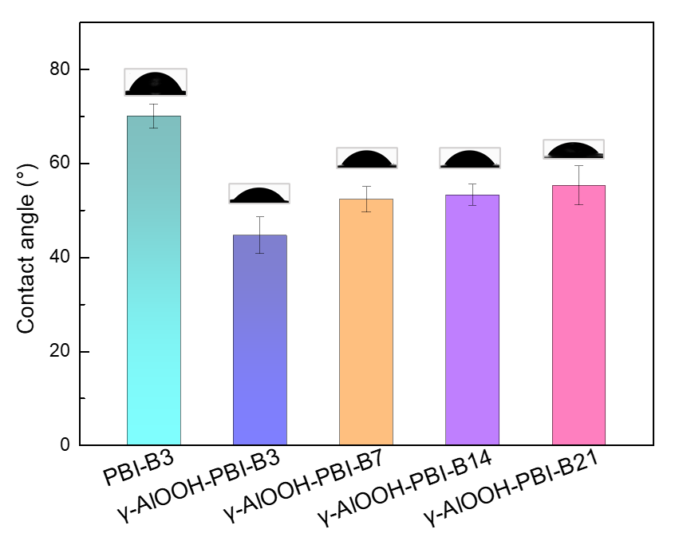
Fig. S6. The water contact angle of PBI-B3, γ-AlOOH-B3, γ-AlOOH-B7, γ-AlOOH-B14, γ-AlOOH-B21 membranes under dry state.

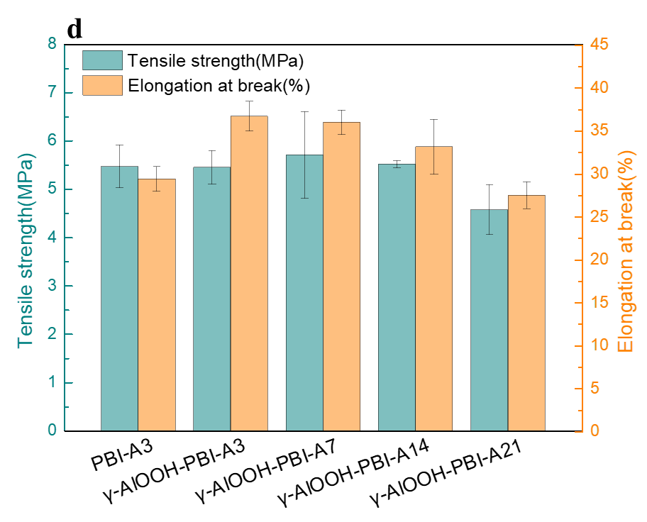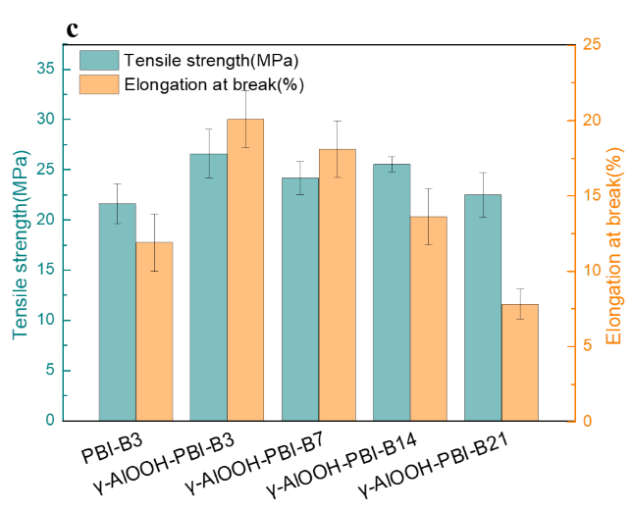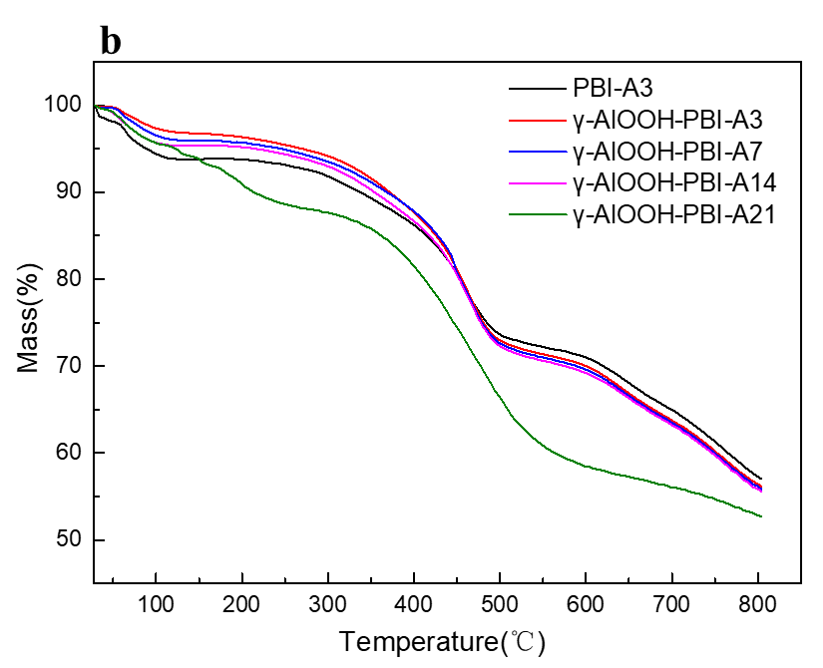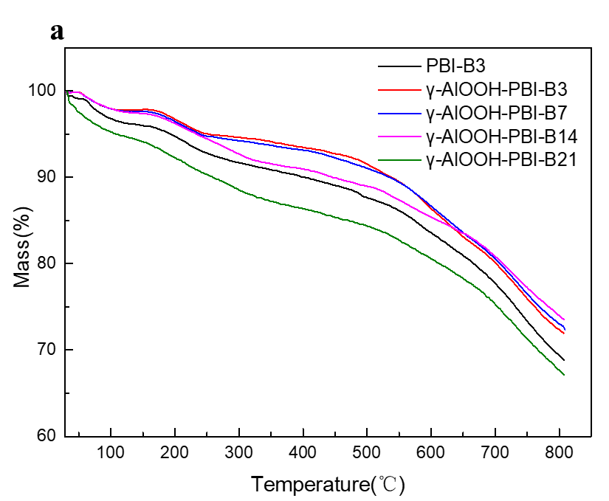
Fig.S7. a and b) TGA curves and c and d) stress–strain behaviors of pristine PBI andγ-AlOOH-PBI. Of note, B3, B7, B14, B21, A3, A7, A14, and A21 represent soaking days in alkaline and acid solution, respectively.

Table. S1 Physicochemical properties of pristine PBI and γ-AlOOH-PBI
Sample | Thickness（μm） | WU  （%） | SR  （%）
PBI-B3 | 75±5 | 149.81±1.01 | 4.33±0.58
γ-AlOOH-PBI-B3 | 75±5 | 150.77±3.64 | 2.60±0.05
γ-AlOOH-PBI-B7 | 75±5 | 175.39±0.72 | 2.73±0.08
γ-AlOOH-PBI-B14 | 75±5 | 181.51±0.99 | 2.78±0.56
γ-AlOOH-PBI-B21 | 75±5 | 185.62±4.26 | 2.80±1.44

Table. S2 Comparison of the electrolysis performance for water electrolysis reported in literatures.
The types of water electrolysis | Membrane | Temperature  (℃) | Feed | Current density(mAcm⁻²) at cell voltage 1.8V | Reference
Alkaline | γ-AlOOH-PBI-B14 | 25 | 1M KOH | 633.00 | This work
Alkaline | Linear PBI | 80 | 30wt% KOH | 20.00 | [1]
Alkaline | Crosslinked PBI | 80 | 30wt% KOH | 85.00 | [1]
Alkaline | Thermally cured PBI | 80 | 30wt% KOH | 40.00 | [1]
Alkaline | L-ABPBI | 70 | 1.9moldm⁻³ | 63.00 | [2]
Alkaline | C-ABPBI | 70 | 1.9moldm⁻³ | 60.00 | [2]
Alkaline | PVA-PBI | 50 | 15wt% KOH | 50.00 | [3]
Alkaline | FAA3-PBI | 60 | 20wt% KOH | 40.00 | [4]
Alkaline | PAEK-APBI | 60 | 10wt% KOH | 250.00 | [5]
Alkaline | mes-PBI | 80 | 30wt% KOH | 45.00 | [6]
Acid-alkaline amphoteric | mPBI | 40 | 6MKOH(Anode)//3MH₂SO₄(Cathode) | ~360.00 | [7]
Acid-alkaline amphoteric | OPBI | 20 | 6MKOH(Anode)//3MH₂SO₄(Cathode) | ~38.00 | [7]
Alkaline | FAA3-50 | 60 | 1M KOH | 320.00 | [8]
Alkaline | FAA3-PK-130 | 25 | DI water | 250.00 | [9]
Alkaline | A-201 | 60 | 1M KOH | 260.00 | [10]
Alkaline | Sustainion | 60 | 1M KOH | 160.00 | [10]

References
- Aili D, et al. Heterogeneous anion conducting membranes based on linear and crosslinked KOH doped polybenzimidazole for alkaline water electrolysis. Journal of Membrane Science 447, 424-432 (2013).
- Diaz LA, et al. Alkali doped poly (2,5-benzimidazole) membrane for alkaline water electrolysis: Characterization and performance. Journal of Power Sources 312, 128-136 (2016).
- Diaz LA, Coppola RE, Abuin GC, Escudero-Cid R, Herranz D, Ocón P. Alkali-doped polyvinyl alcohol – Polybenzimidazole membranes for alkaline water electrolysis. Journal of Membrane Science 535, 45-55 (2017).
- Konovalova A, et al. Blend membranes of polybenzimidazole and an anion exchange ionomer (FAA3) for alkaline water electrolysis: Improved alkaline stability and conductivity. Journal of Membrane Science 564, 653-662 (2018).
- Tham DD, Kim D. C₂ and N₃ substituted imidazolium functionalized poly(arylene ether ketone) anion exchange membrane for water electrolysis with improved chemical stability. Journal of Membrane Science 581, 139-149 (2019).
- Aili D, Wright AG, Kraglund MR, Jankova K, Holdcroft S, Jensen JO. Towards a stable ion-solvating polymer electrolyte for advanced alkaline water electrolysis. Journal of Materials Chemistry A 5, 5055-5066 (2017).
- Wan L, Xu Z, Wang P, Lin Y, Wang B. H₂SO₄-doped polybenzimidazole membranes for hydrogen production with acid-alkaline amphoteric water electrolysis. Journal of Membrane Science 618, (2021).
- Park JE, et al. Graphitic carbon nitride-carbon nanofiber as oxygen catalyst in anion-exchange membrane water electrolyzer and rechargeable metal–air cells. Applied Catalysis B: Environmental 237, 140-148 (2018).
- Pandiarajan T, John Berchmans L, Ravichandran S. Fabrication of spinel ferrite based alkaline anion exchange membrane water electrolysers for hydrogen production. RSC Advances 5, 34100-34108 (2015).
- Pushkareva IV, Pushkarev AS, Grigoriev SA, Modisha P, Bessarabov DG. Comparative study of anion exchange membranes for low-cost water electrolysis. International Journal of Hydrogen Energy 45, 26070-26079 (2020).

