Figure S1. Expression of inflammation-related factors in N9 microglia cells treated with EGCG and Aβ₁₋₄₂ 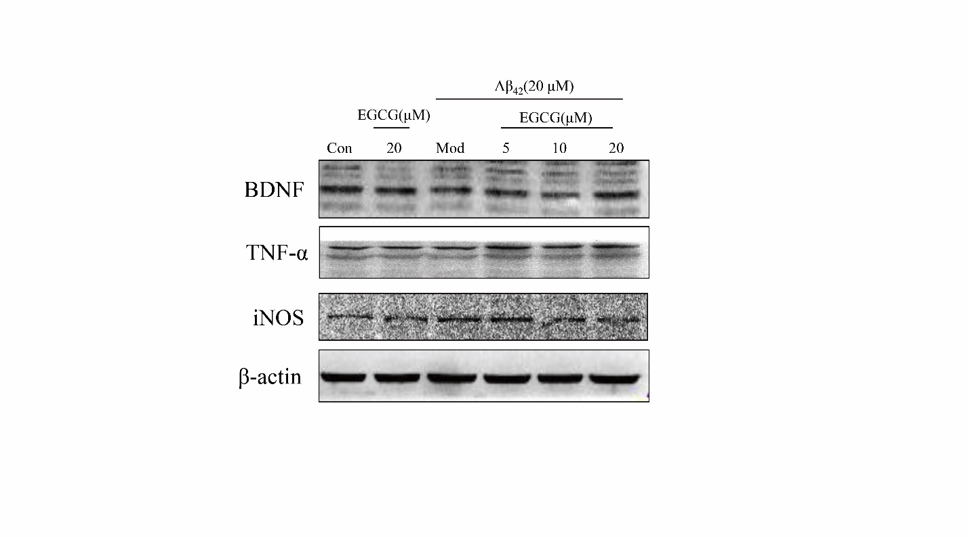
The inflammation-related factors BDNF, TNF-α, and iNOS in N9 microglial cells treated with EGCG and Aβ₁₋₄₂. BDNF, TNF-α, and iNOS levels in microglia cells treated with EGCG and Aβ₁₋₄₂ for 24 h were estimated by western blotting.

