Extended data for

A tin-based tandem electrocatalyst for CO₂ reduction to ethanol with 80% selectivity
Authors:
Jie Ding^{1,2,#}, Hong Bin Yang^{1,2,#}, Xue-Lu Ma^{3,4,#}, Song Liu^{1,2,#}, Wei Liu¹, Qing Mao⁵, Yanqiang Huang^{1,*}, Jun Li^{3,*}, Tao Zhang^{1,} and Bin Liu^{2,*}
Affiliations:
¹CAS Key Laboratory of Science and Technology on Applied Catalysis, Dalian Institute of Chemical Physics, Chinese Academy of Sciences, Dalian, China.
²School of Chemical and Biomedical Engineering, Nanyang Technological University, Singapore, Singapore.
³Department of Chemistry and Key Laboratory of Organic Optoelectronics & Molecular Engineering of Ministry of Education, Tsinghua University, Beijing, China.
⁴School of Chemical & Environmental Engineering, China University of Mining & Technology, Beijing, China.
⁵School of Chemical Engineering, Dalian University of Technology, Dalian, China.
#Equal contribution.
Correspondence to: yqhuang@dicp.ca.cn (Y. Huang); junli@mail.tsinghua.edu.cn (J. Li); and liubin@ntu.edu.sg (B. Liu).
This PDF file includes:
Materials and Methods
Figs. 1 to 58
Tables 1 to 18

Methods
Preparation of three-dimensional (3D) carbon
The 3D carbon was prepared according to a literature procedure (Extended data Fig. 1) ¹. In brief, HY zeolite was first heated to 600 °C under a dry N₂ flow in a fused quartz reactor. Then, a mixture of ethylene gas and N₂ (volume ratio = 50 : 50) was passed through a water bubbler and fed into the zeolite bed at 600 °C for 30 min. The gas flow was switched to dry N₂ when carbon deposition was completed. Afterwards, the temperature was increased to 950 °C and maintained there for 2 h. The resulting product was washed in a 0.5 M HF/0.2 M HCl solution to release carbon from the template. Finally, the as-prepared 3D carbon was dried in a vacuum oven for 24 h at 60 °C for further utilization.
Preparation of SnS₂/ Sn₁-O3G
The detailed preparation procedure of vertically aligned SnS₂ on Sn₁-O3G is illustrated in Extended data Fig. 2, in which, 2 mmol SnBr₂ and 2 mmol thiourea were added into a mixed solution containing 20 mL of oleic acid and 2.5 mL of oleyamine under magnetic stirring at 80 °C for 8 h (SnS₂ precursor solution). Meanwhile, 20 mg 3D carbon was dispersed into 10 mL of isopropanol under magnetic stirring at room temperature, followed by added into the SnS₂ precursor solution under magnetic stirring at room temperature for 2 h. Then, the obtained solution was transferred to a 100 ml Teflon-lined stainless-steel autoclave to perform solvothermal reaction at 200 °C for 20 h. After cooling down to room temperature, the solid product was washed with ethanol and deionized water, collected by centrifugation, and dried in a vacuum oven for 24 h at 40 °C for further utilization (SnS₂/Sn₁-O3G).
Preparation of Sn single-atom catalyst
The SnS₂/Sn₁-O3G was successively leached at 80 °C in 2 M HCl for 24 h to remove SnS₂ nanosheets and unstable species (Sn₁-O3G).
Preparation of SnS₂
2 mmol SnBr₂ and 2 mmol thiourea were added into a mixed solution containing 20 mL of oleic acid and 2.5 mL of oleyamine under magnetic stirring at 80 °C for 8 h. Then, the solution was transferred to a 100 ml Teflon-lined stainless-steel autoclave to perform solvothermal reaction at 200 °C for 20 h. After cooling down to room temperature, the solid product was washed with ethanol and deionized water, collected by centrifugation, and dried in a vacuum oven for 24 h at 40 °C for further utilization.

Characterization
The crystal structure and morphology of the catalysts were examined by X-ray diffraction (XRD, Bruker AXS D8 Advance) with Cu Kα radiation (λ = 1.5406 Å), field-emission scanning electron microscopy (FESEM, JEOL JSM-6700F), transmission electron microscopy (TEM, JEOL JEM-2100F), and energy dispersive X-ray spectroscopy (EDX, Aztec X-Max 80T). Sub-ångström-resolution high-angle annular dark-field scanning transmission electron microscopy (HAADF-STEM) characterization was conducted on a JEOL JEMARM200F STEM/TEM with a guaranteed resolution of 0.08 nm. Detailed chemical compositions were analyzed by X-ray photoelectron spectroscopy (XPS) on an ESCALAB 250 photoelectron spectrometer (Thermo Fisher Scientific) using a monochromatic Al Kα X-ray beam (1,486.6 eV). All binding energies were referenced to the C 1s peak (284.6 eV). The ¹¹⁹Sn Mössbauer spectra were collected at room temperature using ¹¹⁹Sn in the BaSnO₃ as an emitter, and the isomer shift (IS) was given with respect to the centroid of BaSnO₃ at room temperature. The Sn contents in the catalysts were quantified by inductively coupled plasma optical emission spectroscopy (ICP-OES; ICPS-8100, Shimadzu).
Electrochemical measurements
Electrochemical CO₂ reduction reaction. A 0.5 M potassium bicarbonate aqueous solution was used as the electrolyte for the electrochemical CO₂ reduction reaction (CO₂RR). Ultrapure water (18.2 MΩ∙cm) was used to prepare all electrolytes. Electrochemical measurements were conducted in a H-type cell separated by a Nafion 117 membrane between the cathodic and anodic chambers. A mass flow controller was used to control the CO₂ flow rate at 20 sccm. Extended data Fig. 3 shows the experimental setup for electrochemical CO₂RR, in which, Pt sheet and saturated calomel electrode (SCE) serve as counter and reference electrode, respectively. To prepare the working electrode, the catalyst ink (5 mg∙ml⁻¹) that was prepared by ultrasonically mixing 10 mg of the catalyst, 0.98 mL of Millipore Q H₂O (15 MU), 0.98 mL of isopropyl alcohol, and 50 mL of 5 wt.% D520 Nafion dispersion solution, was brush-painted onto a carbon fiber paper (AvCarb P75T) at a temperature of 40 °C, giving a catalyst loading of 0.5 mg∙cm⁻². The CO₂ was bubbled into the potassium bicarbonate electrolyte for 1 h before starting electrolysis. The pH of electrolyte in bulk and near the surface of working electrode (WE) during the CO₂RR were measured by a pH meter (S220 SevenCompactTM pH/Ion) (Extended data Table 1). The Ohmic resistance was measured by electrochemical impedance spectroscopy (EIS) at open circuit voltage. In the EIS measurement, a sinusoidal AC perturbation of 5 mV was applied to the electrode over the frequency range from 0.5 to 10⁵ Hz. The typical Ohmic resistance of the electrode (1 cm²) is about 4.5 Ω in CO₂ saturated 0.5 M bicarbonate solution. The linear sweep voltammetry (LSV) curves were recorded on a CHI-660E electrochemical workstation at a scan rate of 5 mV∙s^{–1}. All potentials were reported with respect to the RHE scale and corrected by IR drop compensation. All potentials were calculated with respect to the reversible hydrogen electrode (RHE) scale according to the Nernst equation (E_{RHE} = E_{SCE} + 0.0591 × pH + 0.241 V, at 25 °C).
CO₂RR products quantification
The gaseous products (H₂, CO and CH₄) were quantified by a gas chromatograph (GC, Agilent 7890) equipped with a flame ionization detector (FID) for CO and CH₄ and a thermal conductivity detector (TCD) for H₂ quantification. Ultrapure N₂ was used as the carrier gas for the chromatography. The Faradaic efficiency (FE) of each gas product was calculated by:
$$FE=\frac{z_{i×v_{i}×G×F×P_{0}}}{I×R×T_{0}×60000}$$
where i represents CO, H₂ or CH₄; z_{i} is the number of electrons required to produce an i molecule, which is 2, 2 and 8 for CO, H₂ and CH₄; v_{i} is the volume ratio of product i in the GC sampling loop; G is the volumetric flow rate; F is Faradaic constant (96,500 C∙mol⁻¹); P₀ is atmospheric pressure (1.013 × 10⁵ Pa); I is the average current, calculated from the chronoamperometric curves (Extended data Fig. 4) in a period (t) of electrocatalysis: I=$\frac{\int_{0}^{t}{I\left(t\right)dt}}{t}$; R is ideal gas constant (8.314 J·mol^{–1}·K^{–1}); and T₀ is the reaction temperature (298 K).
NMR is generally not used quantitatively because differences in the T1s of analytes can lead to different peak areas when measurements are made under different conditions, such as different number of scans or different solution compositions. In addition, there are other factors, such as shimming and phasing, that can cause differences in peak areas. Despite these difficulties, we found NMR extremely useful for the detection of electrochemical products because it could be performed directly on the electrolyte solution without the need to remove KHCO₃. To avoid issues arising from the analyte and internal standard having different T1s, the same spectral acquisition parameters were used for all quantification spectra. In addition, solvent suppression was used to decrease the size of the water peak so that the smaller CO₂ reduction product peaks could be visible. Extended data Fig. 5 shows a typical 1D ¹H NMR spectrum collected for quantification of a sample containing CO₂ reduction products and internal standard. Peak areas of products were compared to the internal standard to make standard curves. The internal standard, dimethyl sulfoxide (DMSO) was chosen because it does not interfere with peaks arising from CO₂ reduction products and at the same time its non-volatility allows for the use and storage of the same internal standard solution for all product measurements in this study without appreciable change in concentration. Extended data Fig. 6 shows the standard curves for C₂H₅OH and HCOO⁻ prepared from purchased standards based on the peaks as indicated in Extended data Table 2. Different standard curves for the same product are in good agreement with each other. When normalized to the number of protons in each of the peaks used to construct the standard curves, the slopes of the lines are in good agreement. The linearity of the curves and the good agreement of the normalized slopes suggest that it is possible in this case to accurately determine the concentration of products using NMR. Thus, all liquid products were analyzed by ¹H NMR on a Bruker Avance III HD 400 NMR spectroscope. NMR data was analyzed by the NMR software (MestReNova). Before integration of the NMR peak, the phase and baseline correction of NMR peak were performed. The baseline and integration region of the NMR peak are marked up in each of the zoomed region as shown in Extended data Figs. 1-6. Integration of the peak area was performed using the NMR software (MestReNova). Extended data Fig. 7 shows the calibration curves used to determine the concentration of ethanol produced from CO₂RR.
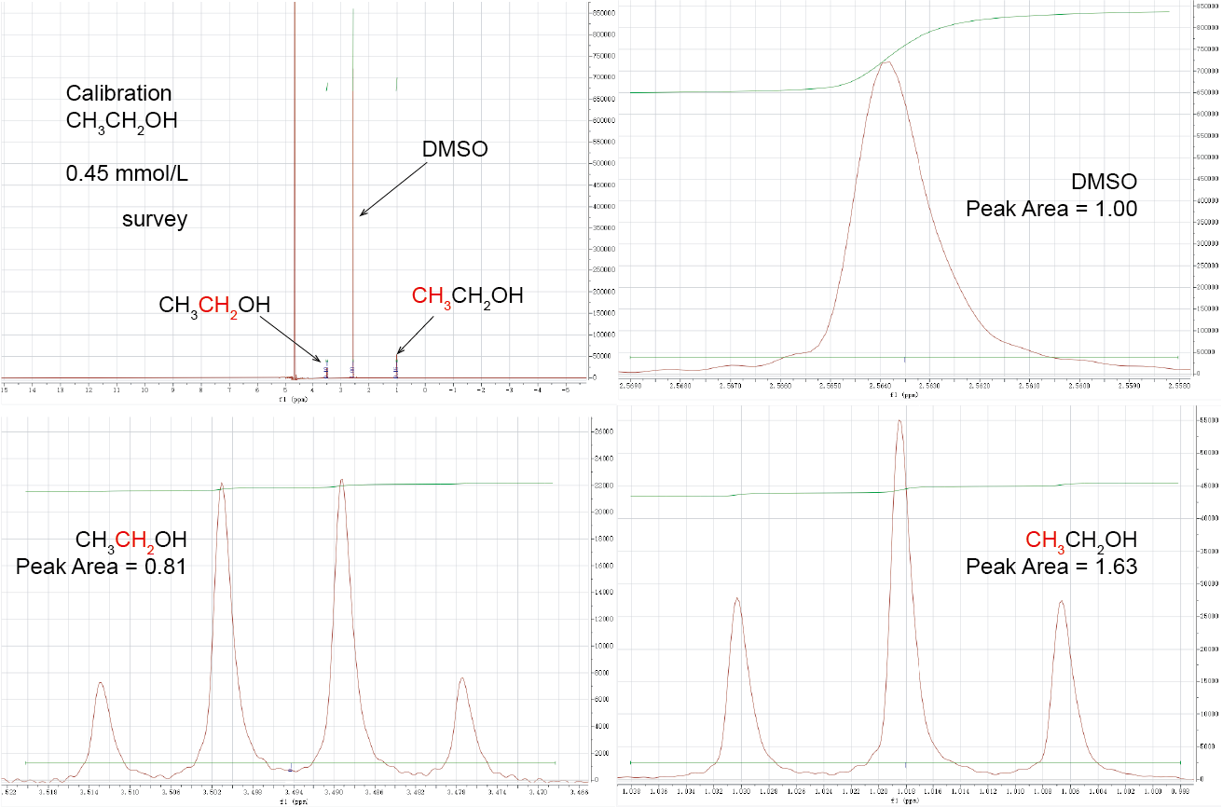
Extended data Fig. 1 | (a) The survey NMR spectrum of 0.45 mmol/L ethanol. The zoom in region of (b) DMSO, (c) CH₂ and (d) CH₃ with baseline and integrated peak area indicated.
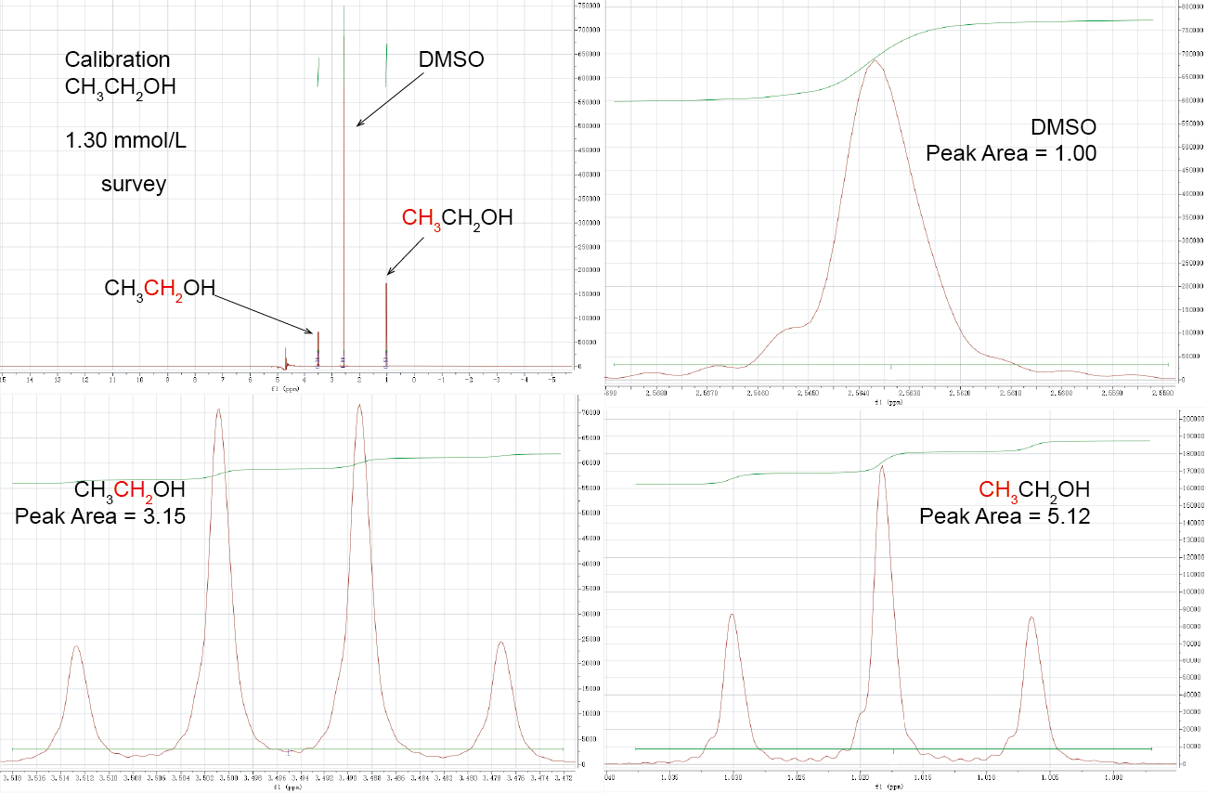
Extended data Fig. 2 | (a) The survey NMR spectrum of 1.30 mmol/L ethanol. The zoom in region of (b) DMSO, (c) CH₂ and (d) CH₃ with baseline and integrated peak area indicated.
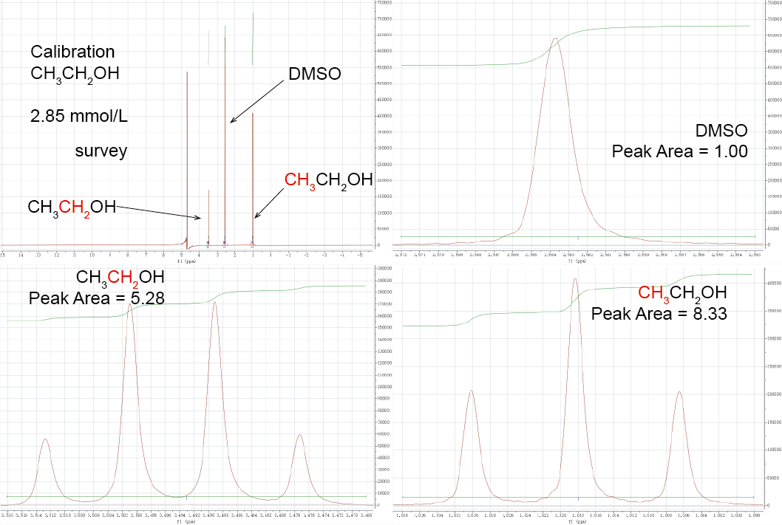
Extended data Fig. 3 | (a) The survey NMR spectrum of 2.85 mmol/L ethanol. The zoom in region of (b) DMSO, (c) CH₂ and (d) CH₃ with baseline and integrated peak area indicated.
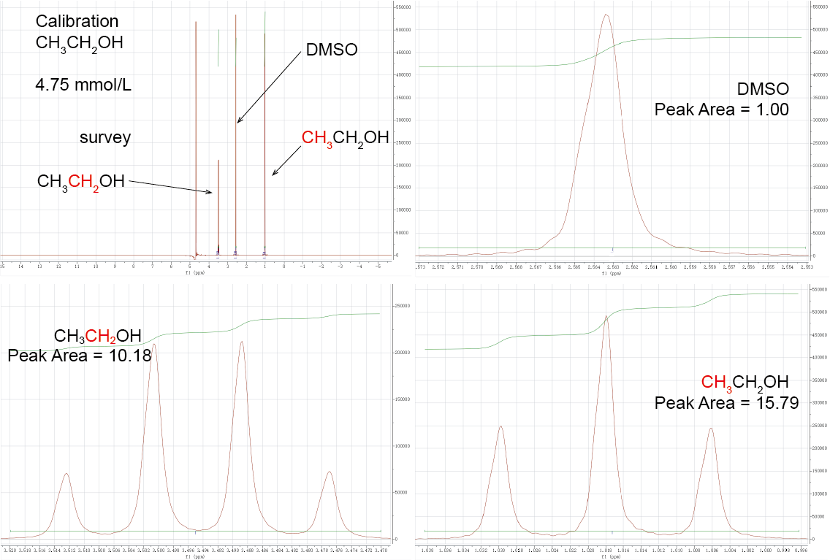
Extended data Fig. 4 | (a) The survey NMR spectrum of 4.75 mmol/L ethanol. The zoom in region of (b) DMSO, (c) CH₂ and (d) CH₃ with baseline and integrated peak area indicated.
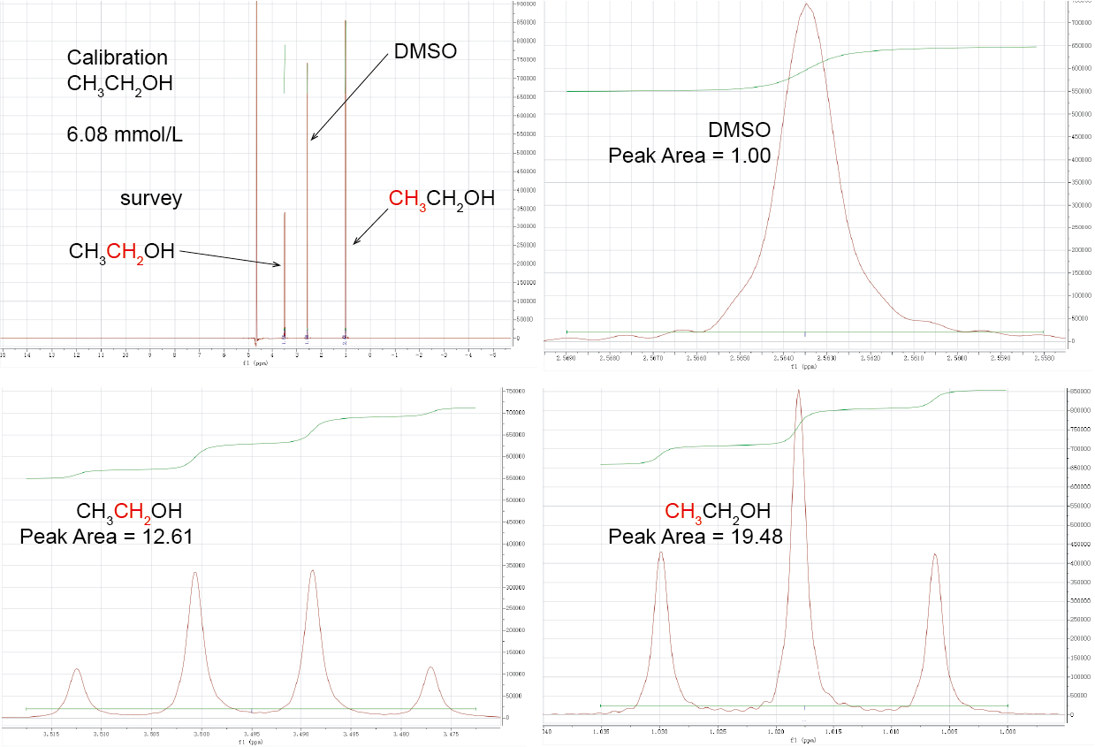
Extended data Fig. 5 | (a) The survey NMR spectrum of 6.08 mmol/L ethanol. The zoom in region of (b) DMSO, (c) CH₂ and (d) CH₃ with baseline and integrated peak area indicated.
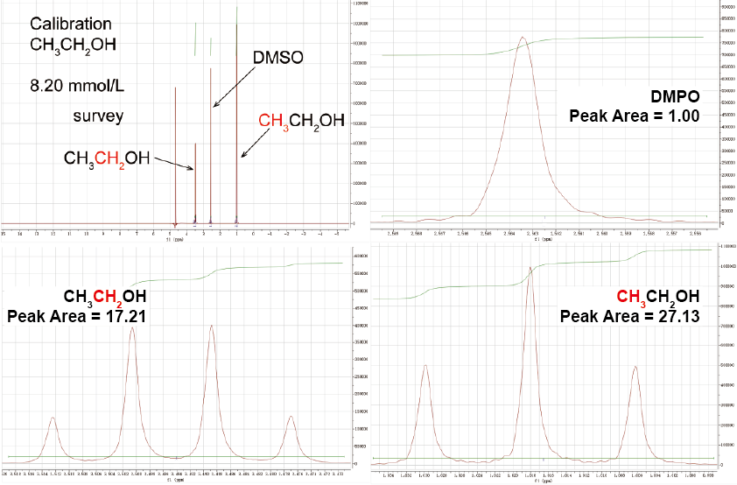
Extended data Fig. 6 | (a) The survey NMR spectrum of 8.20 mmol/L ethanol. The zoom in region of (b) DMSO, (c) CH₂ and (d) CH₃ with baseline and integrated peak area indicated.
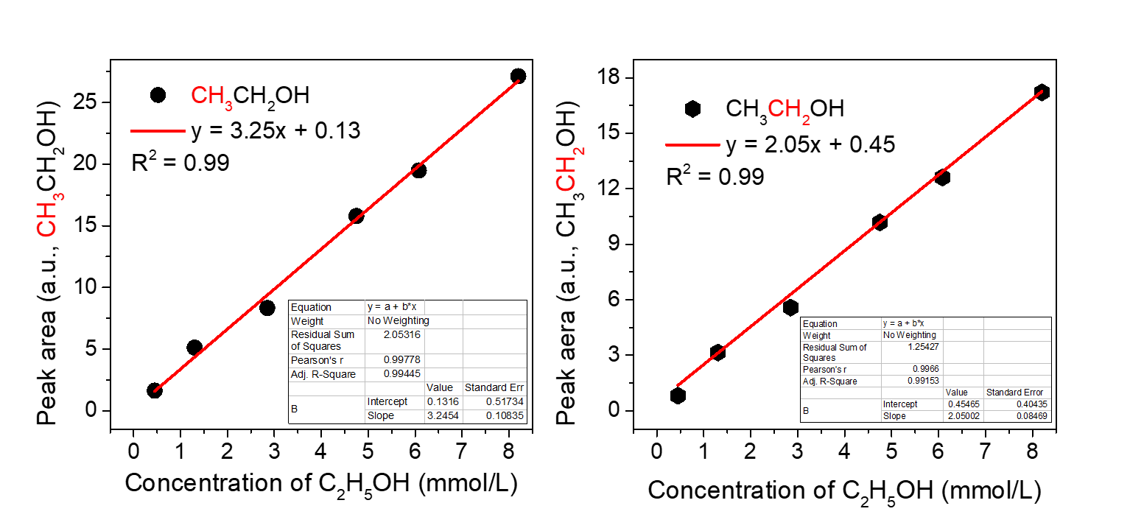

Extended data Fig. 7 | Calibration curves based on the area of the CH₃ and CH₂ peak in the NMR spectra.
The uncertainties of calibration by the peak area of CH₃ and CH₂ were determined based on the method described in the NIST/SEMATECH, e-Handbook of Statistical Methods (https://www.itl.nist.gov/div898/handbook/mpc/section3/mpc3672.htm). The calibration standard deviation based on the peak area of CH₃ and CH₂ was estimated to be 0.077 and 0.066 mmol/L, respectively.
The regression equation from the calibration experiment is:
$Y=a+bX$ (eq. 1)
Thus, based on the regression equation, by measuring the peak area of CH₃ or CH₂ from ¹H 1D NMR spectrum, the concentration of ethanol could be determined:
${{CC}_{i}=X}_{i}=\frac{Y_{i}-a}{b}$ (eq. 2)
Extended data Table 1. The concentration of ethanol determined based on calibration curves of CH₃ and CH₂.
 |  | y = 3.25x + 0.13 (CH₃CH₂OH) |  |  | y = 2.05x + 0.45 (CH₃CH₂OH)
 |  | AC | A | CC | AC | A | CC
1 |  | 2.5 | 7.70 | 2.33 | 2.5 | 5.39 | 2.41
2 |  | 4.8 | 15.83 | 4.83 | 4.8 | 10.66 | 4.98
3 |  | 6.0 | 20.02 | 6.12 | 6.0 | 12.52 | 5.89
4 |  | 7.5 | 25.09 | 7.68 | 7.5 | 15.89 | 7.53
AC represents the actual concentration (mmol/L), CC represents the calculated concentration (mmol/L) according to the calibration equation, and A represents the integrated peak area of NMR spectrum.
The four control measurements were made on reference standards with concentration of 2.5, 4.8, 6, and 7.5 mmol/L. Then, the difference between the estimated concentration (CC) from NMR measurement and the actual concentration (AC) was computed by eq. 3, the results are listed in Table 2:
$W_{i}={CC}_{i}-{AC}_{i}=\frac{(Y_{i}-a)}{b}-X_{i}$ (eq. 3)
Finally, the calibration standard deviation was estimated by:
$S=\sqrt{\frac{\sum{{(W_{i}-\overline{W})}^{2}}}{n-1}}$ (eq. 4)
where $\overline{W}=\frac{\sum_{1}^{n}{W_{i}}}{n}$.
Extended data Table 2. The uncertainties of calibration based on the peak area of CH₃ and CH₂.
 | y = y = 0.39x + 0.02 (CH₃CH₂OH) | y = 0.25x + 0.04 (CH₃CH₂OH)
 | W = CC-AC (mmol/L) | W = CC-AC (mmol/L)
1 | -0.17 | -0.09
2 | 0.03 | 0.18
3 | 0.12 | -0.11
4 | 0.18 | 0.03
S | 0.077 mmol/L | 0.067 mmol/L
The calibration standard deviation based on the peak area of CH₃ and CH₂ is 0.077 and 0.067 mmol/L, respectively.

The original NMR data for quantifying the liquid products at -0.6 to -1.1 V (vs. RHE) are displayed as the following:
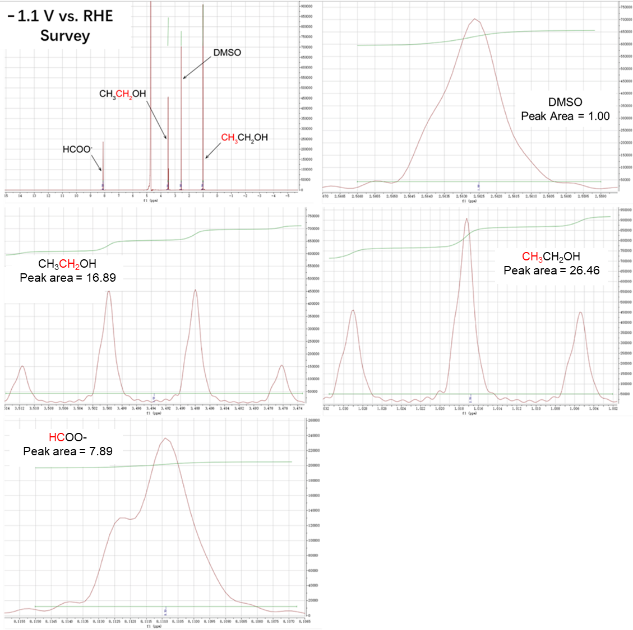
Extended data Fig. 8 | ¹H 1D NMR spectra of products and DMSO at -1.1 V (vs. RHE), with baseline and integrated peak area indicated.
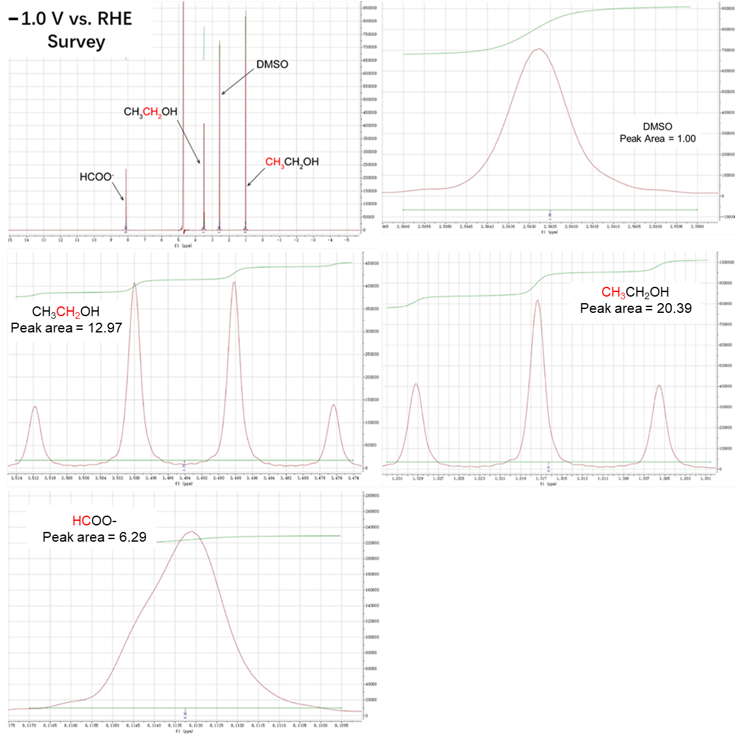
Extended data Fig. 9 | ¹H 1D NMR spectra of products and DMSO at -1.0 V (vs. RHE), with baseline and integrated peak area indicated.
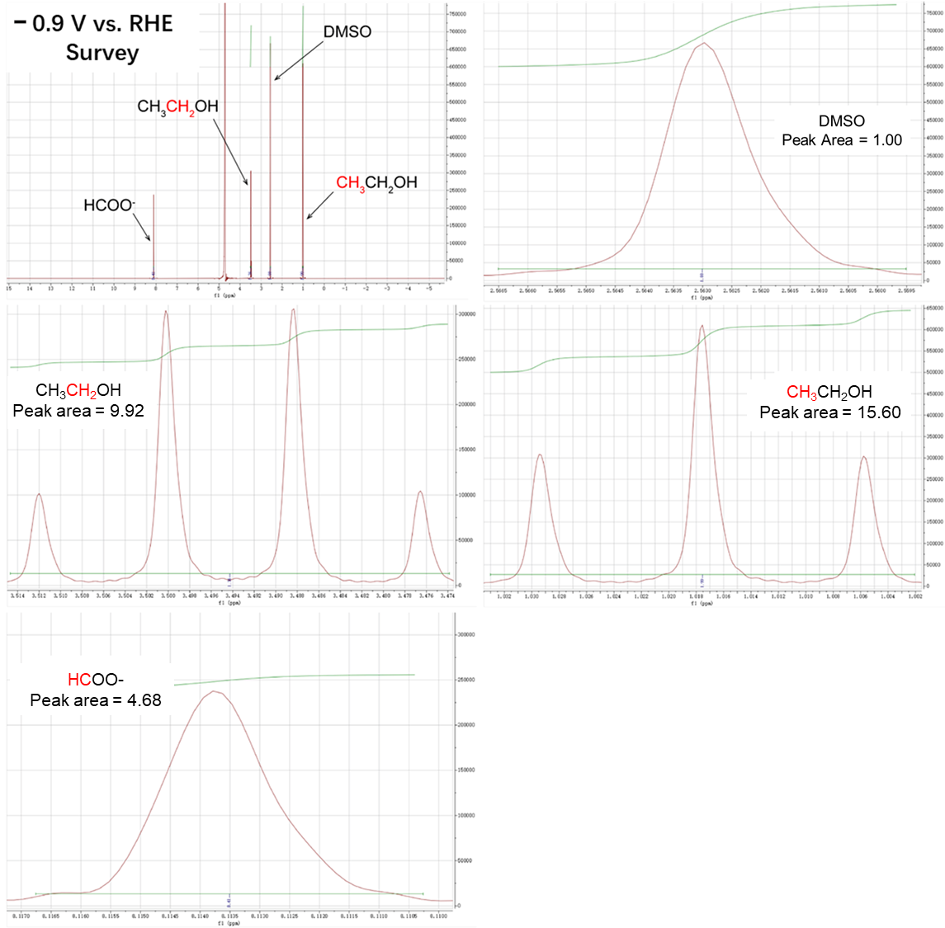
Extended data Fig. 10 | ¹H 1D NMR spectra of products and DMSO at -0.9 V (vs. RHE), with baseline and integrated peak area indicated.
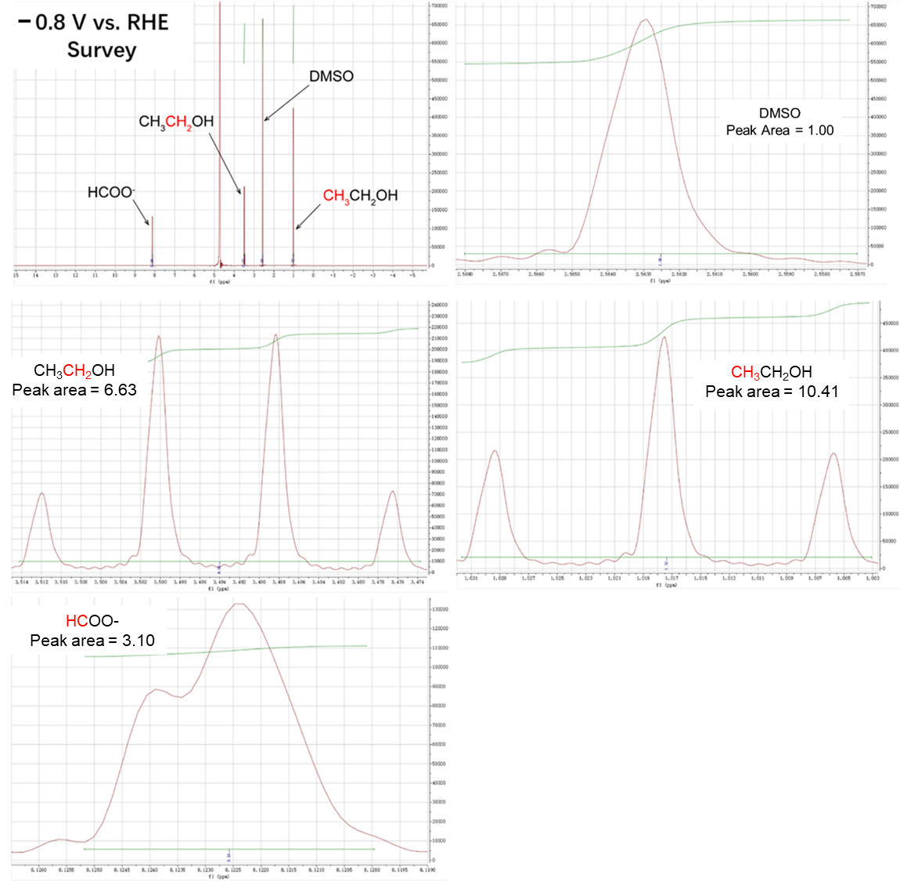
Extended data Fig. 11 | ¹H 1D NMR spectra of products and DMSO at -0.8 V (vs. RHE), with baseline and integrated peak area indicated.

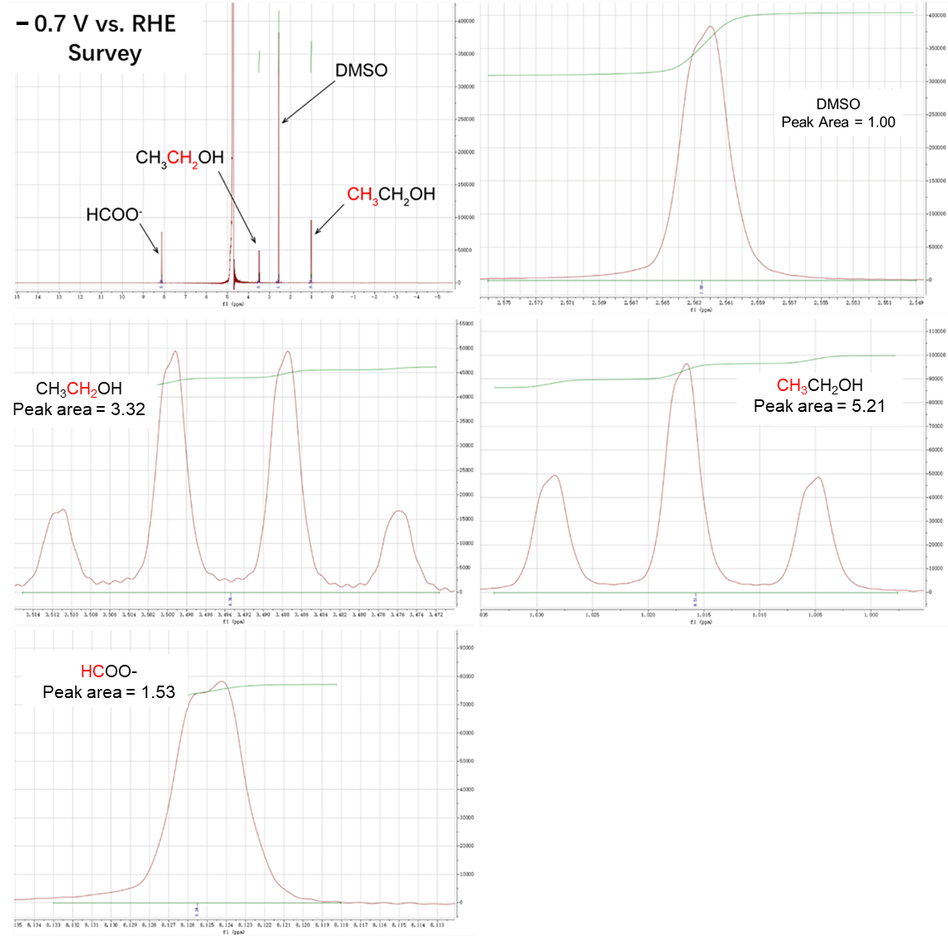
Extended data Fig. 12 | ¹H 1D NMR spectra of products and DMSO at -0.7 V (vs. RHE), with baseline and integrated peak area indicated.
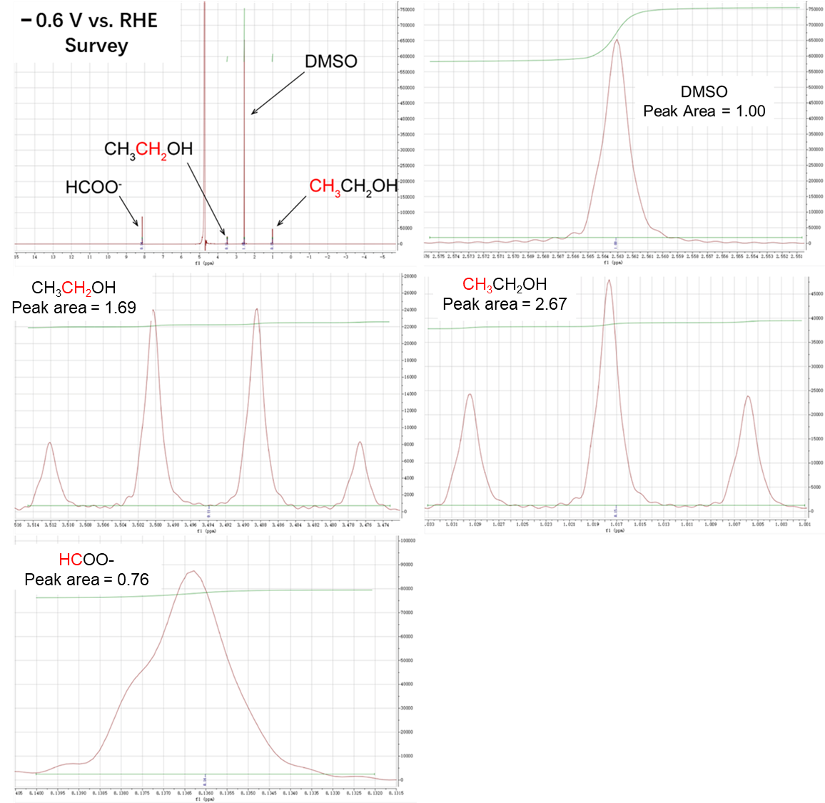
Extended data Fig. 13 | ¹H 1D NMR spectra of products and DMSO at -0.6 V (vs. RHE), with baseline and integrated peak area indicated.

The concentrations of ethanol produced using isotopically labelled ¹³CO₂ as the reactant were determined by the calibration curve (Extended data Fig. 20), in which the standards were constructed using the ¹³C isotopically labelled ethanol (¹³CH₃¹³CH₂OH) (Extended data Figs. 14-19).
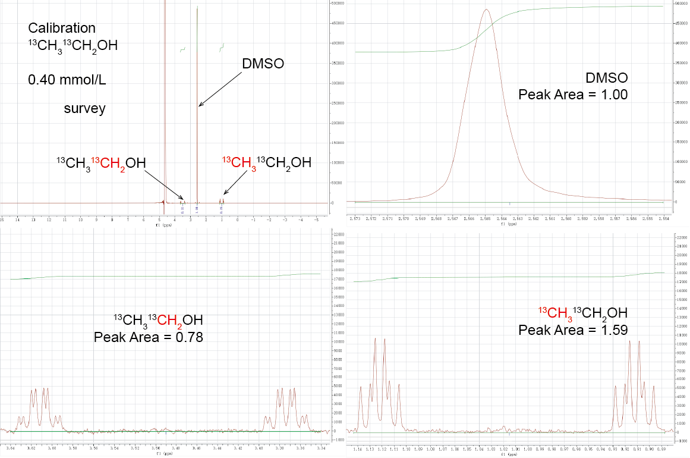
Extended data Fig. 14 | (a) The survey NMR spectrum of 0.40 mmol/L ¹³C labelled ethanol (¹³CH₃¹³CH₂OH). The zoom in region of (b) DMSO, (c) CH₂ and (d) CH₃ with baseline and integrated peak area indicated.

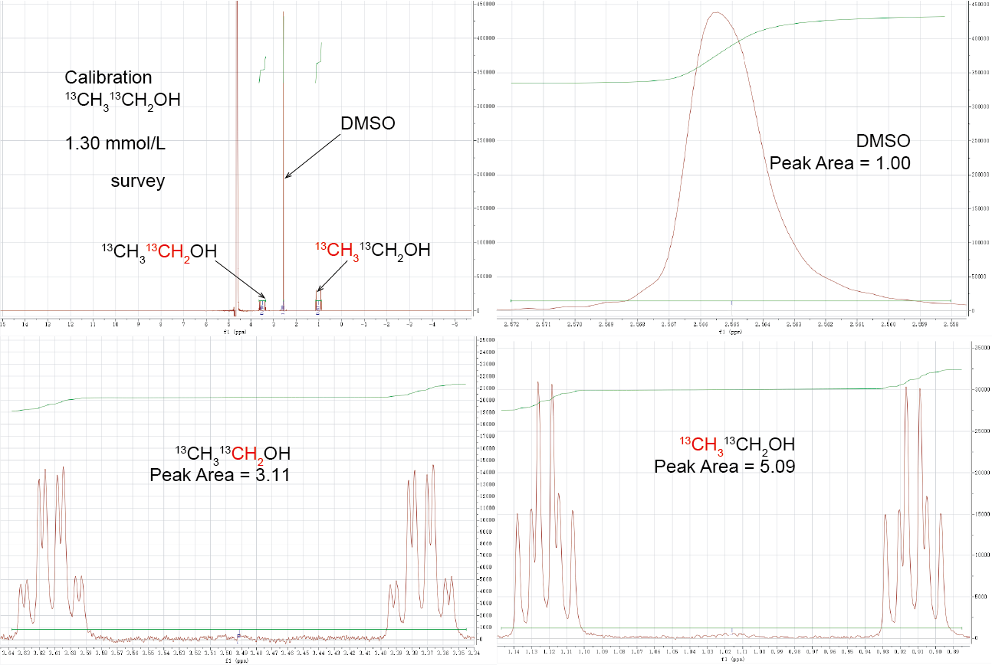
Extended data Fig. 15 | (a) The survey NMR spectrum of 1.30 mmol/L ¹³C labelled ethanol (¹³CH₃¹³CH₂OH). The zoom in region of (b) DMSO, (c) CH₂ and (d) CH₃ with baseline and integrated peak area indicated.
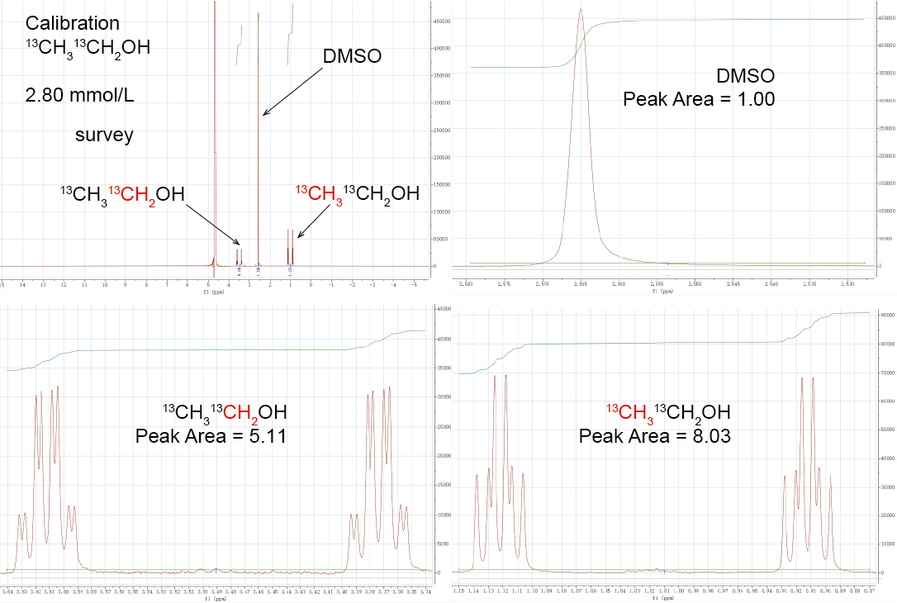
Extended data Fig. 16 | (a) The survey NMR spectrum of 2.80 mmol/L ¹³C labelled ethanol (¹³CH₃¹³CH₂OH). The zoom in region of (b) DMSO, (c) CH₂ and (d) CH₃ with baseline and integrated peak area indicated.
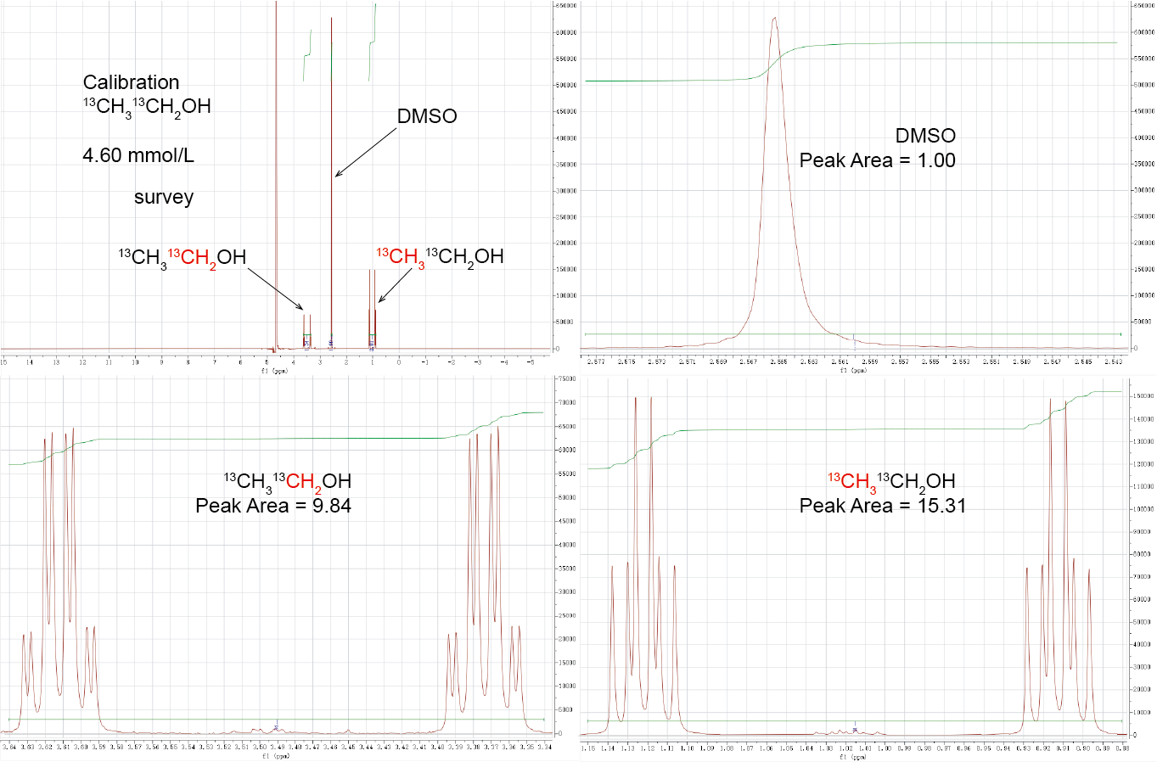
Extended data Fig. 17 | (a) The survey NMR spectrum of 4.60 mmol/L ¹³C labelled ethanol (¹³CH₃¹³CH₂OH). The zoom in region of (b) DMSO, (c) CH₂ and (d) CH₃ with baseline and integrated peak area indicated.
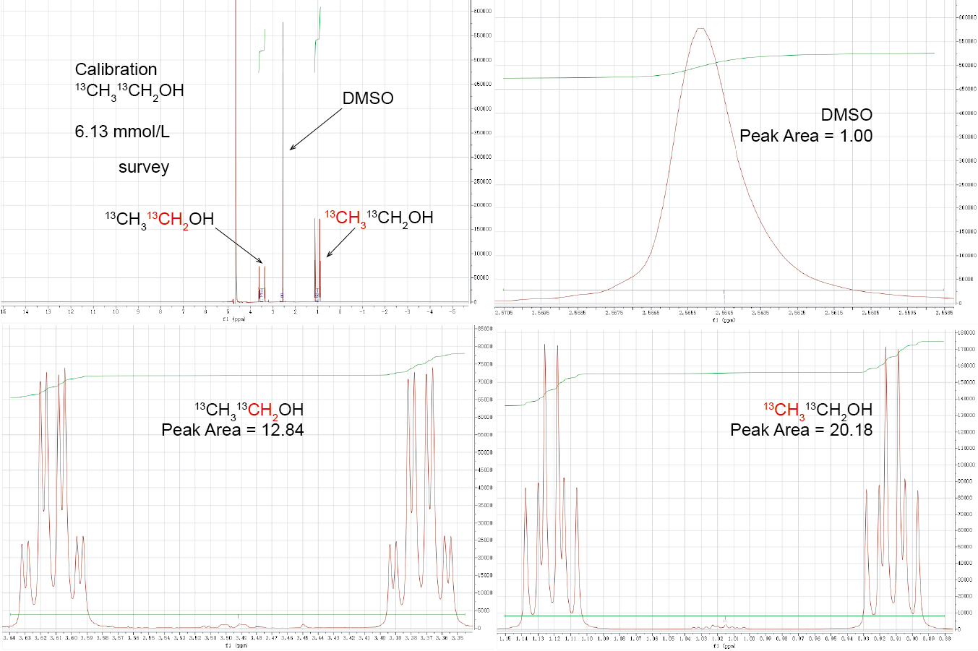
Extended data Fig. 18 | (a) The survey NMR spectrum of 6.13 mmol/L ¹³C labelled ethanol (¹³CH₃¹³CH₂OH). The zoom in region of (b) DMSO, (c) CH₂ and (d) CH₃ with baseline and integrated peak area indicated.
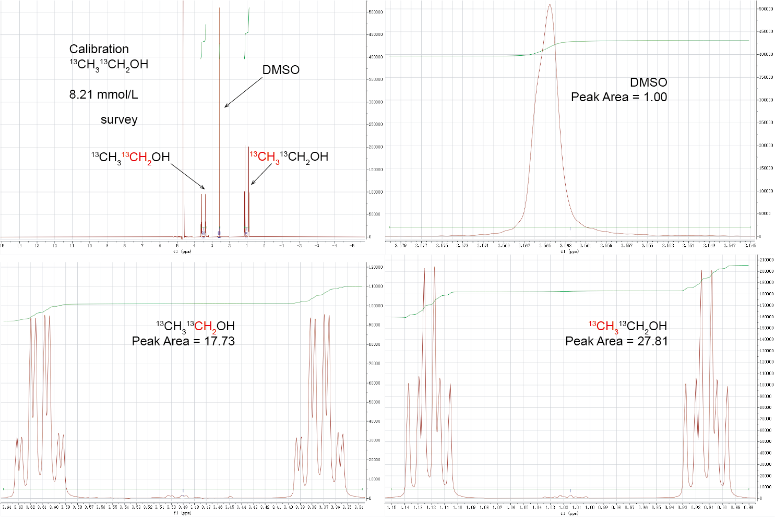
Extended data Fig. 19 | (a) The survey NMR spectrum of 8.21 mmol/L ¹³C labelled ethanol (¹³CH₃¹³CH₂OH). The zoom in region of (b) DMSO, (c) CH₂ and (d) CH₃ with baseline and integrated peak area indicated.
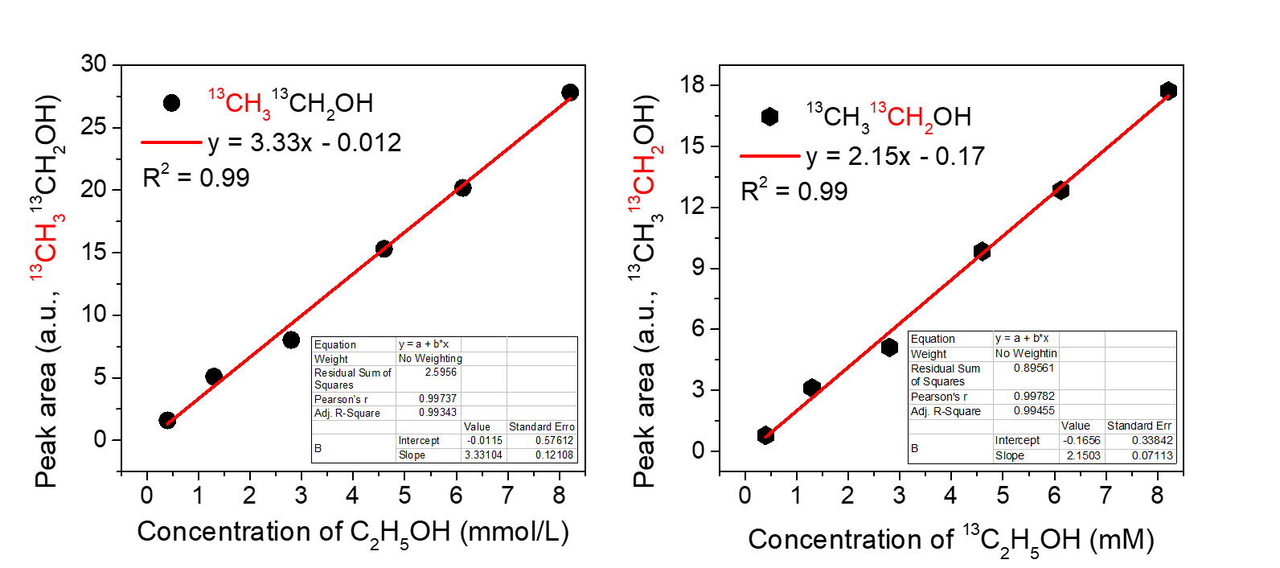
Extended data Fig. 20 | Calibration curves based on the area of the ¹³CH₃ and ¹³CH₂ peak in the NMR spectra.
Extended data Table 3. The concentration of ethanol determined based on calibration curves of ¹³CH₃ and ¹³CH₂.
 | y = 3.33x – 0.012 (¹³CH₃CH₂OH) |  |  | y = 2.15x - 0.17 (CH₃¹³CH₂OH)
 | AC | A | CC | AC | A | CC
1 | 0.52 | 1.62 | 0.49 | 0.52 | 1.01 | 0.55
2 | 1.68 | 5.72 | 1.72 | 1.68 | 3.38 | 1.65
3 | 3.20 | 10.88 | 3.27 | 3.20 | 6.62 | 3.16
4 | 5.80 | 18.14 | 5.45 | 5.80 | 12.41 | 5.85
AC represents the actual concentration (mmol/L), CC represents the calculated concentration according to the calibration equation (mmol/L), and A represents the integrated peak area of NMR spectrum.

The four control measurements were made on reference standards with concentration of 0.52, 1.68, 3.2 and 5.8 mmol/L.
Extended data Table 4. The uncertainties of calibration based on the peak area of ¹³CH₃ and ¹³CH₂.
 | y = 0.41x + 0.04 (¹³CH₃CH₂OH) | y = 0.28x + 0.02 (CH₃¹³CH₂OH)
 | W = CC-AC (mmol/L) | W = CC-AC (mmol/L)
1 | -0.03 | 0.03
2 | 0.04 | -0.03
3 | 0.07 | -0.04
4 | -0.05 | 0.05
S | 0.028 mmol/L | 0.022 mol/L
The calibration standard deviation based on the peak area of ¹³CH₃ and ¹³CH₂ is 0.028 and 0.022 mmol/L, respectively.
The electrolyte solution after the CO₂RR (20 mL) was mixed with 50 µL of internal standard 99.99% dimethyl sulfoxide (DMSO) and 0.2 mL of D₂O. Then 0.5 mL of the solution was sent for the ¹H NMR measurement.
The Faradaic efficiency (FE) of each liquid product was calculated by:
$$FE=\frac{12×96500×2×peak area of CH_{3}×concentration of DMSO}{Q×peak area of DMSO}$$
where peak area of DMSO is 1, concentration of DMSO is 0.035 mol/L; Q = I × t, in which I (in amperes) is the reduction current at a specific applied potential and t is the reaction time (in seconds) for constant current reduction.
To study the C-C coupling reaction mechanism, a 0.5 M potassium bicarbonate aqueous solution (20 mL) was used as the electrolyte for CO₂RR with addition of 50 µL HCOOH. A 0.5 M sodium sulfate aqueous solution (25 mL) was also used as the electrolyte for CO₂RR with addition of different quantity of HCOOH to study the influence of HCOOH.
We further conducted isotope labeling experiments to study the intermediates involved in the CO₂RR. The concentrations of ethanol produced using isotopically labelled ¹³CO₂ as the reactant were determined by the calibration curve (Extended data Fig. 20), in which the standards were constructed using the ¹³C isotopically labelled ethanol (¹³CH₃¹³CH₂OH). Moreover, the uncertainties of calibration were calculated, they are 0.028 and 0.022 mmol/L for calibrations based on the peak area of ¹³CH₃ and ¹³CH₂, respectively. A 0.5 M potassium bicarbonate aqueous solution (20 mL) was used as the electrolyte; a mass flow controller was used to control the ¹²CO₂ (¹³CO₂) flow rate at 20 sccm for CO₂RR with addition of 50 µL of H¹³COOH (H¹²COOH).

X-ray absorption spectroscopy
X-ray absorption spectroscopy (XAS) was collected by employing synchrotron radiation light source at BL14W1 beamline of Shanghai Synchrotron Radiation Facility (SSRF) at room temperature. Energy calibration was performed with a tin foil standard by shifting all spectra to a glitch in the incident intensity. Fluorescence spectra were recorded using a seven-element Ge solid state detector. Extended X-ray absorption fine structure (EXAFS) spectra were fitted using the FEFF 8.2 code and the structure parameters of Sn₁-O3G was obtained from the DFT calculation. The K-edge X-ray absorption spectra of C and O were measured in total electron yield mode (TEY-XAS) at room temperature using BL-20A at the National Synchrotron Radiation Research Center (Hsinchu, Taiwan).
Theoretical and computational methods
All density functional theory (DFT) calculations were performed using the Vienna Ab-initio Simulation Package (VASP) ^{2,3}. The electron exchange and correlation energy were treated within the generalized gradient approximation (GGA) in the Perdew-Burke-Ernzerhof scheme (PBE) ⁴. The interaction between ions and electrons was described by the projector augmented wave (PAW) method. To examine the effect of van der Waals interaction on reaction energetics, calculations were performed using the DFT-D3 functional with PBE-PAW potentials ^{5,6}. Iterative solutions of the Kohn-Sham equations were expanded in a plane-wave basis sets defined by a kinetic energy cutoff of 400 eV, and the Brillouin zone was sampled using a 2 × 2 × 1 Monkhorst-Pack grid. The convergence criteria for the electronic self-consistent iteration and force were set to 10⁻⁵ eV and 0.02 eV/Å, respectively. A vacuum region of 15 Å was set between the periodically repeated slabs to avoid artificial interactions.
The adsorption energies (E_{ads}) were calculated according to the equation,
E_{ads} = E(adsorbate/substrate) -[E(substrate) + E(adsorbate)]
where E(adsorbate/substrate), E(substrate) and E(adsorbate) represent the total energy of substrate with adsorbed species, the clean substrate and the molecule in the gas phase, respectively. Each electrochemical reaction step of CO₂ reduction involves a (H⁺ + e⁻) pair transfer from the adsorbed species on the surface to the electrolyte. The energy change of each (H⁺ + e⁻) pair transfer reaction was calculated using the computational hydrogen electrode (CHE) method developed by Nørskov et al ^{6,7}. The free energy (ΔG⁰) was calculated by:
ΔG⁰ = ΔE + ΔZPE + Δ_{0→298K}ΔH – TΔS
The reaction enthalpy (ΔH) of an elementary step was estimated by the reaction energy ΔE from DFT calculations with zero-point energy (ZPE) correction and enthalpy correction (Δ_{0→298K}ΔH); TΔS is the change in entropy contribution to the free energy. The enthalpy and entropy of the ideal gas were taken from the standard thermodynamic tables.
Extended data figures:

Extended data Fig. 21 ǀ A schematic illustration showing the procedure to prepare 3D carbon.

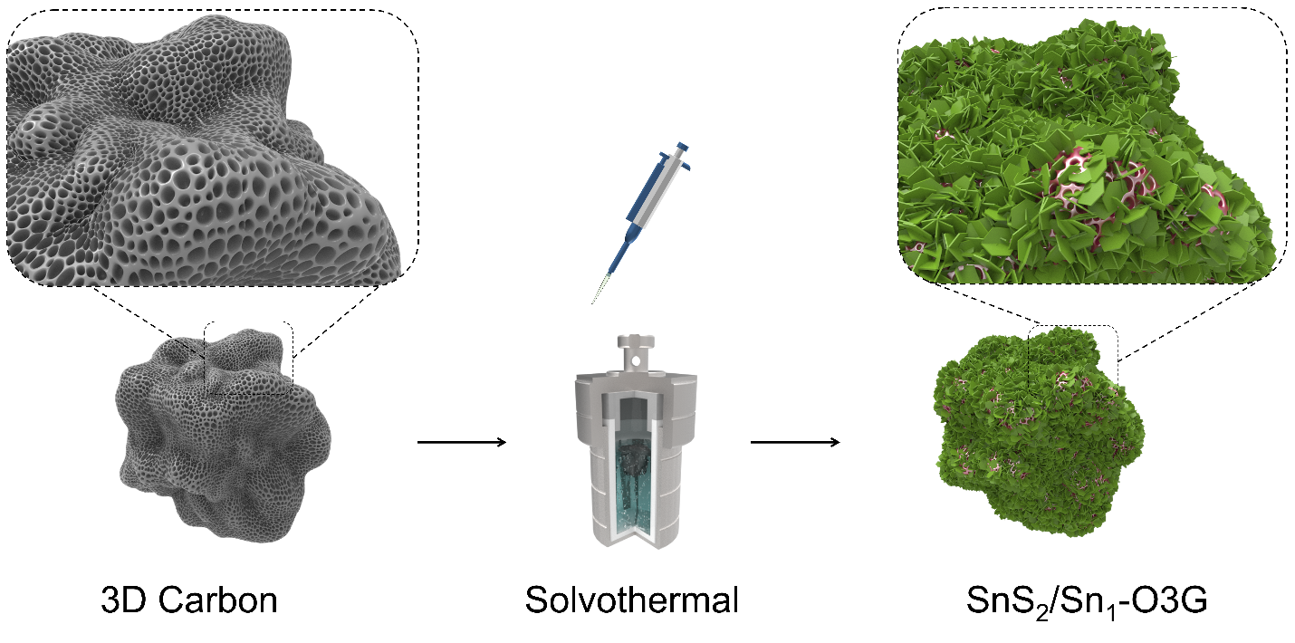
Extended data Fig. 22 | A schematic illustration showing the procedure to prepare SnS₂/Sn₁-O3G.

Extended data Fig. 23 | Electrochemical CO₂RR setup. (a) A H-type electrochemical cell used for CO₂RR. WE: working electrode, CE: counter electrode, and RE: reference electrode. (b) GC used to quantity the gas phase products, and (c) NMR used to quantify the liquid products.

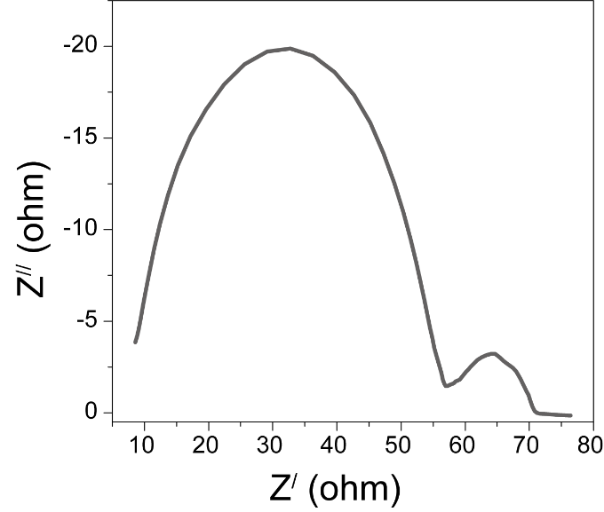
Extended data Fig. 24 | The EIS spectrum of SnS₂/Sn₁-O3G.

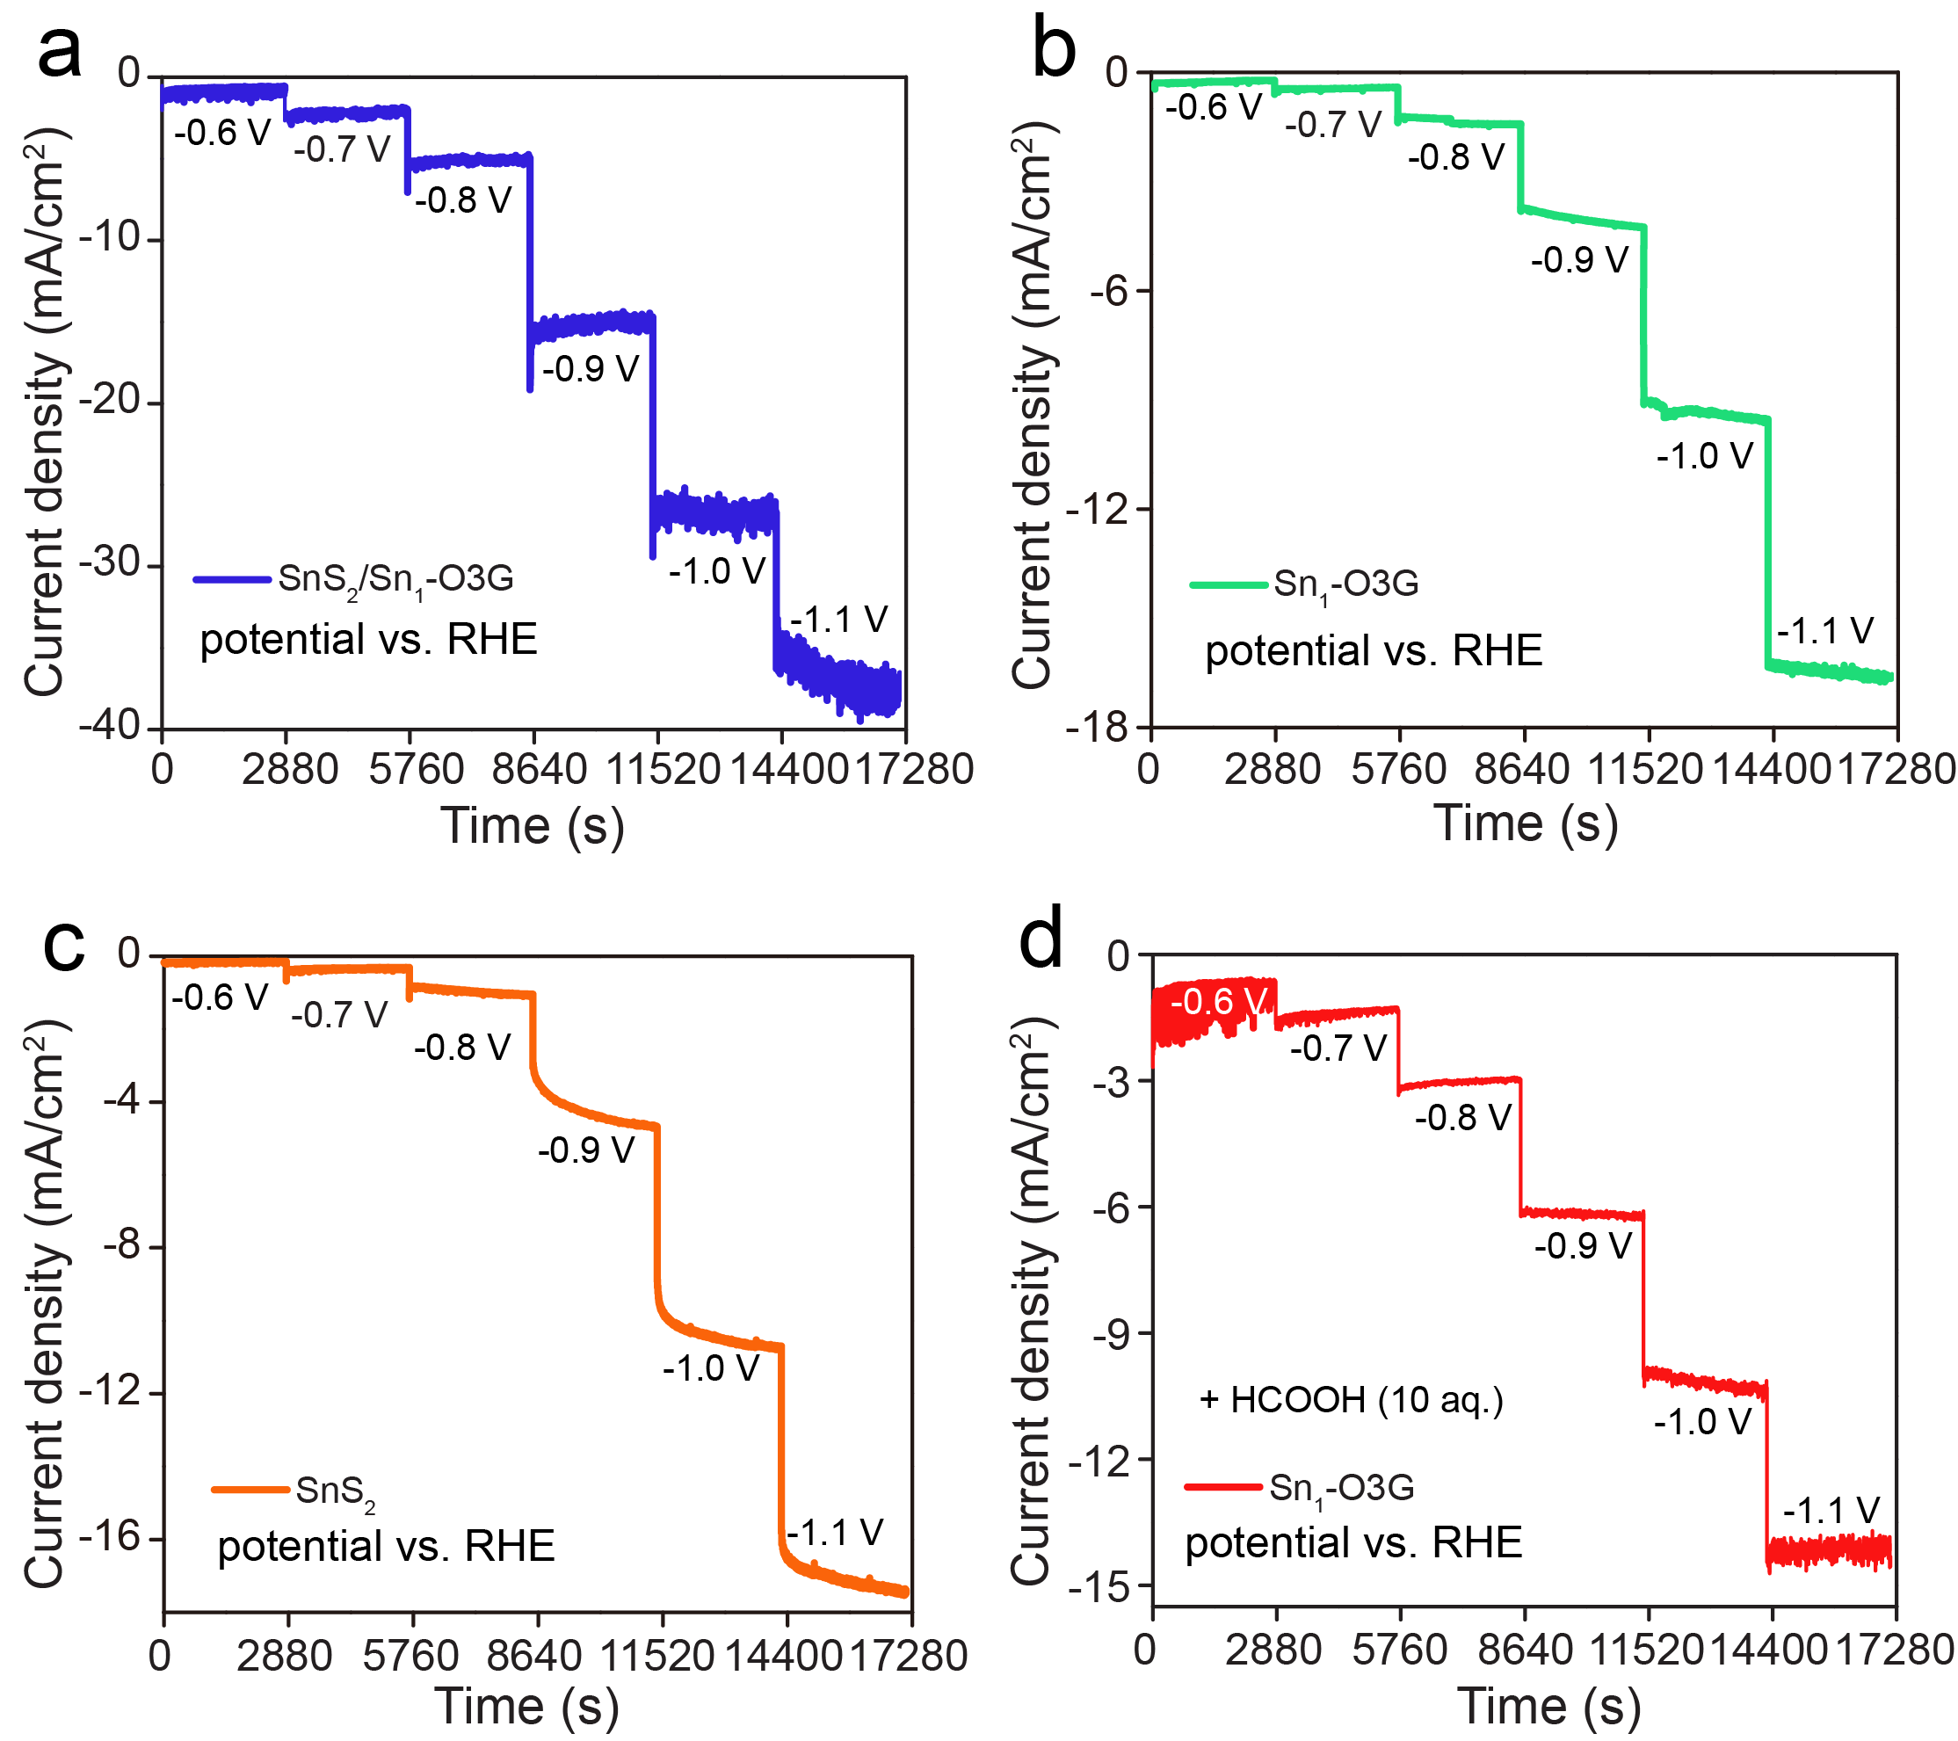
Extended data Fig. 25 | Chronoamperometric curve of (a) SnS₂/Sn₁-O3G, (b) Sn₁-O3G, and (c) SnS₂ electrode under bias from -0.6 to -1.1 V versus RHE in 0.5 M CO₂-saturated KHCO₃ aqueous solution. (d) Chronoamperometric curve of Sn₁-O3G with adding HCOOH.

Extended data Fig. 26 | (a) NMR spectra of the electrolyte solution after 5 hours of CO₂RR at -0.6 to -1.1 V (vs. RHE) for SnS₂/Sn₁-O3G, (b) NMR spectra showing the CH₃ peaks and (c) the integrated peak area of CH₃ peaks.

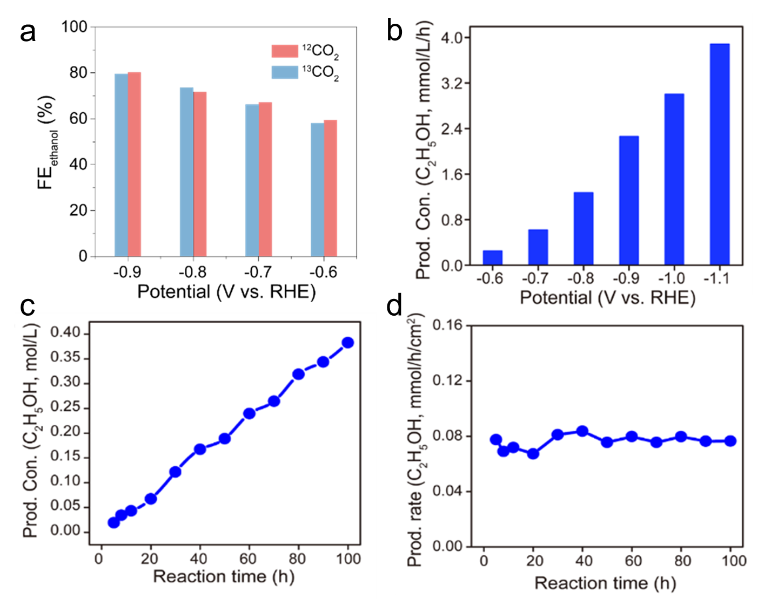
Extended data Fig. 27 | (a) Comparison of Faradaic efficiency of ethanol with ¹³CO₂ and ¹²CO₂ as the reactant. (b) Concentration of ethanol produced at various applied cathodic potentials in the H-type cell for SnS₂/Sn₁-O3G. (c) Rate, and (d) specific rate (normalized to geometric electrode area) of ethanol produced at -0.9 V (vs. RHE) in the H-type cell for SnS₂/Sn₁-O3G in 100 h. All measurements were performed at 1 atm CO₂ and room temperature in 0.5 M KHCO₃ (pH = 7.3). Electrode area: 1 cm² and volume of cathodic electrolyte: 20 ml.

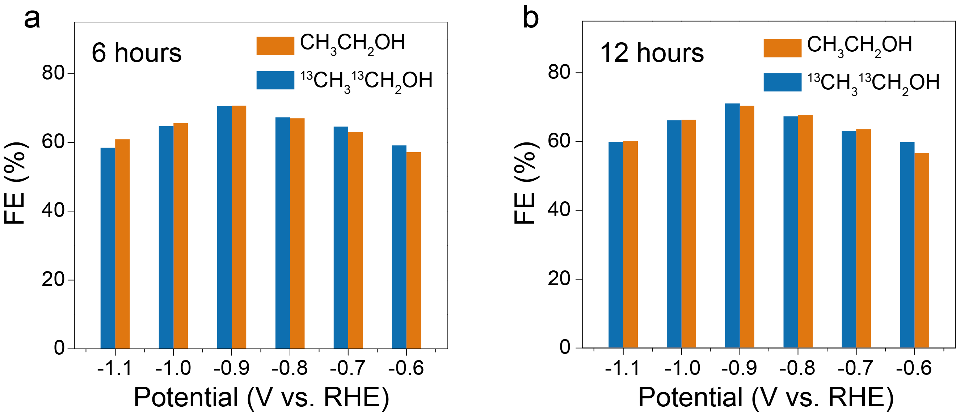
Extended data Fig. 28 | (a) Comparison of Faradaic efficiency of ethanol with ¹³CO₂ and ¹²CO₂ as the reactant after 6 hours of reaction at different applied potentials. (b) Comparison of Faradaic efficiency of ethanol with ¹³CO₂ and ¹²CO₂ as the reactant after 12 hours of reaction at different applied potentials. All measurements were performed at 1 atm CO₂ and room temperature in CO₂-saturated 0.5 M KHCO₃ (CO₂ + KOH → KHCO3) (pH = 7.3). Electrode area: 1 cm² and volume of cathodic electrolyte: 20 ml.

Extended data Fig. 29 | (a) Transmission electron microscopy image and the corresponding line-scan TEM-EDX elemental analysis, and (b) elemental mapping of the SnS₂/Sn₁-O3G.

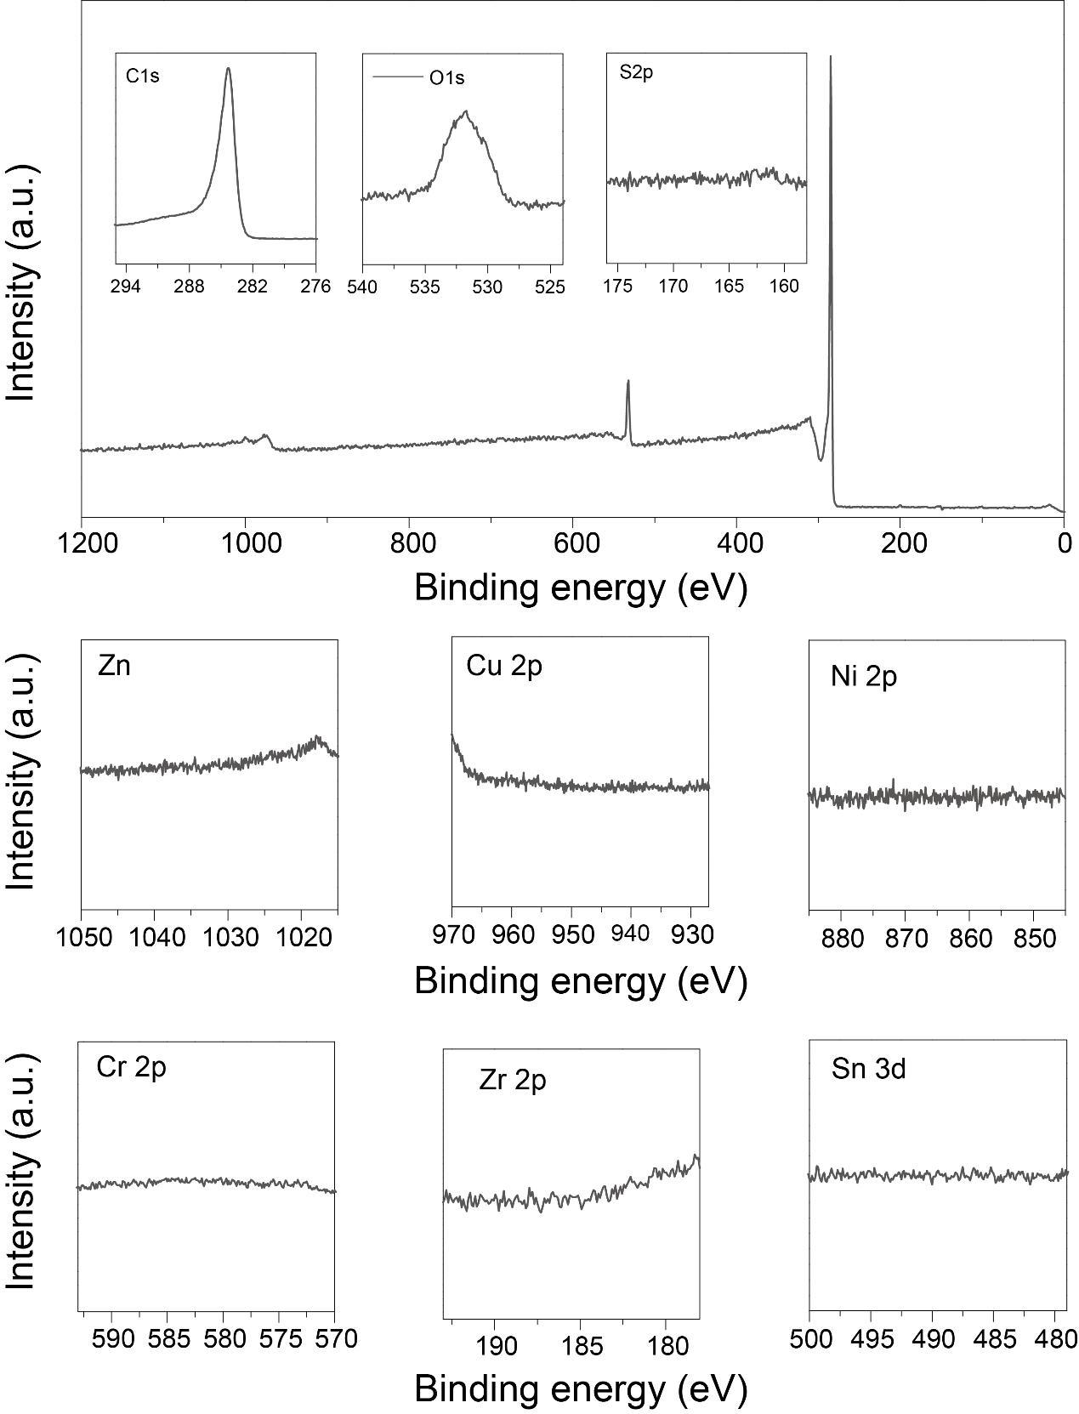
Extended data Fig. 30 | XPS spectra of 3D carbon to determine metal contamination.
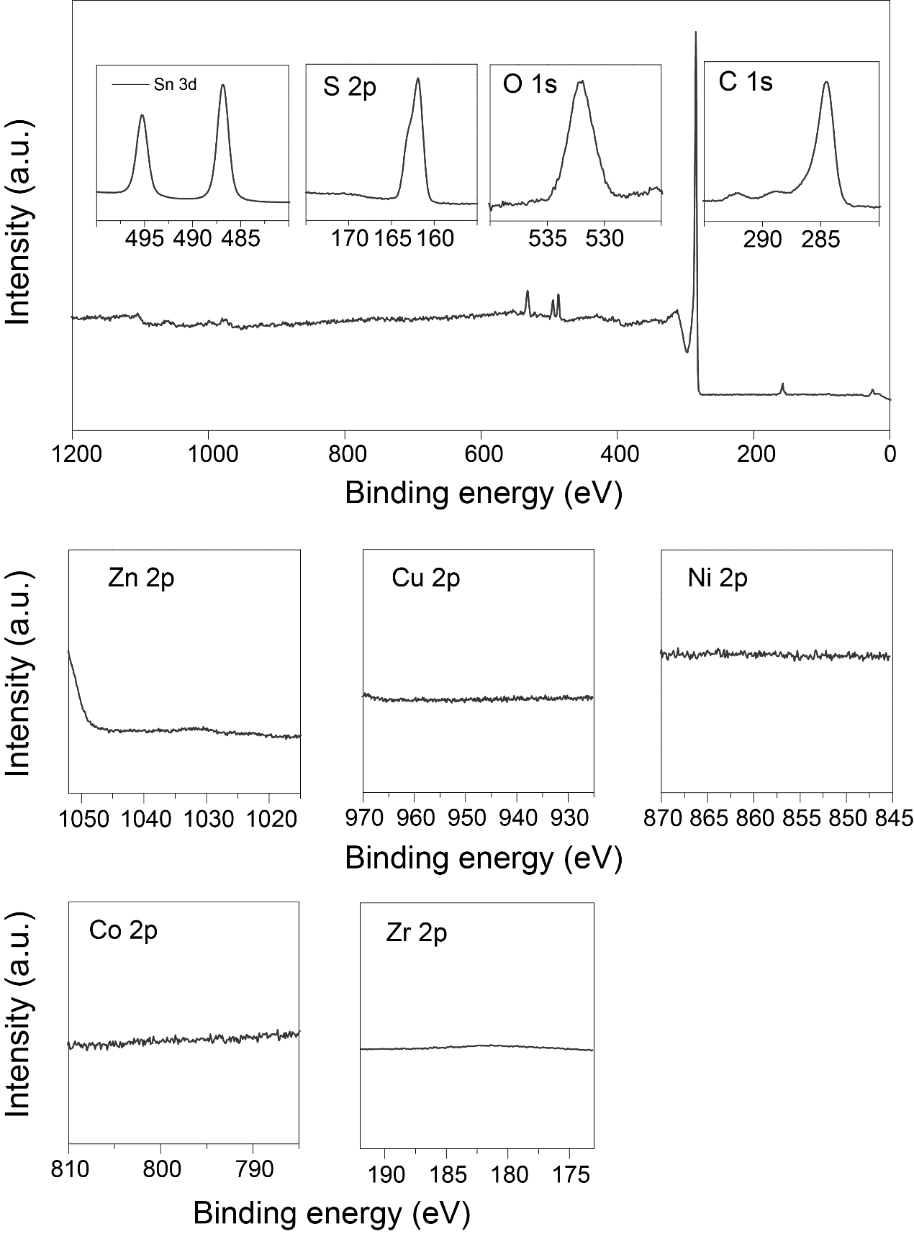
Extended data Fig. 31 | XPS spectra of SnS₂/Sn₁-O3G to determine metal contamination.
Extended data Fig. 32 | Sn 2p (a), S 2p (b), C 1s (c), and O 1s (d) XPS spectrum for SnS₂/Sn₁-O3G.
Note: The high-resolution C 1s XPS spectrum can be deconvoluted into three peaks. The most obvious peak is located at 284.6 eV, which can be assigned to the sp²-hydridized C-C/C=C bonds. The peaks in the binding energy ranges of 285.6-286.6 and 288.6-290.3 eV are ascribed to the C-O and C=O bonds. The O 1s XPS spectrum are deconvoluted into three peaks at 530.5, 532.0 and 533.1 eV, respectively, corresponding to O=C, O-C and O-C=O. Two peaks at 486.9 and 495.3 eV corresponding to Sn 3d_{5/2} and Sn 3d_{3/2} suggest Sn⁴⁺ in SnS₂/Sn₁-O3G. The peaks at 161.6 and 163.1 eV show the existence of SnS₂ in SnS₂/Sn₁-O3G.
Extended data Fig. 33 | (a-c) XPS spectrum of C 1s, O 1s, and Sn 2p. (d) Mössbauer spectrum of Sn₁-O3G.
Note: Mossbauer spectrum of Sn₁-O3G shows a single peak with isomer shift of 0.088 mm s⁻¹ and quadrupole splitting of 0.22 mm s⁻¹, which agrees well with Sn⁴⁺ ^{8,9,10}, indicating that the valence state of Sn in Sn₁-O3G is +4.

Extended data Fig. 34 | (a-c) SEM images. (d) STEM image and the corresponding elemental mappings for Sn₁-O3G.

Extended data Fig. 35 | (a) HAADF-STEM image showing the atomic configuration of Sn atoms. (b) The corresponding line profile of Sn atoms as shown in (a).
Extended data Fig. 36 | Wavelet transform of the k³-weighted EXAFS data of reference Sn foil, Sn²⁺ and Sn⁴⁺ samples.

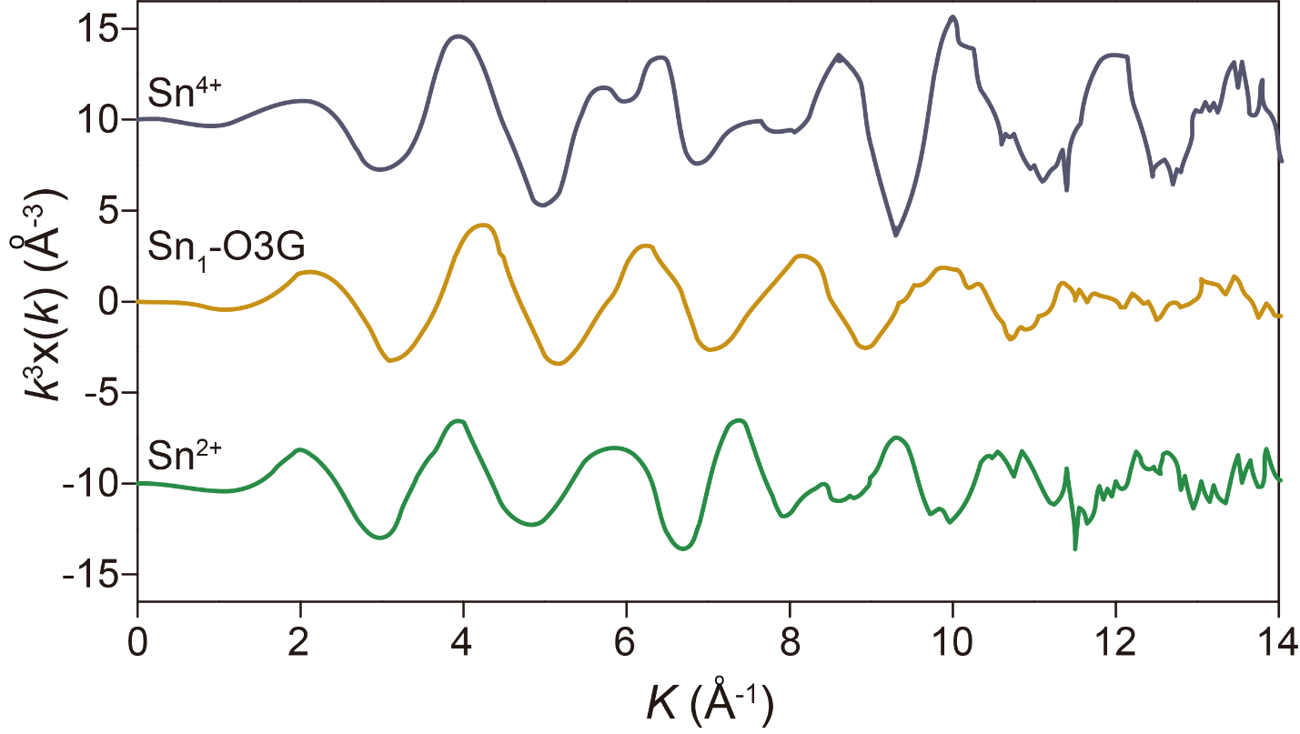
Extended data Fig. 37 | Sn²⁺, Sn⁴⁺ and Sn₁-O3G in k3-weighted k-space spectra.

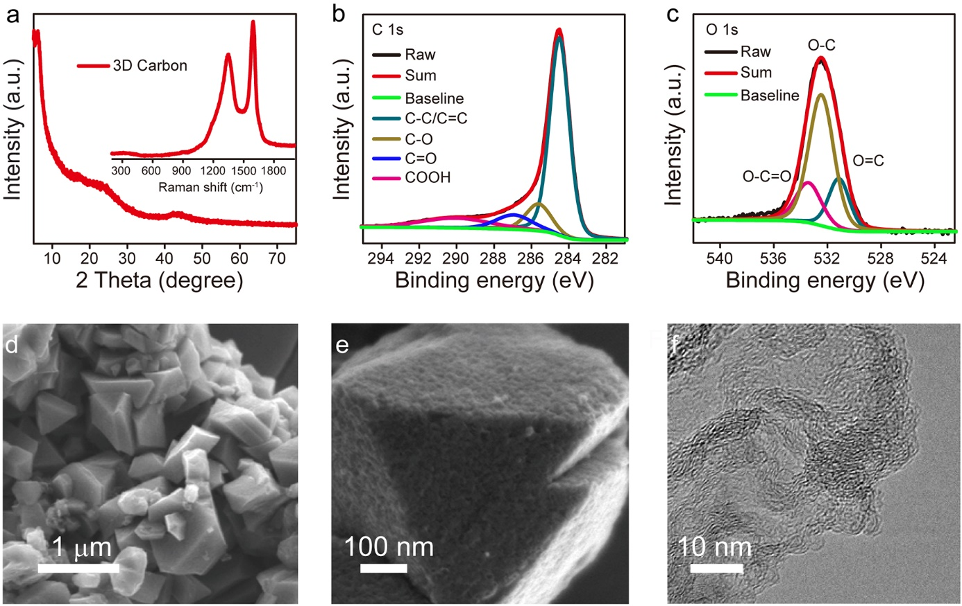
Extended data Fig. 38 | Characterization of the as-prepared 3D carbon. (a) XRD pattern and Raman spectrum (inset). High-resolution XPS spectrum of (b) C 1s and (c) O 1s. (d, e) SEM images and (f) TEM image.
Note: The as-prepared 3D carbon keeps the morphology of the HY zeolite, characterized by the graphitic-G band at ∼1350 cm⁻¹ and the D band at ∼1580 cm⁻¹ in the Raman spectrum. The high-resolution XPS spectrum of C 1s can be divided into four peaks, ascribed to the sp² hybridized C-C/C=C, C-O, C=O and O-C=O bonds, respectively. High-resolution O 1s XPS spectrum confirms presence of O-C, O=C and O-C-O groups on surface of 3D carbon.

Extended data Fig. 39 | Carbon and oxygen K-edge XANES spectra of Sn₁-O3G.

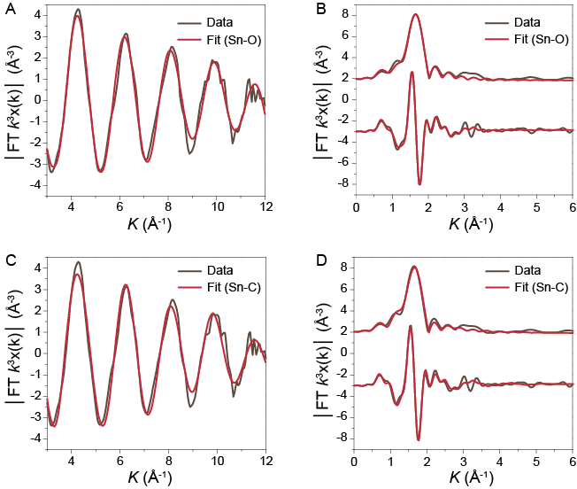
Extended data Fig. 40 | First-shell fitting of the Fourier transformation of EXAFS spectrum of Sn₁-O3G by (a, b) Sn-O and (c, d) Sn-C path. Detailed fitting parameters of the two paths are listed in Extended data Table 2.

Extended data Fig. 41 | (a) The optimized catalytic active center structure (with the Sn-O bond length labelled). (b) Differential charge density distribution of Sn site in Sn₁-O3(OH)G. Isosurface value: 0.08 e/A³; green: Δρ > 0, yellow: Δρ < 0. Charge transfer from Sn atom to oxygen atoms causes oxidation of Sn. Based on the DFT calculation, the Bader charge of Sn/O1/O2/O3/O4 atoms of the initial catalytic center structure are +1.97|e| / -1.19|e| / -0.91|e| / -0.88|e| / -0.77|e|, respectively. The 5s and 5p orbitals of Sn are virtually unoccupied, implying the oxidation state of Sn as +4.

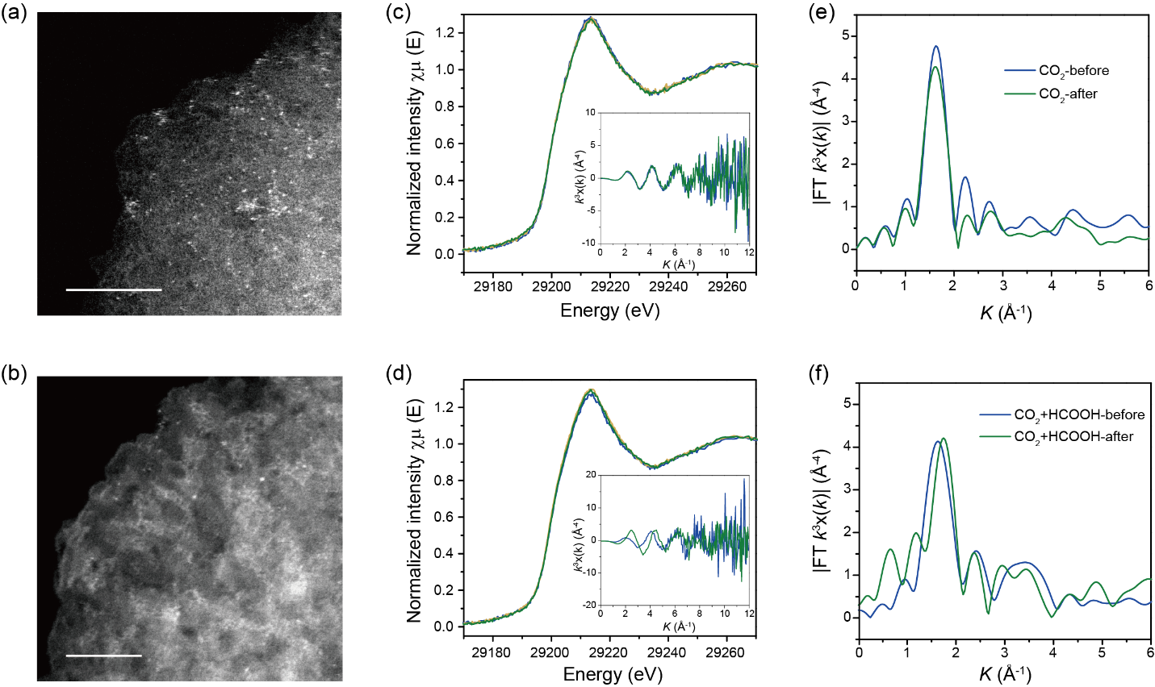
Extended data Fig. 42 | (a) & (b) HAADF-STEM images of Sn₁-O3G before and after 10 h of CO₂RR at an applied potential of -0.8 V (vs. RHE). Scale bar: 5 nm. (c) to (f) Sn K-edge XANES spectra and Fourier transformed (phase uncorrected) Sn K-edge EXAFS spectra of Sn₁-O3G, (c, d) in CO₂ and (e, f) in CO₂ + HCOOH. Insets in c and d are the corresponding k3-weighted EXAFS data.
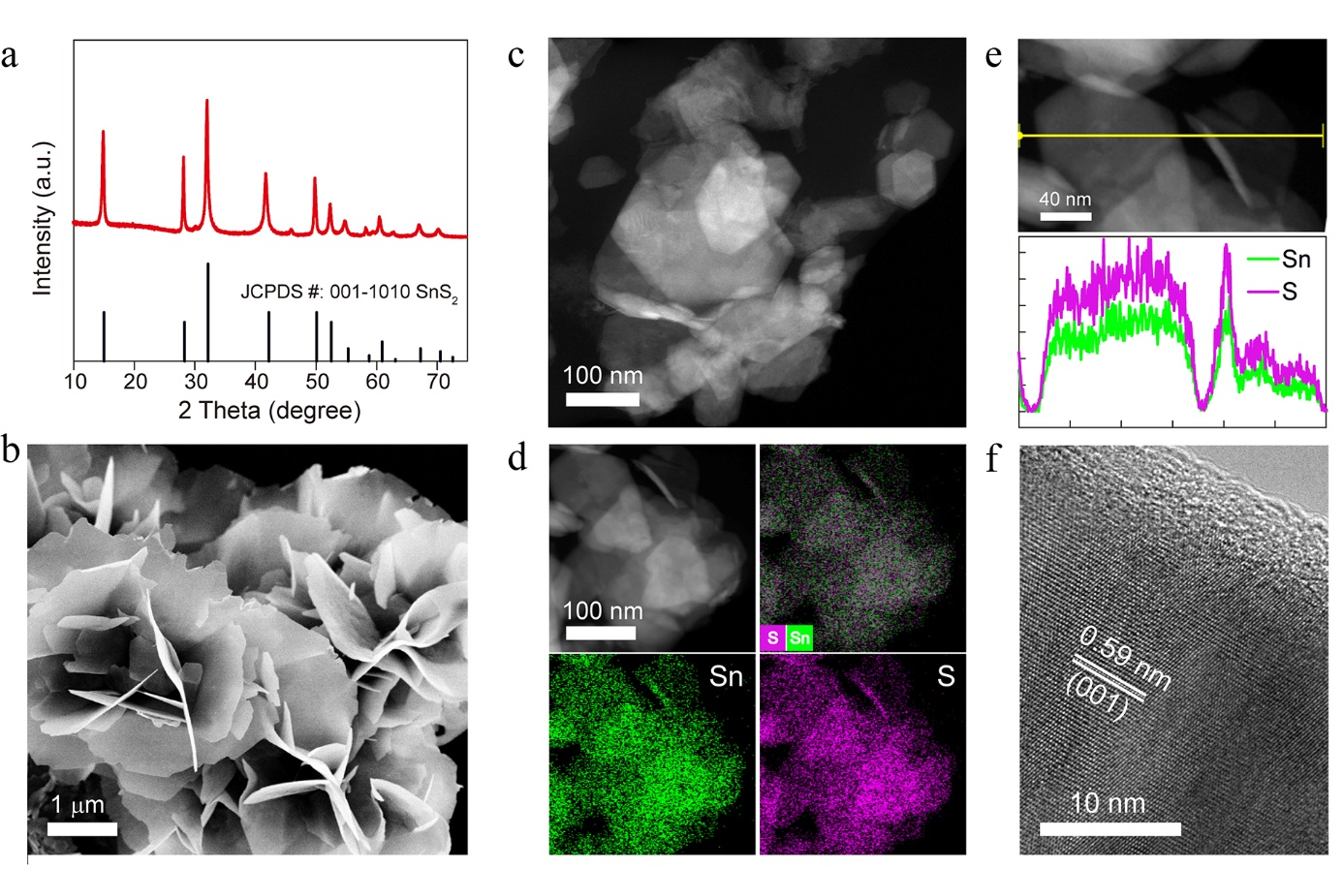
Extended data Fig. 43 | (a) XRD pattern, (b) SEM and (c) STEM image, (d) TEM-EDX mapping, (e) line-scan TEM-EDX elemental analysis, and (f) HRTEM image of SnS₂.

Extended data Fig. 44 | (a) LSV curves of the 3D carbon electrode collected in N₂ and CO₂ saturated 0.5 M KHCO₃ solution. (b) Potential dependent faradaic efficiency for the 3D carbon catalyst. Catalyst loading: 0.5 mg/cm².

Extended data Fig. 45 | (a) LSV curve, (b) FE of CO and (c) FE of H₂ for Sn₁-O3G with different quantities of HCOOH addition in N₂ saturated 0.5 M Na₂SO₄ electrolyte. Catalyst loading: 0.5 mg/cm².
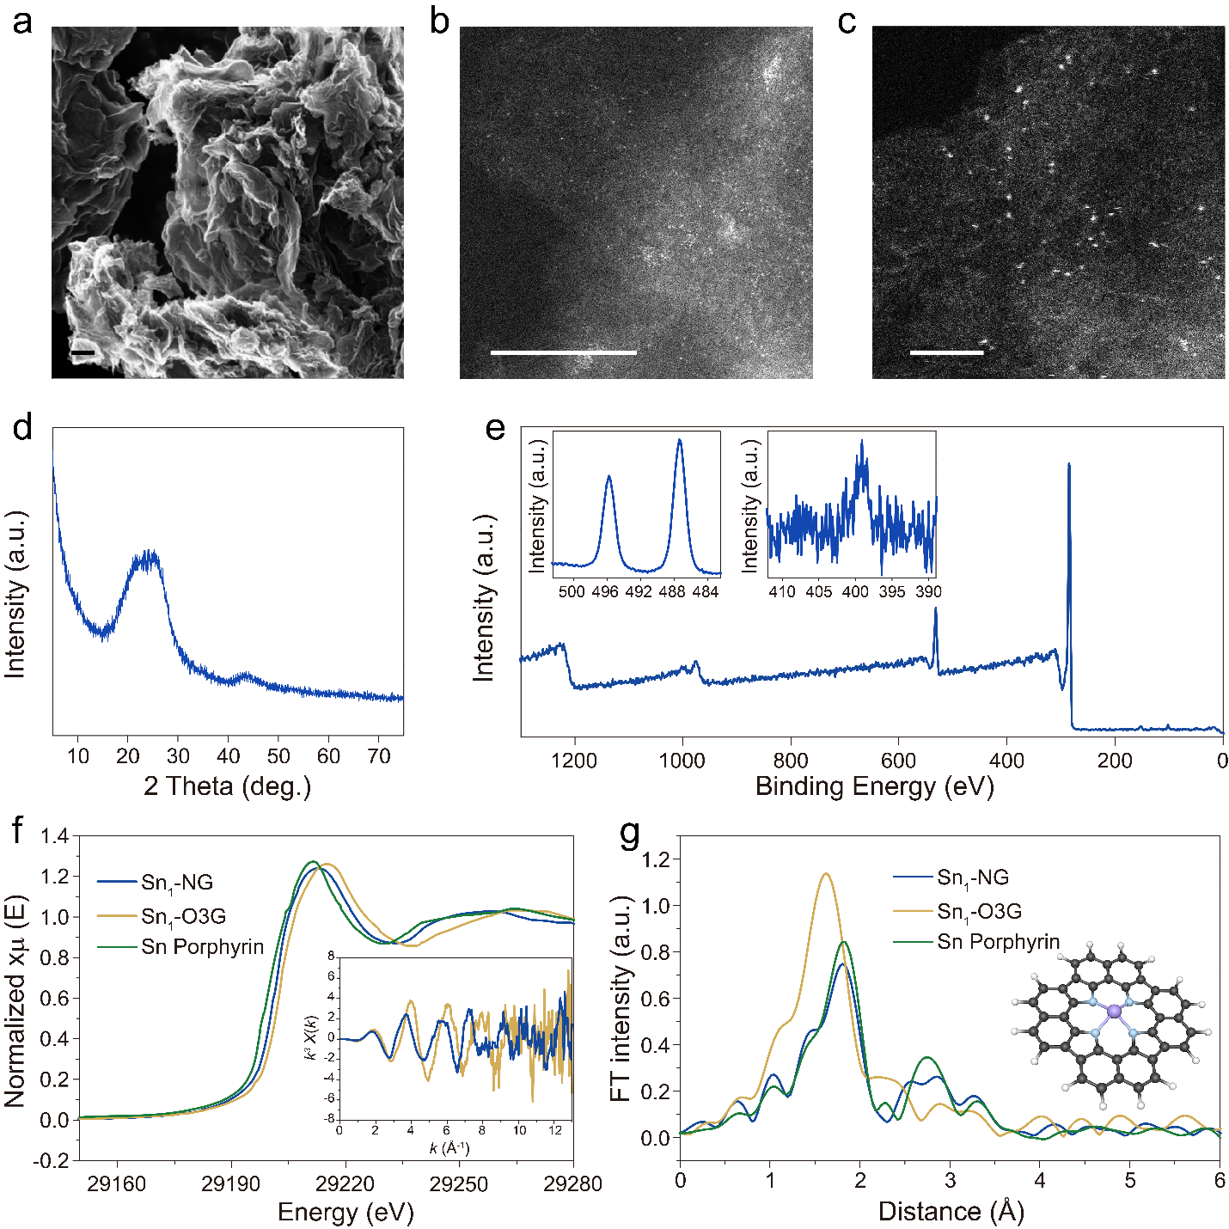
Extended data Fig. 46 | Structural characterizations of Sn₁-N4G. (a) SEM image (scale bar: 200 nm), (b) HAADF-STEM image of Sn₁-N4G (scale bar: 10 nm), (c) HAADF-STEM image of Sn₁-N4G (scale bar: 2 nm), (d) XRD pattern, (e) XPS spectra, (f) Sn K-edge XANES spectra (inset shows the k2-weighted k-space spectra), and (g) Fourier-transformed (phase uncorrected) Sn K-edge EXAFS spectra (inset shows the atomic model for Sn₁-N4G), where grey, blue, purple, and white spheres represent C, N, Sn and H atoms, respectively.
Note: The unique C-C coupling ability on the Sn₁-O3G catalyst (with O atoms coordinated Sn center) is not an accidental discovery, which is the result from our early works on the CO₂RR catalytic behavior of transition metal single atom catalysts. Specifically, in our preliminary experiments, the Sn based CO₂RR catalysts, including metallic Sn nanoparticles, SnS₂ nanosheets, SnS₂ on nitrogen doped graphene and single Sn atom on nitrogen doped graphene (Sn₁-N4G) were investigated. Based on the systematic structural and electrochemical characterizations, we found that the Sn₁-N4G and Sn₁-O3G displayed distinguished behaviors for the CO₂RR in the condition with presence of formate in KHCO₃, although both of them reduced CO₂ to CO in KHCO₃ without formate.
The detailed structural characterizations and electrocatalytic behaviors of Sn₁-N4G are summarized in Extended data Figs. 45 and 46. Scanning electron microscopy (SEM) measurement (Extended data Fig. 46a) reveals that the as-prepared Sn₁-N4G has a stratified structure. The aberration corrected high-angle annular dark-field scanning transmission electron microscopy (HAADF-STEM) images display bright spots, which can be assigned to the heavy Sn single atoms dispersed on N-doped carbon support (Extended data Fig. 46b and c). X-ray diﬀraction (XRD) pattern shows no characteristic peaks of metallic Sn and Sn compounds (Extended data Fig. 46d). X-ray photoelectron spectroscopy (XPS) was used to characterize the valence state of N and Sn (Extended data Fig. 46e). The peak at 401.3 eV can be assigned to graphitic N. Pyridinic N (398.7 eV) and pyrrolic N (398.7 eV) are dominant in the Sn₁-N4G, which are in a π conjugated system whose p-electrons synergistically facilitate the stabilization of Sn single atoms. The chemical state of Sn atoms in Sn₁-N4G was further investigated by X-ray absorption spectroscopy (XAS) (Extended data Fig. 46f-g). Extended data Fig. 46f shows that the Sn absorption rising-edge for Sn₁-N4G is close to that for Sn porphyrin (Sn²⁺), indicating that the oxidation state of Sn in Sn₁-N4G is close to +2, which is obviously lower as compared to that in Sn₁-O3G (Sn⁴⁺). Extended data Fig. 46g shows the FT-EXAFS spectra. The bond length of the first shell for Sn₁-N4G is almost the same with that for Sn porphyrin, suggesting nearly identical coordination environment of the Sn atoms (with SnN₄ configuration) in the two samples.
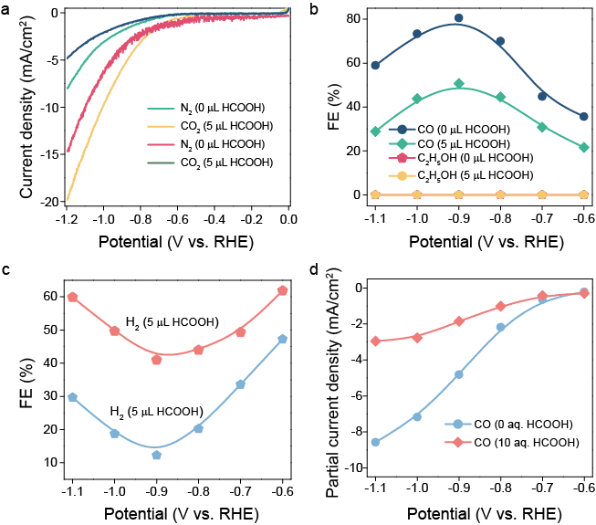
Extended data Fig. 47 | (a) LSV curves. Faradaic efficiency for (b) CO and (c) H₂. (d) Potential dependent CO partial current density of Sn₁-N4G measured in CO₂ saturated 0.5 M KHCO₃ electrolyte without and with addition of HCOOH.
Note: Extended data Fig. 47a shows the LSV curves of Sn₁-N4G measured in N₂ and CO₂ saturated 0.5 M KHCO₃ electrolyte without and with addition of HCOOH. As shown, the HCOOH addition leads to a reduced polarization current density, indicating interaction of HCOOH with the Sn₁-N4G catalyst. But unlike the result for the Sn₁-O3G catalyst, the Sn₁-N4G catalyst (with 4 nitrogen atoms coordinated Sn center) failed to produce any ethanol, indicating the critical roles of both the single atomic Sn center and the coordinated oxygen atoms in Sn₁-O3G for the C-C coupling reaction.
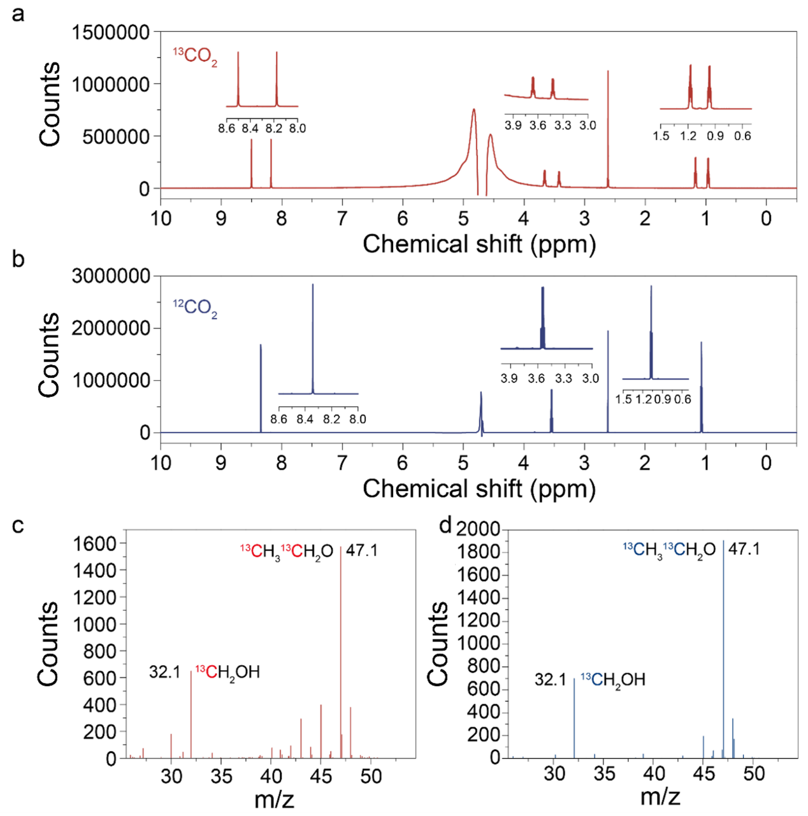
Extended data Fig. 48 | ¹H 1D NMR spectrum of products and DMSO recorded using isotopically labelled ¹³CO₂ (a) and ¹²CO₂ (b) at -0.8 V (vs. RHE). Mass spectra recorded using isotopically labelled ¹³CO₂ at (c) -0.8 V and (d) -0.9 V (vs. RHE).

To understand the ethanol formation process on the SnS₂/Sn₁-O3G tandem catalyst, the following additional experiments and kinetics simulation were performed.
- Characterization of the morphology and structure change of the SnS₂ layer on the SnS₂/Sn₁-O3G tandem catalyst in CO₂RR.
To probe the C-C coupling reaction taking place on SnS₂/Sn₁-O3G, the morphology and structure change of the SnS₂ overlayer on SnS₂/Sn₁-O3G in CO₂RR was investigated by TEM and XPS. Extended data Figs. 49a-d show the TEM images of SnS₂/Sn₁-O3G after 30 min and 1 h CO₂RR at -0.8 V vs. RHE. It is found that the SnS₂ nanosheets on Sn₁-O3G disappeared, at the same time, some nanoparticles were formed on 3D carbon support. The lattice constants of the nanoparticles measured in Extended data Figs. 49b and d are ~2.37 and ~3.45 Å, which can be assigned to the (200) and (111) planes of metallic Sn. The Fast-Fourier-transform (FFT) also confirms the metallic fcc structure of Sn. XPS survey spectrum of SnS₂/Sn₁-O3G collected after the CO₂RR as displayed in Extended data Fig. 49e shows a dramatically reduced Sn content. Moreover, high-resolution Sn 3d spectrum shows a -0.7 eV shift in the Sn binding energy, suggesting that SnS₂ nanosheets were reduced to metallic Sn nanoparticles, closely attached to the Sn₁-O3G, which is expected to reduce the diffusion distance of HCOOH generated on Sn nanoparticles to the Sn site of Sn₁-O3G.

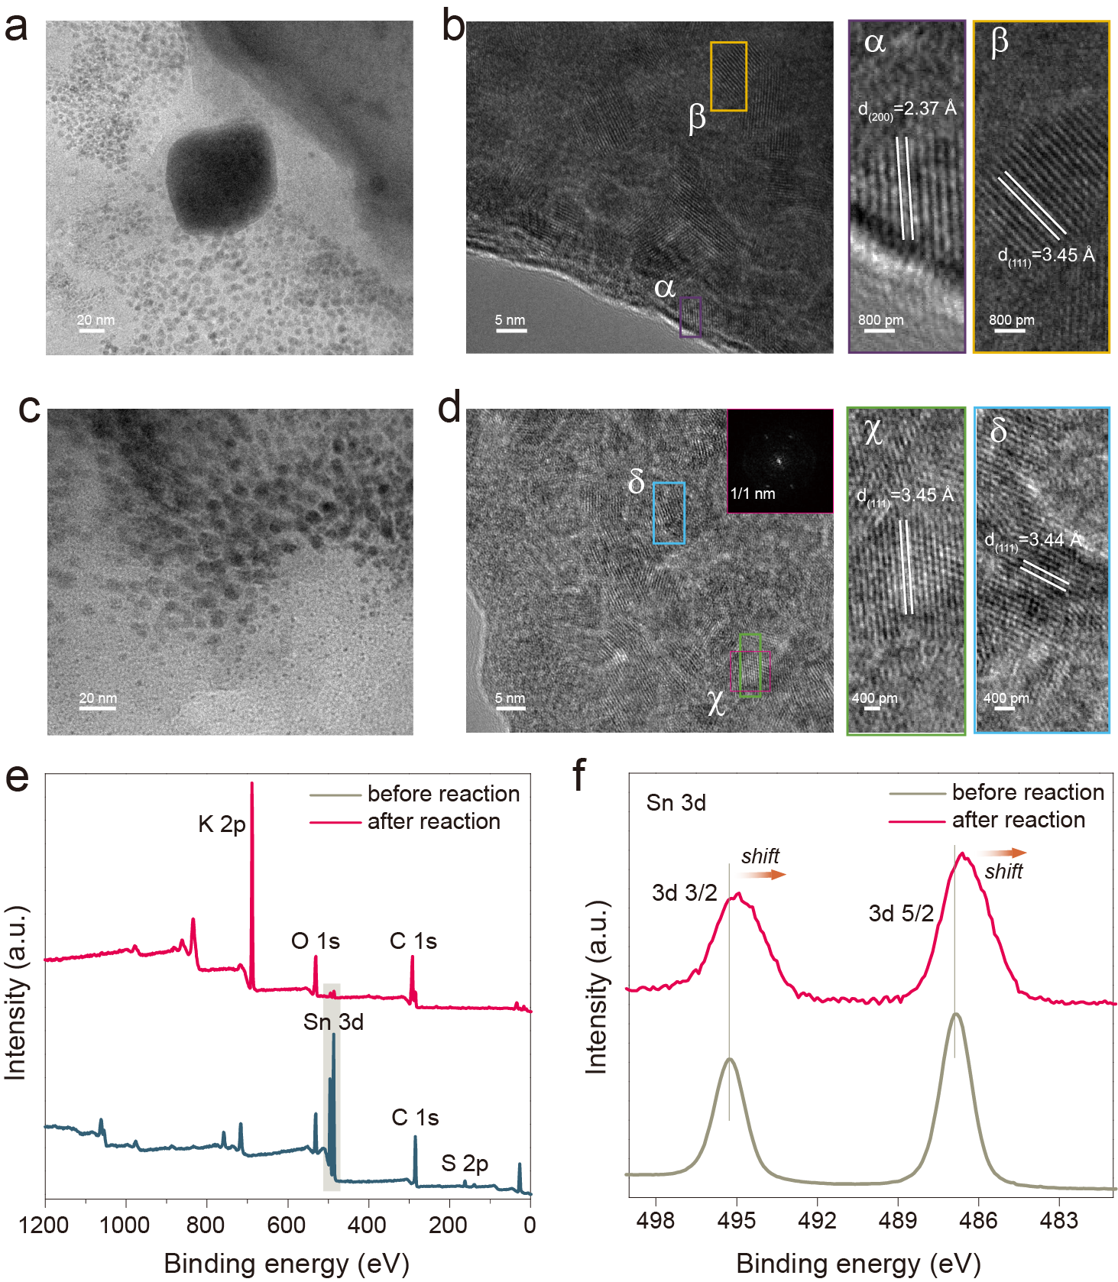
Extended data Fig. 49 | TEM images of SnS₂/Sn₁-O3G after (a & b) 30 min and (c & d) 1 h CO₂RR at -0.8 V (vs. RHE). Inset in Extended data Fig. 49d shows the Fast-Fourier-transform (FFT) of the selected area. XPS survey (e) and high-resolution Sn 2p spectra (f).

- Kinetics modeling to probe ethanol formation process on the SnS₂/Sn₁-O3G tandem catalyst.
To understand the kinetics of ethanol formation on the SnS₂/Sn₁-O3G tandem catalyst, kinetic models for CO₂ reduction to HCOOH on SnS_{x} (reduced SnS₂), CO₂ reduction to CO as well as ethanol formation on Sn₁-O3G were constructed. The kinetics parameters of the kinetic models were obtained by fitting the models with steady-state internal resistance (IR) corrected J-V curves by a global optimization method, which composes of a random search using genetic algorithm and a local optimization employing trust-region-reflective algorithm. All simulations were performed using a commercial software package (MATLAB R2010b, the MathWorks Inc.). The relative error tolerance for the initial value problem of ordinary differential equations is set as 10⁻⁸.
  - CO₂ reduction to CO on Sn₁-O3G
Assuming the Sn single atom is the active site (*) in CO₂ reduction to CO, the elementary reaction steps and enrolled reaction rate equations are listed in Extended data Table 9. The control equations are listed in Extended data Table 10, where r is the elementary reaction rate [mol·m⁻²·s⁻¹], K is the reaction rate constant [mol·m⁻²·s⁻¹], c is the concentration [mol·m⁻³], θ is the coverage, α is the symmetry coefficient, η is the overpotential [V], R is the gas constant [J·mol⁻¹·K⁻¹], T is the temperature [K], θ subscripts CO₂ and COOH represent the intermediate CO_{2,ads} and COOH_{ads}, respectively, and c subscripts CO₂ and HCO₃ represent the reactant CO₂ and electrolyte KHCO₃, respectively.
Extended data Fig. 50 displays the comparison of the experimental CO₂RR polarization curve with the simulated one, as well as the coverage of intermediates COOH_{ads} and CO_{2, ads}. It can be observed that the three-step mechanism (TS7.1~TS7.3) can reproduce the experimental data and intermediates coverage decreases with increasing current density. The kinetics parameters are listed in Extended data Table 11. The magnitude of the reaction rate constant K₂₀₁ and the coverage difference of COOH_{ads} and CO_{2, ads} ($θ_{CO_{2,ads}}≫θ_{COOH}$) suggest that the COOH_{ads} formation step (TS7.2) is the rate determining step. Therefore, the dissociative COOH⁻ from COOH_{ads} is negligible in CO₂ reduction process to CO on the Sn₁-O3G.
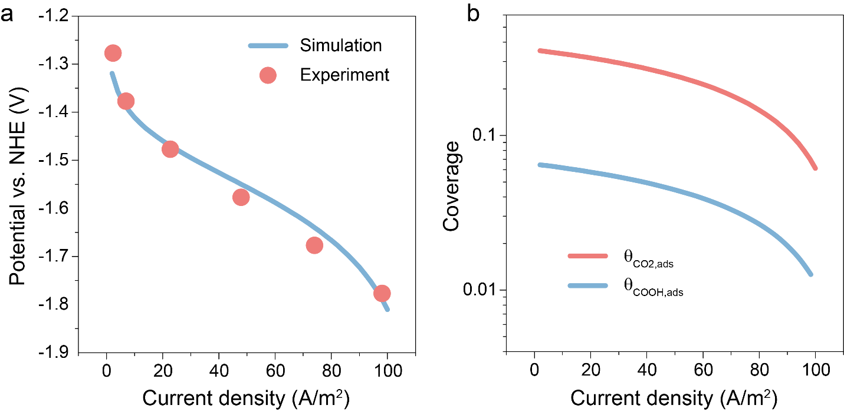
Extended data Fig. 50 | (a) Comparison of experimental polarization curve with the simulated one by the kinetic model. (b) Simulated coverage of intermediates COOH_{ads} and CO_{2, ads} with current density.
  - CO₂ reduction to HCOOH on SnS_{x}
The Sn nanoparticles reduced from SnS₂ nanosheets are able to electrochemically reduce CO₂ to HCOOH. Taking SnS_{x} as the active site (**), the elementary reaction steps and enrolled reaction rate equations are listed in Extended data Table 12, where r’ is the elementary reaction rate [mol·m⁻²·s⁻¹] and K’ is the reaction rate constant [mol·m⁻²·s⁻¹]. The control equations are listed in Extended data Table 13.
Extended data Fig. 51 displays the comparison of the experimental polarization curve of CO₂ reduction to HCOOH on SnS_{x} with the simulated one, the dissociative COOH⁻ concentration as well as the coverage of intermediates COOH_{ads} and CO_{2, ads}, respectively. The kinetics parameters of the CO₂ reduction to HCOOH (TS10.1~TS10.3) are listed in Extended data Table 14.
It is observed that the simulated CO₂RR polarization curve using the three-step mechanism can reproduce the experimental data. The concentration of the dissociative COOH⁻ increases and the coverage of intermediates COOH_{ads} and CO_{2, ads} decreases with increasing current density. The magnitude of the reaction rate constant K’₂₀₁ and the coverage difference between COOH_{ads} and CO_{2, ads} suggest that the COOH_{ads} formation is the rate determining step. It is obvious that most part of SnS_{x} is covered with CO_{2, ads} and the dissociative COOH⁻ from COOH_{ads} is negligible.
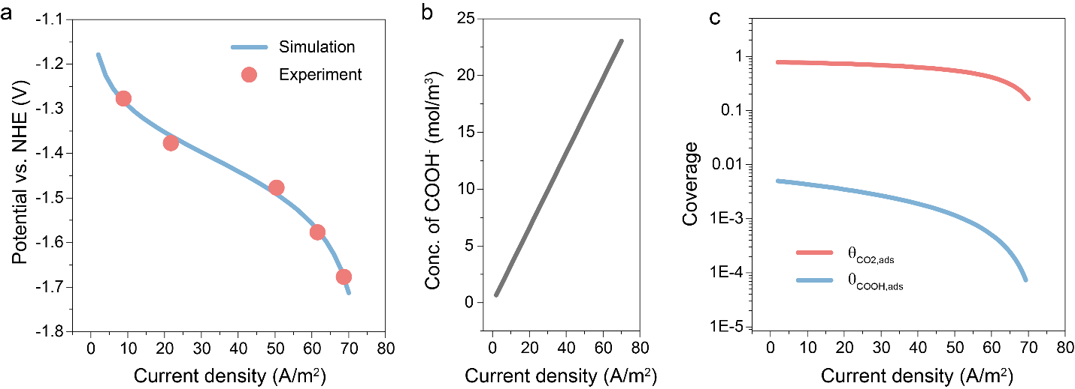
Extended data Fig. 51 | (a) Comparison of experimental polarization curve with the simulated one by the kinetic model. (b) Variation of COOH⁻ concentration with current density. (c) Simulated coverage of intermediates COOH_{ads} and CO_{2, ads} with current density.
  - CO₂ + COOH⁻ reduction to ethanol
Sn₁-O3G is able to reduce CO₂ to ethanol in the presence of HCOOH. Based on isotope experiments together with DFT calculations, CO_{2, ads}, COOH_{ads,} CO_{ads} and COOHCOH_{ads} are taken as the intermediates in the CO₂RR to ethanol, and the elementary reaction steps and enrolled reaction rate equations are listed in Extended data Table 15, where r’’ is the elementary reaction rate [mol·m⁻²·s⁻¹] and K’’ is the reaction rate constant [mol·m⁻²·s⁻¹]. θ subscripts CO₂, COOH, CO and COOHCOH represent the intermediates CO_{2, ads}, COOH_{ads,} CO_{ads} and COOHCOH_{ads}, respectively. The control equations are listed in Extended data Table 16.
Extended data Fig. 52 displays the comparison of the experimental polarization curve of CO₂ reduction to ethanol on Sn₁-O3G in presence of HCOOH and the simulated result, as well as the intermediates coverage obtained in the simulation. By fitting the kinetic model with experimental data, the kinetics parameters are listed in Extended data Table 17.
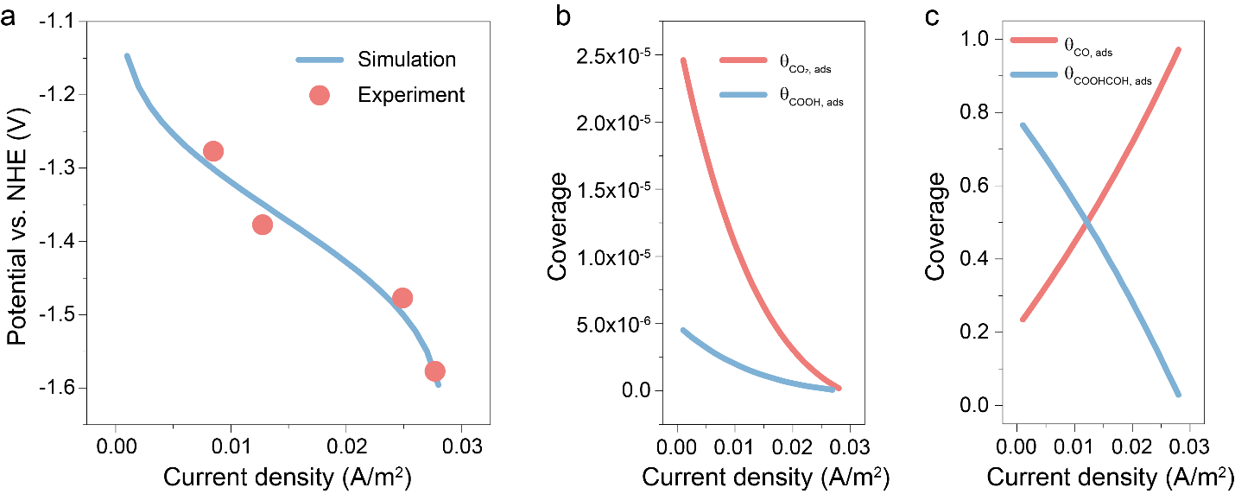
Extended data Fig. 52 | (a) Comparison of experimental polarization curve with the simulated one by the kinetic model. (b) Simulated coverage of intermediates COOH_{ads} and CO_{2, ads} with current density. (c) Simulated coverage of intermediates CO_{ads} and COOHCOH_{ads} with current density.
It can be observed in Extended data Fig. 52 that electrochemical reduction of reactant CO₂ and COOH⁻ to ethanol mechanism (TS13.1~TS13.5) reproduces the experimental data well. The coverage of the intermediates COOH_{ads} and CO_{2, ads} are low, both of which decrease with increase in current density. However, the coverage of intermediates CO_{ads} and COOHCOH_{ads} are high. The former increases with increase of current density, while the later shows an opposite tendency. The CO₂ + COOH⁻ reduction to ethanol mechanism involves both chemical (TS13.1 and TS13.4) and electrochemical elementary steps (TS13.2, TS13.3 and TS13.5). It is well-known that the rate constants of the electrochemical elementary steps are potential dependent that increase with increasing current density. At a current density of 8.5×10⁻³ A m⁻², the term K’’₁₀₁, $K_{201}^{''}⋅\exp\left(\frac{αFη}{RT}\right)$, $K_{301}^{''}⋅\exp\left(\frac{αFη}{RT}\right)$ and $K_{501}^{''}⋅\exp\left(\frac{αFη}{RT}\right)$ are 1.56×10¹, 4.06×10⁻², 2.22×10⁻¹ and 2.67×10⁴ mol·m⁻²·s⁻¹, respectively, which is 5, 2, 3 and 8 order of magnitudes higher than K’’₄₀₁ (1.26×10⁻⁴ mol·m⁻²·s⁻¹). In combination with the magnitude of the coverage of CO_{ads} and COOHCOH_{ads,} it can be concluded that the elementary chemical step TS13.4 is the rate determining step. From section 2.1 and 2.2, it is clear that dissociative COOH⁻ enrolled in the rate determining step can only result from the CO₂-to-HCOOH reduction step taking place on SnS_{x.} Therefore, the overall CO₂RR to ethanol would be rate-limited by diffusion of COOH⁻.

- Analysis of Faradaic efficiency for ethanol in CO₂RR.
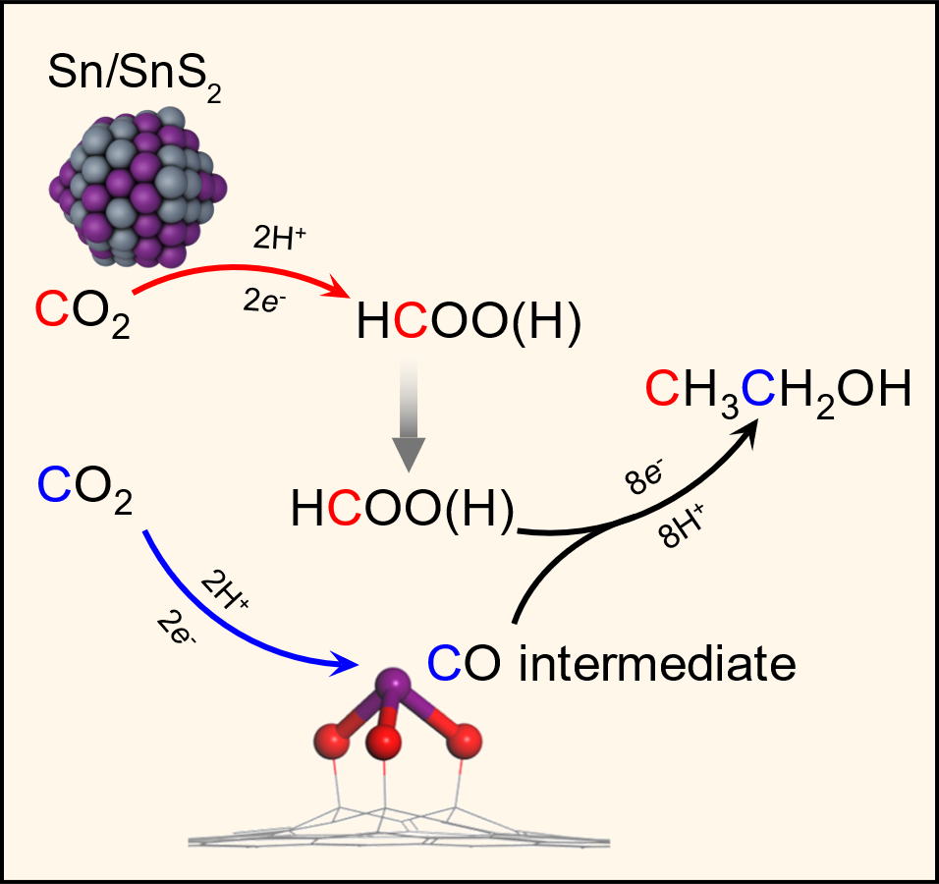
Extended data Fig. 53 | A schematic illustration showing the cascade reaction during CO₂ reduction to ethanol over SnS₂/Sn₁-O3G (grey: S, red: O, yellow: H and purple: Sn).
CH₃CH₂OH is formed on the dual functional Sn site by coupling the *CO intermediate with COOH⁻, which is generated on reduced SnS₂, as shown in Extended data Fig. 53. Considering an idealized situation, the generated COOH⁻ has an equal probability to diffuse towards the dual functional Sn site to participate in the CO₂RR to ethanol (based on kinetics analysis, the CO₂RR to ethanol is rate-determined by diffusion of COOH⁻) as well as towards the bulk solution to produce COOH⁻. Generating two COOH⁻ ions (2HCOOH→2COOH⁻+2H⁺) consumes 4e⁻. Based on the idealized situation, one of them diffuses to the dual functional Sn site, reacting with one *CO intermediate to produce one ethanol molecule. In total, there involve 12e⁻ transfer to produce one ethanol molecule. The other COOH⁻ ion diffuses to the bulk solution, which involves 2e⁻ transfer. As a result, the FE_{ethanol} can be estimated as:
$${FE}_{ethanol}=\frac{Number of electrons transferred to produce ethanol}{Total number of electrons transferred}=\frac{12}{12+2}=85.7\%$$
This value is higher than the best FE_{ethanol} obtained experimentally.
Extended data Fig. 54 | Calculated spin density for 0, 1 and 1-1. Yellow stands for spin up and blue for spin down. Isosurface value: 0.01 e/Å³.
Note: The magnetic moment μ_{B} of the active site plays an important role in activation of CO₂. As displayed in Extended data Fig. 54, the calculated μ_{B} for Sn/O2/O3/O4 atoms of the initial catalytic center structure 0 are nonmagnetic (μ_{B} = 0), while Sn-3O active sites in the intermediates 1 and 1-1 exhibit nonzero magnetism. In the intermediate 1, the calculated μ_{B} for Sn/O2/O3/O4 atoms are 0.00, 0.04, -0.04, and -0.02, respectively. In the intermediate 1-1, the calculated μ_{B} for Sn/O2/O3/O4 atoms are 0.40, 1.24, -0.04, and -0.04. The spin polarization of three oxygen atoms in the intermediate 1 forces one of the oxygen atoms to be of radical nature (with unpaired electron) in intermediate 1-1 that is active for CO₂ adsorption. Therefore, the spin-polarization on oxygen atoms of Sn-3O dual functional active site is responsible for the activation of CO₂.
Extended data Fig. 55 | (a) Proposed mechanism for formation of major CO₂RR products (CO and ethanol) on Sn₁-O3G. (b) The formation of dual active centers comprising Sn and O atoms that can adsorb *CO(OH) and *COH intermediates.
Note: According to the experimental observations, we propose a catalytic cycle as shown in Extended data Fig. 55a. At the standard condition (U = 0, p = 1 bar, T = 298 K), the free energy ΔG of the reaction A + H⁺ + e⁻→*AH, can be calculated as the free energy of the reaction A + 1/2H₂→*AH. ΔG = ΔE + ΔZPE + ΔH_{Δ0→298K}–TΔS was calculated as follows: the reaction energy ΔE = E(product) - E(reactant), where ΔZPE, ΔH and ΔS denote the difference in zero-point energy, enthalpy, and entropy due to the reaction, respectively. Depending on the different activity sites of Sn₁-O3G catalyst, there are two binding modes of CO₂, labeled as 2-1 and 2, which lead to two pathways of CO₂ electrochemical reduction. For 2-1, CO₂ is adsorbed on the top of the Sn site, with an adsorption energy of -0.07 eV. The following COOH* formation on the Sn site are the energy-demanding steps with the barriers of 0.86 eV. In 2, the carbon atom of CO₂ binds to the oxygen site of Sn₁-O3G with adsorption energy of -0.75 eV, while the O-C bond between the active oxygen site and carbon support cleavages, which indicates a strong interaction between the adsorbed CO₂ and the multifunctional oxygen site on Sn₁-O3G. With the exergonicity of 1.68 eV, species 3 is formed as the dominant intermediate in the hydrogenation process of CO₂, which hardly generates CO directly except from the recovered catalyst going through 3-1 intermediate. Hence, CO desorption occurs at the Sn site of Sn₁-O3G catalyst, which explains the catalytic role of Sn₁-O3G in electrochemical reduction of CO₂ to CO without HCOOH.
Based on the electrochemical data, addition of HCOOH during CO₂RR decreases the Faradaic efficiency of CO, while promoting ethanol formation, in which the methyl carbon (*CH₃) and the methylene carbon (*CH₂OH) in CH₃CH₂OH come from HCOOH and CO₂, respectively. After formation of the preferred intermediate (Extended data Fig. 55b), 3, the HCOOH adsorbs at the Sn site with the carbon atom, and the carbonyl group in HCOOH* is hydrogenated to form 4-11 with the free energy barrier of 0.17 eV, and dehydrated to generate intermediate 4-21(4), with the free energy barrier of 0.35 eV as shown in Extended data Fig. 54b.

Extended data Fig. 56 | (a) Reaction pathways to competing products and (b) DFT calculated free energy profile for competing products, including formic acid, formaldehyde, CO and H₂ at standard condition (U = 0, p = 1 bar, and T = 298 K).
Note: The DFT calculation results show that the protonation of Sn₁-O3(OH)-G pre-catalytic site is exergonic to give more stable intermediate 1 compared to 1-1, and CO₂ binding is also exergonic, which is more favorable than H₂ formation with the free energy barrier of 0.38 eV. The other competing products, including formic acid, formaldehyde and CO, stem from the *CO(OH) intermediate 3-1 on Sn site, and the free energy barriers of the rate-determining step are 0.23 eV, 0.34 eV and 0.06 eV, respectively. While the *CO(OH) intermediate 3 on O site is apt to generate by a process of continuous exergonic steps, which provides the possibility of C-C coupling.

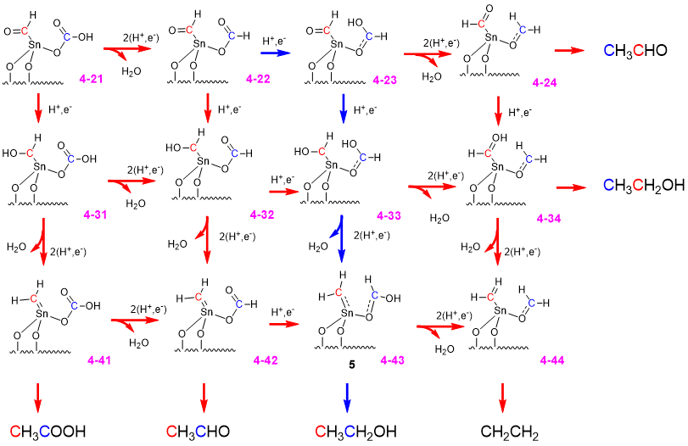
Extended data Fig. 57 | (a) The network of competing C2 products stemming from 3. (b) The free energies for the network of competing C2 products relative to 3 (unit: eV). The contents in bold represent the favorable intermediates (or transition states) and the corresponding free energies relative to 3 (U = 0, p = 1 bar, and T = 298 K).
Note: Based on the systematical calculation using the computational hydrogen electrode (CHE) model, the networks of competing C2 products are displayed in Extended data Fig. 57a, and the free energies relative to 3 are listed in Extended data Table 18. The computational results suggest that *CO(OH) on the O site is initially reduced with an endergonic energy of 0.14 eV. Then, *CHO on the O site and the Sn site transforms to *CHOH via continuous endergonic processes, respectively. The suspension of the reduction takes place at intermediate 5 after the hydrogenation of *CHOH on the Sn site. With the free energy barrier of 0.13 eV, C-C bond is formed between *CH₂ on Sn site and *CHOH on O site. The C2 adsorbate 6 is the precursor for ethanol detected by the experiment, in which the methyl C (*CH₃) comes from HCOOH and the C in CO₂ goes to the methylene C (*CH₂OH).
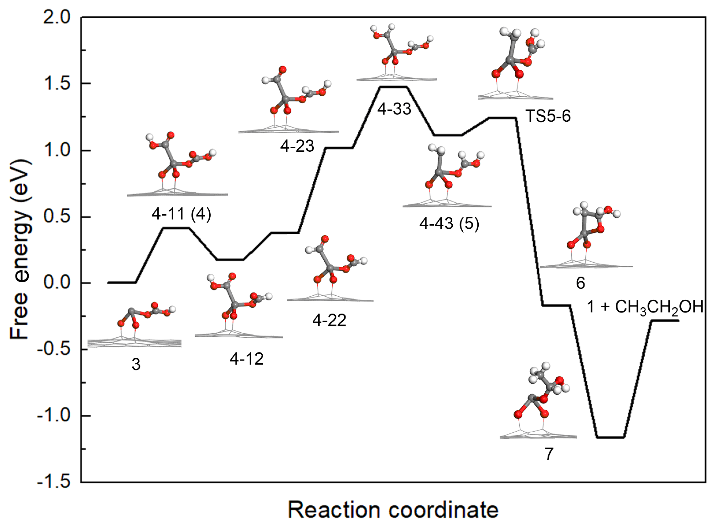 Extended data Fig. 58 | Free energy profiles of favorable pathway for the formation of ethanol via the CO₂RR on the Sn₁-O3G catalyst.
Note: With drastic reduction of all carbonyl groups in 4, the intermediate 5 is formed as the precursor for C-C coupling. With a barrier of 0.13 eV in the step of C-C bond formation, the intermediate 6 is generated with the structural characteristics of Sn-C-C-O quaternary ring. As the reduction process proceeds, the Sn-C bond and O-C bond are broken in succession, which is followed by CH₃CH₂OH desorption at the oxygen site of Sn₁-O3G with a free energy barrier of 0.87 eV. Due to the flexibility of the O-C bond between the active oxygen site and carbon support, Sn₁-O3G catalyst is distinguished by the bi-active site of Sn and O to adsorb different CO₂RR intermediates, which offers a novel platform for the C-C bond formation in ethanol synthesis.

Extended data Table 5. Product identification based on peak information for CO₂ reduction products compared to peak information for commercial standards.
CO₂ Reduction Products |  |  |  |  |  | Assignment |  | Standards
Chemical shift | ¹H splitting | J coupling | ¹³C (HSQC) | ¹³C (1D) | ¹³C splitting | Probed nucleus | Product name | ¹H  splitting | Chemical shift | J coupling | ¹³C (1D)
8.33 | s |  | 172.2 | 171.76 | s | HCOO⁻ | Formate | s | 8.33 |  | 171.77
 |  |  |  |  |  | H₂O
3.54 | q | 7.03 | 58.3 | 58.3 | d | CH₃CH₂OH | Ethanol | q | 3.53 | 7.32 | 58.3
 |  |  |  |  |  | DMSO | Internal standard | s | 2.6 |  | 39.6
1.06 | T | 7.03 | 17.4 | 17.62 | d | CH₃CH₂OH | Ethanol | t | 1.06 | 7.08 | 17.63

Extended data Table 6. Performance comparison of various CO₂RR to ethanol catalyst.
Catalyst | Medium and electrode | Onset potential vs. RHE (mV) | Ethanol Faradaic efficiency (%) | Geometric current density (mA/cm²) | Refs.
Cu-TiO₂/NG | CO₂-saturated 0.2 M KI solution, carbon paper | 200 | 43.6 | -2.5 | (11)
Cu nanoparticle | 0.1 M KHCO₃ or CsHCO₃  at 1 atm CO₂, carbon-paper | 530 | 14.8 | -12.3 | (12)
Cu₂O-derived Cu | 0.1 M KHCO₃, glassy carbon | N/A | 8.52 | -17.3 | (13)
Ag-Cu₂O | 0.1 M KHCO₃, glassy carbon | N/A | 33.6 | -3.1 | (14)
Plasma activated Cu | 0.1 M KHCO₃, N/A | N/A | 22.6 | -11.5 | (15)
Cu₂O | 0.1 M KHCO₃, carbon paper | 330 | 15.3 | -32.1 | (16)
[4-(3-Phenoxy-2,2-bis(phenoxymethyl)  propoxy)pyridine]@Cu–Pd | 0.5 M KCl, carbon paper | 230 | 12 | -21 | (17)
Cu nanowire | 0.1 M KHCO₃, N/A | N/A | 9.6 | -18.5 | (18)
B, N-doped nanodiamond | 0.1 M NaHCO₃,  glassy carbon | 330 | 93.2 | -0.8 | (19)
N-doped mesoporous carbon | 0.1 M KHCO₃, N/A | 260 | 62.5 | -0.9 | (20)
Cu cube | 0.1 M KHCO₃, carbon-paper | N/A | 5.1 | -18.2 | (21)
HKUST-1 | 0.2 M KHCO₃, carbon-paper | N/A | 20.1 | -10.3 | (22)
Cu (111) | 0.1 M KClO₄, Cu | N/A | 17.8 | -18.1 | (23)
AuCu/Cu-SCA | 0.5 M KHCO₃, carbon-paper | N/A | 17.6 | -23.5 | (24)
NGQDs | 1M KOH  gas diffusion electrode | N/A | 18.1 | -20.3 | (25)
Cu/N doped carbon | 0.5 M KHCO₃, carbon-paper | 250 | 63 | -2.2 | (26)
SnS₂/Sn₁-O3G | 0.5 M KHCO₃, carbon-paper | 210 | 82.5 | -17.8 | This work

Extended data Table 7. Impurity content in 3D carbon and SnS₂/Sn₁-O3G determined by XPS and ICP-MS.
Sample | ICP (wt.%) |  |  |  |  | XPS (wt.%)
Sample | Zn | Cu | Ni | Co | Zr | Zn | Cu | Ni | Co | Zr
3D carbon | 0.008 | 0.003 | 0.007 | 0.001 | 0.003 | 0 | 0 | 0 | 0 | 0
SnS₂/Sn₁-O3G | 0.007 | 0.002 | 0.009 | 0.003 | 0.005 | 0 | 0 | 0 | 0 | 0

Extended data Table 8. Fitting parameters of EXAFS data using the Sn-C and Sn-O paths for Sn₁-O3G.
Path | N | R/Å (DFT) | R/Å (EXAFS) | Debye-Waller factor Δσ² (Å²) | ΔE | R-factor
Sn-C | 6.8±0.74 | – | 2.096±0.01 | 0.0070±0.0015 | 1.14±1.38 | 0.02
Sn-O | 3.65±0.25 | 1.976-2.009 | 2.087±0.007 | 0.0055±0.0009 | 4.35±0.85 | 0.01
EXAFS: extended X-ray absorption fine structure
DFT: density functional theory
N: coordination number
Note: The data range adopted for data fitting in k-space (Δk) and R space (ΔR) are 3.2-12.0 and 1-3 Å, respectively. Debye–Waller factors were fixed (to the values obtained in the best fit with set coordination numbers) during fitting the EXAFS to reduce the number of fitting parameters.
Extended data Table 9. Elementary reaction steps and reaction rate equations for CO₂ reduction to CO taking place on Sn₁-O3G.
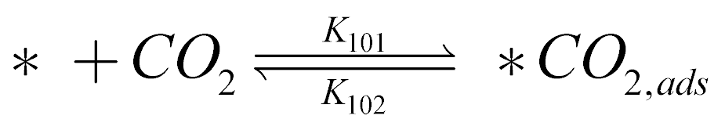 | (TS7.1)
 | (TS7.2)
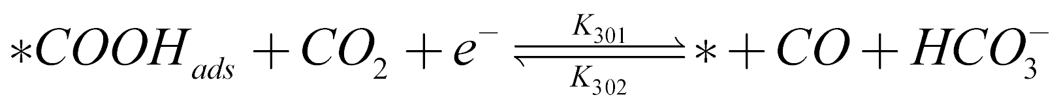 | (TS7.3)
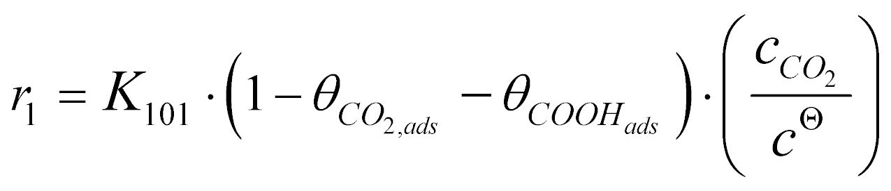 | (TS7.4)
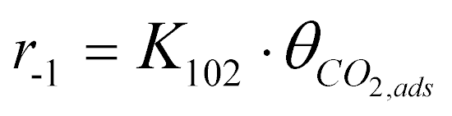 | (TS7.5)
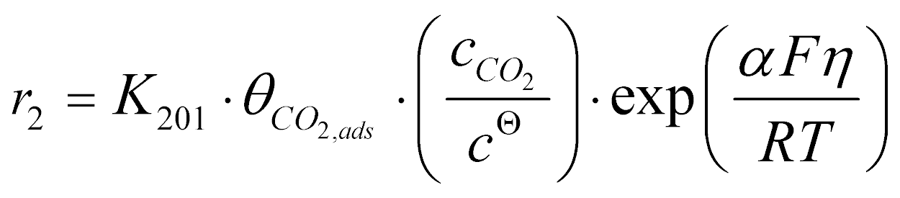 | (TS7.6)
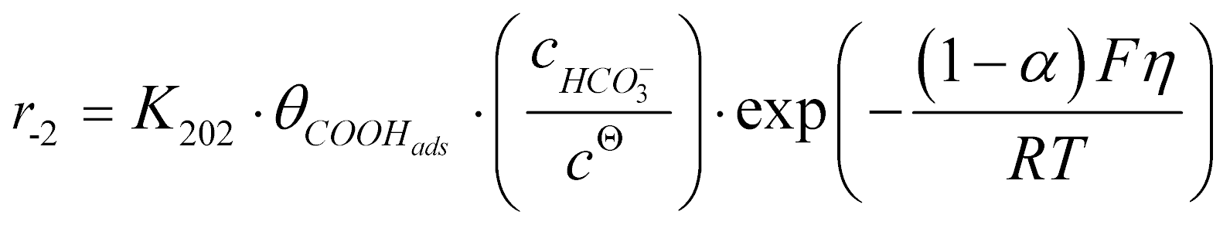 | (TS7.7)
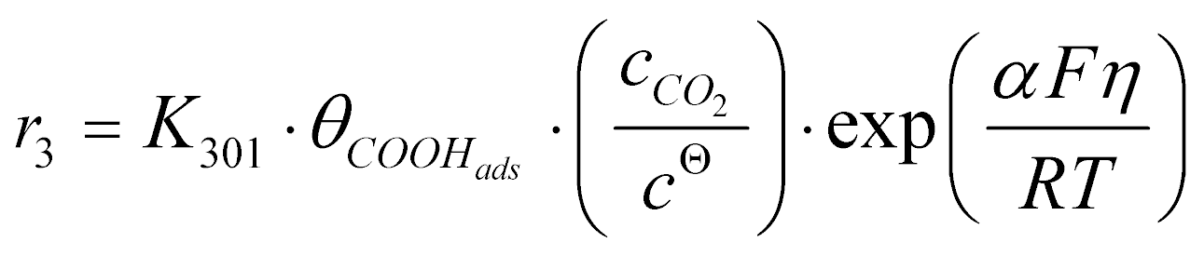 | (TS7.8)
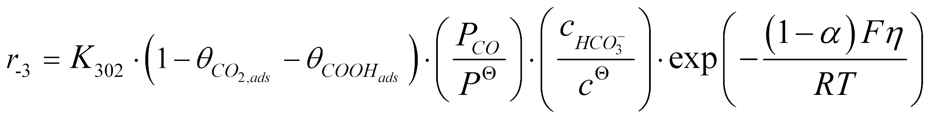 | (TS7.9)

Extended data Table 10. Control equations for CO₂ reduction to CO taking place on Sn₁-O3G.
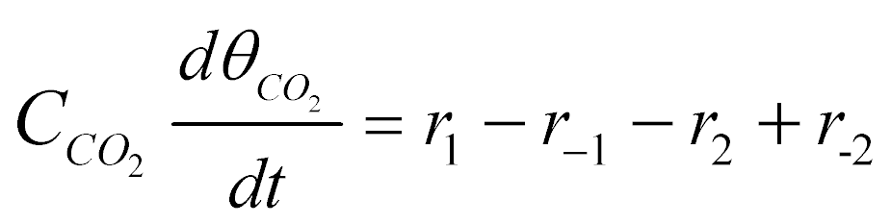 | (TS8.1)
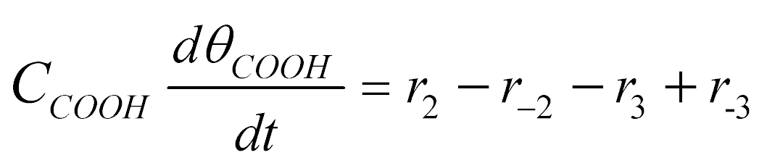 | (TS8.2)
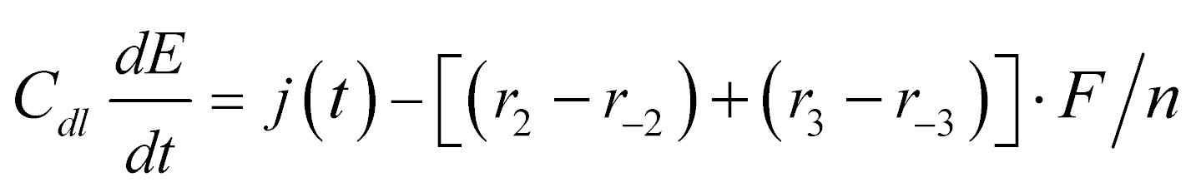 | (TS8.3)
Extended data Table 11. Kinetics parameters for CO₂ reduction to CO taking place on Sn₁-O3G.
K₁₀₁ | K₁₀₂ | K₂₀₁ | K₂₀₂ | K₃₀₁ | K₃₀₂
1.56×10¹ | 8.57×10⁻¹ | 6.19×10⁻¹⁰ | 1.18×10⁻¹⁴ | 3.38×10⁻⁹ | 1.18×10⁻¹¹
Extended data Table 12. Elementary reaction steps and reaction rate equations for CO₂ reduction to HCOOH taking place on SnS_{x}.
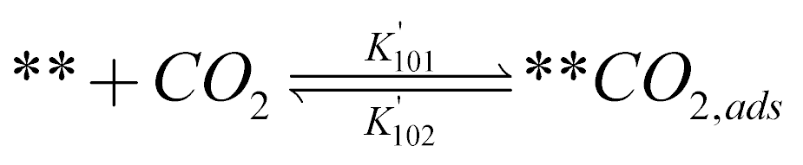 | (TS10.1)
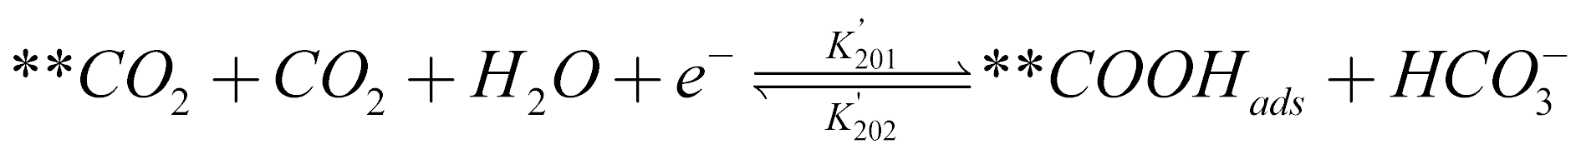 | (TS10.2)
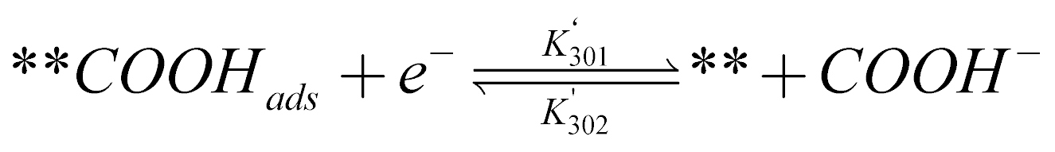 | (TS10.3)
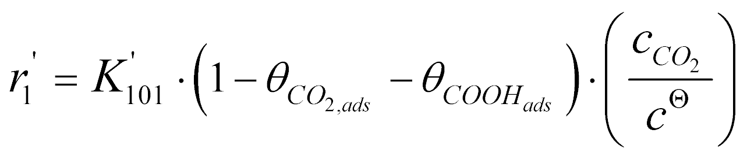 | (TS10.4)
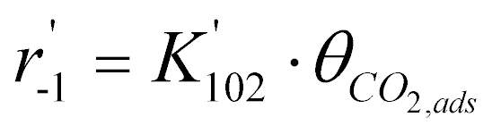 | (TS10.5)
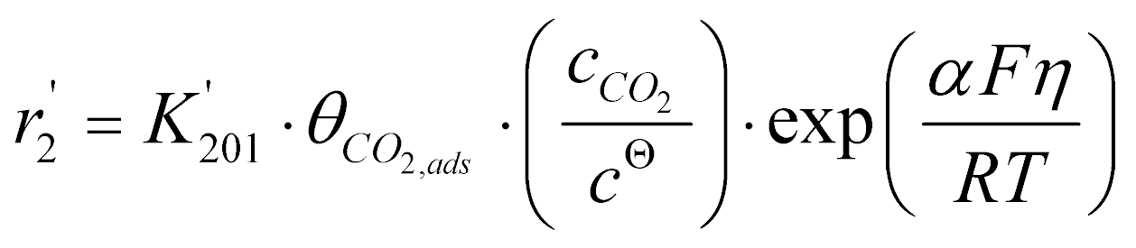 | (TS10.6)
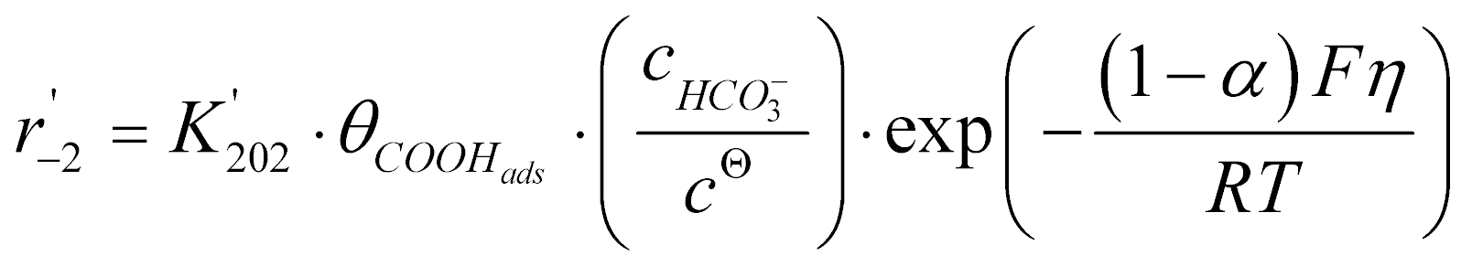 | (TS10.7)
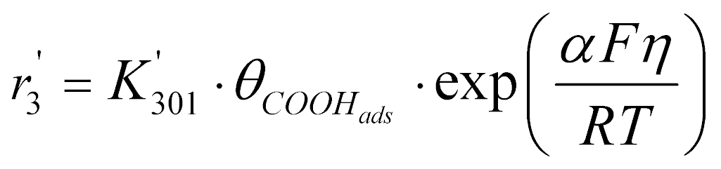 | (TS10.8)
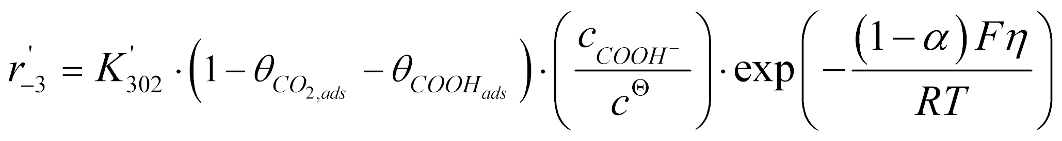 | (TS10.9)

Extended data Table 13. Control equations for CO₂ reduction to HCOOH taking place on SnS_{x}.
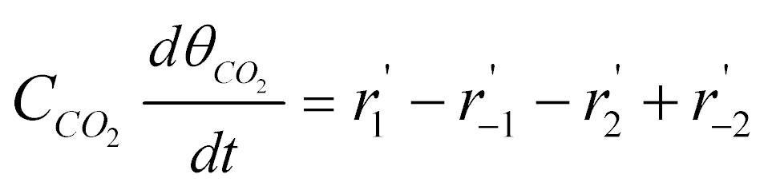 | (TS11.1)
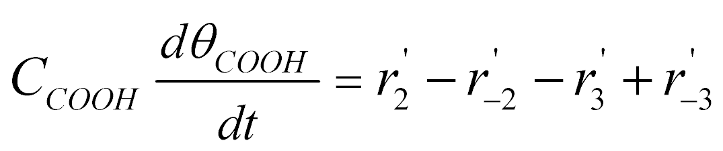 | (TS11.2)
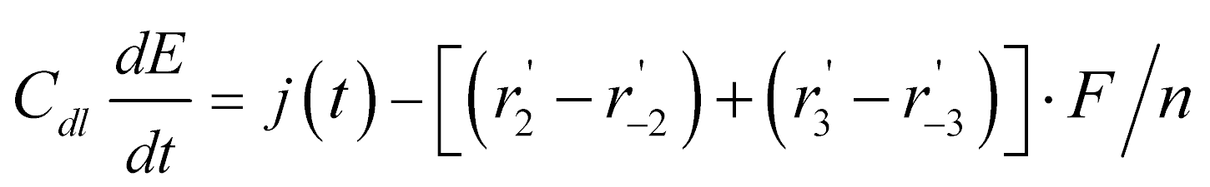 | (TS11.3)

Extended data Table 14. Kinetics parameters for CO₂ reduction to HCOOH taking place on SnS_{x}.
K’₁₀₁ | K’₁₀₂ | K’₂₀₁ | K’₂₀₂ | K’₃₀₁ | K’₃₀₂
5.49×10¹ | 5.01×10⁻¹ | 1.40×10⁻⁹ | 5.11×10⁻¹⁴ | 7.23×10⁻⁹ | 4.83×10⁻¹¹

Extended data Table 15. The elementary reaction steps and enrolled reaction rate equations for CO₂ reduction to ethanol taking place on Sn₁-O3G in the presence of HCOOH.
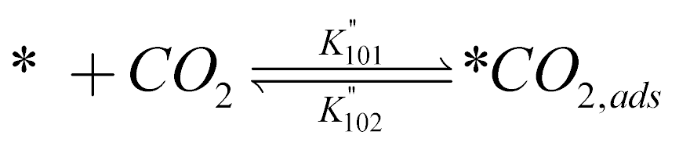 | (TS13.1)
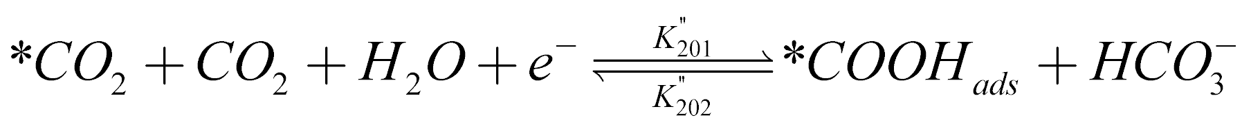 | (TS13.2)
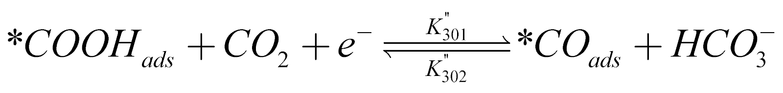 | (TS13.3)
 | (TS13.4)
 | (TS13.5)
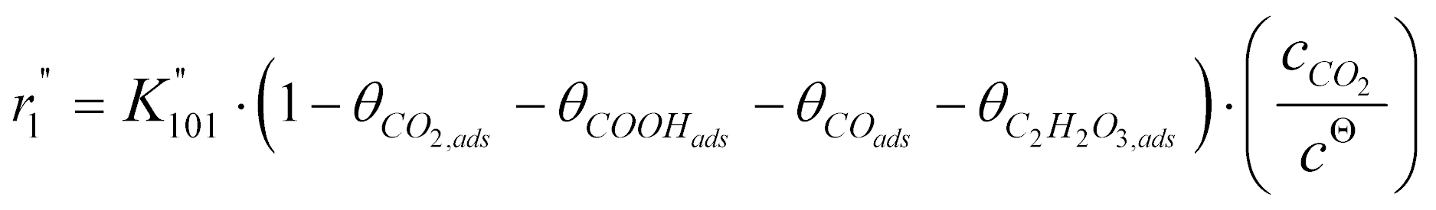 | (TS13.6)
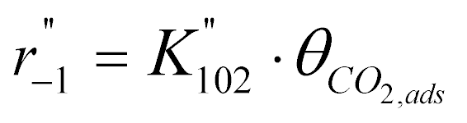 | (TS13.7)
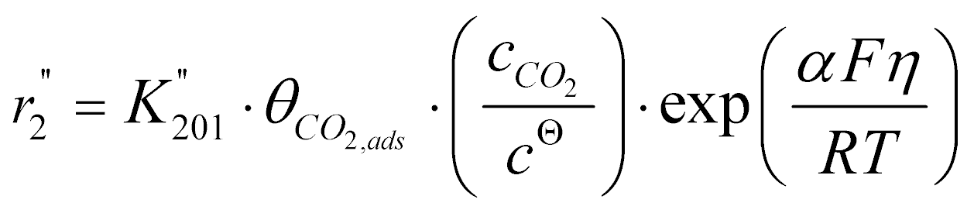 | (TS13.8)
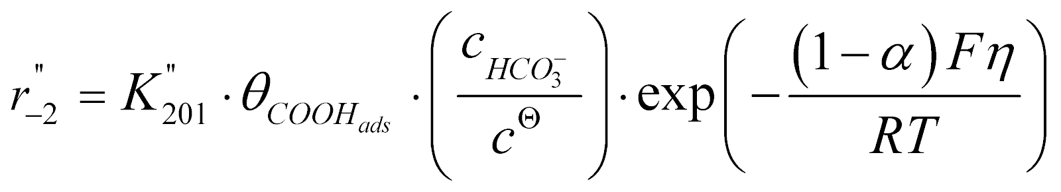 | (TS13.9)
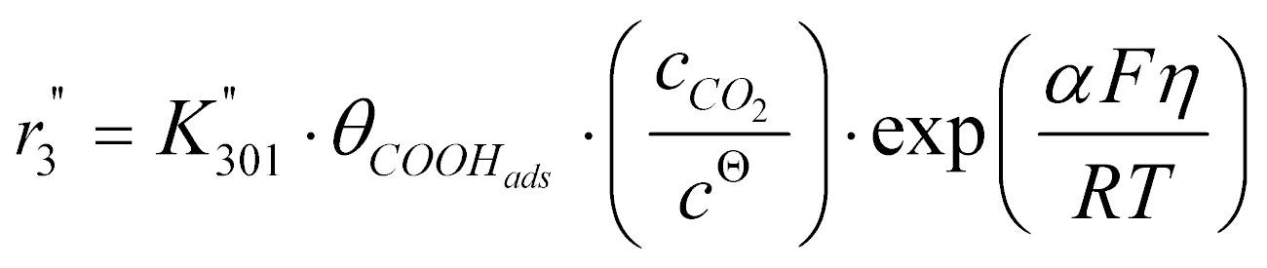 | (TS13.10)
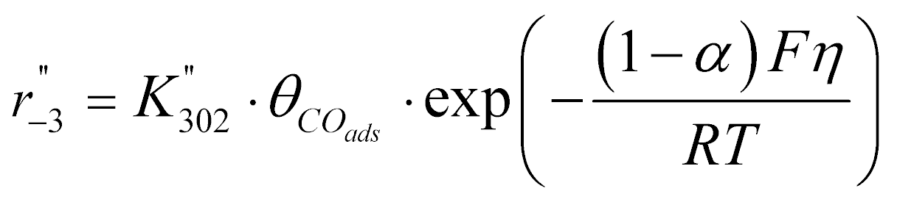 | (TS13.11)
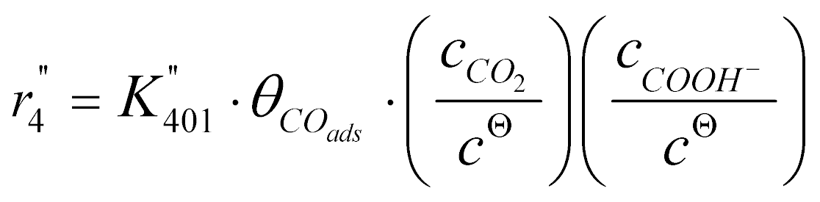 | (TS13.12)
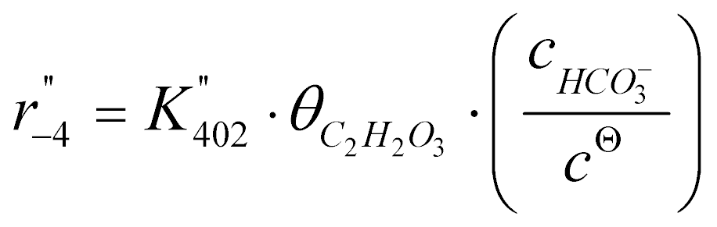 | (TS13.13)
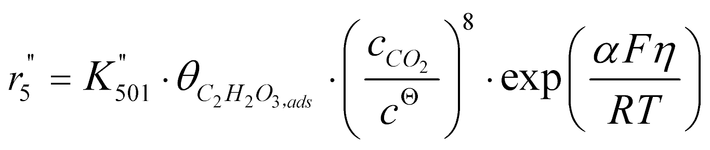 | (TS13.14)
 | (TS13.15)

Extended data Table 16. Control equations for CO₂ reduction to ethanol taking place on Sn₁-O3G in the presence of HCOOH.
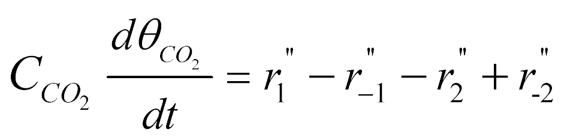 | (TS14.1)
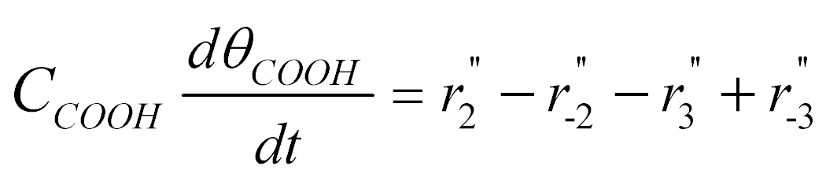 | (TS14.2)
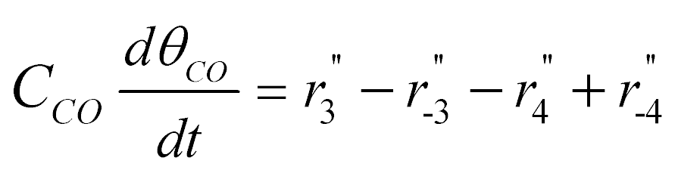 | (TS14.3)
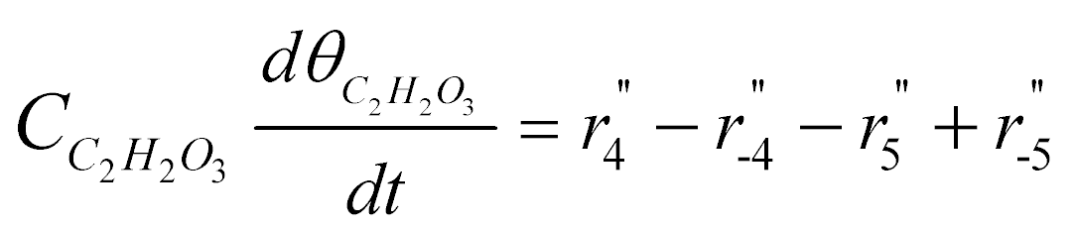 | (TS14.4)
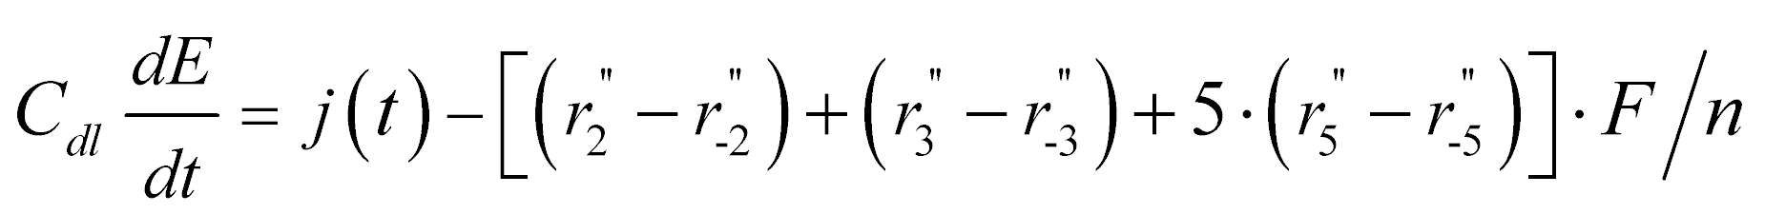 | (TS14.5)

Extended data Table 17. Kinetics parameters for CO₂ reduction to ethanol taking place on Sn₁-O3G in presence of HCOOH.
K’’₁₀₁ | K’’₁₀₂ | K’’₂₀₁ | K’’₂₀₂ | K’’₃₀₁
1.56×10¹ | 8.57×10⁻¹ | 6.19×10⁻¹⁰ | 1.18×10⁻¹⁴ | 3.38×10⁻⁹
K’’₃₀₂ | K’’₄₀₁ | K’’₄₀₂ | K’’₅₀₁ | K’’₅₀₂
1.18×10⁻¹¹ | 1.26×10⁻⁴ | 2.27×10⁻⁸ | 4.08×10⁻⁴ | 5.13×10⁻⁴

Extended data Table 18. The free energies for the network of competing C2 products relative to 3-2 (unit: eV). The contents in bold represent the favorable intermediates (or transition states) and the corresponding free energies relative to 3-2.
The group on  O site  The group on  Sn site | (1) COOH | (2) CHO | (3) CHOH | (4) CH₂
(2) CHO | 4-21(4)  (0.517) | 4-22  (0.376) | 4-23  (1.018) | 4-24  (2.178)
(3) CHOH | 4-31  (1.858) | 4-32  (1.273) | 4-33  (1.475) | 4-34  (2.666)
(4) CH₂ | 4-41  (0.662) | 4-42  (0.479) | 4-43  (1.116) | 4-44  (1.274)
TS of C-C coupling | (2.298) | (1.937) | (1.243) | (1.418)
C2 adsorbate | 6-41  (2.143) | 6-42  (1.784) | 6  (-0.167) | 6-44  (-0.619)

References and Notes
- K. Kim et al., Lanthanum-catalysed synthesis of microporous 3D graphene-like carbons in a zeolite template. Nature 535, 131-135 (2016).
- G. Kresse, J. Furthmüller, Efficient iterative schemes for ab initio total-energy calculations using a plane-wave basis set. Phys. Rev. B 54, 11169-11186 (1996).
- G. Kresse, J. Furthmüller, Efficiency of ab-initio total energy calculations for metals and semiconductors using a plane-wave basis set. Comput. Mater. Sci. 6, 15-50 (1996).
- J. P. Perdew, K. Burke, M. Ernzerhof, Generalized gradient approximation made simple. Phys. Rev. Lett. 77, 3865-3868 (1996).
- G. Kresse, D. Joubert, From ultrasoft pseudopotentials to the projector augmented-wave method. Phys. Rev. B 59, 1758-1775 (1999).
- S. Grimme, J. Antony, S. Ehrlich, H. Krieg, A consistent and accurate ab initio parametrization of density functional dispersion correction (DFT-D) for the 94 elements H-Pu. J. Chem. Phys. 132, 154104 (2010).
- J. Rossmeisl, Z. W. Qu, H. Zhu, G. J. Kroes, J. K. Nørskov, Electrolysis of water on oxide surfaces. J. Electroanal. Chem. 607, 83-89 (2007).
- P. B. Fabritchnyi et al. Tin-doped MgTiO₃: a new material for studying the solid-gas interface making use of the ¹¹⁹Sn Mössbauer spectroscopic probe. Z. Naturforsch. B 63, 637-640 (2008).
- H. Hayashi et al. Discovery of a novel Sn(II)-based oxide β-SnMoO₄ for daylight-driven photocatalysis. Adv. Sci. 4, 1600246-1600253 (2017).
- J. G. Ballard et al. ¹¹⁹Sn Mössbauer spectra of some tin(II)-oxygen compounds. Can. J. Chem. 53, 3371-3373 (1975).
- J. Yuan et al., Cu/TiO₂ nanoparticles modified nitrogen-doped graphene as a highly efficient catalyst for the selective electroreduction of CO₂ to different alcohols. J. CO₂ Util. 24, 334-340 (2018).
- D. Kim, C. S. Kley, Y. Li, P. Yang, Copper nanoparticle ensembles for selective electroreduction of CO₂ to C2–C3 products. Proc. Natl. Acad. Sci. USA 114, 10560 (2017).
- Y. Huang, A. D. Handoko, P. Hirunsit, B. S. Yeo, Electrochemical reduction of CO₂ using copper single-crystal surfaces: effects of CO* coverage on the selective formation of ethylene. ACS Catal. 7, 1749-1756 (2017).
- S. Lee, G. Park, J. Lee, Importance of Ag–Cu biphasic boundaries for selective electrochemical reduction of CO₂ to ethanol. ACS Catal. 7, 8594-8604 (2017).
- D. Gao et al., Plasma-activated copper nanocube catalysts for efficient carbon dioxide electroreduction to hydrocarbons and alcohols. ACS Nano 11, 4825-4831 (2017).
- D. Ren et al., Selective electrochemical reduction of carbon dioxide to ethylene and ethanol on copper(I) oxide catalysts. ACS Catal. 5, 2814-2821 (2015).
- H.-P. Yang et al., Entrapment of a pyridine derivative within a copper–palladium alloy: a bifunctional catalyst for electrochemical reduction of CO₂ to alcohols with excellent selectivity and reusability. Catal. Sci. Technol. 6, 6490-6494 (2016).
- M. Ma, K. Djanashvili, W. A. Smith, Controllable hydrocarbon formation from the electrochemical reduction of CO₂ over Cu nanowire arrays. Angew. Chem. Int. Ed. 55, 6680-6684 (2016).
- Y. Liu et al., Selective electrochemical reduction of carbon dioxide to ethanol on a boron- and nitrogen-co-doped nanodiamond. Angew. Chem. Int. Ed. 56, 15607-15611 (2017).
- Y. Song et al., Metal-free nitrogen-doped mesoporous carbon for electroreduction of CO₂ to ethanol. Angew. Chem. Int. Ed. 56, 10840-10844 (2017).
- P. Grosse et al., Dynamic changes in the structure, chemical state and catalytic selectivity of Cu nanocubes during CO₂ electroreduction: size and support effects. Angew. Chem. Int. Ed. 57, 6192-6197 (2018).
- J. Albo et al., Copper-based metal–organic porous materials for CO₂ electrocatalytic reduction to alcohols. ChemSusChem 10, 1100-1109 (2017).
- Y. Huang, C. W. Ong, B. S. Yeo, Effects of electrolyte anions on the reduction of carbon dioxide to ethylene and ethanol on copper (100) and (111) surfaces. ChemSusChem 11, 3299-3306 (2018).
- D. Kim, J. Resasco, Y. Yu, A. M. Asiri, P. Yang, Synergistic geometric and electronic effects for electrochemical reduction of carbon dioxide using gold–copper bimetallic nanoparticles. Nat. Commun. 5, 4948 (2014).
- J. Wu et al., A metal-free electrocatalyst for carbon dioxide reduction to multi-carbon hydrocarbons and oxygenates. Nat. Commun. 7, 13869 (2016).
- Y. Song et al., High-selectivity electrochemical conversion of CO₂ to ethanol using a copper nanoparticle/N-doped graphene electrode. ChemistrySelect 1, 6055-6061 (2016).

