Supplementary Information for
Solvent-free and long-cycling garnet-based lithium-metal batteries

Jiameng Yu¹, Chang Zhang¹, Cong Wu¹, Ran Wei¹, Shaojie Chen¹, Yingjie He¹, Qilin Hu¹, Wei Liu^{1,2}

¹School of Physical Science and Technology, ShanghaiTech University, Shanghai 201210, China.
²Shanghai Key Laboratory of High-resolution Electron Microscopy, ShanghaiTech University, Shanghai 201210, China

E-mail address: liuwei1@shanghaitech.edu.cn

Supplementary Figure 1. Synthetic diagram of the preparation of (Li,K,Cs)FSI molten salt electrolyte.

Supplementary Figure 2. Phase diagram of ternary system LiFSI–KFSI–CsFSI ¹.

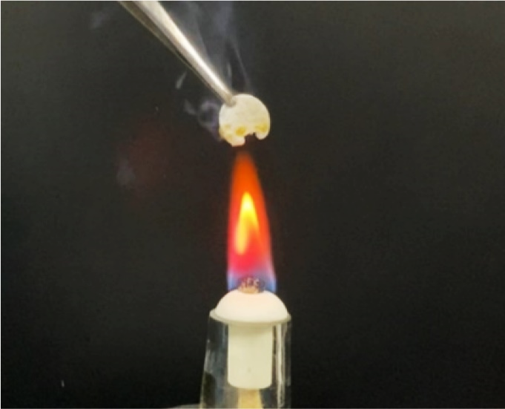
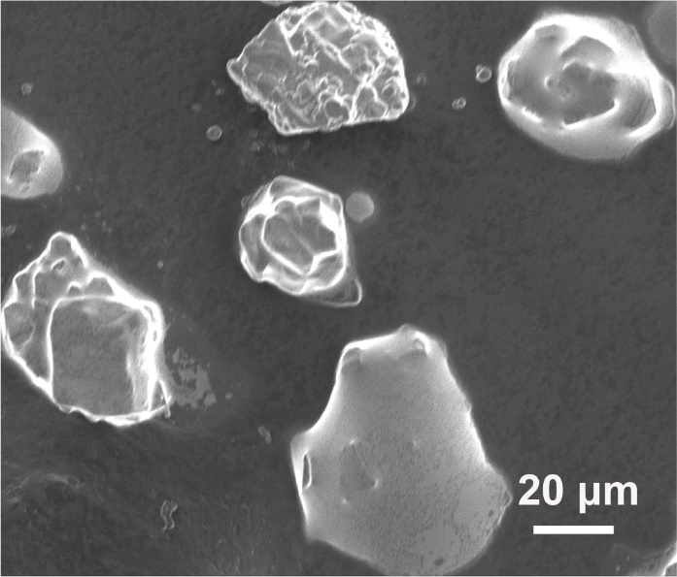
Supplementary Figure 3. Characterization of molten salts. a XRD patterns of the LiFSI, KFSI, CsFSI and (Li,K,Cs)FSI. b SEM image of (Li,K,Cs)FSI eutectic powder. c Optical image of flame test of molten salts. d Impedance spectra of the (Li,K,Cs)FSI electrolytes held by glass fiber separator with 0.18 mm in thickness and 16 mm in diameter as the configuration of SS/ (Li,K,Cs)FSI /SS at the temperature range from 10 to 80 °C.
b
c
d
a

a
d
b
c
Supplementary Figure 4. Characterization of garnet electrolyte. a XRD patterns of the LLZTO powder and pellet. b Optical photograph of ceramic pellet and SEM morphology of LLZTO powder, pellet’s surface and across section. c Nyquist plots of the LLZTO pellet measured at the temperature range from 20 to 80 °C. d The fitted Arrhenius plot of the garnet electrolytes.

c
b
d
a
Supplementary Figure 5. Performance of Li/LLZTO/Li symmetric battery. a EIS spectra of symmetric battery tested at RT, 45 °C, 60 °C and 80 °C. b Critical current density of the Li symmetric battery at 60 °C. c,d Galvanostatic cycling performance of the Li/LLZTO/Li cells at 0.3 mA cm⁻² 45 °C (c) and 0.6 mA cm⁻² 60 °C (d) with 0.5 h for each plating/stripping half cycle and for a total cycling time of 1000 hours.

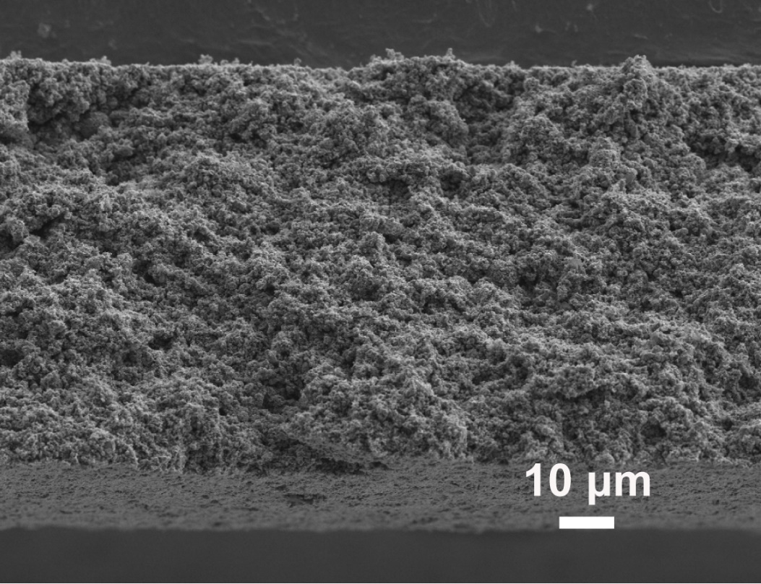
Supplementary Figure 6. Morphology of the cross section of pristine commercial cathode piece.

b
a

Supplementary Figure 7. a,b EIS spectra of LFP half cells with liquid electrolyte modification in the cathode side (a) and without any modification (b).

b
a

Supplementary Figure 8. a Rate capacity performance of LFP half cell at 80 °C. b The corresponding charge-discharge voltage profiles.

Supplementary Figure 9. Cycling performance of LFP half cells with liquid electrolyte as cathode interlayer at RT and 45 °C.

Supplementary Figure 10. Cycling performance of Li||LFMP cell with molten salts as catholyte at 45 °C.

a
b
c
d

Supplementary Figure 11. Finite element analysis of Model 1 with low σ and ${\text{D}}_{{\text{Li}}^{\text{+}}}$and Model 2 with high σ and ${\text{D}}_{{\text{Li}}^{\text{+}}}$during the discharge process. a The built model for simulation. b The EIS spectra of Li||LFP half cells modified by molten salts and PEO-LiTFSI. c The ion diffusion coefficient fitted by EIS. d The Voltage-Time plot for Model 1 (PEO-LiTFSI) and Model 2 (molten salts) through simulation.

Battery structure | Temperature (°C) | Cathode  Fabrication | Mass loading  (mg cm⁻²) | Rate/  current | Voltage  (V vs Li/Li⁺) | Cycling number | Ref.  in main text
Li-SnF₂/LLZO/liquid electrolyte/LFP | 30 | Slurry coating | ~1.6  ~3.3 | 0.5 C  1 C  0.2 C | 2.5–4.0 | 200  200  90 | 42
Li-Ge/LLZO/PVDF-HFP &liquid electrolyte /LFP | RT | Slurry coating | ~0.6 | 1 C | 2.4–4.0 | 100 | 43
Li/PEO-LiTFSI/LLZO/ PEO-LiTFSI /LFP | 90 | Slurry coating | ~2 | 0.2 C | 2.5–4.2 | 200 | 44
Li/CPMEA-LiTFSI/LLZO/ CPMEA-LiTFSI /LFP | 65 | Slurry coating | ~5 | 0.2 C | 2.8–3.8 | 100 | 45
Li /3D LLZO-ZnO/ LiTFSI- LFP | 60 | Slurry infiltration | ~2 | 0.2 C | 2.8–3.8 | 300 | 46
Li/PVDF-HFP&LLZO&LiTFSI&TEGDME/LFP | 25 | Slurry coating | 2.1~2.3 | 0.5 C | 3.0–3.8 | 180 | 47
Li/PVDF-PEO&LLZO NPs&LiTFSI/LFP | 50 | Slurry coating | ~1.5 | 0.2 C | 2.5–4.0 | 180 | 48
Li/PEO-LiTFSI-LLZO NWs /LFP | 45  60 | Slurry coating | ~1.68 | 0.1 C  0.5 C | 2.8–4.2 | 80  70 | 49
Li/PEO-LiTFSI & LLZO nanosheets | 45  60 | Slurry coating | ~1.2 | 0.3 C  0.5 C | 2.5–4.0 | 150  200 | 50
Li/LLZTO/molten salts/LFP | 45  60  80 | Slurry coating | 3.3~3.8 | 0.5 C  0.5/1 C  0.5 C | 2.5–4.0 | 200  600/1000  200 | Our  work
Li/LLZTO/molten salts/LFP | 100 | Slurry coating | 3.3~3.8 | 2 C | 2.8–4.0 | 200 | Our  work
Li/LLZTO/molten salts/LFP | 60  80 | Slurry coating | ~12 | 0.1 C  0,2 C | 2.5–4.0 | 100 | Our  work
Li/LLZTO/molten salts/LFMP | 45 | Slurry coating | 3.1 | 0.5 C | 2.5–4.5 | 100 | Our  work
Li/LLZTO/molten salts/LFMP | 60 | Slurry coating | 3.1
Table 1. Performance comparison with various strategies in garnet-type solid batteries

Reference

1. Kubota, K.; Nohira, T.; Hagiwara, R., New inorganic ionic liquids possessing low melting temperatures and wide electrochemical windows: Ternary mixtures of alkali bis(fluorosulfonyl)amides. Electrochim. Acta 2012, 66, 320-324.

