For Table of Contents Only

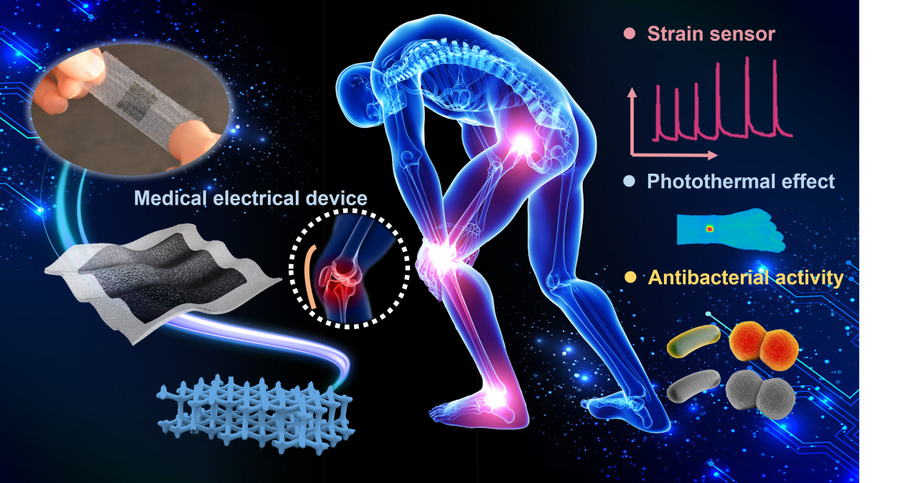
A novel biocompatible and breathable healthcare electronic which exhibits excellent sensing performance in motion monitoring and ability of distinguishing stretching, low pressure, high pressure and bending stimuli, is fabricated. Combined with outstanding photothermal effect and antibacterial activity, the healthcare electronic achieves wireless giant monitoring and sit position detecting accompanied by performing hot therapy/antibacterial treatment in the application of sports injury site, which possesses high potential in next-generation medical assistive and therapeutic systems.

