Supplementary information

Biocompatible and Breathable Healthcare Electronics with Outstanding Sensing Performances and Photothermal Antibacterial Effect for Sport Rehabilitation

Xinyi Wang¹, Yan Tao², Shaoshan Pan¹, Xue Fang¹, Congcong Lou¹, Yunqi Xu¹, Jianpeng Wu¹, Liang Lu³, Xinglong Gong^{1,*}, Tianzhi Luo¹, Shouhu Xuan^{1,*}

¹ CAS Key Laboratory of Mechanical Behavior and Design of Materials, Department of Modern Mechanics, University of Science and Technology of China, Hefei 230027, PR China
² Outpatient Department, The First Affiliated Hospital of University of Science and Technology of China, Hefei 230001, PR China
³ The First Affiliated Hospital of USTC, Division of Life Sciences and Medicine, University of Science and Technology of China, Hefei, Anhui, 230036, PR China
*Email: xuansh@ustc.edu.cn, gongxl@ustc.edu.cn

Supplementary Notes
Note 1
The WVTR is calculated using the following formula:
$$WVTR=\frac{G}{tA}$$
where G is the loss of weight, t is the period elapsed during the test, and A is the area of the test region.
Note 2
The relative cell viability is calculated using the following formula:
$Relative cell viability (\%)$=$\frac{A_{i}}{A_{0}}×100\%$
where A₀ is the average absorbance of the control group, and A_{i} is the average absorbance of the experimental group.
Note 3
The photothermal conversion efficiency is calculated using the following formula:
$$η=\frac{Q}{Q_{total}}=\frac{C_{p}∙m∙∆T}{I∙S∙t}$$
where C_{p} represents the specific heat capacity, m is the sample weight, ΔT is the membrane temperature change, I is the light intensity, S is the effective light area, and t is the response time.
Here using DSC Heat Capacity Analysis (DSC Q2000) measured the C_{p} is 1.775 J /(kg·℃)
- η=$\frac{1.775×0.07×（100.9-23）}{0.884×47}$=23.99%
Note 4
The antibacterial efficiency was calculated by plate counting method.
$$Survival \%=\frac{N_{i}}{N_{0}}×100\%$$
$$Sterilizing \%=1-Survival \%$$
where N₀ is the maximum number of colonies in the original bacterial solution (no sample group) can be counted, N_{i} is the colony value of the sample after antibacterial and the gradient corresponding to the original bacterial solution.

Supplementary Figures

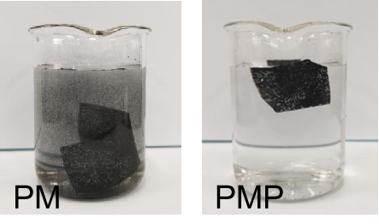
Figure 1 Digital images of PM and PMP after washed.

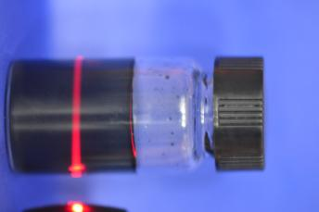
Figure 2 MXene colloidal solution produces Tyndall effect.

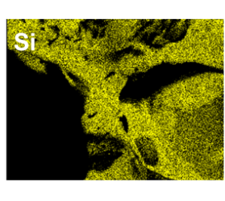
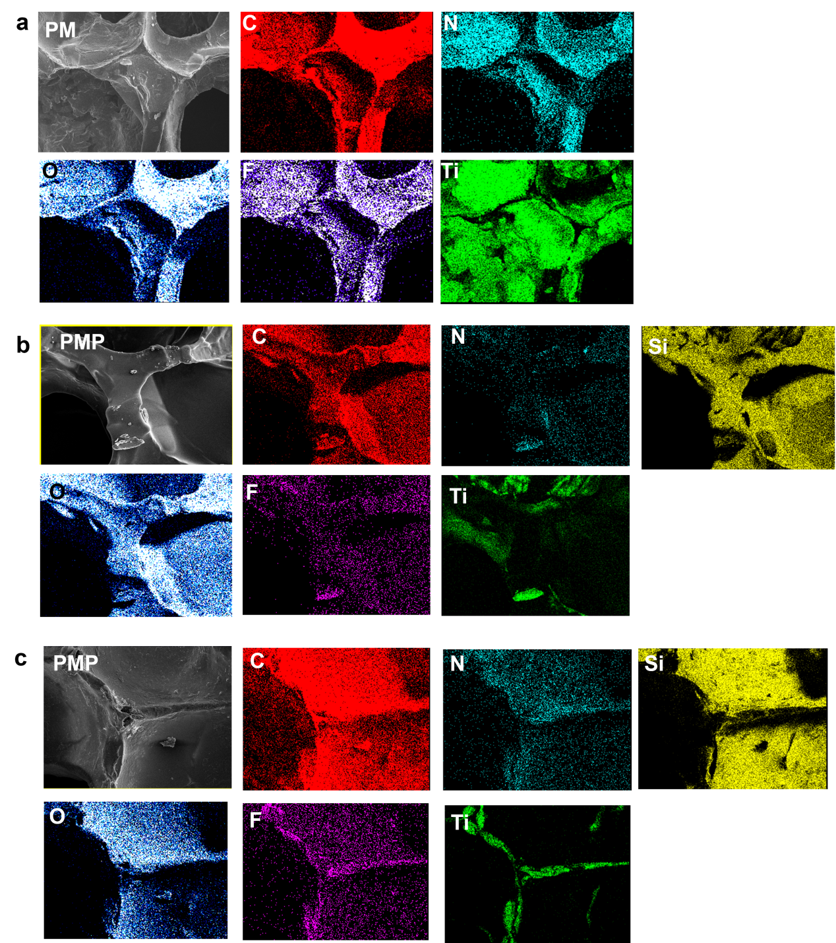

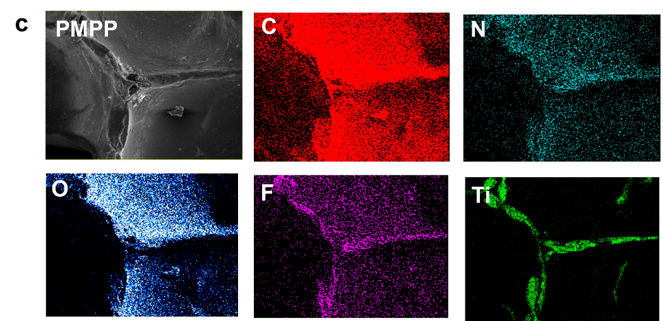

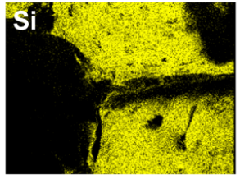

Figure 3 Element mapping of (a) PM, (b) PMP, (c) PMPP.

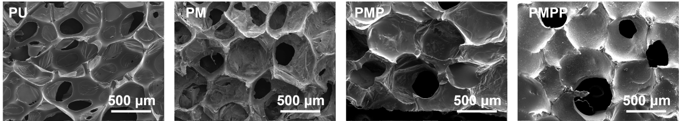
Figure 4 SEM images of PU, PM, PMP, PMPP.

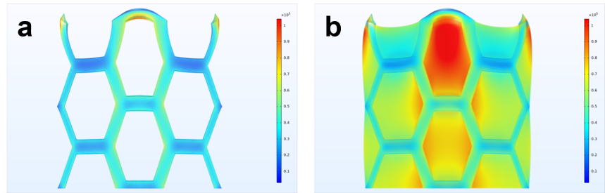
Figure 5 Finite element simulation process, the tap bears most of the stress. (a) no tape. (b) with tape.

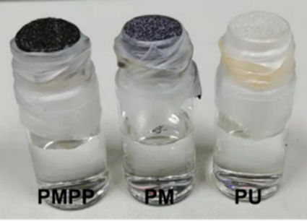
Figure 6 Photographs of the setup for measuring the gas permeability of the PU, PM, PMPP.

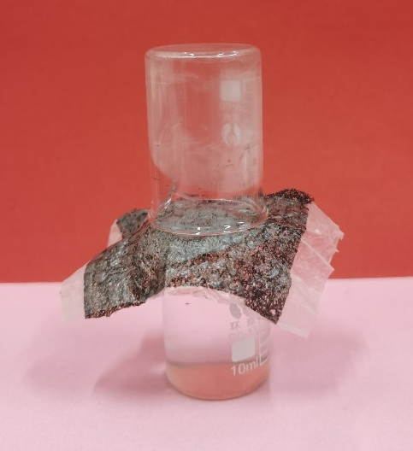
Figure 7 Photograph showing water vapor transmission performance of the breathable electrical device (PMPPF). The water vapor can pass through the PMPP hybrid sponge and escape from the vial containing hot water (greater than 80 °C), and is finally transformed to the condensed water inside the beaker, which proves the satisfactory water vapor permeability.

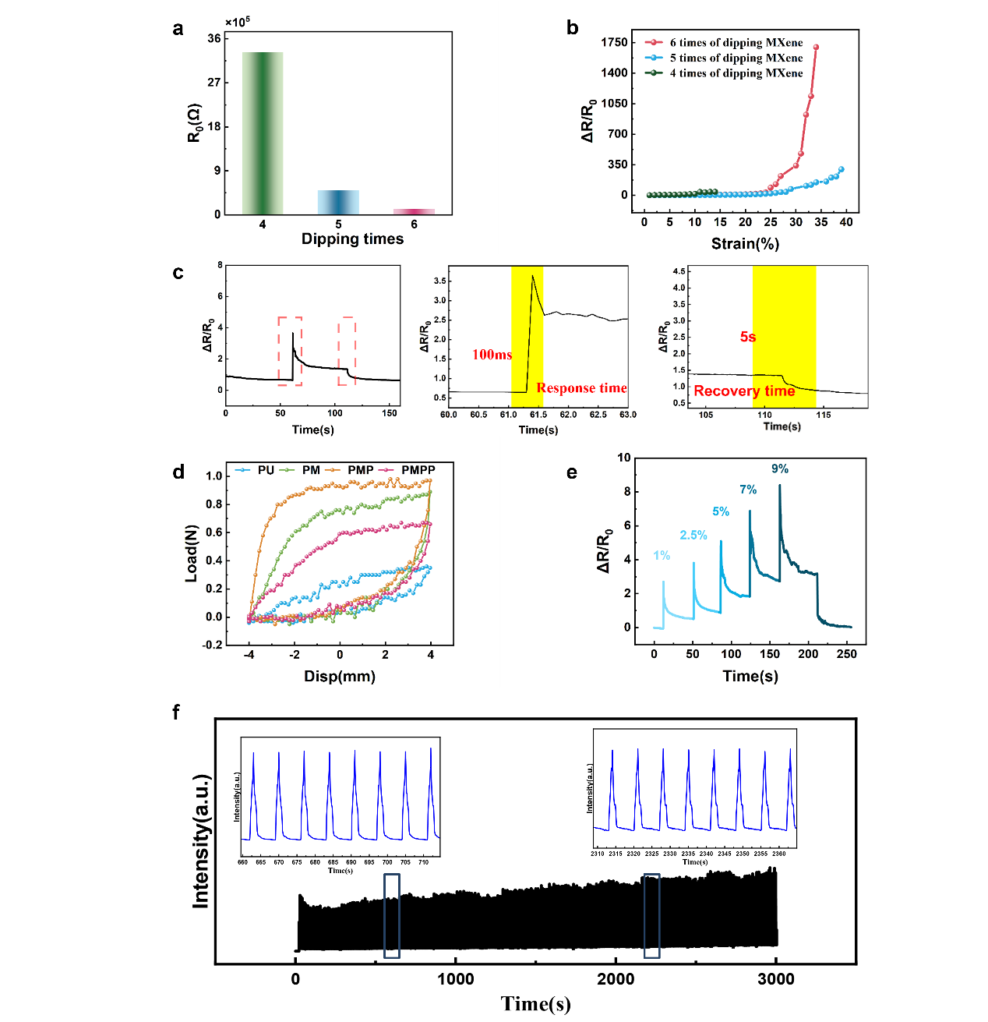
Figure 8 (a) Resistance of PMPP at different times of coating MXene (n=4, 5, 6). (b) GF (GF=(ΔR/R0) /ε, where R0 is the initial resistance, ΔR denotes the change of the resistance before and after the application of strain, and ε represents the applied strain) of PMPPF sensor at different times of coating MXene (n=4, 5, 6). (c) Recovery time (6s) and response time (100ms) of PMPPF sensor. (d) Loading-unloading curve of the Load-Disp. (e) Continuous stretch loading. (1%, 2.5%, 5%, 7%, 9%) (f) The performance of PMPPF sensor for 300 cycles under 15% strain.
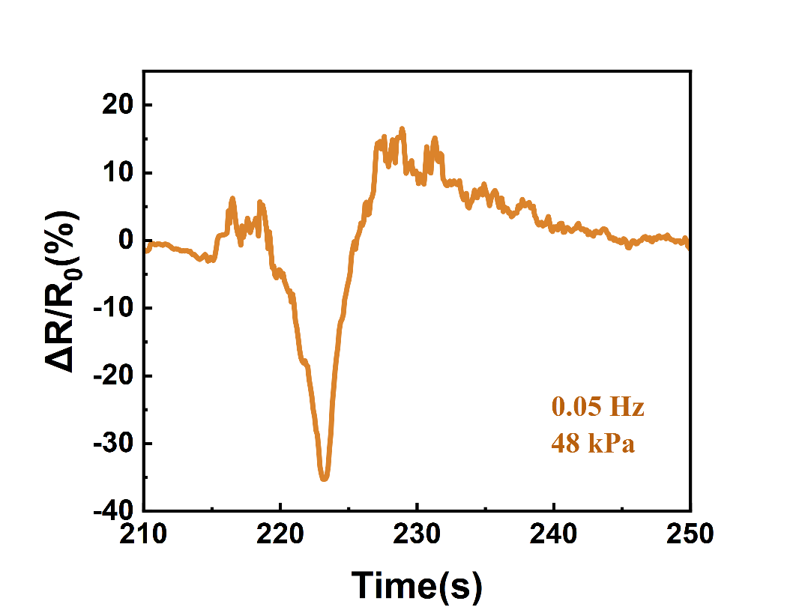
Figure 9 Details of resistance change under high pressure.
Figure 10 Relative resistance changes of the sensor under compress-release cycles at a maximum pressure of 0.1 kPa, 0.3 kPa, and 0.44 kPa, respectively.

Figure 11 The performance of PMPPF sensor after bending for 300 cycles under 6.9°and 0.25 Hz.

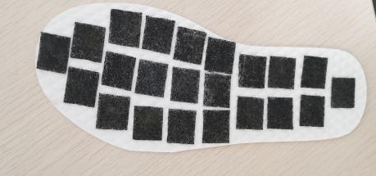

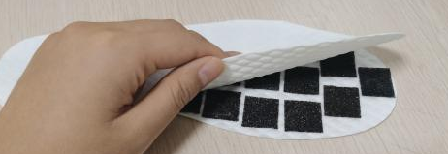
Figure 12 Digital images of smart insole.

Supplementary Tables
Table 1 Different breathability of electronics in previous works
Functional fillers | Substrate materials | Environment  temperature | Relative humidity | WVTR  (g m⁻² day⁻¹) | References
MWCNTs | TPU foam | 37 ℃ | 35% | 270-352 | 1
MXene | Nano PE Film | 26 ℃ | 30% | 533 | 2
Copper | Textile | - | - | 600-1440 | 3
Sericin–  graphene | Textile | 40 ℃ | - | 8400 | 4
Ag | Kirigami structure PET | 38 ℃ | 50% | 1260 | 5
Ionic liquid | TPU nanofibrous mat | 24 ℃ | 75% | 427.62-532.45 | 6
PMPP |  | 24 ℃ | 39% | 1026 | This work
PMPPF |  | 24 ℃ | 39% | 560 | This work

Table 2 Relationship between relative viability and cytotoxicity.
Relative cell viability % | Cytotoxicity Grade | Biocompatibility
≥100 | 0 | Qualified
75~99 | 1 | Qualified
50～74 | 2 | Combined with the cell morphology analysis
25～49 | 3 | Unqualified
1～24 | 4 | Unqualified
0 | 5 | Unqualified

Table 3 Cell relative viability and Biotoxicity grade of different samples.
Sample | Relative cell viability % | Cytotoxicity Grade | Biocompatibility
Ctrl | 100% | 0 | Qualified
PM | 41.2% | 3 | Unqualified
PMP | 46.5% | 3 | Unqualified
PMPP | 69.6% | 2 | Qualified

Table 4 Specific data of the sterilization rate.
 | Power Density (W/cm²) |  |  |  | Time (min)
 | 0 | 0.22 | 0.25 | 0.27 | 0 | 10 | 15 | 20
S. aureus | 18.2% | 92% | 99.3% | 99.998% | 18.2% | 98.8% | 99.95% | 99.998%
E. coli | 37% | 98% | 99.989% | 99.998% | 37% | 95% | 99.74% | 99.998%
*In the absence of light, PMPPF showed slight inhibition of bacterial growth (18.2% against S. aureus, 37% against E. coli), which may be attributed to the surface adsorption of the bacteria to the sponge.

Supplementary Videos
Video 1 COMSOL simulation of hybrid sponge stretching process.
Video 2 COMSOL simulation of hybrid sponge compression process.
Video 3 Optical microscope movie of the resumable deformation of the stretching sensor during stretch-recover cycle.
Video 4 Optical microscope movie of the resumable deformation of the pressure sensor during compress-recover cycle.
Video 5 Wireless smart insole for real-time gait detection.
Video 6 Wireless smart cushion for real-time alerting wrong sit position.

References
[1] Wang, H. et al. High-performance foam-shaped strain sensor based on carbon nanotubes and Ti₃C₂T_{x} MXene for the monitoring of human activities. ACS Nano 15. 9690-9700 (2021).
[2] Shi, M. et al. Ti₃C₂T_{x} MXene-decorated nanoporous polyethylene textile for passive and active personal precision heating. ACS Nano 15. 11396-11405 (2022).
[3] Liu, Z. et al. Highly breathable and stretchable strain sensors with insensitive response to pressure and bending. Adv. Funct. Mater. 31. 2007622 (2021).
[4] Liang, X. et al. Hydrophilic, breathable, and washable graphene decorated textile assisted by silk sericin for integrated multimodal smart wearables. Adv. Funct. Mater. 2200162 (2022). DOI: 10.1002/adfm.202200162.
[5] Xuan, Y. et al. Wireless, minimized, stretchable, and breathable electrocardiogram sensor system. Appl. Phys. Rev. 9. 011425 (2022).
[6] Chen, J. et al. Breathable strain/temperature sensor based on fibrous networks of ionogels capable of monitoring human motion, respiration, and proximity. ACS Appl. Mater. Interfaces 13. 54567-51577 (2021).

